# CSE344

# System Programming Homework 1 Report

**Süleyman Koramaz**

**1901042615**

**PART-1**

First test:

Second test:

First results rate is 1.81 / 2.00

Second results rate is 3.66 / 4.00

**EXPLANATION:**

Since the O_APPEND flag works in an atomic way, 2 processes running at the same time can run without any errors without overwriting each other. On the other hand, if we try to do what O_APPEND does without using O_APPEND, we can do it with the lseek() function by adding the offset to the end of the file in each write.

However, since the fseek() function does not work in an atomic way, in processes with a large number of executions, 2 processes running at the same time can affect each other. In this test code, while 2 processes are writing at the same time, they can overwrite each other with small probability since it is not atomic.

**PART-2**

I have an header file that contains my dub() and dub2() functions.

**my_dub()**

**This function does:**

**-take a file descriptor as a parameter**

**-create new file descriptor**

**-control oldfd (taken with parameter) is valid or not**

**-duplicate oldfd to newfd with using fcntl() function**

**-control duplication success**

**-return new file descriptor**

**my_dub2()**

**This function does:**

**-take old file descriptor and new file descriptor as a parameter**

**-control oldfd is valid or not**

**-control oldfd and newfd is equal or not**

**-if newfd is open close it**

**-return duplicated old file descriptor**

**In my_dup() function we create new file descriptor, it assign lowest available file descriptor number.**

**In my_dup2() function we duplicate newfd over oldfd.**

**When we do that, return value (oldfd) still using same file, but it is descripting newfd’s value now.**

**For example; newfd was 3 and oldfd was 4, if newfd was open, it is closed. If oldfd was using example.txt file, it is still using it but it is 3 now.**

**PART-3**

I wrote a program that verify my dup() and dup2() implementations in the part2

**This program does:**

**-create 5 file descriptor**

**-open 4 file for writing with fd1,fd2,fd3 and fd4**

**-print values before duplications**

**-write to file with fd1 and fd2: this write 1 line to test1.txt and 1 line to test2.txt**

**-duplicate fd1 to fd2 with my_dup()**

**-write to file with fd1 and fd2: this write 2 line to test1.txt because both of them using test1.txt because of duplication**

**-write to file with fd3 and fd4: this write 1 line to test3.txt and 1 line to test4.txt**

**-duplicate fd3 to fd4 with my_dup2() but use 10 as a file descriptor value, with this function; fd4 is 10 now and using test3.txt file because fd3 is using test3.txt file and fd4 duplicated from fd3.**

**-write to file with fd3 and fd4: this write 2 line to test3.txt because both of descriptors using test3.txt file now.**

**-print values after duplications**

**-printf fd5 value before duplication**

**-duplicate fd3 to fd5 with fd1 as a newfd**

**-with this function: fd5 is using test3.txt now because fd3 was using test3.txt and fd5’s value is fd1’s value now and fd1 is closed.**

**-write to file with fd1 and fd5: this write 2 line to test3.txt because fd5 and fd1 is using test3.txt**

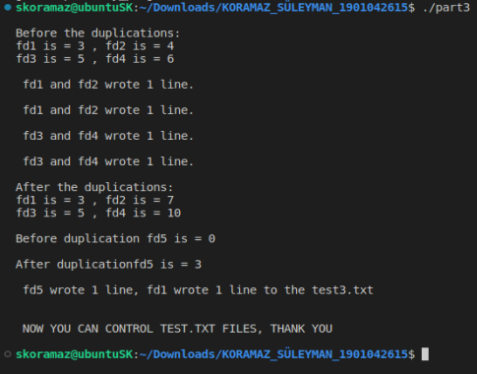**PART-3 Results and test.txt files**

**MAKEFILE NOTES:**

-‘make’ command compile both of the C files.

-‘make clean’ command remove all files instead of C files and clear terminal

-In part1, command must be exactly same with the input in the PDF. If it is not 3 or 4 word, or while second use last argument is not ‘x’ letter, it will not work!!!