

# CSE344 HOMEWORK 2

# REPORT

Süleyman Koramaz

1901042615

# FUNCTİONS

## signal_handler

This function handle signals. When signal is SIGKILL, this function does:

-print signal number

## parser

This function take an string which is user input line. Parse commands by ‘|’ and put them to string array.

## execute_command

This function use execl() function to execute that command. Control is execl function return and if it return give an error and exit the program.

## main

### Variables:

commands[20] -> This string array holds commands parsed from user input line.

input[500] -> This string holds user input line.

filename[100] -> This string holds log file name that opened for each execution.

raw_time , *timeinfo -> This variables used for use time.

count -> This variable used for index of commands array

pid -> This variable used for fork() - child/parent control

status -> This variable used for signal status

fd[] -> This variable used for pipeing

pre_fd -> This variable used for previous pipe file descriptor

log_fd -> This variable used for log file descriptor

## Testing

make compile -> compile code

make test -> create test .txt files

make runValgrind -> run program with valgrind for verified memory leaks

## TEST FILES:

## COMMAND TESTS:

ls



ls | grep .txt

cat file.txt > output.txt

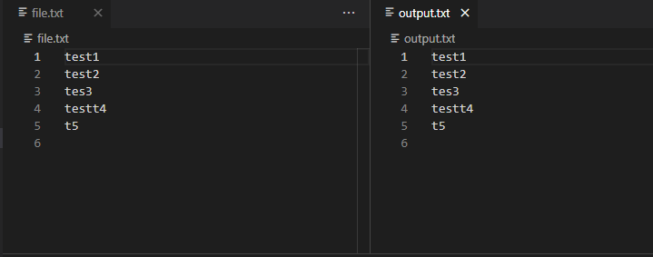

grep test file.txt | sort | uniq | uniq -c | wc -l



ls -lh | grep .txt | sort -k 5 -h | head -n 5

NOTE:

IN COMMAND LINE STRINGS MUST BE WRITEN WITHOUT “” BECAUSE PROGRAM ALSO ENCLOSES “” SIGNS IN STRING.

For ex:

NOT: grep “.txt” -> CORRECT: grep .txt

MAKEFILE NOTES:

* make compile

compiling

* make test

create test files

* make run

run program

* make runValgrind

run program with valgrind

* make clean

remove .txt files and program.o

SIGNAL HANDLING

Program handle SIGINT, SIGTSTP and SIGKILL signals. It print which signal received and exit

VALGRIND REPORT OF TESTING