L.N. Gumilyov Eurasian National University

Faculty of Information Technology

Department of Information Systems

Report

**Учебная практика**

Student: Suleymenova Inkara

Group: Multilingual Information Systems

______________

Supervisor: PhD, Zhukabayeva Tamara Kokenovna

______________

Astana, 2023

**Introduction**

As part of my project, which I called the Bank App, I focused on creating an application that provides users with the opportunity to manage their finances in a convenient and efficient way. The main task was to develop an interface that would ensure secure registration and authentication of users.

I decided to use a MySQL database to store and manage user data. This choice was due to the need for ease of integration and reliability of working with data. Although it was originally planned to use SQL Server Management Studio (SSMS), but for technical reasons I ran into difficulties and decided to use MySQL, which allowed me to maintain the continuity of work on the project.

After successful authentication, the user gets to his personal account, where full access to financial management is provided. Here, the user can view the current balance of his account, make transfers to other users, view the history of past transactions, as well as make deposits and withdrawals.

As a result, my Bank App is not only a convenient tool for financial management, but also a reliable partner in ensuring the safety and comfort of users when working with their financial assets.

My biggest headache was that I couldn't connect the database to java.

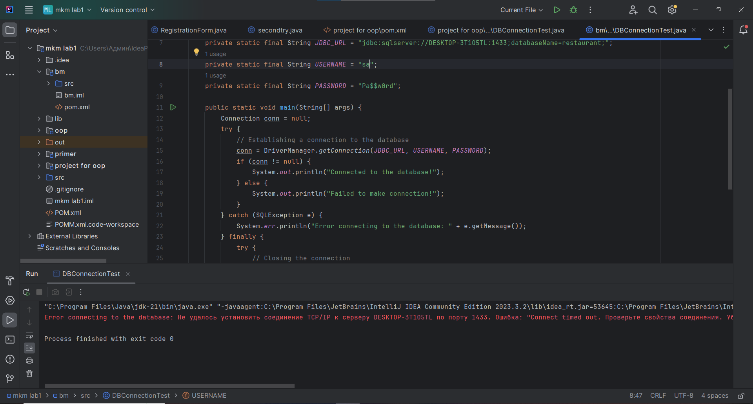

Figure 1. Error

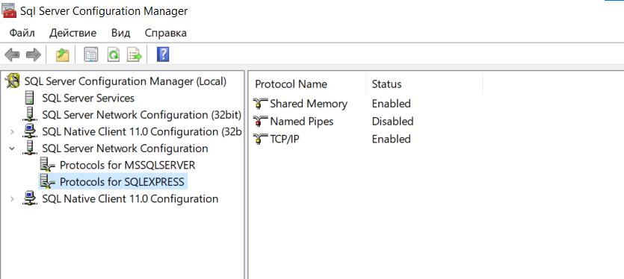Figure 2.TCP/IP.Enabled

And after so much time, I succeeded with mysql:

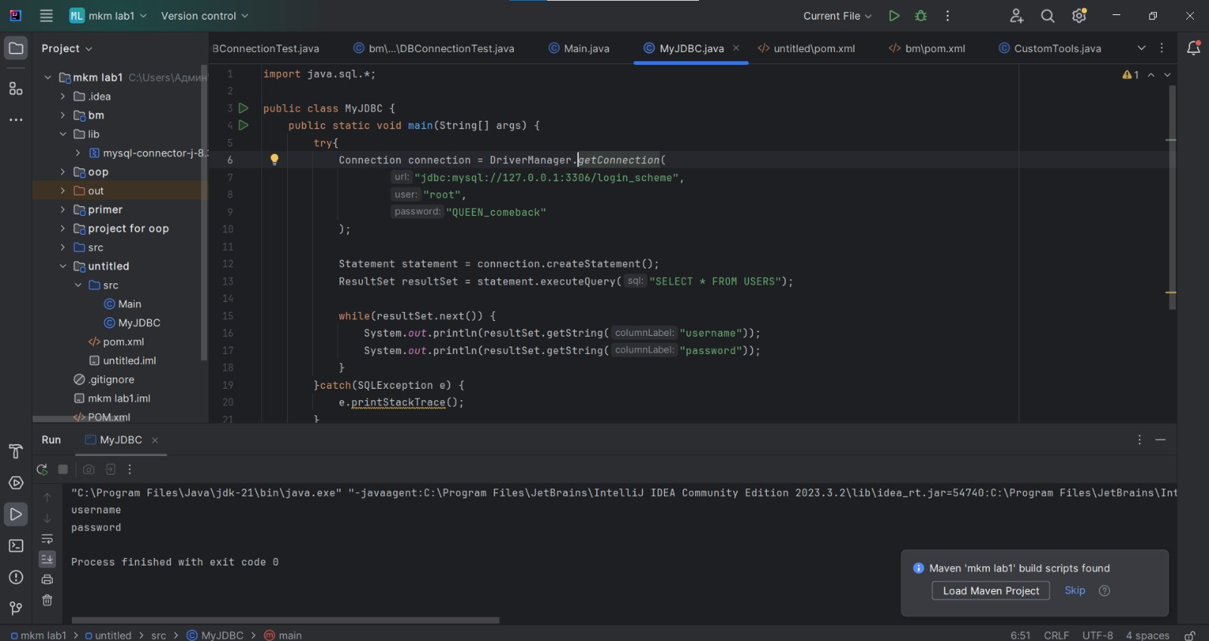

Figure 3. Success

My db on SQL:

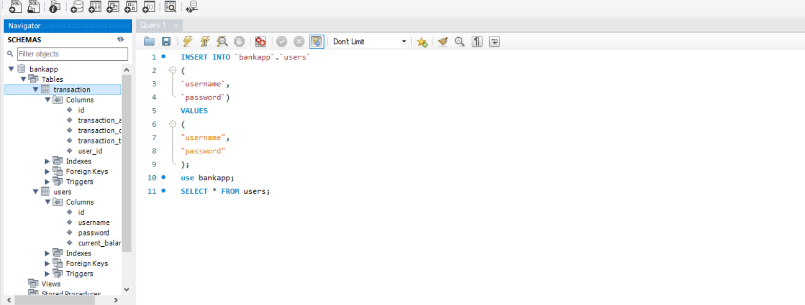

Figure 4. MySQL

Creating an abstract class helps us set up the blueprint that our Guys will follow, for example in each of the Guys they will be the same size and will need to invoke their own add GUI Components() which will be unique to each subclass. I have create an abstract class BaseFrame.

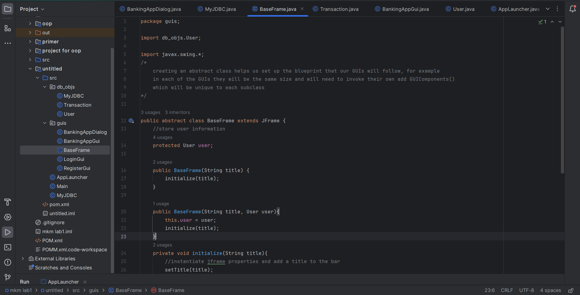

Figure 5. Abstract class BaseFrame

I have created a class LoginGUI. This gui will allow user to login or launch the register gui. This extends from the BaseFrame which emans we will need to define our own addGuiComponent()

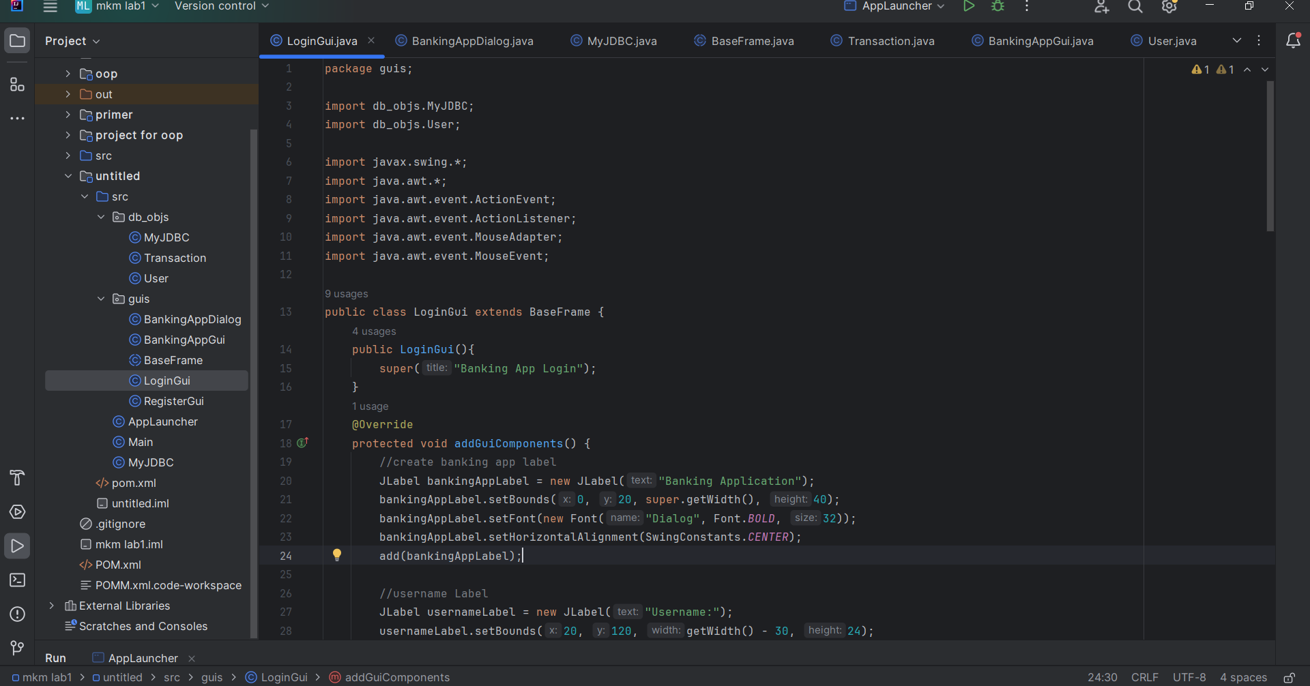

Figure 6. Login Gui

I have created a RegisterGui

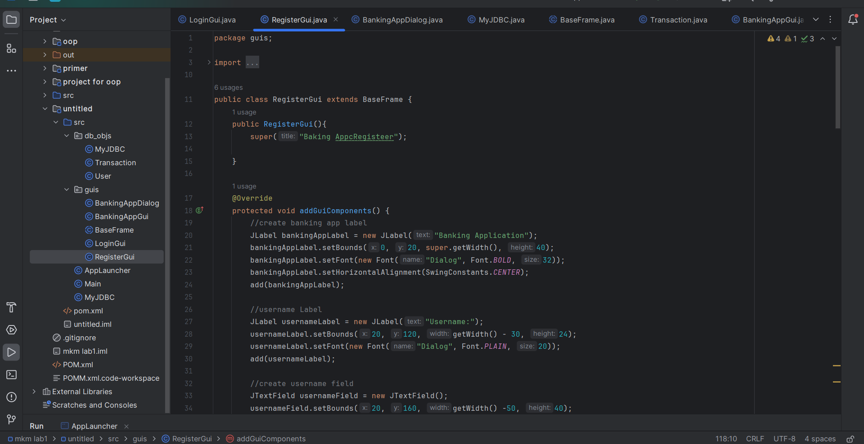

Figure 7. Class RegisterGui

I have created a bankingAppGui. Performs banking functions such as depositing, withdrawing, seeing past transaction, and transferring. This extends from the BaseFrame which means we will need to define our own addGuiComponent:

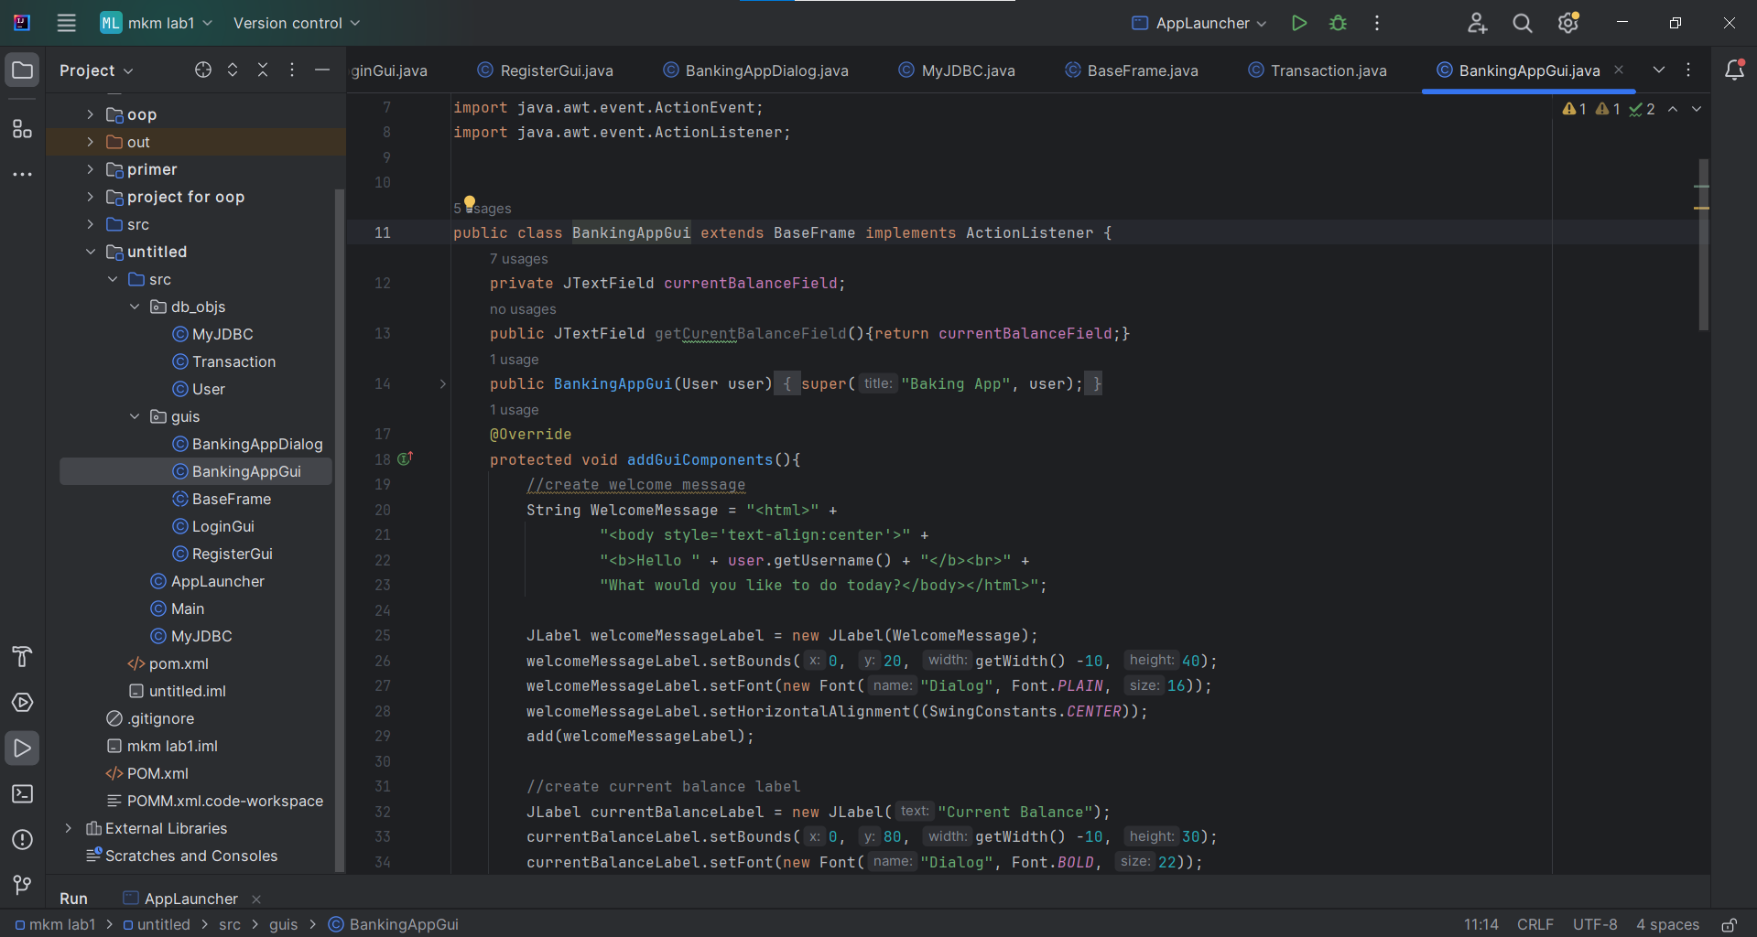

Figure 8. BankingAppGui

I have created BankingAppDialog. Displays a custom dialog for our BankingAppGui

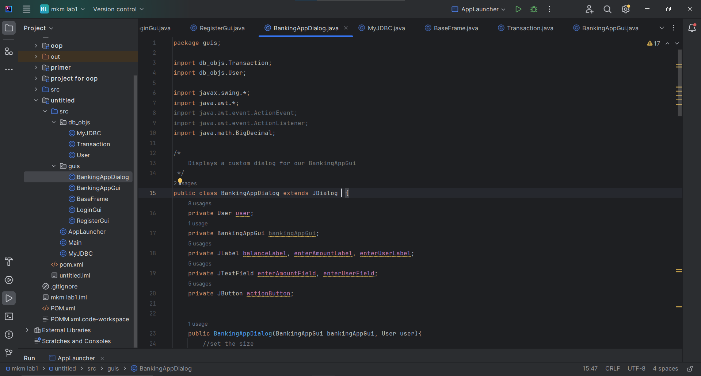

Figure 9. BankingAppDialog

I have created MyJDBC. JDBC class is used to interact with our MySQL Database to perform activities such as retrieving and updating our db

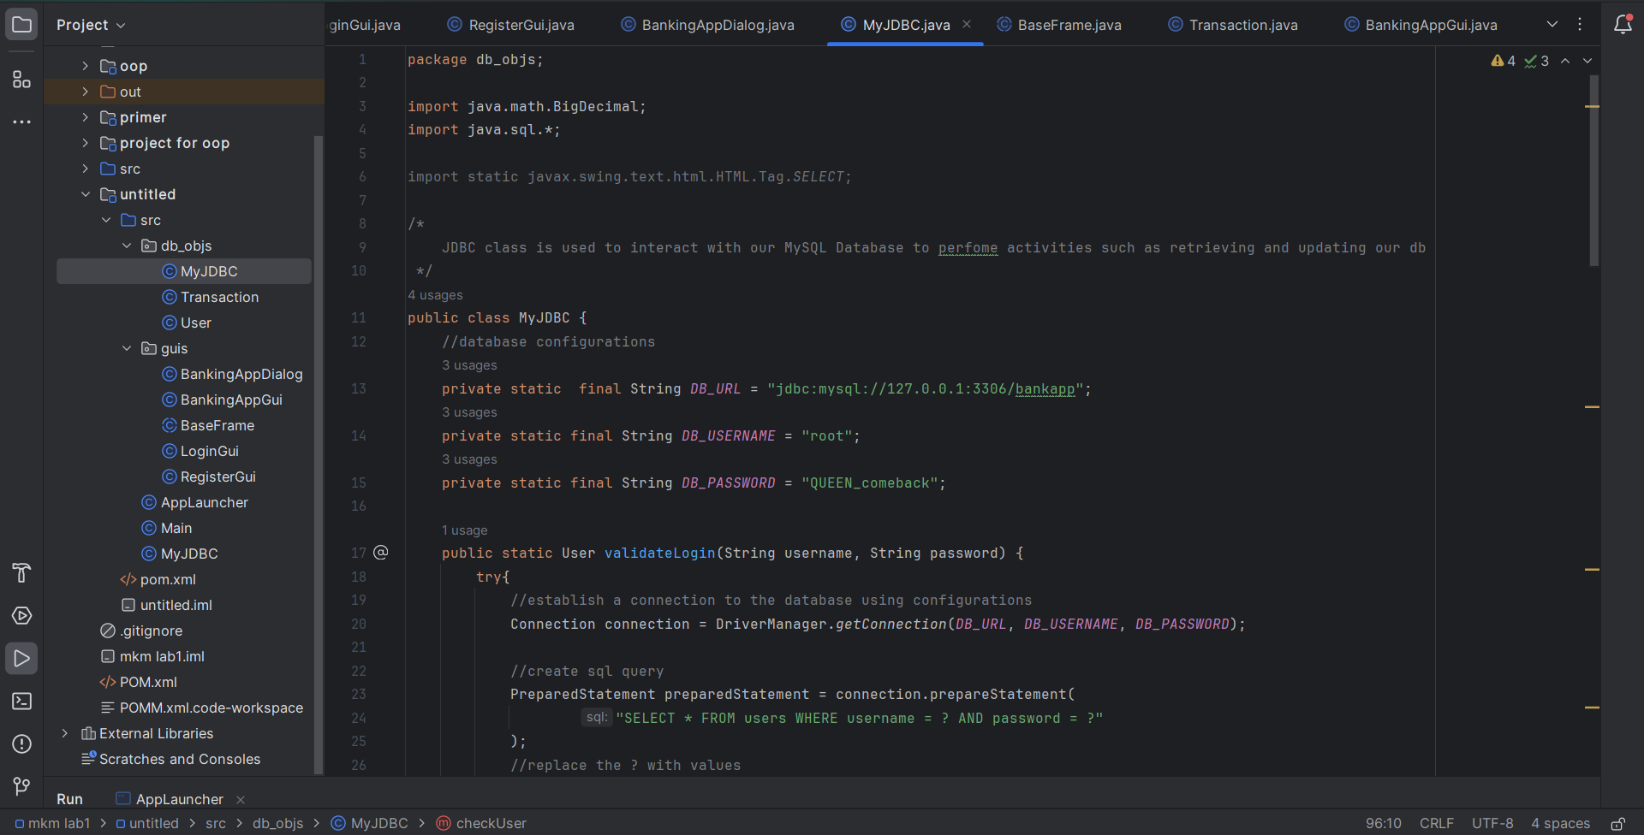

Figure 10. MyJDBC

I have created Transaction. Transaction entity used to store transaction data

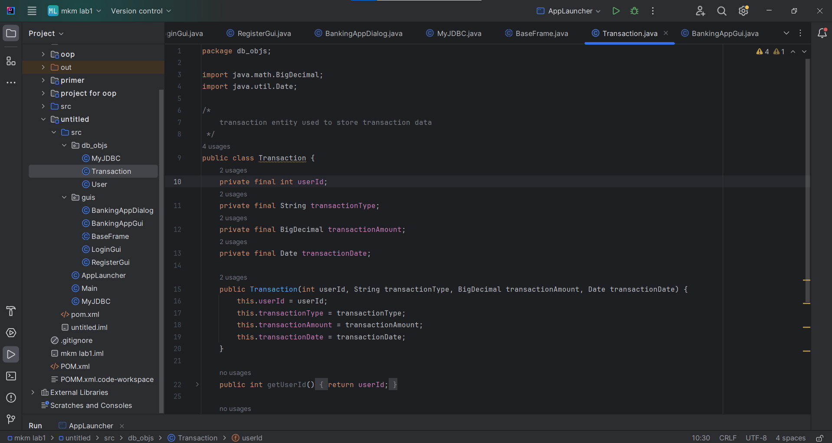

Figure 11. Transaction

I have created a class User. User entity which is used to store user information (i.e. id, username, password, and current balance)

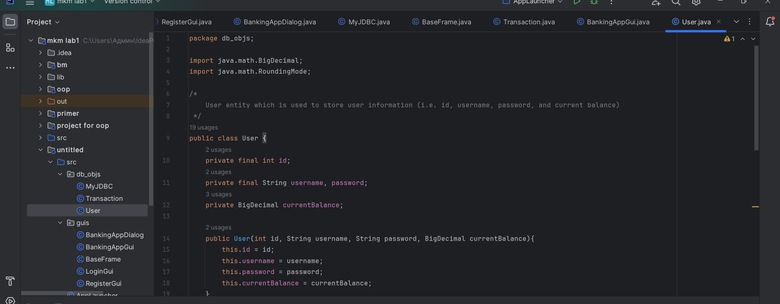

Figure 12. User