|  |  |
| --- | --- |
| **DOKUMENTASI EKSTERNAL**  External Documentation |  |
| **[TUGAS MANDIRI / PROYEK ]**  **[*Assignment / Project*]** |
| **MATAKULIAH <COMP6176> – <HUMAN AND COMPUTER INTERACTION>**  ***Subject*** |
| SEMESTER GENAP 2018/2019 ***Even Semester Year 2018/2019*** |

## Judul Proyek

*[Assignment / Project]**Title*

* **PO-with-Vinda**

## Abstrak [50 – 200 words]

*Abstract*

**POwithVinda** is a name for pre-order service or shopping entrusted goods service in Indonesia. **POwithVinda** is formed in October 29, 2008 and based on Tangerang, Indonesia.

Lately, **POwithVinda** finds it’s quite hard to handle the transaction without **automatic system**. To solve the problem, **POwithVinda** decides to create a **website.** Thewebsitewill be used by their **customers** to view **POwithVinda’s** product and buy them via online. In matter of that, **POwithVinda** is looking for a web designer to do those jobs. Looked from many candidates, we are chosen to design the **logo** and **website**.

## Pendahuluan

*Introduction*

To finish the work that **POwithVinda** gave us, we do this project. We mainly use the color blue because the color blue represents the commitment given to customers. We also make our web easy to use and simple.

## Dokumentasi

*Report / Documentation*

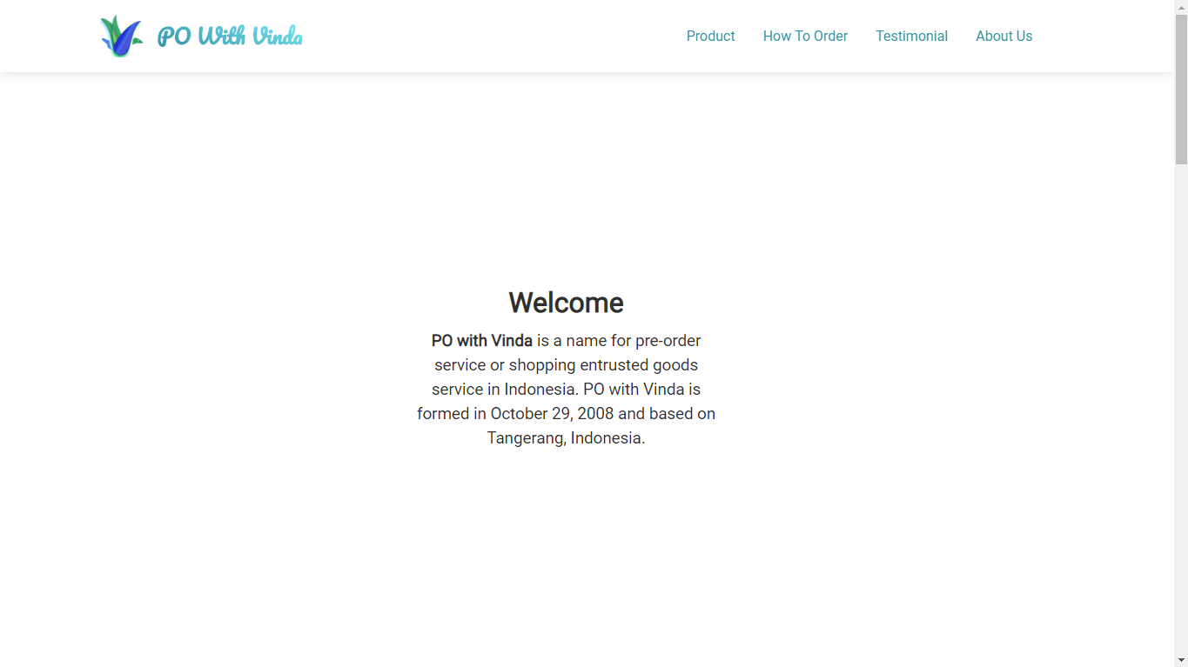

This is the what the home page shows when you first open the web. You can scroll down to see more.

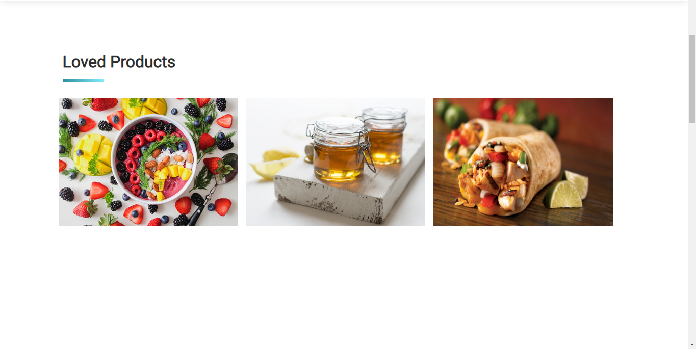

This is the Loved Products shown when you scroll down the above page. It shows the loved products that usually ordered by customers.

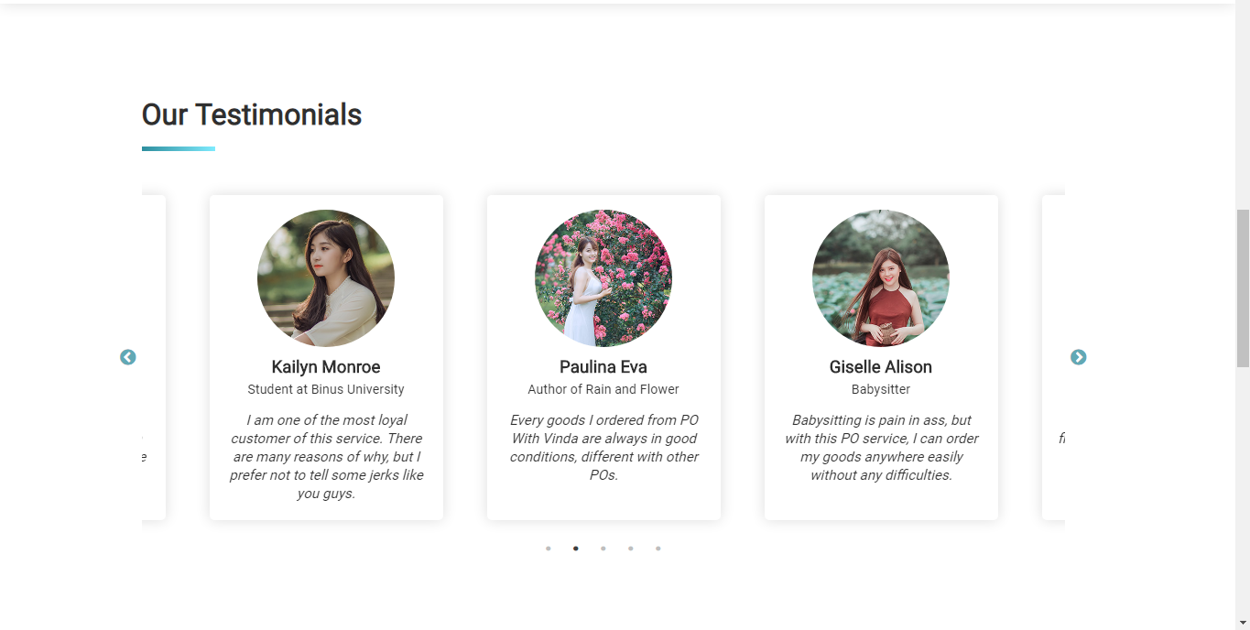

This is the list of testimonials in form of slider. You can slide through them to see more testimonials from many famous people around Indonesia.

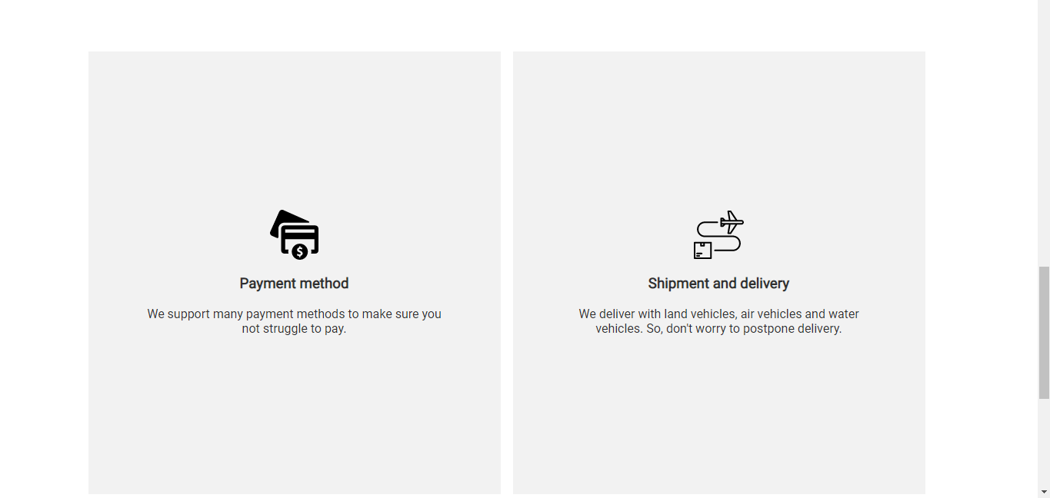

This is the profit you can gain if you order with POwithVinda.

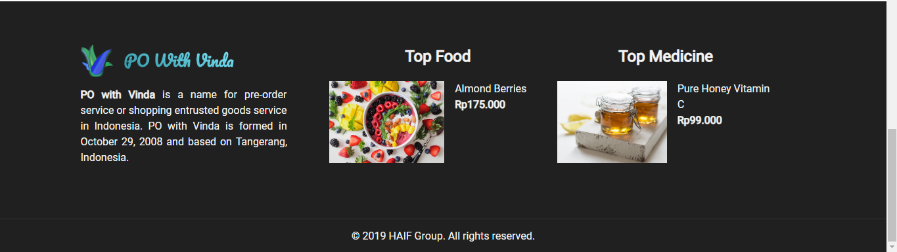

This is the footer of the page. It shows a little detail that you can see in the photo.

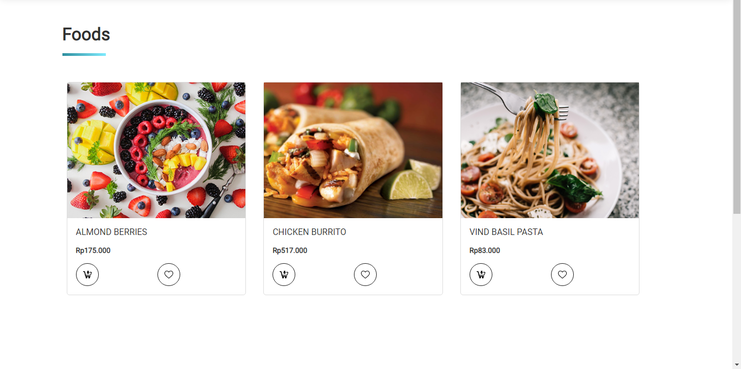

If you hover the Product dropdown at the header. The dropdown will show you two choices, the *Foods* page and the *Medicine* page. If you choose the *Foods* in the dropdown, this page will be shown.

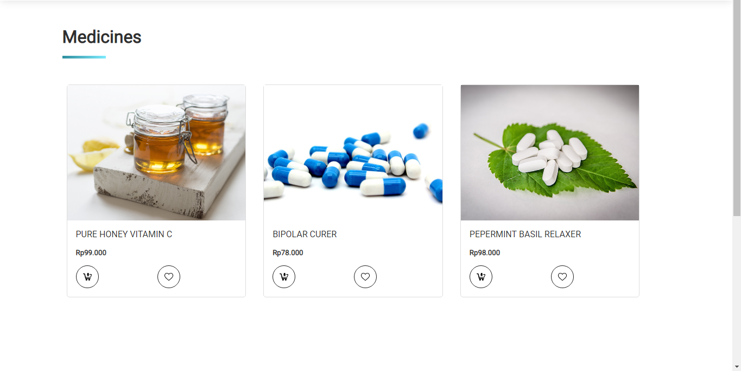

Otherwise if you click on *Medicine* page, this page will be shown.

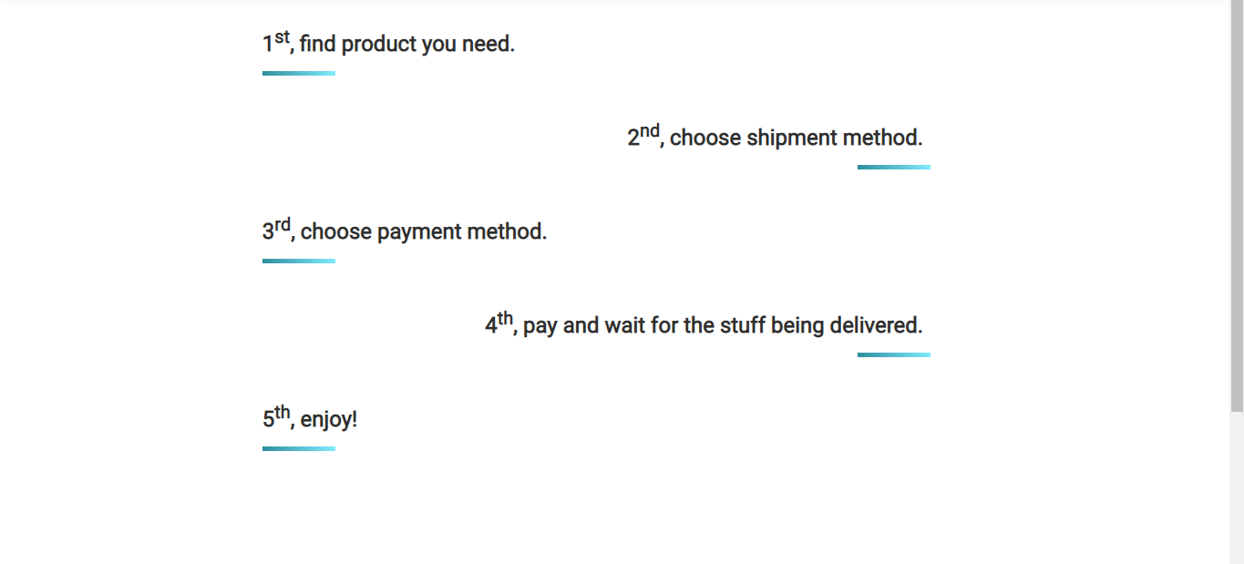

This page summarize How you can order the product in five easy steps as you can see above.

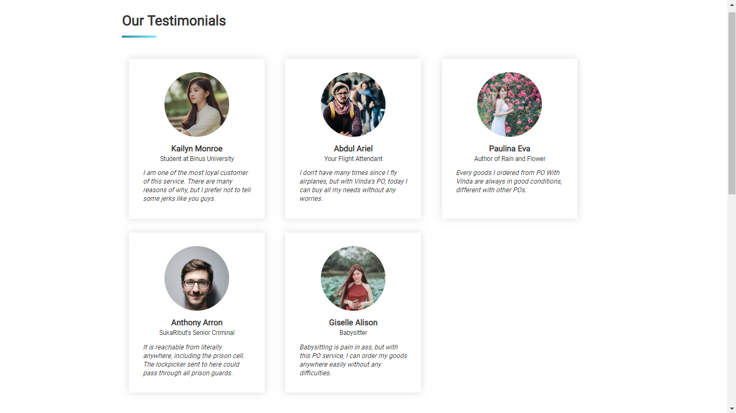

This page lists all the complete testimonials that people has given to us.

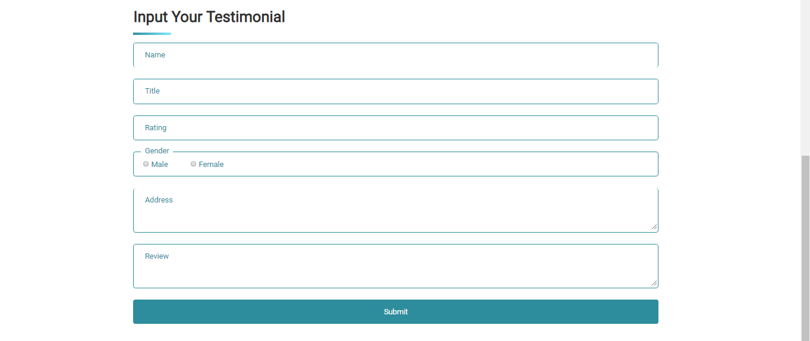

You can also fill your own testimonial if you want! Just fill the form and submit. But you need to fill the correct information, otherwise the validation will not let your testimonial go through!

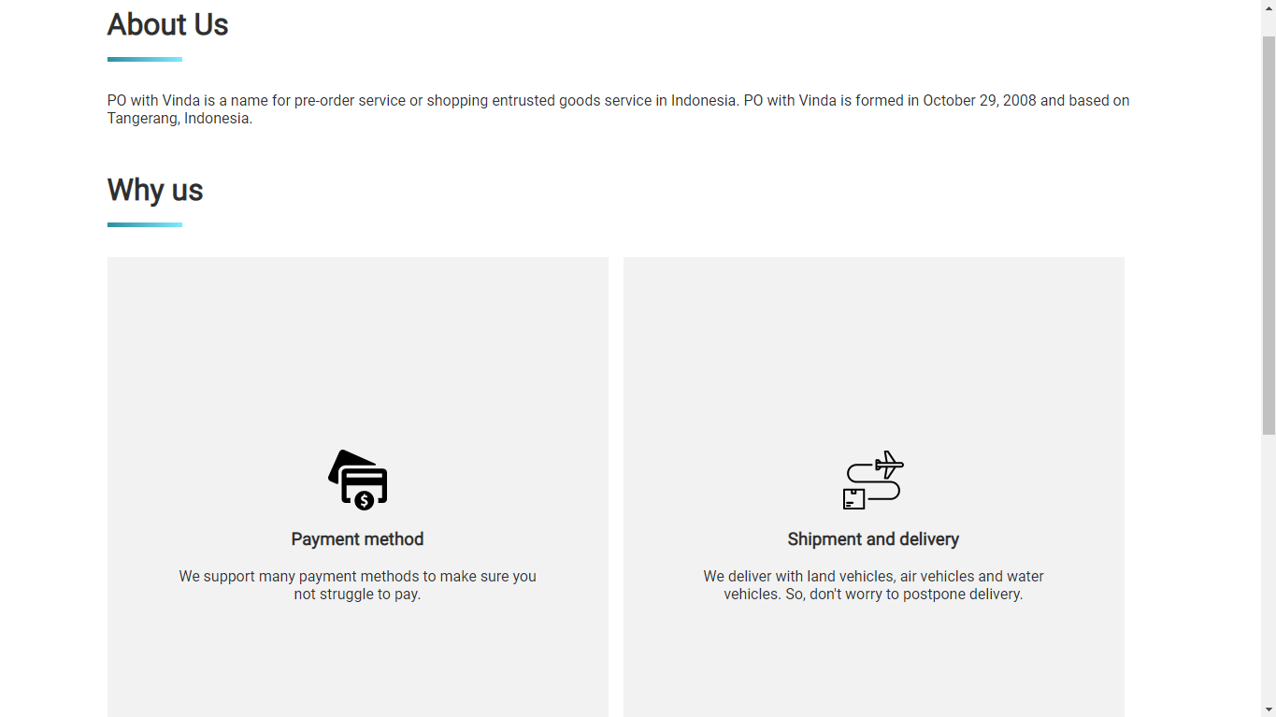

This page will show you short history of our company. It also tells you why you should trust our company and use our service instead of others.

## Referensi

*References*

* **REFERENCES**

**Foods :**

* **https://images.pexels.com/photos/1099680/pexels-photo-1099680.jpeg?cs=srgb&dl=almonds-berries-blackberries-1099680.jpg&fm=jpg**
* **https://images.pexels.com/photos/461198/pexels-photo-461198.jpeg?cs=srgb&dl=burrito-chicken-close-up-461198.jpg&fm=jpg**
* **https://images.pexels.com/photos/1279330/pexels-photo-1279330.jpeg?cs=srgb&dl=basil-blur-cheese-1279330.jpg&fm=jpg**

**Medicine :**

* **https://images.pexels.com/photos/415825/pexels-photo-415825.jpeg?cs=srgb&dl=capsules-cure-drug-415825.jpg&fm=jpg**
* **https://images.pexels.com/photos/50994/medications-cure-tablets-pharmacy-50994.jpeg?cs=srgb&dl=cure-herbal-medications-50994.jpg&fm=jpg**
* **https://images.pexels.com/photos/414115/pexels-photo-414115.jpeg?cs=srgb&dl=bottle-color-container-414115.jpg&fm=jpg**

**People :**

* **https://images.pexels.com/photos/220453/pexels-photo-220453.jpeg?cs=srgb&dl=adult-beard-boy-220453.jpg&fm=jpg**
* **https://images.pexels.com/photos/211050/pexels-photo-211050.jpeg?cs=srgb&dl=adult-beard-city-211050.jpg&fm=jpg**
* **https://images.pexels.com/photos/1386608/pexels-photo-1386608.jpeg?cs=srgb&dl=baskets-blurred-background-cute-1386608.jpg&fm=jpg**
* **https://images.pexels.com/photos/1391498/pexels-photo-1391498.jpeg?cs=srgb&dl=beautiful-beauty-blurred-background-1391498.jpg&fm=jpg**
* **https://images.pexels.com/photos/1406764/pexels-photo-1406764.jpeg?cs=srgb&dl=beautiful-bloom-blossom-1406764.jpg&fm=jpg**

**Icons:**

* **https://www.flaticon.com/free-icon/credit-card_126057#term=payment&page=1&position=43**
* **https://www.flaticon.com/free-icon/plane_1832576#term=shipment%20and%20delivery&page=1&position=11**
* **https://www.flaticon.com/free-icon/heart_1077035#term=heart&page=1&position=7**
* **https://www.flaticon.com/free-icon/add-to-cart_70021#term=add%20to%20cart&page=1&position=4**

**Slider Library:**

* **https://kenwheeler.github.io/slick/**

Disiapkan Oleh,

*Prepared by,*

* **2101667595 – Ivan Favian Elianto**
* **2101644875 – Albertus Hermanto**
* **2101696696 – Frederick Lungken**
* **2101641431 - Arvinda**