Battery Sizing: Mechanistic vs. Neural Network Comparison (V2)

1. Introduction
This report documents the second iteration (“V2”) of a bachelor thesis project comparing a mechanistic (physics-based) battery-sizing method against a neural-network method for a hybrid PV + wind + battery power system. V2 is a from-scratch rebuild of the mechanistic pipeline against a specific course lecture’s exact equations (Campana, Deploying LLMs for the Management of Microgrids, OptiCE slide deck), a narrower and stricter comparison scope (mechanistic vs. neural network only — no other machine- learning baselines), and a return to an off-grid system configuration (a hard reliability constraint, no diesel backup), reversing V1’s later diesel-backed pivot. Section 15 details exactly why, and what the consequence was for the scenario dataset.
Everything in this report is generated from real, executed code against this project’s actual data — no numbers are invented or extrapolated. The V1 build (documented separately, reports/ at the repository root) remains the historical record of the diesel-backed, four-model comparison; this report supersedes it only in scope (off-grid, NN-only), not in validity — V1’s results still describe V1’s own configuration correctly.

2. Relationship to V1
V1 completed a full mechanistic-vs-four-ML-model comparison under a diesel-backed system (battery capacity chosen to minimize system LCOE, reliability guaranteed near-universally by the diesel generator’s power sizing). An independent engineering review of that build recommended eleven concrete improvements; V2 implements all of them:
- Rewrite the mechanistic PV/wind/battery physics to strictly match the course lecture’s exact equations, with hand-computed reference tests.
- Remove every ML baseline except the neural network.
- Resolve, with the thesis author, whether V2 studies a diesel-backed or an off-grid system (a checkpoint requiring explicit sign-off — §15).
- Fix a load-profile-shape coherence gap between the baseline showcase and the ML dataset.
- Add cross-validation error bars to the NN’s accuracy claim.
- Add a learning curve across training-set sizes.
- Add permutation feature importance.
- Add a cost-sensitivity analysis.
- Sharpen the computational-efficiency claim’s text.
- Trim the figure set to a lean, curated set.
- Regenerate every affected artifact and rewrite this report end-to-end.
Section numbers below map onto this list where relevant.

3. Research Objective and Questions
The objective is unchanged from V1: compare a mechanistic battery-sizing method against a neural-network method, and investigate:
- How accurately can a neural network reproduce the battery capacities a mechanistic optimization would have found, and how stable is that accuracy across independent train/test splits (§5, cross-validation)?
- How does accuracy scale with training-set size (§6, learning curve)?
- Which scenario characteristics does the model rely on most (§7, permutation importance)?
- Does the AI-selected battery achieve the required reliability when verified using hourly mechanistic simulation — a genuine pass/fail question again under off-grid, not the near-universal-by-construction check V1’s diesel-backed system produced (§12)?
- How sensitive is the system’s economics to the battery cost assumption (§13)?
- How much faster is neural-network inference than a complete mechanistic battery-size search, precisely stated (§14)?
Research hypothesis, tested rather than assumed: the neural network can approximate mechanistic battery-sizing outputs closely, at a fraction of the per-scenario compute cost once trained, but its accuracy and reliability depend on the representativeness of its training data, and mechanistic verification remains necessary before trusting any single prediction. The mechanistic model is the reference method throughout: the neural network is trained on mechanistic outputs, so its performance is reported as agreement with that reference, not as validation against real, metered operational data (which this project does not have access to).

4. System Description
Off-grid configuration (V2’s sole study configuration, config/ jinan.yaml → system.backup: none): PV + wind generation, battery storage, and an electrical load, simulated hourly over one complete local calendar year (8,760 hours, non-leap). No diesel or grid backup exists. The reliability target (reliability.primary_lpsp_target, 1% loss-of- power-supply-probability) is a hard constraint: the mechanistic search finds the smallest battery (by module count, 0–80 modules of 250 kWh each) that meets it; if no candidate in that range meets it, the scenario is genuinely infeasible — reported and labelled as such, never silently replaced by a maximum-battery guess (src/physics/optimization.py, _select_smallest_feasible).
This reverses V1’s later diesel-backed pivot (Addendum 3 in the shared PROJECT_BRIEF.md), under which diesel — sized by power, always ≥ peak load — made reliability near-guaranteed for every candidate, and the objective became minimizing system LCOE instead. Diesel-backed remains fully supported by the same code (system_backup="diesel") and is V1’s documented, valid prior result; it is not re-run here. §15 explains why off-grid was chosen for V2.
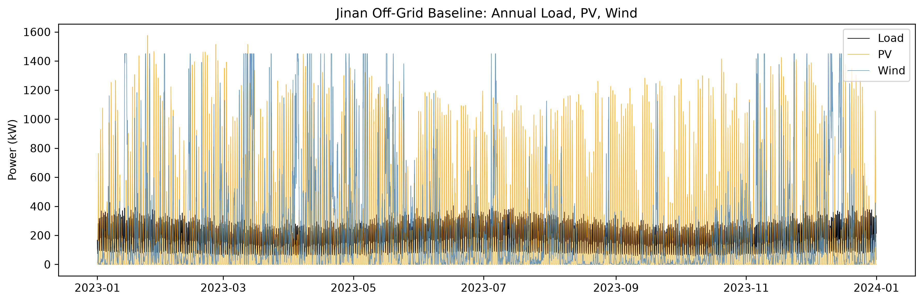
Baseline off-grid annual load, PV, and wind profile (Jinan, 2023)
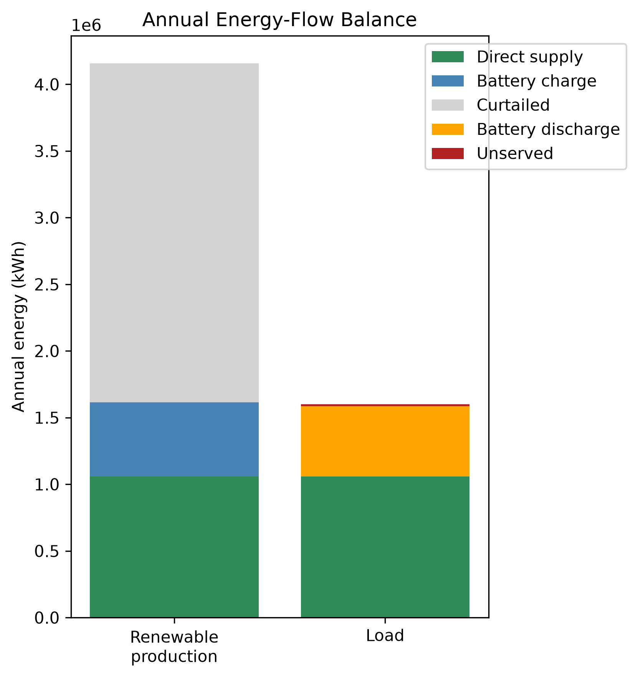
Baseline energy-flow balance at the optimal battery size (20 modules, 5,000 kWh)
Site: Jinan, China (36.65°N, 117.12°E), industrial scale (matching V1’s post-completion Addendum 2 pivot). PV 1,800 kWp, wind 1,450 kW (latitude- tilt fixed array + a single utility-class turbine), baseline annual load 1.6 GWh/year at a 430 kW peak (§15 explains why this differs from V1’s 3.8 GWh/year figure).

5. Weather and Load Data
Unchanged from V1: NASA POWER’s hourly reanalysis product for Jinan, 2023 local calendar year, GHI/DNI/DHI/temperature/wind-speed channels, validated for unit consistency and completeness (8,760 records, no gaps). The synthetic residential-shaped load profile generator (src.physics.load_profile.generate_load_profile) is reused unchanged from V1 — this is not real metered data, and is documented as a limitation in both versions.

6. Mechanistic Models: PV, Wind, Battery (Task 1)
Rewritten from scratch against the course lecture’s exact equations, with hand-computed-reference unit tests for every function (tests/ test_pv_model.py, tests/test_wind_model.py, tests/ test_energy_balance.py).
PV (src/physics/pv_model.py): clearness index and extraterrestrial irradiance (k_t = GHI / EGHI), Erbs decomposition, and Liu & Jordan isotropic-sky tilted-plane transposition (GTI = R_b·(GHI−DHI) + DHI·(1+cos β)/2 + ρ_g·GHI·(1−cos β)/2) are all implemented and tested standalone. The main pipeline transposes using NASA POWER’s measured DNI/DHI directly via pvlib.irradiance.get_total_irradiance(model= "isotropic") rather than decomposing DHI from GHI via Erbs — verified numerically to be the same Liu & Jordan model, componentwise identical for the sky-diffuse and ground-reflected terms, differing only in which measured channel supplies the beam term (measured DNI vs. re-derived GHI−DHI, which are not perfectly consistent in real NASA POWER data — residuals up to several tens of W/m², an inherent property of independently-measured irradiance channels, not a bug). NOCT cell temperature, a linear temperature-derating coefficient, and an incidence- angle modifier complete the model.
Wind (src/physics/wind_model.py): power-law height extrapolation (v(z) = v(z_r)·(z/z_r)^α, α = 0.14) and turbine output evaluated by linear interpolation on a manufacturer-style power curve (numpy.interp, matching MATLAB’s interp1), replacing V1’s closed-form cubic ramp formula. The power-curve table is a discretized (0.5 m/s resolution) sampling of the same generic cubic-ramp shape used before — a documented generic curve, not a certified manufacturer curve — so this change affects the evaluation mechanism, not the underlying curve shape.
Battery (src/physics/battery.py, src/physics/dispatch.py): the lecture’s exact SOC state equation, including self-discharge:
Charging: E[t] = min(E[t-1]·(1-SDR) + η_c·E_in,t − E_out,t/η_d, E_max)
Discharging: E[t] = max(E[t-1]·(1-SDR) + η_c·E_in,t − E_out,t/η_d, E_min)
SDR (self-discharge rate per hour) is new in V2 — previously omitted entirely. Set to ≈3.4658×10⁻⁵/hour (a typical LFP value of 2.5%/month, converted to hourly), it is now active in every scenario, not just theoretically supported.

7. Neural Network Model
Unchanged Keras/TensorFlow MLP architecture from V1 (config/ ml_training.yaml): three hidden layers (128/64/32 units, ReLU), 10% dropout after the first layer, ReLU output (non-negative capacity by construction), Huber loss, Adam optimizer, early stopping and best- checkpoint restoration on validation loss. Inputs are 37 engineered features per scenario (load shape, PV/wind generation statistics, net- load/deficit statistics, and the scenario’s own reliability target/round-trip efficiency/usable-SOC-window — see src/ai/features.py for the full list); the target is the mechanistic optimal battery capacity (kWh). Every leakage-prone column (optimal capacity, module count, reference LPSP/cost/LCOE/renewable share) is excluded from the feature set and enforced by an automated guard (LEAKAGE_COLUMNS, checked on every feature-matrix build and by tests/test_features.py).
No other ML baselines are used in V2 (Task 2): V1’s naive/Ridge/ Random-Forest comparisons are historical V1 results only, not reproduced here, since the thesis’s core comparison is mechanistic vs. neural network.

8. Scenario Dataset
5,000 scenarios sampled (config/scenario_generation.yaml, PV capacity 500–3,500 kWp, wind 200–2,000 kW, combined cap 5,000 kW, annual load 800,000–2,500,000 kWh/year, peak load 150–550 kW, reliability target 99.0–99.9%, round-trip efficiency 88–97%, usable SOC window 70–90%), each independently run through the full mechanistic pipeline (src.scenarios.scenario_runner.run_scenario) at Jinan’s 2023 weather. 4,526 of 5,000 (90.5%) are feasible under off-grid (§15); the remaining 474 (9.5%) are genuinely infeasible — no battery within the tested 0–80 module range bridges their renewable/load mismatch — and are kept honestly labelled with an infeasibility_reason string, never replaced by a maximum-battery guess. Only feasible scenarios have a target to regress on and are used for NN training/evaluation.
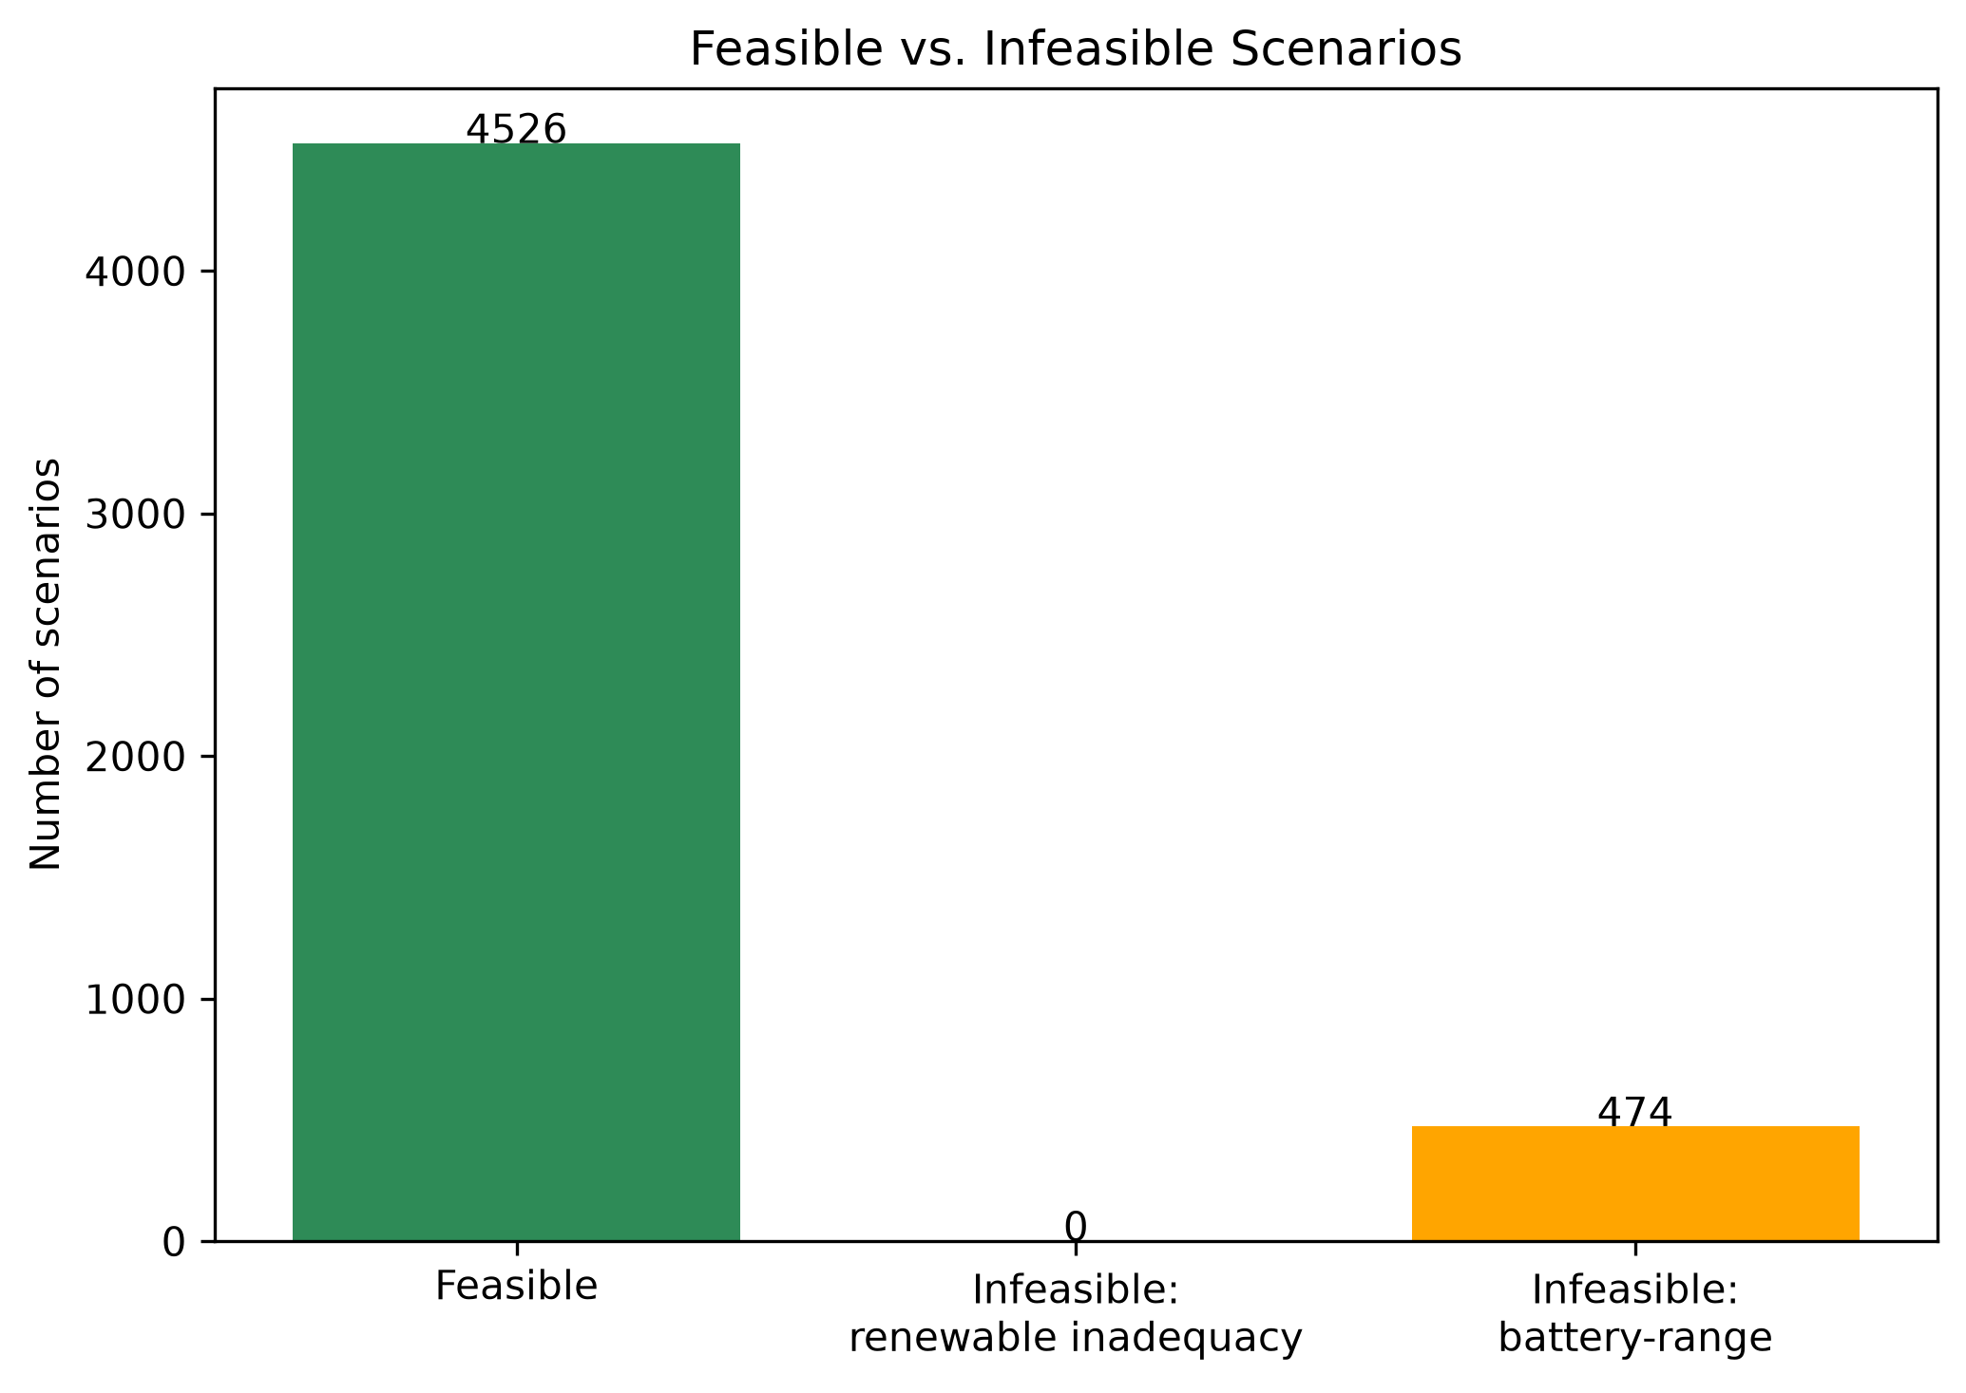
Feasible vs. infeasible scenario counts, full 5,000-scenario dataset
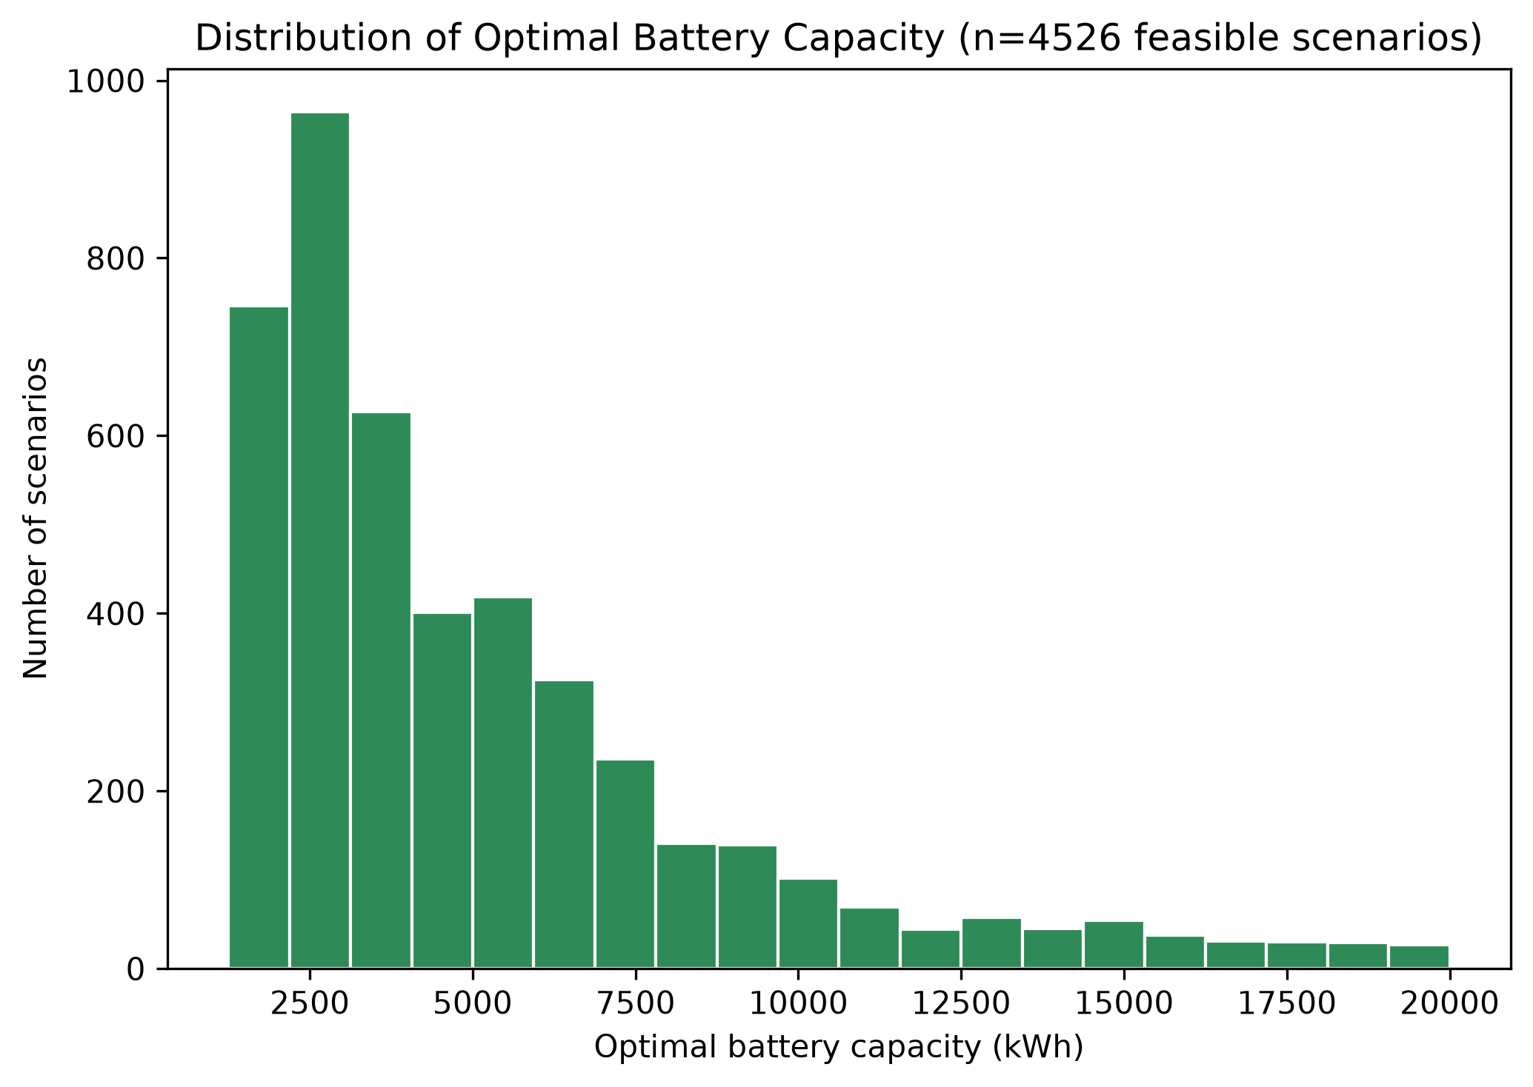
Distribution of mechanistically optimal battery capacities among feasible scenarios

9. The Off-Grid Decision and the Sampling-Range Retune (Task 3)
This was a required checkpoint, not a unilateral choice. The engineering review’s Task 3 explicitly required confirming with the thesis author whether V2 should study a diesel-backed system (continuing V1’s Addendum-3 framing) or revert to the original off-grid specification, because the two configurations test fundamentally different things: diesel-backed makes reliability near-universal by construction and verification tests cost-optimality; off-grid makes reliability a real constraint and verification tests genuine pass/fail correctness. That decision was made explicitly: off-grid, on the grounds that it is the harder, more informative case for a mechanistic-vs-NN comparison — the NN must learn to respect a real reliability constraint, not just approximate a cost curve. Diesel-backed stays as V1’s valid, documented result.
The trap, and how it was avoided. Naively flipping the system_backup config flag to "none" under V1’s diesel-era sampling ranges (tuned only for annual energy balance, since diesel-backed never needed a battery large enough to bridge a full shortfall) reproduced this project’s original, historical finding under off-grid conditions: only 39 of 100 scenarios were feasible in a direct test, because those ranges allowed renewable-to-load ratios as low as ~1.1 — too close to parity for any battery within the tested range to bridge a seasonal shortfall. Generating the full dataset under those ranges would have collapsed the ML task to mostly-infeasible labels, telling us little about battery sizing and mostly just re-confirming a known energy-balance limitation.
The sampling ranges were therefore re-tuned — narrowing annual_load_kwh to 800,000–2,500,000 kWh/year and peak_load_kw to 150–550 kW, leaving the PV/wind/combined-capacity ranges untouched — and validated empirically, before committing to the full run: two independent 100-scenario pilots (different random seeds) under the new ranges showed 88% and 90% feasible respectively, comfortably above an 80% target while deliberately not pushed toward ~100% — a genuine ~10–12% infeasible tail was kept, so infeasible labels remain a real, informative minority outcome rather than an edge case scrubbed away by over-tuning. The full 5,000-scenario run then confirmed 90.5% feasible (see the feasibility-counts figure in §8), consistent with both pilots. The Jinan baseline case (§4) was re-aligned to the same envelope for the same reason (1.6 GWh/year replaces V1’s 3.8 GWh/year, at a renewable/load ratio of ~2.6, confirmed off-grid-feasible: 20 modules, LPSP 0.94%, 99% renewable share).

10. Load-Profile-Shape Coherence Fix (Task 4)
V1 had an undocumented gap: config/jinan.yaml’s baseline showcase used profile_family: industrial_baseline, but every sampled ML scenario (src.scenarios.sampling, src.ai.features) always called generate_load_profile without a profile_family argument — silently defaulting to residential_baseline regardless of the config file’s setting. The Stage-3 baseline “showcase” case therefore never actually used the same load shape the ML dataset was trained on. V2 fixes this by setting profile_family: residential_baseline explicitly in the config, so the documented setting matches what every code path has always actually used.

11. Results: Accuracy and Cross-Validation (Task 5)
A single 70/15/15 grouped train/val/test split (seed 42, scenario_id as the group column — a proxy for a plain random split here, since every scenario is an i.i.d. draw with no near-duplicate family structure to protect against) gives:
Metric | Value
MAE | 158.8 kWh
RMSE | 328.8 kWh
R² | 0.9926
Within 10% of reference | 98.2%
Within 20% of reference | 100.0%
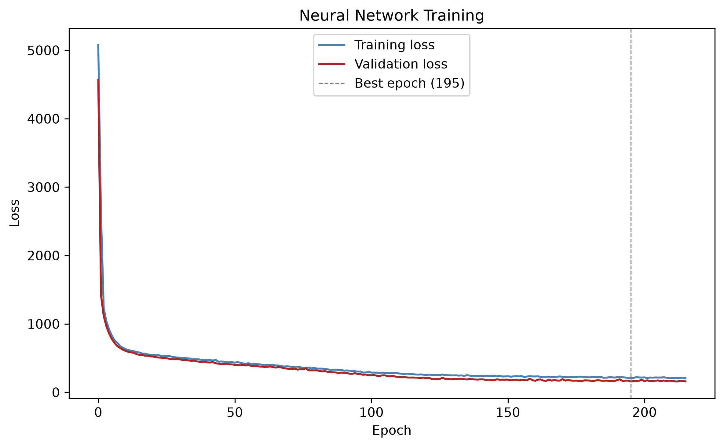
Neural network training/validation loss curves
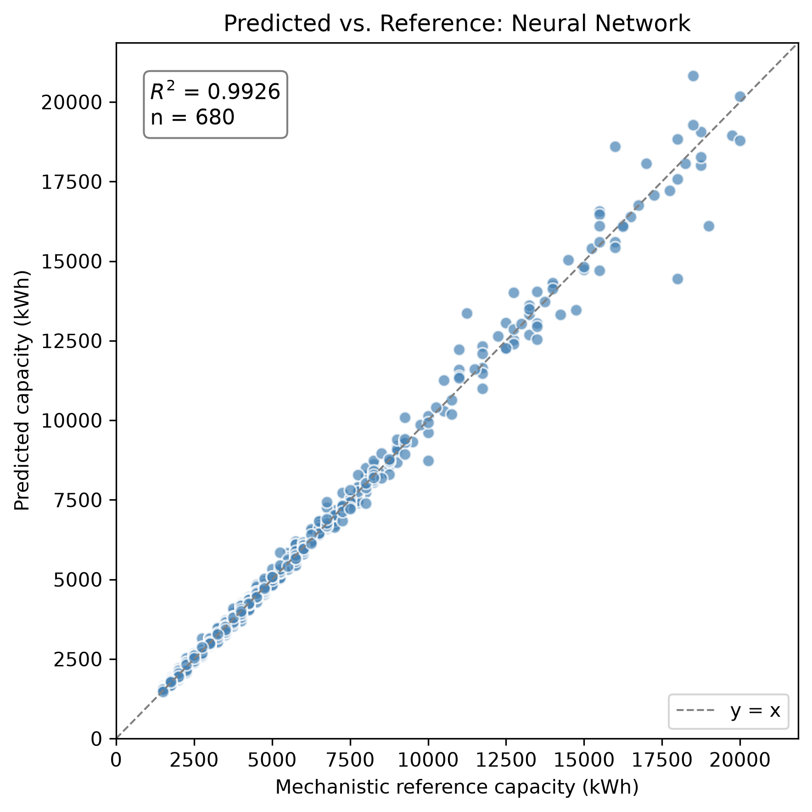
Predicted vs. reference capacity, 1:1 line, R² annotated, 680-scenario test split
The figure above shows predicted vs. mechanistic-reference capacity on the 680-scenario test split, with the 1:1 line and R² annotated directly.
A single split does not, by itself, establish that this result is typical rather than a favorable draw. Ten independent repeated 70/15/15 splits (seeds 0–9, full retraining each time) give:
Metric | Mean ± Std | Min | Max
MAE (kWh) | 162.7 ± 11.1 | 142.9 | 177.4
RMSE (kWh) | 289.5 ± 39.8 | 218.0 | 335.0
R² | 0.9939 ± 0.0015 | 0.9914 | 0.9961
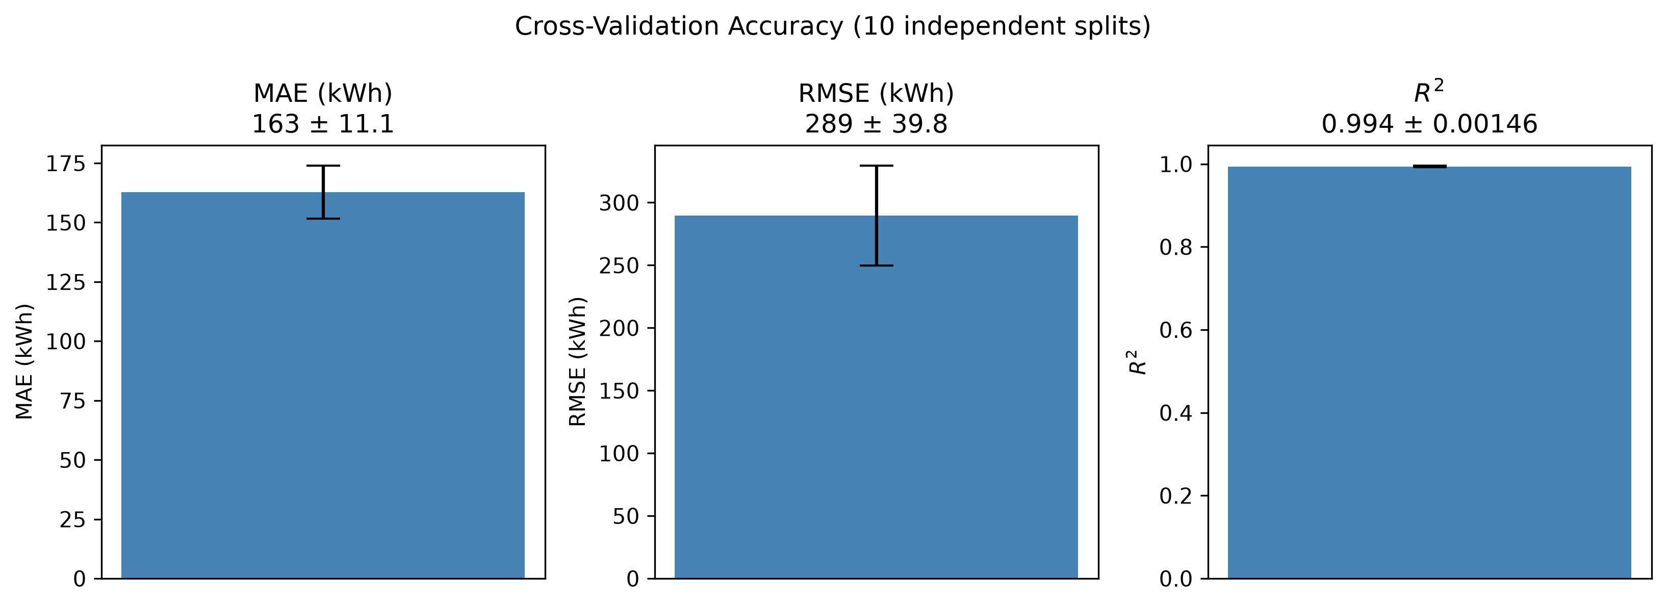
Cross-validation error bars: MAE, RMSE, and R² (mean ± std, 10 independent splits)
The headline seed-42 result falls squarely within this range: the reported accuracy is representative, not an outlier.

12. Results: Learning Curve (Task 6)
Training-set size was varied from 100 to the full available 3,168-scenario training split (fixed val/test at seed 42), rather than the suggested 3,500 — this dataset’s 4,526 feasible scenarios yield only 3,168 training rows under a fixed 70/15/15 split, fewer than 5,000 × 0.70 = 3,500; the last point is honestly capped at what is actually available rather than forcing an unreachable number.
Training scenarios | MAE (kWh) | R²
100 | 790.1 | 0.870
250 | 598.9 | 0.914
500 | 480.0 | 0.941
1,000 | 228.6 | 0.986
2,000 | 179.9 | 0.991
3,168 (full) | 179.3 | 0.991
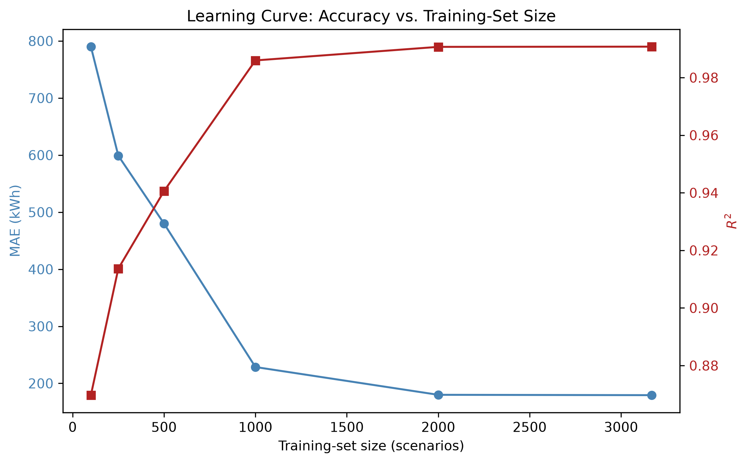
Learning curve: MAE and R² vs. training-set size
The figure above shows this curve visually: accuracy improves sharply up to ~1,000 scenarios, then plateaus — the jump from 2,000 to the full 3,168 training scenarios buys essentially nothing (179.9 → 179.3 kWh MAE). Collecting substantially more scenarios beyond ~2,000 would not be an efficient way to improve this model further; the useful lever for future work is more informative features or a richer training distribution, not raw dataset size.

13. Results: Permutation Feature Importance (Task 7)
Each of the 37 input features was independently shuffled on the test split (10 repeats each) and the resulting increase in MAE recorded, using the already-trained headline model (no retraining). The five most important features are:
Feature | Mean MAE increase | % of baseline MAE
monthly_renewable_variability | 1,332.7 kWh | 839%
worst_monthly_renewable_to_load_ratio | 1,260.5 kWh | 794%
reliability_target_load_served | 943.7 kWh | 594%
n_surplus_hours | 699.6 kWh | 440%
n_deficit_hours | 654.4 kWh | 412%
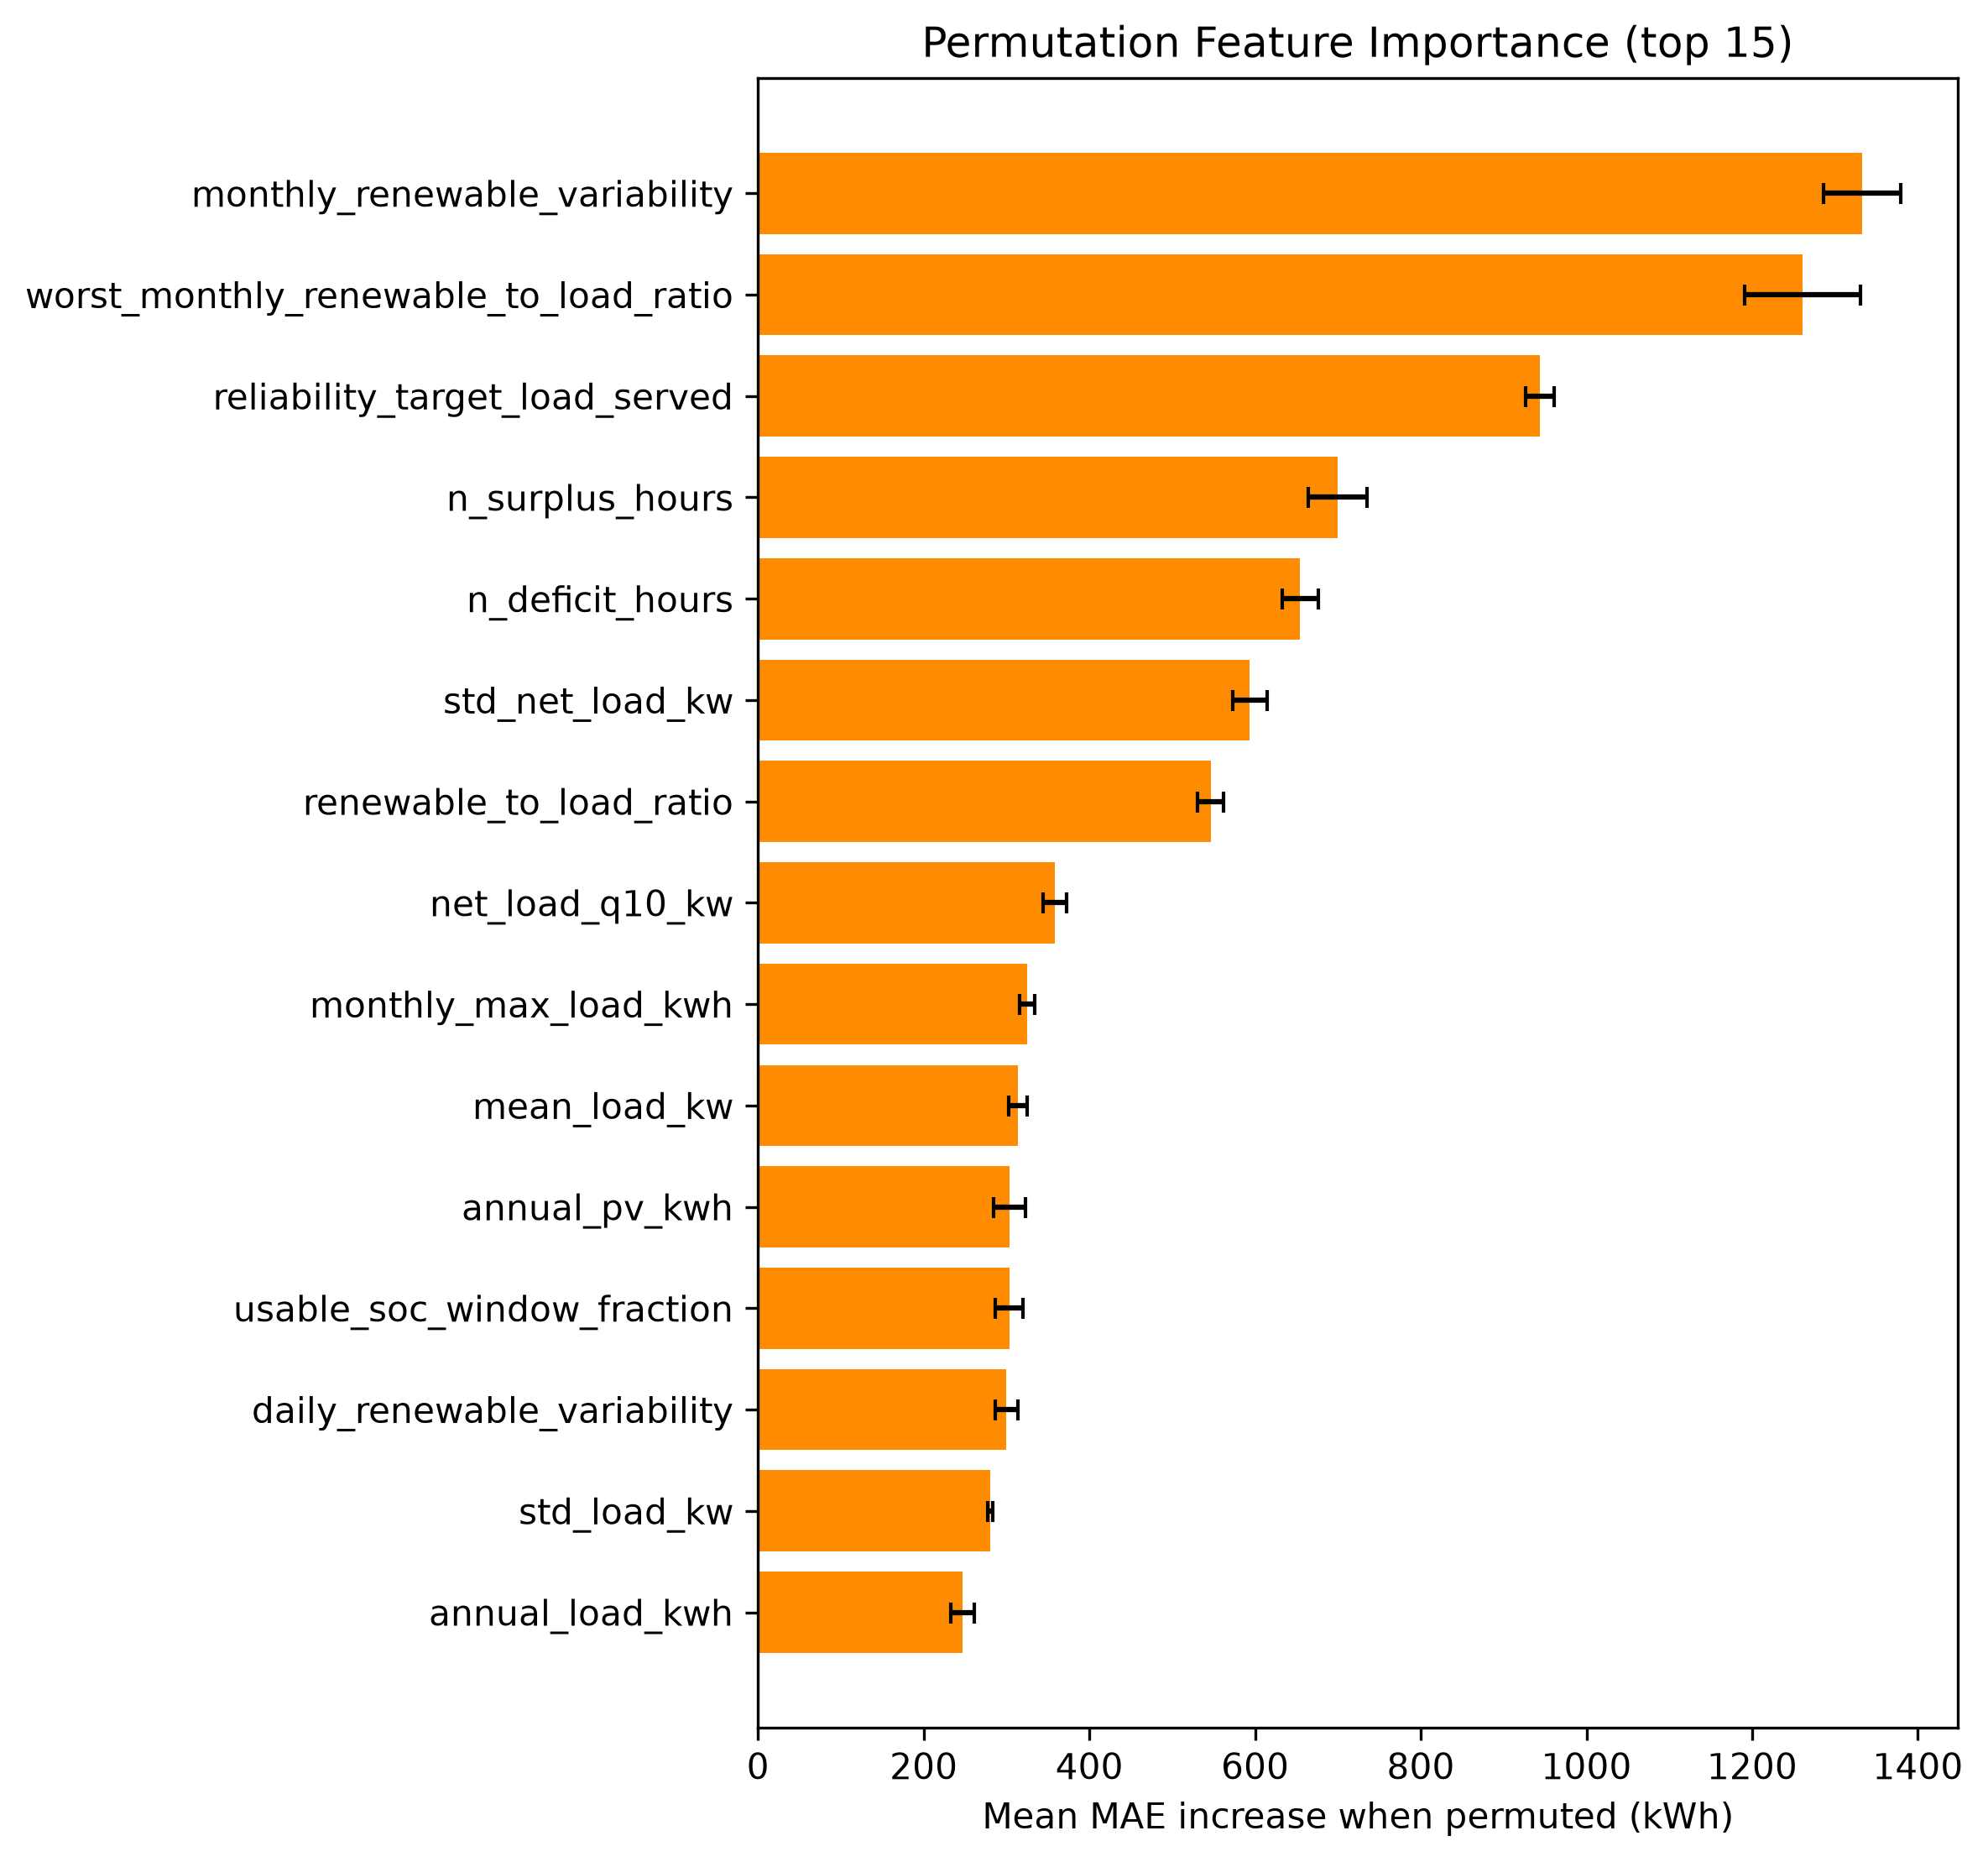
Permutation feature importance, top 15 features by mean MAE increase
This is physically sensible, and reassuring: under an off-grid hard reliability constraint, the model relies most heavily on exactly the quantities that should determine how much battery is needed to bridge a shortfall — how variable renewable generation is month-to-month, how bad the single worst month’s generation/load ratio is, and how strict the reliability target itself is — rather than on some spurious correlate.

14. Results: Physical Verification
Every test-split prediction was rounded up to an installable module count (never down) and re-simulated through the full hourly mechanistic dispatch model, exactly as a deployment would have to (src.ai. physical_verification):
Metric | Value
Predictions meeting their own reliability target after rounding | 93.97%
Mean extra system LCOE vs. the true optimum | 0.0046 EUR/kWh
Within 5% of optimal system LCOE | 96.9%
Undersized (predicted < reference) | 6.0%
Oversized (predicted > reference) | 52.9%
Unlike V1’s diesel-backed system — where reliability was near-guaranteed by construction and physical verification’s headline question became “how much extra does trusting the AI cost” — off-grid reliability is a real, non-trivial pass/fail question again: 6.0% of test predictions underestimate the required capacity by enough that, even after rounding up to the nearest 250 kWh module, the resulting system misses its own reliability target. This is the direct, honest answer to Research Question 4 (§3): the neural network’s rounded predictions do not achieve the required reliability in every case, and mechanistic re-verification before deployment remains necessary, exactly as the tested hypothesis anticipated.

15. Results: Cost Sensitivity (Task 8)
Battery installed cost was swept across the project’s own documented sensitivity range (config/jinan.yaml battery.cost_sensitivity_eur_per_kwh: [220, 300, 400] EUR/kWh, baseline 300) across all 4,526 feasible scenarios, closed-form (PV/wind/battery capital+O&M cost are pure functions of capacity and configuration, independent of the hourly dispatch — a sanity-check assertion confirms this reconstruction exactly recovers the stored baseline system LCOE before trusting the swept points):
Battery cost (EUR/kWh) | Mean system LCOE (EUR/kWh) | Battery share of total cost
220 | 0.360 | 33.1%
300 (baseline) | 0.403 | 39.2%
400 | 0.456 | 45.3%
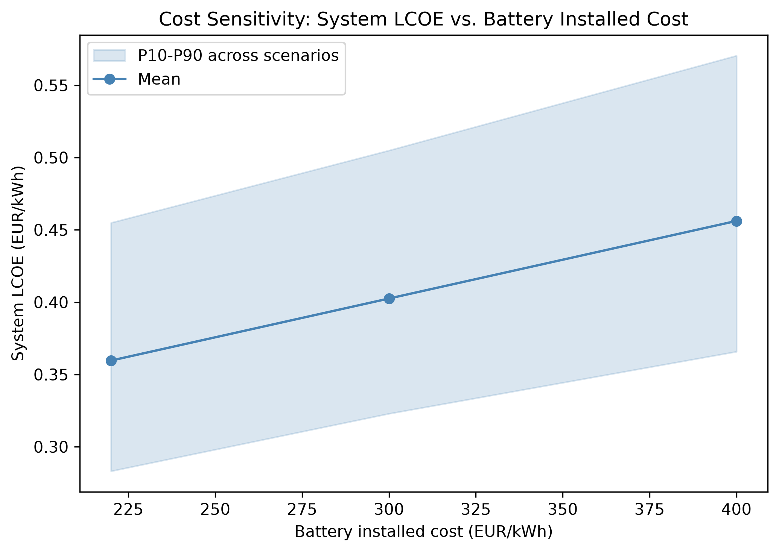
System LCOE vs. battery installed cost, P10-P90 band across scenarios
The figure above shows the full distribution (P10–P90 band). Battery cost drives roughly a third to nearly half of total system cost across this range — a materially significant, but not dominant, share; PV and wind capital cost make up the remainder. Diesel price sensitivity, the brief’s other suggested leg, does not apply to V2’s off-grid study — diesel’s rated power is exactly 0 kW for every V2 scenario, so no diesel cost assumption can affect anything here. That sensitivity remains meaningful only for V1’s diesel-backed configuration, where it was not separately explored either (a genuine limitation of both versions, noted rather than glossed over).

16. Computational Efficiency, Precisely Stated (Task 9)
V1’s efficiency claim (“neural-network inference is much faster than a complete mechanistic search”) is true but was previously stated loosely. Measured directly on this project’s own hardware:
- Mechanistic optimization (searching all 0–80 candidate battery sizes, each requiring a full 8,760-hour dispatch simulation): 0.377 seconds per scenario on average (5,000-scenario dataset, median 0.370s, range 0.310–2.641s).
- Neural-network inference, batched (predicting all 680 test-split scenarios in one call — the realistic regime for evaluating many candidate scenarios at once): 0.15 milliseconds per scenario, roughly 2,500× faster than the mechanistic search, per scenario.
- Neural-network inference, single scenario at a time (one ad-hoc query, e.g. an interactive tool evaluating one design at a time): ~58 milliseconds, dominated by per-call framework overhead rather than the arithmetic itself — still ~6.5× faster than the mechanistic search, but nowhere near the batched figure.
The precise, honest claim is therefore: the neural network’s efficiency advantage is real but regime-dependent — it is dramatic (~2,500×) when many scenarios are evaluated together, and much more modest (~6.5×) for one-off single predictions, because a large fraction of the single-call latency is fixed per-call overhead rather than genuine computation. This advantage also excludes the NN’s own one-time training cost (a few minutes per training run, §11–§12), which the mechanistic method does not incur at all — the NN is only “free” per new scenario after that upfront investment, and only pays off if many scenarios need evaluating.

17. Discussion and Limitations
- The load profile remains a synthetic, parametrically-shaped generator, not real metered data (unchanged limitation from V1).
- The wind power curve remains a generic normalized shape, not a specific manufacturer’s certified curve.
- The scenario dataset is single-location, single-weather-year (Jinan, 2023); geographic transfer and unseen-weather-year holdout (V1’s Experiments B/C) remain unattempted stretch goals in V2 as well.
- The learning curve (§12) shows this model is not data-starved at its current scale — the plateau past ~2,000 scenarios suggests further gains would need better features or a wider training distribution, not simply more scenarios of the same kind.
- Permutation importance (§13) measures the trained model’s sensitivity, not a causal claim about which physical quantities matter in general.
- Diesel-price cost sensitivity is not explored in either V1 or V2 (§15).
- Off-grid physical verification (§14) shows a genuine ~6% undersizing- driven reliability-violation rate on the test split — a real risk any deployment of this model would need to guard against (e.g. by always rounding up with a safety margin, or by treating the NN’s prediction as advisory pending mechanistic confirmation), not a solved problem.

18. Conclusion
Under V2’s off-grid configuration, with a mechanistic model rewritten to strictly match the course lecture’s exact equations, the neural network reproduces mechanistic battery-sizing decisions closely (R² = 0.993 ± 0.002 across ten independent splits) and does so at a genuine, precisely- quantified computational advantage over the full mechanistic search — dramatic when evaluating many scenarios at once, more modest for one-off queries. That accuracy is not free of risk: physical re-verification catches a real ~6% reliability-violation rate among rounded NN predictions, confirming the tested hypothesis that mechanistic verification remains necessary rather than optional. The learning curve indicates the model is well past the point of diminishing returns from more data at its current scale, and permutation importance confirms it has learned physically sensible relationships rather than spurious correlations. Battery cost materially affects system economics (33–45% of total system cost across a realistic price range) without changing which battery size is selected, since off-grid sizing is driven by the reliability constraint alone, not cost.

