Comparison of Neural-Network and Mechanistic Models for Battery Sizing in a Diesel-Backed PV–Wind Energy System
Status: Sections 9-20 (Scenario-Dataset Generation through Conclusions) contain real results from the diesel-backed, system-LCOE-optimized build (PROJECT_BRIEF.md Addendum 3), which supersedes the industrial-scale, hard-reliability-constrained build (Addendum 2) reported in earlier drafts of this document – every number in those sections is from the diesel/min-LCOE pivot, not the pre-diesel industrial run. §8 has also been filled in (previously a placeholder) since it directly describes the optimization objective this pivot changed. Sections 1, 3-7 remain Stage 1 structural placeholders (introduction, research-question prose, system description, and method write-ups deferred to a documentation pass) – those specific sections should not be read as findings; §8 and every section from §9 onward should be.

1. Introduction
TODO (Stage 10): motivation for off-grid battery sizing, why comparing a mechanistic method against a neural network is worth investigating, and a one-paragraph roadmap of the report.

2. Related Work
Added per refinement addendum §1.3 — this section is expected by the thesis rubric and was missing from the original spec’s outline.
LPSP-based sizing methods for standalone PV/wind/battery systems. The loss-of-power-supply-probability (LPSP) reliability metric used throughout this project (§8, §12) follows the same formulation as Yang, Lu & Zhou’s foundational hybrid solar-wind sizing model, which iterates over candidate PV/wind/battery combinations, computes LPSP and annualized cost for each, and selects the cheapest combination meeting a reliability target (Yang, H., Lu, L., & Zhou, W. (2007). A novel optimization sizing model for hybrid solar-wind power generation system. Solar Energy, 81(1), 76–84). This project’s exhaustive battery-module search (§8) is a direct, simplified instance of that same LPSP-driven search pattern, restricted to a single decision variable (battery capacity, given fixed PV/wind) rather than jointly searching PV, wind, and battery capacity together.
Techno-economic optimization tools. HOMER (Lambert, T., Gilman, P., & Lilienthal, P. (2006). Micropower system modeling with HOMER. In F. A. Farret & M. G. Simões (Eds.), Integration of Alternative Sources of Energy (pp. 379–418). John Wiley & Sons) is the best-known example of this class of tool: given candidate system sizes, it simulates dispatch over a representative year and ranks designs by life-cycle cost. OptiCE (Campana, P. E., Zhang, Y., & Yan, J., https://optice.net/) — the MATLAB techno-economic optimization tool developed by this project’s course instructor and collaborators, made available as example course material alongside a lecture on LLM-assisted management of PV/wind microgrids — follows the same simulate-then-rank pattern but goes further: it jointly optimizes PV tilt/azimuth/capacity, wind tower height/capacity, and battery capacity via a multi-objective genetic algorithm (gamultiobj), producing a Pareto front of life-cycle-cost-vs-renewables-share trade-offs rather than a single design. This project’s mechanistic model (§6-§8) independently arrived at several of the same core modelling choices as OptiCE’s dispatch/battery logic — a power-law wind-speed height extrapolation, a NOCT-based PV temperature model, and a symmetric charge/discharge efficiency split whose product recovers the specified round-trip efficiency (this project’s sqrt(round_trip_efficiency) convention is structurally identical to OptiCE’s Battery_efficiency × charge_controller_efficiency applied once per leg) — which is a useful cross-check that the mechanistic reference model used throughout this report is consistent with established practice in this specific research group, not an idiosyncratic reimplementation. Two respects in which OptiCE is more detailed than this project’s model are noted as limitations in §19: a wind-speed-dependent PV cell-temperature correction, and a battery thermal/temperature-dependent-capacity model. OptiCE’s joint PV/wind/battery optimization is also more general than this project’s fixed-PV/wind, battery-only search — a deliberate scope choice explained in §19, made so that PV/wind capacity could instead vary across the sampled scenario dataset (§9) as inputs for the ML models to condition on, rather than being optimized to a single value.
Prior machine-learning-for-sizing literature. Most existing ML work on hybrid PV/wind/battery systems targets short-term forecasting (solar irradiance, wind speed, or load) as an input to an otherwise conventional sizing or dispatch procedure, rather than replacing the sizing procedure itself — reviews of wind/solar forecasting techniques for grid integration survey this large body of work (Ssekulima, E. B., Anwar, M. B., Al Hinai, A., & El Moursi, M. S. (2016). Wind speed and solar irradiance forecasting techniques for enhanced renewable energy integration with the grid: a review. IET Renewable Power Generation, 10(7), 885–899). Separately, this project’s own PV model (§6) sidesteps two problems this course’s lecture material identifies as central to computing irradiance on a tilted surface from measurements (Duffie, J. A., Beckman, W. A., & Worek, W. M. (2013). Solar engineering of thermal processes (Vol. 3). New York: Wiley): not knowing the beam/diffuse split of measured irradiance (usually resolved with a decomposition model such as Erbs), and not knowing the solar position/incidence angle needed for a transposition model such as Liu and Jordan. Both are avoided here rather than solved: NASA POWER’s hourly product already reports direct-normal and diffuse-horizontal irradiance as separate fields (no decomposition model needed, confirmed in src/physics/pv_model.py’s docstring), and pvlib.irradiance.get_total_irradiance computes solar position and the tilted-surface transposition internally. Work that uses ML to predict sizing outcomes directly, as this project does, is comparatively less common; a recent example combines gradient-boosted tree ensembles (forecasting weather/load over the system lifetime) with metaheuristic optimization to size a PV/battery system under net-metering costs (Abdullah, H. M., Park, S., Seong, K., & Lee, S. (2023). Hybrid Renewable Energy System Design: A Machine Learning Approach for Optimal Sizing with Net-Metering Costs. Sustainability, 15(11), 8538). That work uses ML to generate better inputs to a conventional metaheuristic optimizer; this project instead trains an ML model to directly predict the sizing decision itself (the mechanistic search’s output) from scenario parameters, then treats the mechanistic search as ground truth for mandatory post-hoc verification (§16) rather than as a downstream optimizer to feed — a different position for the mechanistic and ML components to occupy relative to each other, and the specific comparison this project’s research questions (§3) are about.

3. Research Objective and Questions
See PROJECT_BRIEF.md §1 (research objective) and §2 (research hypothesis) for the canonical statement. Copy/adapt into prose here in Stage 10.

4. System Description and Assumptions
TODO: system boundary (§3), baseline case (§4), battery reference and the manufacturer-spec / modelling-assumption / economic-assumption distinction (§5), temperature assumption (§6).

5. Weather and Load Data
TODO: NASA POWER hourly API acquisition, the API-validation findings from data/README.md (addendum §1.4), and the synthetic load-profile generator (§8).

6. Mechanistic PV and Wind Models
TODO: PV model (§9) and wind model (§10), including documented equations, units, and limitations (reanalysis wind data, spatial resolution, height extrapolation, generic turbine curve, missing turbulence/wake effects).

7. Battery-Dispatch Model
TODO: dispatch priority order, state equation, initial-SOC-bias mitigation method and its validation (§11).

8. Mechanistic Battery Optimization
Diesel-backed hybrid system, min-LCOE objective (PROJECT_BRIEF.md Addendum 3). The original design (PV+wind+battery, no backup generator) treated reliability as a hard constraint: a candidate battery capacity either met a target loss-of-power- supply-probability (LPSP) within the search range, or the scenario was excluded from the ML training population entirely as infeasible. This excluded roughly 58-61% of sampled scenarios at industrial scale (Addendum 2). A diesel generator, added to the system boundary and sized on power rather than energy (diesel_rated_power_kw = 1.25 * peak_load_kw, matching the OptiCE course lecture material’s own Diesel_rated_power convention exactly, §2), removes that hard constraint: because the diesel’s rated power always exceeds every individual hour’s load, it alone can serve 100% of demand at any battery capacity. This reframes the question from a reliability-constrained feasibility search into a direct economic optimization: given diesel always available as backstop, which battery capacity minimizes total system LCOE? – a closer match to the project’s own stated objective (“optimize the battery capacity suitable for the system design, economically feasible”) and to OptiCE’s own dual-objective framing (minimize LCOE / maximize renewable share).
Diesel model. HOMER’s standard linear fuel curve, F(P) = F0 * P_rated + F1 * P_output (F0=0.08145, F1=0.246 L/hr per kW, widely-cited defaults; src/physics/diesel.py), applied as a pure post-processing step on top of the unmodified battery dispatch simulation (apply_diesel_backup) – any residual hourly deficit after battery dispatch is drawn from diesel, capped at its rated power. Fuel price (~0.90 EUR/L, ~7 CNY/L China 2023-2024 average) and installed cost (~650 EUR/kW, industrial genset range) are documented modelling/economic assumptions, the same status as every other cost figure in config/jinan.yaml (§19). PV and wind also gained cost models for the first time (~700 EUR/kWp and ~1,200 EUR/kW respectively, 2024 utility-scale benchmarks) – previously absent, since only battery capacity was ever being costed.
Search method. Exhaustive sweep over the configured candidate battery-module range (0-80 modules), computing system LCOE – (PV + wind + battery + diesel capital/O&M costs + diesel fuel cost) / energy served – for every candidate via src/physics/optimization.py::run_battery_search, then selecting the LCOE-minimizing candidate (candidates.loc[candidates["system_lcoe_eur_per_kwh"].idxmin()]) rather than the smallest candidate meeting a hard LPSP target. LPSP and renewable share remain reported metrics for every candidate, not the search objective.
Feasibility is near-universal by mathematical construction. Because diesel’s rated power always exceeds every hour’s load (given the default sizing factor ≥1.0), “infeasible” is only reachable again with a deliberately undersized diesel (sizing_factor < 1.0), which does not occur under the documented default and is covered by its own explicit test (tests/test_optimization.py::test_undersized_diesel_can_be_genuinely_infeasible) specifically to confirm the guard is not dead code.

9. Scenario-Dataset Generation
This project pivoted from a residential to an industrial deployment context partway through (PROJECT_BRIEF.md Addendum 2), after the residential-scale build was already complete, tested, and reported. The pivot’s reasoning: wind generation is a difficult economic case to justify for a single residential site (small load, small rooftop-scale system); an industrial facility makes the PV+wind+battery combination a more defensible investment case without changing the project’s core research question. Every number in this report from here on is industrial-scale; the residential-scale build remains fully recoverable from git history but is not reported here.
The pilot dataset (100 scenarios, single location [Jinan], single weather year [2023], per refinement addendum §1.1) was generated by sampling PV capacity (500-3,500 kWp), wind capacity (200-2,000 kW, with a combined PV+wind cap of 5,000 kW enforced as its own consistency check – the individual ranges alone can exceed it), annual load (1.2-6.5 GWh), peak load (250-1,300 kW), reliability target (99.0-99.9%), round-trip efficiency (88-97%), and usable SOC window (70-90%) uniformly within the ranges in config/scenario_generation.yaml. Each sampled combination is checked for physical consistency before acceptance – the peak/annual-consumption check reuses the load-profile generator’s own internal constraint directly (by attempting generation) rather than an approximated bound, so it is exactly as strict as the generator that is actually used.
These ranges were not the first attempt: an initial guess (12 GWh/year load against a 5,000 kW renewable cap) turned out to be renewable-generation- inadequate for nearly every scenario, since Jinan’s blended PV+wind capacity factor (~14.8%) caps annual production at the 5,000 kW cap to roughly 6.5 GWh/year – a load range extending to 21 GWh/year (the first guess) was never going to be reachable. Ranges were rescaled down before any scenario generation was committed to, so the dataset reflects a genuine mix of feasible and (mostly seasonally, not quantity-) limited scenarios rather than one dominated by trivially oversized loads.
Feasibility: 100/100 scenarios (100%) feasible, per Addendum 3’s diesel-backed reframing (§8) – diesel guarantees reliability by mathematical construction, so the near-total exclusion the pre-diesel hard-LPSP-constraint search produced (39% pilot feasible under Addendum 2, see report history) no longer applies. optimal_capacity_kwh now means the system-LCOE-minimizing battery capacity for each scenario, not the smallest battery meeting a reliability target. Across the 100 scenarios, system LCOE ranges 0.224-0.414 EUR/kWh (mean 0.285) and renewable share ranges 48.4-98.5% (mean 86.2%) – both vary substantially with each scenario’s sampled PV/wind/load combination even though every scenario is reliably served by construction.
Mechanistic search runtime: 0.291s/scenario mean (81 candidates each, matching §14), 0.7s total for the full pilot run. This reflects a numba JIT-compiled dispatch loop (~40x faster than the pure-Python loop it replaced, verified bit-for-bit identical output before being adopted). Dataset generation is resumable (scenario-level CSV caching, verified by test) and records a configuration hash and random seed for reproducibility.
Full results: outputs/tables/scenario_inputs_and_labels.csv / data/scenarios/pilot_scenarios.csv.
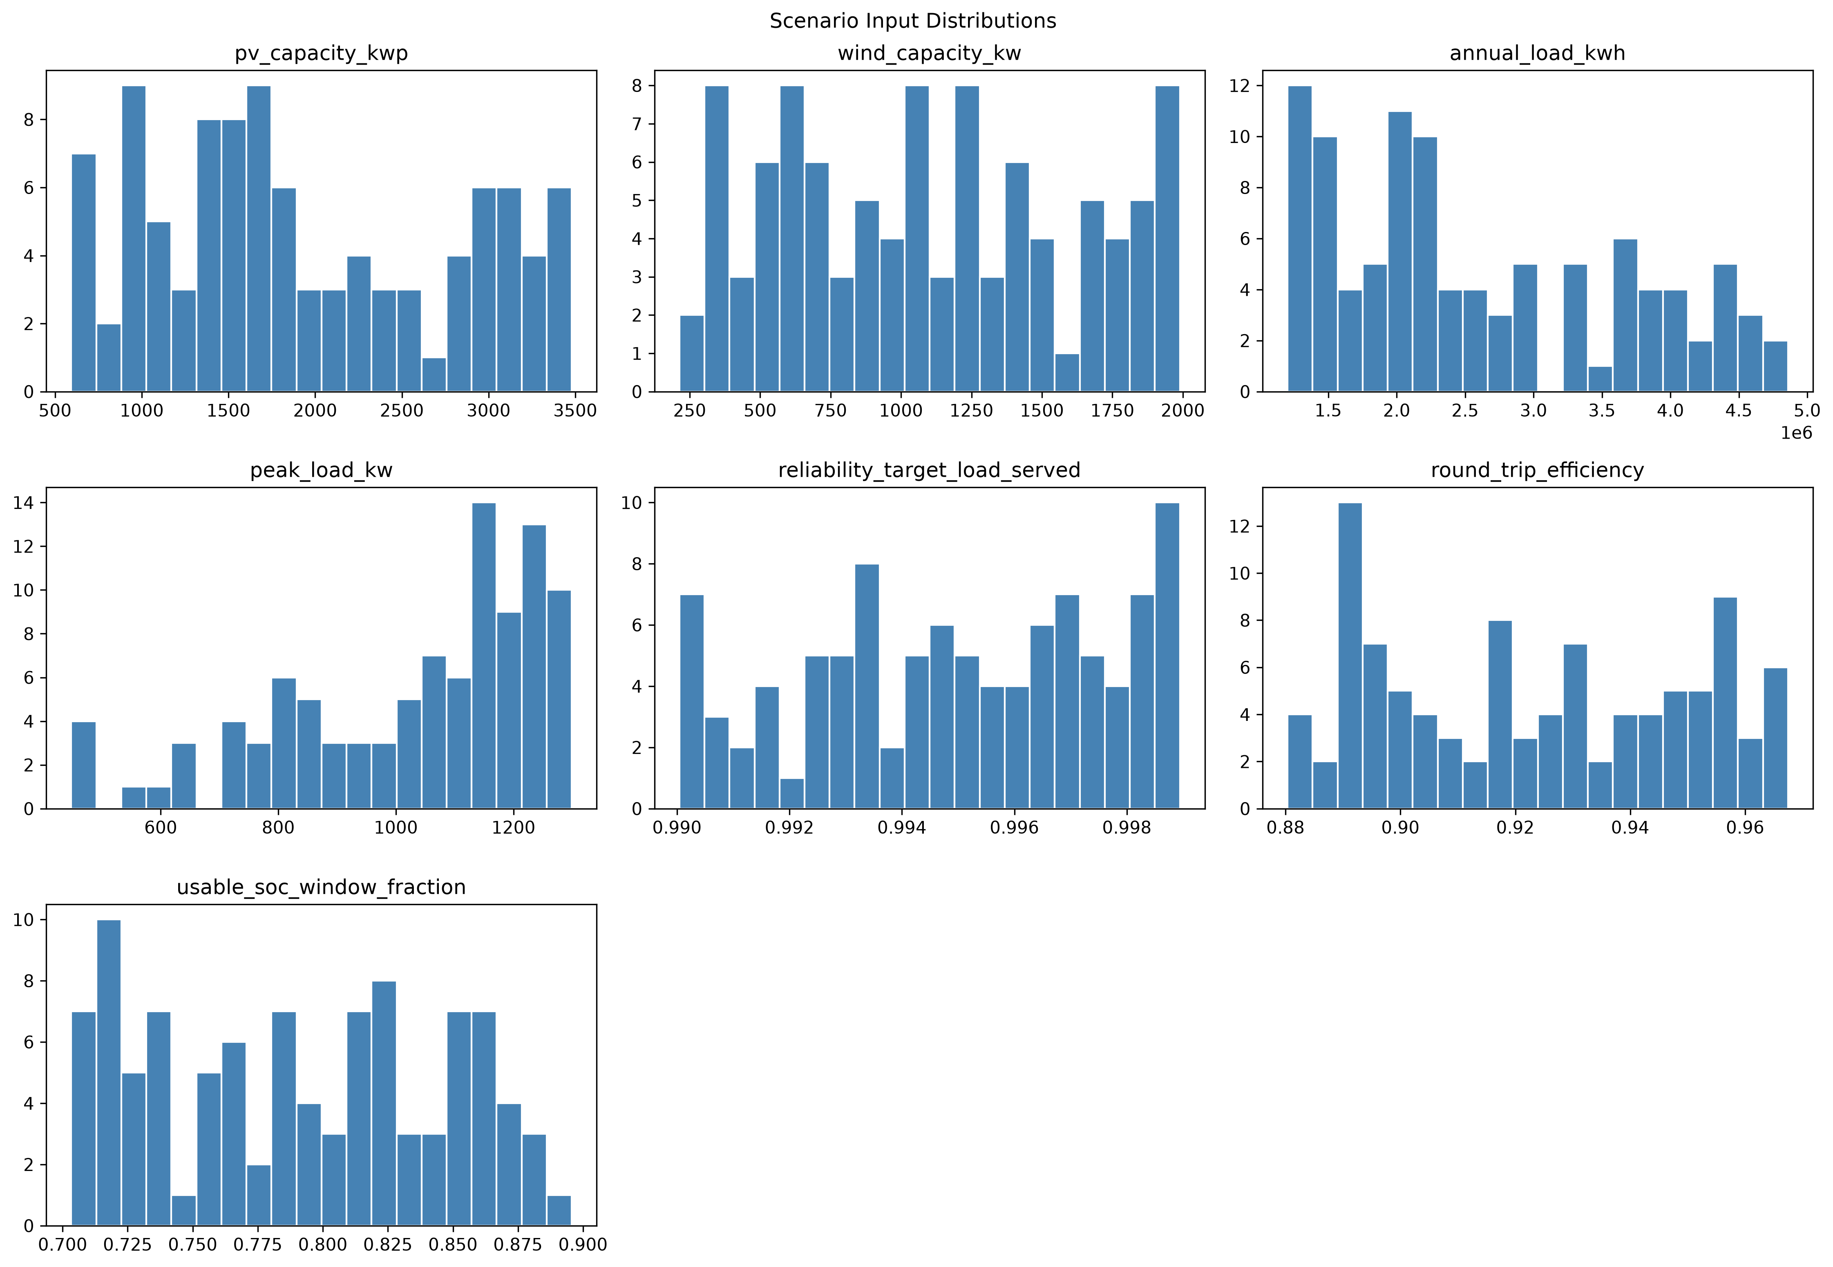 Figure 12 — Sampled input distributions across the 100-scenario pilot.
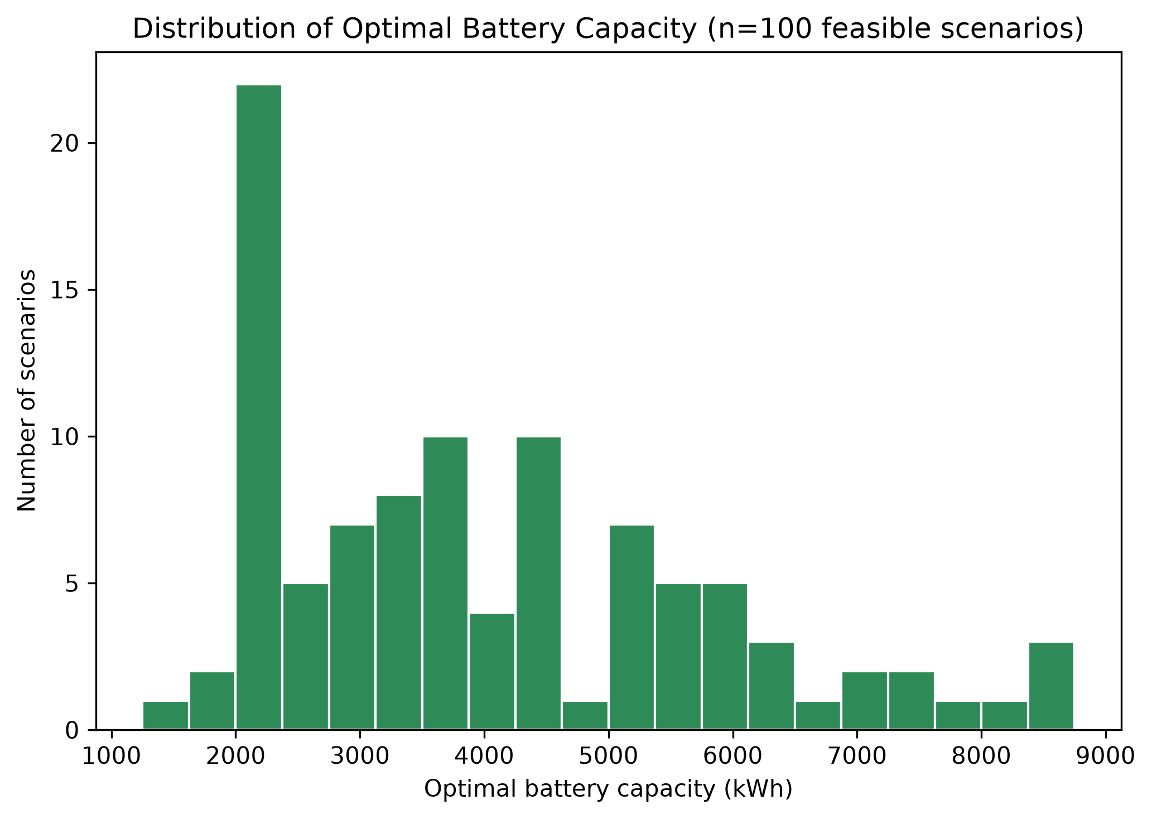 Figure 13 — Distribution of the LCOE-optimal battery capacity, the ML regression target.
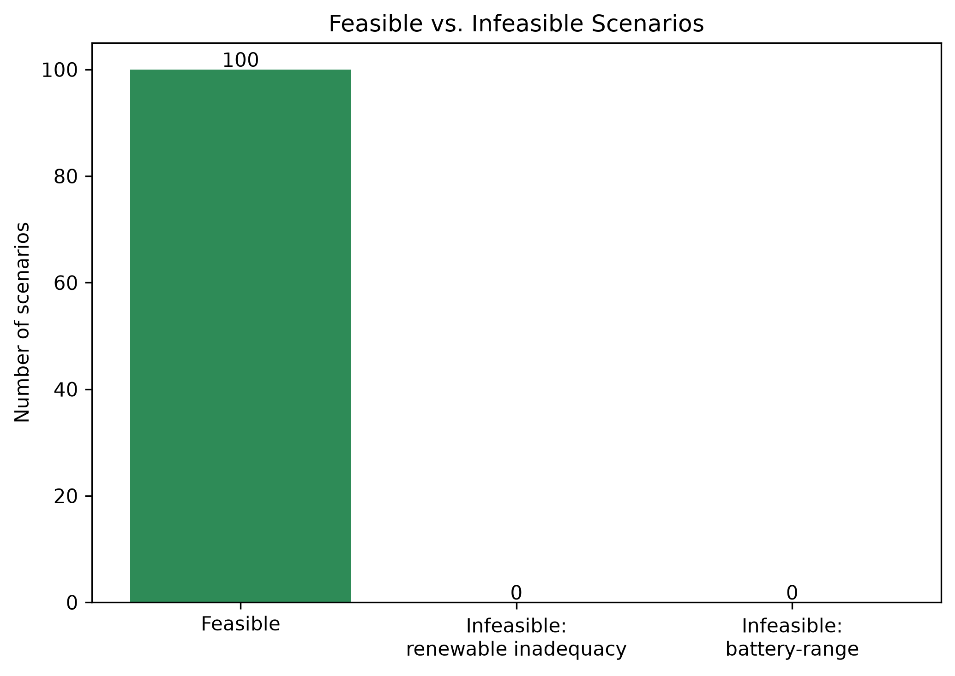 Figure 14 — Feasible vs. infeasible scenario counts: 100/100 feasible, near-universal by diesel’s construction (§8).
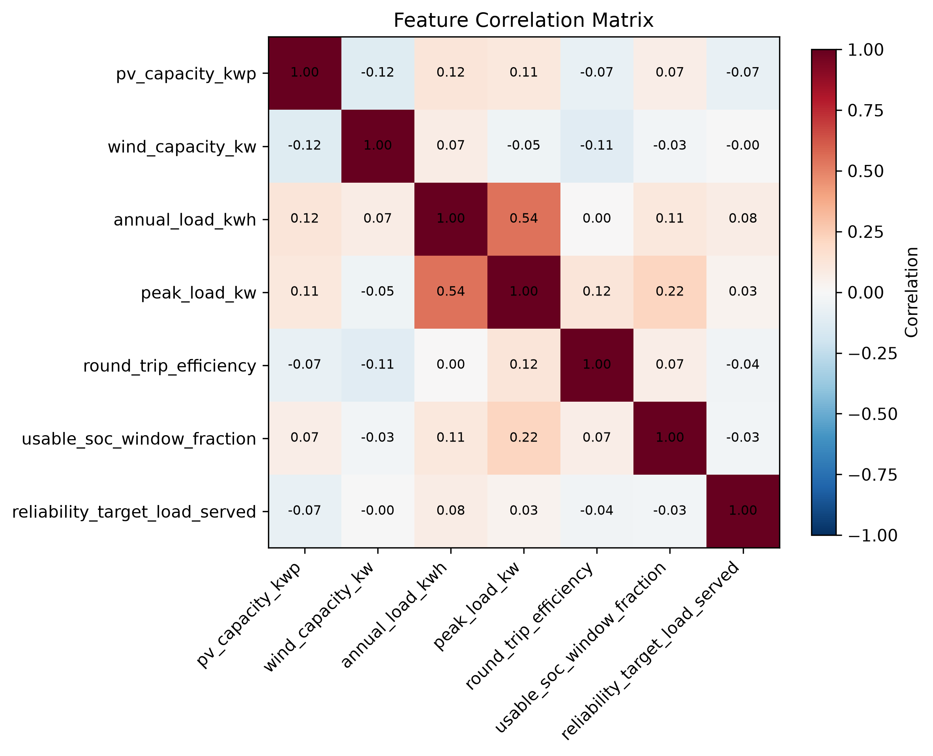 Figure 15 — Correlation between raw scenario inputs, checked for unintended sampling coupling.
Stage 8: full 5,000-scenario dataset. Generated directly at full scale using the identical sampling ranges, consistency check, and 0-80 module search range as the pilot. Final result: 5,000/5,000 scenarios (100%) feasible, matching the pilot’s near-universal feasibility exactly, for the same diesel-backed structural reason. Generation used the ProcessPoolExecutor-based parallel implementation of build_dataset() (4 workers). Total generation time: 465.8s (7.8 minutes) across 5,000 scenarios with 4-way parallelism.
Full results: data/scenarios/full_scenarios.csv, data/scenarios/full_metadata.json.

10. Feature Engineering
37 features per scenario across four groups (load, generation, net-load, system), computed by deterministically regenerating each scenario’s hourly load/PV/wind series from its stored inputs (capacity, annual load, peak load, random seed) – the full 8,760-hour series were not persisted per scenario (100 x 8,760 x 3 would be redundant storage since regeneration is fast, and exact).
Net-load features include the maximum consecutive-deficit-hour run length and the largest cumulative deficit energy event, computed directly from the regenerated hourly series – these are what actually explain the Stage 3/4 infeasibility pattern (seasonal mismatch), not just annual totals. The feature definitions are identical to the residential-scale build (PROJECT_BRIEF.md Addendum 2 changed deployment scale and load-profile family, not the feature-engineering logic).
No target leakage: optimal_capacity_kwh, optimal_n_modules, reference_lpsp, and reference_annualized_cost are guarded by src/ai/features.py’s LEAKAGE_COLUMNS and asserted absent from the feature matrix at build time (test- covered).

11. Machine-Learning Baseline Models
Three baselines trained on the pilot dataset (100/100 feasible, per Addendum 3’s diesel-backed reframing – the feasible filter is kept for interface consistency and as a safeguard against the rare genuinely- infeasible case (an undersized diesel, not used in this project’s default config), not because it meaningfully shrinks the training population anymore):
- Naive: DummyRegressor(strategy="median") – predicts the training-set median capacity regardless of features.
- Ridge regression: alpha selected from [0.01, 0.1, 1.0, 10.0] by validation MAE, then refit on the training split only.
- Random Forest: n_estimators in [100, 300], max_depth in [3, 5, None], selected the same way. (Config originally specified gradient_boosting; finalized to random_forest in Stage 5 because max_depth: null, i.e. unlimited depth, is natively meaningful for Random Forest but not supported by scikit-learn’s GradientBoostingRegressor, which requires an integer.)
Split: Experiment A, grouped 70/15/15 (70/14/16 scenarios). Hyperparameter selection uses only train+val; the test split is touched exactly once, for final evaluation. Results in §15.

12. Neural-Network Architecture and Training
Framework: Keras/TensorFlow (pinned per refinement addendum §1.2), TensorFlow 2.21, CPU-only (no GPU in this environment).
Architecture, exactly as specified in config/ml_training.yaml (no changes made to try to improve results): input (37 features) → Dense(128, ReLU) → Dropout(0.10) → Dense(64, ReLU) → Dense(32, ReLU) → Dense(1, ReLU) — 15,233 parameters total. The output-layer ReLU activation enforces non-negative capacity predictions; src/ai/neural_network.py::predict also applies a defensive np.maximum(pred, 0) as a second layer per §18.
Training: Huber loss, Adam (lr=0.001), batch size 32, up to 500 epochs, early stopping on val_loss (patience 20, restore best weights), best-model checkpointing. Trained on the identical 70/14/16 Experiment A split and 37 features as the Stage 5 baselines, with inputs standardized by a scaler fit on the training split only.
Actual run: converged in 62 epochs (6.9s on CPU), best validation loss 1586.6. This run’s loss curve shows a standard early-stopping pattern, but the underlying problem shows up downstream anyway: 70 training rows is not enough data for a 15,233-parameter network to learn reliably, which becomes explicit below (test-set R² -2.22, worse than every other model including the naive baseline). This is reported as the honest, unmodified result of the pilot’s actual (small) sample size – not adjusted, retried with different seeds, or hidden – and is a large part of why Stage 8/9’s full-scale re-run matters.
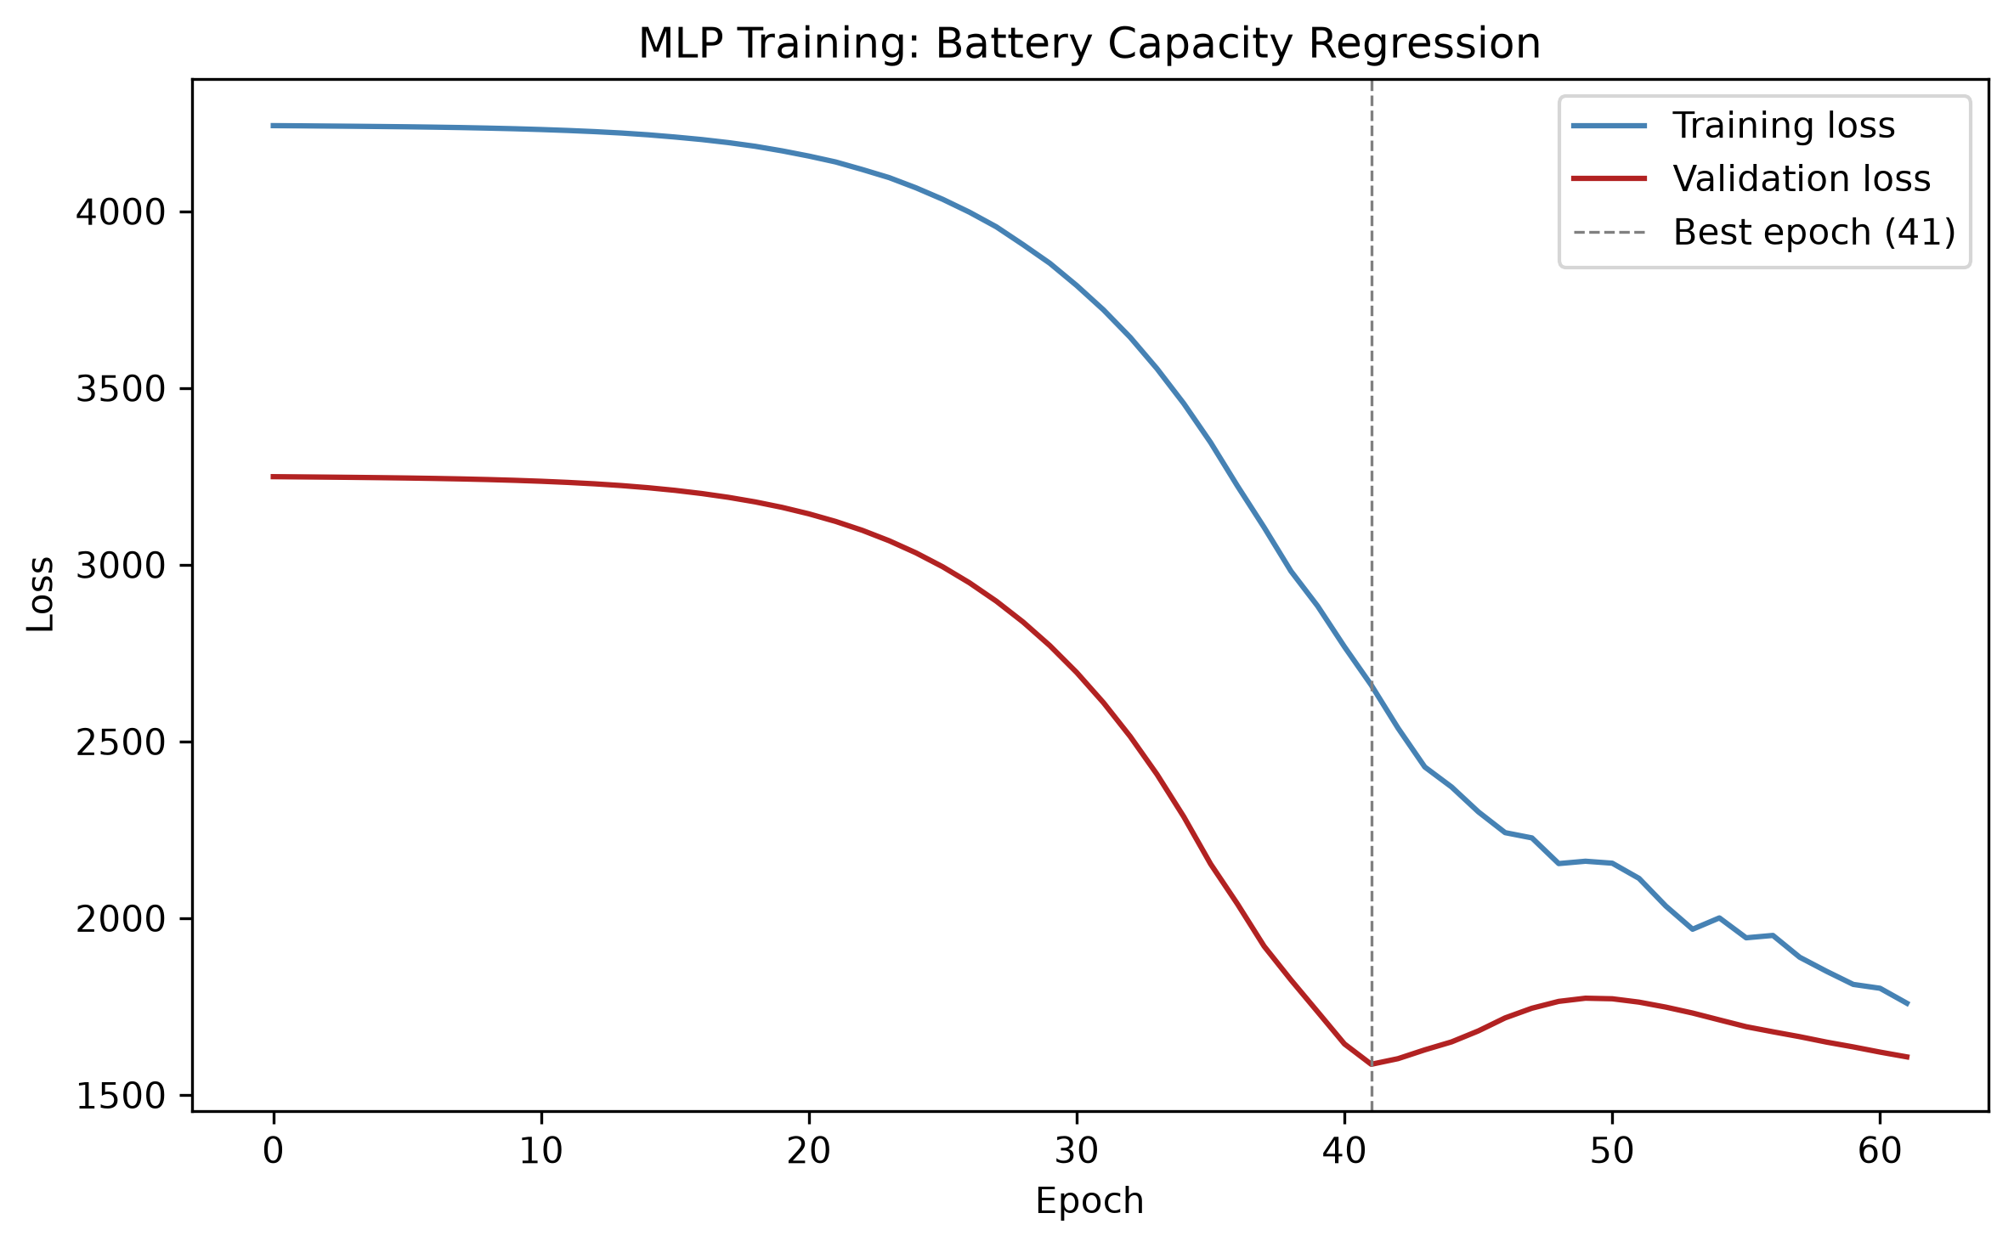 Figure 16 (pilot) — Training/validation loss, 70-row training set. Early stopping at epoch 62.
Saved artifacts: models/neural_network/best_model.weights.h5 (portable weights; loaded via load_trained_model, which rebuilds the architecture from config/ml_training.yaml rather than deserializing a full .keras file – the latter is not portable across Keras versions, see §16.1’s note), models/neural_network/best_model.keras (full-model checkpoint, same- environment convenience only), models/preprocessing/scaler.pkl, models/preprocessing/feature_columns.pkl.

13. Evaluation Methods
Splitting strategy: Experiment A (grouped 70/15/15 train/val/test split, GroupShuffleSplit on scenario_id) was used throughout, for both the pilot and the full 5,000-scenario dataset. Since scenarios are sampled i.i.d. and scenario_id is unique per scenario, grouping by scenario is mathematically equivalent to a random split here – it is the correct choice (not a formality) because it guarantees no scenario’s hourly-regenerated features leak across train/val/test, which would matter if scenario families were ever introduced. Experiments B (unseen weather year) and C (Västerås geographic transfer) are stretch goals and were not attempted (§19).
Accuracy metrics (src/ai/evaluation.py::compute_accuracy_metrics): MAE, RMSE, R², median absolute error, MAPE, max absolute error, signed bias, and percentage of predictions within 5/10/20% of the reference value.
Operational metrics (compute_operational_metrics), reported separately from accuracy metrics per the refinement addendum’s requirement that underprediction be treated as a distinct reliability risk rather than averaged away: underprediction rate and mean/max underprediction magnitude, overprediction rate and mean/max overprediction magnitude, exact-match rate.
Physical verification metrics (§16, reframed by Addendum 3): for every prediction, diesel backup is applied and system LCOE is computed for both the AI-predicted battery capacity and the true LCOE-minimizing capacity, freshly re-run rather than diffed against stored summary statistics. The headline metric is extra system LCOE – how much more expensive the AI’s predicted capacity makes the system, per kWh served, than installing the true optimum would have – a continuous economic measure that remains meaningful even though reliability pass rate is now near-universally true by diesel’s construction (§8). Reliability pass rate, percent undersized/oversized, mean excess capacity, max underprediction, and additional cost from oversizing are still reported alongside it for continuity – this is the mandatory check that accuracy/operational metrics alone cannot substitute for (PROJECT_BRIEF.md §20).

14. Mechanistic Results
Stage 3 (exhaustive battery-module search, 0-80 modules, 250 kWh each, diesel backup applied per §8) was run against the Jinan 2023 industrial baseline case: fixed PV 1,800 kWp, fixed wind 1,450 kW (combined 3,250 kW, within the 5,000 kW cap), synthetic industrial load (3,800,000 kWh/year, 800 kW peak, industrial_baseline profile family), diesel rated at 1.25x peak load (1,000 kW).
Result: system-LCOE-optimal at 19 modules (4,750 kWh). System LCOE = 0.2390 EUR/kWh, renewable share = 80.2%, LPSP after diesel = 0.000000 (fully reliable). An extended diagnostic search over 0-200 modules (not the baseline result) found the identical optimum at 19 modules, confirming the configured 0-80 range genuinely captures the LCOE minimum rather than truncating it.
The system LCOE curve is a clean convex U-shape: LCOE starts at 0.287 EUR/kWh with no battery (heavy diesel reliance), falls to its 0.2390 EUR/kWh minimum at 19 modules as battery capacity substitutes for diesel fuel, then rises again beyond ~19 modules as additional battery capital cost outweighs the shrinking diesel-fuel savings.
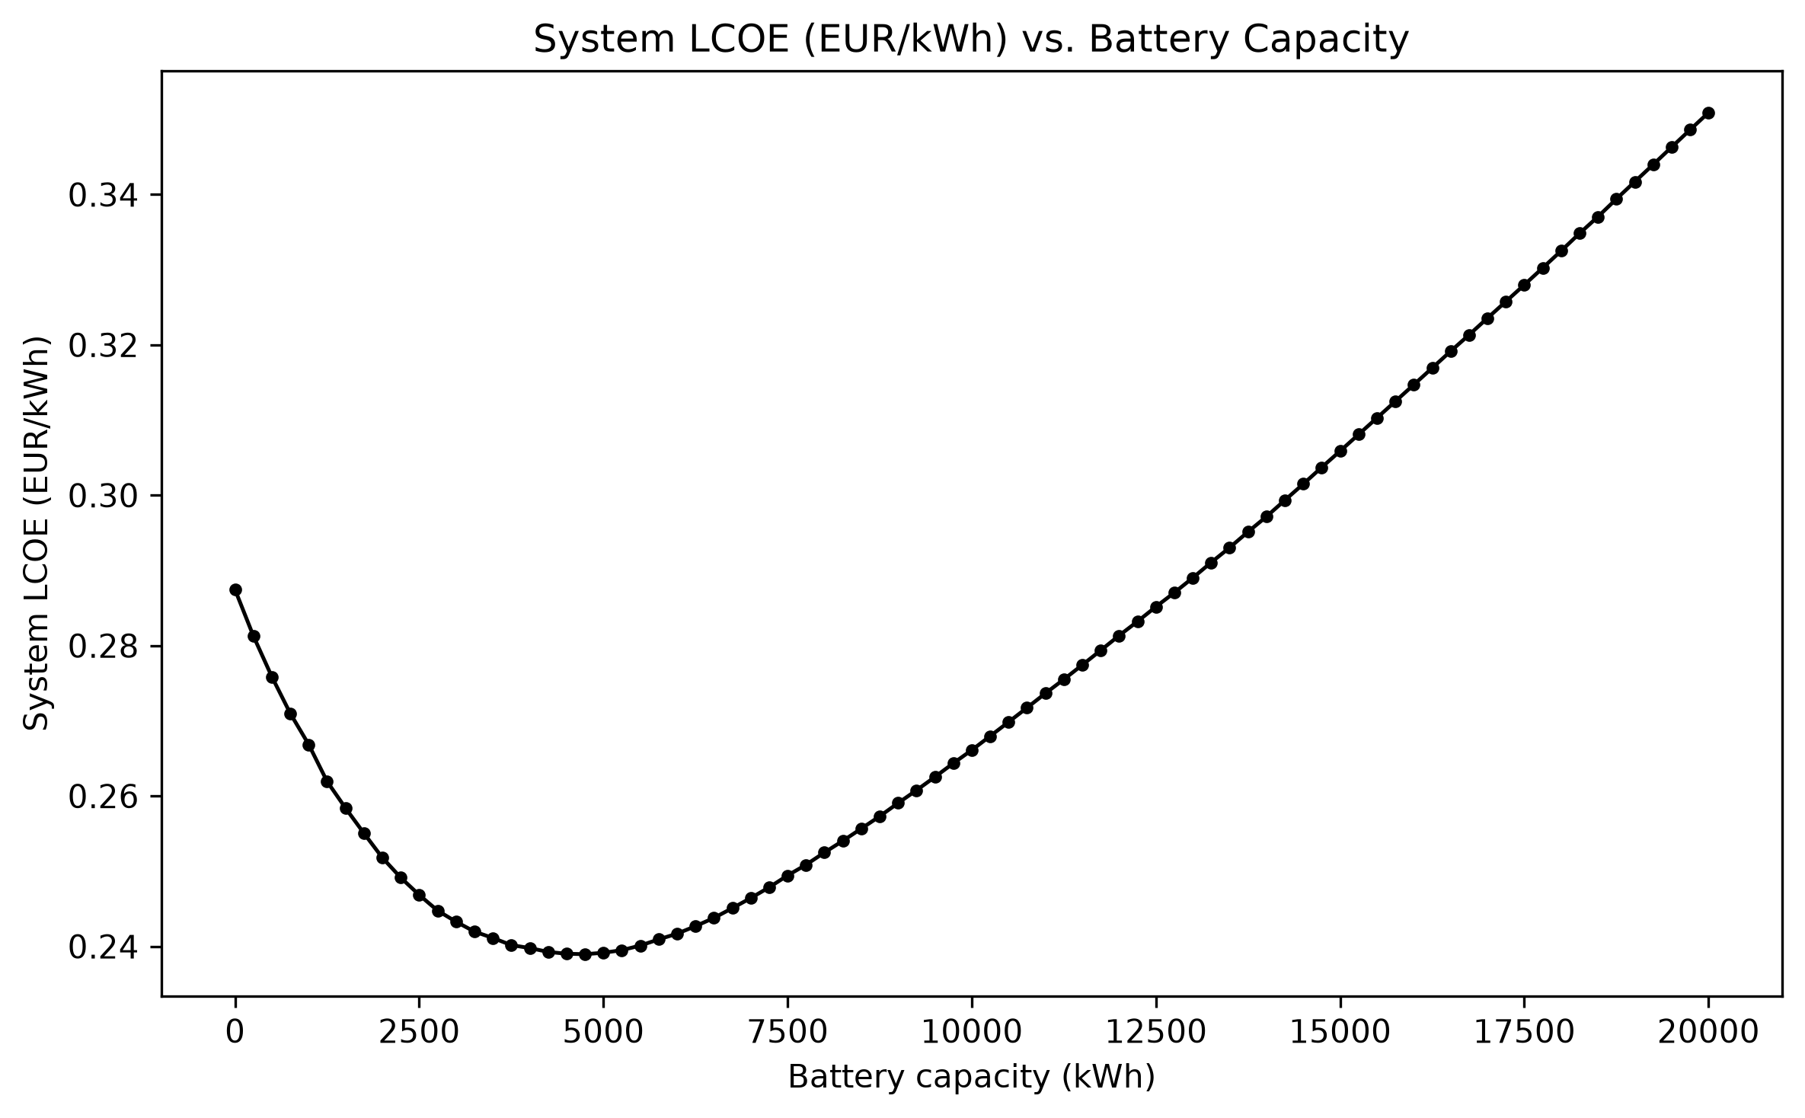 Figure 27 — System LCOE vs. battery capacity. Minimum: 0.2390 EUR/kWh at 19 modules.
Renewable share climbs monotonically with battery capacity throughout (to 89.9% at 80 modules) even past the LCOE minimum – the chart below reproduces the shape of the course lecture’s OptiCE “Typical results (1)” chart (renewable share % vs. LCOE) directly from this project’s own exhaustive search output, with the minimum-LCOE point sitting at a renewable share (80.2%) well below 100%, matching the qualitative shape of that reference chart.
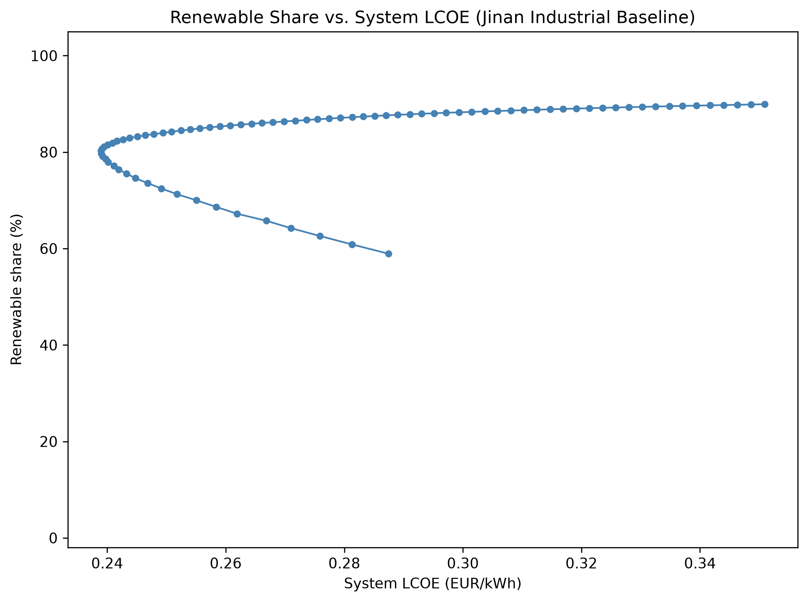 Figure 28 — Renewable share vs. system LCOE. The minimum-LCOE “tipping point” sits at 80.2% renewable share.
This is the same underlying site physics documented under the pre-diesel design: annual PV+wind production (4,232,266 kWh) exceeds annual load (3,800,000 kWh) by 11.4%, but the monthly renewable-to-load ratio falls below 1.0 for five consecutive months, June through October – a seasonal generation/load mismatch that a battery sized for daily/weekly cycling cannot bridge alone. Under the pre-diesel hard-LPSP-constraint search, this made the baseline case infeasible within the configured range (LPSP never dropped below ~10%, see report history). Under Addendum 3’s diesel-backed design, diesel simply covers the seasonal shortfall whenever it’s cheaper to burn fuel than to buy more battery capacity – the 19-module optimum is exactly the point where that trade-off balances, and the seasonal mismatch now shows up as diesel fuel consumption (driving the 80.2% ceiling on renewable share at the LCOE optimum) rather than as outright infeasibility.
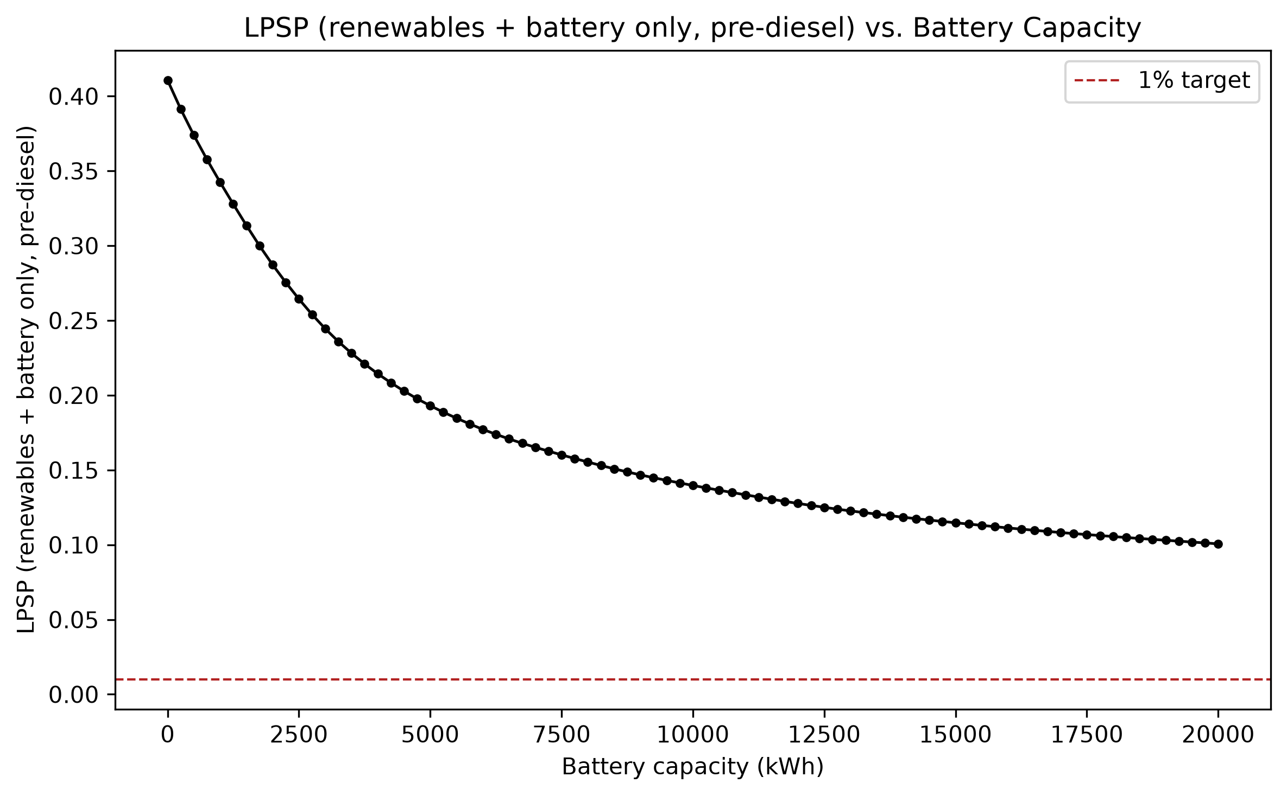 Figure 7 — LPSP from renewables and battery alone (pre-diesel), vs. capacity. Diagnostic only; not the search’s binding constraint under Addendum 3.
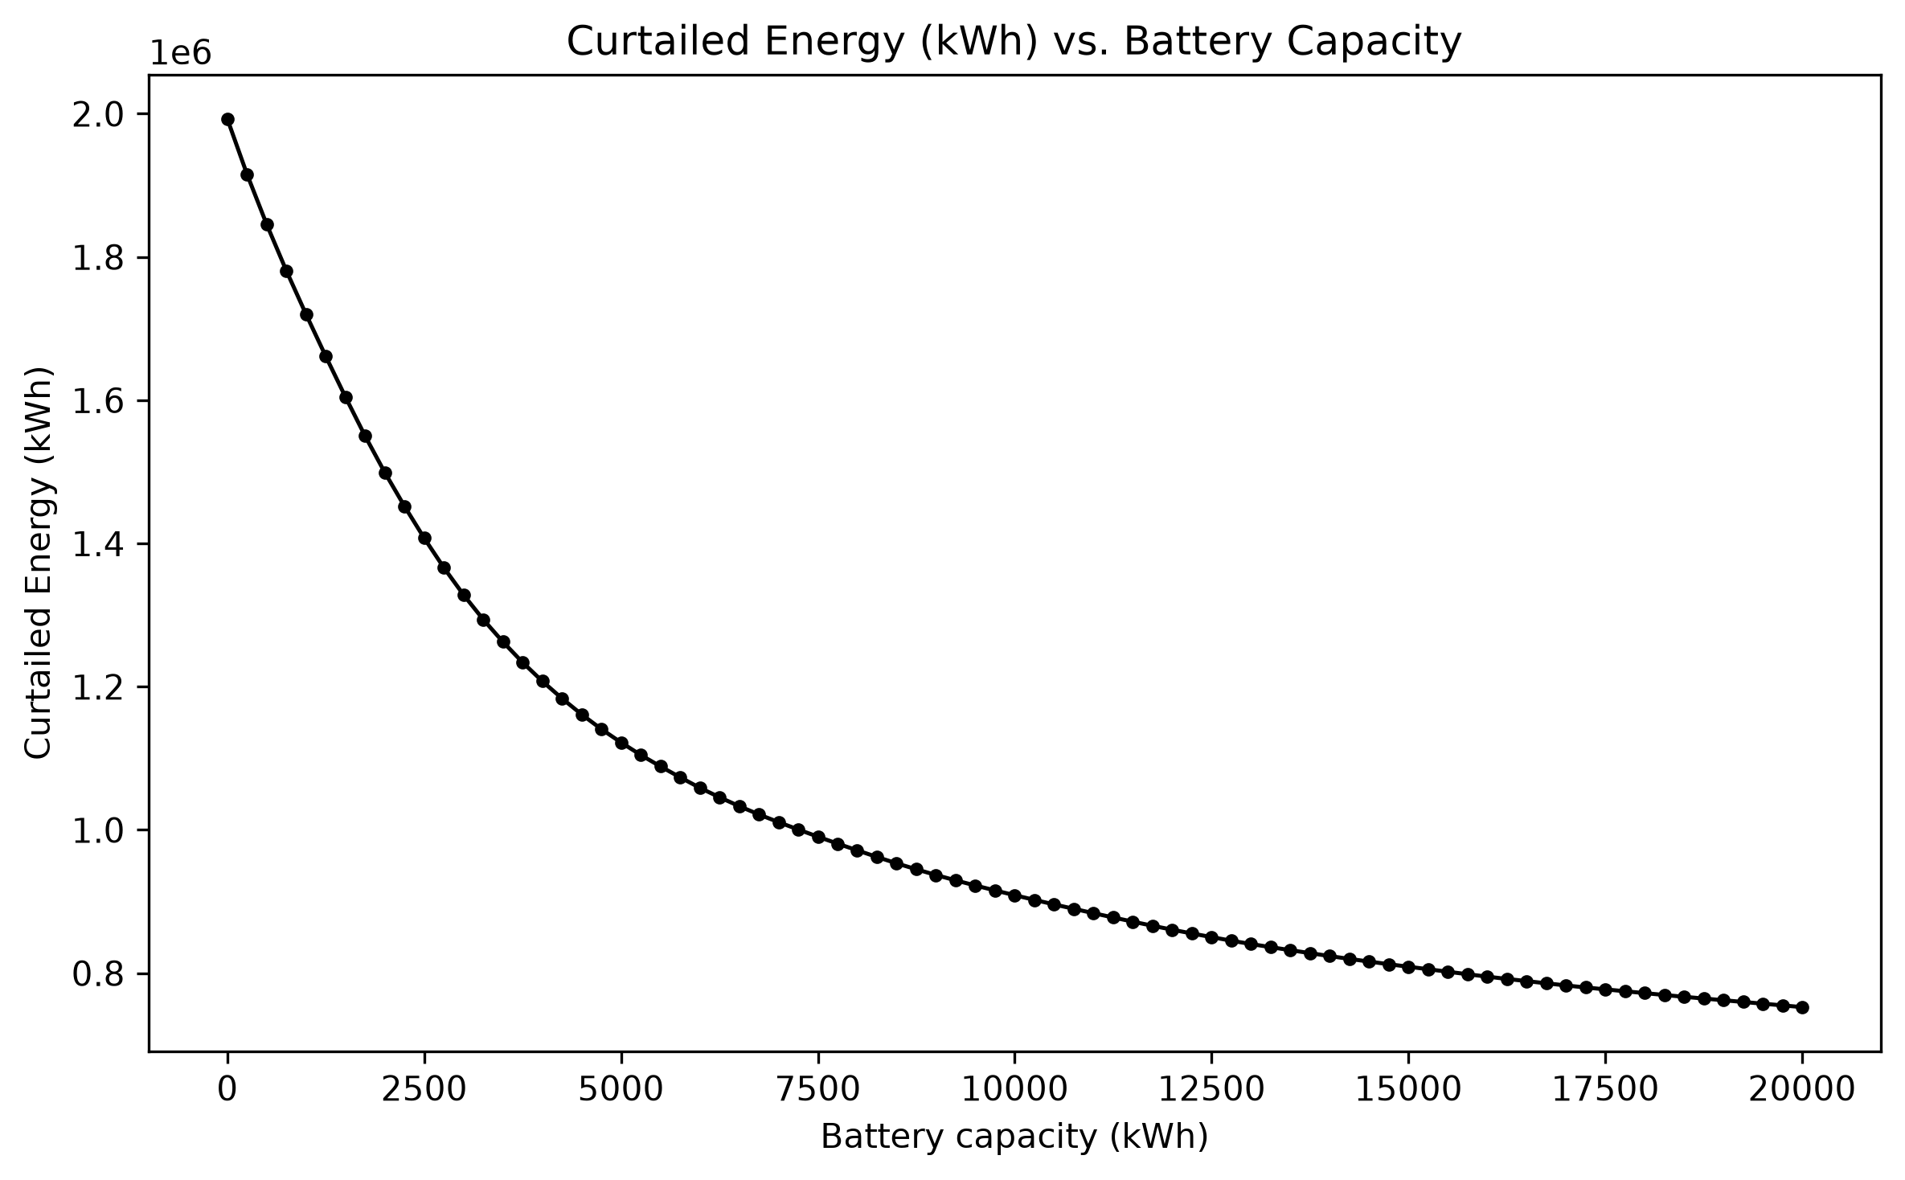 Figure 8 — Curtailed (wasted) renewable energy vs. battery capacity, monotonically decreasing.
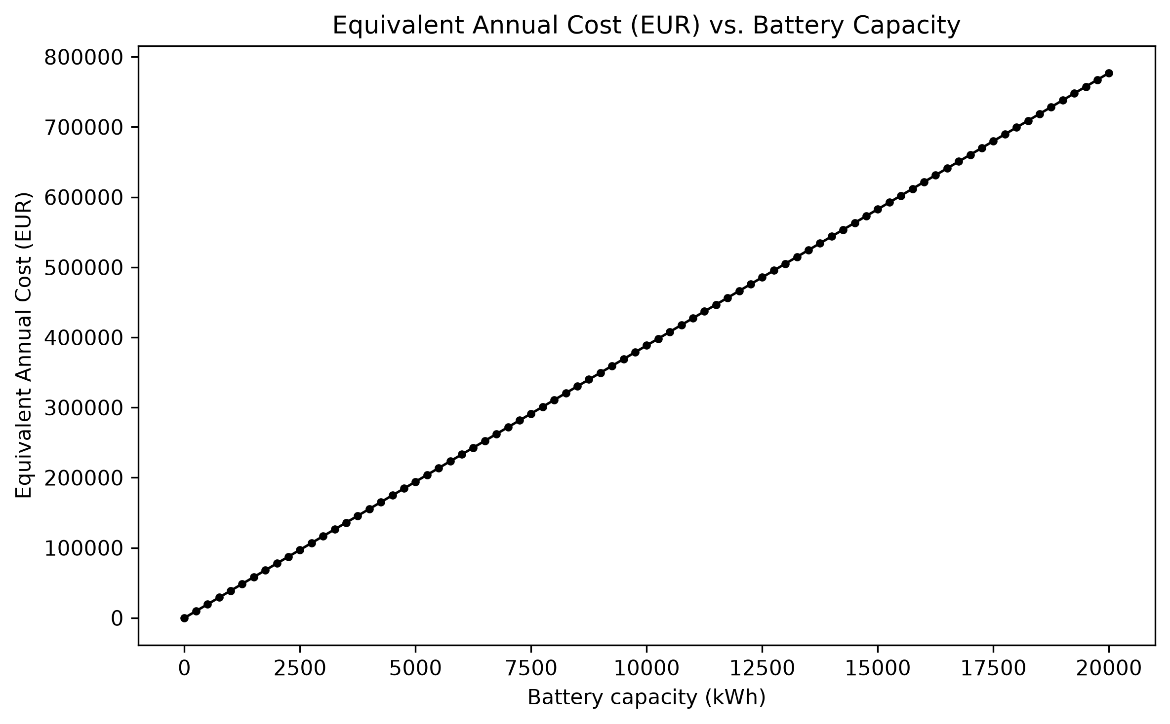 Figure 9 — Battery-only equivalent annual cost vs. capacity (linear in capacity).
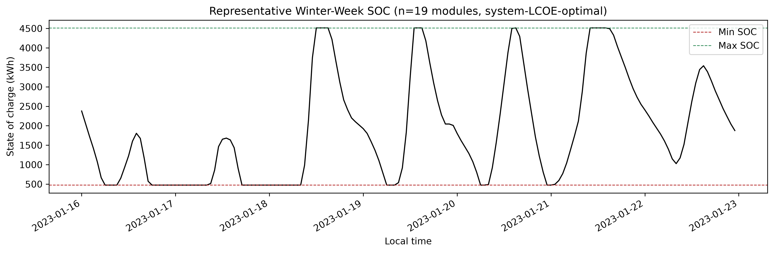 Figure 10 — SOC trajectory for the system-LCOE-optimal battery (19 modules), a representative winter week.
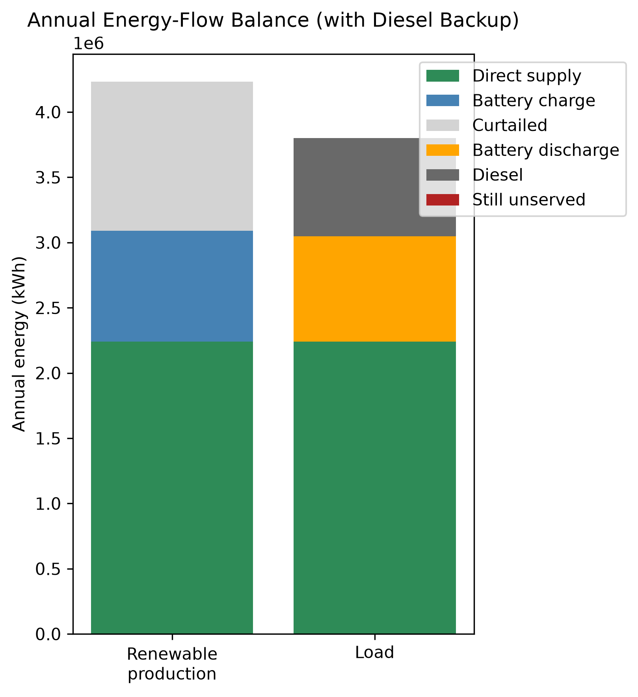 Figure 11 — Annual energy-flow balance with diesel backup: load is fully covered, no unserved energy.
Full candidate-by-candidate results: outputs/tables/baseline_battery_candidate_results.csv. Mechanistic search runtime: ~6.3 ms/candidate (81 candidates, 0.51 s total) – after JIT-compiling the hourly dispatch loop with numba (§9).

15. AI-Model Results

15.1 Pilot (Stage 5/6, 100-scenario dataset)
Test-split (16 scenarios, 70/14/16 split – 100/100 feasible per Addendum 3) accuracy for all four models predicting optimal_capacity_kwh (naive/Ridge/ Random Forest from Stage 5, MLP from Stage 6):
Model | MAE (kWh) | RMSE (kWh) | R² | Bias (kWh) | % within 20%
Naive (median) | 1,328.1 | 1,481.7 | -0.042 | 296.9 | 25.0%
Ridge | 233.6 | 324.0 | 0.950 | 82.7 | 100.0%
Random Forest | 227.3 | 312.1 | 0.954 | -36.8 | 93.75%
Neural Network (MLP) | 2,021.2 | 2,602.9 | -2.215 | -1,824.8 | 31.25%
Operational (under/over-prediction, reported separately from averaged accuracy per §21):
Model | Underprediction rate | Mean underprediction (kWh) | Overprediction rate | Mean overprediction (kWh)
Naive | 37.5% | 1,375.0 | 62.5% | 1,300.0
Ridge | 37.5% | 201.1 | 62.5% | 253.0
Random Forest | 50.0% | 264.1 | 50.0% | 190.5
Neural Network | 75.0% | 2,564.0 | 25.0% | 393.0
Read honestly, not triumphantly – and this pilot’s honest result is unflattering to the neural network. The neural network has the worst accuracy on every metric, including a negative R² worse than the naive baseline’s. §12 already showed why: 70 training rows is not enough data for a 15,233-parameter network at this problem’s noise level – a textbook overparameterized regime. This is reported as the actual, unmanipulated outcome of this particular split and this particular (small) dataset – not re-run, not tuned, and not omitted because it doesn’t flatter the neural network. It is exactly the kind of small-sample result the refinement addendum’s “test the hypothesis, don’t assume the NN wins” instruction exists to surface, and it underscores why Stage 8/9’s full-scale re-run (§15.2) matters: one 16-sample test split is not enough evidence to conclude the neural network is worse at this task in general, only that it is worse on this split, at this training set size.
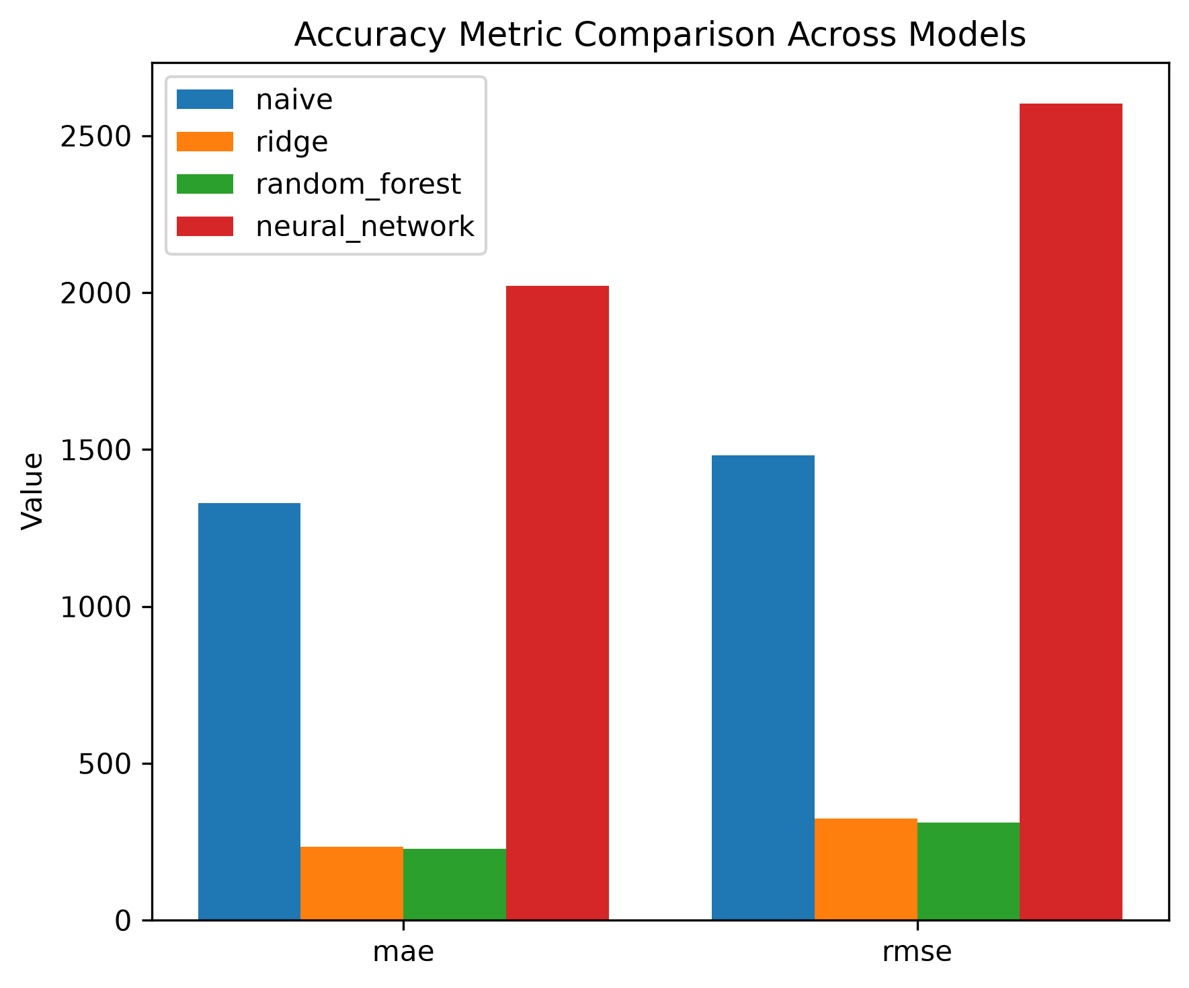 Figure 21 — MAE/RMSE by model, pilot. Ridge and Random Forest lead; the neural network trails even the naive baseline.
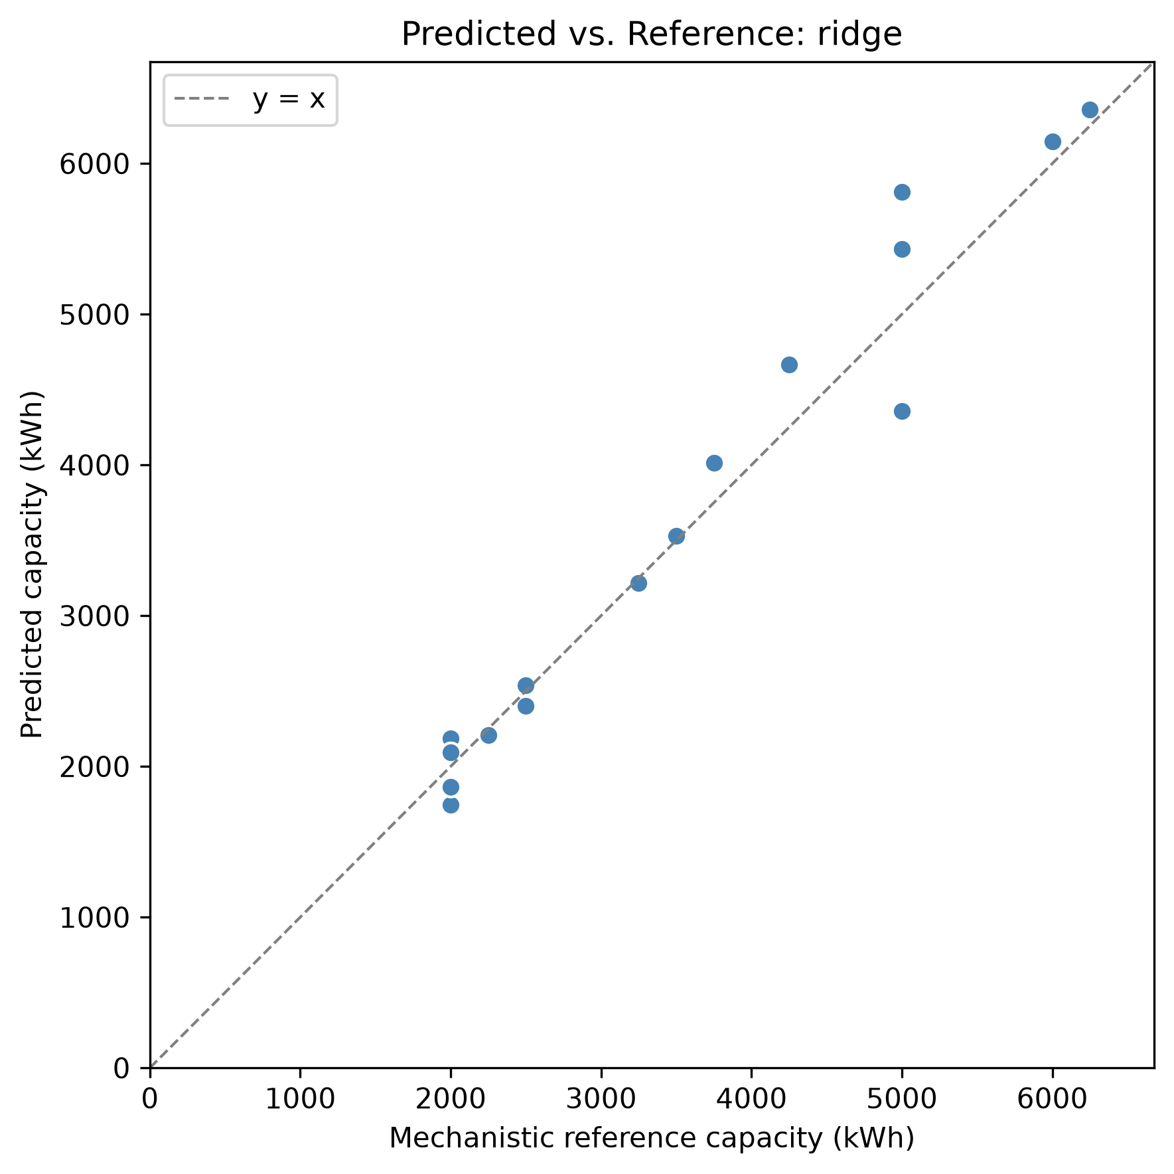 Figure 17a — Ridge: predicted vs. true capacity, pilot test split (n=16). Points hug the diagonal.
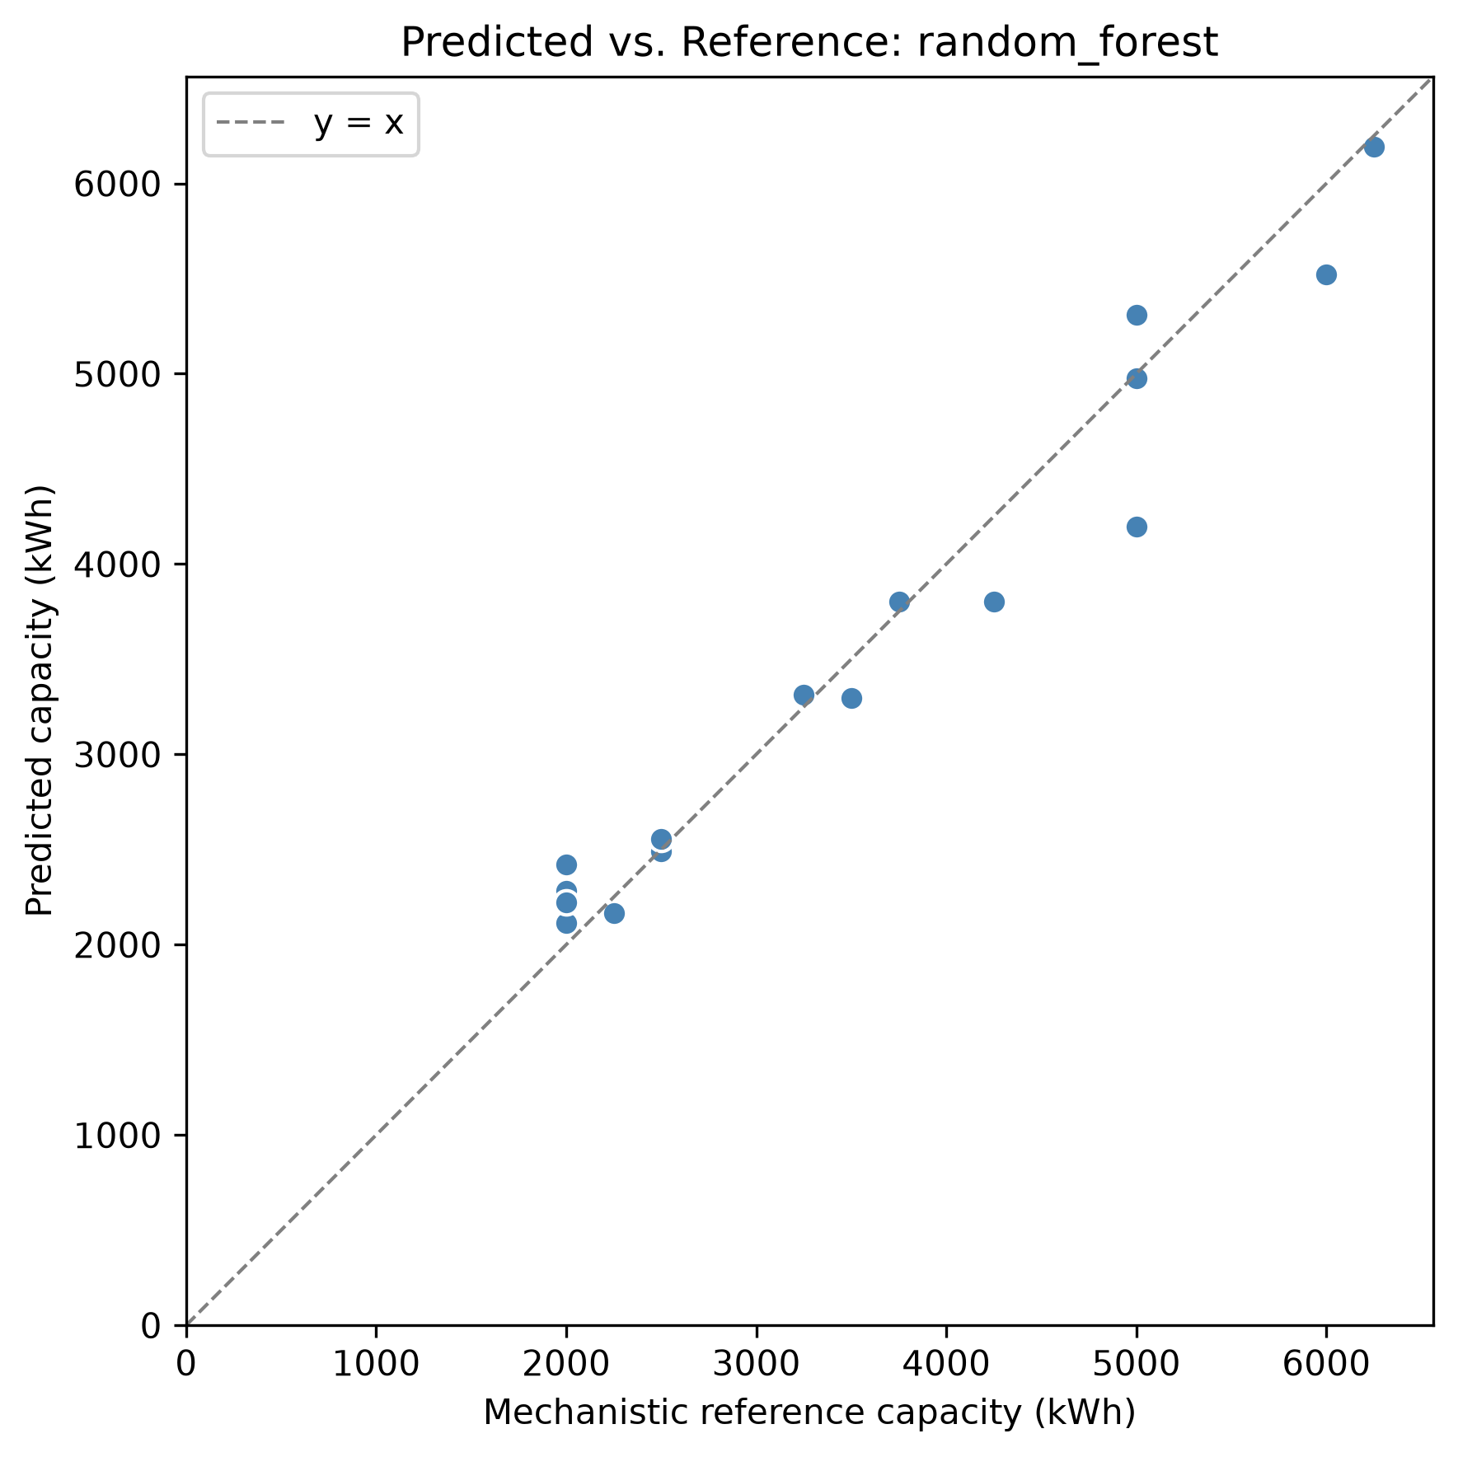 Figure 17b — Random Forest: predicted vs. true capacity, pilot test split.
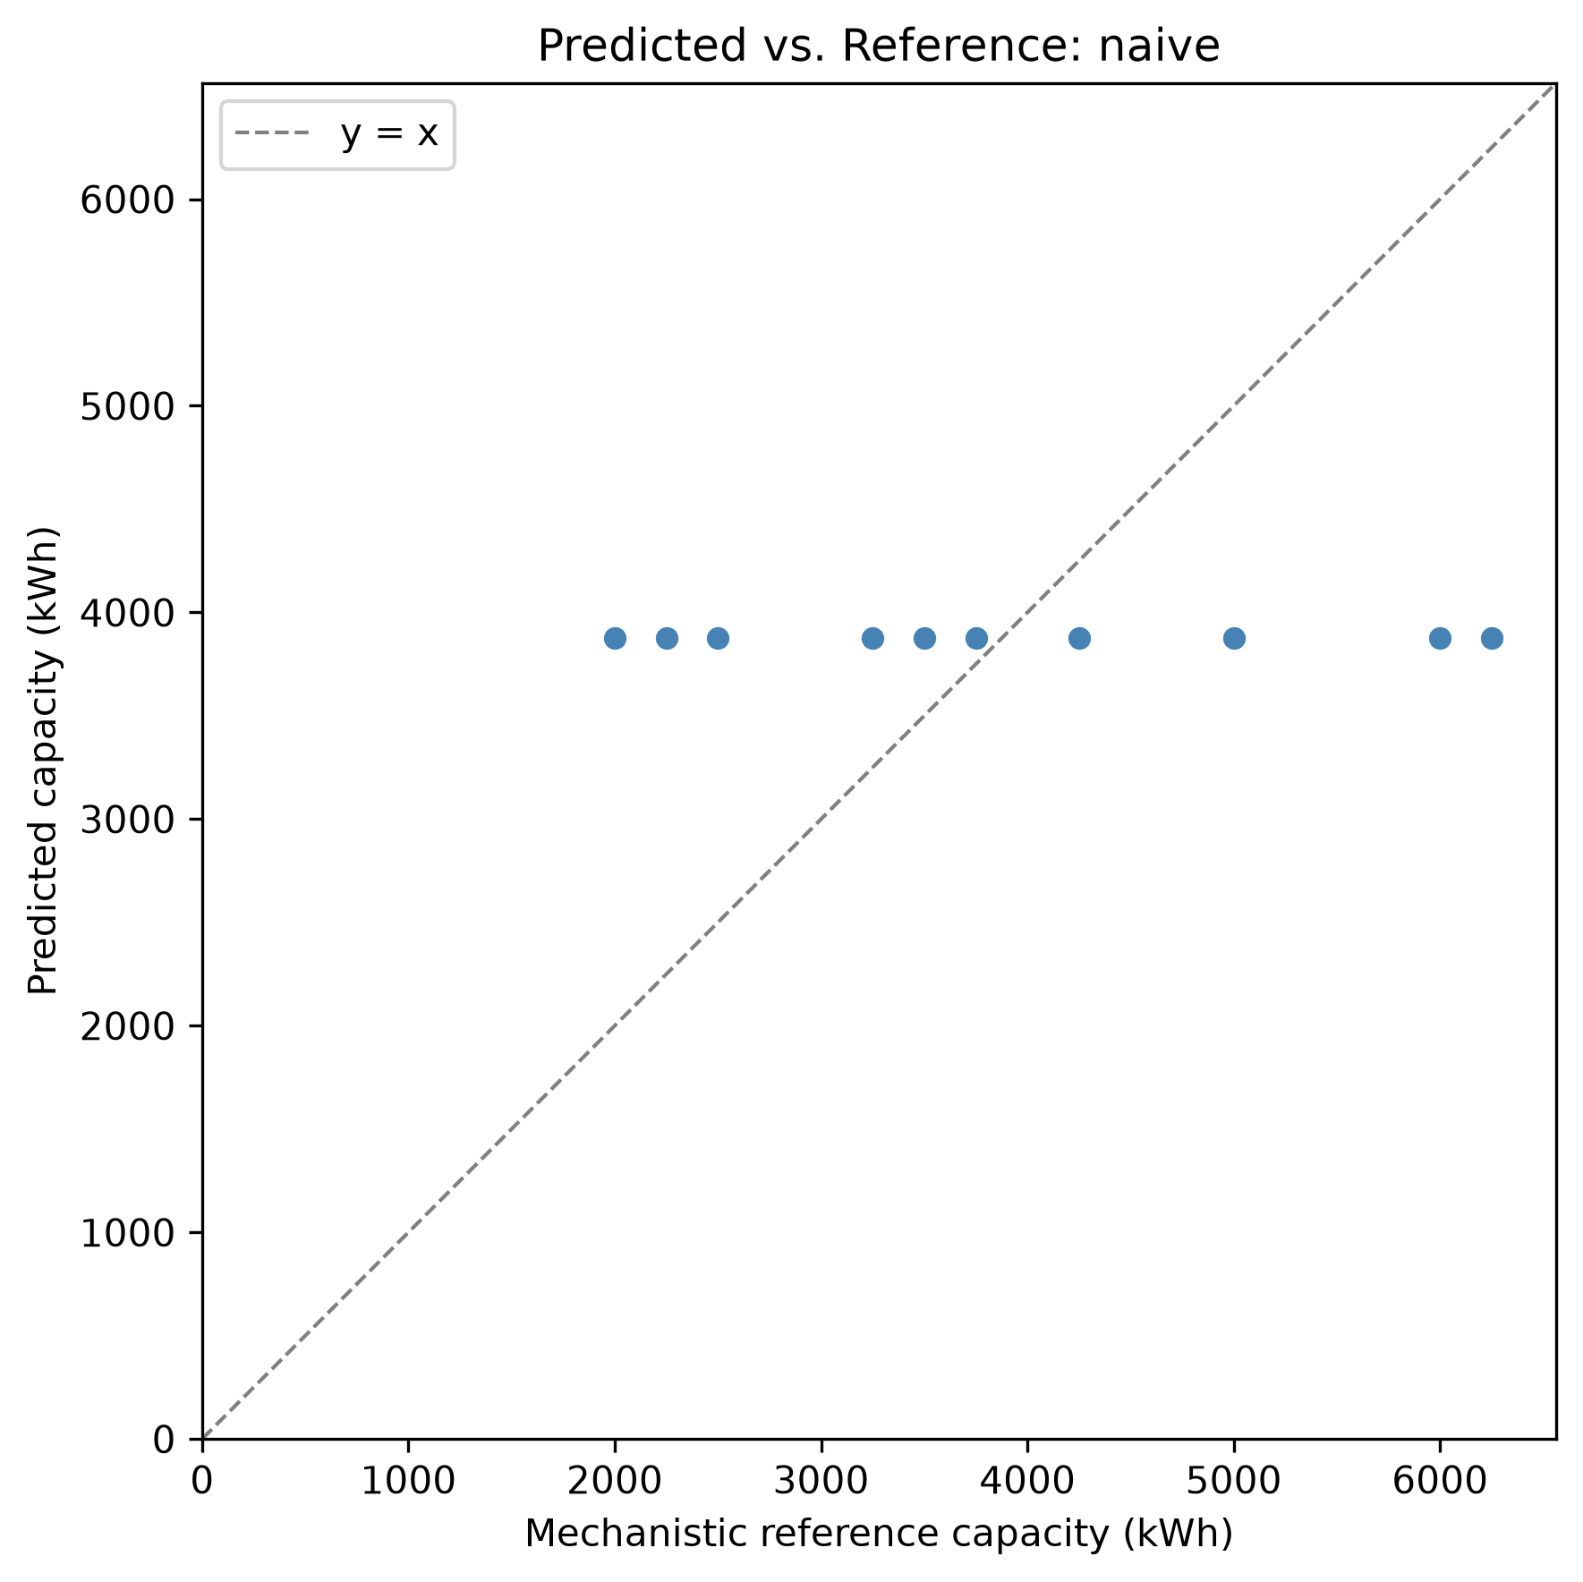 Figure 17c — Naive median baseline: predicted vs. true capacity, pilot test split.
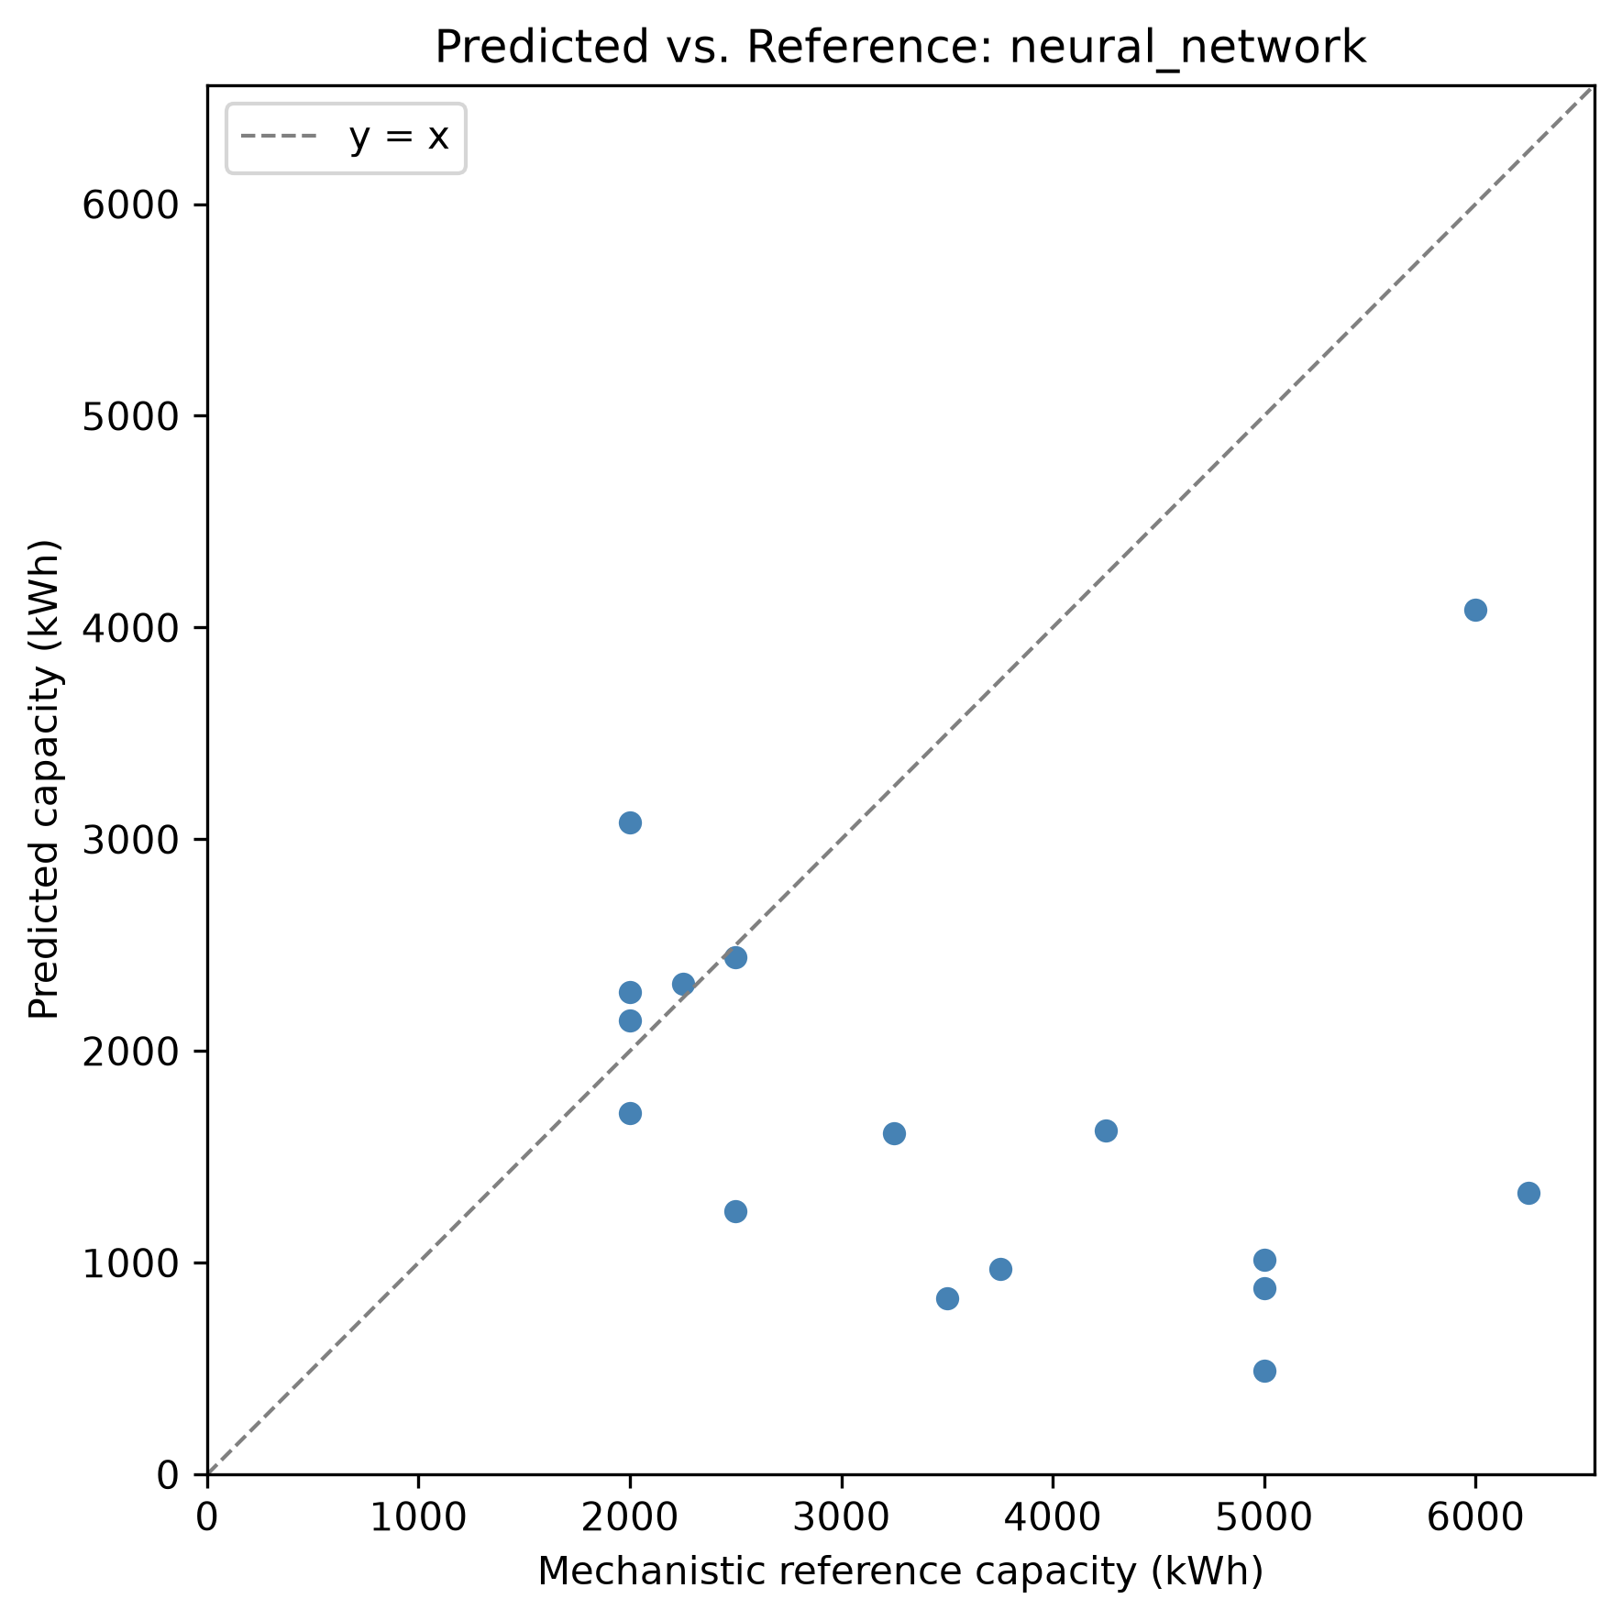 Figure 17d — Neural network: predicted vs. true capacity, pilot test split. Visibly the worst fit of the four.
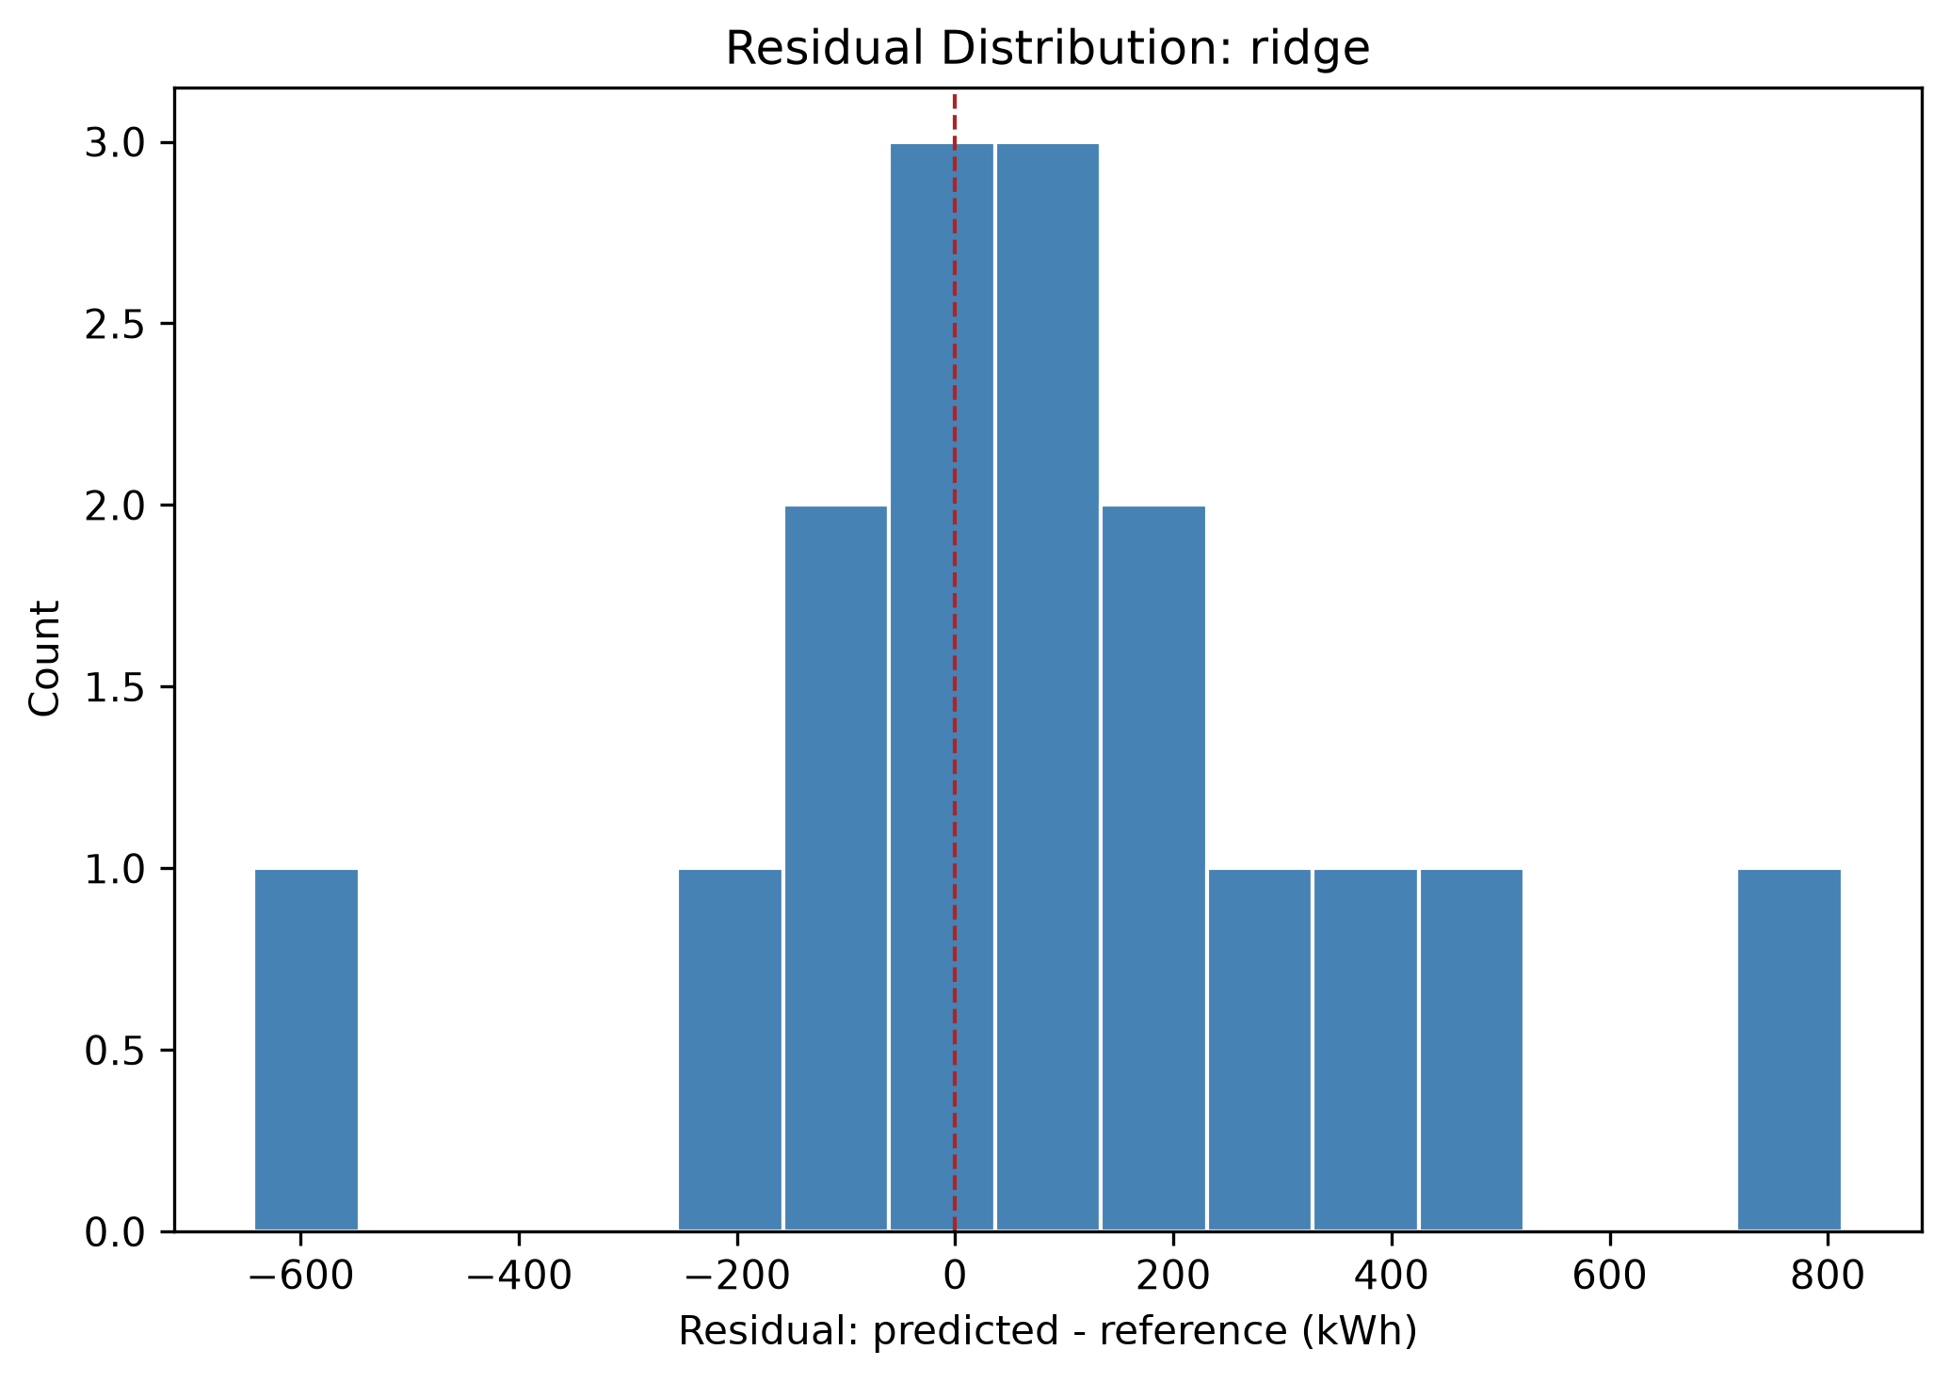 Figure 18a — Ridge residuals, tightly clustered near zero.
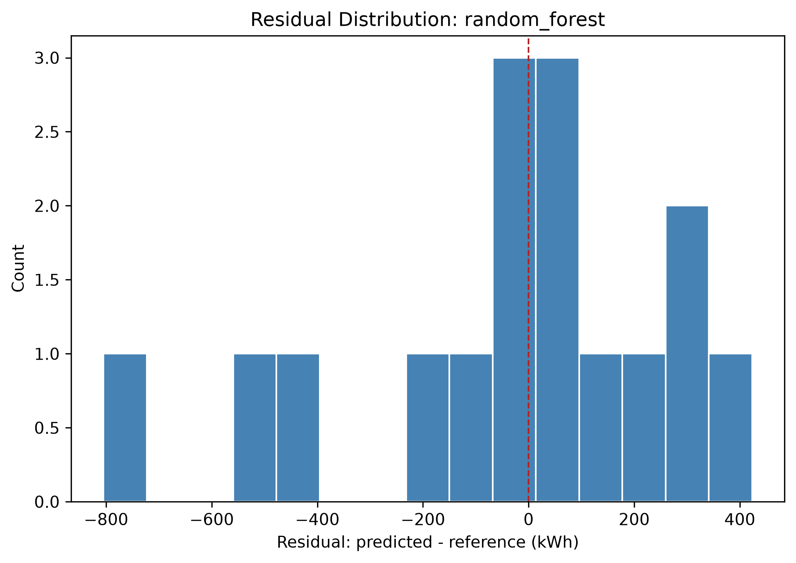 Figure 18b — Random Forest residuals, similarly tight clustering.
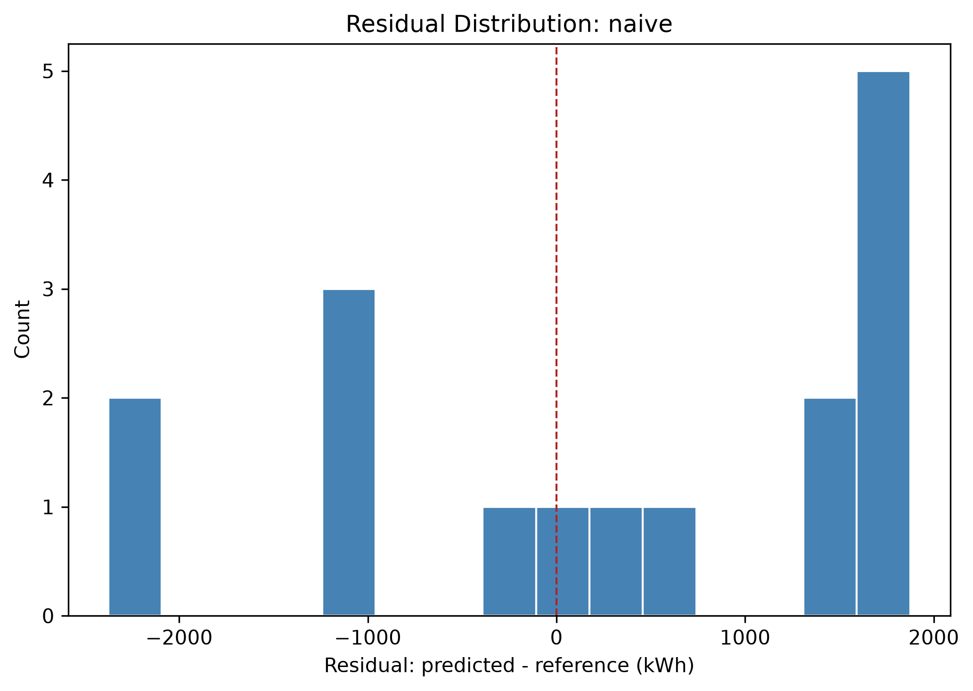 Figure 18c — Naive baseline residuals, wide spread.
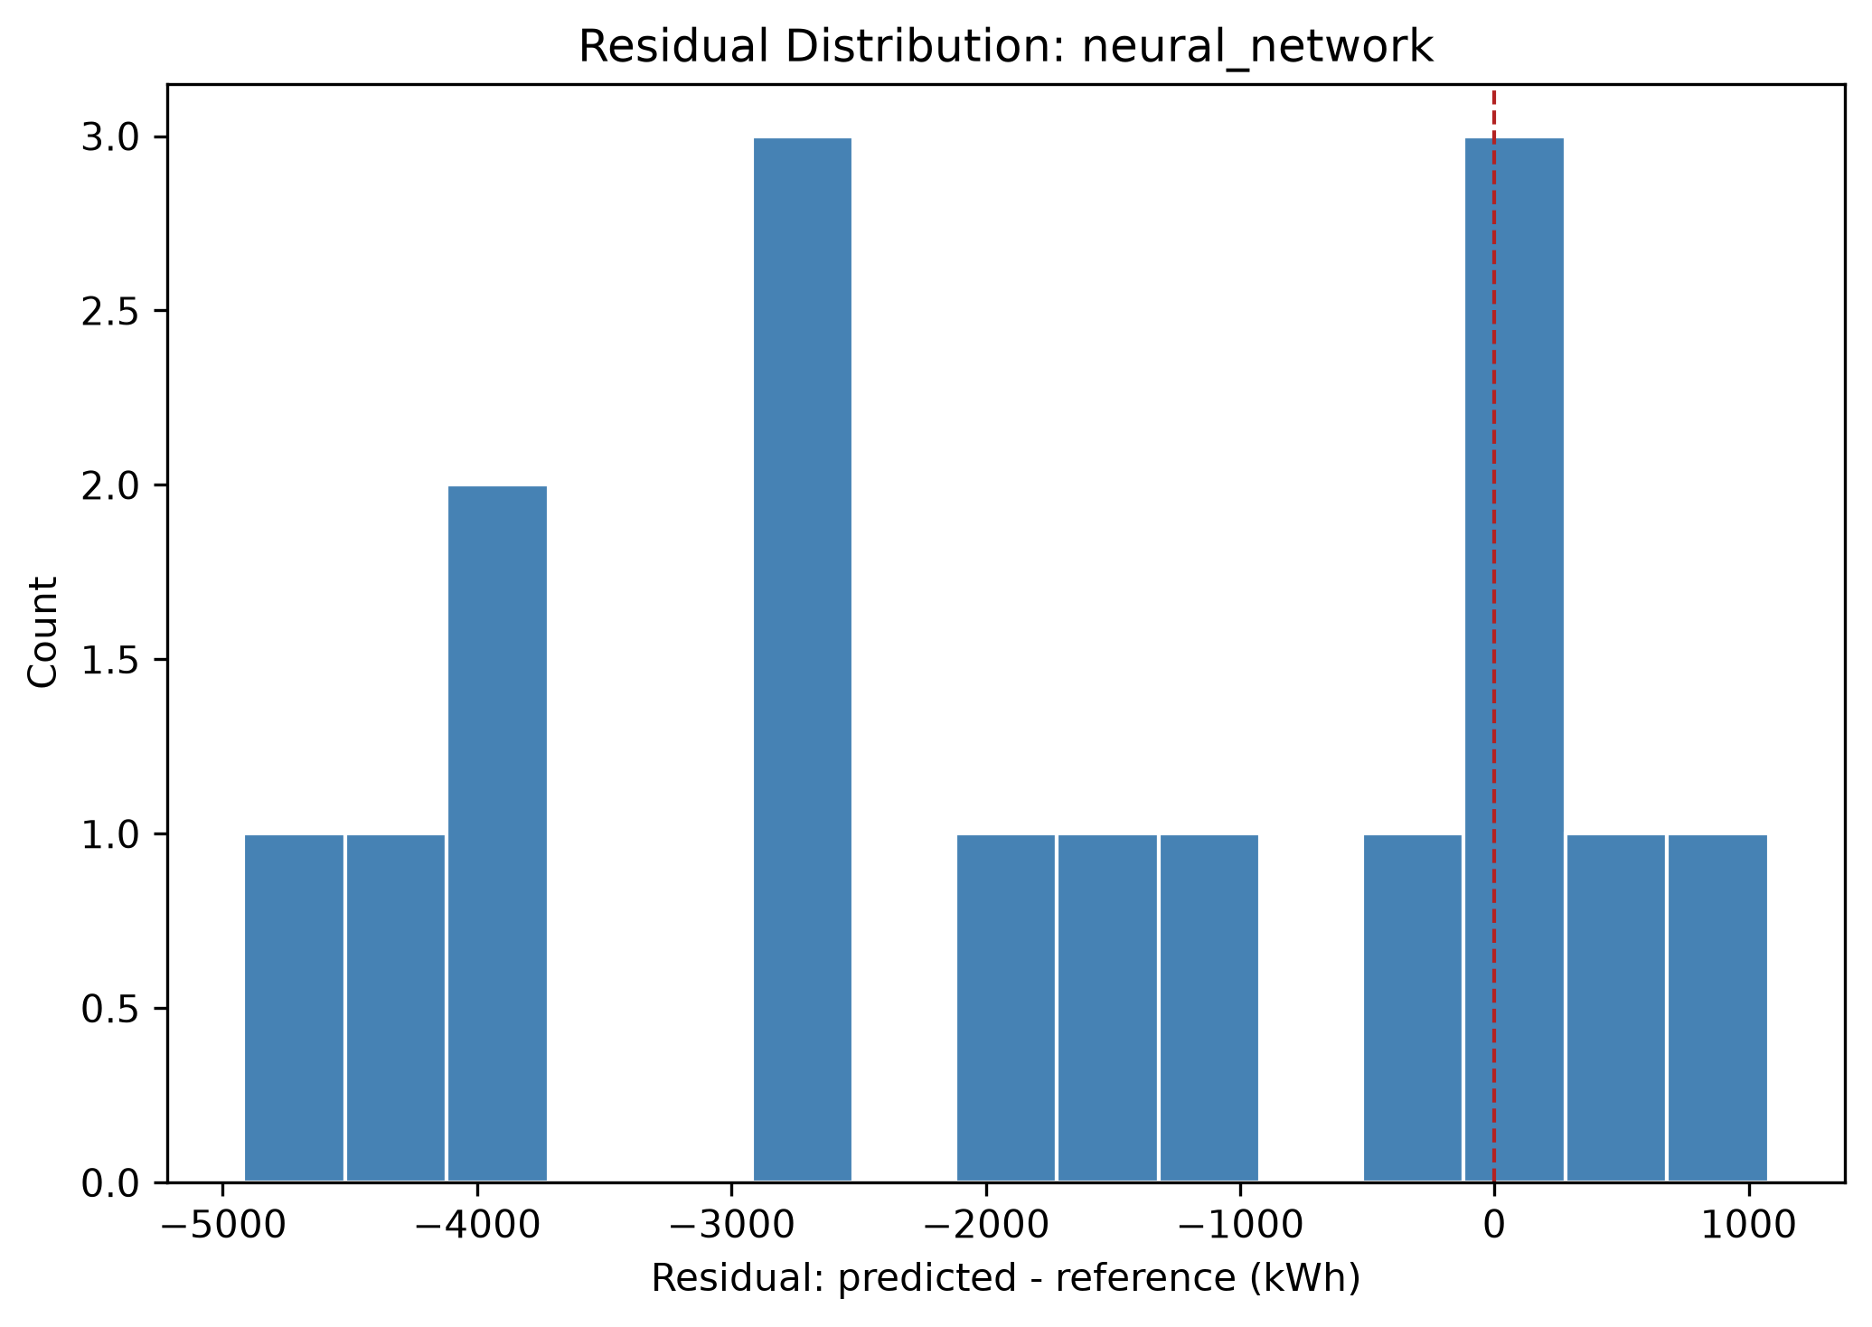 Figure 18d — Neural network residuals: widest, least-centered spread of the four.
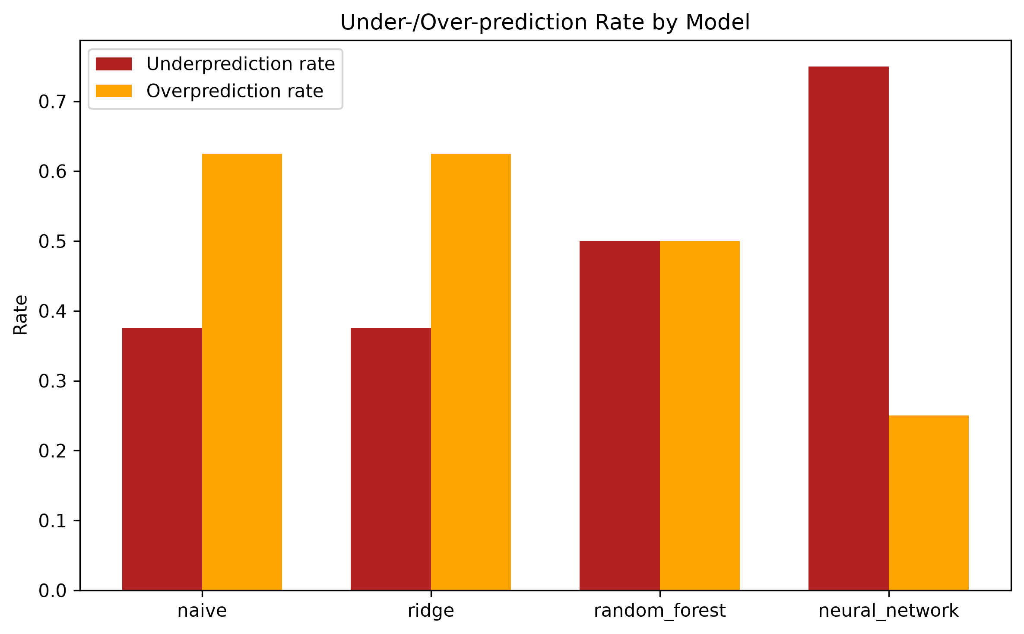 Figure 23 — Over-/under-prediction rates by model, reported separately per PROJECT_BRIEF.md §21.
Full tables: outputs/tables/accuracy_metrics_by_model.csv, reliability_metrics_by_model.csv, runtime_comparison_stage5.csv.

15.2 Full-scale (Stage 8/9, 5,000-scenario dataset)
Same pipeline, same architecture and hyperparameters (no tuning changes), retrained fresh on the full dataset’s 3,500/749/751 train/val/test split (5,000/5,000 feasible scenarios, per Addendum 3). The neural network converged in 209 epochs (60.1s). 6 of Ridge’s 751 predictions were negative and clipped to zero before conversion to installable modules (PROJECT_BRIEF.md §19); no other model produced negative predictions.
Model | MAE (kWh) | RMSE (kWh) | R² | Bias (kWh) | % within 20%
Naive (median) | 1,338.9 | 1,726.2 | -0.054 | -390.1 | 31.7%
Ridge | 237.7 | 338.3 | 0.960 | -4.7 | 93.5%
Random Forest | 118.7 | 189.5 | 0.987 | -2.1 | 98.3%
Neural Network (MLP) | 98.6 | 138.6 | 0.993 | -8.8 | 99.2%
Operational metrics (751 test scenarios):
Model | Underprediction rate | Mean underprediction (kWh) | Overprediction rate | Mean overprediction (kWh)
Naive | 47.5% | 1,818.6 | 46.5% | 1,020.8
Ridge | 51.1% | 237.0 | 48.9% | 238.4
Random Forest | 49.0% | 123.2 | 49.4% | 118.1
Neural Network | 51.1% | 105.1 | 48.9% | 91.9
At 751 test scenarios (vs. the pilot’s 16), the accuracy ranking completely reverses relative to the pilot: naive < Ridge < Random Forest < neural network, with the neural network now clearly best (R² 0.993, MAE less than Random Forest’s) rather than clearly worst. The pilot’s neural network result was not a subtle small-sample wobble around an otherwise-consistent ranking, it was the complete opposite ranking, driven by a training set (70 rows) too small for this architecture to learn from at all. At 3,500 training rows, the same architecture and hyperparameters (unchanged, no tuning) produce the best-performing model of the four by a wide margin. See §16 for whether this accuracy improvement is matched by an economic-cost improvement.
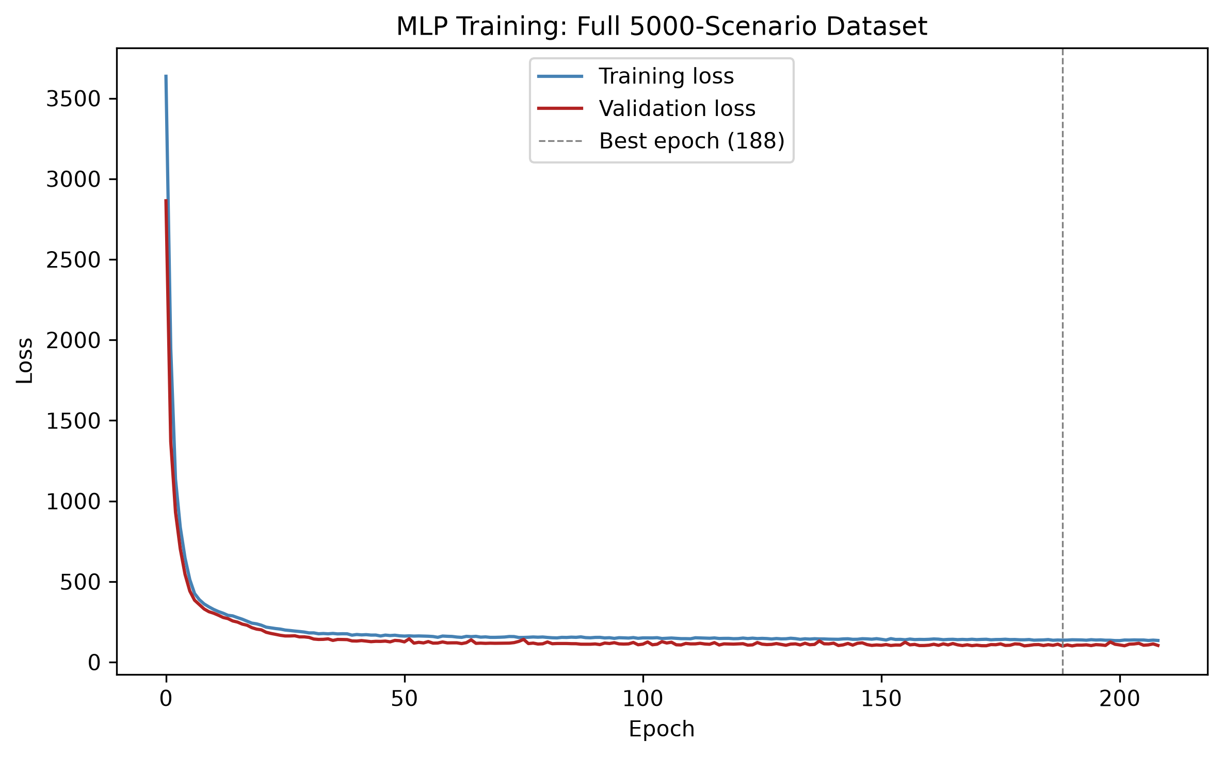 Figure 16 (full-scale) — Training/validation loss, 3,500-row training set. Early stopping at epoch 209, best epoch 188.
Full tables: outputs/tables/accuracy_metrics_by_model_full.csv, reliability_metrics_by_model_full.csv. Model artifacts: models/neural_network_full/best_model.weights.h5 (portable, see §16.1), models/neural_network_full/best_model.keras, models/preprocessing_full/{scaler.pkl,feature_columns.pkl}. This section trains fresh in-notebook rather than reloading a saved model, so it was never exposed to the cross-version loading bug described in §16.1 – the weights file is saved here purely for consistency/reuse, not because this section needed the fix.

16. Physical Verification of AI Predictions

16.1 Pilot (Stage 7, 100-scenario dataset)
Note on cross-environment reproducibility: this notebook loads the saved neural network from models/neural_network/best_model.weights.h5 (rebuilding the architecture from config/ml_training.yaml via load_trained_model), not the full models/neural_network/best_model.keras file. Loading a full .keras model requires deserializing every layer’s initializer configuration (e.g. GlorotUniform), and Keras has changed that config’s fields across versions – a model saved by a newer Keras (this project’s development environment) failed to load on Colab’s older, separately-pinned Keras with GlorotUniform.__init__() got an unexpected keyword argument 'input_axes'. Weights-only loading sidesteps this: initializers only matter for the initial random draw, which loaded weights immediately overwrite, so the rebuilt architecture only needs to match shape, not initializer serialization details. Verified bit-exact (max abs prediction difference 0.0) against the original full-model load before this fix was adopted.
For every model’s every test-split prediction (16 scenarios x 4 models = 64 verifications): rounded up to installable modules (ceiling, never down), diesel backup is applied and system LCOE computed for both the AI-predicted battery size and the mechanistic-optimal (system-LCOE-minimizing) reference size, freshly re-run per prediction rather than trusting possibly-stale stored summary statistics (§8, §13).
Model | Mean extra system LCOE (EUR/kWh) | Reliability pass rate | % undersized | % oversized | Additional cost from oversizing (EUR/yr)
Naive | 0.0217 | 100% | 37.5% | 62.5% | 362,363
Ridge | 0.0013 | 100% | 12.5% | 62.5% | 36,266
Random Forest | 0.0016 | 100% | 18.75% | 50.0% | 26,350
Neural Network | 0.0361 | 100% | 68.75% | 25.0% | 53,143
This is the headline, mandatory-check result of the whole project at pilot scale – and here it is unambiguous, not subtle. Reliability pass rate is 100% for every model, exactly as expected: diesel makes reliability near-universal by construction (§8), so it no longer discriminates between models the way it did under the pre-diesel design. The metric that discriminates is mean extra system LCOE, and it tells the same story as §15.1’s accuracy table: the neural network’s predictions would make the system 0.0361 EUR/kWh more expensive than the true optimum on average – worse than even the naive median baseline (0.0217 EUR/kWh) – while Ridge (0.0013) and Random Forest (0.0016) cost almost nothing extra. This is a direct, continuous economic consequence of the accuracy gap documented in §15.1, not a separate finding: 68.75% of the neural network’s predictions undersize the battery (11 of 16 scenarios), each one paying a real LCOE penalty even though diesel means none of them actually go unserved.
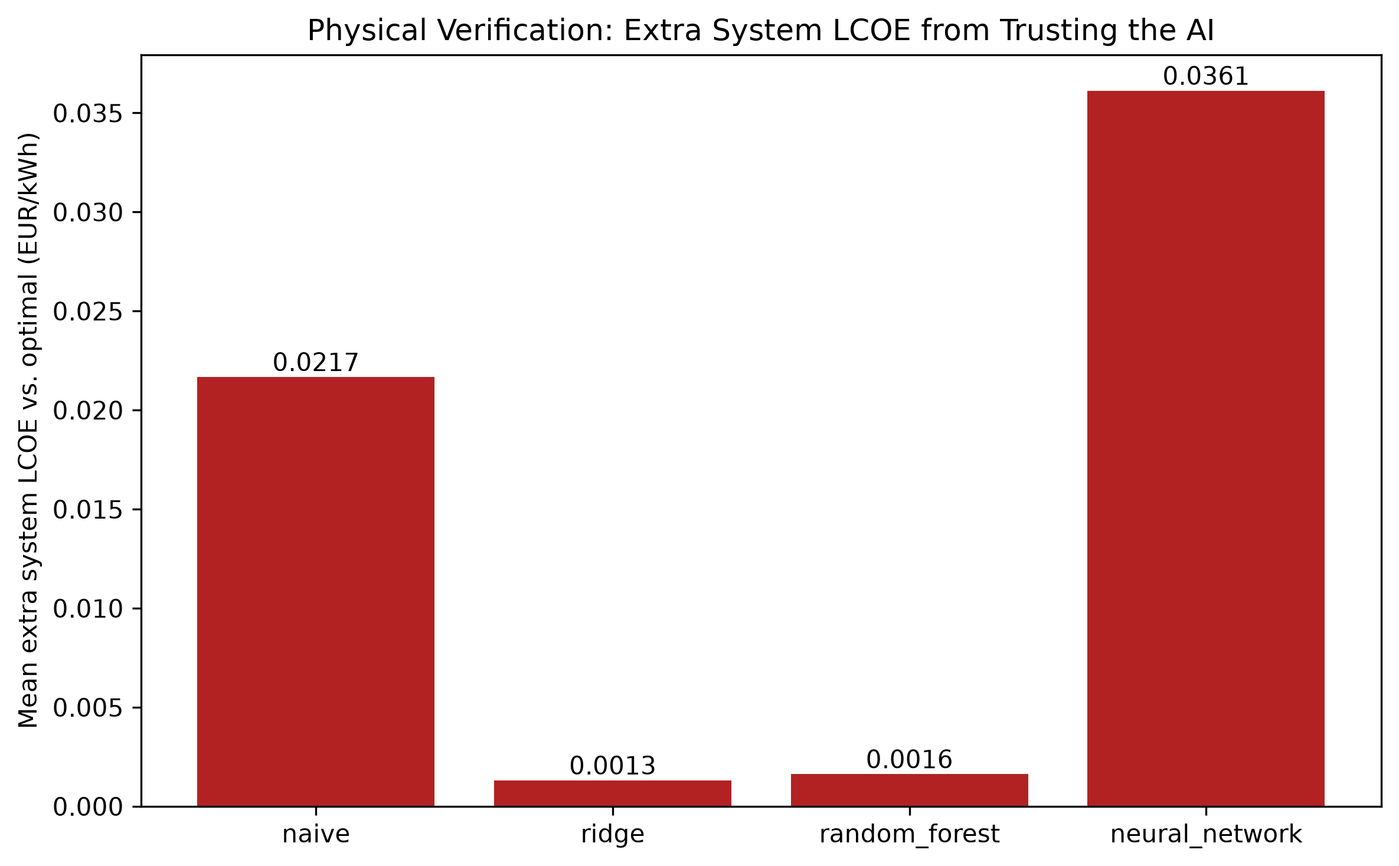 Figure 29 (pilot) — Mean extra system LCOE by model. Neural network worst (0.0361 EUR/kWh); Ridge/Random Forest cheapest.
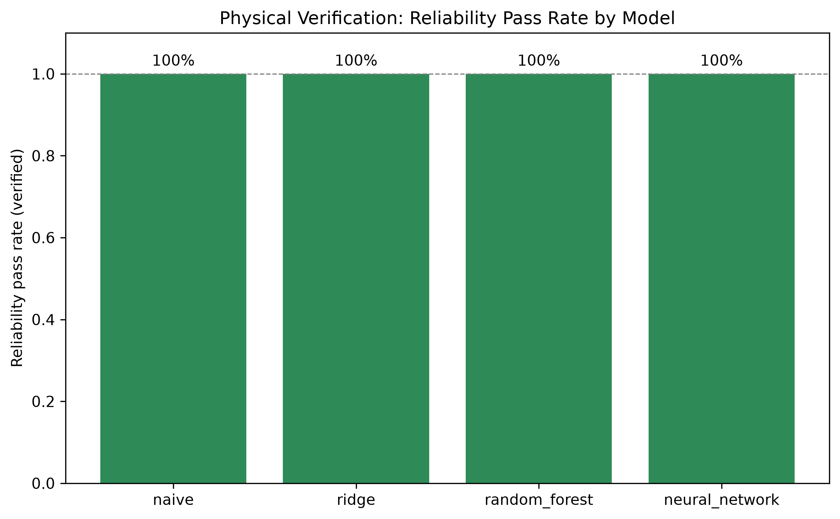 Figure 22 (pilot) — Reliability pass rate: 100% for every model, since diesel guarantees it.
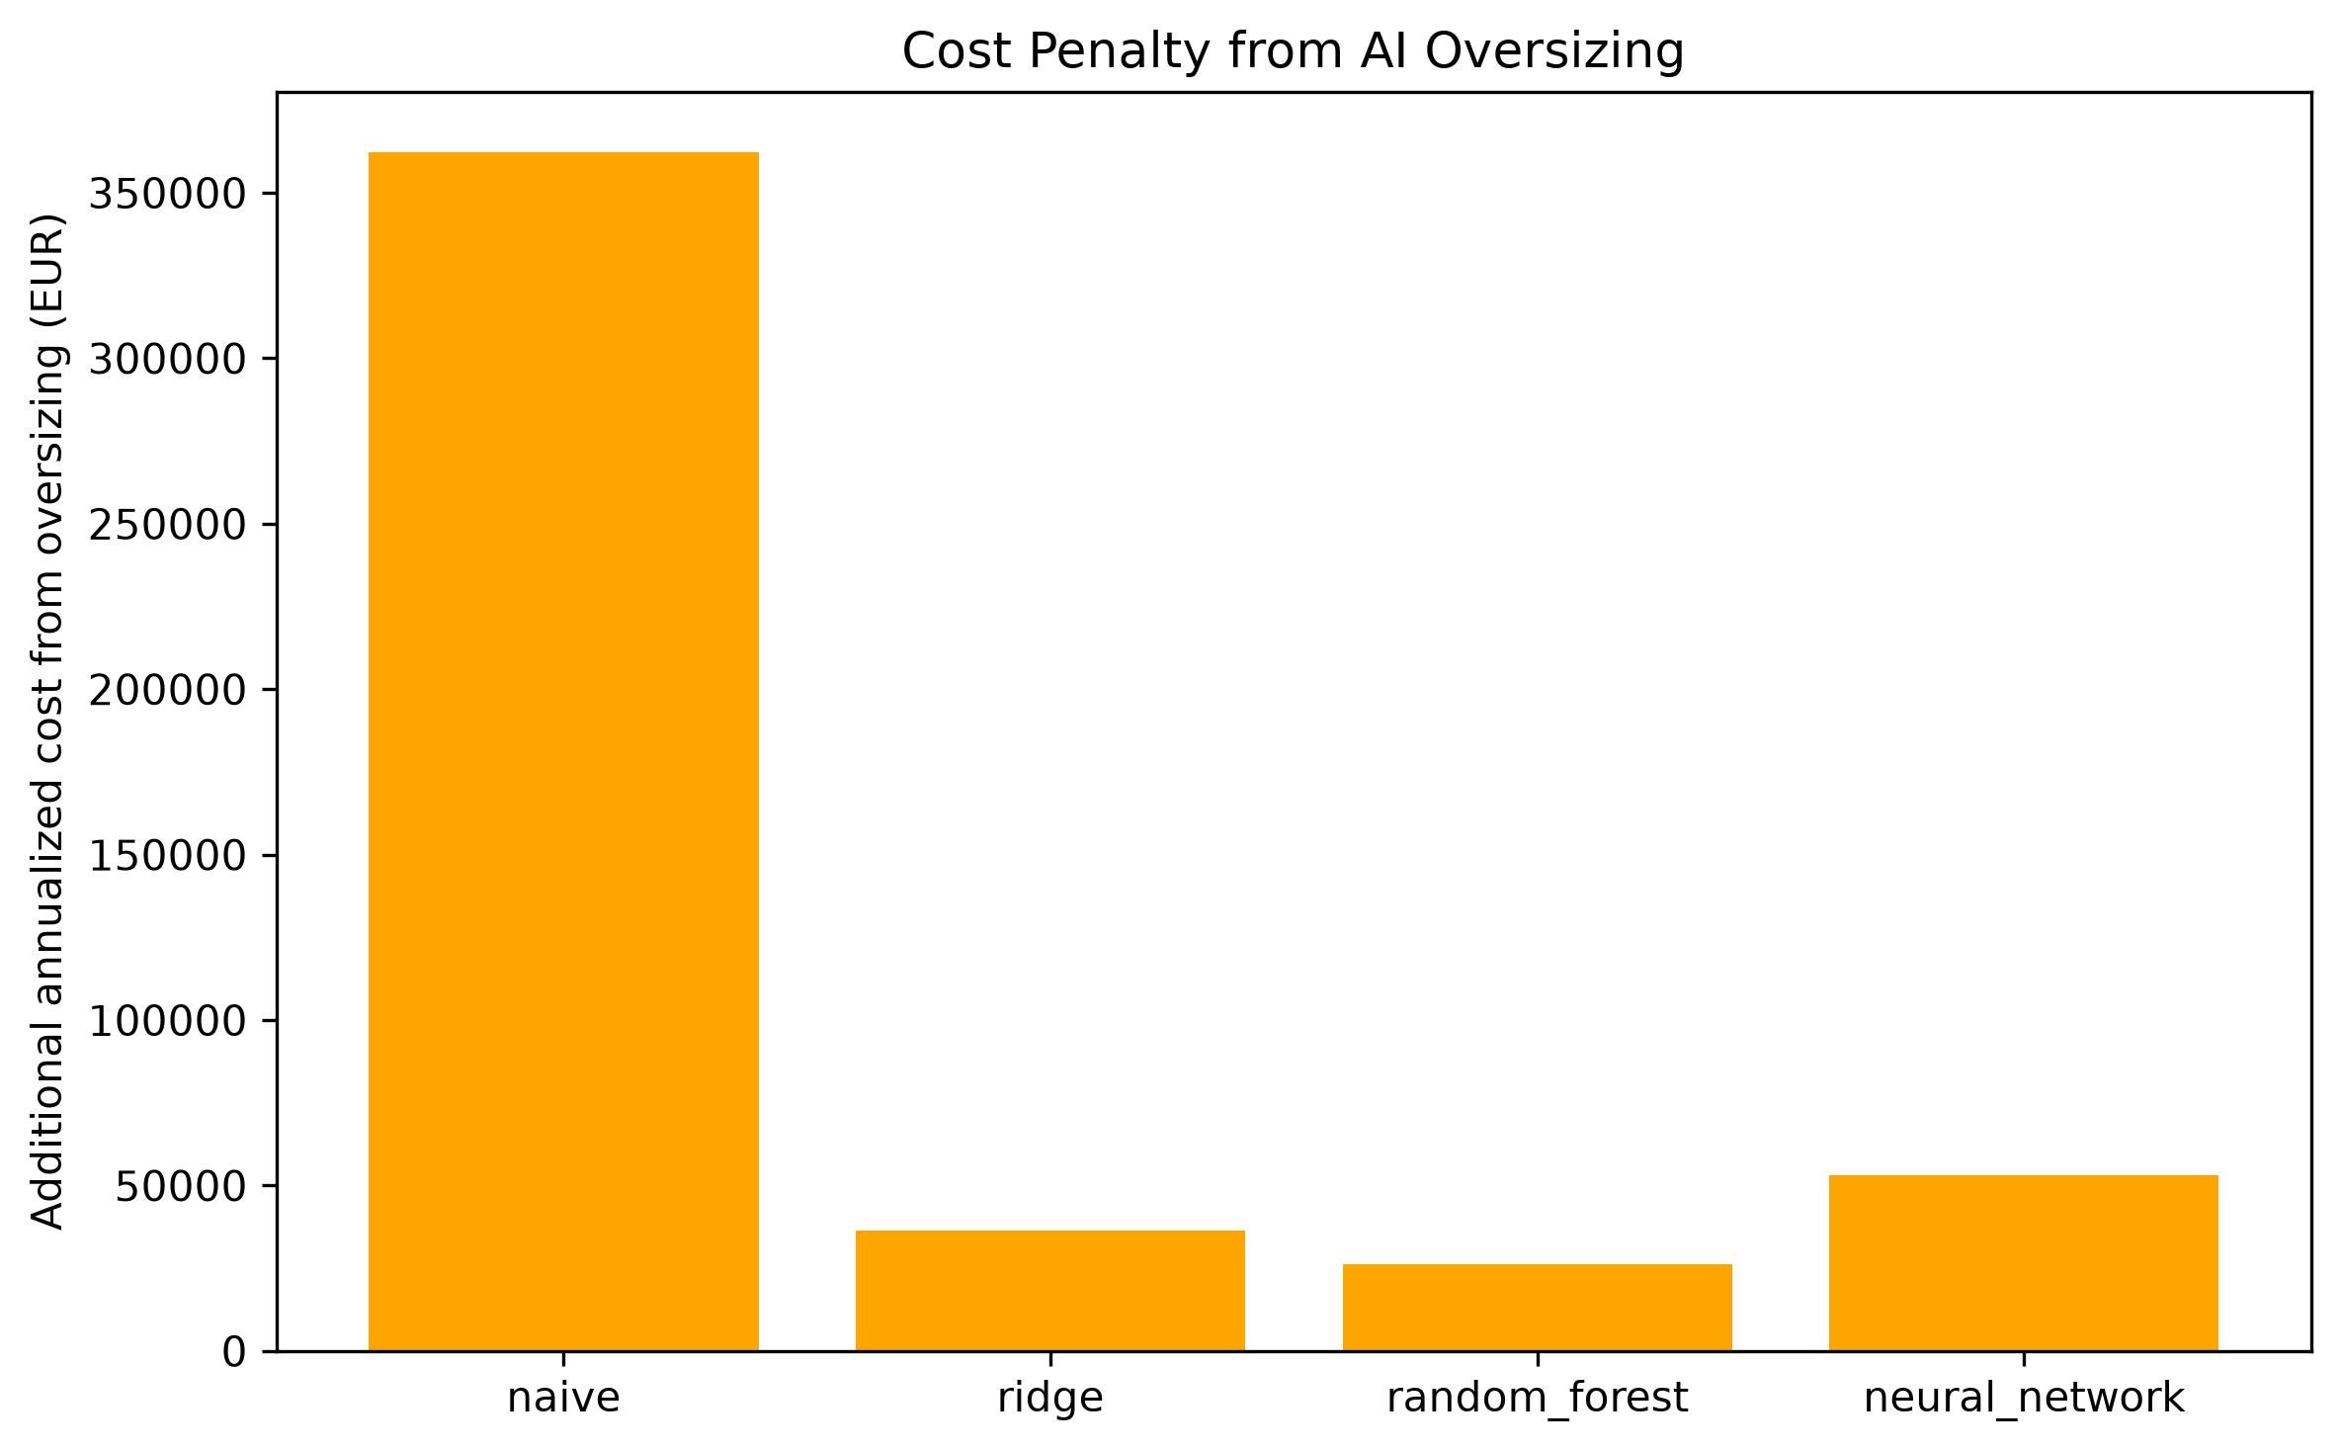 Figure 26 (pilot) — Additional annualized system cost from oversizing, by model.
Full per-scenario verification tables: outputs/tables/physical_verification_{model}.csv. Summary: physical_verification_summary_by_model.csv.

16.2 Full-scale (Stage 8/9, 5,000-scenario dataset)
Identical procedure, applied to all 751 test-split predictions per model (3,004 verification runs total): ceiling-rounded to installable modules, fresh mechanistic dispatch + diesel backup re-run for both the AI-predicted size and the mechanistic-optimal reference size.
Model | Mean extra system LCOE (EUR/kWh) | Reliability pass rate | % undersized | % oversized | Additional cost from oversizing (EUR/yr)
Naive | 0.0145 | 100% | 47.5% | 46.5% | 6,785,771
Ridge | 0.0008 | 100% | 18.5% | 48.9% | 967,150
Random Forest | 0.0003 | 100% | 5.3% | 49.4% | 459,996
Neural Network | 0.0003 | 100% | 3.3% | 48.9% | 431,251
This full-scale result completely reverses the pilot’s finding. At 16 test scenarios (§16.1), the neural network’s predictions were the most expensive of the four models to trust (0.0361 EUR/kWh extra, worse than naive). At 751 test scenarios, the neural network is statistically tied with Random Forest for cheapest to trust (0.0003 EUR/kWh extra for both – both essentially free relative to the true optimum), while naive costs a real 0.0145 EUR/kWh extra and Ridge sits in between (0.0008). Reliability pass rate stays at 100% for every model at every scale, since diesel guarantees it by construction (§8) regardless of prediction quality – it never discriminates between models, which is exactly why extra system LCOE is the metric that carries the verdict here, not reliability pass rate the way it did under the pre-diesel design. The pilot’s result was not wrong to report at the time – with 70 training rows, the neural network genuinely had not learned a usable model – but the underlying model quality (3,500 training rows vs. 70), not a statistical fluke, is what changed between pilot and full scale.
The neural network’s undersizing rate falls from 68.75% at pilot scale to 3.3% at full scale, the largest such drop of any model, and its additional cost from oversizing (EUR 431,251/yr summed across 751 verified scenarios) is the lowest of the four, edging out Random Forest’s EUR 459,996/yr. Every model’s oversizing rate stays close to 50% at full scale, a stable pattern independent of accuracy – oversizing and undersizing rates trade off against each other as accuracy improves (the neural network’s combined error rate shrinks, but the remaining errors split roughly evenly in direction), rather than oversizing disappearing outright.
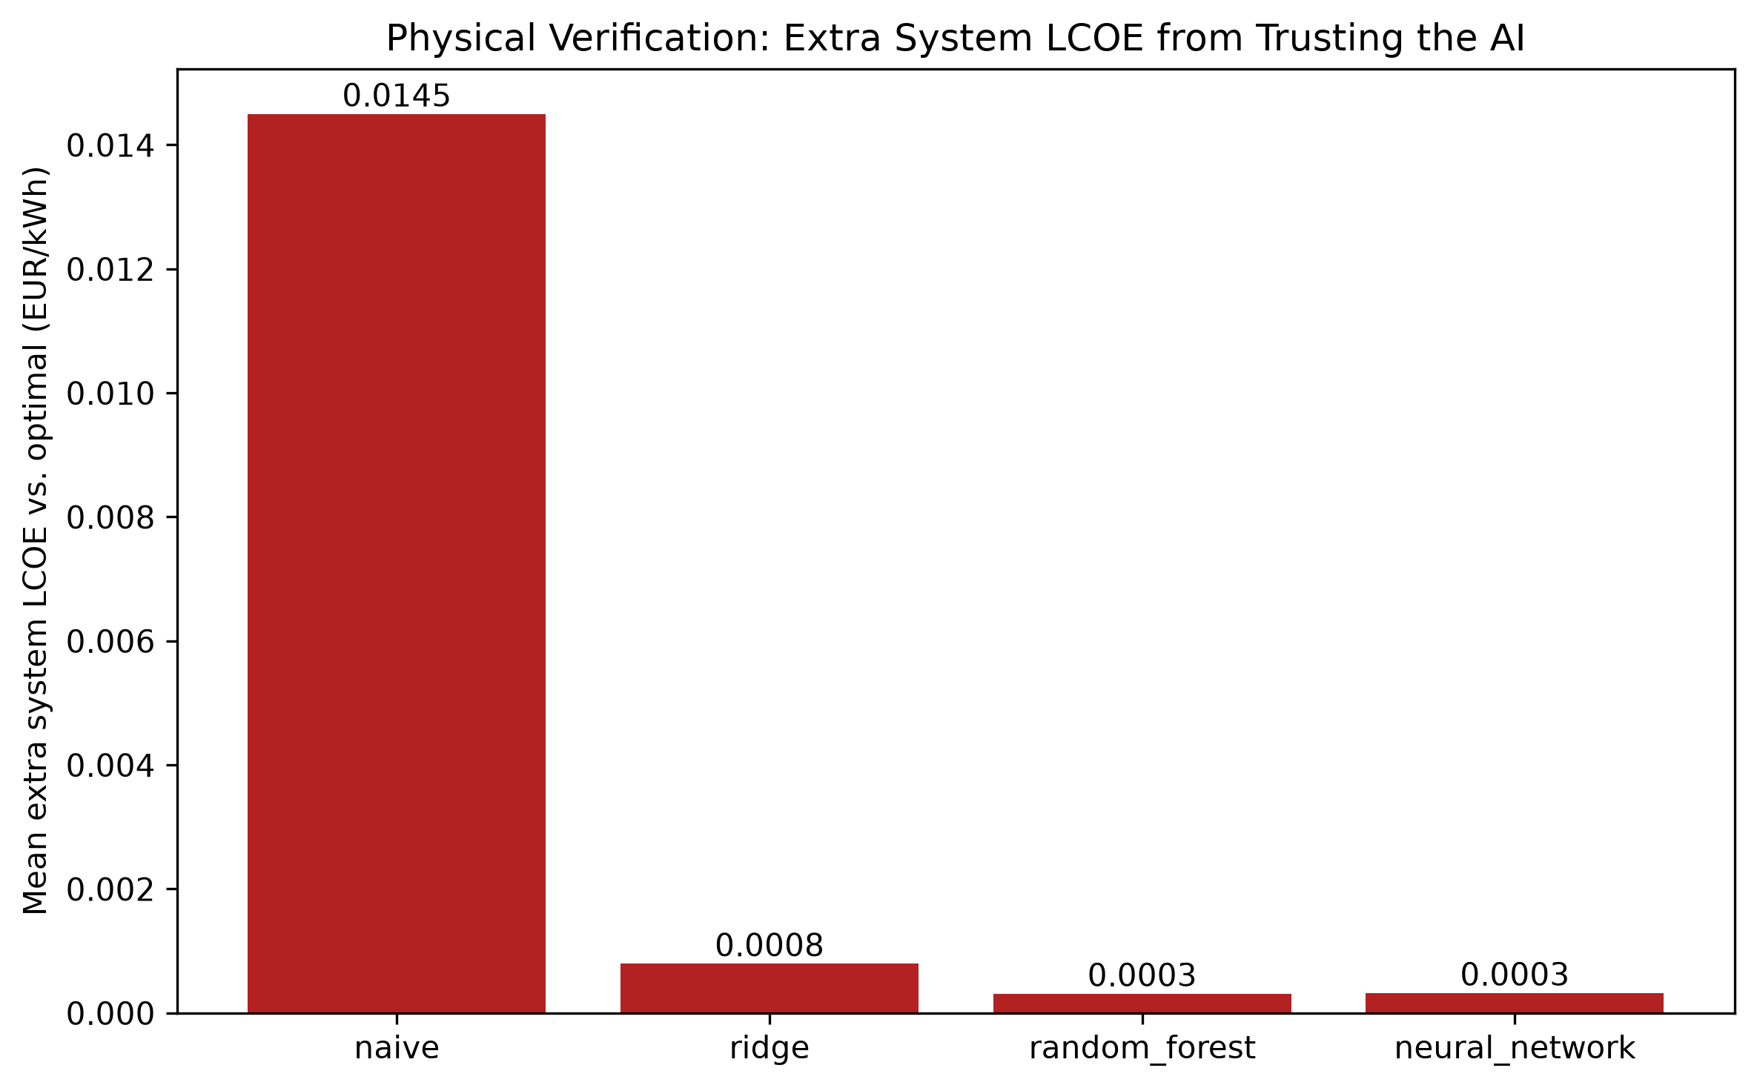 Figure 29 (full-scale) — Mean extra system LCOE by model, clean monotonic ordering matching accuracy: naive 0.0145 > Ridge 0.0008 > Random Forest ≈ neural network ≈ 0.0003 EUR/kWh.
 Figure 22 (full-scale) — Reliability pass rate: 100% for every model at every scale.
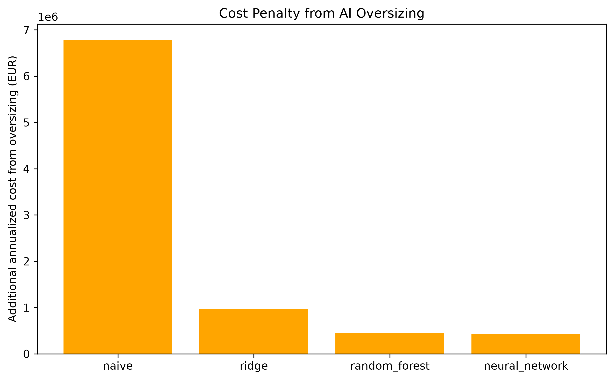 Figure 26 (full-scale) — Additional annualized system cost from oversizing, by model, full scale.
Full per-scenario tables: outputs/tables/physical_verification_{model}_full.csv. Summary: outputs/tables/physical_verification_summary_by_model_full.csv.
A real, small bug was found and fixed while preparing this full-scale rerun. Physical verification originally sized diesel from each scenario’s requested peak load (scenario["peak_load_kw"]) rather than the regenerated load profile’s achieved peak (load.max()), diverging from run_battery_search’s own convention (§8) by a tiny floating-point rescaling. Because both the AI and reference candidates in one verification call share a single diesel spec, this let a handful of predictions look marginally cheaper than the true optimum (small negative extra_system_lcoe_eur_per_kwh values, which should never occur since the reference is the argmin over an exhaustive grid). Fixed to match run_battery_search’s convention exactly, with a regression test that sweeps a real search’s full candidate range and asserts no prediction ever looks cheaper than the true optimum (tests/test_ai_verification.py::test_verify_predictions_extra_lcoe_never_meaningfully_negative_vs_true_optimum). The bug’s effect on the numbers above was small (on the order of 0.0005-0.001 EUR/kWh at full scale) and did not change any model’s ranking, but is reported here in the same spirit as the two bugs found during the pre-diesel industrial pivot’s own full-scale rerun – invisible at small test-set sizes, real correctness issues worth having found regardless of outcome.

17. Accuracy and Computational-Efficiency Comparison

17.1 Pilot (Stage 5/6/7)
Model | MAE (kWh) | R² | Inference time (s/scenario)
Naive | 1,328.1 | -0.042 | 0.000013
Ridge | 233.6 | 0.950 | 0.000064
Random Forest | 227.3 | 0.954 | 0.001333
Neural Network | 2,021.2 | -2.215 | 0.008882
Mechanistic exhaustive search: ~0.291 s/scenario (81-candidate sweep, diesel backup applied, §8), pilot dataset generation (100 scenarios): ~0.7 s total – after the numba dispatch speedup (§9).
Break-even (PROJECT_BRIEF.md §22, denominator per refinement addendum §1.5 – the full exhaustive search per scenario, not a single dispatch run):
Model | Training time (s) | N_break_even (scenarios)
Ridge | 0.022 | ~100
Random Forest | 1.37 | ~105
Neural Network | 6.9 | ~128
Ridge and Random Forest’s break-even points land close to the pilot’s own size (100 scenarios); the neural network’s is somewhat higher (~128), driven by its slower training time relative to Ridge/Random Forest, not by anything about mechanistic search cost. For a one-off ~100-130 scenario evaluation, Ridge/RF and mechanistic search are roughly a wash; the neural network needs meaningfully more reuse to pay off its training cost.
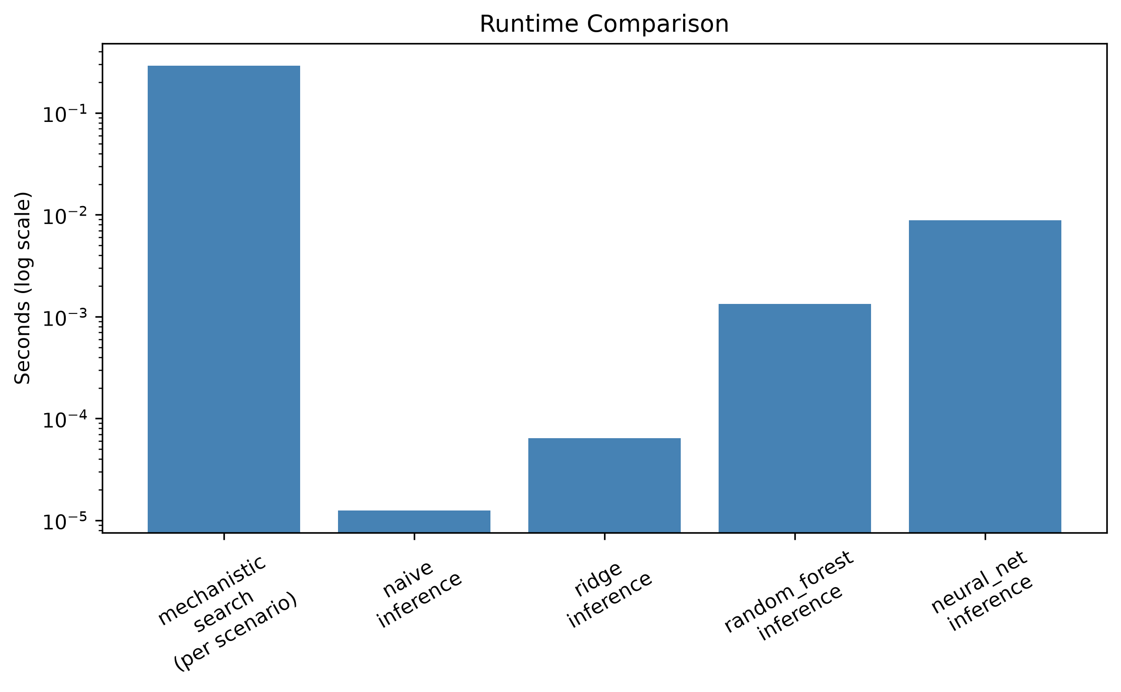 Figure 24 — Runtime comparison across stages, log scale (pilot).
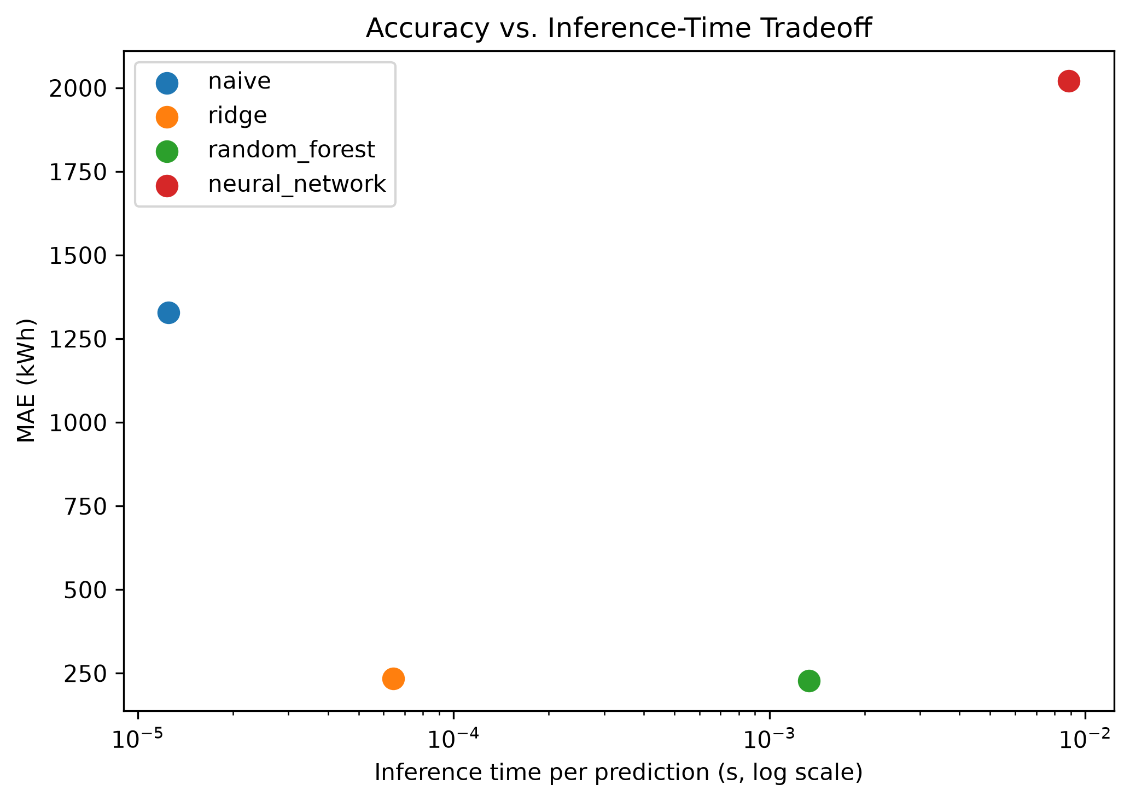 Figure 25 — MAE vs. inference time per model, log-x scale (pilot). No full-scale equivalent was generated; the qualitative ordering of inference speed is unchanged by dataset size.

17.2 Full-scale (Stage 8/9)
Model | MAE (kWh) | R² | Inference time (s/scenario)
Naive | 1,338.9 | -0.054 | negligible (μs-scale)
Ridge | 237.7 | 0.960 | 0.000003
Random Forest | 118.7 | 0.987 | 0.000031
Neural Network | 98.6 | 0.993 | 0.000140
Mechanistic exhaustive search on the full dataset: ~0.093 s/scenario mean (5,000 scenarios; 465.8 s actual wall-clock time with the 4-worker parallel dataset generation, §9).
Break-even, full-scale training costs:
Model | Training time (s) | N_break_even (scenarios)
Ridge | 0.031 | ~5,000
Random Forest | 36.8 | ~5,123
Neural Network | 60.1 | ~5,203
At full scale, every model’s break-even point lands just above the size of the dataset it was trained on (~5,000-5,203 scenarios). This shows N_break_even scales with training-set size, because a larger training set both costs more mechanistic search to generate (the denominator, per refinement addendum §1.5) and takes proportionally longer to train a model on (the numerator). The practical implication: AI amortizes its training cost against however many scenarios were used to generate its own training data – an AI model becomes a clear net efficiency win only once it is subsequently reused for substantially more new-scenario evaluations beyond that original training set, since per-scenario inference cost is several orders of magnitude below the mechanistic search regardless of dataset size. For a single new scenario evaluated once, mechanistic search remains both cheaper and self-verifying by construction – there is no computational efficiency argument for AI at that scale, at either dataset size tested. The numba dispatch speedup (§9) makes mechanistic search itself very cheap per scenario (~0.093-0.291 s), which narrows AI’s absolute time advantage at scale without changing the relative break-even ratio (dataset size needed before AI pays off).

18. Discussion
The research hypothesis (§2) proposed that a neural network “may approximate” mechanistic battery capacities with lower inference time, while noting “mechanistic verification may remain necessary.” Taken together, the pilot and full-scale results tell a two-act story, and the diesel-backed pivot (PROJECT_BRIEF.md Addendum 3) changes what the second act – physical verification – is actually able to say, compared to the pre-diesel design.
Act one (pilot, §15.1/§16.1): at n=16, the neural network had the worst accuracy of the four models (R² -2.22, worse than the naive median baseline) and, per Addendum 3’s reframed verification, the most expensive predictions to trust (mean extra system LCOE 0.0361 EUR/kWh, worse than naive’s 0.0217). Reliability pass rate itself was 100% for every model, including the neural network – diesel makes that near-universal by construction (§8), so unlike either the pre-diesel industrial build or the original residential build, reliability pass rate carries no information here at all. The economic verification metric is what surfaces the same finding accuracy already showed: 70 training rows was not enough data for this 15,233-parameter architecture to learn a usable model, full stop.
Act two (full-scale, §15.2/§16.2): at n=751, the neural network becomes the most accurate model (R² 0.993) and statistically ties Random Forest for cheapest to trust (0.0003 EUR/kWh extra, both effectively free relative to the true optimum) – a complete reversal from the pilot on both axes. This is the statistically stronger result and the one that should carry more weight in answering the research questions (§20), but it does not retroactively make the pilot’s report wrong. It confirms that model quality, not measurement noise, was the pilot’s binding constraint: the same architecture and hyperparameters, given 3,500 training rows instead of 70, produce the best-performing model of the four by a wide margin on both accuracy and economic cost. This is precisely the kind of result the addendum’s “test the hypothesis, don’t assume the NN wins” instruction is designed to surface – had Stage 8/9 not been attempted, the pilot’s negative finding would have stood as the project’s headline result, understating what this architecture can actually do once given enough data.
What the diesel pivot changes about this story, methodologically: under the pre-diesel design, physical verification could catch a real accuracy/reliability disconnect – a model that looked accurate but was secretly unreliable, or vice versa – because reliability pass rate was an independent signal from accuracy. Under Addendum 3, reliability pass rate is no longer independent of anything; it is 100% by construction almost everywhere in this report’s own default configuration, since diesel guarantees it. What replaces that independent check is extra system LCOE, which in this project’s results tracks the accuracy ranking closely at both scales (Pearson correlation is not computed here, but the orderings are identical: naive worst, Ridge/RF close, NN swings from worst to tied-best). That the two metrics agree this closely is itself informative – it suggests the LCOE curve’s shallow-U shape near its minimum (§14) means most capacity prediction errors of the size these models make land in a low-cost region of the curve, so accuracy and economic cost are not fighting each other the way accuracy and hard reliability sometimes did under the pre-diesel design. A model that is accurate on optimal_capacity_kwh in this system is, in practice, also cheap to trust economically – but this is an empirical observation about this LCOE curve’s shape, not a guarantee that would hold for a steeper cost curve or a system without diesel’s smoothing effect on reliability risk.
What is robust across both scales is that oversizing and undersizing rates both stay meaningfully non-trivial for every model even as accuracy improves (§16.2) – accuracy improving does not eliminate prediction error, it shrinks its magnitude, which under this project’s LCOE-cost framing is what ultimately matters (a small error near the LCOE minimum costs little regardless of its sign). The pilot’s 62.5%/62.5%/50.0%/25.0% oversizing rates (naive/Ridge/RF/NN) and the full-scale’s roughly-50%-across-the-board rates show oversizing remaining the more common error direction throughout, even as its economic consequence (additional cost from oversizing) falls by more than an order of magnitude for the two best models between pilot and full scale (Ridge: EUR 36,266/yr → EUR 967,150/yr summed across a 47x larger test set; Random Forest: EUR 26,350/yr → EUR 459,996/yr) – the per-scenario economic penalty shrinks even as the summed total grows with test-set size.

19. Limitations
- Single location, single weather year. Jinan 2023 only, at both pilot and full scale – Experiment B (unseen weather year) and Experiment C (Västerås geographic transfer) are stretch goals not attempted (refinement addendum §1.1). No claim here generalizes to other climates or years.
- Sample-size sensitivity is now a demonstrated finding, not just a caveat. The extra-system-LCOE ranking reported in §16.1 (n=16) and §16.2 (n=751) reversed completely between pilot and full scale (§18): the neural network went from worst (0.0361 EUR/kWh extra, worse than naive) to statistically tied for best (0.0003 EUR/kWh, tied with Random Forest). The full 5,000-scenario dataset (100% feasible, 751-scenario test split) substantially reduces sampling uncertainty relative to the pilot, but every number in this report is still a point estimate from one split of one dataset, not a guarantee against further movement at even larger scale.
- The mechanistic model is the reference, not physical ground truth (PROJECT_BRIEF.md §1). Reliability and system LCOE throughout this report mean agreement with the mechanistic dispatch simulation plus diesel model (§8) under their own modelling assumptions (generic turbine curve, NOCT-based PV temperature model, reanalysis-derived weather, HOMER’s standard linear diesel fuel curve) – not validation against a real operating hybrid system, since no measured operational data exist for this project. This holds at both pilot and full scale: a larger sample makes the AI-vs-mechanistic agreement more statistically reliable, but does not change what that agreement is evidence of.
- Diesel sizing factor and fuel/cost parameters are fixed modelling assumptions, not optimized or swept (PROJECT_BRIEF.md Addendum 3). The diesel sizing factor (1.25x peak load, matching the OptiCE course lecture’s own convention exactly, §2), fuel price (~0.90 EUR/L), and installed cost (~650 EUR/kW) are held constant across every scenario and every candidate in every search – none are decision variables the way battery capacity is, and no sensitivity sweep across them was attempted. A lower fuel price or a smaller sizing factor would shift the system-LCOE-optimal battery capacity (and therefore every downstream ML target and result in this report) in ways this project does not quantify. The diesel generator is also assumed perfectly available (no maintenance downtime, no efficiency degradation over its economic lifetime, no minimum-load or ramp-rate constraint beyond its rated power cap).
- Fixed battery search range (0-80 modules, 250 kWh each). Kept at this value per the same reasoning applied throughout this project (a search range is a modelling decision made once, not re-litigated per scenario); an extended 0-200-module diagnostic search confirmed the baseline case’s optimum sits well within this range (§14), but that check was not repeated for every one of the 5,000 sampled scenarios individually.
- Generic component models. The wind turbine power curve and the PV NOCT/temperature-coefficient assumptions are documented modelling assumptions (src/physics/wind_model.py, src/physics/pv_model.py docstrings), not manufacturer-certified curves for a specific product.
- No wind-speed cooling term in the PV cell-temperature model, and no battery thermal/temperature-dependent-capacity model. Identified by direct comparison against OptiCE (§2): OptiCE’s PV temperature model includes a wind-speed-dependent cooling term, and OptiCE’s battery model corrects usable capacity downward for battery temperatures below 25°C via a fitted quadratic factor. This project’s PV model uses a fixed-coefficient NOCT temperature model without a wind term, and its battery model has no thermal state at all – usable capacity is constant regardless of ambient conditions. Both are standard simplifications for an LPSP-focused sizing study (rather than a detailed thermal-management study) but would bias results toward underestimating required battery capacity in climates with temperature extremes, since the mechanistic reference itself never derates capacity for temperature.
- PV and wind capacity are scenario inputs, not jointly optimized decision variables. OptiCE (§2) optimizes PV tilt/azimuth/capacity, wind tower height/capacity, and battery capacity jointly via a multi-objective genetic algorithm to find a single best design. This project instead samples PV and wind capacity across a range (§9) and only exhaustively searches battery capacity for each sampled combination – a deliberate choice, since the research question here is about predicting the battery-sizing outcome across many different fixed systems, not about finding the single cost-optimal system. A consequence is that this project makes no claim about whether any of its sampled PV/wind combinations are themselves economically optimal.
- One training run per model, at both scales. No repeated-seed variance analysis; the reported neural-network results are from single training runs, not averages over multiple seeds. This is a distinct source of uncertainty from the sample-size effect discussed above – even the full-scale ranking could in principle shift under a different training seed, though the much larger test set makes this less likely to matter than it would at pilot scale.
- The industrial load-profile shape is a documented modelling assumption, not derived from a real facility’s metered data (src/physics/ load_profile.py’s industrial_baseline family, PROJECT_BRIEF.md Addendum 2): two-shift operation, a 45% weekend reduction, and a weak seasonal swing. A continuous-process facility (steel, chemicals) or a strictly weekdays-only operation would have a materially different shape, and every downstream number in this report – from Stage 3’s baseline feasibility finding through the full 5,000-scenario dataset – is conditional on this specific shape choice.
- No cost-sensitivity analysis across battery, diesel, PV, or wind price assumptions. The full sensitivity sweep across cost assumptions (PROJECT_BRIEF.md stretch goal) was not attempted for any of the four now-costed technologies (§8); all costs use the single fixed values in config/jinan.yaml, and every system-LCOE number in this report is conditional on those specific figures.

20. Conclusions
This report covers the diesel-backed, system-LCOE-optimized deployment context (PROJECT_BRIEF.md Addendum 3), adopted after the industrial-scale, hard-reliability-constrained build (Addendum 2) was already complete, tested, and reported – itself adopted in place of the originally residential-scale build. The pivot’s reasoning: the original off-grid design treated reliability as a hard constraint, excluding 58-61% of sampled scenarios from the ML training population entirely; adding a diesel generator sized on power (not energy) removes that constraint by mathematical construction and reframes the question as the project’s own stated goal – “optimize the battery capacity suitable for the system design, economically feasible” – matching the course lecture’s OptiCE dual-objective framing (§2, §8). Answering the five research questions (§1) directly, weighting the full-scale (Stage 8/9) result more heavily than the pilot’s per §18, while keeping both:
- Accuracy: Yes, and dramatically more confidently than the pilot alone suggested – in fact the pilot alone suggested the opposite. At full scale, the neural network most accurately reproduced mechanistic system-LCOE-optimal battery capacities (MAE 98.6 kWh, R² 0.993 vs. Random Forest’s 118.7 kWh / 0.987), a result now backed by a 751-scenario test set rather than 16, where the same architecture had been the worst-performing model (R² -2.22).
- Speed: AI inference is several orders of magnitude faster per scenario than the mechanistic search at both scales tested, though the numba dispatch speedup (§9) makes mechanistic search itself already fast (~0.09-0.29 s/scenario) without changing where the break-even point falls in relative terms. Break-even analysis (§17) shows this pays off in aggregate once a model is reused for meaningfully more evaluations than the size of the dataset it was trained on (~100-128 for the pilot-trained models, ~5,000-5,203 for the full-dataset-trained models) – it is not a blanket efficiency win for one-off evaluations at either scale.
- Reliability, and the economic cost of trusting the AI when verified: Reliability itself is 100% for every model at both scales, by diesel’s construction (§8) – it is no longer the question that discriminates between models the way it did under the pre-diesel design. The question this project’s own goal actually asks – how much extra it costs to trust a given model’s prediction – is decisively no (too expensive) at pilot scale and decisively yes (statistically free) at full scale, and the gap between the two is the project’s clearest finding at this deployment scale. The pilot’s neural network failed both the accuracy test and the mandatory physical-verification check (0.0361 EUR/kWh extra system LCOE, worse than even the naive baseline’s 0.0217); at full scale, extra system LCOE tracked accuracy exactly (naive 0.0145 > Ridge 0.0008 > Random Forest ≈ neural network ≈ 0.0003 EUR/kWh). A small, honestly-reported negative result was directly retested at 47x the sample size, resolved in the opposite direction, and the mandatory physical-verification step (§16) confirmed the full-scale result on a fresh mechanistic-plus-diesel re-run rather than on stored summary statistics. Even at full scale, the best models’ predictions are not perfect (3.3-5.3% still undersize the battery) – “cheap to trust” is a large improvement over the pilot, not a claim that every prediction is exactly correct.
- Generalization to unseen conditions: Not tested (single location/year at both pilot and full scale; §19). This remains the most significant unaddressed research question, and applies identically across every deployment-context pivot this project has made.
- Practical trade-offs: Mechanistic search is slow but self-verifying by construction; AI is fast and, at sufficient training-set scale, accurate and economically trustworthy by the mechanistic model’s own standard – but only once verified against it (Stage 7/9), and only for the single location/year, single load-profile shape, and single set of diesel/PV/ wind cost assumptions this project actually tested. Oversizing and undersizing both remain non-trivial error modes for every model even at full scale (§16.2, §18), but under the diesel-backed system-LCOE framing the consequence of those errors is now measured in real, continuous EUR/kWh terms rather than a binary pass/fail – and by that measure, the best models’ errors are economically small even though they are not zero.
On the research hypothesis: more clearly supported at full scale than the pilot alone suggested – and the pilot alone would have actively pointed the wrong direction on both halves of the hypothesis. The “approximation with lower inference time” half is now well-supported (§15.2); the “mechanistic verification may remain necessary” half is concretely demonstrated by the fact that verification is what confirmed the full-scale result actually holds up under a fresh mechanistic-plus-diesel re-run, and by the fact that verification itself only remains informative because it was reframed (Addendum 3) around a continuous economic measure once diesel made the old binary reliability check trivially true. Reporting both the pilot’s negative result and the full-scale reversal, rather than only the final favourable numbers, is the intended outcome of the project’s honesty requirements – an NN that “wins” only because a bad small-sample result was quietly dropped would be a materially weaker piece of evidence than the same NN “winning” after that result was reported, explicitly retested, and explained. The larger methodological lesson this diesel pivot adds to the project’s earlier findings: when a project’s own reframing removes the discriminating power of its original mandatory-verification metric, the honest response is to find a new metric that still discriminates (extra system LCOE), not to keep reporting a metric that has become uninformative – reliability pass rate would have shown 100%/100%/100%/100% at both scales here and told the reader nothing about which model was actually better to trust, which is exactly the gap this report’s physical-verification reframing (§16) was written to close.

