Proposal : Filament Combiner

The FabLab has a lot of 3D printers, However not a single one is able to print in multiple colors. This is a limitation I would like to try and overcome. The project I propose in this document has the ability to make all our printers able to print in multiple colors, theoretically as many colors as you want.
The thought process is to make a custom spool of filament with multiple colors in it and feed that into the printer.

Idea:
The idea is to make a device that will stitch together different color filaments of plastic into 1 spool. The amount of plastic stitched will be determined by software that will also be made in house.
There is already a device that sort of does this, however, I plan on making this for much less than the cost of the device, and there will be features that are more relevant to the FabLab.

Proposed Design:
This is a diagram depicting the big picture:
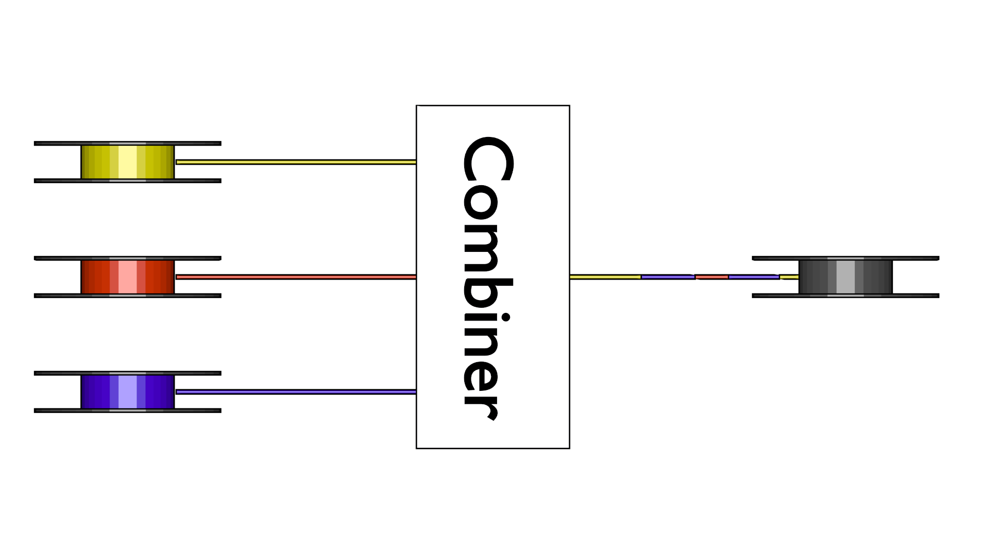
This is a picture of the planned layout of the combiner:
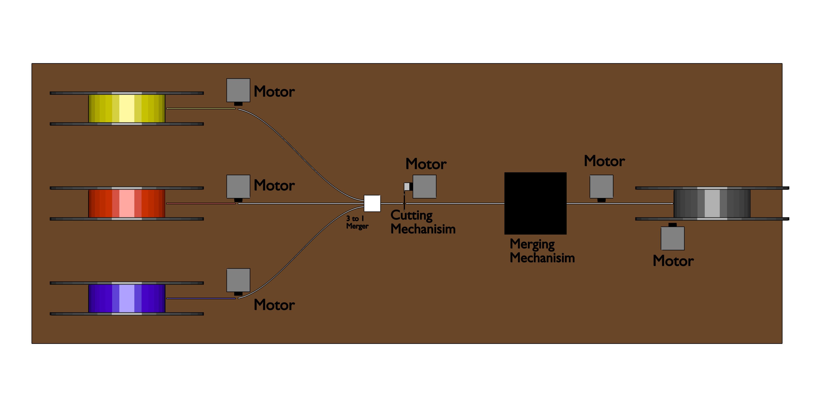
As you can see, there is a significant amount of motors in this design. After thinking it through, my opinion was that this amount of motors allows for a lot of control over the filament in the various points of the process.
There is also a big black block. This represents the filament merger. I am still experimenting with a good way to merge the filament. As of today, I tested out some heating elements and they seem promising. Todays design works but unreliably. I will work on getting the combining more reliable for the end product.

Requirements For The Project:
I was hoping the FabLab would want to aid me in the building of this device and writing of the software. The things I would hope the FabLab can help with are the following:

- Ability to 3D print parts for the machine at the expense of the lab
- Reimbursement for cost of parts.
- Get some help from the technicians with the milling of some metal parts. As this would be needed for the filament merging part.

The estimated costs are:
Stepper motors x 7 ( or 8) = $91
Stepper Drivers x 7 = $20
Rasberry Pi = $35
Heating element x 2 = $3
Filament Extruder x 3 = $45
Heat Proof 2mm Tube = $8

Total = $202

While this may seem like a lot of money for a simple design, The current device that does something similar cost $999 and is limited to 1 printer. However the proposed device will not only costs much less, but also be able to be used with all our printers.
This device can cause a significant change in the ability of our printers as we will be able to print with many different colors.

