View available

| **Requirement ID** | REQ_F0001 | **Version** | 1.0 |
| --- | --- | --- | --- |
| **Description** | When user clicks on the button, the system shall display the relevant event’s details | | |
| **Author** | Lim Ai Nee | | |

| **Feature** | F00 View Available Events | **Version** | 1.0 |
| --- | --- | --- | --- |
| **Purpose** | To allow user have a quick glance and check out for upcoming and happening events | | |
| **Actor** | Student | | |
| **Precondition** | An event is create in the system | | |
| **Postcondition** | The details of selected event will be displayed | | |
| **Main flow** | 1. The System display a list of events 2. The Student scrolls to view multiple events | | |
| **Alternative scenario** | None | | |
| **Author** | Lim Ai Nee | | |

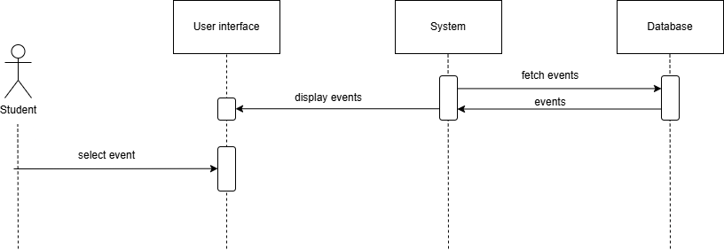

View event details

| **Requirement ID** | REQ_F1001 | **Version** | 1.0 |
| --- | --- | --- | --- |
| **Description** | The system display an image such as flyer, poster, and logo of the event that is upload by the event organizer | | |
| **Author** | Lim Ai Nee | | |

| **Requirement ID** | REQ_F1002 | **Version** | 1.0 |
| --- | --- | --- | --- |
| **Description** | The system display the event title that is filled by the event organizer | | |
| **Author** | Lim Ai Nee | | |

| **Requirement ID** | REQ_F1003 | **Version** | 1.0 |
| --- | --- | --- | --- |
| **Description** | The system display the event starting date and time and ending date and time that is filled by the event organizer | | |
| **Author** | Lim Ai Nee | | |

| **Requirement ID** | REQ_F1004 | **Version** | 1.0 |
| --- | --- | --- | --- |
| **Description** | The system display the event location and address(if it is provided) that is filled by the event organizer | | |
| **Author** | Lim Ai Nee | | |

| **Requirement ID** | REQ_F1005 | **Version** | 1.0 |
| --- | --- | --- | --- |
| **Description** | The system display the event location and address(if it is provided) that is filled by the event organizer | | |
| **Author** | Lim Ai Nee | | |

| **Requirement ID** | REQ_F1005 | **Version** | 1.0 |
| --- | --- | --- | --- |
| **Description** | The system display the event capacity for participants that is filled by the event organizer | | |
| **Author** | Lim Ai Nee | | |

| **Requirement ID** | REQ_F1006 | **Version** | 1.0 |
| --- | --- | --- | --- |
| **Description** | The system display the event ticket price that is filled by the event organizer | | |
| **Author** | Lim Ai Nee | | |

| **Requirement ID** | REQ_F1007 | **Version** | 1.0 |
| --- | --- | --- | --- |
| **Description** | The system display the event additional information such as attire, restricted items and others that is filled by the event organizer | | |
| **Author** | Lim Ai Nee | | |

| **Requirement ID** | REQ_F1008 | **Version** | 1.0 |
| --- | --- | --- | --- |
| **Description** | When user clicks on the button, the system shall display the register event page that requires user to filled up all the field | | |
| **Author** | Lim Ai Nee | | |

| **Requirement ID** | REQ_F1009 | **Version** | 1.0 |
| --- | --- | --- | --- |
| **Description** | When user clicks on the button, the system shall display the the view event page | | |
| **Author** | Lim Ai Nee | | |

| **Feature** | F01 View Event Details | **Version** | 1.0 |
| --- | --- | --- | --- |
| **Purpose** | To allow user view the event details like location, time, ticket price and others and to let the user to decide register for the event | | |
| **Actor** | Student | | |
| **Precondition** | An event is selected | | |
| **Postcondition** | User will need to provide necessary information to register for participating in the event | | |
| **Main flow** | 1. The Student had select an event to view its details 2. The System will display relevant event details 3. The Student can choose to click on the “Register” button to register for the event | | |
| **Alternative scenario** | 1. If the Student does not want to register for the event, they can choose to click on the “<” button to redirect to the view available event page | | |
| **Author** | Lim Ai Nee | | |

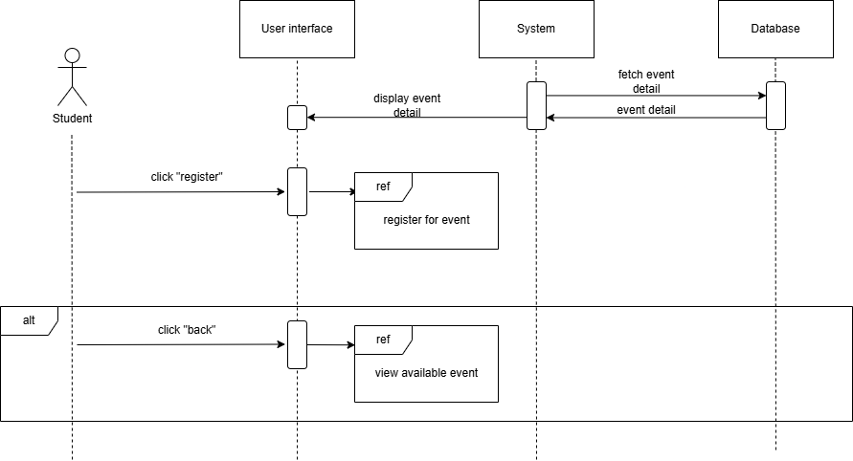

Register for event

| **Requirement ID** | REQ_F2001 | **Version** | 1.0 |
| --- | --- | --- | --- |
| **Description** | The system shall retrieve from the user account to get their name and display on this field and it is editable | | |
| **Author** | Lim Ai Nee | | |

| **Requirement ID** | REQ_F2002 | **Version** | 1.0 |
| --- | --- | --- | --- |
| **Description** | The system shall retrieve from the user account to get their student ID and display on this field and it is editable | | |
| **Author** | Lim Ai Nee | | |

| **Requirement ID** | REQ_F2003 | **Version** | 1.0 |
| --- | --- | --- | --- |
| **Description** | The system shall display this field with the text of “Mobile Number” and shall let user to enter their mobile number | | |
| **Author** | Lim Ai Nee | | |

| **Requirement ID** | REQ_F2004 | **Version** | 1.0 |
| --- | --- | --- | --- |
| **Description** | The system shall display this field with the text of “Email” and shall let user to enter their email | | |
| **Author** | Lim Ai Nee | | |

| **Requirement ID** | REQ_F2005 | **Version** | 1.0 |
| --- | --- | --- | --- |
| **Description** | The system shall direct user to the page to make payment and save the datas into a temporary database | | |
| **Author** | Lim Ai Nee | | |

| **Requirement ID** | REQ_F2006 | **Version** | 1.0 |
| --- | --- | --- | --- |
| **Description** | When user clicks on the button, the system shall display the the view event detail page | | |
| **Author** | Lim Ai Nee | | |

| **Feature** | F02 Register for Event | **Version** | 1.0 |
| --- | --- | --- | --- |
| **Purpose** | Let the user register and book a slot for the event they wanted to participate in | | |
| **Actor** | Student | | |
| **Precondition** | The “Register” button is clicked by the user | | |
| **Postcondition** | The user shall proceed to make payment for the event ticket after clicked on the button of “Pay for Ticket” | | |
| **Main flow** | 1. The Student had click on “Register” button 2. The System shall display text fields for Student to filled up necessary information 3. The Student can choose to click on the “Pay for Ticket” button to proceed make payment for the ticket | | |
| **Alternative scenario** | 1. If the Student decide not to pay for the event, they can choose to click on the “<” button to redirect to the view event details page | | |
| **Author** | Lim Ai Nee | | |

