

CSE6224-SOFTWARE REQUIREMENTS ENG Project 2 (50%)
Title: Campus Event Check-in System
Prepared By:
ID | Name | Contribution
1211305566 | Alkatheri, Suliman Ali Mahdi | 25%
1221101391 | LIM AI NEE | 25%
1221100800 | MUHAMMAD AZHAR BIN AHMAD ROSEHAIZAT | 25%
1211103488 | YOUSEF ELSAYED EZZAT ELSAYED | 25%

Group: 1
Supervision By:
Dr. Zarina Binti Che Embi (zarina.embi@mmu.edu.my)
Table of Contents
List of Figures 4
List of Tables 5
1. Introduction 10
1.1 Purpose 10
1.2 Scope 10
1.3 Product Overview 10
1.3.1 Product Perspective 10
1.3.2 Product Functions 17
1.3.3 User Characteristics 18
1.3.4 Limitations 19
1.4 Definitions 19
2. References 21
3. Requirements 22
3.1 External Interfaces 22
3.1.1 Login 22
3.1.2 Event Registration 23
3.1.3 Event Check-in 24
3.1.4 Make Payment 26
3.1.5 Manage Events 27
3.1.6 Manage Attendance 29
3.1.7 Manage Payment 31
3.1.8 View Sales Report 32
3.1.9 Generate Event Report 33
3.1.10 Add Vendor Account 34
3.2 Functions 35
3.2.1 Functional Requirements 35
3.3 Performance Requirements 56
3.4 Usability Requirements 56
3.5 Logical Database Requirements 57
3.6 Design Constraints 57
3.7 Software System Attributes 58
3.8 Supporting Information 59
3.8.1 Validation Activities 59
3.8.2 Traceability Matrix 65
4. VERIFICATION 66
4.1 Verification Approach 66
4.2 Verification Criteria 66
5. APPENDICES 68
5.1 Assumptions and Dependencies 68
5.2 Acronyms and Abbreviations 68

List of Figures
Figure 1. 1 System Context Diagram 11
Figure 3. 1 Use Case Diagram – Campus Event Check-In System 36
Figure 3. 2 F001 Login Sequence Diagram 38
Figure 3. 3 F002 Event Registration Sequence Diagram 40
Figure 3. 4 F003 Event Check-in Sequence Diagram 42
Figure 3. 5 F004 Make Payment Sequence Diagram 43
Figure 3. 6 F005 Manage Events Sequence Diagram 46
Figure 3. 7 F006 Manage Attendance Sequence Diagram 48
Figure 3. 8 F007 Manage Payment Sequence Diagram 50
Figure 3. 9 F008 View Sales Report Sequence Diagram 52
Figure 3. 10 F009 Generate Event Report Sequence Diagram 53
Figure 3. 11 F010 Add Vendor Account Sequence Diagram 55

List of Tables
Table 1. 1 System Goals Table 12
Table 1. 2 System Interface Requirements 13
Table 1. 3 User Interface Requirements 14
Table 1. 4 Hardware Interface Requirements 15
Table 1. 5 Software Interface Requirements 16
Table 1. 6 Communication Interface Requirements 17
Table 1. 7 Product Functions Table 18
Table 1. 8 User Characteristics Table 18
Table 1. 9 Definition of Terms Table 19
Table 3.1. 1 REQ_IO0001 Table 22
Table 3.1. 2 REQ_IO0002 Table 22
Table 3.1. 3 REQ_IO0003 Table 22
Table 3.1. 4 REQ_IO0004 Table 23
Table 3.1. 5 REQ_IO0005 Table 23
Table 3.1. 6 REQ_IO0006 Table 23
Table 3.1. 7 REQ_IO0007 Table 23
Table 3.1. 8 REQ_IO0008 Table 24
Table 3.1. 9 REQ_IO0009 Table 24
Table 3.1. 10 REQ_IO0010 Table 24
Table 3.1. 11 REQ_IO0011 Table 25
Table 3.1. 12 REQ_IO0012 Table 25
Table 3.1. 13 REQ_IO0013 Table 25
Table 3.1. 14 REQ_IO0014 Table 25
Table 3.1. 15 REQ_IO0015 Table 26
Table 3.1. 16 REQ_IO0016 Table 26
Table 3.1. 17 REQ_IO0017 Table 26
Table 3.1. 18 REQ_IO0018 Table 26
Table 3.1. 19 REQ_IO0019 Table 27
Table 3.1. 20 REQ_IO0020 Table 27
Table 3.1. 21 REQ_IO0021 Table 27
Table 3.1. 22 REQ_IO0022 Table 27
Table 3.1. 23 REQ_IO0023 Table 28
Table 3.1. 24 REQ_IO0024 Table 28
Table 3.1. 25 REQ_IO0025 Table 28
Table 3.1. 26 REQ_IO0026 Table 28
Table 3.1. 27 REQ_IO0027 Table 29
Table 3.1. 28 REQ_IO0028 Table 29
Table 3.1. 29 REQ_IO0029 Table 29
Table 3.1. 30 REQ_IO0030 Table 29
Table 3.1. 31 REQ_IO0031 Table 30
Table 3.1. 32 REQ_IO0032 Table 30
Table 3.1. 33 REQ_IO0033 Table 30
Table 3.1. 34 REQ_IO0034 Table 30
Table 3.1. 35 REQ_IO0035 Table 31
Table 3.1. 36 REQ_IO0036 Table 31
Table 3.1. 37 REQ_IO0037 Table 31
Table 3.1. 38 REQ_IO0038 Table 31
Table 3.1. 39 REQ_IO0039 Table 32
Table 3.1. 40 REQ_IO0040 Table 32
Table 3.1. 41 REQ_IO0041 Table 32
Table 3.1. 42 REQ_IO0042 Table 32
Table 3.1. 43 REQ_IO0043 Table 33
Table 3.1. 44 REQ_IO0044 Table 33
Table 3.1. 45 REQ_IO0045 Table 33
Table 3.1. 46 REQ_IO0046 Table 34
Table 3.1. 47 REQ_IO0047 Table 34
Table 3.1. 48 REQ_IO0048 Table 34
Table 3.1. 49 REQ_IO0049 Table 34
Table 3.1. 50 REQ_IO0050 Table 35
Table 3.1. 51 REQ_IO0051 Table 35
Table 3.2. 1 FR0101 Table 36
Table 3.2. 2 FR0102 Table 37
Table 3.2. 3 FR0103 Table 37
Table 3.2. 4 FR0104 Table 37
Table 3.2. 5 F001 Login Use Case Specification Table 37
Table 3.2. 6 FR0201 Table 38
Table 3.2. 7 FR0202 Table 38
Table 3.2. 8 FR0203 Table 39
Table 3.2. 9 FR0204 Table 39
Table 3.2. 10 FR0205 Table 39
Table 3.2. 11 F002 – Event Registration Use Case Specification Table 39
Table 3.2. 12 FR0301 Table 40
Table 3.2. 13 FR0302 Table 40
Table 3.2. 14 FR0303 Table 41
Table 3.2. 15 FR0304 Table 41
Table 3.2. 16 F003 Event Check-In Use Case Specification Table 41
Table 3.2. 17 FR0401 Table 42
Table 3.2. 18 FR0402 Table 42
Table 3.2. 19 FR0403 Table 42
Table 3.2. 20 FR0404 Table 43
Table 3.2. 21 F004 Make Payment Use Case Specification Table 43
Table 3.2. 22 FR0501 Table 44
Table 3.2. 23 FR0502 Table 44
Table 3.2. 24 FR0503 Table 44
Table 3.2. 25 FR0504 Table 44
Table 3.2. 26 FR0505 Table 44
Table 3.2. 27 FR0506 Table 44
Table 3.2. 28 F005 Manage Events Use Case Specification Table 45
Table 3.2. 29 FR0601 Table 47
Table 3.2. 30 FR0602 Table 47
Table 3.2. 31 FR0603 Table 47
Table 3.2. 32 FR0604 Table 47
Table 3.2. 33 F006 Manage Attendance Use Case Specification Table 47
Table 3.2. 34 FR0701 Table 48
Table 3.2. 35 FR0702 Table 48
Table 3.2. 36 FR0703 Table 48
Table 3.2. 37 FR0704 Table 49
Table 3.2. 38 FR0705 Table 49
Table 3.2. 39 F007 Vendor Payment Management Use Case Specification Table 49
Table 3.2. 40 FR0801 Table 50
Table 3.2. 41 FR0802 Table 50
Table 3.2. 42 FR0803 Table 50
Table 3.2. 43 FR0804 Table 51
Table 3.2. 44 FR0805 Table 51
Table 3.2. 45 F008 View Sales Report Use Case Specification Table 51
Table 3.2. 46 FR0901 Table 52
Table 3.2. 47 FR0902 Table 52
Table 3.2. 48 FR0903 Table 52
Table 3.2. 49 FR0904 Table 52
Table 3.2. 50 FR0905 Table 53
Table 3.2. 51 F009 Generate Event Report Use Case Specification Table 53
Table 3.2. 52 FR1001 Table 54
Table 3.2. 53 FR1002 Table 54
Table 3.2. 54 FR1003 Table 54
Table 3.2. 55 FR1004 Table 54
Table 3.2. 56 FR1005 Table 54
Table 3.2. 57 F010 Admin Vendor Account Use Case Specification Table 55
Table 3.3. 1 Performance Requirements Table 56
Table 3.4. 1 Usability Requirements Table 57
Table 3.5. 1 Logical Database Requirements Table 57
Table 3.6. 1 Design Constraints Table 58
Table 3.7. 1 Software System Attributes 58
Table 3.8. 1 Supporting Information (SRS1) 59
Table 3.8. 2 Defects Table 62
Table 3.8. 3 Conflicts Table 64
Table 3.8. 4 Traceability Matrix Table 65
Table 4. 1 Verification Criteria 67
Table 5. 1 Acronyms and Abbreviations 68

Introduction

Purpose
The purpose of this project is to develop a digital check-in and payment system for campus events that seamlessly integrates with the university’s student identification database and a secure payment gateway. The system aims to automate event attendance through student ID verification and ticket validation, reducing manual processes and human error. Additionally, it enables secure on-site purchases—such as food, merchandise, and services—and equips event organizers with real-time analytics and reports to improve event management. Ultimately, the system enhances operational efficiency, security, and user experience for both students and staff.

Scope
The system allows students and vendors to check in to events via QR code, providing a streamlined and user-friendly experience. Key features include real-time notifications, integrated payment processing, and an event rating mechanism. The system does not include support for mapping, third-party navigation systems, or outdoor location services.

Product Overview
The digital check-in system is designed to manage campus event attendance and transactions efficiently. It enables students to check in using their university-issued IDs and supports both digital and physical ticket validation. The system interfaces with the university’s student database for real-time identity verification and with payment gateways for secure transactions. Admin users can oversee events, monitor attendance, manage ticketing, and access comprehensive reports. The platform is intended for use by students, vendors, and administrators.

Product Perspective
The Campus Check-in System operates as a centralized event management platform that interacts with multiple user roles and external systems. The system interfaces with:
- Students, who can log in, register for events, view event details, and make payments.
- Vendors, who can log in, accept payments and view sales data.
- Admins, who manage events, monitor attendance, add vendor accounts, and generate reports.
- External systems, including:
  - University student database for verification,
  - Online payment gateways for transaction processing,
This interaction is illustrated in Figure 1. 1, which shows the high-level context of the system and its key data exchanges.
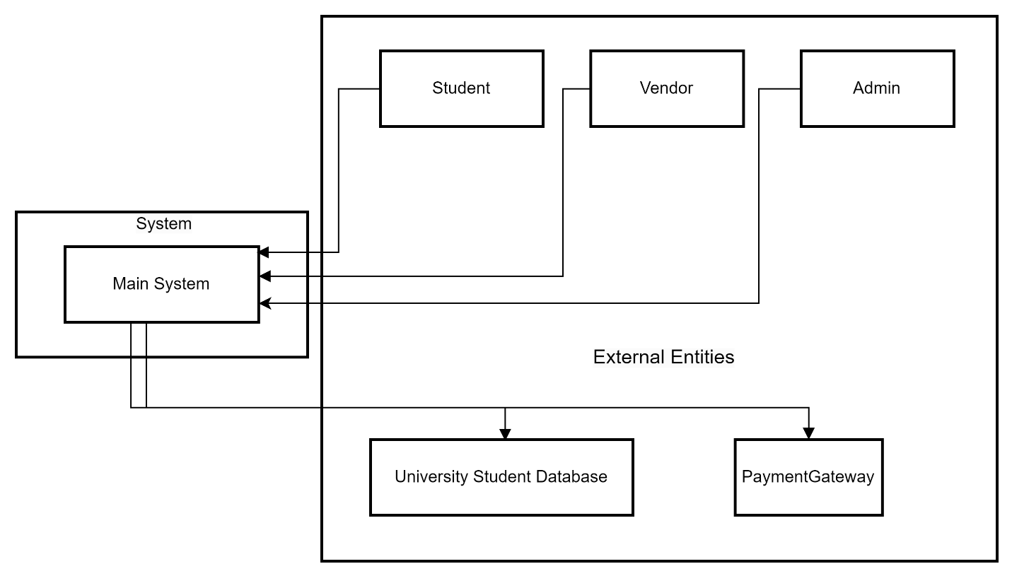
Figure 1. 1 System Context Diagram

System Goals
Table 1. 1 outlines the high-level system goals for the Campus Event Check-in & Payment System. Each goal is stated in measurable terms to guide the development team in meeting performance expectations. These objectives address critical aspects such as check-in efficiency, digital payment enablement, real-time data visibility, data accuracy, system scalability, security compliance, and administrative workload reduction—ensuring the system delivers a seamless and impactful user experience.
Table 1. 1 System Goals Table
Requirement ID | Description | Priority | Author
REQ_GO01 | Reduce average student check-in time to < 5 seconds per attendee, compared with manual paper sign-in. | High | Suliman
REQ_GO02 | Enable 100 % of on-site vendor purchases to be completed digitally (QR / wallet / card) without cash handling. | High | Suliman
REQ_GO03 | Provide organisers a live dashboard showing ≤ 30-second latency from check-in or purchase event to dashboard display. | Medium | Suliman
REQ_GO04 | Achieve ≥ 99.5 % accuracy between recorded check-ins and ticket registrations (mismatches < 0.5 %). | High | Suliman
REQ_GO05 | Support 300 concurrent users and 3 000 total event participants with no perceptible performance degradation. | High | Suliman
REQ_GO06 | Maintain zero known data-breach incidents and comply with university privacy policy plus PCI DSS for all payments. | Medium | Suliman
REQ_GO07 | Cut post-event attendance-report preparation time for admins by ≥ 80 % (from hours to under 10 minutes). | Medium | Suliman

System Interface
This section outlines the system interface requirements that define how the system will interact with external components and services. It specifies the integration points with institutional databases, third-party payment gateways, and backend services. These interfaces ensure secure identity validation, payment processing, data synchronization for admin functionalities, and system activity logging, thereby enabling seamless interaction between different modules and ensuring compliance, security, and real-time performance. Table 1. 2 shows the system interface.
Table 1. 2 System Interface Requirements
Requirement ID | Description | Priority | Author
REQ_SI001 | The system must be linked to the university’s student database via an authenticated API or secure connection to validate student identity in real-time. | High | Suliman
REQ_SI002 | The system will integrate with Stripe, a PCI-compliant digital payment service, to allow vendors to process purchases using debit, credit, or e-wallets. | High | Suliman
REQ_SI003 | Admin interfaces must connect to the centralized backend to retrieve and update data related to events, tickets, and attendance. | Medium | Suliman
REQ_SI004 | All check-ins, purchases, and admin actions will be logged securely. | High | Suliman

User Interface
This section specifies the logical characteristics of each interface between the software product and its end users as shown in Table 1. 3. It describes how the user interface should appear and behave from the perspective of the user. These requirements ensure that the system remains accessible, responsive, and user-friendly across different devices. It emphasizes consistent layout and interaction patterns, provides clear feedback mechanisms, supports multilingual needs, and accommodates accessibility standards for an inclusive user experience.

Table 1. 3 User Interface Requirements
Requirement ID | Description | Priority | Author
REQ_UI001 | The system shall offer a responsive design that adjusts to different screen sizes and devices. | High | Suliman
REQ_UI002 | Interfaces must maintain consistency in layout, colors, icons, and interaction patterns to support usability. | High | Suliman
REQ_UI003 | Navigation must be simple and intuitive, allowing users to complete tasks with minimal steps. | High | Suliman
REQ_UI004 | All forms shall provide real-time validation feedback, including helpful error messages for incorrect input. | Medium | Suliman
REQ_UI005 | Visual feedback (e.g., success, loading, or failure indicators) must be provided for all user actions. | Medium | Suliman
REQ_UI006 | Text fields, buttons, tables, and other components must be clearly labeled and accessible. | High | Suliman
REQ_UI007 | QR code-based interactions (for check-in and vendor payments) must be integrated seamlessly into the mobile interface. | High | Suliman
REQ_UI008 | The UI must be accessible, supporting standard keyboard navigation and readable contrast ratios. | High | Suliman
REQ_UI009 | The system should allow for language localization in future versions to support multilingual users. | Low | Suliman

Hardware Interface
This section describes the physical and technological hardware requirements necessary for the system to operate effectively, as outlined in Table 1. 4. It includes specifications for the types of devices to be used by students, vendors, and administrators, covering essential features such as internet connectivity, camera functionality, QR code scanning, and display resolution. It also outlines the infrastructure needed to support secure communication and reliable server hosting to ensure consistent performance and data protection throughout system operations.

Table 1. 4 Hardware Interface Requirements
Requirement ID | Description | Priority | Author
REQ_HW001 | Student devices must be smartphones (Android/iOS) equipped with cameras to enable QR scanning at event check-in. | High | Suliman
REQ_HW002 | Student devices must be internet-enabled, supporting either Wi-Fi or mobile data connections. | High | Suliman
REQ_HW003 | The app will access the camera for QR scanning functionality on student devices. | High | Suliman
REQ_HW004 | Vendor devices must be smartphones or tablets capable of managing sales and logging payments. | High | Suliman
REQ_HW005 | Vendor devices must have reliable internet connectivity to ensure real-time transaction logging. | High | Suliman
REQ_HW006 | Admins will use laptops or desktops to manage events, generate reports, and control attendance. | High | Suliman
REQ_HW007 | Admin devices must support standard web browsers and secure system access protocols. | High | Suliman
REQ_HW008 | Admins may use tablets or laptops to display QR codes for check-in purposes. | Medium | Suliman
REQ_HW009 | QR code display devices should have high-resolution displays to ensure easy and accurate scanning. | Medium | Suliman
REQ_HW010 | The backend system must be hosted on a university-managed server infrastructure. | High | Suliman
REQ_HW011 | All client-server communications must be secured using HTTPS with TLS encryption. | High | Suliman

Software Interface
This section defines the software-level interactions between the system and external services, as illustrated in Table 1. 5. It outlines how the system will securely connect to university databases and third-party services such as Stripe and the Elastic Stack. These interfaces facilitate operations like login verification, payment processing, real-time QR code generation, and backend activity logging. The requirements ensure secure communication using APIs and encryption, while also supporting data analysis through integrated monitoring tools like Logstash and Kibana.
Table 1. 5 Software Interface Requirements
Requirement ID | Description | Priority | Author
REQ_SW001 | The system shall connect to the university’s student information system via a hosted API to verify credentials during login and check-in. | High | Suliman
REQ_SW002 | The system shall integrate with Stripe as a payment gateway to manage payment sessions, confirm transactions, and verify payment success. | High | Suliman
REQ_SW003 | Communication with Stripe shall occur over HTTPS, with API keys securely stored in the backend system. | High | Suliman
REQ_SW004 | The system shall use the qr_flutter library or an equivalent package to generate dynamic QR codes for each event. | Medium | Suliman
REQ_SW005 | Generated QR codes shall include encrypted event IDs and be displayed in real-time during check-in. | High | Suliman
REQ_SW006 | The system shall utilize the Elastic Stack (Elasticsearch, Logstash, Kibana) for backend logging of check-ins, transactions, and admin activities. | Medium | Suliman
REQ_SW007 | All logs shall be pushed to Logstash and visualized through Kibana dashboards for monitoring and analysis. | Medium | Suliman

Communication Interfaces
This section outlines the protocols and methods used for data exchange between the system and its components, as presented in Table 1. 6. It focuses on ensuring secure and encrypted communication across all channels, including interactions with the university database, payment gateway, internal system modules, and user-facing interfaces. All communications are enforced through HTTPS using TLS encryption to maintain data confidentiality, integrity, and security throughout system operations.
Table 1. 6 Communication Interface Requirements
Requirement ID | Description | Priority | Author
REQ_COM001 | Communication with the student database shall use HTTPS over a REST API to securely validate student records during login and check-in. | High | Suliman
REQ_COM002 | Payment transactions shall be transmitted securely using HTTPS with TLS encryption between student devices and the Stripe system. | High | Suliman
REQ_COM003 | Internal system communications, including QR code generation, event syncing, and logging, shall use HTTPS to ensure secure operations. | High | Suliman
REQ_COM004 | All frontend interfaces for students, vendors, and admins shall communicate with the backend over HTTPS via web-based protocols to ensure secure and encrypted interactions. | High | Suliman

Product Functions
Table 1. 7 provides an overview of the essential functions offered by the system. Each function represents a key capability designed to support core event operations such as student check-in, ticket verification, payment processing, and attendance tracking. The descriptions highlight how these features interact with various components, including the student database and reporting tools, to ensure a secure, efficient, and insightful event experience for students, vendors, and administrators.

Table 1. 7 Product Functions Table
Function | Description
Student Check-in | Allows students to check in to events using their university ID cards or student numbers.
Ticket Verification | Validates tickets during entry to ensure that only authorized participants are admitted.
Payment Processing | Enables secure on-site purchases (e.g., food, merchandise) through integration with payment gateways.
Real-time Attendance Tracking | Records attendance as students check in and provides up-to-date data to the admin interface.
Student Database Integration | Connects to the university’s identification database for real-time verification of student status.
Analytics and Reports | Generates post-event reports including attendance logs, transaction summaries, and ticket scan histories for students and vendors.

User Characteristics
Table 1. 8 outlines the primary user roles that will interact with the system. Each role is accompanied by a brief description of their expected usage and the level of knowledge required to operate the system effectively. This helps ensure the system design supports users with varying technical backgrounds, from students performing simple check-ins to administrators and vendors managing transactions and reports.
Table 1. 8 User Characteristics Table
Role | Description | Required Knowledge
Student | University students using the system to check in and make purchases at events. | Basic familiarity with mobile or web-based applications.
Admin | Staff responsible for managing events, tracking attendance, and accessing reports. | Familiarity with admin dashboards, event management tools, and reporting interfaces.
Vendor | On-site service providers (e.g., food or merchandise vendors) using the system to process transactions and monitor sales. | Basic understanding of digital payment platforms and ability to navigate the vendor interface.

Limitations
- Dependence on Internet Connectivity: The system requires a stable internet connection for real-time check-ins, payment processing, and data synchronization.
- Scalability Constraints: Performance may degrade in large-scale events without proper server infrastructure.
- Lack of Offline Support: Version 1.0 does not support offline operations, including check-in and payment processing.
- User Training Needs: Admins and vendors may require minimal training to operate the system efficiently and avoid errors.
- Device Compatibility: Admins and vendors must use compatible tablets or laptops; inadequate hardware could hinder functionality.

Definitions
This section provides definitions of key terms used throughout the document, as shown in Table 1. 9. These definitions help establish a clear and consistent understanding of core concepts such as integration, analytics, check-in systems, payment gateways, and user roles. Defining these terms ensures that all stakeholders share a common interpretation of system components, features, and interactions.
Table 1. 9 Definition of Terms Table
Term | Definition
Integration | The process of linking the system with external platforms such as databases and payment gateways.
Analytics | Data analysis activities aimed at extracting insights, such as user activity or attendance patterns.
On-site Purchases | Purchases made at the event location (e.g., food, merchandise).
Payment Gateway | A service that securely processes digital payments such as credit/debit card transactions.
Check-in System | A digital tool used to verify participant presence at events.
Ticket Verification | The validation process that determines whether an event ticket is genuine and valid.
End Users | Individuals interacting directly with the system (students, admins, vendors).
Backend | The server-side logic and infrastructure that supports data processing, storage, and core functionality.

References
The 12 Event Check-In Apps Every Planner Should Know About in 2025. (2025, January 24). InEvent. Retrieved May 25, 2025, from
https://inevent.com/blog/events/event-check-in-app.html
Elastic Stack: (ELK) Elasticsearch, Kibana & Logstash. (n.d.). Elastic. Retrieved May 25, 2025,
from https://www.elastic.co/elastic-stack
How to Write an SRS Document (Software Requirements Specification Document). (2023, January 17). Perforce. Retrieved May 25, 2025, from
https://www.perforce.com/blog/alm/how-write-software-requirements-specification-srs-document
ISO/IEC/IEEE 29148 Requirements Specification Templates. (n.d.). ReqView. Retrieved May 25, 2025, from
https://www.reqview.com/doc/iso-iec-ieee-29148-templates/
Jain, S. (2024, June 19). Classification of Software Requirements – Software Engineering. GeeksforGeeks. Retrieved May 25, 2025, from
https://www.geeksforgeeks.org/software-engineering-classification-of-software-requirements/
Jain, S. (2025, March 17). Flutter Tutorial. GeeksforGeeks. Retrieved May 25, 2025, from
https://www.geeksforgeeks.org/flutter-tutorial/
Lemburg, M. (n.d.). sqlite3 — DB-API 2.0 interface for SQLite databases. Python documentation. Retrieved May 25, 2025, from
https://docs.python.org/3/library/sqlite3.html

Requirements

External Interfaces
This section defines the external interface requirements of the Campus Event Check-In System. It describes the user-facing actions, and the corresponding inputs and outputs expected in each interaction. The interface elements are designed to offer a seamless and user-friendly experience, while ensuring secure and efficient communication with external components such as the university’s student database, integrated payment systems, and QR scanning tools. These interfaces serve as the connection point between users and the system’s core functionalities.

Login
Tables Table 3.1.1 – Table 3.1.4 define the interface components used in the login user interface.
Table 3.1. 1 REQ_IO0001 Table
Requirement ID | REQ_IO0001 | Version | 1.0
Item | Login Button (Input)
Item Description | A button labeled “Login”
Item Purpose | Submits login credentials for authentication
Input Format | Button | Valid Input | Not Applicable
Related I/O | REQ_IO0002, REQ_IO0003 (Both fields must be filled)
Author | Sulaiman

Table 3.1. 2 REQ_IO0002 Table
Requirement ID | REQ_IO0002 | Version | 1.0
Item | Student ID Field (Input)
Item Description | A text field labeled “Student ID”
Item Purpose | Allow users to enter their Student ID
Input Format | String | Valid Input | ASCII code from decimal 32 to 126
Related I/O | None
Author | Sulaiman

Table 3.1. 3 REQ_IO0003 Table
Requirement ID | REQ_IO0003 | Version | 1.0
Item | Password Field (Input)
Item Description | A text field labeled “Password”
Item Purpose | Allow users to enter their password
Input Format | String | Valid Input | ASCII code from decimal 32 to 126
Related I/O | None
Author | Sulaiman

Table 3.1. 4 REQ_IO0004 Table
Requirement ID | REQ_IO0004 | Version | 1.0
Item | Failure Message (Output)
Item Description | Toast message for login failure
Item Purpose | Notifies users of incorrect login
Input Format | Not Applicable | Valid Input | Not Applicable
Related I/O | REQ_IO0001 (Only displayed after submission)
Author | Sulaiman

Event Registration
Tables Table 3.1.5 – Table 3.1.10 define the interface components used in the event registration user interface.
Table 3.1. 5 REQ_IO0005 Table
Requirement ID | REQ_IO0005 | Version | 1.0
Item | Event List (Output)
Item Description | A list displaying available events with key details
Item Purpose | Allow students to browse and select events
Input Format | Not Applicable | Valid Input | Not Applicable
Related I/O | REQ_IO0006
Author | Sulaiman

Table 3.1. 6 REQ_IO0006 Table
Requirement ID | REQ_IO0006 | Version | 1.0
Item | Register Button (Input)
Item Description | Button labeled “Register” next to each event
Item Purpose | Initiates the registration process for a selected event
Input Format | Button | Valid Input | Not Applicable
Related I/O | REQ_IO0005, REQ_IO0007
Author | Sulaiman

Table 3.1. 7 REQ_IO0007 Table
Requirement ID | REQ_IO0007 | Version | 1.0
Item | Event Details Modal (Output)
Item Description | A popup/modal showing full event information
Item Purpose | Allow students to review event details before confirming
Input Format | Not Applicable | Valid Input | Not Applicable
Related I/O | REQ_IO0006, REQ_IO0008
Author | Sulaiman

Table 3.1. 8 REQ_IO0008 Table
Requirement ID | REQ_IO0008 | Version | 1.0
Item | Confirm Registration Button (Input)
Item Description | Button to finalize event registration
Item Purpose | Submits event registration request
Input Format | Button | Valid Input | Not Applicable
Related I/O | REQ_IO0007
Author | Sulaiman

Table 3.1. 9 REQ_IO0009 Table
Requirement ID | REQ_IO0009 | Version | 1.0
Item | Registration Success Message (Output)
Item Description | A confirmation message after successful registration
Item Purpose | Informs student that registration is complete
Input Format | Not Applicable | Valid Input | Not Applicable
Related I/O | REQ_IO0008
Author | Sulaiman

Table 3.1. 10 REQ_IO0010 Table
Requirement ID | REQ_IO0010 | Version | 1.0
Item | Registration Error Message (Output)
Item Description | A message displayed when registration fails
Item Purpose | Notifies student of issues with registration
Input Format | Not Applicable | Valid Input | Not Applicable
Related I/O | REQ_IO0008
Author | Sulaiman

Event Check-in
Tables Table 3.1.11 – Table 3.1.14 define the interface components used in the event check-in user interface.

Table 3.1. 11 REQ_IO0011 Table
Requirement ID | REQ_IO0011 | Version | 1.0
Item | QR Scanner Button (Input)
Item Description | A button that activates the device camera for QR scanning
Item Purpose | Allow student to initiate the check-in process by scanning a QR code
Input Format | Button | Valid Input | Not Applicable
Related I/O | REQ_IO0012
Author | Sulaiman

Table 3.1. 12 REQ_IO0012 Table
Requirement ID | REQ_IO0012 | Version | 1.0
Item | QR Code Data (Input)
Item Description | Encoded event-specific QR code content
Item Purpose | Provides event identity to validate check-in
Input Format | String | Valid Input | Valid event token (UUID format or predefined code)
Related I/O | REQ_IO0011
Author | Sulaiman

Table 3.1. 13 REQ_IO0013 Table
Requirement ID | REQ_IO0013 | Version | 1.0
Item | Check-in Confirmation Message (Output)
Item Description | A success message upon successful check-in
Item Purpose | Confirms successful attendance logging
Input Format | Not Applicable | Valid Input | Not Applicable
Related I/O | REQ_IO0011
Author | Sulaiman

Table 3.1. 14 REQ_IO0014 Table
Requirement ID | REQ_IO0014 | Version | 1.0
Item | Error Message (Output)
Item Description | A message displayed if QR is invalid or student not registered
Item Purpose | Informs user that check-in failed
Input Format | Not Applicable | Valid Input | Not Applicable
Related I/O | REQ_IO0011
Author | Sulaiman

Make Payment
Tables Table 3.1.15 – Table 3.1.20 define the interface components used in the make payment user interface.
Table 3.1. 15 REQ_IO0015 Table
Requirement ID | REQ_IO0015 | Version | 1.0
Item | QR Scanner Button (Input)
Item Description | A button to activate QR code scanner to identify the vendor
Item Purpose | A button to activate QR code scanner to identify the vendor
Input Format | Button | Valid Input | Not Applicable
Related I/O | REQ_IO0016
Author | Lim Ai Nee

Table 3.1. 16 REQ_IO0016 Table
Requirement ID | REQ_IO0016 | Version | 1.0
Item | Vendor QR Code (Input)
Item Description | Encoded vendor ID or payment session token
Item Purpose | Identifies which vendor the payment is intended for
Input Format | String | Valid Input | Valid vendor ID or session token
Related I/O | REQ_IO0015
Author | Lim Ai Nee

Table 3.1. 17 REQ_IO0017 Table
Requirement ID | REQ_IO0017 | Version | 1.0
Item | Amount Field (Input)
Item Description | A numeric text field for entering payment amount
Item Purpose | A numeric text field for entering payment amount
Input Format | Number | Valid Input | Positive decimal number (e.g., 1.00 to 999.99)
Related I/O | REQ_IO0018
Author | Lim Ai Nee

Table 3.1. 18 REQ_IO0018 Table
Requirement ID | REQ_IO0018 | Version | 1.0
Item | Pay Button (Input)
Item Description | A button to submit payment request
Item Purpose | Confirms and initiates the payment
Input Format | Button | Valid Input | Not Applicable
Related I/O | REQ_IO0017
Author | Lim Ai Nee

Table 3.1. 19 REQ_IO0019 Table
Requirement ID | REQ_IO0019 | Version | 1.0
Item | Payment Confirmation Message (Output)
Item Description | A success message displayed after payment completion
Item Purpose | Confirms that the payment has been processed
Input Format | Not Applicable | Valid Input | Not Applicable
Related I/O | REQ_IO0018
Author | Lim Ai Nee

Table 3.1. 20 REQ_IO0020 Table
Requirement ID | REQ_IO0020 | Version | 1.0
Item | Payment Error Message (Output)
Item Description | Message shown when payment fails
Item Purpose | Alerts user to retry or check their input
Input Format | Not Applicable | Valid Input | Not Applicable
Related I/O | REQ_ IO0018
Author | Lim Ai Nee

Manage Events
Tables Table 3.1.21 – Table 3.1.29 define the interface components used in the manage events user interface.
Table 3.1. 21 REQ_IO0021 Table
Requirement ID | REQ_IO0021 | Version | 1.0
Item | Event Table (Output)
Item Description | A table displaying all existing events with action buttons
Item Purpose | Allows admins to view, edit, or delete existing events
Input Format | Not Applicable | Valid Input | Not Applicable
Related I/O | REQ_IO0022, REQ_IO0023, REQ_IO0024
Author | Lim Ai Nee

Table 3.1. 22 REQ_IO0022 Table
Requirement ID | REQ_IO0022 | Version | 1.0
Item | Create Button (Input)
Item Description | A button labeled “Create Event”
Item Purpose | Opens a form/modal to create a new event
Input Format | Button | Valid Input | Not Applicable
Related I/O | REQ_IO0025 to REQ_IO0029
Author | Lim Ai Nee

Table 3.1. 23 REQ_IO0023 Table
Requirement ID | REQ_IO0023 | Version | 1.0
Item | Edit Button (Input)
Item Description | A button next to each event in the table to edit it
Item Purpose | Opens the form pre-filled with event details for editing
Input Format | Button | Valid Input | Not Applicable
Related I/O | REQ_IO0025 to REQ_IO0029
Author | Lim Ai Nee

Table 3.1. 24 REQ_IO0024 Table
Requirement ID | REQ_IO0024 | Version | 1.0
Item | Delete Button (Input)
Item Description | A button next to each event for deletion
Item Purpose | Deletes the selected event after confirmation
Input Format | Button | Valid Input | Not Applicable
Related I/O | None
Author | Lim Ai Nee

Table 3.1. 25 REQ_IO0025 Table
Requirement ID | REQ_IO0025 | Version | 1.0
Item | Event Name Field (Input)
Item Description | Text field to enter the event name
Item Purpose | Specifies the name of the event
Input Format | String | Valid Input | Alphabetic + alphanumeric string (3–50 characters)
Related I/O | REQ_IO0022, REQ_IO0023
Author | Lim Ai Nee

Table 3.1. 26 REQ_IO0026 Table
Requirement ID | REQ_IO0026 | Version | 1.0
Item | Event Date Field (Input)
Item Description | Date picker for selecting the event date
Item Purpose | Specifies when the event will occur
Input Format | Date | Valid Input | Any valid future date
Related I/O | REQ_IO0022, REQ_IO0023
Author | Lim Ai Nee

Table 3.1. 27 REQ_IO0027 Table
Requirement ID | REQ_IO0027 | Version | 1.0
Item | Location Field (Input)
Item Description | Text field to enter the location of the event
Item Purpose | Specifies the venue where the event will take place
Input Format | String | Valid Input | Free-text, max 100 characters
Related I/O | REQ_IO0022, REQ_IO0023
Author | Lim Ai Nee

Table 3.1. 28 REQ_IO0028 Table
Requirement ID | REQ_IO0028 | Version | 1.0
Item | Capacity Field (Input)
Item Description | Numeric field to define max number of attendees
Item Purpose | Limits how many students can register
Input Format | Integer | Valid Input | 1–1000
Related I/O | REQ_IO0022, REQ_IO0023
Author | Lim Ai Nee

Table 3.1. 29 REQ_IO0029 Table
Requirement ID | REQ_IO0029 | Version | 1.0
Item | Save/Update Button (Input)
Item Description | A button to save or update event information
Item Purpose | Commits the event changes to the system
Input Format | Button | Valid Input | Not Applicable
Related I/O | REQ_IO0025 to REQ_IO0028
Author | Lim Ai Nee

Manage Attendance
Tables Table 3.1.30 – Table 3.1.34 define the interface components used in the manage attendance user interface.
Table 3.1. 30 REQ_IO0030 Table
Requirement ID | REQ_IO0030 | Version | 1.0
Item | Event Dropdown (Input)
Item Description | Dropdown list of events for selection
Item Purpose | Allows admin to select the event for attendance management
Input Format | Dropdown | Valid Input | Valid event names from system
Related I/O | REQ_IO0031, REQ_IO0032
Author | Azhar

Table 3.1. 31 REQ_IO0031 Table
Requirement ID | REQ_IO0031 | Version | 1.0
Item | Generate QR Button (Input)
Item Description | A button to generate the event-specific check-in QR code
Item Purpose | Enables the admin to display the QR code used by students to check in
Input Format | Not Applicable | Valid Input | Not Applicable
Related I/O | REQ_IO0030
Author | Azhar

Table 3.1. 32 REQ_IO0032 Table
Requirement ID | REQ_IO0032 | Version | 1.0
Item | QR Code Image (Output)
Item Description | QR code generated for check-in
Item Purpose | Displayed on the screen for scanning by students
Input Format | Not Applicable | Valid Input | Not Applicable
Related I/O | REQ_IO0031
Author | Azhar

Table 3.1. 33 REQ_IO0033 Table
Requirement ID | REQ_IO0033 | Version | 1.0
Item | Attendance List Table (Output)
Item Description | Table listing all students who checked in
Item Purpose | Allows admin to view all registered attendees in real time
Input Format | Not Applicable | Valid Input | Not Applicable
Related I/O | REQ_IO0030, REQ_IO0034
Author | Azhar

Table 3.1. 34 REQ_IO0034 Table
Requirement ID | REQ_IO0034 | Version | 1.0
Item | Refresh Button (Input)
Item Description | A button to reload the attendance list
Item Purpose | Refreshes the displayed attendance table to include latest check-ins
Input Format | Button | Valid Input | Not Applicable
Related I/O | REQ_IO0033
Author | Azhar

Manage Payment
Tables Table 3.1.35 – Table 3.1.38 define the interface components used in the manage payment user interface.
Table 3.1. 35 REQ_IO0035 Table
Requirement ID | REQ_IO0035 | Version | 1.0
Item | Payment Amount Field (Input)
Item Description | Text field where vendor inputs the amount to be charged
Item Purpose | Captures the transaction amount for a vendor sale
Input Format | Decimal Number | Valid Input | Positive values (e.g., 1.00 – 999.99)
Related I/O | REQ_IO0036
Author | Azhar

Table 3.1. 36 REQ_IO0036 Table
Requirement ID | REQ_IO0036 | Version | 1.0
Item | Confirm Payment Button (Input)
Item Description | Button to submit the entered payment
Item Purpose | Saves the transaction to the database
Input Format | Button | Valid Input | Not Applicable
Related I/O | REQ_IO0035
Author | Azhar

Table 3.1. 37 REQ_IO0037 Table
Requirement ID | REQ_IO0037 | Version | 1.0
Item | Success Message (Output)
Item Description | Message confirming successful payment submission
Item Purpose | Informs vendor that transaction was recorded
Input Format | Not Applicable | Valid Input | Not Applicable
Related I/O | REQ_IO0036
Author | Azhar

Table 3.1. 38 REQ_IO0038 Table
Requirement ID | REQ_IO0038 | Version | 1.0
Item | Error Message (Output)
Item Description | Message shown if input is missing or invalid
Item Purpose | Warns vendor to enter a valid amount
Input Format | Not Applicable | Valid Input | Not Applicable
Related I/O | REQ_IO0035
Author | Azhar

View Sales Report
Tables Table 3.1.39 – Table 3.1.42 define the interface components used in the view sales report user interface.
Table 3.1. 39 REQ_IO0039 Table
Requirement ID | REQ_IO0039 | Version | 1.0
Item | Date Range Picker (Input)
Item Description | A pair of date fields (start and end)
Item Purpose | Allows vendor to select the time period for the report
Input Format | Date | Valid Input | Valid past dates (from - to)
Related I/O | REQ_IO0040
Author | Yousef

Table 3.1. 40 REQ_IO0040 Table
Requirement ID | REQ_IO0040 | Version | 1.0
Item | Generate Report Button (Input)
Item Description | Button to submit the date range and retrieve data
Item Purpose | Triggers backend process to compile sales report
Input Format | Button | Valid Input | Not Applicable
Related I/O | REQ_IO0039, REQ_IO0041, REQ_IO0042
Author | Yousef

Table 3.1. 41 REQ_IO0041 Table
Requirement ID | REQ_IO0041 | Version | 1.0
Item | Sales Report Table (Output)
Item Description | Table showing list of transactions, dates, and totals
Item Purpose | Displays results of report request
Input Format | Not Applicable | Valid Input | Not Applicable
Related I/O | REQ_IO0040
Author | Yousef

Table 3.1. 42 REQ_IO0042 Table
Requirement ID | REQ_IO0042 | Version | 1.0
Item | Empty Result Message (Output)
Item Description | Message shown when no data is available in selected range
Item Purpose | Informs vendor of absence of sales records
Input Format | Not Applicable | Valid Input | Not Applicable
Related I/O | REQ_IO0040
Author | Yousef

Generate Event Report
Tables Table 3.1.43 – Table 3.1.46 define the interface components used in the generate event report user interface.
Table 3.1. 43 REQ_IO0043 Table
Requirement ID | REQ_IO0043 | Version | 1.0
Item | Event Dropdown (Input)
Item Description | Dropdown menu listing past events
Item Purpose | Allows admin to select the event for report generation
Input Format | Dropdown | Valid Input | Valid past event names
Related I/O | REQ_IO0044, REQ_IO0045
Author | Yousef

Table 3.1. 44 REQ_IO0044 Table
Requirement ID | REQ_IO0044 | Version | 1.0
Item | Event Dropdown (Input)
Item Description | Dropdown menu listing past events
Item Purpose | Allows admin to select the event for report generation
Input Format | Dropdown | Valid Input | Valid past event names
Related I/O | REQ_IO0044, REQ_IO0045
Author | Yousef

Table 3.1. 45 REQ_IO0045 Table
Requirement ID | REQ_IO0045 | Version | 1.0
Item | Event Report Table (Output)
Item Description | Table summarizing attendance and sales for selected event
Item Purpose | Presents full event metrics in readable format
Input Format | Not Applicable | Valid Input | Not Applicable
Related I/O | REQ_IO0044
Author | Yousef

Table 3.1. 46 REQ_IO0046 Table
Requirement ID | REQ_IO0046 | Version | 1.0
Item | No Data Message (Output)
Item Description | Message shown when the selected event has no reportable data
Item Purpose | Informs admin of empty report case
Input Format | Not Applicable | Valid Input | Not Applicable
Related I/O | REQ_IO0044
Author | Yousef

Add Vendor Account
Tables Table 3.1.47 – Table 3.1.51 define the interface components used in the add vendor account user interface.
Table 3.1. 47 REQ_IO0047 Table
Requirement ID | REQ_IO0047 | Version | 1.0
Item | Vendor Name Field (Input)
Item Description | Free-text field for vendor’s legal or trade name
Item Purpose | Records vendor identifier for account creation
Input Format | String | Valid Input | 3–50 UTF-8 characters (letters, spaces, hyphen, apostrophe)
Related I/O | REQ_IO0051
Author | Suliman

Table 3.1. 48 REQ_IO0048 Table
Requirement ID | REQ_IO0048 | Version | 1.0
Item | Vendor Email Field (Input)
Item Description | Text box requiring unique, valid e-mail address
Item Purpose | Serves as username for vendor login; used to send credentials
Input Format | E-mail | Valid Input | RFC 5322-compliant address; must not already exist
Related I/O | REQ_IO0051
Author | Suliman

Table 3.1. 49 REQ_IO0049 Table
Requirement ID | REQ_IO0049 | Version | 1.0
Item | Vendor Phone Field (Input)
Item Description | Vendor’s phone number for contact purposes
Item Purpose | Stores vendor contact phone for support
Input Format | Numeric string | Valid Input | 8–15 digits
Related I/O | REQ_IO0051
Author | Suliman

Table 3.1. 50 REQ_IO0050 Table
Requirement ID | REQ_IO0050 | Version | 1.0
Item | Password Field (Input)
Item Description | A text field labeled “Password”
Item Purpose | Allow users to enter their password
Input Format | String | Input Format | String
Related I/O | REQ_IO0051
Author | Sulaiman

Table 3.1. 51 REQ_IO0051 Table
Requirement ID | REQ_IO0051 | Version | 1.0
Item | Create Button (Input)
Item Description | Commits new vendor record
Item Purpose | Save the vendor account in the database
Input Format | Not Applicable | Valid Input | Not Applicable
Related I/O | None
Author | Suliman

Functions
This section outlines the core functions of the Campus Event Check-In System. The system is designed to facilitate event participation, registration, attendance tracking, and transaction processing for university-based events. It supports three primary user roles: Students, Vendors, and Admins, each with distinct capabilities within the system.

Functional Requirements
The functional requirements of the system are organized by user role and are derived from the system’s high-level use cases. These requirements define what the system shall do to support event check-in, ticket management, payment processing, and administrative oversight.
Figure 3. 1 presents the Use Case Diagram of the Campus Event Check-In System, illustrating the interaction between system users and functional components.
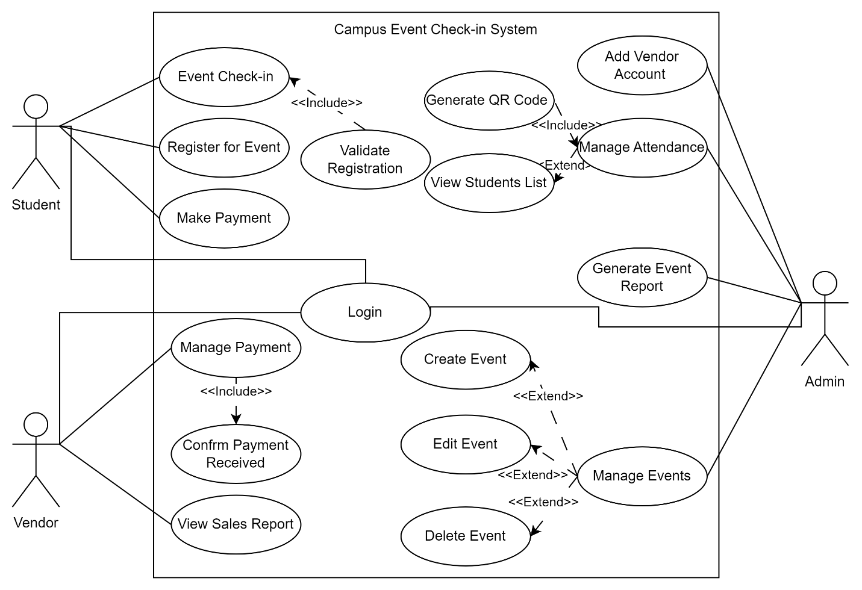
Figure 3. 1 Use Case Diagram – Campus Event Check-In System
Each use case represents a major system function. The following sub-sections (3.2.1) break down these use cases into detailed functional requirements.

Login
This section defines the functional requirements and use case specification for the Login feature of the system. It includes a detailed description of the system behavior, the primary actors involved, and the steps taken during the interaction. A sequence diagram is also provided to visually represent the process flow.
Table 3.2. 1 FR0101 Table
Requirement ID | FR0101 | Version | 2.0
Description | The system shall allow users (student, admin, vendor) to log in using their unique credentials.
Author | Suliman

Table 3.2. 2 FR0102 Table
Requirement ID | FR0102 | Version | 2.0
Description | The system shall validate login credentials against the registered database records.
Author | Suliman

Table 3.2. 3 FR0103 Table
Requirement ID | FR0103 | Version | 2.0
Description | The system shall display an error message if invalid credentials are entered.
Author | Suliman

Table 3.2. 4 FR0104 Table
Requirement ID | FR0104 | Version | 2.0
Description | The system shall prompt the user if required login fields are left empty.
Author | Suliman

Table 3.2. 5 F001 Login Use Case Specification Table
Use Case ID | UC001 | Version | 2.0
Feature | F001 – Login
Purpose | To authenticate users before granting access to the system
Actor | Student / Admin / Vendor
Trigger | User opens the system and enters login credentials
Precondition | User must have a valid account
Scenario Name | Login Process
Main Flow | - User opens the application  - System displays the login form  - User enters credentials  - System checks input format (non-empty, correct format)  - System verifies credentials against the database  - If valid, the user is redirected to the correct interface
Alternate Flow – Empty Fields | 4.1 System shows: “Please fill in all required fields”
Alternate Flow – Invalid Credentials | 5.1 System shows: “Invalid username or password”
Author | Suliman

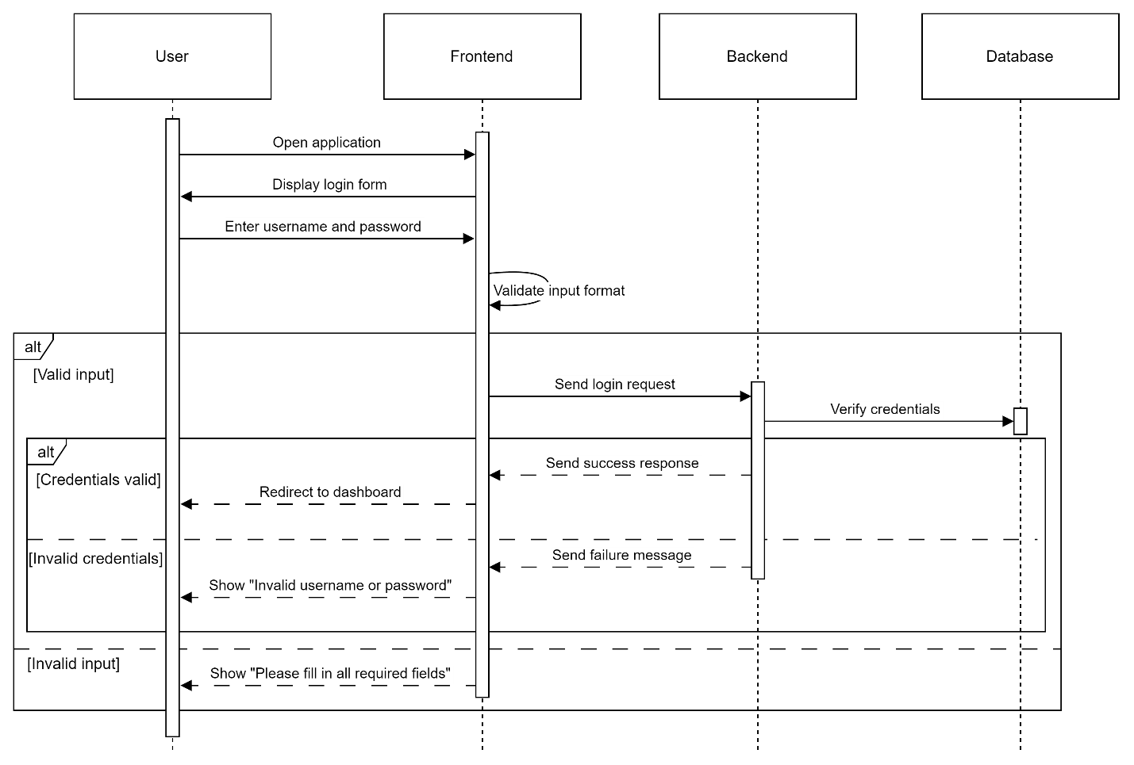
Figure 3. 2 F001 Login Sequence Diagram

Event Registration
This section defines the functional requirements and use case specification for the Event Registration feature of the system. It includes a detailed description of the system behavior, the primary actors involved, and the steps taken during the interaction. A sequence diagram is also provided to visually represent the process flow.
Table 3.2. 6 FR0201 Table
Requirement ID | FR0201 | Version | 2.0
Description | The system shall allow students to register for available events.
Author | Suliman

Table 3.2. 7 FR0202 Table
Requirement ID | FR0202 | Version | 2.0
Description | The system shall check ticket availability before proceeding with registration.
Author | Suliman

Table 3.2. 8 FR0203 Table
Requirement ID | FR0203 | Version | 2.0
Description | The system shall process the event registration payment using an integrated payment gateway.
Author | Suliman

Table 3.2. 9 FR0204 Table
Requirement ID | FR0204 | Version | 2.0
Description | The system shall update the student’s registration record upon successful payment.
Author | Suliman

Table 3.2. 10 FR0205 Table
Requirement ID | FR0205 | Version | 2.0
Description | The system shall notify the student of successful registration or payment failure.
Author | Suliman

Table 3.2. 11 F002 – Event Registration Use Case Specification Table
Use Case ID | UC02 | Version | 2.0
Feature | F002 – Event Registration
Purpose | To allow students to register for events and complete payment
Actor | Student
Trigger | Student selects an event and initiates registration
Precondition | Student must be logged in and the event must have available tickets
Main Flow | - Student opens the event list  - Student selects an event to register for  - System checks ticket availability  - System prompts for payment  - Student completes payment  - System verifies payment  - System updates registration record  - Student receives confirmation
Alternate Flow – Tickets Unavailable: | 3.1 System shows: “Tickets are sold out”
Alternate Flow – Payment Failed: | 6.1 System shows: “Payment unsuccessful. Please try again.”
Author | Suliman

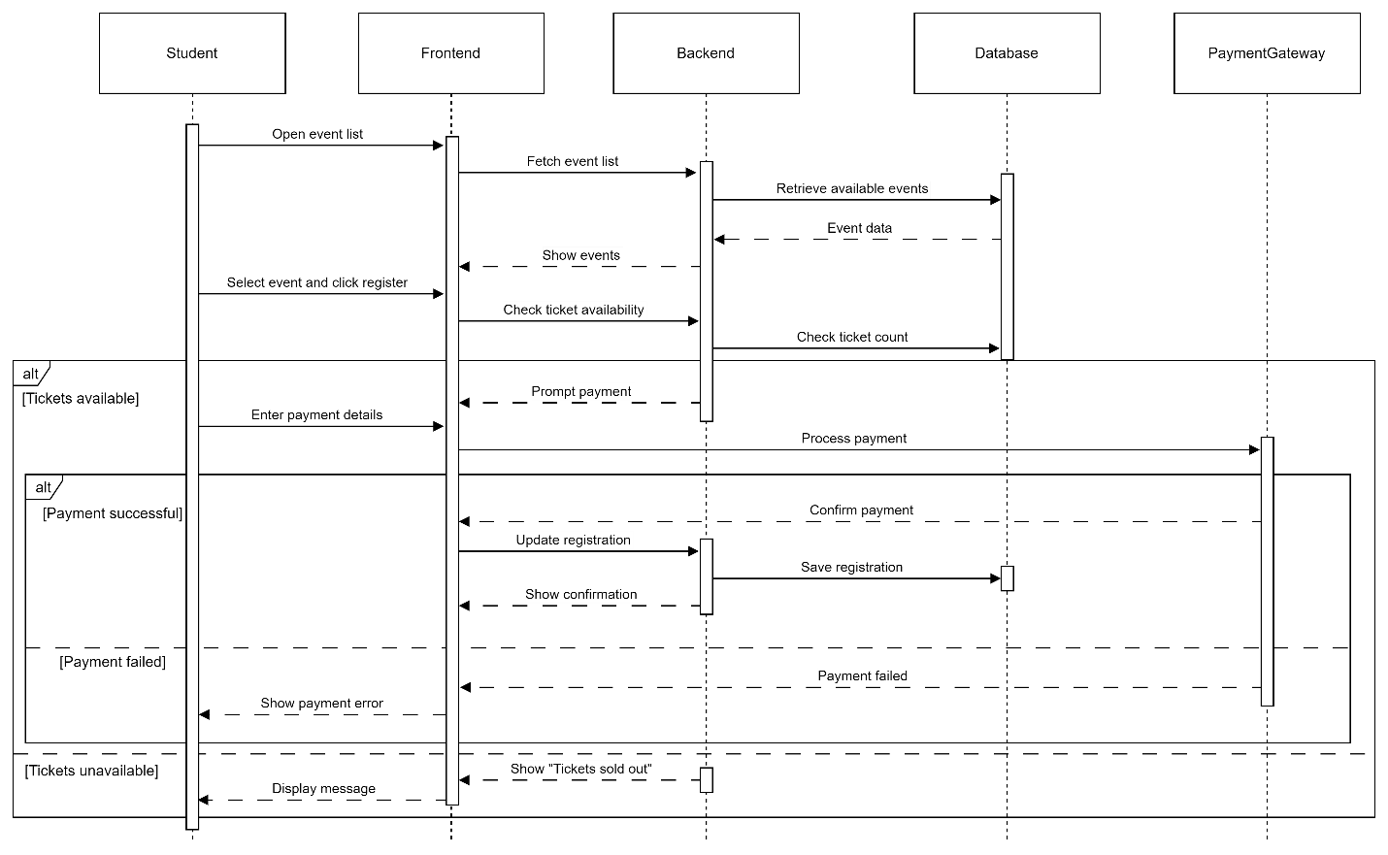
Figure 3. 3 F002 Event Registration Sequence Diagram

Event Check-In
This section defines the functional requirements and the use case specification for the Event Check-In feature of the system. It includes a detailed description of the system behavior, the primary actors involved, and the steps taken during the interaction. A sequence diagram is also provided to visually represent the process flow.
Table 3.2. 12 FR0301 Table
Requirement ID | FR0301 | Version | 2.0
Description | The system shall allow students to check in to events for which they are registered.
Author | Suliman

Table 3.2. 13 FR0302 Table
Requirement ID | FR0302 | Version | 2.0
Description | The system shall verify the student’s registration and identity during check-in.
Author | Suliman

Table 3.2. 14 FR0303 Table
Requirement ID | FR0303 | Version | 2.0
Description | The system shall mark the student as checked in and log the check-in time.
Author | Suliman

Table 3.2. 15 FR0304 Table
Requirement ID | FR0304 | Version | 2.0
Description | The system shall prevent check-in for students who are not registered.
Author | Suliman

Table 3.2. 16 F003 Event Check-In Use Case Specification Table
Use Case ID | UC003 | Version | 2.0
Feature | F003 – Event Check-In
Purpose | To allow students to check in at the event using their registration and identity
Actor | Student
Trigger | Student scans a QR code at the event venue
Precondition | Student must be registered for the event and have a valid ticket
Main Flow | - Student arrives at the event venue  - Student scans the QR code displayed at the check-in point  - System verifies student registration and identity  - If verification succeeds, the system logs check-in and records the timestamp  - Student is allowed to enter the event
Alternate Flow – Not Registered: | 3.1 System shows: “You are not registered for this event”
Author | Suliman

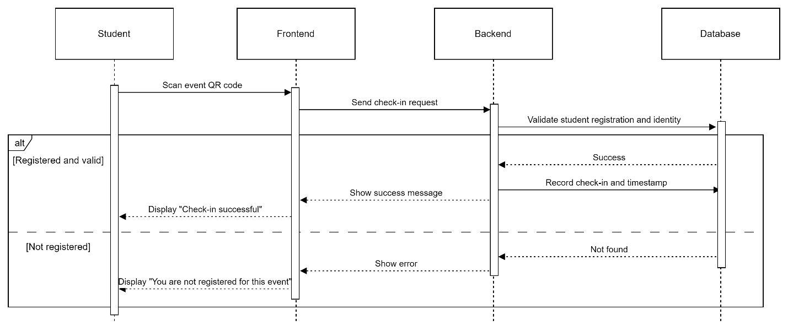
Figure 3. 4 F003 Event Check-in Sequence Diagram

Make Payment
This section defines the functional requirements and use case specification for the Make Payment feature of the system. In earlier versions of the SRS, this was referred to as Process Student Payment, primarily intended for handling payments related to event registration. However, payment for event tickets is now explicitly handled as part of the Event Registration use case and does not require separate modeling.
This Make Payment feature has been redefined to focus exclusively on on-site vendor payments during events, such as purchasing food, merchandise, or other services. This adjustment better aligns with real-time, QR-based vendor interactions. A detailed sequence diagram is provided to illustrate the updated process flow.
Table 3.2. 17 FR0401 Table
Requirement ID | FR0401 | Version | 2.0
Description | The system shall allow students to initiate payments for purchases made at event venues.
Author | Lim Ai Nee

Table 3.2. 18 FR0402 Table
Requirement ID | FR0402 | Version | 2.0
Description | The system shall process the payment via an integrated payment gateway.
Author | Lim Ai Nee

Table 3.2. 19 FR0403 Table
Requirement ID | FR0403 | Version | 2.0
Description | The system shall update the payment database upon successful transaction.
Author | Lim Ai Nee

Table 3.2. 20 FR0404 Table
Requirement ID | FR0404 | Version | 2.0
Description | The system shall notify students of successful or failed payment status.
Author | Lim Ai Nee

Table 3.2. 21 F004 Make Payment Use Case Specification Table
Use Case ID | UC004 | Version | 2.0
Feature | F004 – Make Payment
Purpose | To allow students to make payments to vendors during events
Actor | Student
Trigger | Student selects a vendor or scans a vendor’s QR code to initiate payment
Precondition | Student must be logged in and have a valid payment method
Main Flow | - Student scans vendor QR code or selects vendor  - System prompts for payment details  - Student enters payment amount and confirms  - System processes the payment via the gateway  - If payment is successful, the database is updated and student is notified
Alternate Flow – Payment Failed: | 5.1 System displays: “Payment failed. Please try again.”
Author | Lim Ai Nee

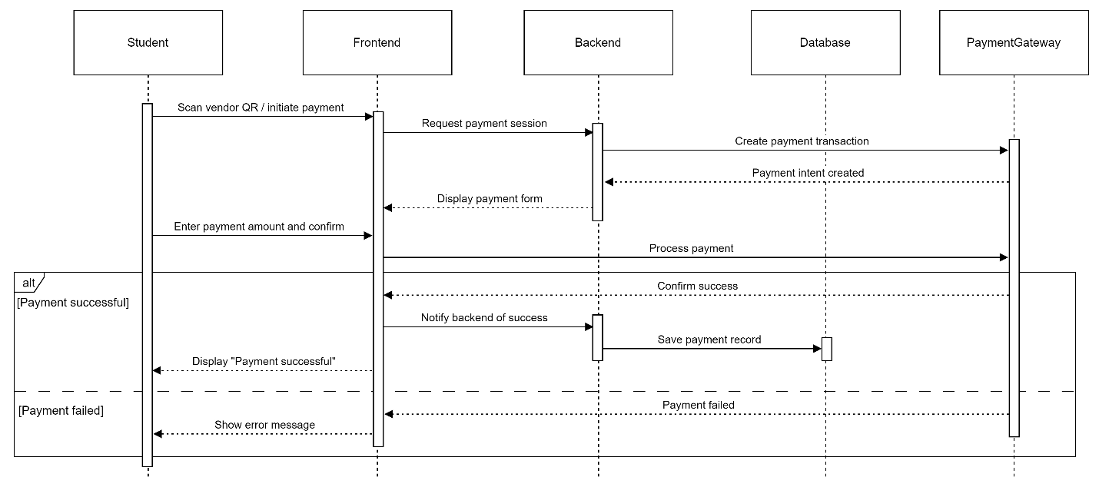
Figure 3. 5 F004 Make Payment Sequence Diagram

Manage Event
This section defines the functional requirements and use case specification for the Manage Event feature of the system. In the previous version of the SRS, this feature bundled all event-related actions under a single generalized flow. However, in this revised version, we explicitly represent Create Event, Edit Event, and Delete Event as extended use cases under Manage Event to more accurately reflect admin interactions and follow proper UML modeling.
A detailed sequence diagram and updated behavior flow are also provided below.
Table 3.2. 22 FR0501 Table
Requirement ID | FR0501 | Version | 2.0
Description | The system shall allow admins to access an event management interface.
Author | Lim Ai Nee

Table 3.2. 23 FR0502 Table
Requirement ID | FR0502 | Version | 2.0
Description | The system shall allow admins to create new events by entering required details.
Author | Lim Ai Nee

Table 3.2. 24 FR0503 Table
Requirement ID | FR0503 | Version | 2.0
Description | The system shall allow admins to modify existing events.
Author | Lim Ai Nee

Table 3.2. 25 FR0504 Table
Requirement ID | FR0504 | Version | 2.0
Description | The system shall allow admins to delete events that are no longer needed.
Author | Lim Ai Nee

Table 3.2. 26 FR0505 Table
Requirement ID | FR0505 | Version | 2.0
Description | The system shall validate event details before saving changes.
Author | Lim Ai Nee

Table 3.2. 27 FR0506 Table
Requirement ID | FR0506 | Version | 2.0
Description | The system shall update the event records in the database after each operation.
Author | Lim Ai Nee

Table 3.2. 28 F005 Manage Events Use Case Specification Table
Use Case ID | UC005 | Version | 2.0
Feature | F005 – Manage Events
Purpose | To enable admins to create, edit, or delete event records
Actor | Admin
Trigger | Admin opens the event management interface
Precondition | Admin must be logged in with event management permissions
Main Flow | - Admin navigates to the event management section  - System displays a list of existing events  - Admin selects one of the following actions:  - Create new event  - Edit an existing event  - Delete an event  - System displays the relevant form or confirmation prompt  - Admin submits the action  - System validates input and saves changes to the database  - System displays a success message
Alternate Flow – Cancelled Action: | 4.1 Admin cancels the action → return to event list
Alternate Flow – Invalid Input: | 6.1 System displays: “Please fill in all required fields”
Author | Lim Ai Nee

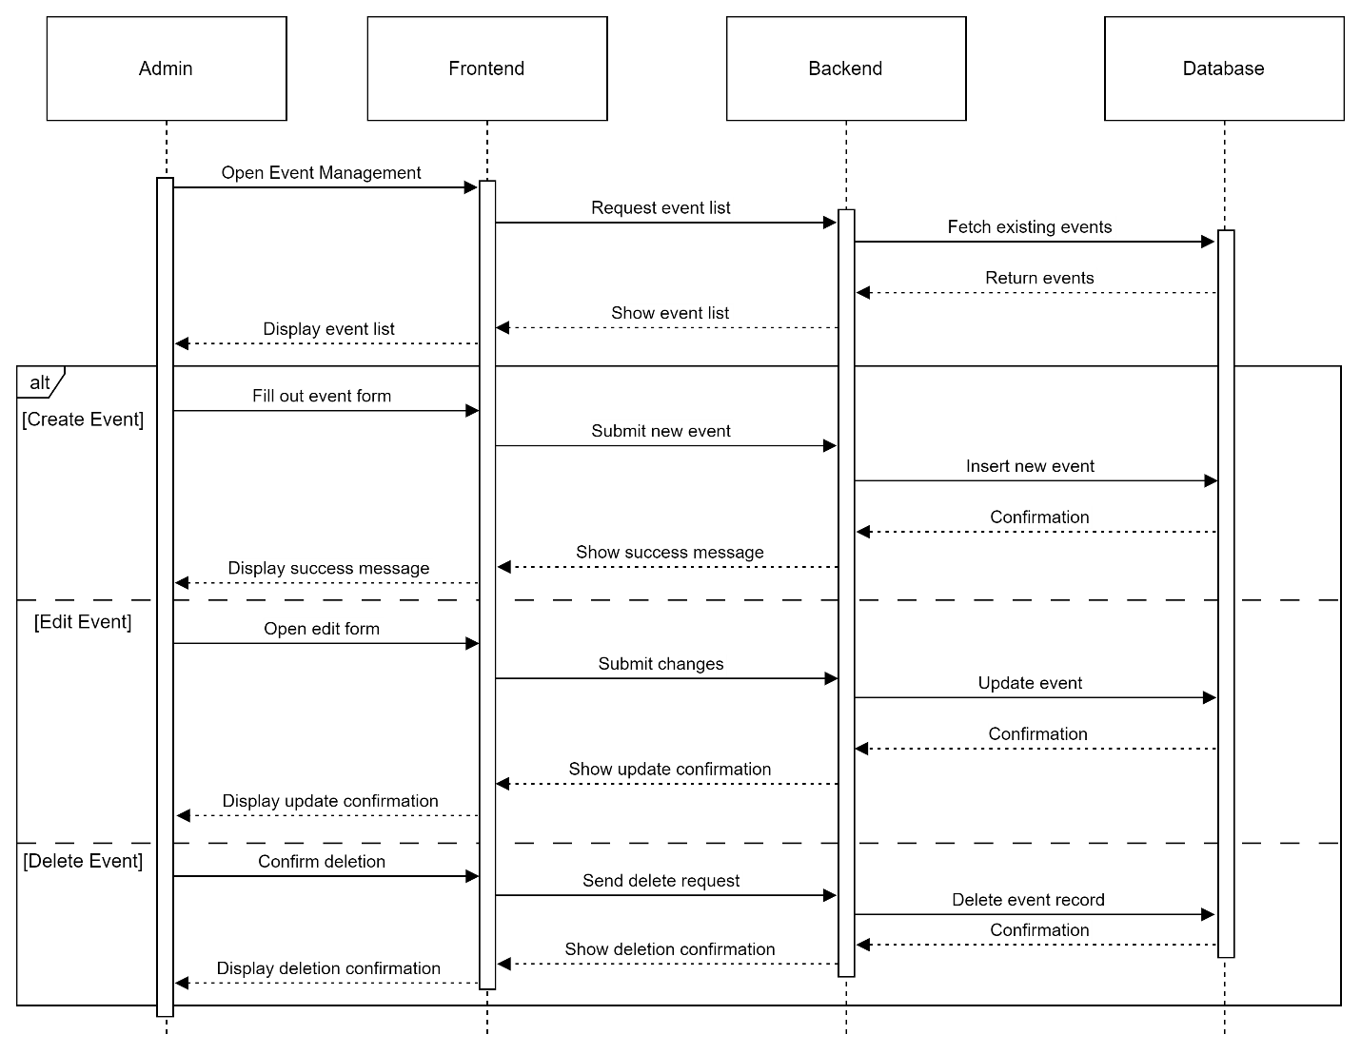
Figure 3. 6 F005 Manage Events Sequence Diagram

Manage Attendance
This section defines the functional requirements and use case specification for the Manage Attendance feature of the system. In the previous version of the SRS, this feature was modeled with limited detail, combining QR code generation and student list display into a simplified linear flow. In this improved version, the system flow is clearly separated into two functional interactions: QR code generation and attendance list retrieval, including database integration for real-time attendance and student identity data. A revised sequence diagram illustrates this process in line with best practices.

Table 3.2. 29 FR0601 Table
Requirement ID | FR0601 | Version | 2.0
Description | The system shall allow admins to generate a unique QR code for event check-in.
Author | Azhar

Table 3.2. 30 FR0602 Table
Requirement ID | FR0602 | Version | 2.0
Description | The system shall retrieve check-in logs of students for a selected event.
Author | Azhar

Table 3.2. 31 FR0603 Table
Requirement ID | FR0603 | Version | 2.0
Description | The system shall retrieve student details associated with each check-in record.
Author | Azhar

Table 3.2. 32 FR0604 Table
Requirement ID | FR0604 | Version | 2.0
Description | The system shall display the list of students who have checked in, along with their basic information.
Author | Azhar

Table 3.2. 33 F006 Manage Attendance Use Case Specification Table
Use Case ID | UC006 | Version | 2.0
Feature | F006 – Manage Attendance
Purpose | To enable admins to manage student attendance during events by generating check-in QR codes and reviewing attendance records
Actor | Admin
Trigger | Admin accesses the attendance management interface
Precondition | Admin must be logged in and have access to an active event
Main Flow | - Admin opens the attendance management tab  - selects an event  - System generates a unique QR code for check-in  - Admin displays the QR code at the event  - Admin requests the attendance list  - System retrieves check-in logs from the event database  - System retrieves student details from the student database  - System displays the full list of attendees with names and check-in timestamps
Alternate Flow – No Check-ins Yet: | 6.1 System displays: “No students have checked in yet”
Author | Azhar

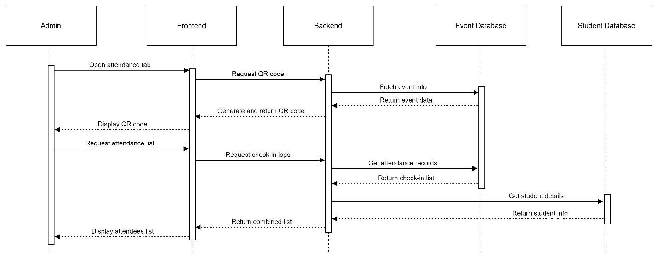
Figure 3. 7 F006 Manage Attendance Sequence Diagram

Manage Payment (Vendor)
This section defines the functional requirements and use case specification for the Manage Payment feature used by vendors during events. In the previous version of the SRS, the process was simplified to basic button clicks and lacked back-end interaction or structured flow. This updated version includes real-time payment entry, transaction handling, and backend database logging. The flow now separates user-facing input from data processing, and includes optional handling of change or balance returns (if applicable).
Table 3.2. 34 FR0701 Table
Requirement ID | FR0701 | Version | 2.0
Description | The system shall allow vendors to input payment amounts during transactions.
Author | Azhar

Table 3.2. 35 FR0702 Table
Requirement ID | FR0702 | Version | 2.0
Description | The system shall process and record each payment in the payment database.
Author | Azhar

Table 3.2. 36 FR0703 Table
Requirement ID | FR0703 | Version | 2.0
Description | The system shall confirm that a transaction has been saved before updating the interface.
Author | Azhar

Table 3.2. 37 FR0704 Table
Requirement ID | FR0704 | Version | 2.0
Description | The system shall allow vendors to mark a sale as complete and begin a new transaction.
Author | Azhar

Table 3.2. 38 FR0705 Table
Requirement ID | FR0705 | Version | 2.0
Description | The system shall display an error message if the entered amount field is empty or invalid.
Author | Azhar

Table 3.2. 39 F007 Vendor Payment Management Use Case Specification Table
Use Case ID | UC007 | Version | 2.0
Feature | F007 – Vendor Payment Management
Purpose | To enable vendors to manage on-site payments during events
Actor | Vendor
Trigger | Vendor opens the in-app payment interface
Precondition | Vendor must be logged in and registered to the event
Main Flow | - Vendor opens the vendor dashboard  - Vendor clicks "Start New Sale"  - Vendor enters the total amount to be paid  - System records the transaction in the payment database  - System confirms and updates the dashboard with the new payment entry  - Vendor can start another transaction
Alternate Flow – Invalid/Empty Field: | 3.1 System displays: “Please enter a valid amount”
Author | Azhar

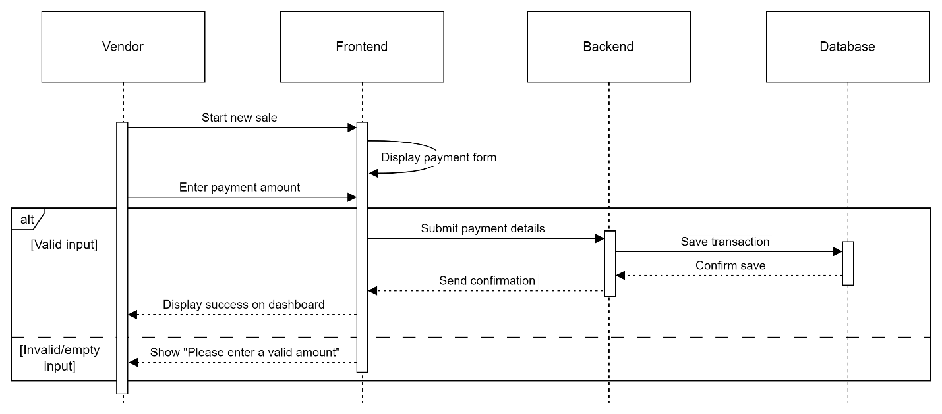
Figure 3. 8 F007 Manage Payment Sequence Diagram

View Sales Report
This section defines the functional requirements and use case specification for the View Sales Report feature for vendors. In the previous version of the SRS, the interaction was oversimplified and assumed the sales report was generated directly from the vendor interface without clearly involving backend verification or data retrieval. In this improved version, the flow explicitly reflects backend interaction with a unified database and provides proper error handling for empty or missing data.
Table 3.2. 40 FR0801 Table
Requirement ID | FR0801 | Version | 2.0
Description | The system shall allow vendors to request a sales report based on a defined period.
Author | Yousef

Table 3.2. 41 FR0802 Table
Requirement ID | FR0802 | Version | 2.0
Description | The system shall retrieve the vendor’s sales data from the database.
Author | Yousef

Table 3.2. 42 FR0803 Table
Requirement ID | FR0803 | Version | 2.0
Description | The system shall generate a structured report based on retrieved sales records.
Author | Yousef

Table 3.2. 43 FR0804 Table
Requirement ID | FR0804 | Version | 2.0
Description | The system shall display the report to the vendor in a readable format.
Author | Yousef

Table 3.2. 44 FR0805 Table
Requirement ID | FR0805 | Version | 2.0
Description | The system shall show an appropriate message if no sales data is found for the selected period.
Author | Yousef

Table 3.2. 45 F008 View Sales Report Use Case Specification Table
Use Case ID | UC008 | Version | 2.0
Feature | F008 – View Sales Report
Purpose | To enable vendors to view and analyze their sales activity for a specific date range
Actor | Vendor
Trigger | Vendor initiates a sales report request from the dashboard
Precondition | Vendor must be logged in and have recorded transactions
Main Flow | - Vendor opens the report section from the dashboard  - Vendor selects a date range and clicks “Generate Report”  - System retrieves relevant sales data from the database  - System generates and formats the report  - System displays the report to the vendor
Alternate Flow – No Sales Found: | 3.1 System displays: “No sales data available for the selected period”
Author | Yousef

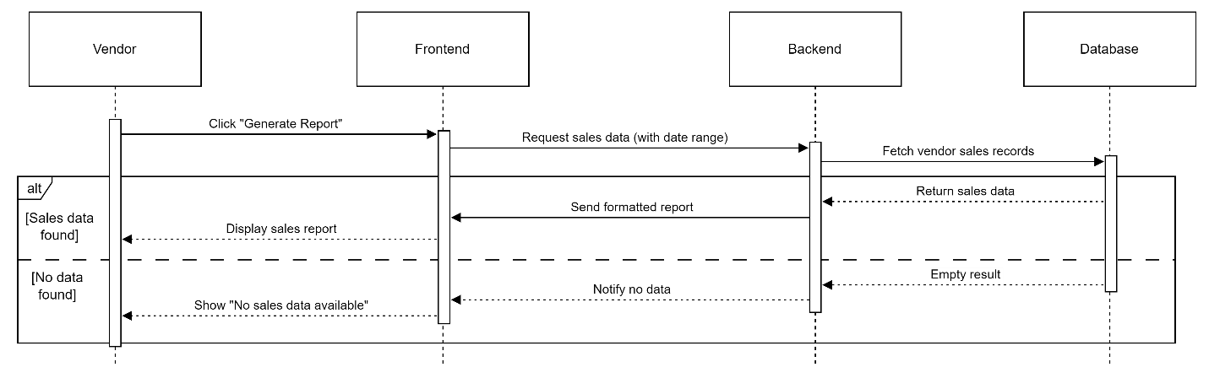
Figure 3. 9 F008 View Sales Report Sequence Diagram

Generate Event Report
This section defines the functional requirements and use case specification for the Generate Event Report feature. In previous versions of the SRS, event reporting functionality was implicitly handled as part of the Manage Event use case. In this updated version, it has been modeled as an individual use case to better reflect its distinct role in providing post-event analytics and documentation. This is the first dedicated version of this feature in the SRS, providing clearer structure and backend integration for generating reports.
Table 3.2. 46 FR0901 Table
Requirement ID | FR0901 | Version | 1.0
Description | The system shall allow admins to generate reports for specific events.
Author | Yousef

Table 3.2. 47 FR0902 Table
Requirement ID | FR0902 | Version | 1.0
Description | The system shall retrieve all relevant attendance and transaction data from the database.
Author | Yousef

Table 3.2. 48 FR0903 Table
Requirement ID | FR0903 | Version | 1.0
Description | The system shall compile the data into a readable and exportable format.
Author | Yousef

Table 3.2. 49 FR0904 Table
Requirement ID | FR0904 | Version | 1.0
Description | The system shall allow the admin to view and optionally download the report.
Author

Table 3.2. 50 FR0905 Table
Requirement ID | FR0905 | Version | 1.0
Description | The system shall notify the admin if no data is available for the selected event.
Author | Yousef

Table 3.2. 51 F009 Generate Event Report Use Case Specification Table
Use Case ID | UC009 | Version | 1.0
Feature | F009 – Generate Event Report
Purpose | To allow admins to generate and access post-event reports including attendance and sales data
Actor | Admin
Trigger | Admin accesses the report section and selects an event
Precondition | Admin must be logged in and the selected event must have at least one data record (attendance or transaction)
Main Flow | - Admin opens the reporting interface  - Admin selects an event to generate a report for  - System retrieves attendance and sales data related to that event  - System formats and compiles the report  - System displays the report and allows optional download
Alternate Flow – No Data: | 3.1 System displays: “No reportable data available for this event”
Author | Yousef

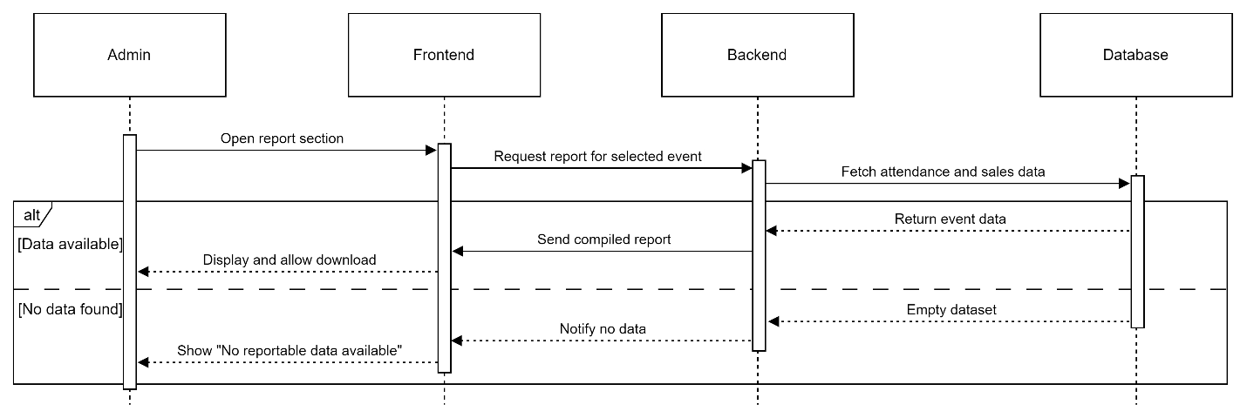
Figure 3. 10 F009 Generate Event Report Sequence Diagram

Add Vendor Account
This section outlines the functional requirements and use case specification for the Add Vendor Account feature. In previous iterations of the SRS, vendor account management was not explicitly defined. This updated version introduces it as a standalone feature to emphasize its importance in onboarding external service providers such as food and merchandise vendors. The feature enables administrators to register new vendor accounts through a guided form, ensuring required fields are validated, and duplicate entries are handled effectively. This dedicated modeling provides greater clarity, improves system robustness, and enhances the onboarding workflow for event-related vendors.
Table 3.2. 52 FR1001 Table
Requirement ID | FR1001 | Version | 1.0
Description | The system shall present an Add Vendor form when the administrator selects “Create Vendor”.
Author | Suliman

Table 3.2. 53 FR1002 Table
Requirement ID | FR1002 | Version | 1.0
Description | The system shall validate all mandatory fields.
Author | Suliman

Table 3.2. 54 FR1003 Table
Requirement ID | FR1003 | Version | 1.0
Description | The system shall check that the vendor email address is unique in the database.
Author | Suliman

Table 3.2. 55 FR1004 Table
Requirement ID | FR1004 | Version | 1.0
Description | Upon successful creation the system shall store the vendor account in the vendors table.
Author | Suliman

Table 3.2. 56 FR1005 Table
Requirement ID | FR1005 | Version | 1.0
Description | If any validation fails, the system shall display an appropriate error message and keep the form open for correction.
Author | Suliman

Table 3.2. 57 F010 Admin Vendor Account Use Case Specification Table
Use Case ID | UC010 | Version | 1.0
Feature | F010 – Admin Vendor Account
Purpose | Allow an admin to create a new vendor account
Actor | Admin
Trigger | Admin clicks “Add Vendor”.
Precondition | Admin is authenticated
Main Flow | - System displays the Add Vendor form.  - Admin fills in fields  - System validates that mandatory fields are non-empty and email format is correct.  - System checks that the email address is not already registered.  - System writes the new vendor record to the.  - System shows a success toast “Vendor created successfully; credentials sent.”
Alternate Flow — Invalid Input | 3.1 If any required field is empty or email invalid, system highlights the field(s) and shows “Please complete all mandatory entries with valid data.”
Alternate Flow — Duplicate Email | 4.1 If the email already exists, system displays “This email is already registered” and prevents submission.
Author | Suliman

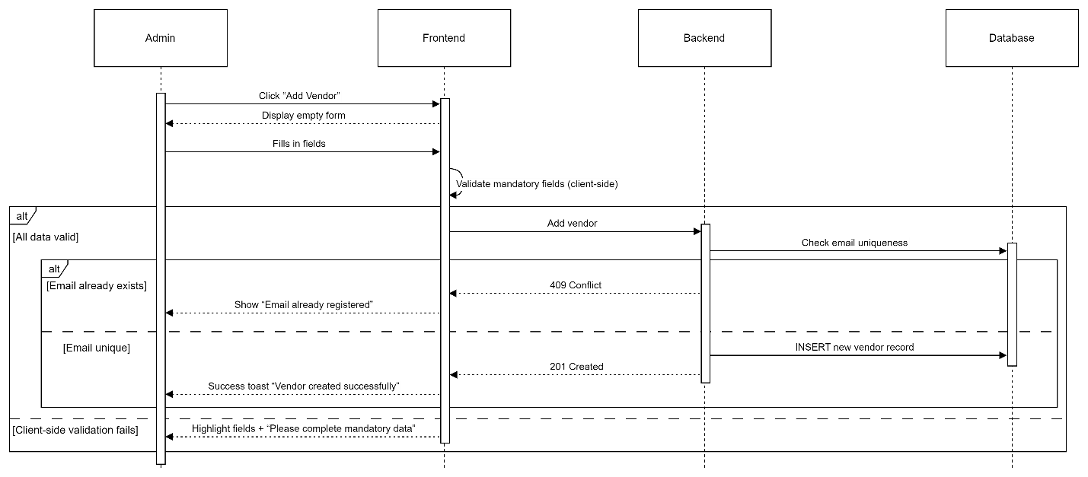
Figure 3. 11 F010 Add Vendor Account Sequence Diagram

Performance Requirements
Table 3.3. 1 describes the performance requirements and their descriptions for the Campus Event Check-in System. These requirements ensure that the system performs efficiently under various conditions, including handling concurrent users, ensuring quick response times for check-in and transactions, supporting system scalability, and maintaining data synchronization across devices.
Table 3.3. 1 Performance Requirements Table
Requirement ID | Description | Priority | Author
REQ_P001 | The system must support up to 300 concurrent users without any noticeable performance degradation. | High | Lim Ai Nee
REQ_P002 | Check-in validation and ticket verification must complete in under 5 seconds. | High | Lim Ai Nee
REQ_P003 | All on-site transactions (e.g., purchases from vendors) must be processed accurately and efficiently. | High | Lim Ai Nee
REQ_P004 | Upon successful registration, the event ticket confirmation should be issued within 10 seconds of form submission. | Medium | Lim Ai Nee
REQ_P005 | The system must scale to support up to 3,000 total users, maintaining stability and preventing data loss. | Medium | Lim Ai Nee
REQ_P006 | Any changes made by admins (such as event updates or ticket changes) must synchronize across all devices. | Medium | Lim Ai Nee

Usability Requirements
Table 3.4. 1 outlines the usability requirements for the Campus Event Check-in System. These requirements focus on delivering an intuitive and accessible user experience across both web and mobile platforms. Emphasis is placed on interface clarity, error recovery, layout organization, and support for diverse user roles to ensure that all users can interact with the system confidently and efficiently.

Table 3.4. 1 Usability Requirements Table
Requirement ID | Description | Priority | Author
REQ_UR001 | The system must deliver a user-friendly interface accessible on both web and mobile platforms. | High | Lim Ai Nee
REQ_UR002 | All users (students, vendors, and admins) must be able to complete their tasks (e.g., check-in, view sales, register for events) without confusion or error. | Medium | Lim Ai Nee
REQ_UR003 | The user interface should maintain readable fonts, well-organized layouts, and support keyboard navigation to ensure accessibility. | High | Lim Ai Nee
REQ_UR004 | Error messages must be clear and informative, providing users with the guidance to recover from errors independently. | High | Lim Ai Nee

Logical Database Requirements
Table 3.5. 1 presents the logical database requirements for the Campus Event Check-in System. Each entry describes a core system database and its function in storing, managing, and linking key data elements such as event details, ticket records, attendance logs, and transaction histories. These databases support the backend processes necessary for efficient event management, user tracking, and secure payment handling.
Table 3.5. 1 Logical Database Requirements Table
Requirement ID | Table Name | Revised Description | Author
DB_001 | Events | Maintains metadata for each campus event including name, date, and venue. | Azhar
DB_002 | Tickets | Links registered users to specific events through unique ticket records. | Azhar
DB_003 | Checkins | Logs each check-in instance during the event for attendance tracking. | Azhar
DB_004 | Transactions | Records all on-site vendor transactions and payment activities. | Azhar
DB_0005 | Vendors | Records the vendors accounts | Suliman

Design Constraints
Table 3.6. 1 outlines the design constraints that impact the development and deployment of the Campus Event Check-in System. These constraints include technical, operational, and regulatory limitations such as device compatibility, reliance on third-party systems, internet connectivity requirements, excluded features, and compliance with data protection regulations. Recognizing these constraints is essential for setting realistic expectations and ensuring system feasibility within the defined scope.
Table 3.6. 1 Design Constraints Table
Requirement ID | Constraint | Revised Description | Author
CON_001 | Device Compatibility | System performance may degrade on outdated devices or unsupported operating systems. | Azhar
CON_002 | Third-party Integrations | The system depends on external services, such as university databases and a secure payment gateway, for full functionality. | Azhar
CON_003 | Network Dependence | A stable internet connection is required for real-time operations like check-ins and payment logging. Offline usage is not supported. | Azhar
CON_004 | Limited Scope | Features like venue navigation, mapping, and social media integration are outside the scope of this release. | Azhar
CON_005 | Security Compliance | The system must adhere to data protection regulations when handling user credentials, financial transactions, and personal data. | Azhar

Software System Attributes
Table 3.7. 1 summarizes the essential software system attributes required for the Campus Event Check-in System. These attributes define the non-functional qualities of the system, such as reliability, availability, security, maintainability, and portability. Each attribute ensures that the system performs effectively under various conditions while remaining secure, scalable, and accessible across multiple platforms and usage scenarios.
Table 3.7. 1 Software System Attributes
Requirement ID | Attribute | Rephrased Description | Author
ATTR_001 | Reliability | The system shall auto-recover from crashes within one minute, ensuring no data loss. All critical data such as check-ins and transactions will be saved and restored automatically. | Yousef
ATTR_002 | Availability | The application shall maintain uptime throughout event hours, with auto-recovery features restoring the latest saved state. | Yousef
ATTR_003 | Security | TLS encryption will be used for data transmission, and AES encryption will secure data at rest. Integrity checks will safeguard against tampering and unauthorized access. | Yousef
ATTR_004 | Maintainability | The system shall be modular and well-documented, enabling easy maintenance, bug fixes, and future enhancements. | Yousef
ATTR_005 | Portability | The application shall be compatible with both Android and iOS platforms. | Yousef

Supporting Information
Table 3.8. 1 provides supporting information relevant to the development and deployment of the Campus Event Check-in System. It includes documentation plans, source code management practices, legal and ethical compliance considerations, and the tools and frameworks selected for implementation. These elements ensure that the system is well-documented, legally compliant, collaboratively developed, and built using appropriate technologies aligned with project needs.
Table 3.8. 1 Supporting Information (SRS1)
Requirement ID | Category | Rephrased Description | Author
INFO_001 | Documentation | - User guides for students, vendors, and admins  - Backend API documentation for third-party integration | Yousef
INFO_002 | Source Code Management | - The project source code will be hosted on GitHub for version control and collaboration | Yousef
INFO_003 | Legal and Ethical Compliance | - Data collection will comply with university privacy policies and local legal requirements  - Payment processing will follow PCI DSS standards via a secure gateway | Yousef
INFO_004 | Tools & Frameworks | - The app will be developed using Flutter; the backend database will use either SQLite or MongoDB depending on deployment requirements. | Yousef

Validation Activities
This section will contain information about the validation activities the team have applied in order to check and validate the SRS report if it meets the three requirements engineering dimensions. However, there are two sub-sections in this section, the first one will show the validation session the team had conducted. The second sub-section will show the validation details.

Validation Sessions
Review Object
ID / Title / Version: v1.0
Author / Groupe Name: G1
Meeting Information
Date / Time: 8 / 6 / 2025 3:00 pm
Participation (Roles):
Suliman (Inspector, Minute-taker)
Yousef (Moderator, Inspector, Reader)
Azhar (Author, Stakeholder)
Lim Ai Nee (Organizer, Inspector, Stakeholder)

Review Object
ID / Title / Version: v1.0
Author / Groupe Name: G1
Meeting Information
Date / Time: 8 / 6 / 2025 3:00 pm
Participation (Roles):
Suliman (Moderator, Inspector, Reader)
Yousef (Inspector, Minute-taker)
Azhar (Author, Stakeholder)
Lim Ai Nee (Organizer, Inspector, Stakeholder)

Review Object
ID / Title / Version: v1.0
Author / Groupe Name: G1
Meeting Information
Date / Time: 16 / 6 / 2025 3:00 pm
Participation (Roles):
Suliman (Moderator, Inspector, Reader)
Yousef (Inspector, Minute-taker)
Azhar (Organizer, Inspector, Stakeholder)
Lim Ai Nee (Author, Stakeholder)

Validation Details
This subsection presents two artefacts:
- Table 3.8. 2 Defects Table – lists every defect discovered during validation. Each entry shows the page or use-case ID where the defect appears, the reviewer who raised it, its impact, and the team’s recommended action. Defects are prefixed C-, D-, or A- to identify Content, Documentation, and Agreement issues respectively.
The “ID / Page No” column always references either a use-case number (e.g., UC010) or the chapter/sub-chapter where the issue existed in the previous SRS draft, allowing traceability across revisions.

Table 3.8. 2 Defects Table
No | ID / Page No | Defect Description | Type | Inspector Name | Impact | Recommended Action
C-1 | 1.3.3 | Vendor account source is undefined; no onboarding workflow | Agreement Defect + Conflict | Suliman | System assumes vendor accounts exist yet provides no creation flow | Add a mechanism to add vendors account
C-2 | UC008, UC006 | Several sequence diagrams lack alternate/error flows (e.g., Sales Report, Admin actions) | Content Defect | Suliman | Edge-case behavior undocumented | Update all UC tables with error flows
C-3 | UC005, UC006, UC007, UC008 | Sequence diagrams omit backend/database calls (e.g., ticket update, payment record) | Content Defect | Suliman | Data-consistency path invisible | Update diagrams
C-4 | 3.5 | Duplicate local Users/Roles tables while identity is handled by university DB | Content Defect | Yousef | Risk of data divergence | Remove duplicate tables
C-5 | UC005, UC007… | “Payment DB / Ticket DB” labels imply separate physical DBs | Content Defect | Azhar | Mis-leads architecture readers | Rename to logical tables in a single DB
C-6 | 1.3 | The system is missing the Goals | Content Defect | Suliman | System purpose and high-level objectives are unclear; traceability to goals impossible | Add “System Goals” subsection (list measurable, high-level goals) under 1.3
D-1 | Most Tables | Inconsistent table formatting & captions | Formatting Defect | Yousef | Hard to scan / reference | Update all tables with a standardized styling
D-2 | 1.1,  1.3.2 | Mixed terminology: “Student ID” vs. “University ID” | Language Defect | Lim Ai Nee | Causes confusion | Choose one term
D-3 | UC003 | Grammar issues in flow descriptions (“Student arrive”, etc.) | Language Defect | Azhar | Reduces professionalism | Correct sentences
D-4 | Most Figures | Figure numbers/captions missing or duplicated | Structural Defect | Azhar | Navigation difficult | Unique numbering
D-5 | UC003, UC005 | Use-case flows mix bullets, numbers, vague labels | Formatting Defect | Suliman | Inconsistent readability | Re-format flows
D-6 | UC007 | Sequence diagrams break UML rules (messages from actors, 2 actors on 1 diagram) | Modeling Defect | Yousef | Non-standard diagrams | Redraw correctly
D-7 | 3.4.4 | References to SQLite in API text but DB undecided | Language Defect | Lim Ai Nee | Creates false specificity | Edit Software Interface section and generalize wording
D-8 | 3.4.2 | UI specification supplied only as mock-ups; interface-element tables missing | Documentation Defect | Yousef | Hard for developers/testers to see precise screen elements | Provide detailed UI tables per function
D-9 |  | Use-case diagram shows erroneous subsystem boundary | Modeling Defect | Azhar | Misrepresents system scope | Replace diagram with corrected single-system use-case
D-10 |  | Interface Requirements section located in wrong chapter | Structural Defect | Lim Ai Nee | Document structure deviates from ISO/IEC 29148 | Relocate section to 1.3 Product Perspective
A-1 |  | UI shows only mobile screens; laptops/tablets promised for admins & vendors | Agreement Defect | Azhar | Platform mismatch | Clarify responsive design
A-2 |  | Stripe named elsewhere but not in System Interfaces table | Agreement Defect | Yousef | Integration uncertainty | Update Sys Interfaces row

Conflict Analysis & Resolution
Table 3.8. 3 Conflicts Table – captures items that could not be classified as straightforward defects because reviewers initially disagreed on how to resolve them. For each conflict we record the description, the rationale behind the disagreement, and the final resolution reached after negotiation.
Table 3.8. 3 Conflicts Table
No | Conflict Description | Conflict Analysis (reason for disagreement) | Final Resolution (what was changed)
1 | Vendor onboarding undefined – some reviewers assumed self-registration via university DB; others expected admin-created accounts | System design only authenticates students via university DB; vendors are external. Expectations differed. | Resolved: Added Admin Adds Vendor Account flow (UC-010) and UI tables; clarified in System Interfaces that vendors are created locally.
2 | Screens showed only mobile layouts while admins/vendors expected tablet / laptop use | Mobile-only mock-ups implied single-platform support. | Resolved: Added statement that UI is fully responsive.
3 | Stripe gateway referenced in text but missing in table | Omission created uncertainty about payment integration. | Resolved: Stripe added to 3.4.1 System Interfaces row (Payment Gateway Integration).
4 | External Interface Requirements located in wrong chapter | ISO/IEC 29148 requires interface desc. In 1.x context. | Resolved: Section relocated to 1.3; cross-refs updated.

Traceability Matrix
Table 3.8. 4 presents the Traceability Matrix, which maps functional requirement scenarios (REQ_Fxxx) to the corresponding system goals (REQ_Gxxx). This matrix ensures that all defined goals are adequately addressed by specific requirements, helping maintain alignment between stakeholder objectives and system functionality throughout the development process. It supports verification, validation, and completeness of the requirement coverage.
Table 3.8. 4 Traceability Matrix Table
Scenarios | REQ_GO01 | REQ_GO02 | REQ_GO03 | REQ_GO04 | REQ_GO05 | REQ_GO06 | REQ_GO07
REQ_F001 |  |  |  |  | satisfies | satisfies
REQ_F002 |  |  |  | satisfies | satisfies
REQ_F003 | satisfies |  |  | satisfies | satisfies
REQ_F004 |  | satisfies |  |  |  | satisfies
REQ_F005 |  |  | satisfies |  |  |  | satisfies
REQ_F006 |  |  | satisfies | satisfies |  |  | satisfies
REQ_F007 |  | satisfies | satisfies |  |  | satisfies
REQ_F008 |  |  | satisfies |  |  |  | satisfies
REQ_F009 |  |  | satisfies | satisfies |  |  | satisfies
REQ_F010 |  | satisfies |  |  |  | satisfies

VERIFICATION

Verification Approach
HOW
Verification will be performed through user, integration, and system testing.
Test cases will be derived directly from SRS requirements to maintain traceability.
WHO
- Developers carry out integration and system tests during development.
- End-users (students, admins, vendors) participate in user-acceptance testing.
- The project manager oversees the process and signs off when all criteria are met.
WHEN
- Integration testing begins once components are integrated.
- System testing is executed after all modules are in place.
- User testing occurs in the pre-deployment phase.
- Final verification is completed before the system goes live.
WHERE
- Integration and system tests run on university-hosted development / test servers.
- Verification artefacts (test plans, results) are stored in the shared GitHub repository, accessible to all stakeholders.

Verification Criteria
Table 4. 1 outlines the verification criteria for the Campus Event Check-in & Payment System. Each requirement area is paired with specific, measurable conditions to determine successful implementation and system behavior. These criteria ensure that key functions—such as login, ticketing, purchases, and admin updates—perform within defined time limits and meet expectations for accuracy, scalability, accessibility, and reliability.

Table 4. 1 Verification Criteria
Requirement Area | Verification Criteria
Login | Users (students, admins, vendors) must log in with valid credentials. Response time ≤ 3 s.
Event Registration | Students must register and receive a ticket within 6 s of submission.
Ticket Verification | System must validate a ticket within 2 s.
On-site Purchases | Vendors must complete a transaction ≤ 3 s after payment confirmation.
Data Consistency | All transactions and check-ins are recorded reliably in the database.
Error Handling | On failure, the system must return an error message ≤ 2 s.
Accessibility | UI meets accessibility standards (readable fonts, keyboard navigation).
Load Handling | System functions with up to 300 concurrent users (no page load > 3 s).
Scalability | Supports scaling to 3 000 total users without errors.
Data Synchronisation | Admin changes (e.g., event status) propagate to all clients within 10 s.
Timezone & Clock Sync | All timestamps stored in UTC and displayed in MYT (GMT+8).
UI Response Time | Any UI action (navigation, form submission) triggers feedback ≤ 3 s.

APPENDICES

Assumptions and Dependencies
Assumptions
- The university provides a secure API or direct connection to its student-identification database.
- Event venues have reliable Internet connectivity to support real-time check-ins and payments.
- Students possess valid IDs and tickets at check-in.
- Students, admins, and vendors have Internet access (campus Wi-Fi or mobile data).
- Administrators operating the system are trained to use the platform effectively.
Dependencies
- Appropriate device compatibility for QR check-in (camera availability, troubleshooting).
- Integration with the university student-ID database for real-time identity verification.
- Integration with a PCI-DSS-compliant payment gateway for transaction processing.

Acronyms and Abbreviations
Table 5. 1 lists the acronyms and abbreviations used throughout this document, along with their corresponding definitions, to ensure clarity and consistency for all readers.
Table 5. 1 Acronyms and Abbreviations
Acronym | Definition
API | Application Programming Interface
e.g. | For example
GMT+8 | Greenwich Mean Time + 8 hours
MYT | Malaysian Time
TLS | Transport Layer Security
AES | Advanced Encryption Standard
PCI | Payment Card Industry (as in PCI-DSS)
HTTPS | Hypertext Transfer Protocol Secure

