Supporter & Patient Android Application

Codebase Dependencies & System Architecture Report
Target SDK Version: 33 | Compile SDK Version: 34
Gradle Modules Analyzed: :app (Android Application), :data (Android Library)
This document lists, analyzes, and explains all external dependencies, compiler plugins, classpaths, and frameworks declared within the Supporter & Patient Android App workspace, and illustrates the application's runtime architecture through a set of process diagrams. The codebase is structured as a modularized project consisting of a main application module (:app) and a data persistence/networking module (:data).

1. System Architecture Diagrams
The diagrams below illustrate the MVVM (UI Layer / ViewModel / Data Layer) architecture used throughout the application, showing how user actions flow from the Activity/Fragment layer through ViewModels and Repositories to Firebase (Authentication, Firestore, Realtime Database, Room) for each major feature.

1.1 Signup Process (Main User)
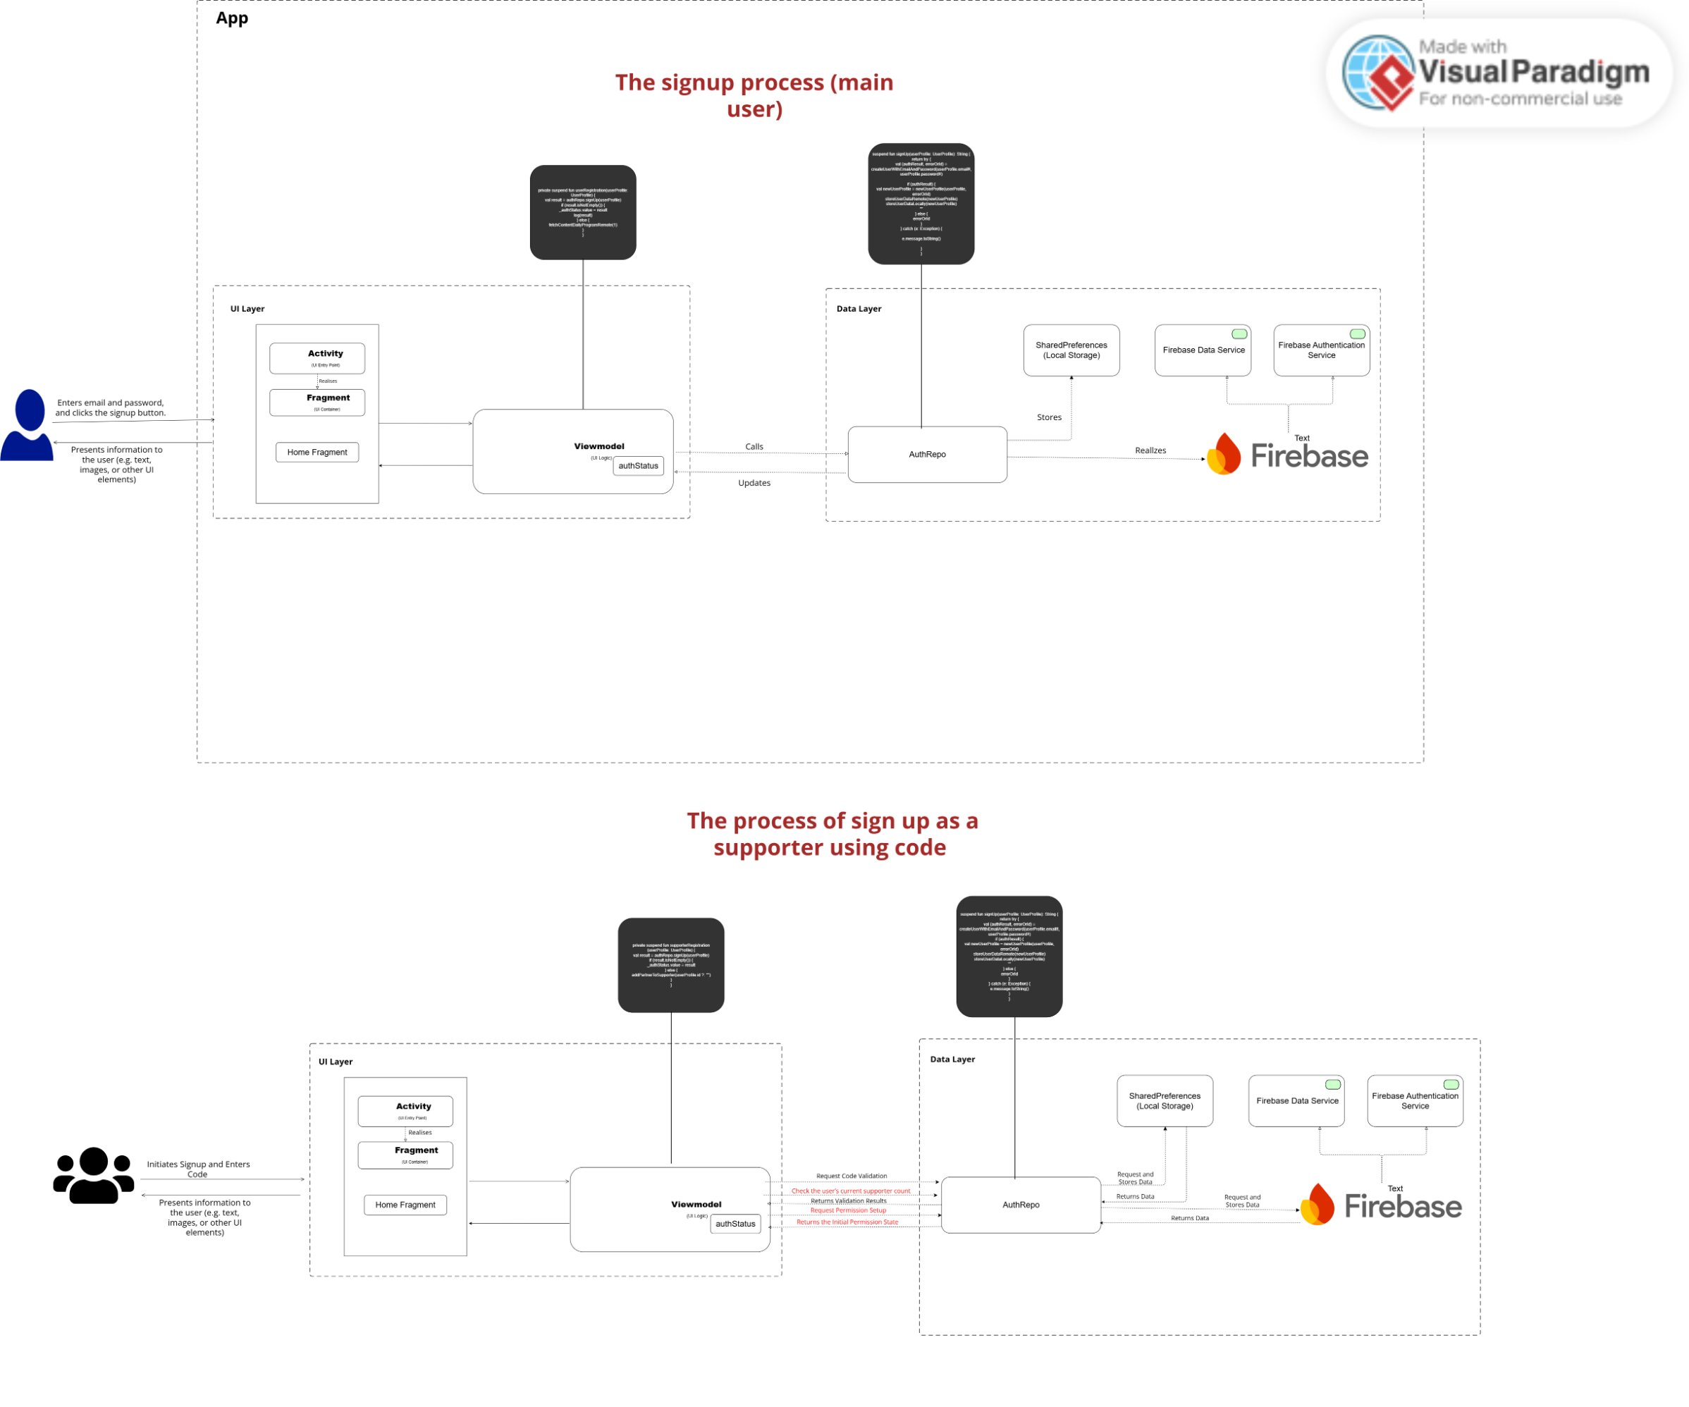
Figure 1 — Main user signup flow: UI Layer (Activity/Fragment) to ViewModel to AuthRepo to Firebase Authentication.

1.2 Supporter Signup via Invitation Code
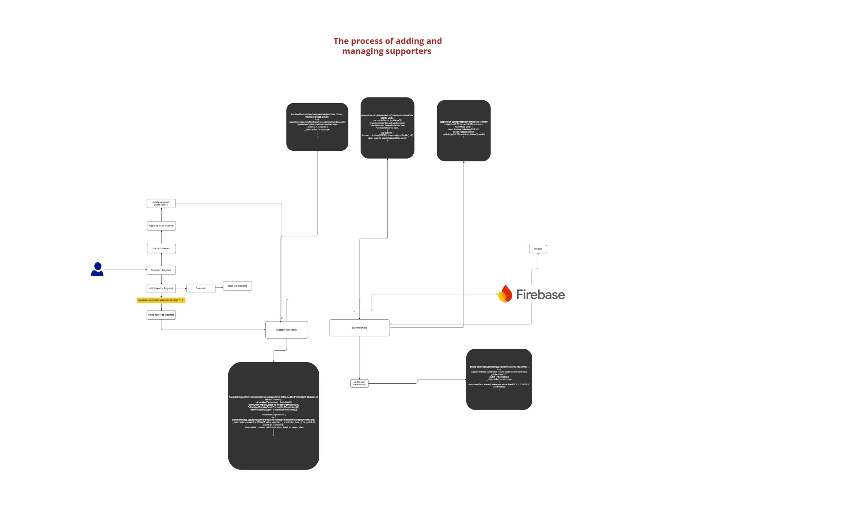
Figure 2 — Supporter onboarding flow using an invitation code, including permission requests handled through AuthRepo.

1.3 Adding and Managing Supporters
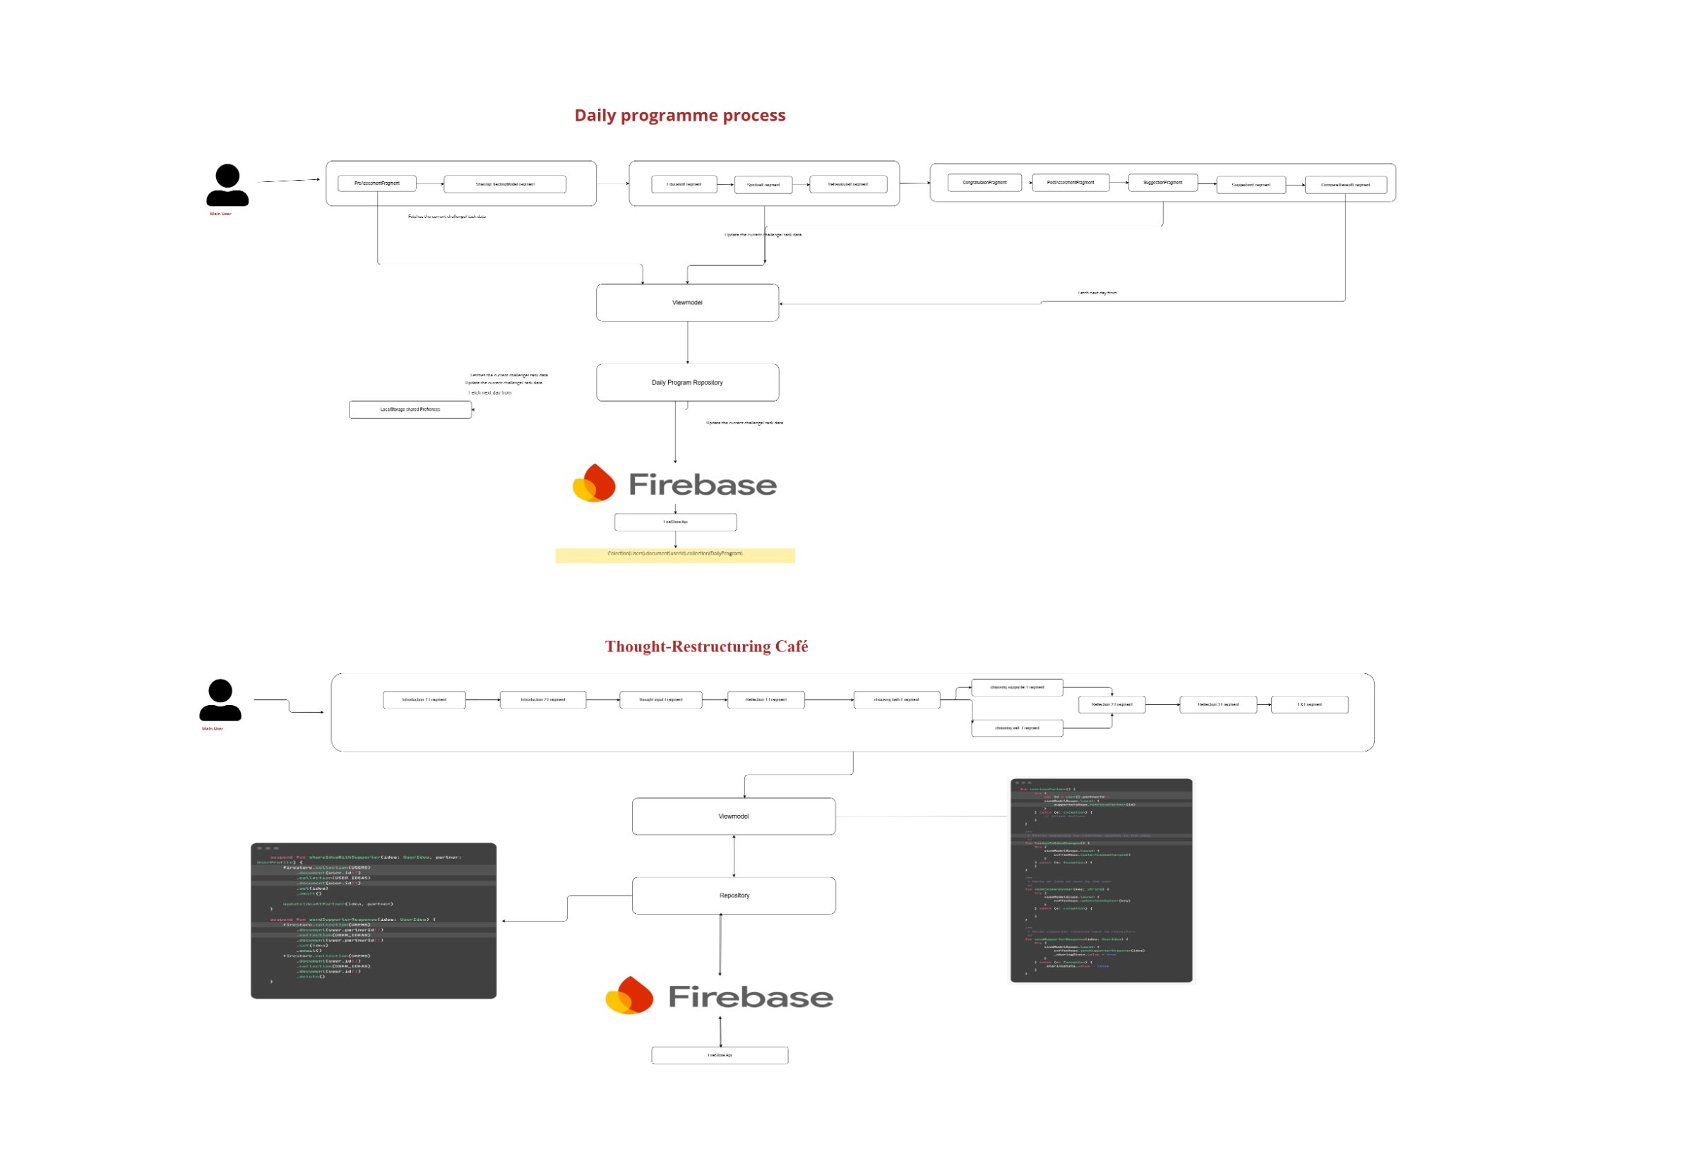
Figure 3 — Flow for inviting, linking, and managing supporter/patient relationships via UsersRepo and Firebase.

1.4 Daily Programme & Thought-Restructuring Café
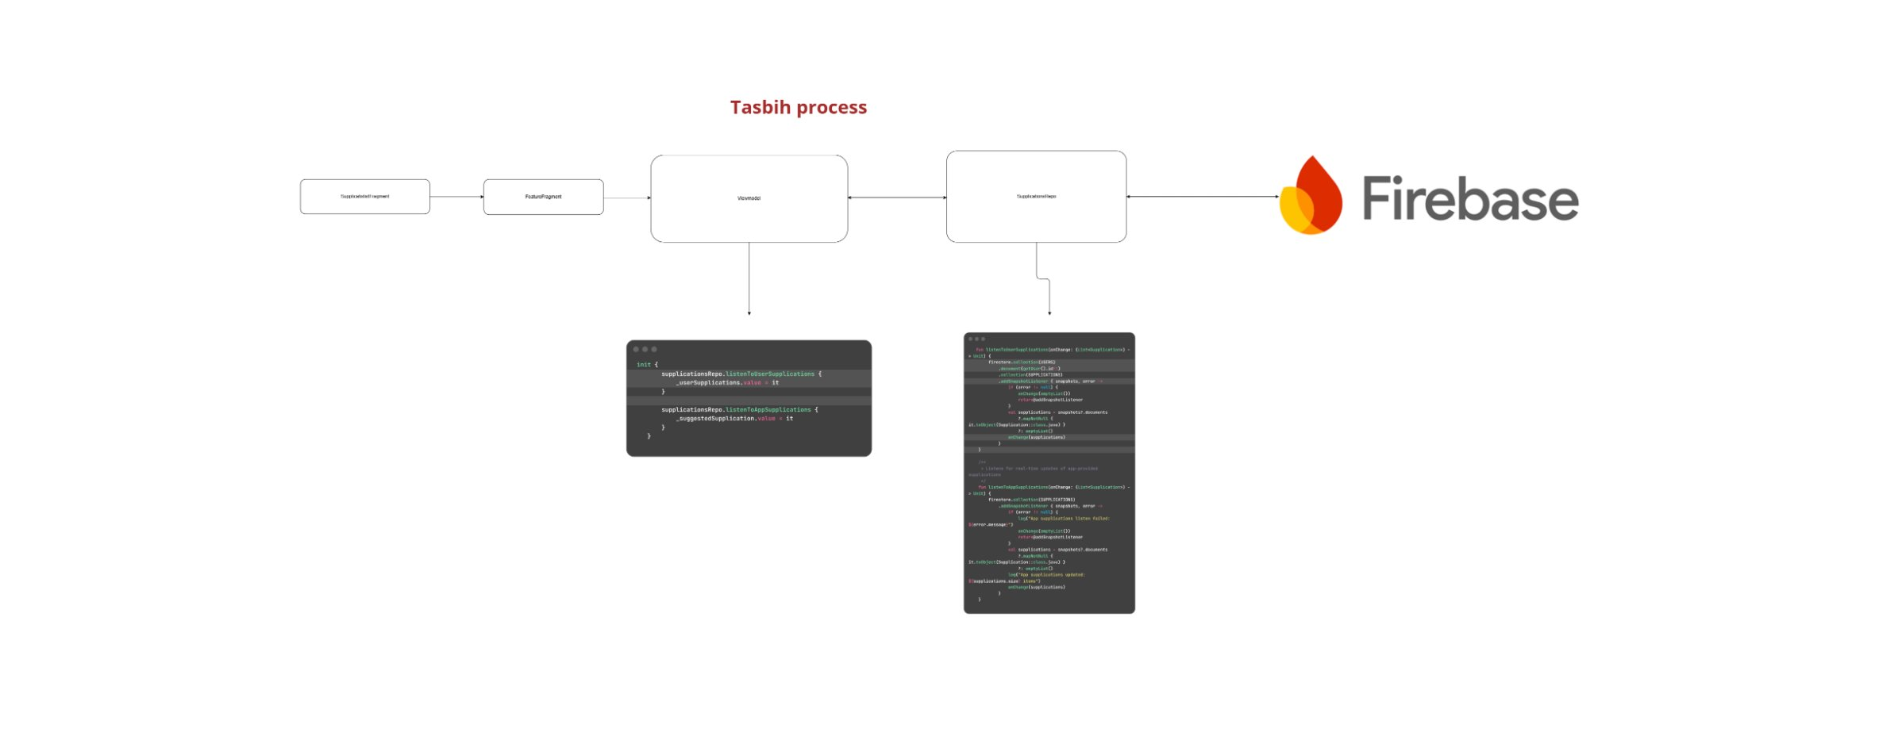
Figure 4 — Daily therapeutic programme delivery and the Thought-Restructuring Café feature, both backed by Firebase.

1.5 Tasbih & Breathing Exercise Process
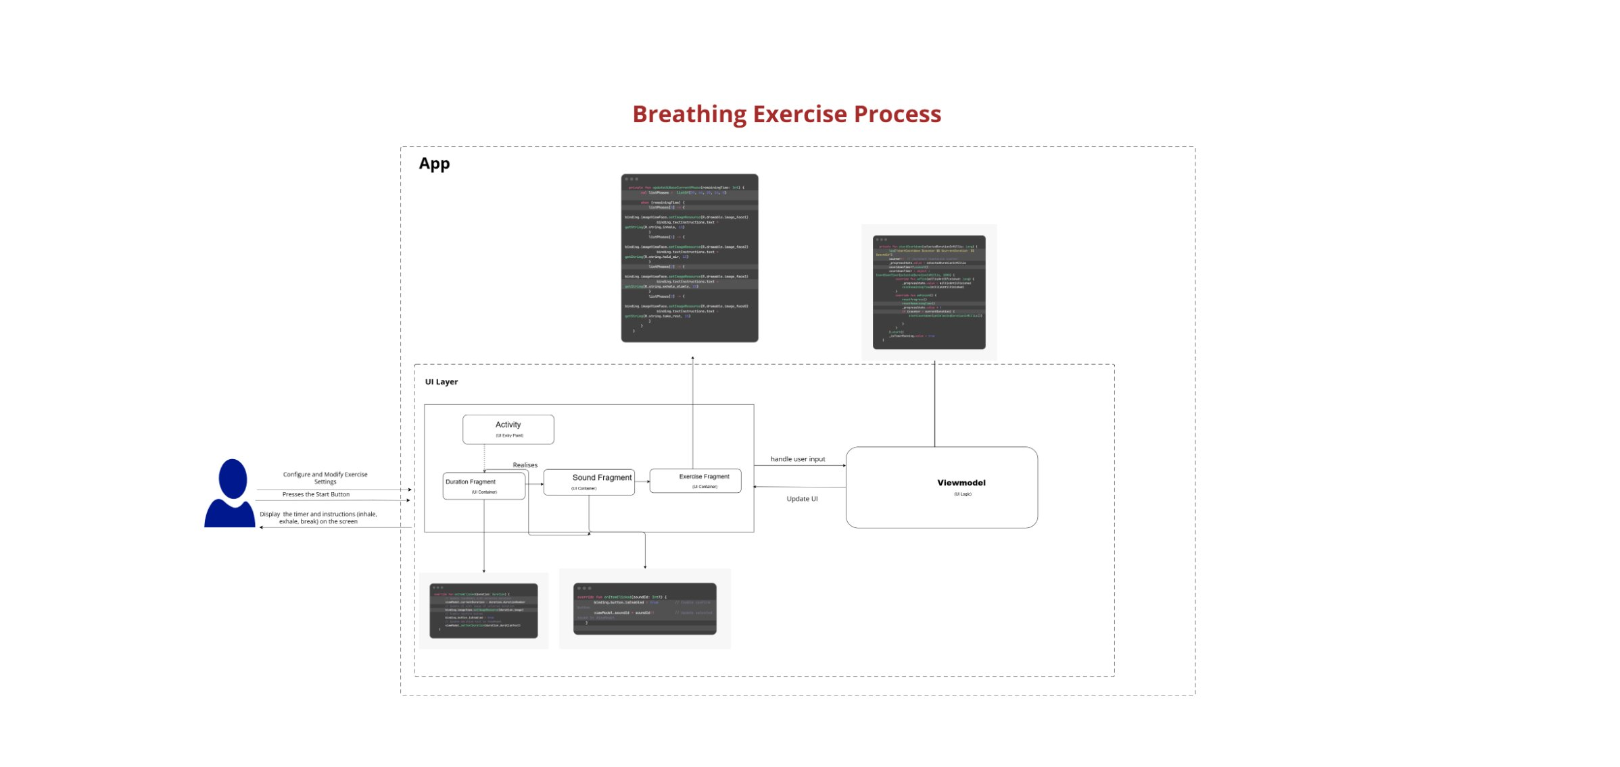
Figure 5 — Tasbih (dhikr counter) flow and the guided Breathing Exercise flow within the UI/ViewModel/Data layers.

1.6 Gratitude Journaling Process
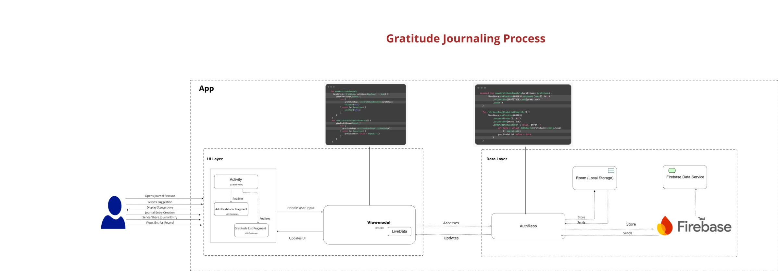
Figure 6 — Gratitude journaling flow, from UI capture through the ViewModel/Repository layer into Firebase and local caching.

2. Build Plugins & Classpaths (Build System)
These definitions govern the gradle execution ecosystem, compiler plugins, code generation pipelines, and external resource resolution classpaths.
Plugin ID / Classpath | Version | Modules Applied | Engineering Role / Description
com.android.application | 8.3.2 | :app | Configures the module as a buildable, runnable Android Application package (.apk/.aab).
com.android.library | 8.1.0 | :data | Configures the module as a reusable, modular Android Library (.aar).
org.jetbrains.kotlin.android | 2.0.20 | :app, :data | Integrates standard Kotlin language and compiler toolchain into Gradle build tasks.
kotlin-parcelize | Implicit | :app | Automates compiler-level Parcelable serialization code generation for Kotlin classes.
com.google.gms.google-services | 4.4.0 (classpath) / 4.3.15 (plugin) | :app | Extracts configuration values from google-services.json to bootstrap Firebase clients.
androidx.navigation.safeargs.kotlin | 2.7.3 (classpath) / Implicit (plugin) | :app | Generates safe, type-guaranteed direction classes to pass arguments across Navigation Graph views.
com.google.devtools.ksp | 2.0.21-1.0.27 | :app | Kotlin Symbol Processing framework for rapid annotation analysis and code generation (Room/Hilt).
com.google.dagger.hilt.android | 2.51.1 | :app | Configures compiler environments for Hilt Dependency Injection generation.
com.google.firebase.crashlytics | 3.0.5 | :app | Gradle hook to upload native symbols and obfuscation mapping files to the Firebase console.

3. Jetpack Core & AndroidX Libraries
Standard Jetpack libraries provided by Google to ensure predictable architecture, lifecycle awareness, backwards compatibility, and smooth visual UI component scaling.
Dependency Notation | Version | Module | Engineering Role / Description
androidx.core:core-ktx | 1.9.0 (app) / 1.17.0 (data) | :app, :data | Provides concise, idiomatic Kotlin extensions (KTX) for core platform API wrappers.
androidx.appcompat:appcompat | 1.6.1 (app) / 1.7.1 (data) | :app, :data | Delivers modern material styles, native ActionBars, and theme managers on legacy Android releases.
com.google.android.material:material | 1.9.0 (app) / 1.13.0 (data) | :app, :data | Renders highly visual components obeying Google's Material Design guidelines.
androidx.constraintlayout:constraintlayout | 2.1.4 | :app | A flexible layout manager allowing flat, performant view arrangements without nested layouts.
androidx.activity:activity | 1.9.0 | :app | Exposes modern Android component hooks to manage layouts, UI overlays, and system back presses.
androidx.recyclerview:recyclerview | 1.3.2 | :app | Highly optimized scrollable container that recycles active Views for fast scroll performance.
androidx.lifecycle:lifecycle-livedata-ktx | 2.6.1 | :app | Provides active lifecycle-aware wrappers around observable models.
androidx.lifecycle:lifecycle-viewmodel-ktx | 2.6.1 | :app | A state preservation engine protecting memory states across configuration changes.
androidx.lifecycle:lifecycle-viewmodel-android | 2.8.3 | :app | Core Android runtime integration layers matching lifecycle ViewModels.
androidx.navigation:navigation-fragment-ktx | 2.7.1 | :app | Decouples fragment transitions into declarative, graph-based configurations.
androidx.navigation:navigation-ui-ktx | 2.7.1 | :app | Integrates bottom menus, drawers, and actionbars with configured Navigation destinations.
androidx.work:work-runtime-ktx | 2.9.0 | :app | Manages guaranteed background execution tasks obeying power, internet, and battery constraints.
androidx.annotation:annotation | 1.6.0 | :app | Exposes structural flags checking thread constraints, asset resource types, and value limits.
androidx.legacy:legacy-support-v4 | 1.0.0 | :app | Backwards compatibility hooks supporting legacy layout components and UI fragments.

4. Firebase Suite & Identity Providers
Handles the cloud-based serverless ecosystem including user accounts, Firestore document models, realtime messaging synchronizations, file buckets, and notifications.
Dependency Notation | Version | Module | Engineering Role / Description
com.google.firebase:firebase-bom | 33.11.0 | :app | Firebase Bill of Materials. Ensures all declared Firebase libraries use aligned, tested versions.
com.google.firebase:firebase-analytics | Managed | :app | Collects detailed telemetry and operational statistics representing user interactions.
com.google.firebase:firebase-auth-ktx | 23.2.0 | :app | Handles registration, sign-in, session validation, and JWT credentials securely in the cloud.
com.google.firebase:firebase-database-ktx | 21.0.0 | :app | A cloud-hosted, real-time NoSQL database keeping app and client values synced in milliseconds.
com.google.firebase:firebase-firestore-ktx | 25.1.3 | :app | Advanced scalable document database offering indexing, transactions, and robust offline queries.
com.google.firebase:firebase-storage-ktx | 21.0.1 | :app | Saves and retrieves heavy static files, user avatars, documents, and other multimedia formats.
com.google.firebase:firebase-messaging | 24.1.1 | :app | Manages downstream push notification signals and cloud messaging alerts.
com.google.firebase:firebase-inappmessaging-display | 21.0.2 | :app | Triggers high-impact dynamic slide-ins, updates, and custom modal prompts on client screens.
com.google.firebase:firebase-crashlytics-ndk | Managed | :app | Captures native C++ architecture crashes for deep stability investigations.
com.firebaseui:firebase-ui-auth | 8.0.2 | :app | Generates pre-optimized, ready-to-use login flows and visual user registration dialogs.
com.firebaseui:firebase-ui-database | 8.0.2 | :app | Binds live Firebase DB query nodes directly to RecyclerView adapters for auto-refreshing feeds.

5. Local Cache & Persistence (Room)
Abstracts low-level SQLite configurations to provide type-safe, compile-time verified local queries and offline state persistence.
Dependency Notation | Version | Module | Engineering Role / Description
androidx.room:room-runtime | 2.6.1 | :app | Manages the local database schema lifecycle, connections, and statement execution managers.
androidx.room:room-ktx | 2.6.1 | :app | Provides coroutines and flow bindings to observe dynamic, live local DB queries.
androidx.room:room-compiler | 2.6.1 (KSP) | :app | Translates @Entity, @Dao, and @Query statements into optimized SQL compilation scripts.

5.1 Room Database Schema — Task Entity
Field | Type | Example
day | String | "1"
nameTask | String | "task1"
image | Integer | Image resource ID
isCompleted | Boolean | true
description | String | "desc task1"

6. Dependency Injection (Dagger Hilt)
Decouples class instantiations, enforces solid architecture, and simplifies code testability by automatically inserting classes at runtime.
Dependency Notation | Version | Module | Engineering Role / Description
com.google.dagger:hilt-android | 2.51.1 | :app | Preconfigured dependency injector engine specializing in modular, clean Android component lifetimes.
com.google.dagger:hilt-compiler | 2.51.1 (KSP) | :app | Build-time generator building dependency factories, scoping layers, and component bindings.

7. Media, Utilities, Networking & Visual Extras
A suite of third-party libraries for media streaming, network operations, asynchronous tasks, image loading, and specific UI calendars/carousel indicators.
Dependency Notation | Version | Module | Engineering Role / Description
org.jetbrains.kotlinx:kotlinx-coroutines-core | 1.7.3 | :app | Core API supporting light threads (coroutines) for asynchronous execution structures.
org.jetbrains.kotlinx:kotlinx-coroutines-android | 1.7.3 | :app | Exposes Android-specific UI thread dispatchers, keeping operations fluid and non-blocking.
com.google.android.exoplayer:exoplayer | 2.16.1 | :app | High-performance modular player for video/audio streams (MP4, HLS, DASH, offline playback).
com.github.bumptech.glide:glide | 4.16.0 | :app | Intelligent media cache and downsampler for loading, formatting, and displaying remote images.
com.google.code.gson:gson | 2.8.6 | :app | Parser library mapping Kotlin objects into JSON representation strings and vice-versa.
com.squareup.okhttp3:okhttp | 4.12.0 | :app | An optimized HTTP client wrapping connection pools, header managers, redirect caches, and sockets.
com.prolificinteractive:material-calendarview | 1.4.3 | :app | A customizable calendar view layout showing schedule selectors, events, and monthly timelines.
com.tbuonomo:dotsindicator | 4.3 | :app | Small stylish layout displaying dot carousels matching sliding screens and page viewers.

8. Quality Assurance & Automated Testing
These dependencies are loaded only during testing configurations to facilitate local unit testing and on-device instrumented UI automated tests.
Dependency Notation | Version | Module | Test Scope | Engineering Role / Description
junit:junit | 4.13.2 | :app, :data | test (Unit) | Core offline JUnit assertion framework for testing classes, logic, and helpers in isolation.
com.google.truth:truth | 1.4.1 | :app | test (Unit) | Google's assertion library providing exceptionally clear, readable test error messages.
androidx.test.ext:junit | 1.1.5 (app) / 1.3.0 (data) | :app, :data | androidTest (UI) | Integrates standard JUnit test execution with Android instrumentation APIs.
androidx.test.espresso:espresso-core | 3.5.1 (app) / 3.7.0 (data) | :app, :data | androidTest (UI) | Automates real user gestures (clicks, sweeps, keystrokes) to test UI flow on devices.
androidx.test:core-ktx | 1.5.0 | :app | androidTest (UI) | Provides clean, declarative Kotlin extension helper methods for instrumentation runners.

9. Project Directory Structure
The application source is organized as a feature-modular package structure inside the :app module, with each feature grouping its data (entity/repo), di (Hilt module), and presentation (Activity/Fragment/ViewModel) layers together.
├── app/
│ ├── MyFirebaseMessagingService.kt
│ ├── data/
│ │ └── AppDatabase.kt
│ ├── di/
│ │ └── AppModule.kt
│ └── presentation/
│ ├── AppViewModel.kt
│ ├── MyApplication.kt
│ └── SplashActivity.kt
├── auth/
│ ├── data/
│ │ ├── entity/
│ │ │ ├── Partner.kt
│ │ │ └── UserProfile.kt
│ │ └── repo/
│ │ └── AuthRepo.kt
│ ├── di/
│ │ └── Di.kt
│ └── presentation/
│ ├── AgeFragment.kt
│ ├── AuthActivity.kt
│ ├── AuthViewModel.kt
│ ├── GenderFragment.kt
│ ├── LanguageFragment.kt
│ ├── LoginFragment.kt
│ ├── MainAuthFragment.kt
│ ├── SignUpFragment.kt
│ └── VerificationEmailFragment.kt
├── base/
│ ├── BaseActivity.kt
│ ├── BaseBottomSheetDialogFragment.kt
│ ├── BaseDialogFragment.kt
│ ├── BaseFragment.kt
│ ├── BaseViewModel.kt
│ └── LisetnerViewModel.kt
├── chatting/
│ ├── data/
│ │ ├── entity/
│ │ │ ├── Chatting.kt
│ │ │ ├── Message.kt
│ │ │ └── MetaDataMessages.kt
│ │ └── repo/
│ │ └── ChattingRepo.kt
│ ├── di/
│ │ └── DI.kt
│ └── presintation/
│ ├── ChatActivity.kt
│ ├── ChatFragment.kt
│ ├── ChatViewModel.kt
│ ├── ChooseUserToChatFragment.kt
│ ├── MessagesAdapter.kt
│ ├── MessagesListAdapter.kt
│ ├── MessagesListFragment.kt
│ └── SupportersChattingAdapter.kt
├── getLibraryContent/
│ ├── data/
│ │ ├── DepressionMisconception.kt
│ │ ├── DepressionMisconceptionRepo.kt
│ │ ├── LibraryContent.kt
│ │ ├── LibraryContentRepo.kt
│ │ └── LibraryDao.kt
│ ├── di/
│ │ └── LibraryDi.kt
│ └── presentaion/
│ ├── ArticleFragment.kt
│ ├── CommonContentFragment.kt
│ ├── CommonContentLibraryAdapter.kt
│ ├── CustomizedContentFragment.kt
│ ├── CustomizedContentLibraryAdapter.kt
│ ├── LibraryActivity.kt
│ ├── LibraryContentFragment.kt
│ ├── LibraryViewModel.kt
│ ├── MisconceptionAdapter.kt
│ ├── MisconceptionsAboutDepressionFragment.kt
│ └── SuggestedContentFragment.kt
├── interfaces/
│ ├── DataReLoader.kt
│ ├── ItemMessagesListClicked.kt
│ ├── ItemPostsClicked.kt
│ ├── ItemStepsClicked.kt
│ ├── ItemSupplicationClicked.kt
│ ├── OnConfirmButtonClicked.kt
│ └── OnItemLibraryContentClicked.kt
├── model/
│ ├── CurrentTask2.kt
│ ├── DataPatient.kt
│ ├── DayTask.kt
│ ├── Duration.kt
│ ├── Partner.kt
│ ├── Permissions.kt
│ ├── StatusDailyProgram2.kt
│ ├── Step.kt
│ ├── Supplication.kt
│ ├── SupplicationsUser.kt
│ ├── Task.kt
│ └── TestD.kt
├── notifications/
│ ├── DI.kt
│ ├── data/
│ │ ├── entities/
│ │ │ └── Notification.kt
│ │ └── repos/
│ │ └── NotificationsRepo.kt
│ └── presentation/
│ ├── NotificationsAdapter.kt
│ ├── NotificationsFragment.kt
│ └── NotificationsViewModel.kt
├── numbersHelping/
│ ├── HelpingAdapterAdapter.kt
│ └── NumberHelpingFragment.kt
├── posts/
│ ├── OnSendButtonClicked.kt
│ ├── data/
│ │ ├── entity/
│ │ │ ├── Post.kt
│ │ │ └── Posts.kt
│ │ └── repo/
│ │ └── PostsRepo.kt
│ ├── di/
│ │ └── DI.kt
│ └── presentation/
│ ├── ChooseSupporterFragment.kt
│ ├── ChooseSupportersAdapter.kt
│ ├── DisplayArticleFragment.kt
│ ├── DisplayGratitudeFragment.kt
│ ├── DisplaySupplicationFragment.kt
│ ├── PostsActivity.kt
│ ├── PostsAdapter.kt
│ ├── PostsFragment.kt
│ └── PostsViewModel.kt
├── users/
│ ├── data/
│ │ ├── entity/
│ │ │ ├── InvitationCode.kt
│ │ │ └── ReligionData.kt
│ │ └── repo/
│ │ └── UsersRepo.kt
│ ├── di/
│ │ └── DI.kt
│ └── presentation/
│ ├── EditProfileActivity.kt
│ ├── EditProfileViewModel.kt
│ ├── FragmentAddSupporter.kt
│ ├── ProfileFragment.kt
│ ├── SettingsFragment.kt
│ ├── SupporterDetailsFragment.kt
│ ├── SupporterHomeFragment.kt
│ ├── SupportersFragment.kt
│ └── UserHomeFragment.kt
└── util/
├── ClickShrinkEffect.kt
├── ConnectionReceiver.kt
├── Constant.kt
├── CustomToast.kt
├── Extension.kt
├── Resource.kt
└── SharedPreferencesManager.kt

10. Database Schema

10.1 Firestore Database Schema

10.1.1 Daily Program Schema
Collection: daily_program — Document: 1 (e.g., day-1)
- behaviorActivation (Array of Map): ageGroup, arDescription, arTitle, enDescription, enTitle, gender, id, image, link, religion, type
- educational (Array of Map): ageGroup, arDescription, arTitle, enDescription, enTitle, gender, id, image, link, religion, type
- spiritual (Array of Map): ageGroup, arDescription, arTitle, enDescription, enTitle, gender, id, image, link, religion, type

10.1.2 Supplications Schema
Collection: supplications
- User-created — Document: user-id → Array of Map { name: String, number: Number }
- Application-provided — Document: app → Array of Map { name: String, number: Number }

10.1.3 User Profile Schema
Collection: profiles_users — Document: userId_1 (e.g., user12345)
- email, id, name, partnerEmail, partnerId, imageUser: String
- gender, ageGroup, status: Number
- religion, invitationUsed, hasPartner, allowDailyProgramDetails, allowMoodTrackingDetails, allowPrivateMessages: Boolean
- token, invitationBase, invitationCode, supportersNumber, currentDay: String

10.1.4 Posts Schema
Collection: posts — Document: email_1 (e.g., ali@gmail.com)
- posts (Array of Map): postIndex (Number), timeStamp (DateTime), type (String)
- supports (Map of supporter emails), seen_list (Map of viewer emails)
- gratitude (Map): answer (String), index (String), timeStamp (DateTime)

10.1.5 Images Schema
Collection: images — Document: user_id → { imageUrl: String }

10.1.6 Chats Schema
Collection: chats — Document: user_id
- messages (Array of Map): seenByCaregiver, seenByPatient (Boolean); senderId, timeStamp, text (String)
- meta (Object): idCaregiver, idPatient, imageCaregiver, imagePatient, nameCaregiver, namePatient

10.2 Realtime Database Schema

10.2.1 Library Content Schema
Root Node: library_contents → Node: id (e.g., 0)
- id (Integer), date, category, backgroundColor, enText, arDescription, enDescription, arTitle, enTitle, subCategory, type, duration, imageURL, videoURL, audioURL (String)
- rate, viewCount (Integer); religion (Boolean)

10.3 Room Database Schema
See Section 5.1 — Task Entity.

11. External Resources Used
Resource Name | Description | Link
iLoveIMG Crop Image | Online image cropping tool used for resizing and cropping images. | iloveimg.com/crop-image
Image Color Picker | Tool used to identify and extract color codes from images. | imagecolorpicker.com
Remove.bg | AI-powered tool used to remove image backgrounds automatically. | remove.bg

