Empirical Study

Python调用图的empirical
Python调用图工具的对比分析，为不同应用场景进行分析
- Python调用图的构造方程与unsound之间的关系，参考论文：Systematic Evaluation of the Unsoundness of Call Graph Construction Algorithms for Java
难点：Python调用图的构造方程没有
- Github上python调用图构建工具是否sound
sound： A call graph is sound if it safely approximates any program execution

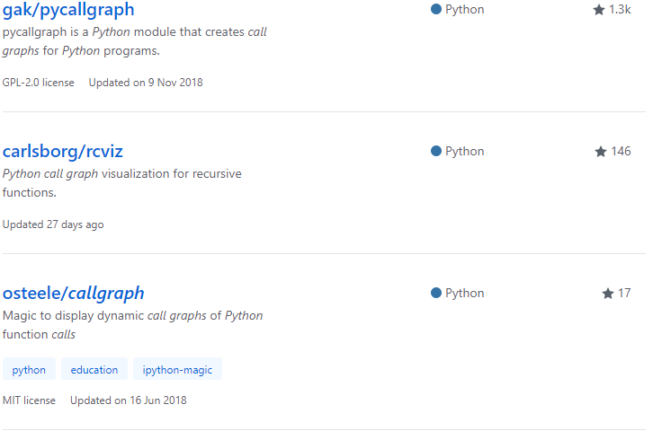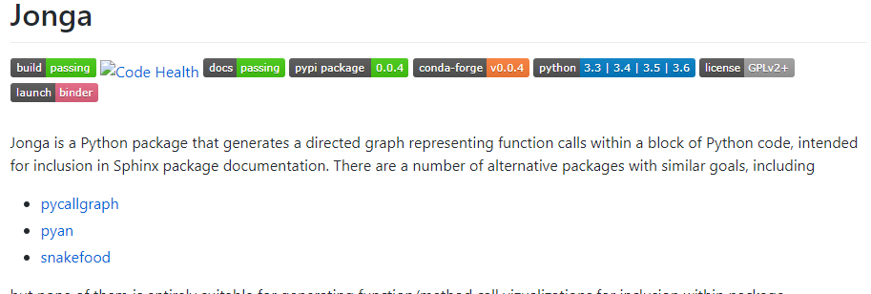

RQ
整体框架
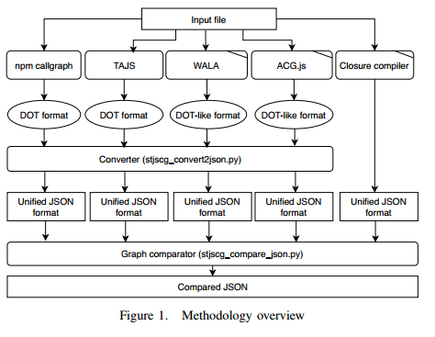
RQ1 不同工具生成的调用图边的重合度，可以比较工具
- 构造方法的问题（方法级别、函数或类级别；定义-使用）
从工具描述（可能涉及到代码）上，按节点级别、实现方法等分类
Codeflow：function级别，不考虑继承等，实现方法：Code2flow will sweep through your project source code looking for function definitions. Then it will do another sweep looking for where those functions are called
Pyan：function/method级别，import可能会出错等
注：通过对一个简单文件的生成调用图对比，发现code2flow会比pyan生成的边少。
- 相似的方法是否构造相似的调用图（应该是）

RQ2 不同工具与baseline的比较 回答好不好的问题
- 性能（耗时）
对同一项目，不同工具构造调用图的耗时情况
- 工具的覆盖率
与baseline对比，不同工具包含了哪些边
- 工具的误报率（包括有争议的边，这些边由人工审查）
与baseline对比，不同工具多生成的边，这些边应该由人工审查，最终区分开错误的边和动态执行未覆盖到的边（争议的边）
- python的语言特性（哪些可以解决，哪些不能解决）
  - 多个项目下，同一工具为什么效果不一样（对python的代码分类统计）
Python代码可能分类：
继承：class A(B)
调用库：import os
项目外调用：在tensorflow项目中，某文件import numpy.zeros
项目内跨文件调用：在tensorflow项目中，某文件import tensorflow.python.framework import ops
文件内调用： input_tensors, shape = _flatten_tensors(input_tensors) _flatten_tensors在该文件中定义
Lambdas：lambda x, y: x*y（一般只会被认为是语句，而不是函数）
Class
Method（参数和返回值）
Function（参数和返回值）：

RQ3 工具设计与具体任务的关系
Call graphs are a central data-structure required by many static analyses which range from the detection of unused methods to advanced control- and data-ﬂow analyses.
Software Understanding
Optimizations

Python调用图应该参考的工具有哪些？

开放性问题：
Does the extractor have constraints that are acceptable to the engineer?
Are the design decisions made clear to the engineer?

可能的代码
比较调用图：Comparing Call Graphs

工具
静态调用图工具：
pyan：a Python module that performs static analysis of Python code to determine a call dependency graph between functions and methods
https://github.com/davidfraser/pyan
code2flow: A call graph generator for Python and Javascript programs that uses Graphviz（function）
https://github.com/scottrogowski/code2flow
Code2flow is especially useful for untangling spaghetti code and getting new developers up to speed.
Spaghetti code is a pejorative phrase for unstructured and difficult-to-maintain source code. Spaghetti code can be caused by several factors, such as volatile project requirements, lack of programming style rules, and insufficient ability or experience.
jonga：
https://github.com/bwohlberg/jonga

动态调用图工具：
pycallgraph：a Python module that creates call graphs for Python programs.
https://github.com/gak/pycallgraph
callgraph：display dynamic call graphs of Python function calls
https://github.com/osteele/callgraph

备选
Static call graph construction tool：pyan、snakefood、
//https://github.com/vadivelmurugank/calltree
https://github.com/nccgroup/call_map
https://github.com/davidfraser/pyan
https://github.com/scottrogowski/code2flow python2 code2flow cyl.py
http://furius.ca/snakefood/
gprof2dot : A call graph generator written in Python that converts profiling data for many languages/runtimes to a Graphviz callgraph

静态分析框架型工具：
https://github.com/bdarnell/plop
https://github.com/davidhalter/jedi

实验项目
TensorFlow, Keras, PyTorch
机器学习：Scikit-learn，Pylearn2，NuPIC，Nilearn，PyBrain，Fuel，MILK
应用：FastText，youtube-dl，Magenta，Style2Paints，Sonnet，fast-style-transfer

实验步骤
- 使用工具生成调用图，并输出统一格式的json文件
- Code2flow Code2flow will sweep through your project source code looking for function definitions. Then it will do another sweep looking for where those functions are called
- Arrays of functions are not handled
- The logic for whether or not a function returns is simply looking for 'return' in that function
- Functions not declared in the initial class/object definitions (e.g. attached later) are mostly not handled
- Dynamically generated and lambda functions are mostly not handled
- In python, functions inherited from a parent class are not handled
- In python, import ... as ... is not handled correctly
 | 节点类型 | 实现方法 | 是否适用于大型项目
Code2flow | Function | 文本 | 否
Pyan |  | Ast
Jonga

已有工作中的结论
- Java调用图source of unsoundness
- APIs that are not or only partially modeled (e.g. Reflection or Unsafe)
- new language features, such as Lambdas
- corner cases that must be covered
- the test suite is not complete

pip install pylint pyreverse会生成uml类图https://blog.csdn.net/u013920085/article/details/53285288

An Empirical Study of Static Call Graph Extractors（ICSE 1996）
该论文通过研究静态分析器执行的情况，为工具设计者design decision的一些建议，为工具使用者在使用场景考虑时提供一些建议。
研究问题：
- 系统地分析不同工具的设计空间design space，为软件工程的使用者提供一个可选集合（与software engineering tasks有关）
- selecting an extractor for a particular task，
quantitative study:
- Quantitative Comparison to the Baseline
- Quantitative Comparison of Overlap among the Graphs
定性分析结果：
- The expectation that extractors built from similar technology will extract similar call graphs thus does not hold.(campare with the baseline)
- how does a software engineer know if a call graph extracted with a particular tool has the appropriate characteristics?（对不同工具与不同baseline上的比较之后被分类，如no false positive）结果说明不同baseline上的分类不同，使得无法提供这一信息（against the expectation）。

An Empirical Study of Java Dynamic Call Graph Extractors（similar to the above paper）

调用图论文综述

术语
过程间控制流图（interprocedural control flow graph）
过程间分析（interprocedural analysis）
面向对象语言的构建调用图问题：类型信息的更改
Sound（可靠性）：A call graph is sound if it safely approximates any program execution
A call graph that represents only a particular execution of a program is said to be optimistic.
构建方程：笛卡尔积方程The Cartesian Product Algorithm (CPA)
Most class analyses construct the call graph on the fly during the analysis
a call graph is the relation describing exactly those calls made from one entity to another in any possible execution of the program

上下文敏感（context-sensitive）：指的是在过程间分析（Interprocedural Analysis）时，考虑函数调用的上下文信息。一个子过程或函数可能会被多个过程调用，那么在不同的过程调用它的时候，对于传给它的实际参数或当时的全局变量有可能会不同，这些被称之为上下文，上下文敏感是考虑了这些不同

循环依赖的原因：
控制流——数据流
过程间分析——调用图
可能的解决方法：

调用图——面向对象
Determining the call graph for a procedural program is fairly simple.However, this is not the case for programs written in objectoriented languages, due to polymorphism.

基于类型的调用图构造
Name-Based Resolution(RA)：主要的挑战在于方法调用的动态绑定的行为，if a method is reachable, and a call site c : e.m(. . .) occurs in its body, then every method M with name m is reachable from c.Finally, rule RAREACHABLE states that any method M reachable from a call site c is contained in the set R of reachable methods.
Implementation：

Class Hierarchy Analysis (CHA)：类层次结构分析通过使用方法调用的接收者表达式的静态类型并结合类层次结构信息来确定可以从调用站点调用哪些方法，从而改进基于名称的解析。
Class Hierarchy Analysis [Dean et al. 1995] improves upon namebased resolution by using the static type of the receiver expression of a method call in combination with class hierarchy information to determine what methods may be invoked from a call site. Following the notation of Tip and Palsberg [2000], we use StaticType(e) to denote the static type of an expression e, and StaticLookup(C, m) to denote the method definition that is invoked when method m is invoked on an object. with runtime type C. If a method is reachable, and a call site c : e.m(. . .) occurs in the body of that method, then every method Mwith name m that is inherited by a subtype of the static type of e is reachable from c.
Rapid Type Analysis (RTA):快速类型分析，CHA loses precision because, effectively, it assumes for a method call e.m(· · · ) that all subtypes of the static type of e may arise at runtime. The set contains the classes that are instantiated in a reachable method.实例化的方法最常用的是new方法。A receiver can only have a type of an object that has been instantiated via a new.快速类型指通过new实例化的类型，使用快速类型代替运行时类型。快速类型弊端：别名和执行路径并没有被考虑进去。
Reaching type Analysis
内容：http://people.cs.vt.edu/~ryder/oosem99/talks/fzeng-virtcall-hendren.pdf
- Framework
- Building a type propagation graph
- Initializing the graph with type information generated by new() statements
- Propagating type information along directed edges
- Terminology
- Representative(o): each receiver o is associated with some node in the type propagation graph, called representative(o)
- Reaching_types(n): after type propagation each node n is associated with a set of types, called reaching_types(n)

- Variable-type Analysis
对于类中每个方法，方法中的参数、局部变量、this、return作为节点。
边包括赋值、方法调用。
别名问题：Ordinary references、Field references、Array reference（有问题）
e.g. A[] a = new A[10]; Object o1 = a;Object o2 = o1; A[] b = (A[]) o2; */
Solution: when adding edges for assignments of the form lhs = rhs, where both sides are of type java.lang.Object, or when at least one side has an array type, edges are added in both directions between the representative of rhs and lhs.
- Initialization
For each statement of the form lhs = new A(); or lhs = new A[n] , add type A to the
Reaching types set of representative node for lhs.
- propagation
Phase 1: Collapse strongly-connected components
Phase 2: Propagation on the DAG (single pass, breadth-first)
Complexity: Both detecting Stronglyconnected components and propagation have O(max(N,E)) operations, the most expensive of which is a union of two ReachingType sets.
- Declared-type Analysis
--- Similar to variable-type analysis,
--- the declared type of the variable instead of the variable name is used as the representative.Thus, basically it is like putting all
variables with the same declared type into the same equivalent class
--- faster but more imprecise

基于流分析的调用图构造
通过静态的追踪数据或者对象的流向，来确定调用图。控制流、数据流、也会使用到静态类型信息（如果有的话）。
propagation-based analyses：this is achieved by associating sets of abstract values
(each representing a set of runtime values) with program expressions, modeling runtime dataflow as inclusion constraints between these sets, and solving the resulting constraint system. If each expression is associated with a single set of abstract values, the analysis is monovariant, whereas polyvariant analyses use multiple sets to capture the possible values of an expression in different contexts to improve precision.
可能的问题。For Java, an important remaining obstacle is the fact that most propagation-based analyses require that the entire program is available and hence have to analyze the massive standard libraries

调用图——函数式编程
Scheme

调用图——脚本式编程
JavaScript

调用图——动态类型语言

调用图——静态类型语言

Points-to analysis
Points-to analysis (PTA) is aimed at determining the set of locations a location may point to.
In general, different algorithms identify a superset of the real set of locations that will be actually pointed by the given pointer.
flow-insensitive 方程：Impact of Function Pointers on the Call Graph &&Program Analysis and Specialization for the c program language

Pointer Alias Analysis Algorithms
- Address Taken
• Basic, fast, ultra-conservative algorithm
– flow-insensitive, context-insensitive
– often used in production compilers
• Algorithm:
– Generate the set of all variables whose addresses are assigned to another variable.
– Assume that any pointer can potentially point to any variable in that set.
• Complexity: O(n) - linear in size of program
• Accuracy: very imprecise
- Andersen’s Algorithm
- Steensgaard’s Algorithm

In the Points-to analysis there are some categories. Flow-sensitive vs. flow-insensitive、Context-sensitive vs. context-insensitive、Field-sensitive vs. field-insensitive、Directional vs. symmetric（Directional analyses(also referred to as subset-based analyses) treat assignments as unidirectional flow of values while symmetric analyses (referred to as unification-based analyses) treat assignments as bidirectional）
The FA analysis identifies pairs of aliases, i.e. multiple names for the same memory location.For example, after the statement p=&x, *p and x are aliases because they denote the same
memory location.

C语言构造
An Empirical Study of Static Call Graph Extractors ISCE1996
集成在的系统：mapmaker, mosaic, and gcc（baseline）
工具：cflow, cawk, CIA, Field,GCT, Imagix, LSME, Mawk, and Rigiparse
论文：Precise Call Graphs for C Programs with Function Pointers
主要的问题：函数指针指向
Simple answer: any function whose address is taken could possibly be called
– Can try to restrict only to functions that “match” the types at the call site; be careful … .e.g., void *xmalloc(size_t)
• Need interprocedural points-to analysis
– Need a call graph! (flow of pointer values through parameter passing and procedure return values)
• Simple solution
– Conservative call graph based on address-taken
– Do points-to analysis
– Re-compute the call graph using points-to information
• Or, call graph construction during points-to analysis
– Start without any knowledge of f.p. calls
– When a f.p. “shows up” in Pt(fp) at a call (*fp)(…), resolve it and update the points-to solution
– Theoretically more precise; hard to design/implement

Javascript的调用图构建
Points-to analysis
Context sensitivity

field-based flow analysis
A points-to analysis technique that, like RFT-reachability, handles field accesses by checking only for matching fields is known as a field-based analysis.
Efficient Construction of Approximate Call Graphs for JavaScript IDE Services
悲观：只考虑过程间流
乐观：考虑过程间流和过程内流
Intraprocedural Flow：处理赋值情况
Intraprocedural Flow

Scala的调用图构建
Scala是一种和Java相像的语言，在构建中也可以采用RA、RTA等方法。（静态类型）
Scala的主要特性：Traits、Abstract Type Members、Closures、Calls on the Variable this、Bytecode-Based Analysis
Trait Composition Analysis (TCA)：

评估方法
Systematic Evaluation of the Unsoundness of Call Graph Construction Algorithms for Java

构建调用图

A framework for call graph construction algorithms
根据不同应用场景构建调用图
流敏感、上下文敏感、域敏感
调用图构造、过程间类分析（因为上下文敏感）
调用图的节点被认为是一个轮廓，
抽象地说，每个轮廓包含三个组成部分:一个标识符，该标识符对构成轮廓的程序所表示的内容进行编码;一种对轮廓所应用的上下文进行编码的轮廓键;并分析在轮廓键编码的上下文中与程序构造相关联的信息。通常，用等高线表示的程序构造是程序的过程。然而，如下所述，轮廓还可以用来表示类和实例变量，以获得对多态数据结构的上下文敏感的分析。在示例程序中，确定从A调用的sumArea只能调用Circle类的area方法(不能调用Square::area)，并且需要使用类和实例变量轮廓来更精确地表示通过第一个类的值流
节点：过程的分析时表示
上下文敏感的含义：
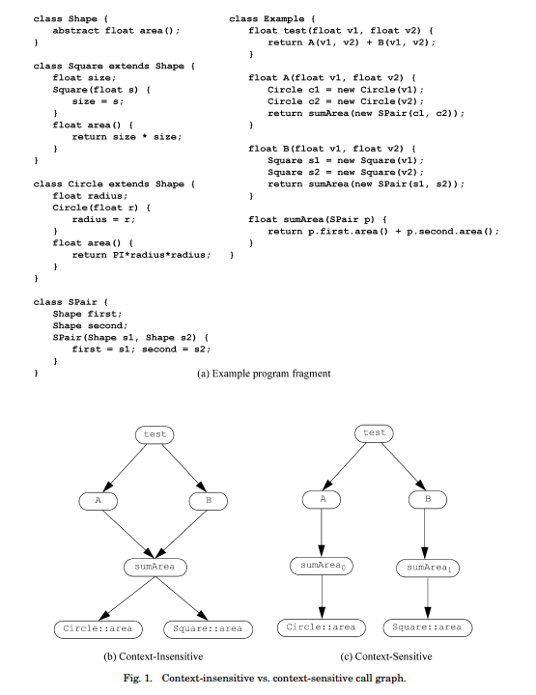

为了更精确地分析多态数据结构（包括数组类），一些过程间类分析算法在对类和实例变量内容的分析中引入了额外的上下文敏感性。例如，通过将类的不同实例化站点视为导致具有不同实例变量轮廓的不同（分析时间）类，分析可以模拟模板或参数化类型的效果，而无需依赖源程序中的显式参数化。因此，在分析期间可以通过多个类轮廓来表示单个源级类。类轮廓不包含任何其他分析信息，因此仅包含类标识符和轮廓键。在文献中，使用多类轮廓有时被描述为带有其创建点的标记类。所有先前描述的类信息，例如在过程和实例变量轮廓中记录的类集，被概括为类轮廓信息。

过程轮廓包含形式参数、局部变量和过程结果的类集
通过Spair类的实例变量精确地建模值流，
全局作用域不能被上下文敏感地分析，上下文敏感只在局部变量间分析

调用图域所有元素未必是可靠的。
上下文敏感的算法引入相互递归的定义，可能使得调用域无限大
调用图的框架（该调用图是上下文敏感的）
四个轮廓键选择功能
- 过程轮廓键选择功能（PKS）定义了算法的过程上下文敏感性策略。 它的参数是专门用于调用过程的轮廓，一个调用站点标识符，作为实际参数传递的类轮廓集，以及被调用者过程。 它返回一组过程轮廓键，指示应该用于分析此调用的被调用程序的轮廓。 如果呼叫站点有多个可能的被调用程序，则分析将通过为每个潜在被调用者调用一次PKS函数来依次为每个调用轮廓键。
- 实例变量轮廓键选择功能（IVKS）与类轮廓键选择功能协作以定义算法的数据结构上下文敏感性策略。 IVKS负责确定应该用于分析特定实例变量加载或存储的实例变量轮廓集。它的参数是被访问的实例变量和加载或存储的基表达式（正在访问其实例变量的对象）的类轮廓集。它返回一组实例变量轮廓键。
- 类轮廓键选择功能（CKS）确定应创建的类轮廓，以表示在类实例化站点创建的对象。它的参数是实例化的类，实例化站点和包含实例化站点的过程轮廓。它返回一组类轮廓键。
- 环境轮廓键选择功能（EKS）确定应使用词法封闭过程的哪些轮廓来分析对闭包中包含的自由变量的任何引用。它的参数是实例化的闭包和分析实例化的过程轮廓。它返回一组程序轮廓键序列，用于编码词法嵌套关系。当一个类轮廓代表一个闭包，到达应用程序站点时，此信息用于初始化为分析应用程序而创建的任何轮廓的词法父信息（ProcID的第三个组件）（请参见图8中的ACS函数）。
论文中定义了每一种类型语句的语法和定义，

循环依赖和解决办法
In object-oriented languages, the potential target method(s) of many calls cannot be precisely determined solely by an examination of the call site source code. The problem is that the target methods that will be invoked as a result of the message send are determined by the classes of the objects that reach the message send site at runtime, and thus act as receivers for the message. In general, the flow of objects to call sites may be interprocedural, and thus precisely determining the receiver class sets needed to build the call graph requires an interprocedural data and control flow analysis of the program. But interprocedural analysis in turn requires that a call graph be built prior to the analysis being performed. There are two possible approaches for handling the circular dependencies among the receiver class sets, the program call graph, and interprocedural analysis:

We can make a pessimistic (but sound) assumption. This approach breaks the circularity by making a conservative assumption for one of the three quantities and then computing the other two. For example, a compiler could perform no interprocedural analysis, assume that all statically type-correct receiver classes are possible at every call site, and in a single pass over the program construct a sound call graph. Similarly, intraprocedural class analysis could be performed within each procedure (making conservative assumptions about the interprocedural flow of classes) to slightly improve the receiver class sets before constructing the call graph. This overall process can be repeated iteratively to further improve the precision of the final call graph by using the current pessimistic solution to make a new, pessimistic assumption for one of the quantities, and then using the new approximation to compute a better, but still pessimistic, solution. Although the simplicity of this approach is attractive, it may result in call graphs that are too imprecise to enable effective interprocedural analysis.
—We can make an optimistic (but likely unsound) assumption, and then iterate to a sound fixed-point solution. Just as in the pessimistic approach, an initial guess is made for one of the three quantities giving rise to values for the other two quantities. The only fundamental difference is that because the initial guess may have been unsound, after the initial values are computed further rounds of iteration may be required to reach a fixed point. As an example, many call graph construction algorithms make the initial optimistic assumption that all receiver class sets are empty and that the main routine1 is the only procedure in the call graph. Based on this assumption, the main routine is analyzed, and in the process it may be discovered that in fact other procedures are reachable and/or some class sets contain additional elements, thus requiring further analysis. The optimistic approach can yield more precise call graphs (and receiver class sets) than the pessimistic one, but is more complicated and may be more computationally expensive

悲观调用图不考虑过程间分析，不考虑回调函数，乐观调用图从一个空调用图开始，迭代到一个定点，会对回调进行推理。
我们将程序的主程序定义为所有程序入口点和静态数据初始化的并集。

Evaluation of Static JavaScript Call Graph Algorithms
过程间流
计算调用图的评估是通过比较计算调用图和动态调用图来完成
如何获取动态调用图？
获取程序的精确调用图是一个不可决定的问题，一个理想的调用图是所有可能的动态调用图的并集。
静态调用图的问题：动态绑定意味着需要过程间流，过程间流也需要调用图
流敏感：分析过程中考虑过程内控制流信息
流不敏感：不考虑过程内流信息
典型术语：保守型和可靠性
JavaScript调用图计算采用的方法：类层次化结构
类层次结构使用类型信息构建调用图，
三个与循环相关的量：receiver类、调用图、程序间分析
设计决策：
- 分析属性时忽略了属性的封闭对象，意味着它对每个属性名使用一个抽象位置，这被成为基于领域的分析。
- 只考虑函数对象，不考虑非函数值，有些永远不会执行的边也会被放在调用图中，比如g函数
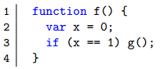
- 忽略动态属性访问
- 忽略动态计算代码，如eval，new Function等，很难且

过程内流分析
建立一个四元组，来储存AST节点信息，对每一种类型节点进行增加边的规则：本文中是7条，这里需要整理出一个文档。
规则集
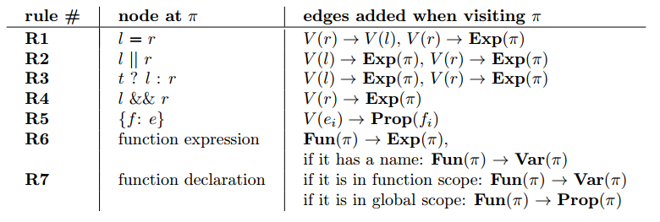
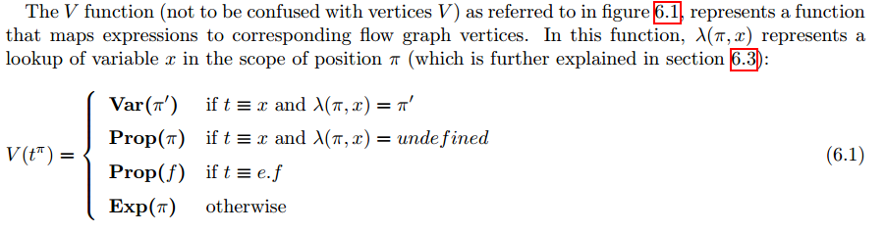

过程间流分析
调用的部分（call site和callee），即call部分的语句，有三条规则
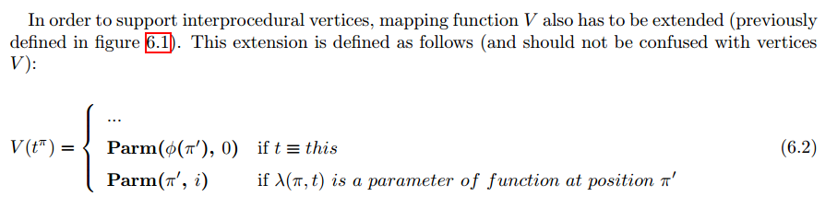
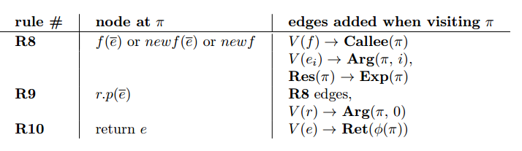
范围
JavaScript的作用域包括全局作用域和局部作用域，暂不考虑块作用域，但是js有一个变量提升机制，https://www.cnblogs.com/fcaa/p/5948438.html，局部变量是使用完之后被覆盖的（映射函数V可以解决覆盖问题，使得结果更准确）

悲观和乐观的区别
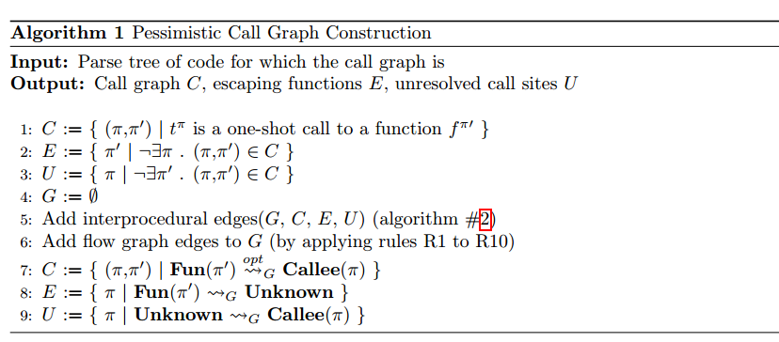
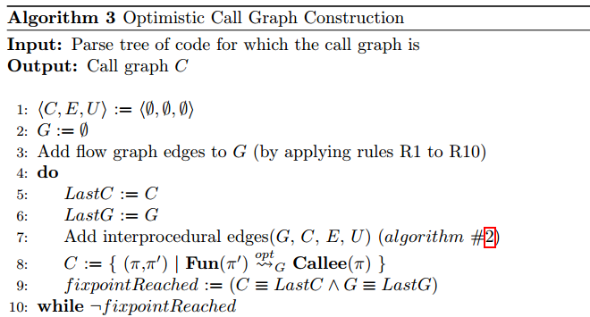
输入：源代码解析树 输出：调用图C，转义函数E，未解析的调用点U
C = 一次性调用闭包
E = 没有被调用的局部函数，不在C中（E中元素是函数
U = 调用点在局部找不到调用目标，不在C中（U中元素是调用点call site）
G代表流向图，初始化为空
增加过程间边
增加流向边G（根据规则R1-R10）
C = 流向图G中调用点和调用目标皆已知的边
E = 调用目标（即函数）不存在于局部
U = 调用点不存在（函数并未被调用）

parameter=形参(formal parameter)， argument=实参(actual parameter)
return是定义时的返回值，result是函数调用的返回值

Call Graph Construction in Object-Oriented Languages OOPSLA 2016
动态分派:被调用方取决于接收方的类别
一类函数:被调用函数依赖于应用函数的值（callee是被调用的函数）
• Dynamic dispatches: callee(s) depend on class of receiver(s)
• First-class functions: callee(s) depend on value(s) of applied function
一种调用图构造算法模型，
包括调用图域的形式格理论模型
•比以前的工作更好地结合更多的算法
•建议新的算法
•灵活实现框架的基础
A model of call graph construction algorithms,
including a formal lattice-theoretic model of call graph domain
• Unifies more algorithms better than previous work
• Suggests new algorithms
• Basis for a flexible implementation framework
sound调用图保守地近似于程序的运行时行为
•包含一些程序执行过程中调用的每个过程
•包含在某些程序执行过程中遍历的每个调用弧
A sound call graph conservatively approximates the program’s runtime behavior
• Every procedure called during some program execution is included
• Every call arc traversed during some program execution is included

analyze each procedure separately for each vector of k enclosing callers k-CFA（判断动态语言中变量的类型，预测面向对象语言中动态调度）
reanalyze based on actual class info passed at that call site （CPA, SCS）
上下文敏感分析
JAVA：k-CFA

Contour: a context-sensitive version of a procedure (object, class)

Code2graph: Automatic Generation of Static Call Graphs for Python Source Code（ASE2018）
该篇论文讨论了静态分析下Python调用图的实现方式，

Static JavaScript Call Graphs: a Comparative Study（SCAM2018）
该文献的主要贡献是分析了五种调用图生成工具，并评估了这些工具。每个工具都会生成独一的边，通过人工审查确定是否正确。

Incremental Call Graph Reanalysis for Object-Oriented Software Maintenance
本文使用增量的方法来提高调用图准确度，所以事先应该有调用图，增加删除和更改

Call Graphs for Languages with Parametric Polymorphism（OOPSLA16）
本文主要考虑了参数类型对于调用图的影响，指方法的上下文信息，包括传递给其类型参数的类型参数，传递给其术语参数的参数的静态类型，
Scala是一种与Java比较相像的语言。
Scala的主要特点：
上下文敏感的调用图（方法使用的上下文包括传递给类型参数的类型参数和传递给术语参数的参数静态类型）基于参数

调用点是单态的（单态式指）
Python与Java在类型上的差别，Java支持泛型参数，Python不做类型检查，参数类型是在运行过程中确定的。
实际上 Python 3.5 中的 PEP 484 和 Python 3.6 的 PEP 526 分别加入了类型提示（Type Hints）的语法，其中 PEP 484 主要关于函数、方法、类的参数和返回值的类型声明语法，而 PEP 526添加了对变量类型的声明
def greeting(name: str) -> str:
return "Hello, {}!".format(name)
实际调用 bar 的位置，即 foo.bar()，称为调用点（callsite），单态（monomorphic）调用点指调用点每次调用都是唯一的。

Test-case-based Call Graph Construction in Dynamically Typed Programming Languages（Master Degree Js）

Eﬀicient Static Checking of Library Updates（FSE18 OO）
该论文是通过计算不同版本之间方法（methods and functions）的不同，来提示库的更新
主要方法：static analysis，control ﬂow
- diff模块
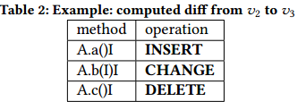 the diff data format
given a method m whose identifer is present in a diﬀ, we also include all public methods that call m.
- 快速查询
Our approach is to precompute diﬀs between only consecutive pairs of library versions, then compose individual diﬀs to derive diﬀs for arbitrary version ranges. This strikes a good balance, requiring a linear amount of space and running quickly enough in practice.
- 更改内容的整合
CHANGED MISSING UNKNOWN

实验对象：Java(Maven Central), Python (PyPI), and Ruby (RubyGems)，GitHub开源项目
实验方法：对前三者进行是否存在向后不兼容情况，是否进行报告on average, 26% of library versions are in violation of semantic versioning, i.e. they break backward compatibility without a major version update，后者用来确定该方法是否能够报告多大比率的API不兼容using our static analysis, we can automatically suggest upgrades for 10% of the libraries in these
open source projects
实验实例：As a concrete example, consider the popular requests library, between versions 2.3.0 and 2.4.0 – a minor version bump, over which breaking changes are not expected – requests.structures. IteratorProxy was deleted。For this not to be considered a SemVer
violation, IteratorProxy must not be part of requests’ public API, however it is difcult to determine this using a static analysis (as nothing prevents one from importing requests.structures). Consulting human-readable sources like commit messages and the
change log also yielded nothing in this case, so we assume it to be a breaking change. The fact that such mistakes may slip through is why a manually-enforced convention like SemVer is insufcient to ensure reliable upgrades.

Practical Virtual Method Call Resolution for Java（OOPSLA 2000）

提出了VTA——variable-type analysis ，解决的问题是the problem of resolving virtual method and interface calls in Java bytecode.论文详细地讲述了rapid type analysis及对此的改进。
实现框架：Soot ；seven bench-marks

Systematic Evaluation of the Unsoundness of Call Graph Construction Algorithms for Java（ISSTA 2018）
通过动态执行的方式来系统地评价调用图的可靠性，涉及到的评估的问题。亮点在于设计了大量的测试用例。
设计测试用例https://bitbucket.org/delors/jcg/
- The Test Cases Extractor
测试用例全部写上注释，分为Indirectcall等，并在后面解析
- Call Graph Matcher
找到缺失的边和错误的边。
实验方法：对不同方法实现的各种情况下调用图的可靠性。Virtual Method Calls等
实验数据：Soot and WALA’s call-graph implementation
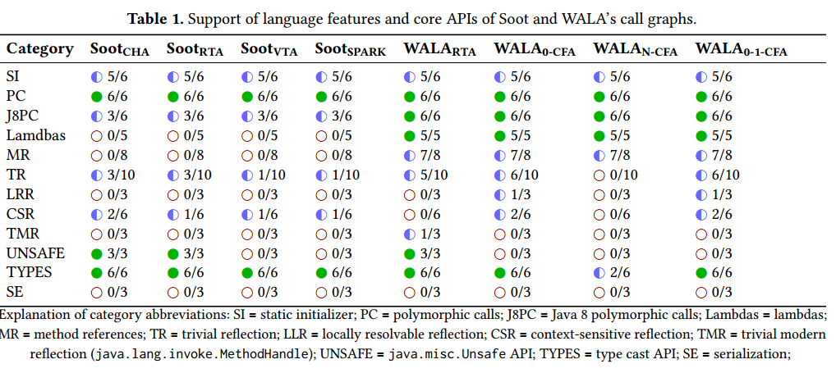

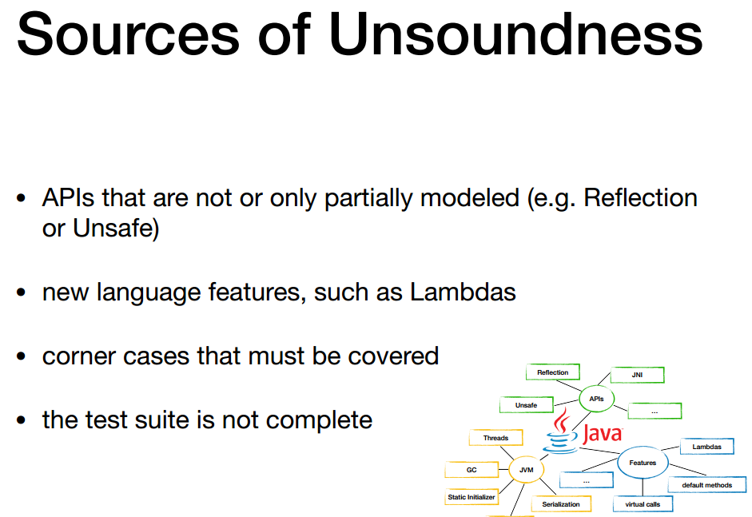

Scalable Propagation-Based Call Graph Construction Algorithms
主要是针对于大规模的调用图构建。提出MTA、FTA、XTA三种方法
Baseline：RTA
Benchmark：Hanoi、Ice Browser、mBird、Cindy、CindyApplet、eSuite Sheet、eSuite Chart、javaFig 1.43、BLOAT、JAX 6.3、javac、Res. System。
评估：

Revamping JavaScript Static Analysis via Localization and Remediation of Root Causes of Imprecision（FSE’16）
静态分析需要考虑精度和性能两个方面，然后该论文使用动态运行信息来找到关键的上下文信息，对这些代码进行上下文敏感分析，会提高精度而不会影响性能。
Motivation：
0-1-CFA analysis的问题是面临精度和性能的问题（如无法达到较好的精度，且耗时较长）
Approach：
Intuitively, an anomaly is flagged if a given variable or reference property, collectively referred to as a program pointer, is associated with a large points-to set, and the label corresponding to the pointer propagates to many other pointers within a small number of evaluations of the propagation system.

Experiment：
Baseline：WALA的全程序1-CFA分析

应用调用图

Statically Checking Web API Requests in JavaScript（ICSE2017）
用于检测Github上的Js文件中API请求是否符合公开的API规范？静态分析
A fundamental part of our approach is to detect and extract web API usages from JavaScript source code。
Approach
- Field-based Call Graph Builder
基于字段的调用图是一个语句级调用图，它对程序中使用的每个属性的所有实例使用一个抽象，而不是像传统调用图中那样对每个抽象对象的每个属性进行一次抽象。（使用WALA实现，）原始实现中会忽略所有不调用函数的数据流，经过改进使得We take all functions in the script as entry points for the call graph。
- Web Request Locator
提取出可能存在Web API调用的地方，To identify API invocations, we look for framework-specific patterns in the call graph. For jQuery, we handle the most common patterns, i.e., function calls to $.ajax, $.get, and $.post。
- Backward Slicer for Request Marshaling：
WALA backward slicer, we recover all possible data flows that lead to the request.Perform path-insensitive data flow analysis。
- checking procedure：
The goal of the checking procedure is to match the information produced by the static analysis against formal web API specifications.
- Checking endpoints
Base URLs（难道是指http或https）
whether any of the URLs for a given request begins with any of the base URLs of the known API specifications
Path
the procedure attempts to match a request’s URLs to paths defined in the API specifications(问题主要是Multiple path definitions)
Any method determined by the static analysis is checked against all methods defined in all matched specifications and all matched paths
- Checking request data
  - Payload data
  - Query data

Evaluation
定量的分析加上定性的原因分析
RQ1: Given JavaScript code describing a web API request, to what degree can the analysis correctly determine whether the request is consistent with an endpoint in given Swagger specifications?
Endpoint Results？
RQ2: For a request consistent with an endpoint in the Swagger specifications, to what degree can the analysis correctly determine whether the request data (the payload and the query parameters) is consistent with specifications?

附录

专有英文词汇
Legitimate：合法
positive matches：正向匹配
Anomalous：异常的
Prefix:前缀
macro:宏观的
vulnerability remediation：漏洞修复
continuous integration：持续集成
semantic versioning：语义版本控制
Systematic Evaluation：系统评价
API specification AP：规范
virtual call site：虚拟调用点
unification-based approach：基于统一的方法
subgraph isomorphism and graph minin：子图同构和图挖掘
programming paradigm：程序范例
circumventable 可规避的
anomalous 异常的
qualitative：定性的
quantitative：定量的
profile：1、技术文档里常见的用法三种：你在 V2EX 的个人页面，是你的 profile （账户）；根据你在 V2EX 的点击、收藏、感谢等行为，可以 profile （画像）你的喜好；你给 V2EX 写了个插件，但是跑起来很慢，所以你决定 profile （性能分析或性能解析）一下，看看哪个环节出问题。2、属性、性质，3、遍历Dynamic optimizers could collect a perfect DCG by profiling every call.

参考文献：
- Grove D, Chambers C. A framework for call graph construction algorithms[J]. ACM Transactions on Programming Languages and Systems (TOPLAS), 2001, 23(6): 685-746.

