Adding Log4j

Add below xml under resources



Open POM.xml and below tag under <build/> tag

<resources>

<resource>

<directory>Pathto-log4j2.xml/</directory>

<filtering>true</filtering>

</resource>

</resources>

Under <build/>

Add Maven Surefireplugin with your XMl

<plugin>

<groupId>org.apache.maven.plugins</groupId>

<artifactId>maven-surefire-plugin</artifactId>

<version>2.20</version>

<configuration>

<suiteXmlFiles>

<suiteXmlFile>testng.xml</suiteXmlFile>

</suiteXmlFiles>

</configuration>

</plugin>

Now go to your project in command prompt and run “mvn clean test”

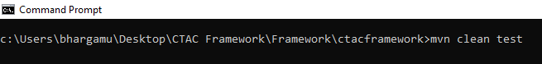

Once the test is complete, refresh your project in eclipse and you will see the logs folder.

