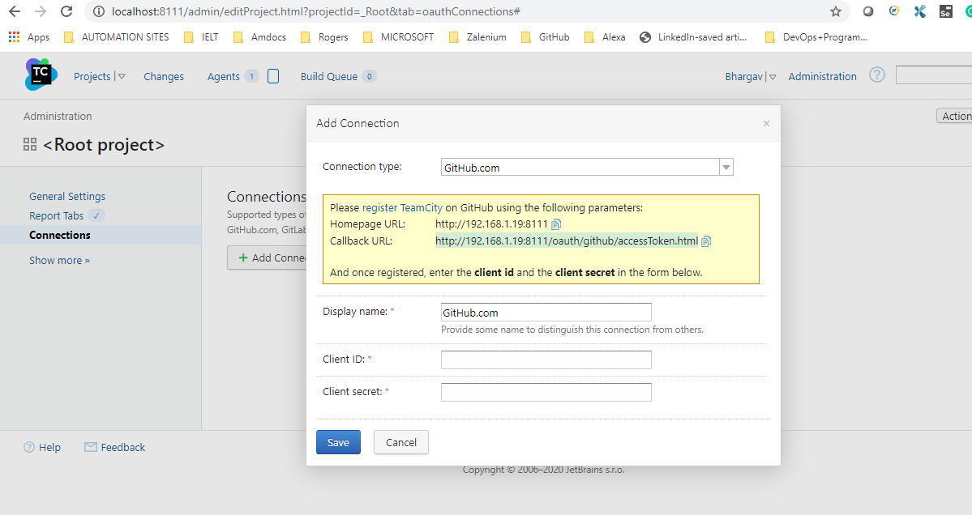

Git Hub-> settings -> developer -> registernewOAuth app

Refer: <https://auth0.com/docs/connections/social/github>

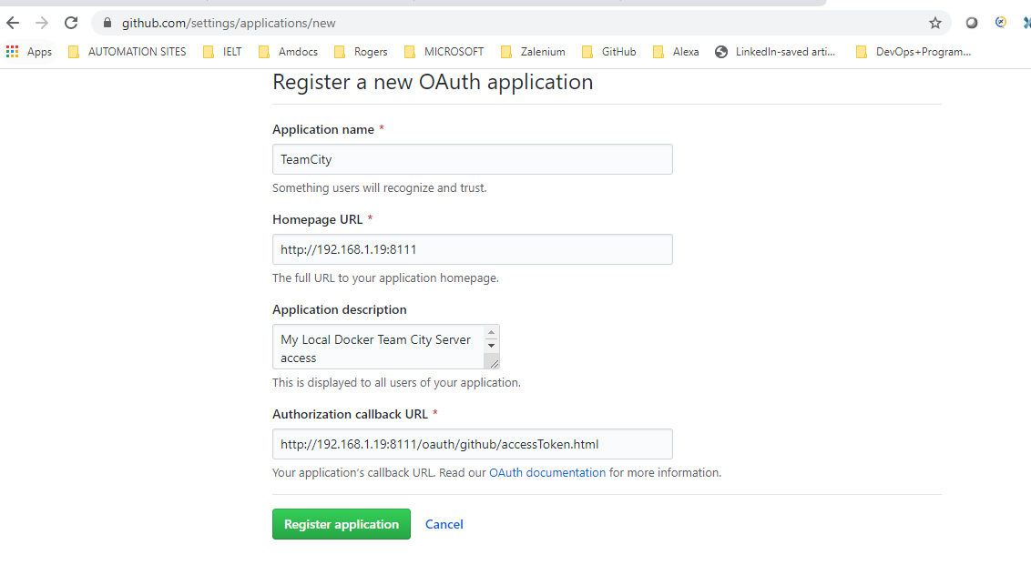

Take client id, secret and put it on team city server.

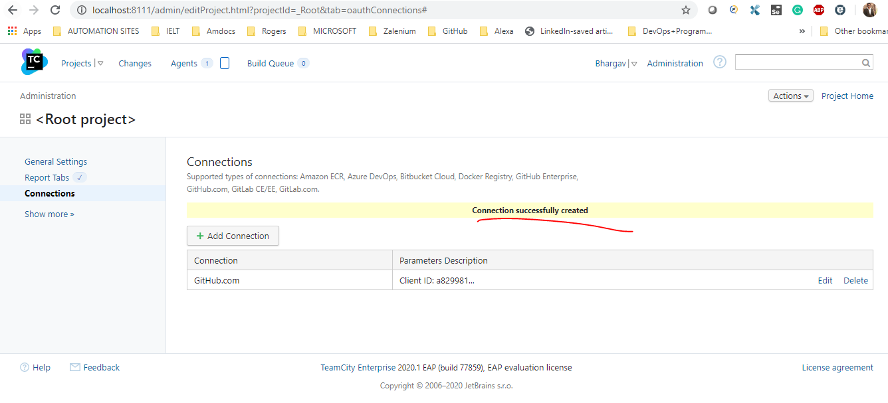

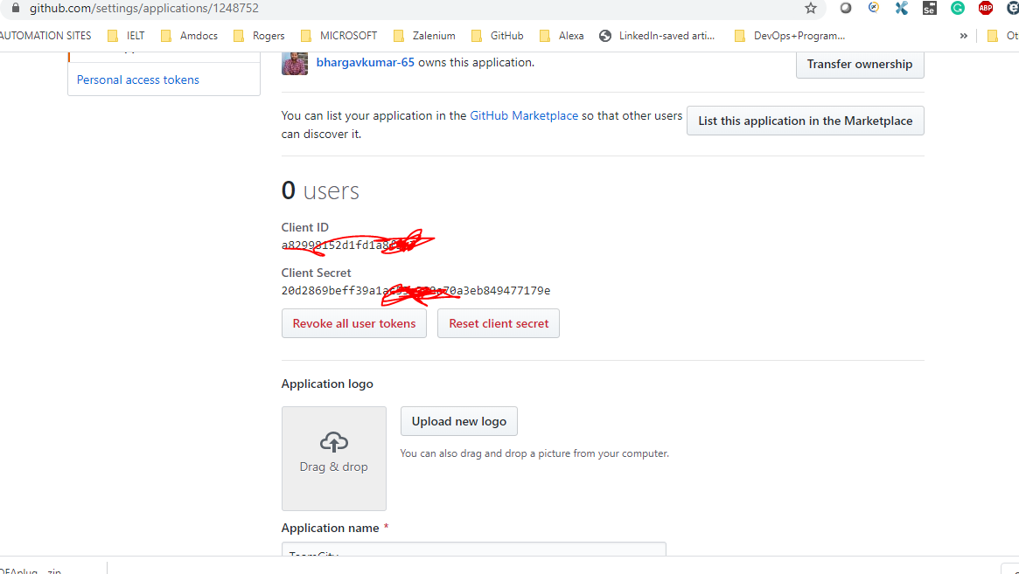

Team City Agent Configuration Guide: <https://confluence.jetbrains.com/pages/viewpage.action?pageId=37239119#SettingupandRunningAdditionalBuildAgents-InstallingviaJavaWebStart>