[Source](https://docs.sonarqube.org/latest/analysis/scan/sonarscanner-for-maven/):

Edit the [settings.xml](http://maven.apache.org/settings.html) file, located in $MAVEN_HOME/conf or ~/.m2, to set the plugin prefix and optionally the SonarQube server URL.

Add sonarqube dependency in POM.xml

<dependency>

<groupId>org.sonarsource.scanner.maven</groupId>

<artifactId>sonar-maven-plugin</artifactId>

<version>3.6.0.1398</version>

</dependency>

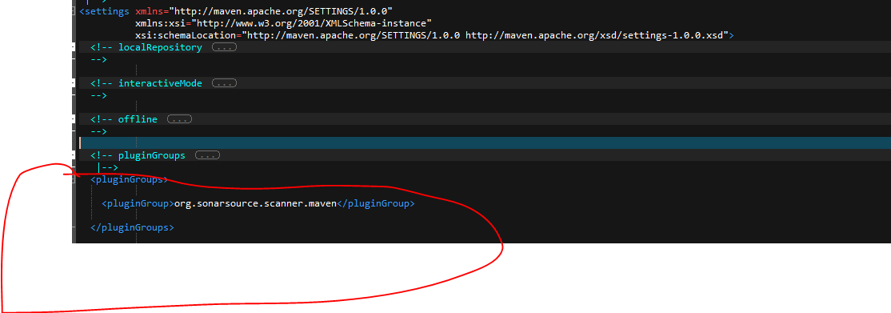

Provide your Sonar Host URL like below, in my case it is localhost:9000

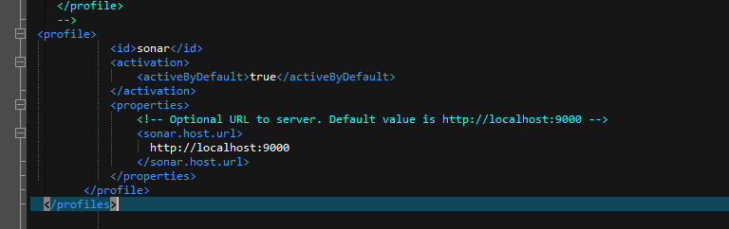

Now go to <http://localhost:9000/> and login with username/pwd: admin/admin.

Now go to Administration -> MarketPlace -> Plugins and install the required plugins.

In my case it is Java Maven project so I added Java and WebDriver Plugins

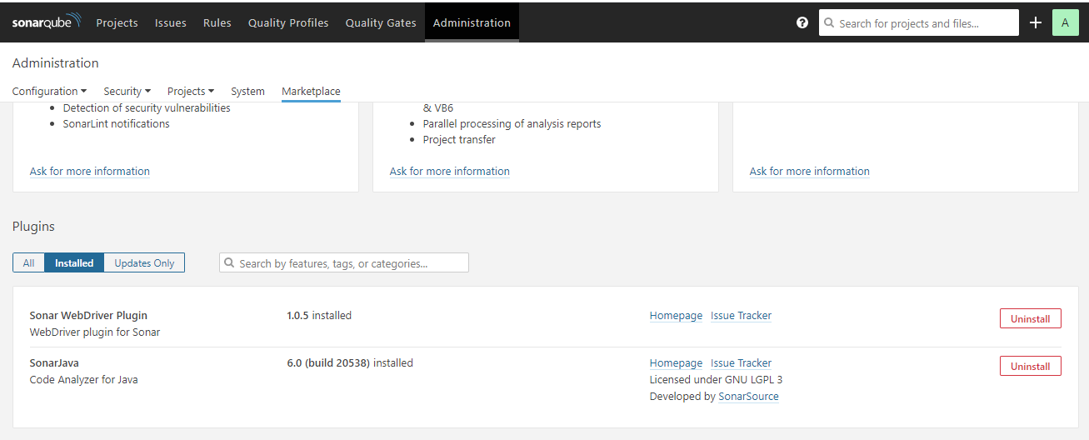

Now go to your maven project and Run command: **mvn sonar:sonar**

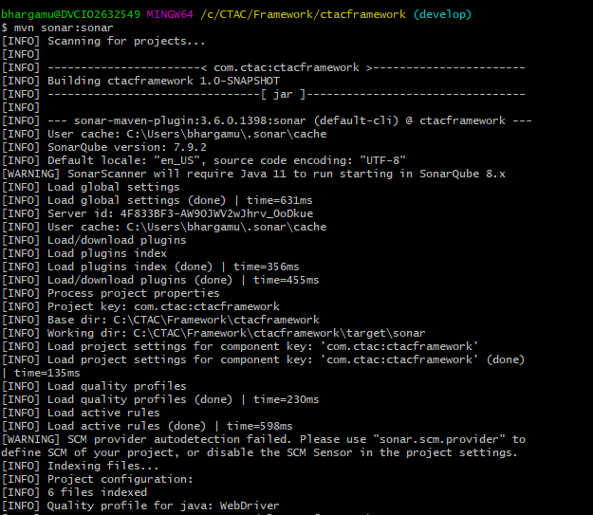

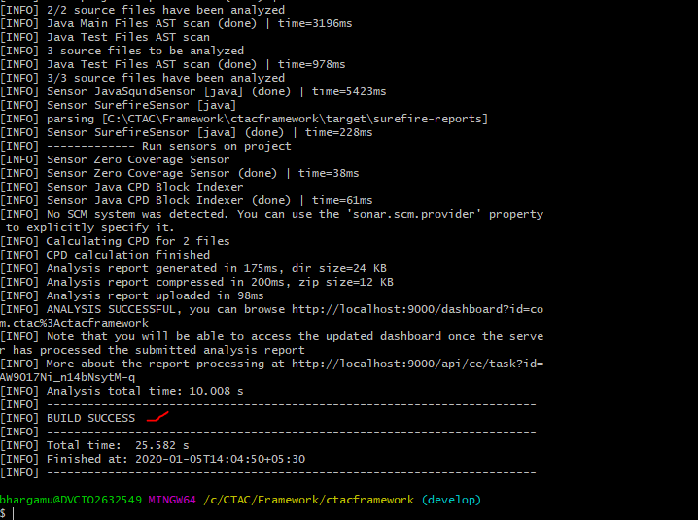

**Once it is success, come back to sonar portal and see your results uploaded there.**

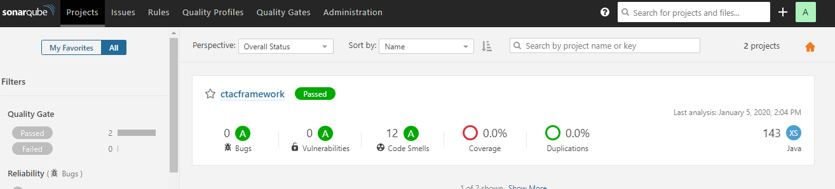

**Troubleshooting**

**If you get a java.lang.OutOfMemoryError**  
Set the MAVEN_OPTS environment variable, like this in *nix environments:

export MAVEN_OPTS="-Xmx512m"

On Windows environments, avoid the double-quotes, since they get misinterpreted.

set MAVEN_OPTS=-Xmx512m