Qian Kuang

Nov. 27, 2019

Working with Classes

Assignment08

<https://github.com/sullakuang/IntroToProg-Python-Mod08>

Working with Classes

**Introduction**

In this Assignment, I will go over how I write custom classes. To make the class, I have written constructors, attributes, properties, and methods.

**Process Performing**

*Created new Folder and new file*

First, I created a new folder called “Assignment08” and added the file called “Assignment08.py” into the “Assignment08” folder.

*Constructors*

In python, we could use constructors to initialize the data of the class, when the object is called, the __init__() method is called. In the class “Product”, I create a parameterized constructor, which has two parameters: product_name and product_price (<https://www.geeksforgeeks.org/constructors-in-python/>). The code is in the Figure01.

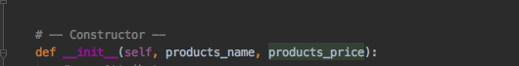

Figure01: Constructors

*Attributes*

I also defined two private attributes, which I use underscore before the variables’ name, thus we could not use the attributes directly(Figure 02).

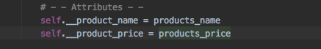

Figure02: Attributes

*Properties*

I write two properties for each attributes, the “getter” properties of product_name will return string value, the “setter” properties of product_name will evaluate whether it’s numeric or not. If it’s numeric, it will shows error. The “setter” properties of product_price will evaluate whether the price is float or not. If it’s not float, it will shows error(Figure03).

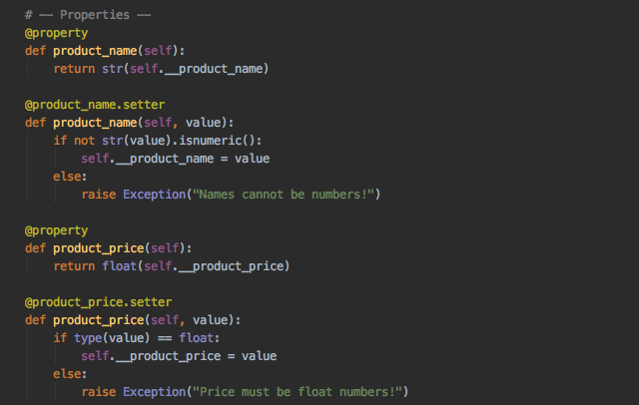

Figure03: Properties

*Methods*

I write two static methods in class “FileProcessor”, and it does not need “self” keyword in this functions(Figure04).

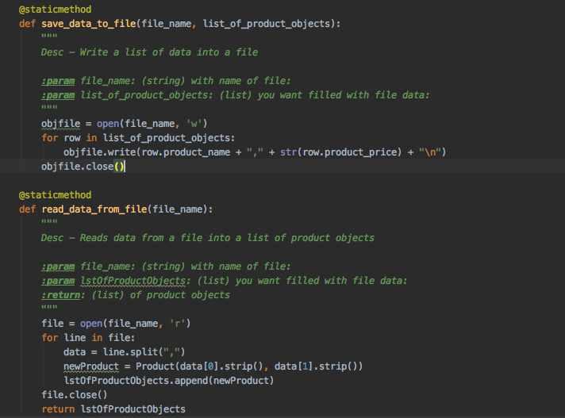

Figure04: Methods

*Running Script in PyCharm and Terminal*

After that, I finished writing the main body of the scripts and then, I run the script in PyCharm and Terminal(Figure05).

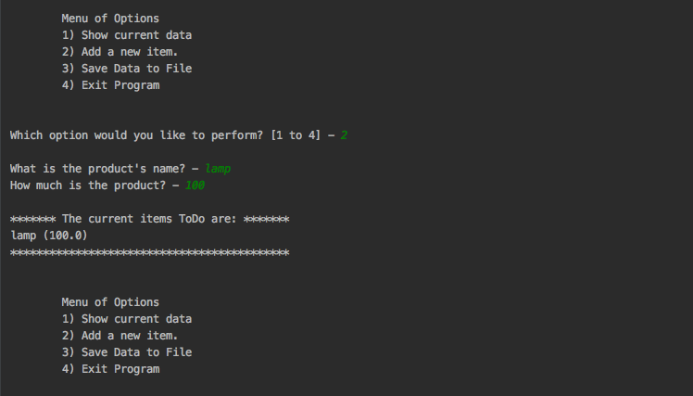

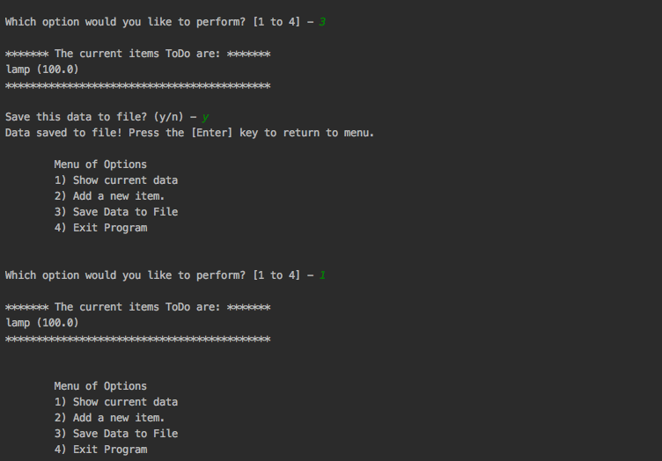

Figure05: A screenshot of running script

*Verify the data*

Finally, I opened the folder and checked that the data is saved in the file (Figure06).



Figure06: Verify the data

*Github desktop*

I download github desktop, and create the repository of Assignment08(Figure07).

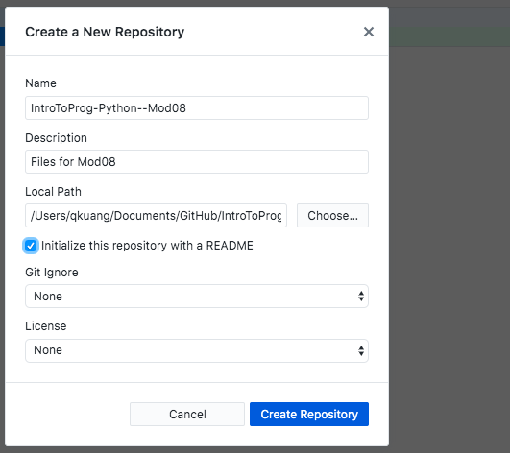

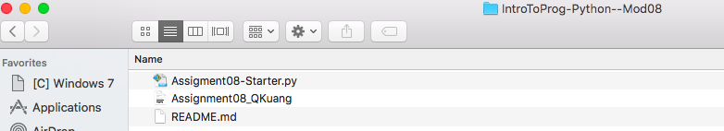

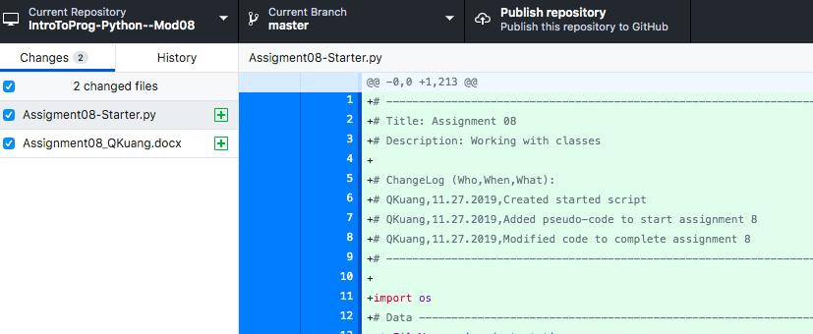

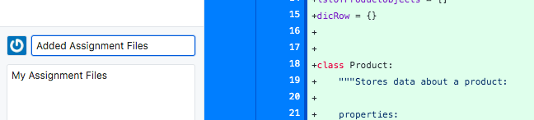

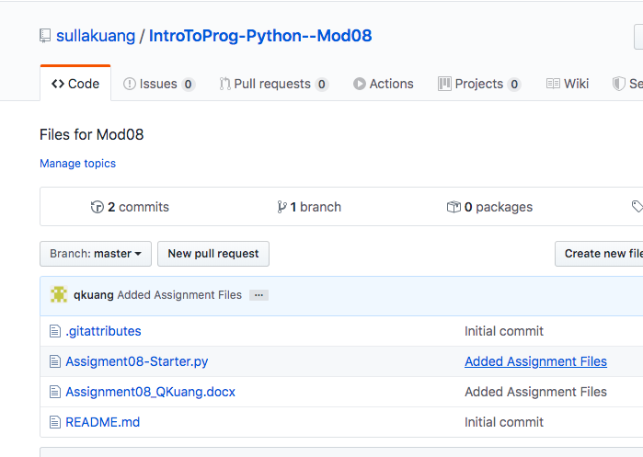

Figure07: Github desktop

**Summary**

In this assignment, I have learned how to write custom functions, and I have learned the general pattern of class. I also know how to write DocString for the class.