Qian Kuang

Nov. 20, 2019

Working with Pickling and Error Handling Script

Assignment07

Working with Pickling and Error Handling Script

**Introduction**

In this Assignment, I will go over how I use pickle to save and load data in a binary format. I will also go over how I conduct error handling in this program. I learned how to create custom Exception class.

**Process Performing**

*Created new Folder and new file*

First, I created a new folder called “Assignment07” and added the file called “Assignment07.py” into the “Assignment07” folder.

*Working with Pickling*

* *Step one*

First, I import pickle through command in the following (Figure01):

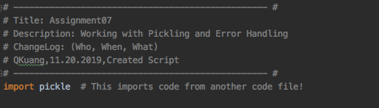

Figure01: Import pickle

* S*tep two*

Then, I write a custom function to save the data to a file with a binary format. I use pickle to dump the data object to the file object. Meanwhile, I write another custom function to read data from a file, and in this function, I use pickle to load the data object from the file object. That’s two main methods of pickle (https://pythontips.com/2013/08/02/what-is-pickle-in-python/

). When I open the file, I also specify the mode as ‘ab’ and ‘rb’, and then I could save and read the data as a binary file. The following code is my custom functions to use pickle.dump method and pickle.load method (Figure02).

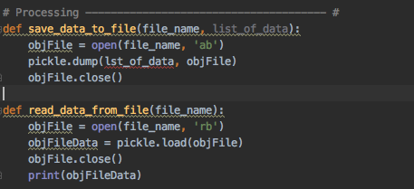

Figure02: use pickle to dump and load data

* *Step three*

Then, I write the processing code which I could get the ID and name from the user, and use the two custom functions to save and read the data (Figure03).

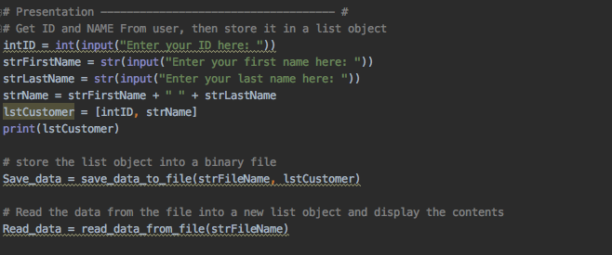

Figure03: store and save data

*Working with Error Handling*

At those three steps, I need to deal with some errors which might be caused by the user. Thus, I used Try-Except to handle those bugs.

In step one, I add a Try-Except to deal with the condition which the user input incorrect ID number instead of letting python show error to the user, for example, some user might type float number by mistake, then it would tell the user that he/she should input integer number here(Figure04).

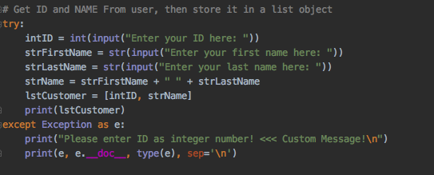

Figure04: Error handling with integer ID number

In step two, If the user does not have the permission to edit the file, thus he/she would not save their new data to the file, and thus I use another Try-Except block of code (Figure05).

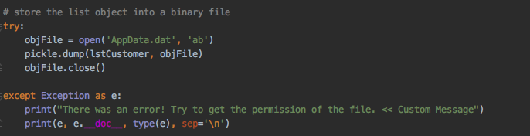

Figure05: Error handling with permission of the file

In step three, I create a custom Exception class which is called “FileNotDatError” to block if the user reading the file which is not “dat” format. Meanwhile, I also use Exception class to block if the file is not existed ( Figure06).

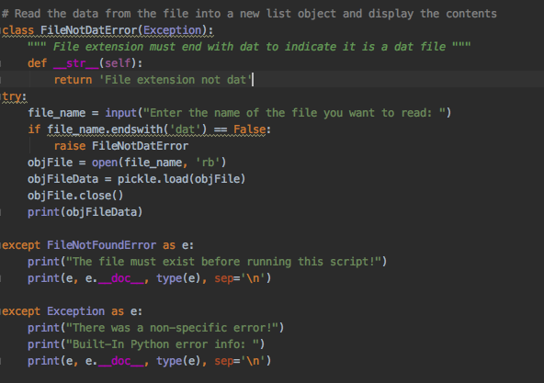

Figure06: Error handling when reading data from the file

*Running Script in PyCharm and Terminal*

Then, I run the script in PyCharm and Terminal(Figure07).

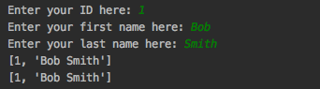

*Verify the data*

Finally, I opened the folder and checked that the data is saved in the file (Figure08).

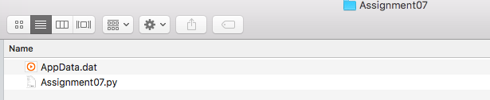

Figure08: Verify the data

**Summary**

In this assignment, I have learned how to use pickle to dump and load data, and also how to use Try-Except to handling with errors.