Qian Kuang

Nov. 13, 2019

To Do Files Script

Assignment06

To Do Files Script

**Introduction**

In this Assignment, I will go over how I modify a program which asks the user to input task item, and it’s priority, and add new data, delete data, and save data into file. I learned how to write functions, how to use global and local variables.

**Process Performing**

*Created new Folder and new file*

First, I created a new folder called “Assignment06” and added the file called “Assignment06_Starter.py” into the “Assignment06” folder.

*Step one*

In the class of “FileProcessor”, I define four functions, which are the followings:

def ReadFileDataToList(file_name, list_of_rows):

def WriteListDataToFile(file_name, list_of_rows):

def AddItemToList(strTask, strPriority):

def RemoveItemToList(lstTable):

In the first two functions, file_name and list_of_rows are the parameters. The first function returns a list of dictionary rows. In the third function, the input of task’s name and task’s priority from user are the parameters. In the function of “RemoveItemToList”, I change variable “blnItemRemoved” to global variable, thus I can use this variable in other function(Figure01).

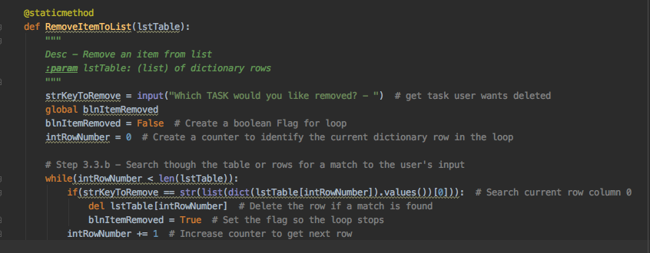

Figure01: changing to global variable

*Step two*

In the class of “IO”, I define five functions, which are the followings:

def OutputMenuItems():

def InputMenuChoice():

def ShowCurrentItemsInList(list_of_rows):

def InputNewTaskAndPriority():

def UpdateSearchStatus():

In the fourth function, I ask the user to input the task’s name and it’s priority, and return them as strings.

*Step three*

It’s time to clean the main body of the script!

I added an “if” conditional expression in the beginning, so that if the file does not exist, the program will not terminate and show error (Figure02).

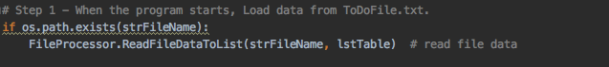

Figure02: Adding “if” conditional expression

In the process of each option the user chooses, I will call the defined function in the class of “FileProcessor” or “IO”. At the step 3.5, I added an empty lstTable (lstTable = []) before reading file to list, so that the data in the existed file would not be read in the new table (Figure03). This is a little bugger I have found when I run the code.

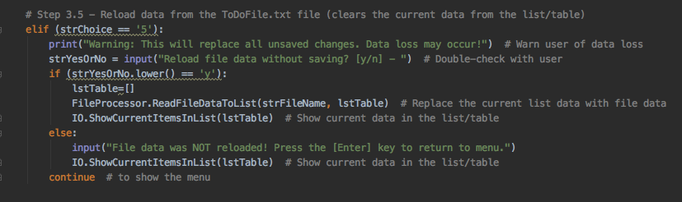

Figure03: Debugging the code

*Running Script in PyCharm and Terminal*

Then, I run the script in PyCharm and Terminal(Figure04).

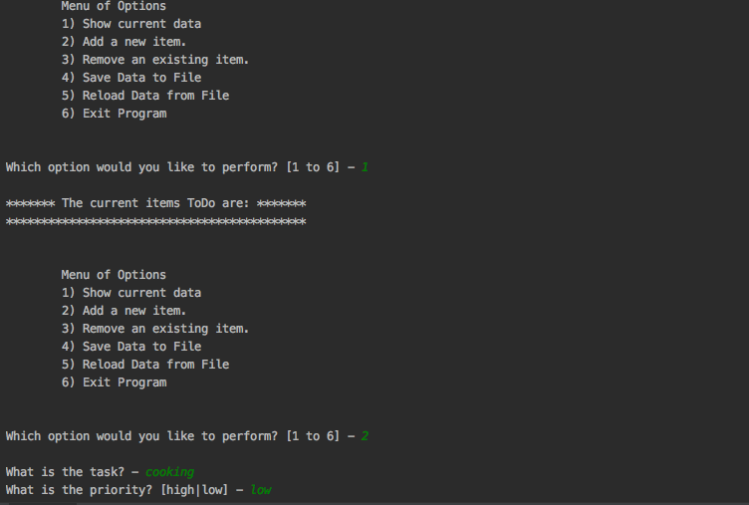

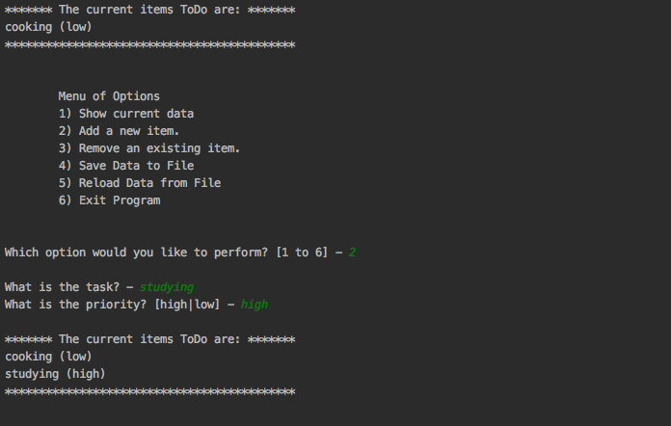

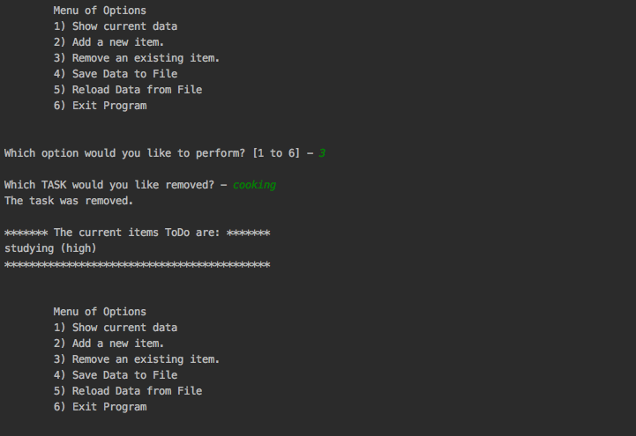

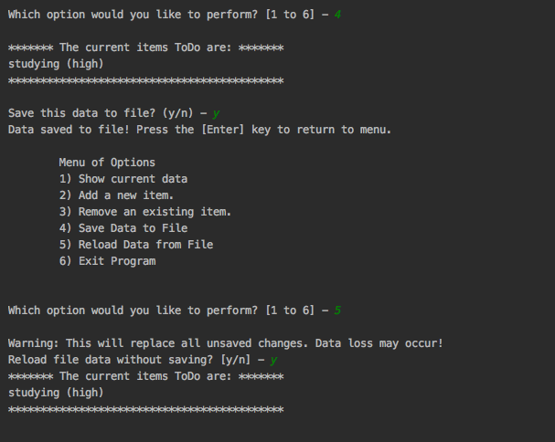

Figure04: A screenshot of running script

*Verify the data*

Finally, I opened the folder and checked that the data is saved in the file (Figure05).



Figure05: Verify the data

**Summary**

In this assignment, I have learned how to write functions, and call functions in the class. I also learned how to use global variables and local variables.