Qian Kuang

Nov. 06, 2019

To Do Lists Script

Assignment05

To Do Lists Script

**Introduction**

In this Assignment, I will go over how I wrote a program which asks the user to input task item, and it’s priority, and add new data, delete data, and save data into file. I learned how to write dictionary, lists, and how to load data in the txt file to a dictionary, how to add each dictionary “row” into a list, and save data back to the txt file.

**Process Performing**

*Created new Folder and new file*

First, I created a new folder called “Assignment05” and added the file called “Assignment05_Starter.py” into the “Assignment05” folder.

*Step one*

First, I would like to write the code to make sure that the data in the “ToDoList.txt” file could be turned into a python dictionary, and each dictionary “row” would be added into a python list. In this process, I found that if there is no such file exists, I could not use “open” function with mode “r”. Thus, I set up an if conditional expression to test whether this file exists or not (https://www.cnblogs.com/jhao/p/7243043.html). Only when it exists, the file will be read and the data in the file will be turned into dictionary, and I used “append()” to add each dictionary “row” into the table list (Figure01).

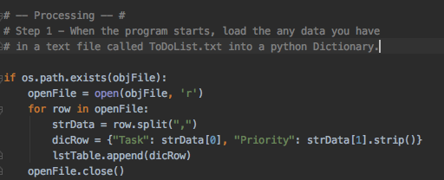

Figure01: Load data from file into Dictionary

*Step two*

I created each new dictionary row when the user input new task item and input it’s priority, and also used append() to add the new row into the list table. When I wrote the code of deleting item from existing data, I used del + loop to remove the exact item the user input (<https://www.geeksforgeeks.org/python-removing-dictionary-from-list-of-dictionaries/>). Once the user input the task he/she would like to delete, then the dictionary “row” which includes the task and it’s priority will both be deleted (Figure02).

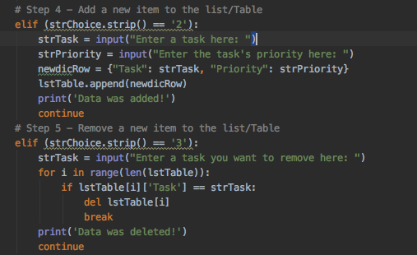

Figure02: Adding new data or deleting existing data.

*Step three*

Last, I used open() function with mode “w” and python file write() method to save each dictionary “row” in the list table into the txt file (Figure03).

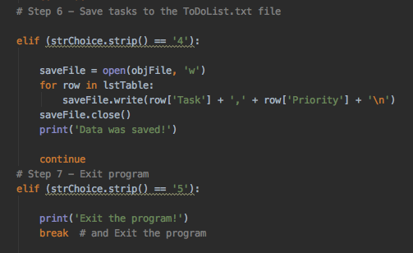

Figure03: Save the data into file and exist the program

*Running Script in PyCharm and Terminal*

Then, I run the script in PyCharm and Terminal(Figure04 and Figure05).

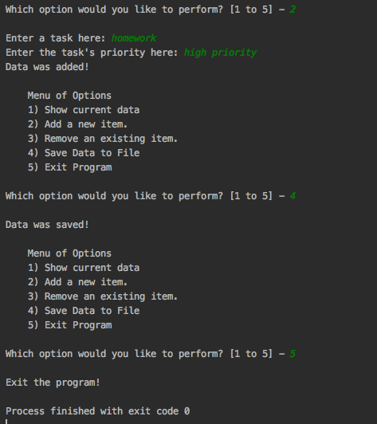

Figure04: A screenshot of running script

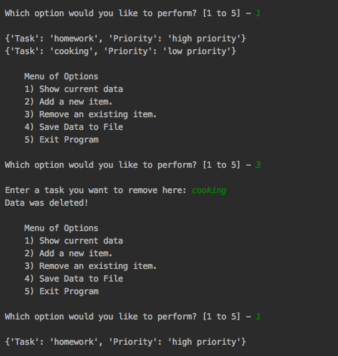

Figure05: Another screenshot of running script

*Verify the data*

Finally, I checked that the data is saved in the file (Figure06).



Figure06: Verify the data in the file

**Summary**

In this assignment, I have learned how to load data in the file in a dictionary, add each dictionary “row” in a python list, and finally save each dictionary “row” back to a file. Meanwhile, I also learned how to create a script template.