

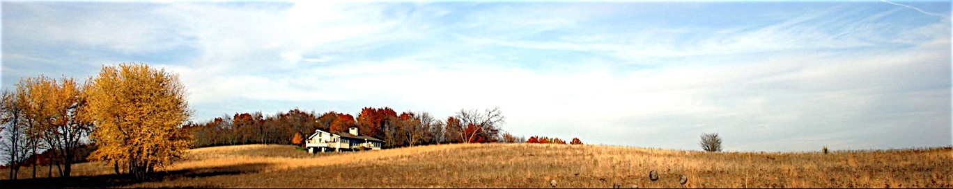

*Solitude with a View*

**HOME THE HOUSE GALLERY THE AREA BOOKING EVENTS WELLNESS SERVICES REVIEWS DIRECTIONS**

**Area Guide**

**ON-SITE**

**Bird watching/Hiking**

**Boating**

**Summer Activities**

**Winter Activities**

**LOCAL FAVORITES**

**LOCAL ARTISANS**

**EVENT RESOURCES**

**VISITOR GUIDES**

**Booking and Inquiries:**

(414) 690-3464

theprairiehouse@charter.net

**(This will continue on using unordered lists. We will use a Json file to allow easier updating of this page)**

**(all descriptions in local favorites will include a link to the activities website)**