

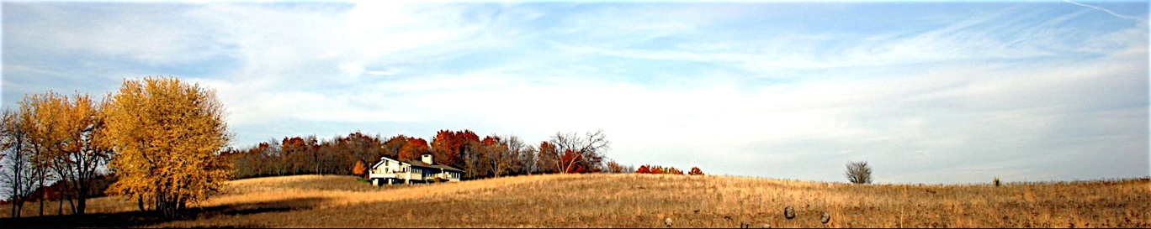

*Solitude with a View*

**HOME THE HOUSE GALLERY THE AREA BOOKING EVENTS WELLNESS SERVICES REVIEWS DIRECTIONS**

**Booking**

**Prairie House Rates:**

**(12 guest maximum)**

Peak season (June through August & Holidays)

One week (minimum) . . . . . . . . . . . . . . .2300.00 (policies below)

Off-Season

Three night (minimum) . . . . . . . . . . . . 1300.00

Each additional night . . . . . . . . . . . . . . .300.00

Special week rate . . . . . . . . . . . . . . . . . 2100.00

*All Rates are subject to the 5.5% Wi sales tax

Booking Details:

Reservation Process

Once availability is confirmed, you will receive an e-mail with a 2-part

guest rental form and reservation procedure. The completed rental

forms and a down payment of half the rental fee (payment by cash or

check payable to Prairie House LLC appreciated) are required to confirm

your reservation.

At Check-in, the following payments would be due:

- Balance of the rental fee.

- Refundable damage deposit of $500.00

The deposit is torn up or mailed back to you as preferred within the week of your visit pending reasonable care of the premises.

**Booking and Inquiries:**

(414) 690-3464

theprairiehouse@charter.net