

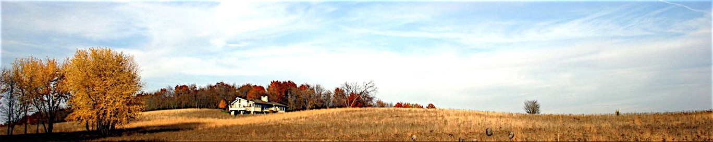

*Solitude with a View*

**HOME THE HOUSE GALLERY THE AREA BOOKING EVENTS WELLNESS SERVICES REVIEWS DIRECTIONS**

**Directions**

**MAP**

(Google Map Here)

**Directions to Prairie House from Milwaukee/Chicago area:**

**N 4898 Arrowhead Trail/Juneau, WI  53039**

Take I-94 West which comes north from Chicago.

Immediately after the Milwaukee Airport (Mitchell Field), take the I-894 bypass west and follow the signs around the west end of Milwaukee toward Fond du Lac/Madison.

Take Hwy 45 north toward Fond du Lac.  (Don’t go west on I-94).

This merges with Hwy 41 and follow 45/41 toward Fond du Lac for about 20 miles to Hwy 60.

Take Hwy 60 west toward Hartford.

Hustisford is about 15 miles west of Hartford.  About 2 miles past Hustisford, look for St. Helena Road.  There’s a green sign that says “St. Helena Rd”.

Turn R (North) on St. Helena and go ½ mile to Arrowhead Trail.

Turn R (East) on Arrowhead and follow it about one mile.  You will pass a “Dead End” sign and then watch on your R for Prairie House.  The entrance is just past the two red barns.  Head up the left branch of the driveway.

**You’re here!**

Any problems call Laurie 414-690-3464 or Larry at 414-719-5000.

**Booking and Inquiries:**

(414) 690-3464

theprairiehouse@charter.net