

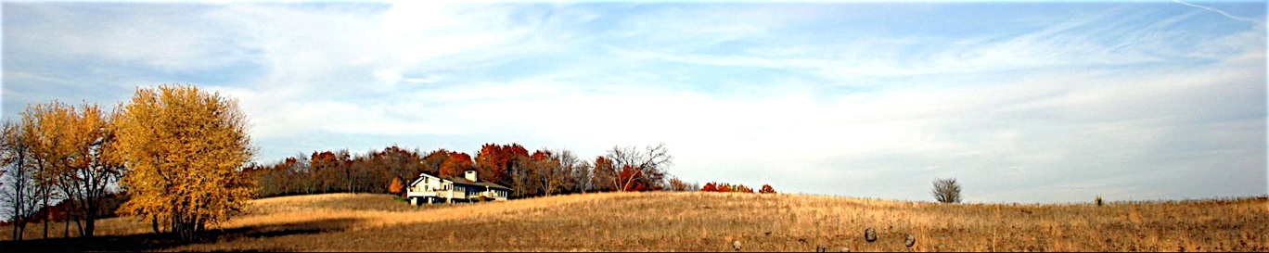

*Solitude with a View*

**HOME THE HOUSE GALLERY THE AREA BOOKING EVENTS WELLNESS SERVICES REVIEWS DIRECTIONS**

**Gallery**



**(slideshow with picture captions)**

**THE PROPERTY**

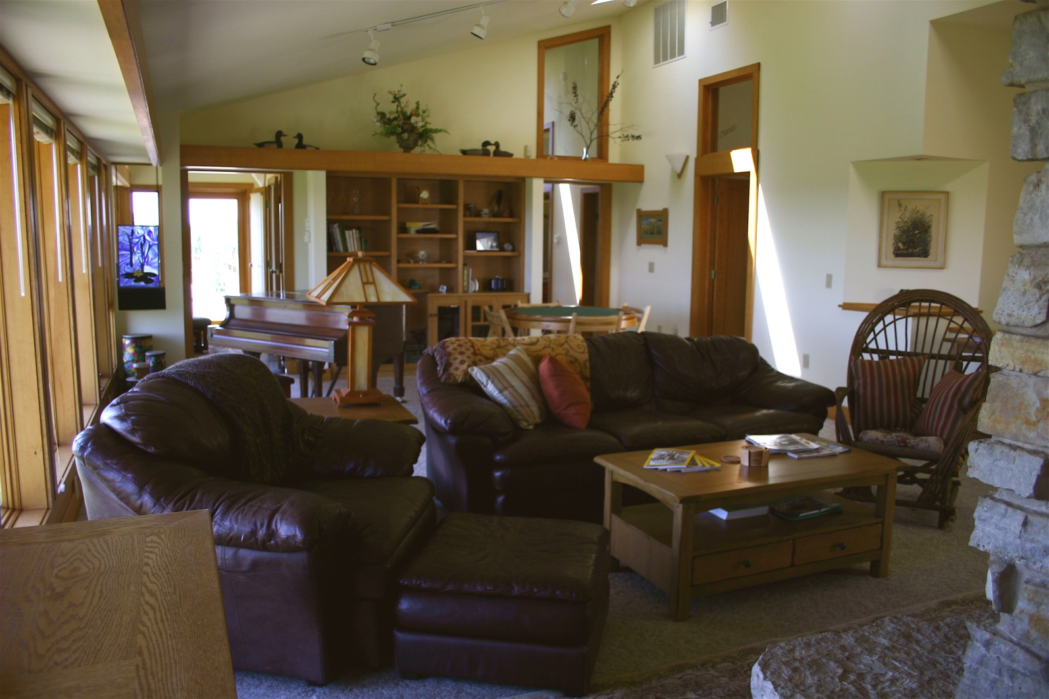

**THE HOUSE**

**PRAIRIE FLOWERS**

**MISC**

**Booking and Inquiries:**

(414) 690-3464

theprairiehouse@charter.net

(slideshows can expand)