



*Solitude with a View*

**HOME THE HOUSE GALLERY THE AREA BOOKING EVENTS WELLNESS SERVICES REVIEWS DIRECTIONS**

**The House**

Spacious prairie-style home on 120 acres of glacial drumlin with panoramic views of prairie, lake, and woods

4 bedroom

3.5 bath

Perfect for retreats in every season!

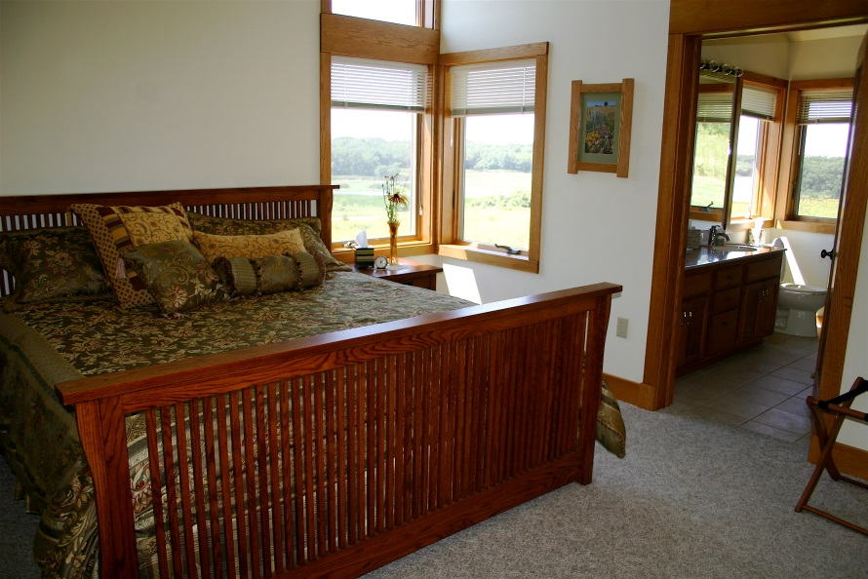

**FEATURES**

Upstairs

Passive solar design with ceiling to floor windows along the south wall

Commercial-grade kitchen and large adjoining dining area with vista views

Prairie House accommodates up to 12 guests with sweeping views from each bedroom. The Master bedroom and bath features a king bed and views of the prairie and eagle island, and master bathroom features an oversized soaking tub and views of the lake.

Natural stone fireplace in the living room, which features a Steinway grand piano and panoramic views with ceiling to floor windows.

Screened cedar porch with canvas awnings: relax and enjoy the views to the sound of the woodland birds.

Library is a quiet getaway with a large maple desk for projects, futon couch/queen sleeper, and books for all ages, including Peterson Field guides.

Sunroom with panoramic views is an inviting place for a game of cards on the felt-top oak card table.

The Observation deck off the sunroom has comfortable adirondack chairs and extends out over the prairie and affords excellent star-gazing and views of the prairie and Eagle Bay.

Downstairs

Game room with a pool table/ping pong, TV, and serving bar that overlooks the walk-out veranda covered with wisteria with views of the prairie.

The downstairs bedrooms feature vista views of the prairie.

There are three bedrooms: two with queen beds, and one with an oak bunk bed in addition to a queen bed.

Two bathrooms: one with bath/shower, and one with shower.

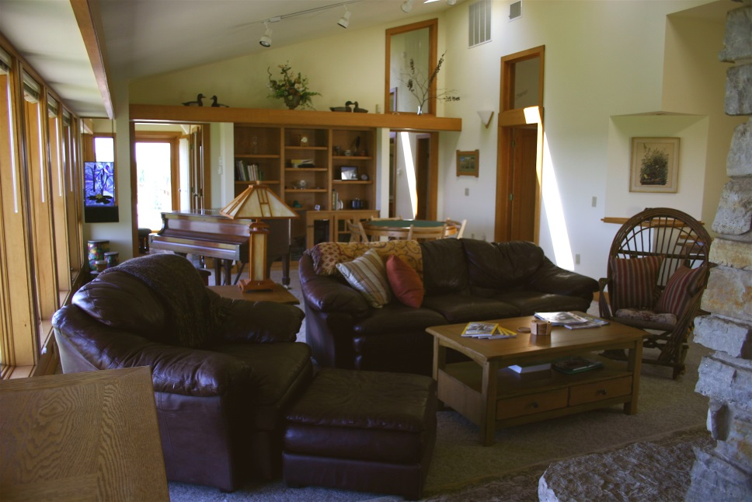

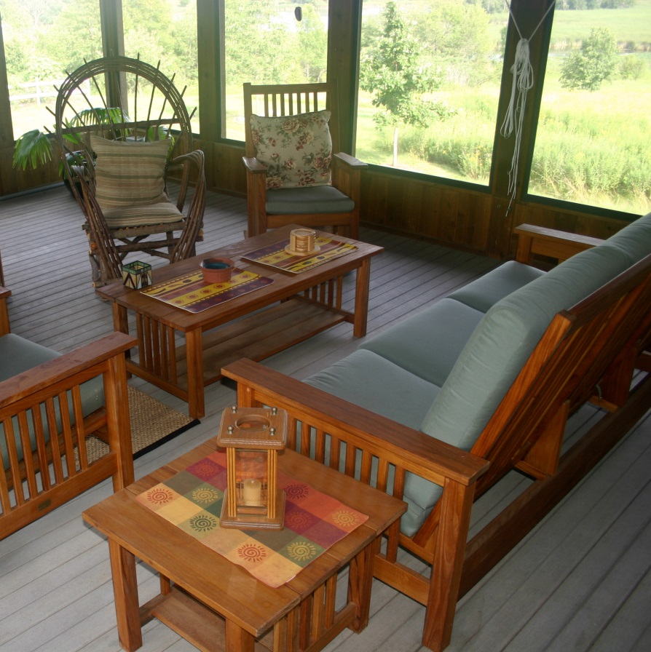

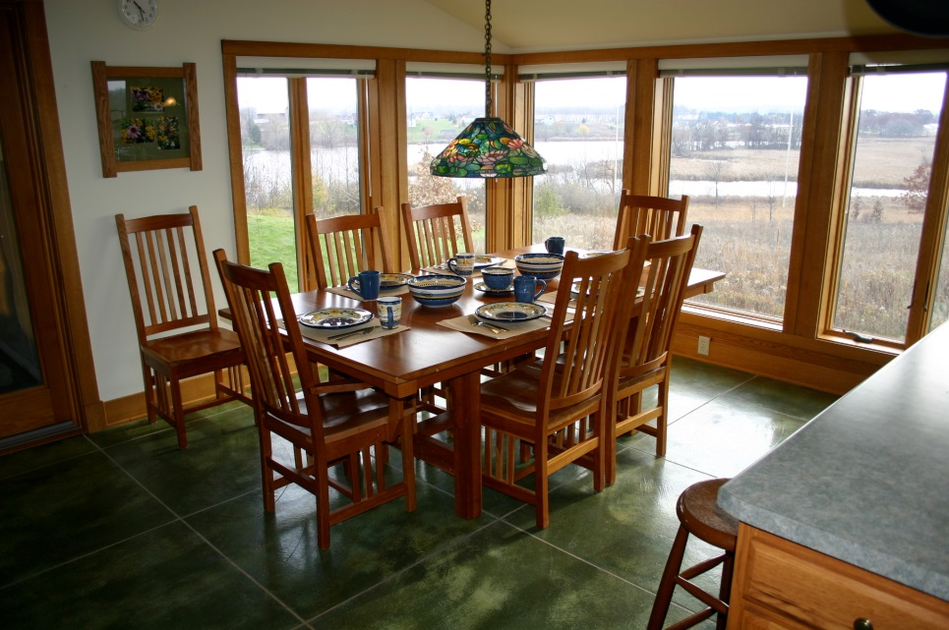

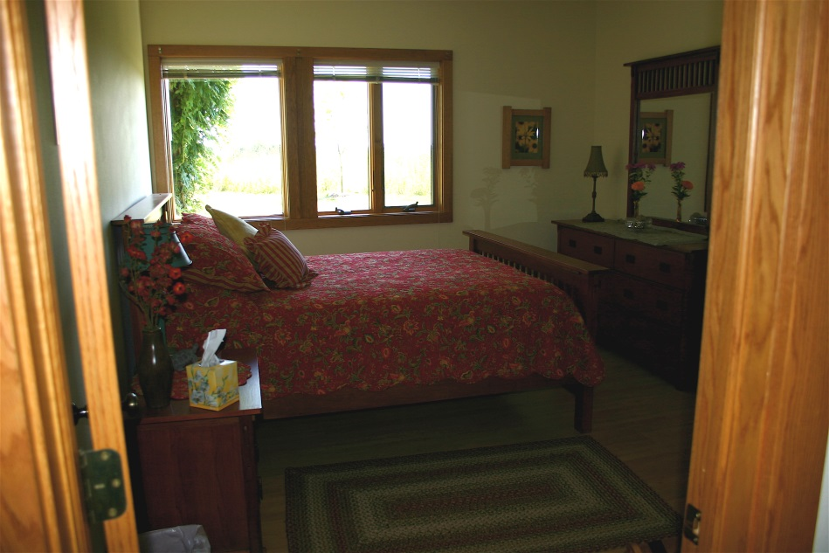

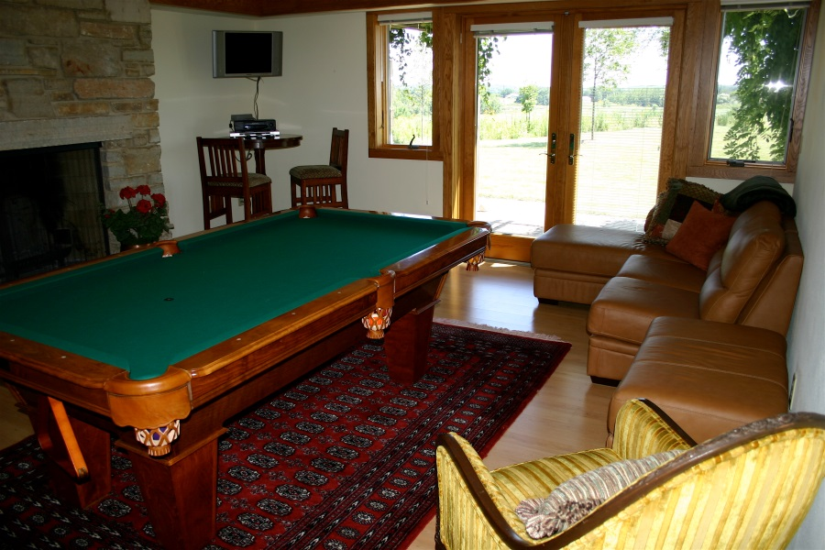

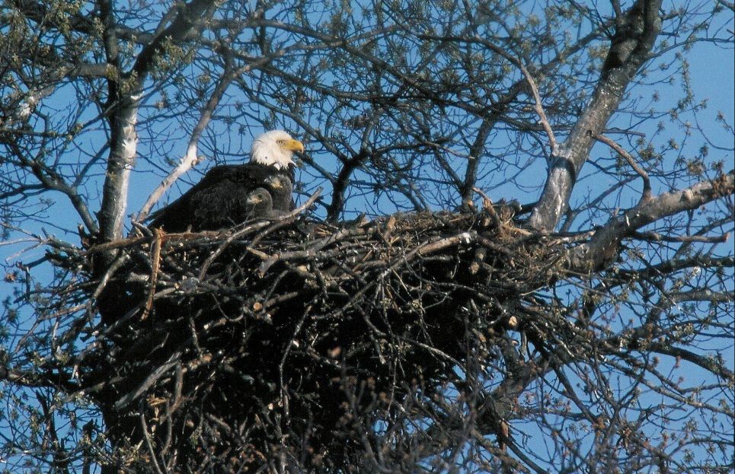

**AMENITIES**

2-car garage

Wifi

Basic extended cable TV/DVD/CD

Binoculars, spotting scope, and Peterson nature guides

Well-stocked kitchen equipped to serve gourmet meals for 12

Local Collectiva coffee and tea selection

Charcoal Weber grill (with charcoal/electric starter/grill tools)

Firewood for the fireplace and fire pit

Linens/towels and laundry room

Hotel toiletries

Variety of indoor/outdoor games including bocce ball, bean bag toss, and volleyball equipment for the spacious backyard

2 kayaks and 2 canoes with life jackets

Guests also enjoy hiking the trails traversing the 120 acre property

**The Property**



THE PRAIRIE

Nature lovers and prairie enthusiasts will love this modern prairie style home built to complement its magnificent surroundings:

18 acres of prairie surround the house

65 native flower species and 7 grasses provide a dynamic collage of color for three seasons.

Enjoy a stroll through the prairie or the 14-acre oak/hickory woods where guests enjoy catching a glimpse of the local wildlife such as deer, fox, red-tailed hawk, owl, bald eagle, and ring-necked pheasant. Mid-summer is the peak prairie flowering time.

Fresh cut flowers from the garden grace the rooms. Volleyball and lawn games are provided for the spacious backyard, and binoculars and a spotting scope are available for wildlife viewing.

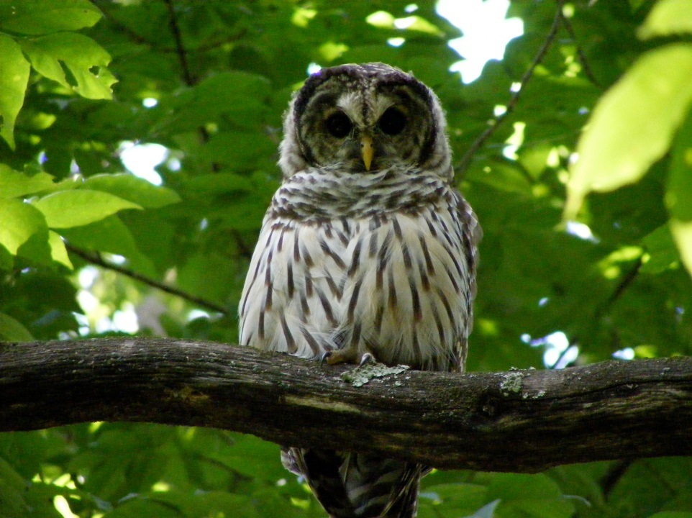

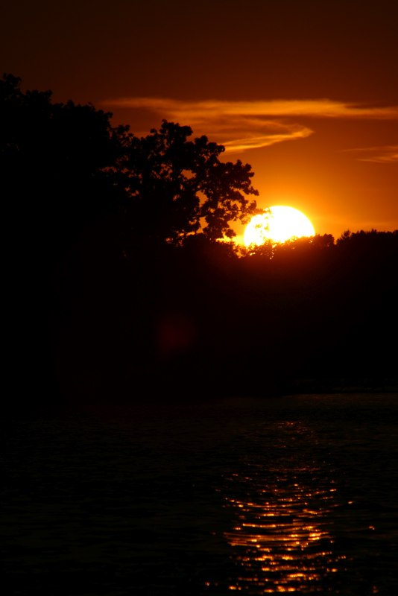

THE LAKE

Two kayaks and two canoes are provided for guest use on Lake Sinissippi, where nesting bald eagles, great blue herons, and flocks of white pelicans and Sandhill cranes are commonly sighted in the marshy bays.

The pier and boat shed are a 5 minute stroll behind the garden on a wide mowed path that winds along the edge of the prairie and lake.

Just upstream from Lake Sinissippi on the Rock River, is Horicon National Wildlife Refuge where over 200 species of birds have been documented, making it an attractive destination for birders and nature photographers.

[www.horiconmarsh.org](http://www.horiconmarsh.org/)



**Booking and Inquiries:**

(414) 690-3464

theprairiehouse@charter.net