HOME

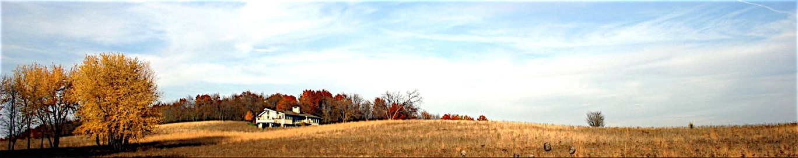

*Solitude with a View*

**HOME THE HOUSE GALLERY THE AREA BOOKING EVENTS WELLNESS SERVICES REVIEWS DIRECTIONS**

**Fine Wisconsin Retreats**

**Let Nature Be Your Backdrop**

Bald eagles, great blue heron and deer are your neighbors when you visit this spacious prairie style 4 bedroom 3.5 bath home with vista views of prairie, woods, and lake. Prairie House’s 120 acres of glacial drumlin and wetland bays of Lake Sinissippi is located just downstream from Horicon Marsh, the largest freshwater cattail marsh in North America. Coined by visitors as a “birder’s paradise” and “a midwest nirvana”, we strive to provide affordable lodging, old-fashioned service, and hospitality since 2006, and in the words of our guests:

*“We had the most perfect vacation!”*

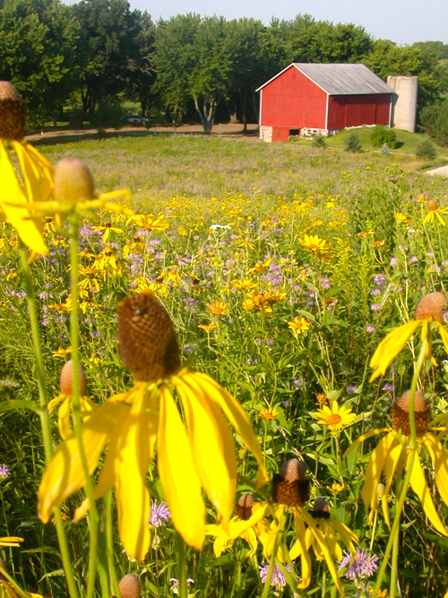

**Announcements**

**COTTAGE UPDATE**

Mar 1, 2015

We have new neighbors at the Cottage!

Larry renovated the original farm house by the barn in the early 1990’s and are thrilled that the cottage will be appreciated and in capable hands.

**Special Offers**

**Spring is for the Birds Weekend Getaway**

May 8-10th, 2016

Relax and Rejuvenate at the Prairie House this Mother’s Day

with a special 2 night rate of $800.00 plus 5.5% sales tax ($200 off).

Enjoy a spring retreat in the Wisconsin countryside with

eaglets on the nest, migratory songbirds, and spring blossoms.

*For additional weekend fun, check out our local

Horicon Bird Festival offerings at:

<http://horiconmarshbirdclub.com/bird-festival/>

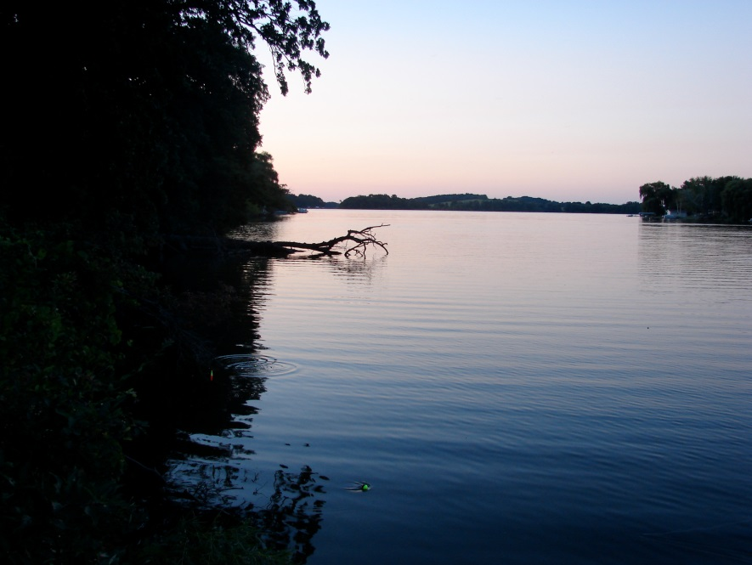

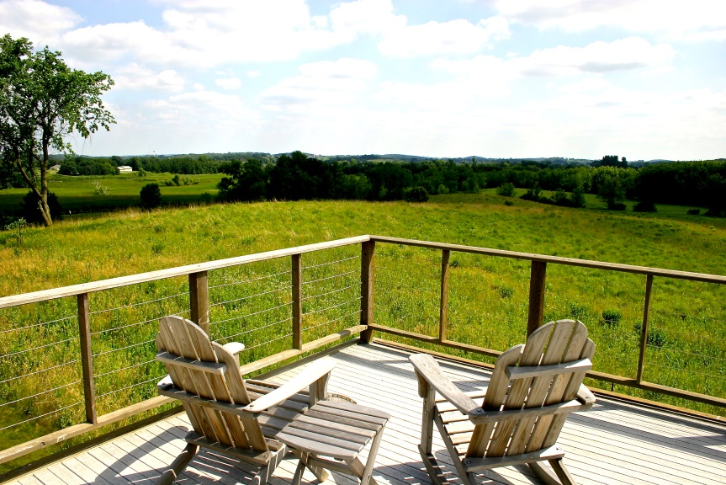

**Upcoming Events**

Event

date

(picture)

**Gift Certificates**

For all occasions:

CONTACT LAURIE FOR DETAILS

414.690.3464

**Booking and Inquiries:**

(414) 690-3464

theprairiehouse@charter.net

Home