

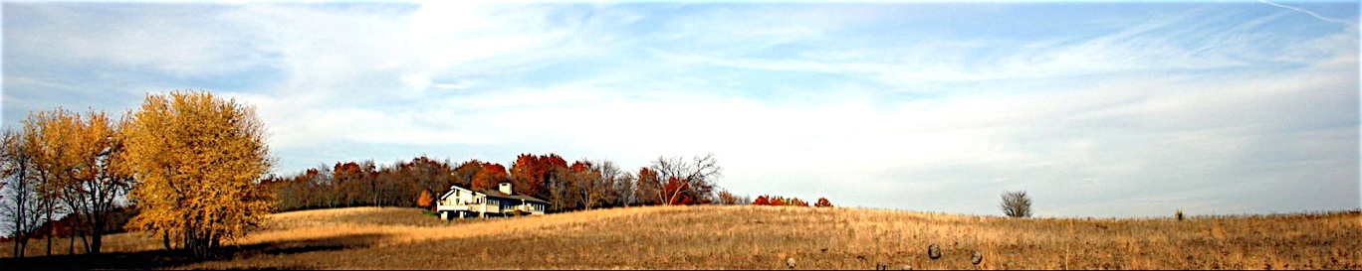

*Solitude with a View*

**HOME THE HOUSE GALLERY THE AREA BOOKING EVENTS WELLNESS SERVICES REVIEWS DIRECTIONS**

**Reviews**

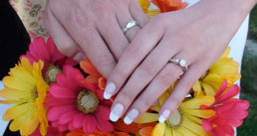

**PERFECT WEDDING GROUP, LAKE VILLA, ILLINOIS**

**Aug 24, 2009**

*“Everything there was wonderful- “* …**READ MORE**

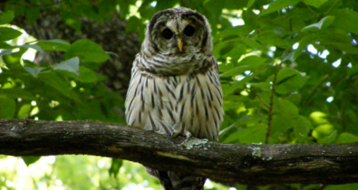

**CONRAD FAMILY FROM OH, IN, WI, NC**

**Aug 2, 2009**

*“Great family time with three generations - Grandma will be 98 next month!*

*We enjoyed “talking” with a pair of Barred owls and watching all the other birds, including the Eagles. The Prairie flowers were in full bloom. Great time!”* …**READ MORE**

**Booking and Inquiries:**

(414) 690-3464

theprairiehouse@charter.net