Turn off IEV?

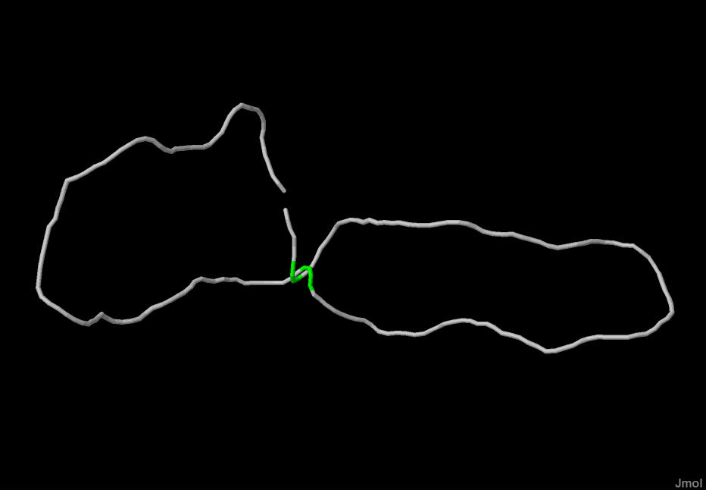

Turn off topology to gain better access?

Reptile movement.

Wrong histogram of r

Stats of r.

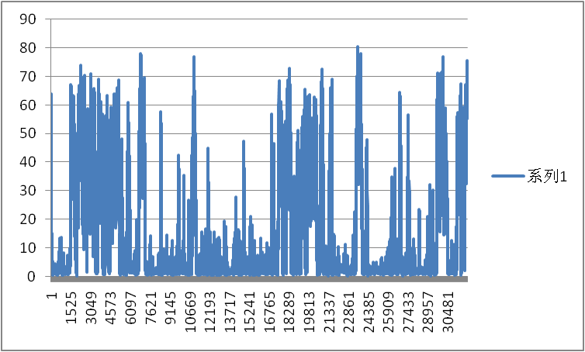

Histogram of r R only potential.

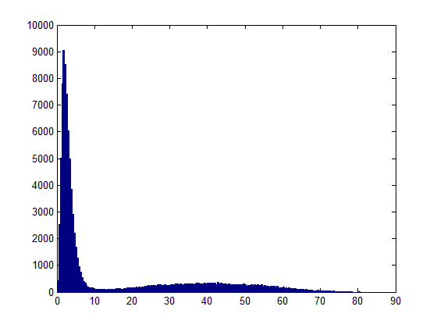

Wrong histogram of axis

Histogram of axis,

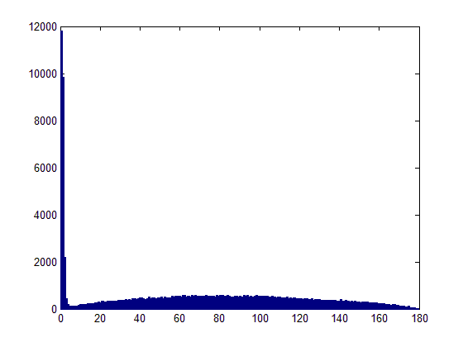

Wrong R

Correct R

