DSCI 512 | Week 8 | Final Course Project
Sully Lynch | April 30, 2026
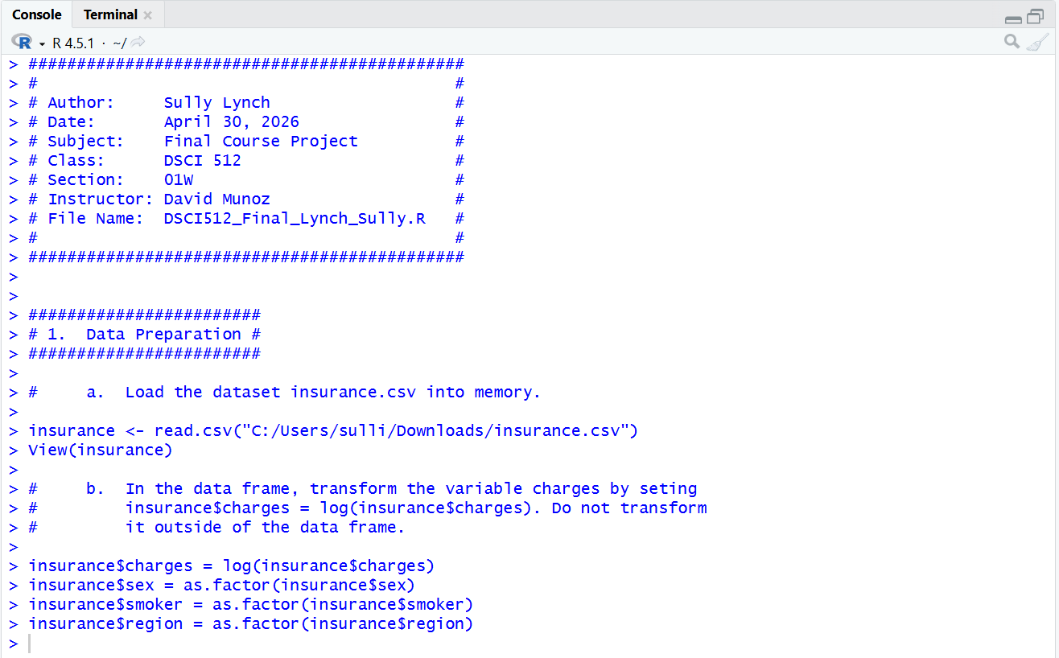
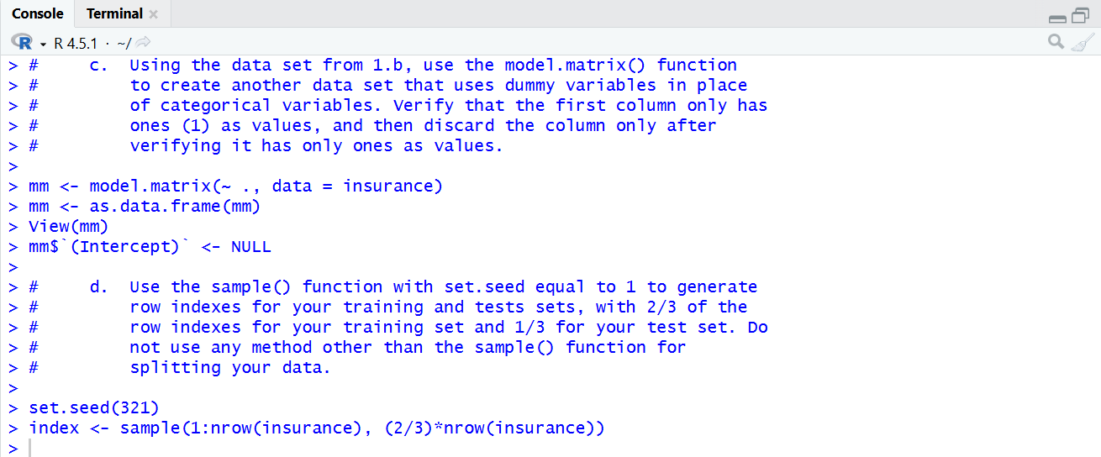
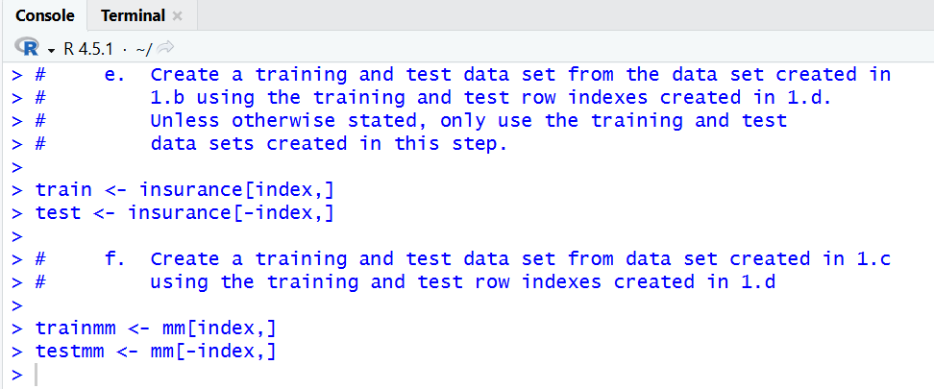
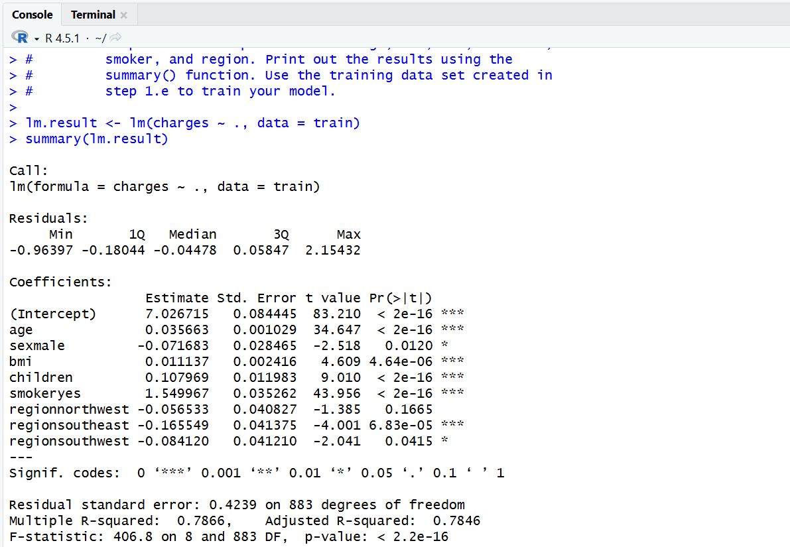
2. b) Is there a relationship between the predictors and the response?
Yes. With an adjusted R-squared of 0.7846 and a statistically significant p-value, there is a correlation between the predictors and the response.
2. c) Does sex have a statistically significant relationship with the response?
At the 0.05 significance level, yes. But not any lower.

2. d)
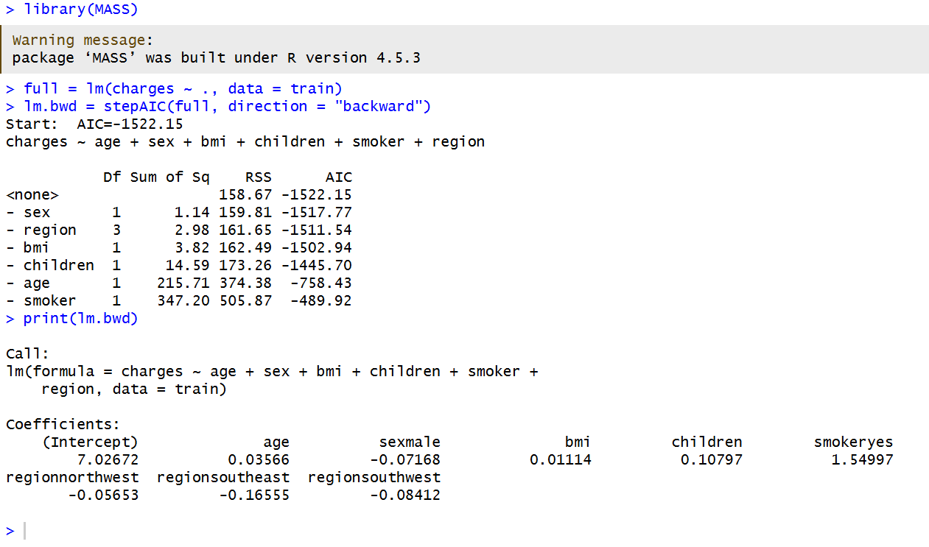
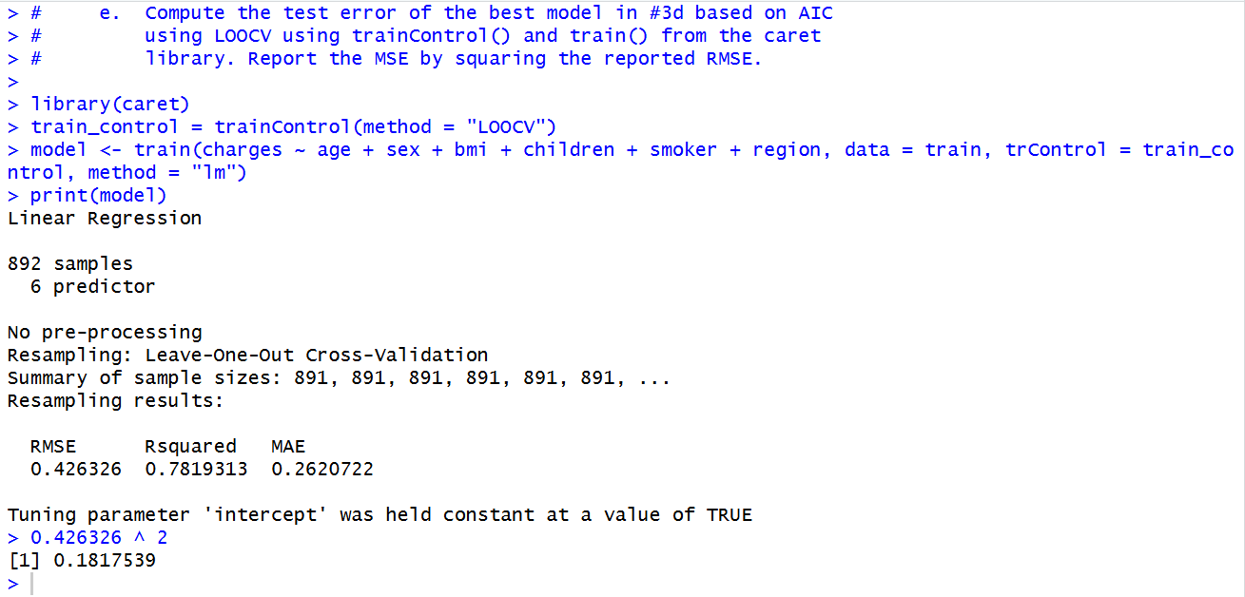
MSE = 0.1817539
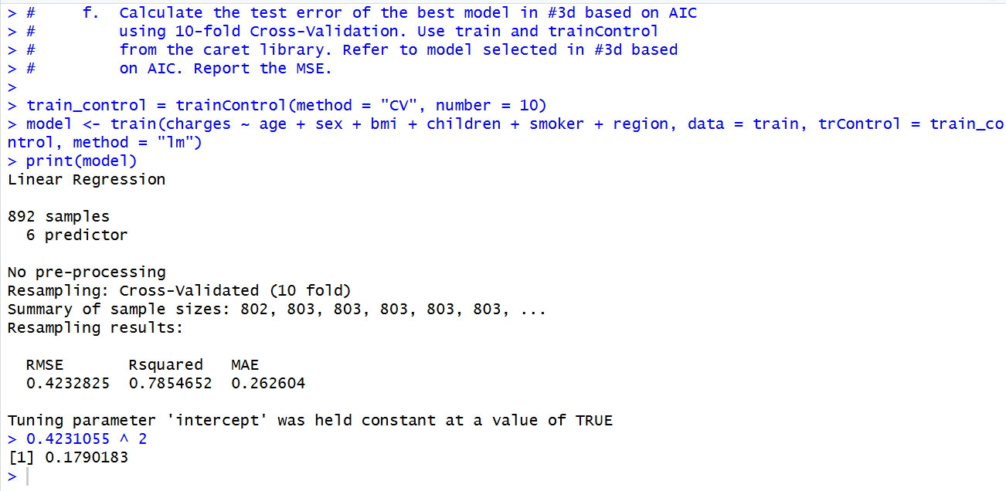
MSE = 0.1790183
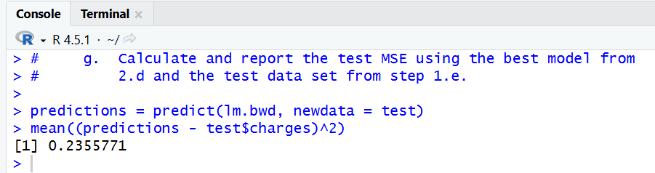
2. h) Compare the test MSE calculated in step 2.f using 10-fold cross-validation with the test MSE calculated in step 2.g. How similar are they?
They are similar, but the test MSE calculated in step 2.g is higher, meaning the best model was less precise with the test set than with the training set. Also, 10-fold cross-validation produced the lowest MSE, meaning it produced the best model.
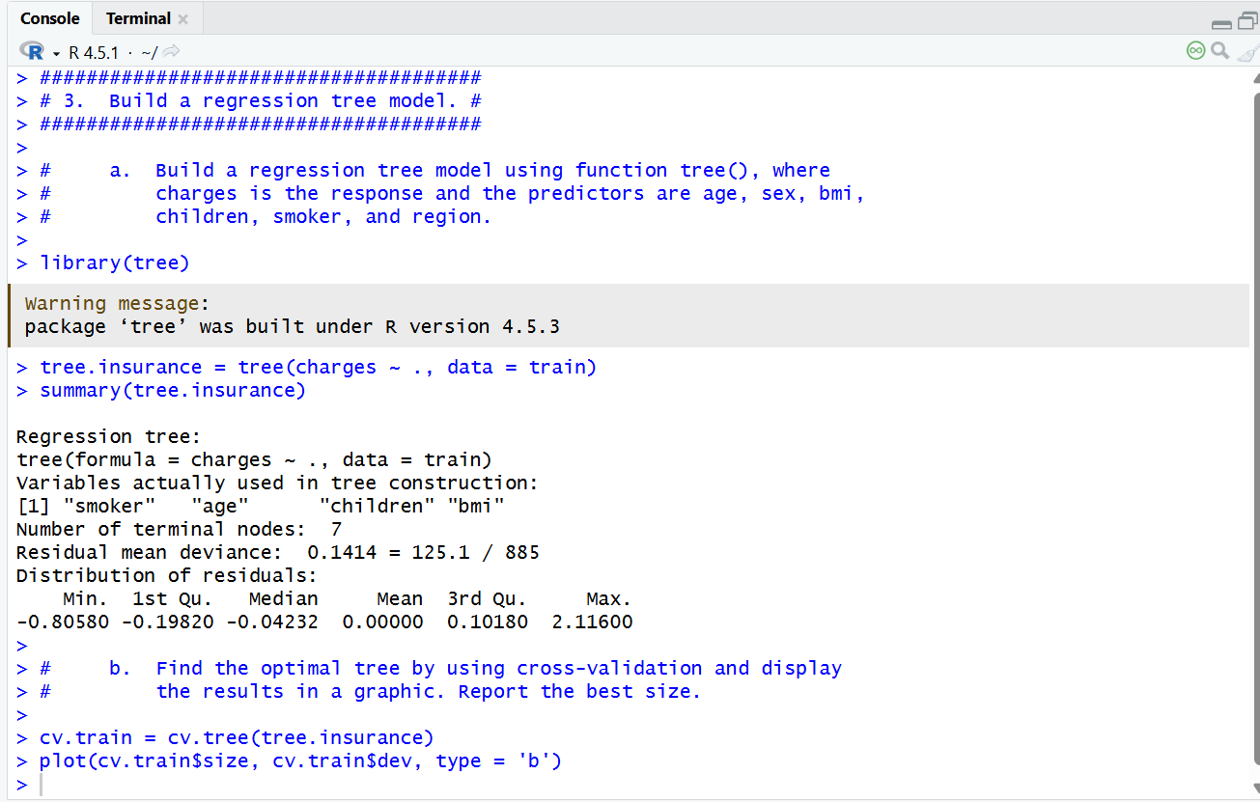
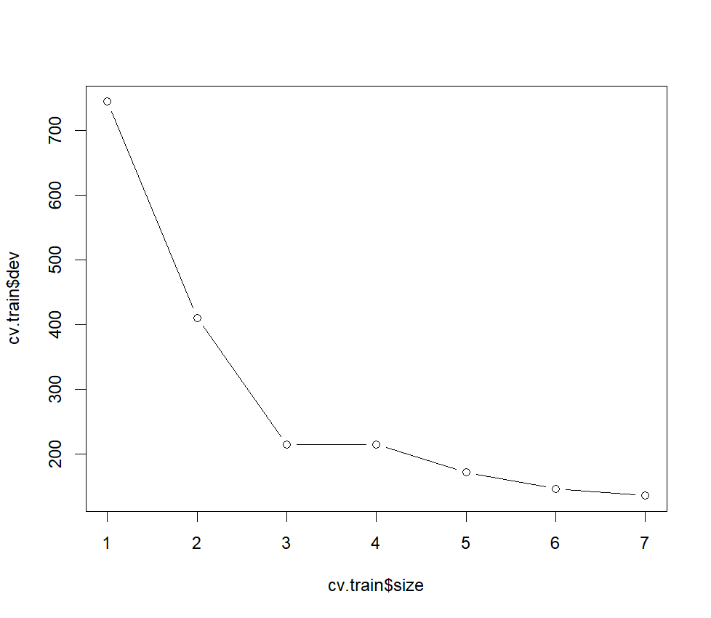
The best size is 3

3. c) Justify the number you picked for the optimal tree with regard to the principle of variance-bias tradeoff.
3 nodes is the optimal tree size for it produces good enough results while maintaining simplicity and reducing the probability of overfitting. As you can see in the chart, at size 3 the variance takes a steep drop, but diminishes quickly thereafter. This is the sweet spot in terms of the variance-bias tradeoff, making it the optimal size for the tree.
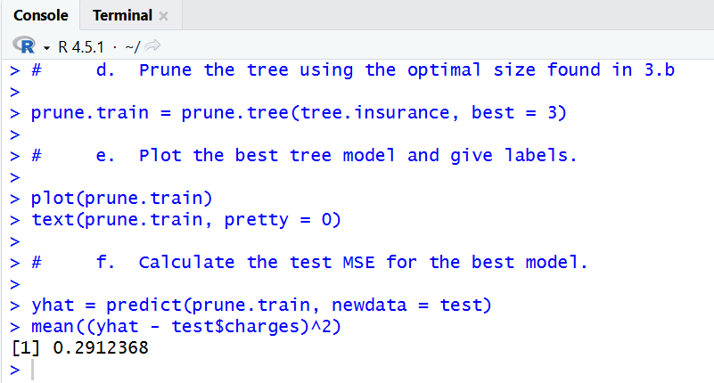
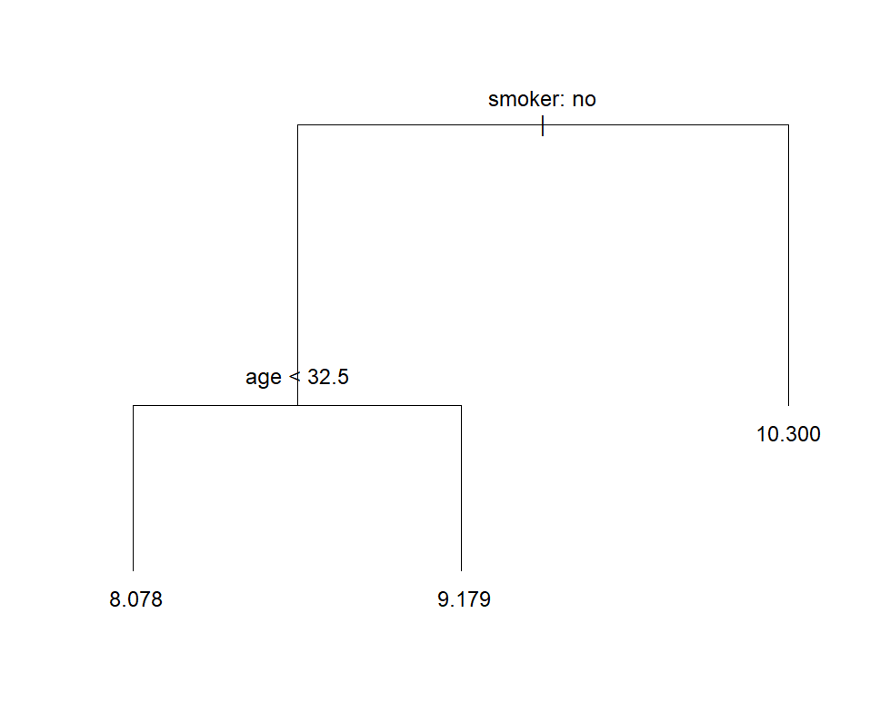
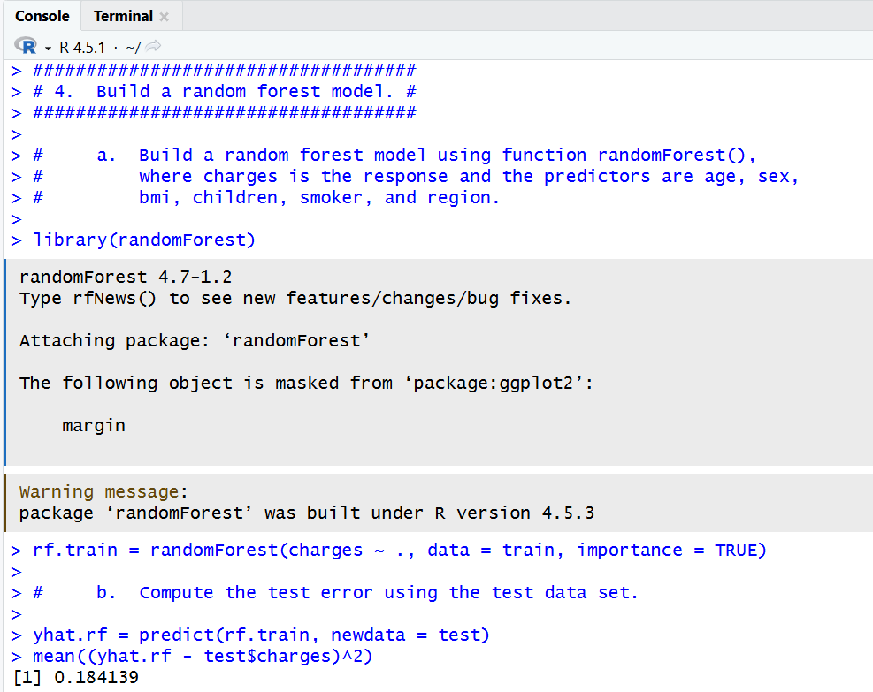
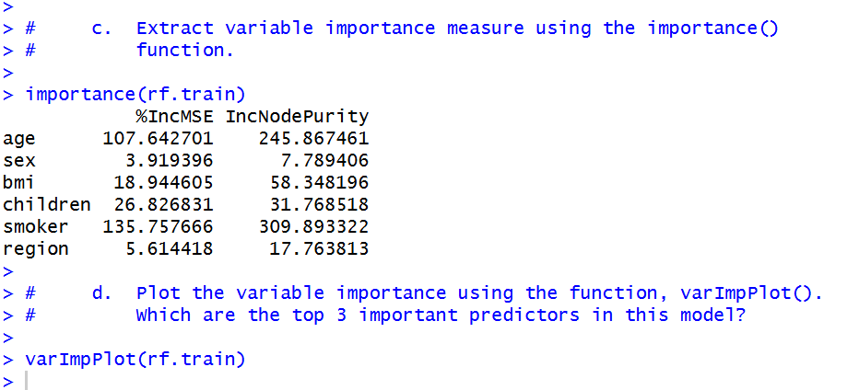
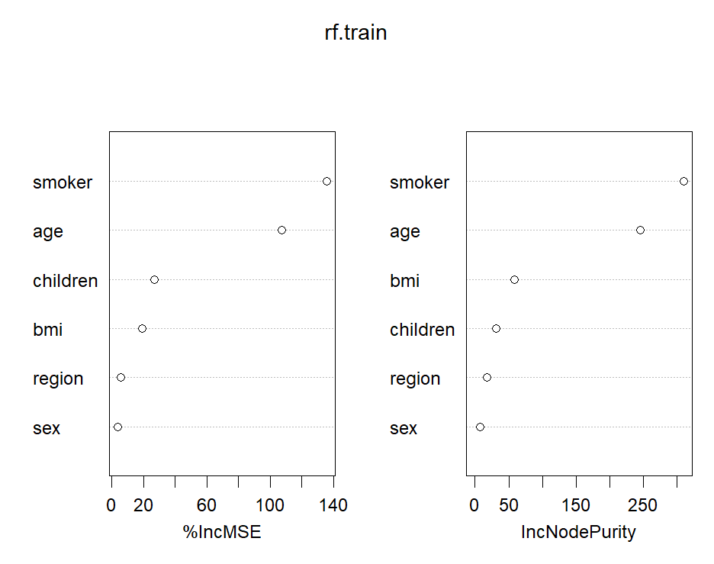
The top 3 most important predictors are smoker, age, and children.
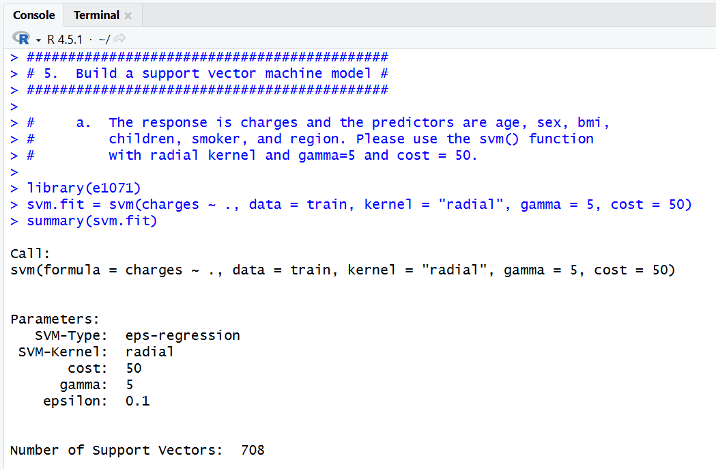

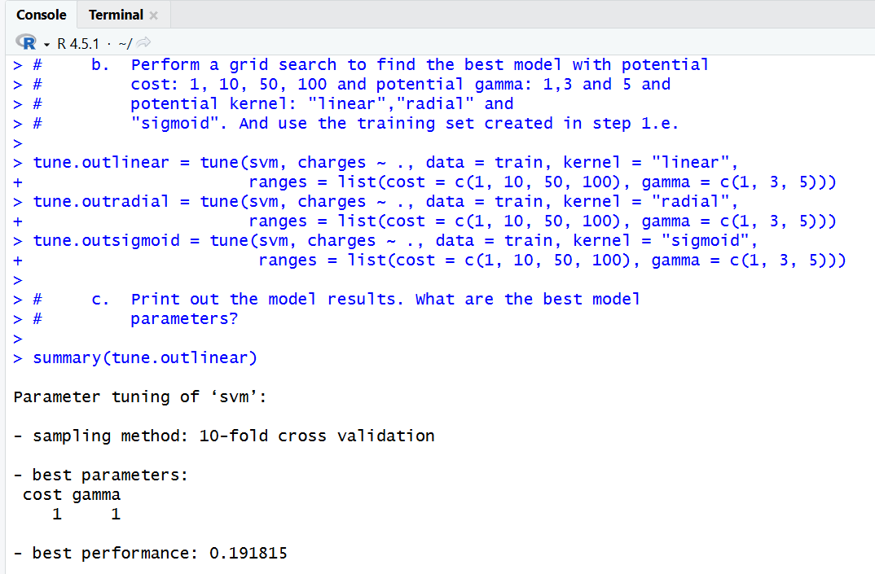
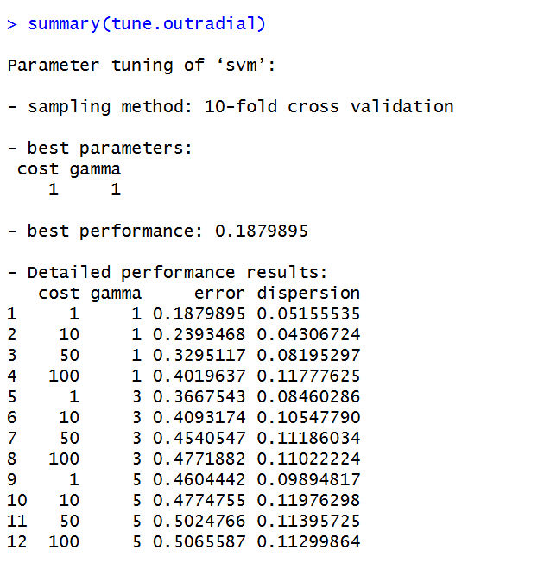
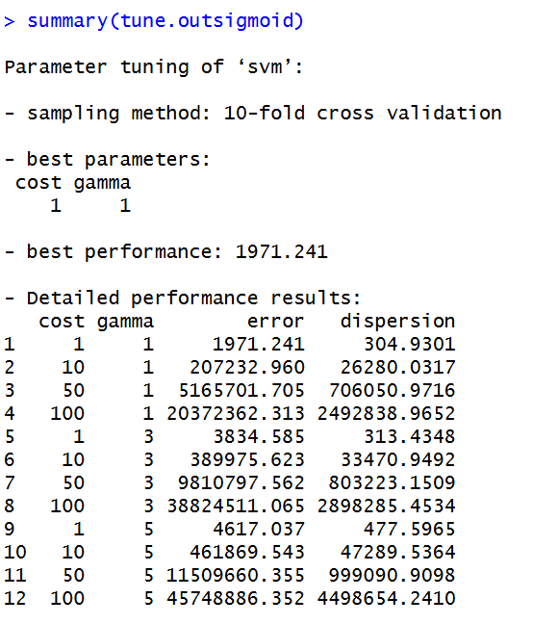
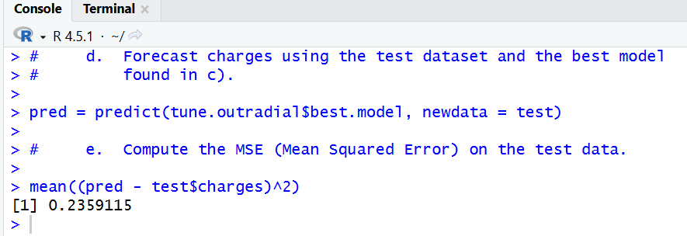
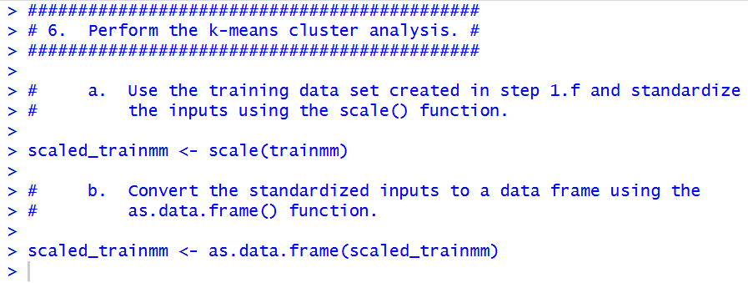
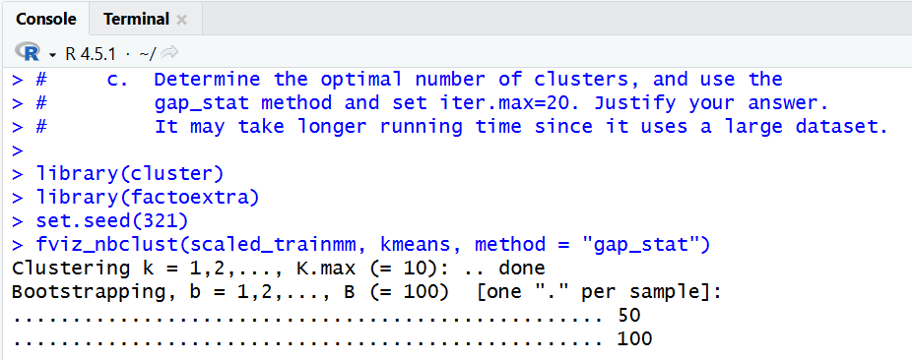
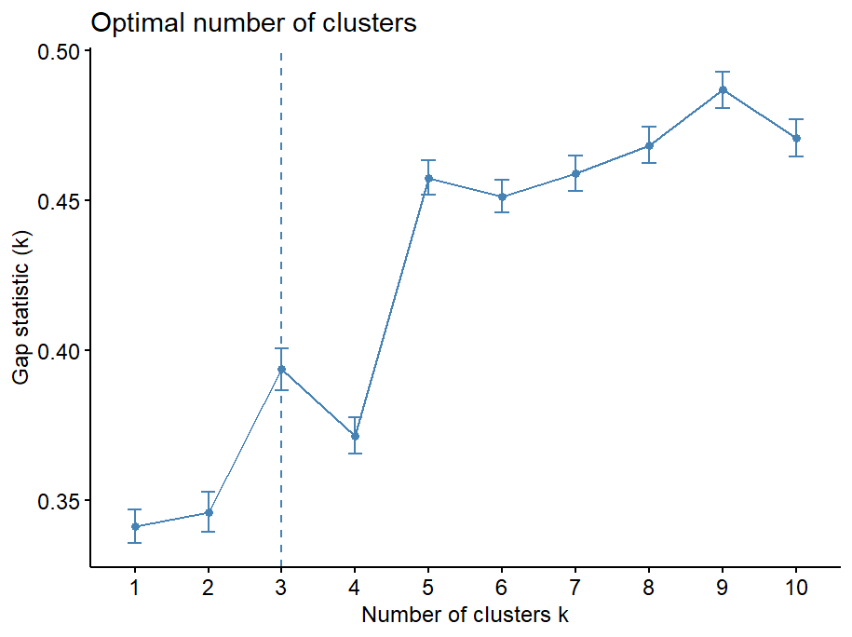
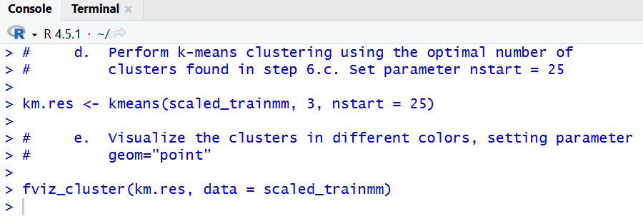
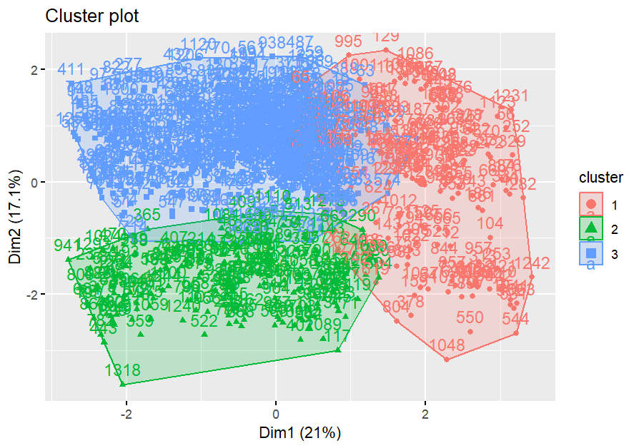
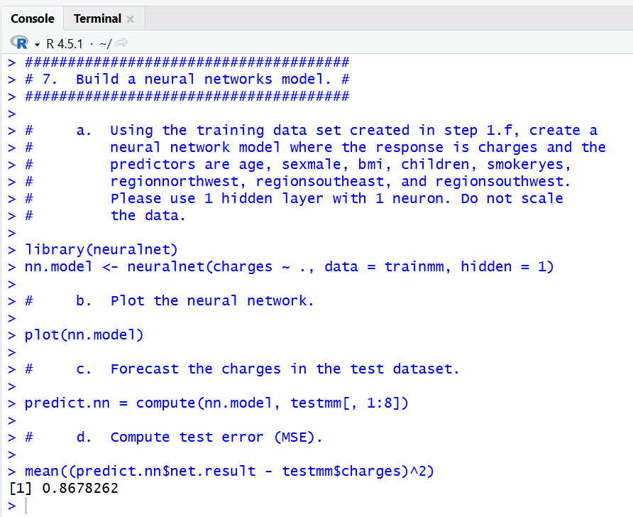
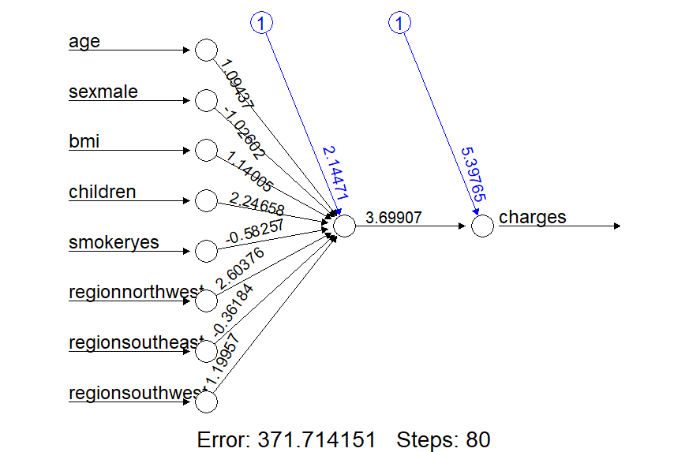
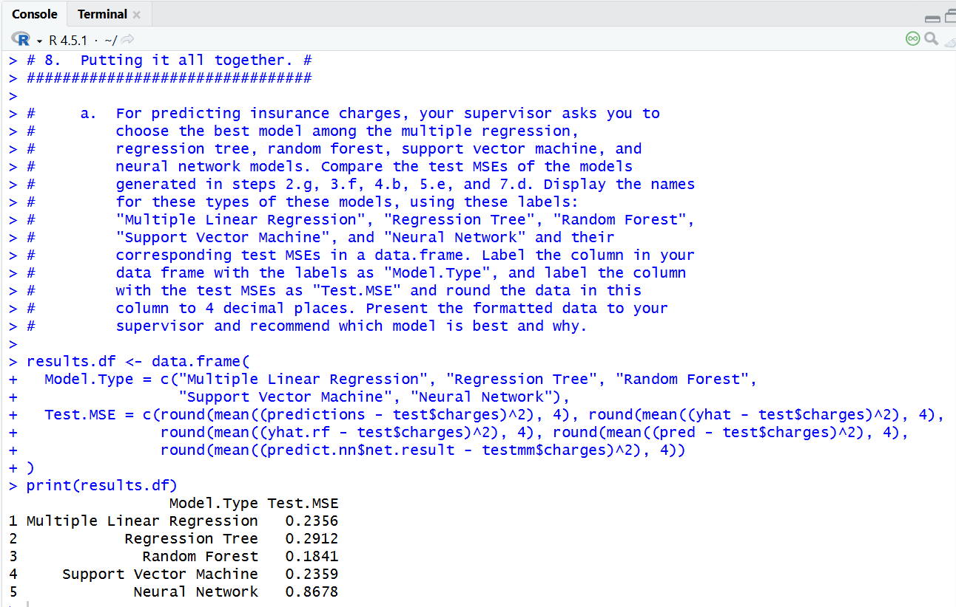
8. b) Another supervisor from the sales department has requested your help to create a predictive model that his sales representatives can use to explain to clients what the potential could be for different kinds of customers, and they need an easy and visual way of explaining it. What model would you recommend, and what are the benefits and disadvantages of your recommended model compared to other models?
The model I'd recommend is the regression tree for its simple visuals and strong results. Although it is not the best model according to MSE, the regression tree would be an effective way of explaining potential costs to clients by showing the tree and asking if they smoke, then ask for their age, and then get a ballpark estimate of what their charge will be. This simple flow from predictor to response gets the point of the model across quickly, while still giving strong predictions.
