

FINE441 – INVESTMENT MANAGEMENT

FALL 2018



INVESTMENT REPORT: CSW CAPITAL

Prepared for: Professor Larbi Hammami

Prepared by:
Siah Jian Wei Claudsen 260875381
Sully Dawood 260679328
Wylan Lee 260722787
Table of Contents
1. Investment Objective 3
2. Listing of All Trades 3
3. Performance Valuation 9
3.1 Stock Information 9
3.2 Relevant Information 9
3.3 Analysis of Relevant Information 10
3.4 Beta for Stocks 11
3.4 Jensen’s Measure 11
3.5 Treynor’s Measure 12
3.6 Sharpe’s Measure 12
4. Efficient Portfolios and Rebalancing 13
4.1 Relevant Information 13
4.2 Efficient Portfolio 14
4.3 Analysis of the Efficient Portfolio 14
4.4 Rebalancing 15
4.5 Choice of Portfolio 15
5. Appendix 17
Appendix 1 – Daily Stock Price for Performance Valuation (17th Sept 2018 to 9th Nov 2018) 17
Appendix 2 – Monthly Stock Price for Beta Calculation (Dec 1998 to Nov 2018) and Efficient Portfolio (Dec 2013 to Nov 2018) 19

1. Investment Objective
CSW Capital aims to satisfy the client’s objectives of building a stable yet appreciating retirement portfolio. The Fund seeks to maximize utility of the portfolio through a balanced risk-adjusted returns approach and at the same time, provide excess returns on the benchmark, the S&P500. The Fund actively allocates to, and within, different undervalued securities based on the identification of their potential to generate investment income/dividends and capital growth for the portfolio.

2. Listing of All Trades
* Mandatory trade (3 options, 1 short sale, 1 margin) highlighted in red
Date | Order | Symbol | Qty | Order Price | Trade Price | Type | Currency
9/19/2018 | MARKET - BUY | T | 7500 | MKT | $33.39 | EQUITIES | USD
AT&T has solid fundamentals and has increased dividends for ~20 years with a relatively high dividend yield of 6% indicating reliable investment income. AT&T is also starting to roll out 5G (fifth-generation) networks to a growing number of cities which promises faster speeds.
9/19/2018 | MARKET - BUY | BAC | 12000 | MKT | $31.30 | EQUITIES | USD
Bank of America is performing well, with costs under control and possesses excellent creditworthiness. Sub-11x forward P/E and a 1.3x price to book multiples leave the stock undervalued. The economy is strong, and Fed rate hikes should help earnings into 2019.
9/19/2018 | MARKET - BUY | PRU | 3000 | MKT | $103.77 | EQUITIES | USD
Prudential (PRU) is currently offering a healthy dividend yield of around 3.5%, but that only represents a payout ratio around 19% of earnings. This indicates a high likelihood that the dividend will be maintained and may keep growing over time.
9/19/2018 | MARKET - BUY | DIS | 3000 | MKT | $110.68 | EQUITIES | USD
Disney’s conservatively-run business and steady earnings make it a favorite for value investing, aligning with the team’s strategy. Financially, Disney is performing pretty well, with robust free-cash-flow growth of 19 percent on a year-to-year basis ending June 30.
9/19/2018 | MARKET - BUY | HON | 2000 | MKT | $166.76 | EQUITIES | USD
A history of strong financial performance and a healthy 40% payout ratio have enabled the company to grow its dividend by 12.3% per year over the last five years. Honeywell last raised its payout by 12% in 2017 and it has paid uninterrupted dividends for more than two decades.
9/26/2018 | MARKET - BUY | SPH | 8600 | MKT | $23.44 | EQUITIES | USD
With a P/E ratio of 19.09, SPH is the lowest among comparable Gas Utilities stocks suggesting SPH is under-priced. Following Value Stock Cyclical theory, the stock price might rise again as there was a ~ 11% decrease in the price since Jan 2018.
9/26/2018 | MARKET - BUY | F | 30000 | MKT | $9.30 | EQUITIES | USD
Of Auto Manufacturers that have large market caps ($10b+), Ford had the second lowest P/E ratio (5.81). Following Cyclical Value Stock Theory, Ford's stock price fell by ~ 28% since January 2018, thus we expect its price to increase within the next 6-12 months.
9/27/2018 | MARKET - BUY | XOM | 7500 | MKT | $86.21 | EQUITIES | USD
ExxonMobil has increased dividends for the past 25 years in a row, showing reliable dividend income. We expect oil prices to remain somewhat stable and XOM also plans on increasing production from 3.8 to 5.0 MMbopd which means the company has promising growth potential.
10/04/2018 | MARKET - SELL | DIS | -3000 | MKT | $115.79 | EQUITIES | USD
Disney shares have mostly appreciated since taking the long position however has recently began dropping with expectation to fall further. As such, we are selling our position to cash out our ~5% gain.
10/04/2018 | MARKET - BUY | JNJ | 1500 | MKT | $139.96 | EQUITIES | USD
Johnson & Johnson has grown dividends for the past 50+ years with 7% CAGR dividend growth in the last 10 years. As one of the largest healthcare companies with strong R&D spending, JNJ is able to continue growing dividends and suggests reliable investment income.
10/04/2018 | MARKET - BUY | VCNS | 10000 | MKT | $25.26 | EQUITIES | USD
Vanguard's Conservative ETF Portfolio matches our investment objective quite closely as it also "seeks to provide a combination of income and moderate long-term capital growth". It also offers diversification (in both stock and fixed income) and helps ease volatility in the portfolio.
10/11/2018 | MARKET - BUY | TSLA 1819V252.5 | 200 | MKT | $7.65 | OPTIONS | USD
Part of mandatory options trades. Tesla’s insolvency is highlighted with the maturity of two convertible notes and a depressed stock price making cash settlement likely (as opposed to stock conversion). Funding requirements also strain Tesla’s debt standing with the incoming Gigafactory 3 in China and burdens from trade-related tariffs.
10/11/2018 | MARKET - SHORT | SQ | -4000 | MKT | $76.25 | EQUITIES | USD
Part of mandatory short sale trade. Square’s recent revenue growth is largely coming from its credit operations. Unless the company underwrites risk competently, SQ likely faces a case of insolvency or default risk. Furthermore, the market is willing to pay less for earnings off of credit lending than it is off of payment processing.
10/12/2018 | MARKET - SHORT | PNC | -2000 | MKT | $123.46 | EQUITIES | USD
PNC holds sales signals from both short- and long-term moving averages. In addition, there is a general sales signal from the relation between the two signals where the long-term average is above the short-term average.
10/16/2018 | MARKET - SELL | TSLA 1819V252.5 | -200 | MKT | $1.52 | OPTIONS | USD
TSLA’s short-term boost in stock prices backfired on this put option, as such we are cutting our losses through this sale.
10/16/2018 | MARKET - COVER | SQ | 4000 | MKT | $74.90 | EQUITIES | USD
The short on SQ has provided a small gain, however the share price has begun appreciating and we have decided to cash out.
10/18/2018 | MARKET - SELL | SPH | -8600 | MKT | $23.62 | EQUITIES | USD
SPH has peaked in the past day and has begun dropping in price; selling to cash out before losing gains on this stock.
10/18/2018 | MARKET - BUY | BTI | 5000 | MKT | $42.50 | EQUITIES | USD
Had the lowest P/E of 2.57 in Consumer Goods that had "large" market capitalization ($10b - $200b) and also has a Dividend yield of 6.31%, which far exceeds the industry average. Trade was made following Cyclical Stock Theory.
10/23/2018 | MARKET - COVER | PNC | 2000 | MKT | $119.48 | EQUITIES | USD
Cashing out the gain on the short position since PNC price has started appreciating.
10/24/2018 | MARKET - SHORT | MA | -1300 | MKT | $197.00 | EQUITIES | USD
The move away from banks, insurance companies, and mortgage lenders came as the financial sector has underperformed the broad S&P 500 benchmark index by more than 5 percent since April. Hence, shorting to balance our portfolio of other financial stock holdings.
10/24/2018 | MARKET - SHORT | GS | -1200 | MKT | $211.04 | EQUITIES | USD
The move away from banks, insurance companies, and mortgage lenders came as the financial sector has underperformed the broad S&P 500 benchmark index by more than 5 percent since April. Hence, shorting to balance our portfolio of other financial stock holdings.
10/24/2018 | MARKET - SHORT | V | -1800 | MKT | $135.36 | EQUITIES | USD
The move away from banks, insurance companies, and mortgage lenders came as the financial sector has underperformed the broad S&P 500 benchmark index by more than 5 percent since April. Hence, shorting to balance our portfolio of other financial stock holdings.
10/24/2018 | MARKET - SHORT | C | -4000 | MKT | $64.42 | EQUITIES | USD
The move away from banks, insurance companies, and mortgage lenders came as the financial sector has underperformed the broad S&P 500 benchmark index by more than 5 percent since April. Hence, shorting to balance our portfolio of other financial stock holdings.
10/24/2018 | MARKET - SHORT | TSLA | -900 | MKT | $317.20 | EQUITIES | USD
Cashing out small gain before price appreciation trend wipes out gains.
10/24/2018 | MARKET - BUY | SNAP 1802W7 | 10 | MKT | $0.71 | OPTIONS | USD
Part of mandatory options trades. Analysts are bearish on SNAP given daily user activity for the app is expected to diminish further from Q2 and insider trading activity shows significant proportion of stock sales.
10/25/2018 | MARKET - COVER | TSLA | 900 | MKT | $310.93 | EQUITIES | USD
Cashing out small gain before price appreciation trend wipes out gains.
10/26/2018 | MARKET - SELL | SNAP 1802W7 | -10 | MKT | $0.92 | OPTIONS | USD
Cashing out a 50% gain after the Snapchat Earnings Report showed declining user activity.
10/29/2018 | MARKET - BUY | ED | 1000 | MKT | $77.67 | EQUITIES | USD
ED has the lowest P/E (3.50) among Mid-market Utilities (Utilities with Market Cap $2b+). It also has a reasonable dividend yield of 3.70%. A forward P/E of 17.81 is a good indicator that the Cyclical Value Stock theory will hold in the long run.
10/29/2018 | MARKET - SHORT | FB | -2000 | MKT | $140.67 | EQUITIES | USD
Facebook is showing an obvious declining trend, shorting makes sense given the tech sector’s largely disappointing earnings reports so far this quarter.
10/29/2018 | MARKET - SHORT | GOOG | -250 | MKT | $1,004.00 | EQUITIES | USD
GOOG is showing a declining trend much like Facebook. With the rest of the tech sector posting disappointing quarterly earnings reports, Google’s stock is expected to depreciate.
11/02/2018 | MARKET - BUY | MCD | 2500 | MKT | $175.33 | EQUITIES | USD
MCD performs well as a defensive stock. Analysts are bullish on MCD because of strategic initiatives related to restaurant remodelling and digital channels. MCD has increased dividends every year since 1976 providing solid investment income for the portfolio with yield of 2.7%.
11/02/2018 | MARKET - BUY | MAR 1830K120 | 1 | MKT | $4.40 | OPTIONS | USD
Part of mandatory options trades. MAR has solid fundamentals. Analysts’ consensus signals that Marriott is a buy however is not overbought ahead of its earnings call on November 5th.
11/06/2018 | MARKET - BUY | DIS | 2000 | MKT | $116.19 | EQUITIES | USD
Disney’s conservatively-run business and steady earnings make it a favorite for value investing, aligning with the team’s strategy. Financially, Disney is performing pretty well, with robust free-cash-flow growth of 19 percent on a year-to-year basis ending June 30.
11/06/2018 | MARKET - BUY | LYB | 2400 | MKT | $96.09 | EQUITIES | USD
Of the Basic Material firms with market capitalization of $30B+, LYB Has the lowest P/E ratio of 7.37 (& a forward P/E of 8.4). LYB also has a decent dividend yield of 4.21%.
11/07/2018 | MARKET - BUY | ABBV | 1000 | MKT | $86.74 | EQUITIES | USD
Part of mandatory margin trade. ABBV has a high dividend yield of 4.95% and has consistently grown dividends for 25+ years showing strong ability to pay dividends. ABBV is still relatively close to its 52-week low, indicating a good time to buy-in as the stock has recently began appreciating again.

3. Performance Valuation

3.1 Stock Information
The team has chosen the following six stocks in our portfolio valuation analysis:
The six stocks are diversified across six different sub-industries.
The six stocks are aligned with our investment strategies of investing in blue-chip and value stocks (pay regular dividends) in stabilized sectors, so as to fulfill our client’s objective of generating a predictable and stable stream of income for long-term retirement purposes.

3.2 Relevant Information
The following is a summary table of the relevant information for performance measures calculation:
The following is the method for retrieving the relevant information:
1) The team retrieved the holding period start and end date for each of the six stocks that the team made on StockTrak, following which we retrieved the purchase price and ending price for each of the six stocks. The HPR is subsequently calculated.
The number of trading days are excluding weekends and public holidays.
For each of the six stocks, the annualized HPR is calculated by [$\frac{HPR}{Number of Trading Days}$ x 250].
The S&P500 annualized returns % is calculated slightly differently from the six stocks, it is calculated by the average daily returns % during the trading period and multiplied by 250.
2) The standard deviation for each of the six stocks is calculated using the STDEV excel formula function and the daily returns % from the start date to the end date. For example, JNJ standard deviation is the STDEV of the daily returns % between 5th October to 9th November.
The annualized standard deviation is calculated by [standard deviation x (250^{0.5})]
3) The team retrieved the number of shares bought and the purchase price for each of the six stocks that the team made on StockTrak. The market value and individual weightage is subsequently calculated.
4) Correlation Matrix: Correlation between the daily returns of the respective two stocks
5) Variance-Covariance Matrix: Multiplication of standard deviation of the respective two stocks and their correlation

3.3 Analysis of Relevant Information
The following is a preliminary analysis of the relevant stock information:
1) S&P500 had a negative average daily return % during the 40-day trading period.
2) Out of the six stocks, four of the stocks (MCD, JNJ, ED and F) experienced a positive HPR while the remaining two stocks experienced a negative HPR (T and XOM).
3) McDonald’s Corp (MCD) experienced the largest positive annualized HPR at 216.64%, partially due to its short holding period of only 6 trading days and the surge in stock price during this period.
4) On the other hand, AT&T Inc (T) experienced the largest negative annualized HPR at -43.83%, partially due to its long holding period of 38 trading days and the sharp decline in its stock price during this period.
5) Correlation ranged from -0.1976 to 0.5732, showing that the stocks are mostly slightly correlated with one another.

3.4 Beta for Stocks
The following is a summary table of the beta for each of the six stocks:
The following is the method for the beta calculation:
1) Retrieve the monthly stock price for each of the six stocks and S&P500 for the past 30 years (Dec 1988 to Nov 2018)
2) Calculate the monthly return
3) Run an Excel regression using the monthly returns between Y-axis: Stock and X-axis: S&P 500
The following is an analysis of the beta results:
1) Only Ford Motor Company (F) has a beta above 1, at 1.5253. In theory, this means that the Ford’s stock price has been more volatile than the market over time. In this case, it is assumed that Ford is 52% more volatile than the market.
2) On the other hand, the remaining five stocks have a beta of less than 1. As a portfolio, since majority of the stocks are less volatile than the market, it can be initially assumed that the portfolio beta will be less than 1 (even though it still depends on the individual weightage). This theoretically means that the portfolio will be relatively defensive and stable. This aligns with our investment strategy of safe investing.

3.4 Jensen’s Measure
Jensen’s measure is the average return on the portfolio over and above that predicted by the CAPM, given the portfolio’s beta and the average market return. Jensen’s measure is the portfolio’s alpha value.
The following is the method for the Jensen’s alpha calculation:
1) Portfolio Actual Return: Multiplication of the current individual weightage between the six stocks and its respective annualized HPR. Excel Formula: =MMULT($U$7:$Z$7,T41:T46)
2) Risk-Free Rate: 13 WEEK TREASURY BILL (^IRX), averaged at 2.2198% (already annualized)
3) Portfolio Beta: Multiplication of the current individual weightage between the six stocks and its respective beta. Excel Formula: =MMULT($U$18:$Z$18,T41:T46)
4) Market Risk Premium: The difference between S&P500 annual returns % and the annualized risk-free rate.
With a Jensen’s alpha of 59.2371%, the team’s portfolio is currently earning more than the expected returns as predicted by the CAPM. Hence, the portfolio is outperforming its expectations.

3.5 Treynor’s Measure
Treynor’s measure gives excess return per unit of risk, but it uses systematic risk instead of total risk.
With a Treynor’s ratio of 0.5399, the portfolio is earning 53.99% in excess return for every 1 unit increase in beta.

3.6 Sharpe’s Measure
Sharpe’s measure divides average portfolio excess return over the sample period by the standard deviation of returns over that period. It measures the reward to (total) volatility trade-off.
With a Sharpe’s ratio of 2.6207, the portfolio is earning 262.07% in excess return for every 100% increase in total risk. This unusually high ratio is partially due to the MCD’s unusually high returns-to-volatility trade-off.

4. Efficient Portfolios and Rebalancing

4.1 Relevant Information
The following is a summary table of the relevant information for efficient portfolio calculation:
The following is the method for retrieving the relevant information:
1) Retrieve the monthly stock price for each of the six stocks and S&P500 for the past 5 years (Dec 2013 to Nov 2018)
2) Calculate the monthly return, then multiply by 12 to get annualized returns
3) Calculate the standard deviation, then multiply by 12^{0.5} to get annualized standard deviation
4) Correlation Matrix: Correlation between the monthly returns of the respective two stocks
5) Variance-Covariance Matrix: Multiplication of standard deviation of the respective two stocks and their correlation

4.2 Efficient Portfolio
Excel Formulation:
1) Objective Function: Maximize Sharpe Ratio
2) Decision Variables: Weightage of the six stocks
3) Constraints: Sum of Weightage = 1
Excel Results:

4.3 Analysis of the Efficient Portfolio
The following is an analysis of the efficient portfolio calculation:
1) MCD has been allocated the highest percentage at 60.51%, due to its highest reward-to-volatility ratio
2) Both F and XOM has been allocated with 0%, due to their inefficient reward-to-volatility ratio
3) The maximum sharpe ratio is 1.3241, with a portfolio return of 14.7745% and standard deviation of 10.6962%

4.4 Rebalancing
The following is the rebalancing method:
1) By using the current individual weightage of MCD: 23.05%, JNJ: 11.04%, ED: 4.08%, F: 14.67%, T: 13.17% and XOM: 34% and the annualized monthly returns and standard deviation (from section 4.1), the current Sharpe ratio is derived, at 0.5397.
2) By using the same standard deviation as the one that maximizes Sharpe ratio: 10.6962% and the current Sharpe ratio: 0.5397, the portfolio returns will be 6.3849%.
The following graph illustrates the rebalancing method:
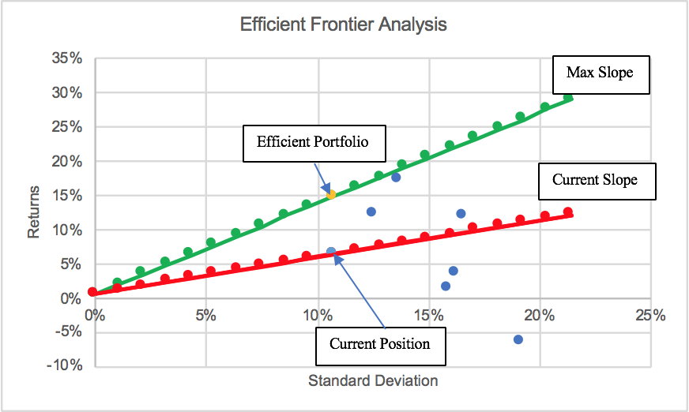

4.5 Choice of Portfolio
In alignment with the investment objective, the team will be building a stable and defensive portfolio by keeping the standard deviation constant at 8%. Hence, the weights of the individual stocks are as follow:
y = $\frac{0.08}{0.106965}$ = 0.7479 % in Risk-Free = 0.2521
Expected Returns = 0.7479 (14.7745%) + 0.2521 (0.6118%) = 11.2045%
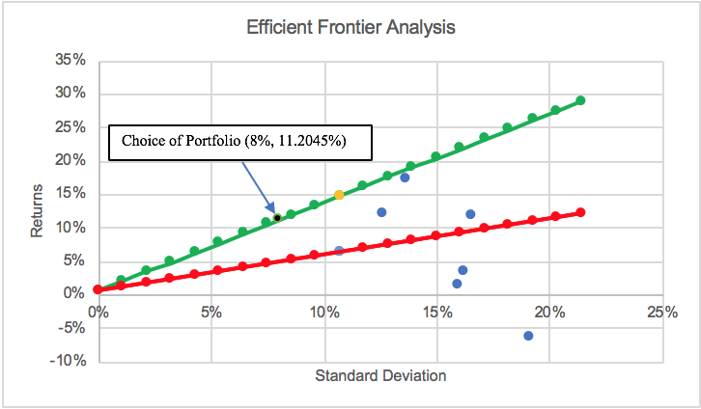

5. Appendix

Appendix 1 – Daily Stock Price for Performance Valuation (17th Sept 2018 to 9th Nov 2018)

Appendix 2 – Monthly Stock Price for Beta Calculation (Dec 1998 to Nov 2018) and Efficient Portfolio (Dec 2013 to Nov 2018)

