Name: A.Reddy Sulochana
Reg.No: 192372370

Exp.No.08 DFS
01.08.26

Aim:
To implement the Depth First Search (DFS) algorithm in Python and traverse all the vertices of a graph starting from a given node.
Algorithm:
- Start the program.
- Read the number of vertices.
- Read each vertex and its adjacent vertices to create the graph.
- Read the starting vertex.
- Create an empty set called visited.
- Visit the starting vertex and mark it as visited.
- Print the visited vertex.
- Recursively visit all unvisited adjacent vertices.
- Repeat until all reachable vertices are visited.
- Stop the program.

Program:
def dfs(graph, node, visited):
visited.add(node)
print(node, end=" ")
for neighbour in graph[node]:
if neighbour not in visited:
dfs(graph, neighbour, visited)
graph = {}
n = int(input("Enter number of vertices: "))
for i in range(n):
vertex = input("Enter vertex: ")
neighbours = input("Enter adjacent vertices (space-separated): ").split()
graph[vertex] = neighbours
start = input("Enter starting vertex: ")
visited = set()
print("DFS Traversal:")
dfs(graph, start, visited)

Input:
Enter number of vertices: 6
Enter vertex: A
Enter adjacent vertices (space-separated): B C
Enter vertex: B
Enter adjacent vertices (space-separated): D E
Enter vertex: C
Enter adjacent vertices (space-separated): F
Enter vertex: D
Enter adjacent vertices (space-separated):
Enter vertex: E
Enter adjacent vertices (space-separated): F
Enter vertex: F
Enter adjacent vertices (space-separated):
Enter starting vertex: A

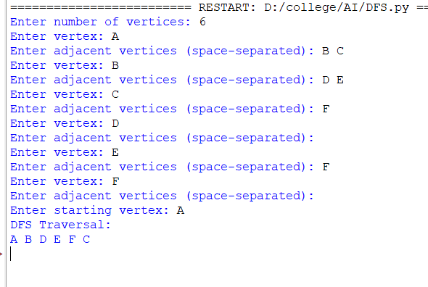
Output:

Result:
Thus, the Python program to implement Depth First Search (DFS) was executed successfully, and the graph was traversed in DFS order starting from the given source vertex.

