I have generated the test cases using randoop. I have created a .class file for the avltree.java and ran the randoop command without any command filters and it generated the test case file.

Then I have created a Maven project with avltree.java as main code and generated test java files in the test code. Modified the pom.xml to include junit runner as dependency.

The code coverage of test cases is 98.5%.

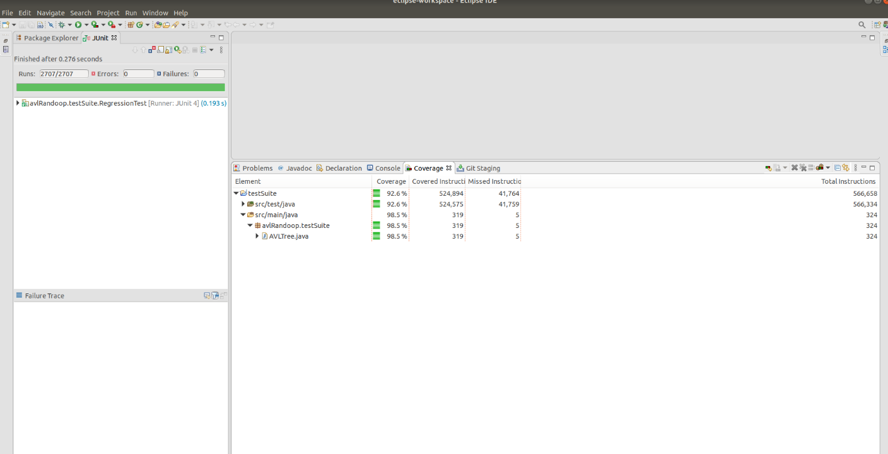

Included .travis.yml file and integrated my travis account and the build was successful after commit.

