1) select NUMBEROFTICKETS AS 'TICKETS SOLD', HOMETEAM, AWAYTEAM

FROM ORDERDETAILS, ORDER#

2) SELECT GAME#, HOME, AWAY, attendance

FROM GAMES

3) SELECT GAME#, ATTENDANCE, RANK() OVER (ORDER BY ATTENDANCE ASC) RANK

FROM GAMES

4) SELECT GAMES.CLUB#, GAMES.GAME#, GAMES.HOME, GAMES.AWAY, GAMES.GAME_DATE

FROM GAMES

JOIN CLUB ON CLUB.CLUB#=GAMES.CLUB#

5) select distinct EMPLOYEE#, stateadd

from EMPLOYEE

6) select NUMBEROFTICKETS as 'Number of Customers', STATEADD

from ORDERDETAILS



8) SELECT GAME#, ATTENDANCE

FROM GAMES

9) select game#, (attendance/CAPACITY *100) as percentage#

from GAMES, STADIUM



10) select NUMBEROFTICKETS, FIRST_NAME, LAST_NAME, CITY

from ORDERDETAILS

where CITY like 'm%'



11) select NUMBEROFTICKETS, LAST_NAME

from ORDERDETAILS



12) select HOME, AWAY, GAME_RESULT, (win/19)*100 as 'win%' , (draw/19)*100 as 'draw%', (lose/19)*100 as 'lose%'

from GAMES

13) select HOME,AWAY

from GAMES, STADIUM s

where attendance < s.CAPACITY

--Part1)

--2)

select t.name TableName, i.rows Records

from sysobjects t, sysindexes i

where t.xtype = 'U' and i.id = t.id and i.indid in (0,1)

order by TableName;

/*

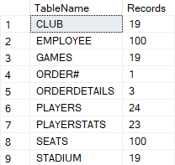

*/

--Part 2)

--a)

select concat(home,'vs', away) as 'Game Name',home, away, STADIUM.STADIUM_NAME

from games

inner join STADIUM on STADIUM.CLUB#=GAMES.CLUB#

/*

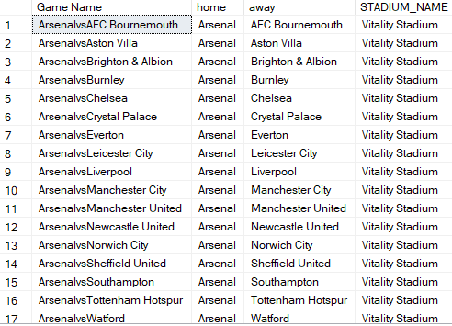

*/

--g)

select distinct monthss, EMPLOYEE_FNAME

from EMPLOYEE

order by monthss desc

/*

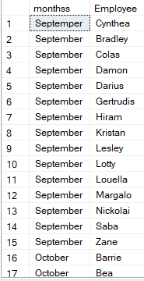

*/

--f)

select GAME_DATE,HOME,AWAY,STADIUM.CAPACITY, ORDERDETAILS.NUMBEROFTICKETS

from GAMES

inner join STADIUM on GAMES.CLUB#=STADIUM.CLUB#

inner join ORDERDETAILS on GAMES.GAME#=ORDERDETAILS.Game#

/*

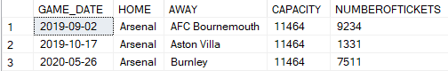

*/

--i)

select NUMBEROFTICKETS, FIRST_NAME, LAST_NAME, CITY

from ORDERDETAILS

where CITY like '[mws]%'

/*

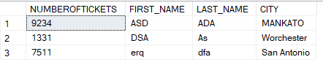

*/

--j)

select HOME, AWAY, GAME_RESULT, (win/19)*100 as 'win%' , (draw/19)*100 as 'draw%', (lose/19)*100 as 'lose%'

from GAMES

/*

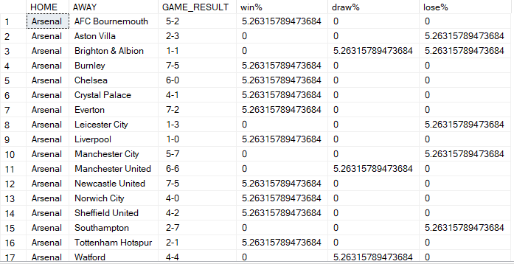

*/

--k)

select HOME,AWAY

from GAMES, STADIUM s

where attendance < (75*s.CAPACITY/100)

/*

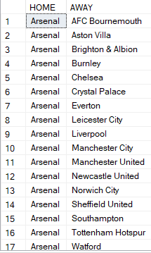

*/

--l)

select HOME, AWAY, GAME_RESULT,

case

when win>0 then win*3

when draw>0 then draw*1

when lose>0 then lose*0

end as points

from GAMES

/*

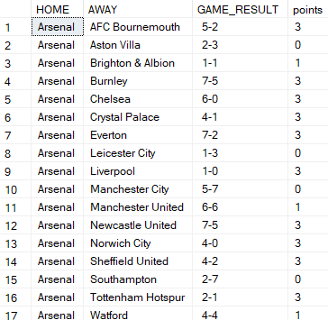

*/

--Part3)

BEGIN

declare @name varchar(10);

declare @tdate date;

declare @dbname varchar(10);

set @name='Aveek';

set @tdate=SYSDATETIME();

set @dbname='Arsenal';

print @name;

print @tdate;

print @dbname;

end

/*

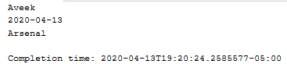

*/

--PART4)

--1)

Create or Alter PROCEDURE spo(

@GAME INT)

AS

BEGIN

SELECT home, away, Game_Date, NUMBEROFTICKETS

FROM ORDERDETAILS JOIN Games

ON orderdetails.Game# = Games.Game#

WHERE Game# = @GAME

END;

GO

EXECUTE spo 1;

DROP PROCEDURE spo ;

/*



*/

--2)

Create or Alter PROCEDURE ga(

@stdname VARCHAR)

AS

BEGIN

SELECT STADIUM_NAME, game# as 'Total Games', NUMBEROFTICKETS

FROM STADIUM, ORDERDETAILS

where STADIUM_NAME=@stdname

and game# =1

END;

GO

EXECUTE ga 'Emirates Stadium';

DROP PROCEDURE ga;

/*



*/

--3)

Create or Alter PROCEDURE ga(

@tickerNO INT)

AS

BEGIN

SELECT LAST_NAME,FIRST_NAME,NUMBEROFTICKETS

FROM ORDERDETAILS

where TICKET#=@tickerNO

END;

GO

EXECUTE ga 1;

DROP PROCEDURE ga;

/*



*/

Create or Alter PROCEDURE ga(

@tickerNO INT)

AS

BEGIN

SELECT ticket# as 'Customer ID',LAST_NAME,g.GAME#,g.GAME_DATE,g.HOME,NUMBEROFTICKETS

FROM ORDERDETAILS, GAMES g

where TICKET#=@tickerNO

END;

GO

EXECUTE ga 1;

DROP PROCEDURE ga;

/*



*/