1. **DATABASE**

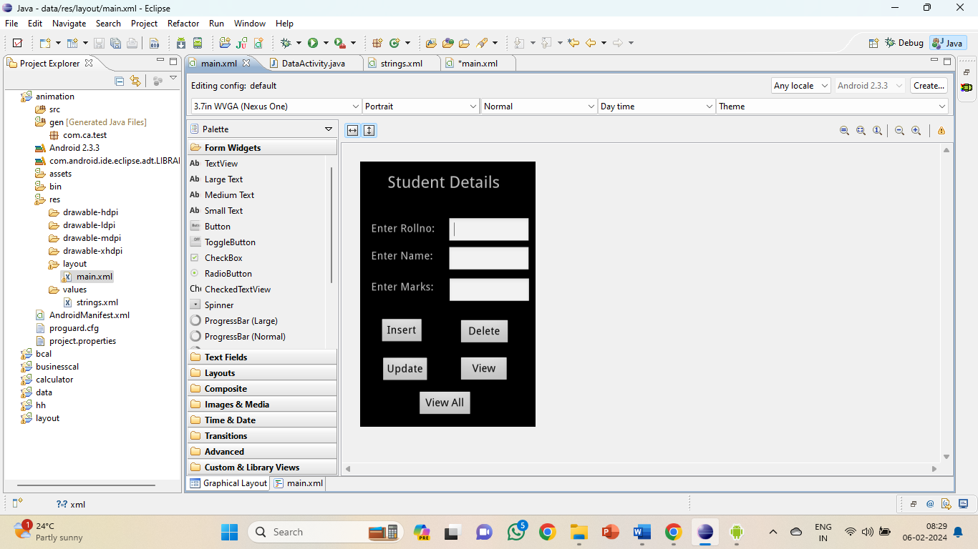

**XML CODE**

<?xml version=*"1.0"* encoding=*"utf-8"*?>

<AbsoluteLayout xmlns:android=*"http://schemas.android.com/apk/res/android"*

android:layout_width=*"match_parent"*

android:layout_height=*"match_parent"*>

<TextView

android:layout_width=*"wrap_content"*

android:layout_height=*"wrap_content"*

android:layout_x=*"50dp"*

android:layout_y=*"20dp"*

android:text=*"Student Details"*

android:textSize=*"30sp"* />

<TextView

android:layout_width=*"wrap_content"*

android:layout_height=*"wrap_content"*

android:layout_x=*"20dp"*

android:layout_y=*"110dp"*

android:text=*"Enter Rollno:"*

android:textSize=*"20sp"* />

<TextView

android:layout_width=*"wrap_content"*

android:layout_height=*"wrap_content"*

android:layout_x=*"20dp"*

android:layout_y=*"160dp"*

android:text=*"Enter Name:"*

android:textSize=*"20sp"* />

<EditText

android:id=*"@+id/Rollno"*

android:layout_width=*"150dp"*

android:layout_height=*"wrap_content"*

android:layout_x=*"160dp"*

android:layout_y=*"102dp"*

android:inputType=*"number"*

android:textSize=*"20sp"* >

<requestFocus />

</EditText>

<EditText

android:id=*"@+id/Name"*

android:layout_width=*"150dp"*

android:layout_height=*"wrap_content"*

android:layout_x=*"160dp"*

android:layout_y=*"155dp"*

android:inputType=*"text"*

android:textSize=*"20sp"* />

<TextView

android:layout_width=*"wrap_content"*

android:layout_height=*"wrap_content"*

android:layout_x=*"20dp"*

android:layout_y=*"217dp"*

android:text=*"Enter Marks:"*

android:textSize=*"20sp"* />

<EditText

android:id=*"@+id/Marks"*

android:layout_width=*"150dp"*

android:layout_height=*"wrap_content"*

android:layout_x=*"161dp"*

android:layout_y=*"212dp"*

android:inputType=*"number"*

android:textSize=*"20sp"* />

<Button

android:id=*"@+id/View"*

android:layout_width=*"91dp"*

android:layout_height=*"wrap_content"*

android:layout_x=*"180dp"*

android:layout_y=*"356dp"*

android:text=*"View"*

android:textSize=*"20dp"* />

<Button

android:id=*"@+id/Delete"*

android:layout_width=*"93dp"*

android:layout_height=*"wrap_content"*

android:layout_x=*"180dp"*

android:layout_y=*"288dp"*

android:text=*"Delete"*

android:textSize=*"20dp"* />

<Button

android:id=*"@+id/Insert"*

android:layout_width=*"80dp"*

android:layout_height=*"wrap_content"*

android:layout_x=*"36dp"*

android:layout_y=*"286dp"*

android:text=*"Insert"*

android:textSize=*"20dp"* />

<Button

android:id=*"@+id/Update"*

android:layout_width=*"wrap_content"*

android:layout_height=*"wrap_content"*

android:layout_x=*"38dp"*

android:layout_y=*"357dp"*

android:text=*"Update"*

android:textSize=*"20dp"* />

<Button

android:id=*"@+id/ViewAll"*

android:layout_width=*"100dp"*

android:layout_height=*"wrap_content"*

android:layout_x=*"105dp"*

android:layout_y=*"419dp"*

android:text=*"View All"*

android:textSize=*"20dp"* />

</AbsoluteLayout>

**JAVA CODE**

package com.database;

import android.app.Activity;

import android.app.AlertDialog.Builder;

import android.content.Context;

import android.database.Cursor;

import android.database.sqlite.SQLiteDatabase;

import android.os.Bundle;

import android.view.View;

import android.view.View.OnClickListener;

import android.widget.Button;

import android.widget.EditText;

public class DataActivity extends Activity implements OnClickListener

{

EditText Rollno,Name,Marks;

Button Insert,Delete,Update,View,ViewAll;

SQLiteDatabase db;

/** Called when the activity is first created. */

@Override

public void onCreate(Bundle savedInstanceState)

{

super.onCreate(savedInstanceState);

setContentView(R.layout.main);

Rollno=(EditText)findViewById(R.id.Rollno);

Name=(EditText)findViewById(R.id.Name);

Marks=(EditText)findViewById(R.id.Marks);

Insert=(Button)findViewById(R.id.Insert);

Delete=(Button)findViewById(R.id.Delete);

Update=(Button)findViewById(R.id.Update);

View=(Button)findViewById(R.id.View);

ViewAll=(Button)findViewById(R.id.ViewAll);

Insert.setOnClickListener(this);

Delete.setOnClickListener(this);

Update.setOnClickListener(this);

View.setOnClickListener(this);

ViewAll.setOnClickListener(this);

// Creating database and table

db=openOrCreateDatabase("StudentDB", Context.MODE_PRIVATE, null);

db.execSQL("CREATE TABLE IF NOT EXISTS student(rollno VARCHAR,name VARCHAR,marks VARCHAR);");

}

public void onClick(View view)

{

// Inserting a record to the Student table

if(view==Insert)

{

// Checking for empty fields

if(Rollno.getText().toString().trim().length()==0||

Name.getText().toString().trim().length()==0||

Marks.getText().toString().trim().length()==0)

{

showMessage("Error", "Please enter all values");

return;

}

db.execSQL("INSERT INTO student VALUES('"+Rollno.getText()+"','"+Name.getText()+

"','"+Marks.getText()+"');");

showMessage("Success", "Record added");

clearText();

}

// Deleting a record from the Student table

if(view==Delete)

{

// Checking for empty roll number

if(Rollno.getText().toString().trim().length()==0)

{

showMessage("Error", "Please enter Rollno");

return;

}

Cursor c=db.rawQuery("SELECT * FROM student WHERE rollno='"+Rollno.getText()+"'", null);

if(c.moveToFirst())

{

db.execSQL("DELETE FROM student WHERE rollno='"+Rollno.getText()+"'");

showMessage("Success", "Record Deleted");

}

else

{

showMessage("Error", "Invalid Rollno");

}

clearText();

}

// Updating a record in the Student table

if(view==Update)

{

// Checking for empty roll number

if(Rollno.getText().toString().trim().length()==0)

{

showMessage("Error", "Please enter Rollno");

return;

}

Cursor c=db.rawQuery("SELECT * FROM student WHERE rollno='"+Rollno.getText()+"'", null);

if(c.moveToFirst()) {

db.execSQL("UPDATE student SET name='" + Name.getText() + "',marks='" + Marks.getText() +

"' WHERE rollno='"+Rollno.getText()+"'");

showMessage("Success", "Record Modified");

}

else {

showMessage("Error", "Invalid Rollno");

}

clearText();

}

// Display a record from the Student table

if(view==View)

{

// Checking for empty roll number

if(Rollno.getText().toString().trim().length()==0)

{

showMessage("Error", "Please enter Rollno");

return;

}

Cursor c=db.rawQuery("SELECT * FROM student WHERE rollno='"+Rollno.getText()+"'", null);

if(c.moveToFirst())

{

Name.setText(c.getString(1));

Marks.setText(c.getString(2));

}

else

{

showMessage("Error", "Invalid Rollno");

clearText();

}

}

// Displaying all the records

if(view==ViewAll)

{

Cursor c=db.rawQuery("SELECT * FROM student", null);

if(c.getCount()==0)

{

showMessage("Error", "No records found");

return;

}

StringBuffer buffer=new StringBuffer();

while(c.moveToNext())

{

buffer.append("Rollno: "+c.getString(0)+"\n");

buffer.append("Name: "+c.getString(1)+"\n");

buffer.append("Marks: "+c.getString(2)+"\n\n");

}

showMessage("Student Details", buffer.toString());

}

}

public void showMessage(String title,String message)

{

Builder builder=new Builder(this);

builder.setCancelable(true);

builder.setTitle(title);

builder.setMessage(message);

builder.show();

}

public void clearText()

{

Rollno.setText("");

Name.setText("");

Marks.setText("");

Rollno.requestFocus();

}

}

**OUTPUT**

