1. Different Layout design including nested layout

**Design**:

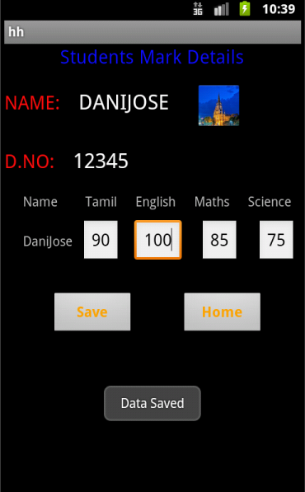

xml code:

<?xml version="1.0" encoding="utf-8"?>

<LinearLayout

xmlns:android="http://schemas.android.com/apk/res/android"

android:layout_width="match_parent"

android:layout_height="match_parent"

android:orientation="vertical">

<LinearLayout

android:id="@+id/linearLayout1"

android:layout_width="match_parent"

android:layout_height="wrap_content"

android:orientation="vertical">

<TextView

android:id="@+id/textView1"

android:layout_width="wrap_content"

android:layout_height="wrap_content"

android:layout_marginLeft="60dp"

android:layout_marginRight="60dp"

android:text="Students Mark Details"

android:textColor="#0e0eff"

android:textSize="20dp" />

</LinearLayout>

<LinearLayout

android:id="@+id/linearLayout2"

android:layout_width="match_parent"

android:layout_height="wrap_content" >

<TextView

android:id="@+id/textView2"

android:layout_width="wrap_content"

android:layout_height="wrap_content"

android:text="NAME:"

android:textSize="20dp"

android:textColor="#ff0e0e"

android:layout_marginTop="20dp"/>

<TextView

android:id="@+id/textView3"

android:layout_width="wrap_content"

android:layout_height="wrap_content"

android:text="DANIJOSE"

android:layout_marginTop="20dp"

android:layout_marginLeft="20dp"

android:textAppearance="?android:attr/textAppearanceLarge" />

<ImageView

android:id="@+id/imageView1"

android:layout_width="wrap_content"

android:layout_height="wrap_content"

android:layout_marginLeft="30dp"

android:layout_marginTop="15dp"

android:src="@drawable/a" />

</LinearLayout>

<LinearLayout

android:id="@+id/linearLayout3"

android:layout_width="match_parent"

android:layout_height="wrap_content" >

<TextView

android:id="@+id/textView4"

android:layout_width="wrap_content"

android:layout_height="wrap_content"

android:text="D.NO:"

android:layout_marginTop="20dp"

android:textSize="20dp"

android:textColor="#ff0e0e" />

<TextView

android:id="@+id/textView5"

android:layout_width="wrap_content"

android:layout_height="wrap_content"

android:text="12345"

android:layout_marginTop="20dp"

android:layout_marginLeft="20dp"

android:textAppearance="?android:attr/textAppearanceLarge" />

</LinearLayout>

<TableLayout

android:id="@+id/tableLayout1"

android:layout_width="match_parent"

android:layout_height="wrap_content">

<TableRow

android:id="@+id/tableRow1"

android:layout_width="wrap_content"

android:layout_height="wrap_content">

<TextView

android:id="@+id/textView6"

android:layout_width="wrap_content"

android:layout_height="wrap_content"

android:text="Name"

android:layout_marginTop="20dp"

android:layout_marginLeft="20dp" />

<TextView

android:id="@+id/textView7"

android:layout_width="wrap_content"

android:layout_height="wrap_content"

android:text="Tamil"

android:layout_marginTop="20dp"

android:layout_marginLeft="30dp" />

<TextView

android:id="@+id/textView8"

android:layout_width="wrap_content"

android:layout_height="wrap_content"

android:text="English"

android:layout_marginTop="20dp"

android:layout_marginLeft="20dp" />

<TextView

android:id="@+id/textView9"

android:layout_width="wrap_content"

android:layout_height="wrap_content"

android:text="Maths"

android:layout_marginTop="20dp"

android:layout_marginLeft="20dp" />

<TextView

android:id="@+id/textView10"

android:layout_width="wrap_content"

android:layout_height="wrap_content"

android:text="Science"

android:layout_marginTop="20dp"

android:layout_marginLeft="20dp" />

</TableRow>

<TableRow

android:id="@+id/tableRow2"

android:layout_width="wrap_content"

android:layout_height="wrap_content" >

<TextView

android:id="@+id/textView11"

android:layout_width="wrap_content"

android:layout_height="wrap_content"

android:layout_marginLeft="20dp"

android:text="DaniJose"

android:layout_marginTop="10dp" />

<EditText

android:id="@+id/editText2"

android:layout_width="wrap_content"

android:layout_height="wrap_content"

android:layout_marginLeft="10dp"

android:layout_marginTop="10dp"

android:text="90" />

<EditText

android:id="@+id/editText1"

android:layout_width="wrap_content"

android:layout_height="wrap_content"

android:layout_marginLeft="15dp"

android:layout_marginTop="10dp"

android:text="100" >

<requestFocus />

</EditText>

<EditText

android:id="@+id/editText3"

android:layout_width="wrap_content"

android:layout_height="wrap_content"

android:layout_marginLeft="20dp"

android:layout_marginTop="10dp"

android:text="85" />

<EditText

android:id="@+id/editText4"

android:layout_width="wrap_content"

android:layout_height="wrap_content"

android:layout_marginLeft="20dp"

android:layout_marginTop="10dp"

android:text="75"/>

</TableRow>

</TableLayout>

<LinearLayout

android:id="@+id/linearLayout4"

android:layout_width="match_parent"

android:layout_height="wrap_content" >

<Button

android:id="@+id/Save"

android:layout_width="wrap_content"

android:layout_height="wrap_content"

android:text="Save"

android:layout_marginLeft="50dp"

android:layout_marginTop="30dp"

android:textColor="#ffa500"

android:textSize="15dp"

android:textStyle="bold"

android:width="90dp" />

<Button

android:id="@+id/first"

android:layout_width="wrap_content"

android:layout_height="wrap_content"

android:text="Home"

android:layout_marginLeft="50dp"

android:layout_marginTop="30dp"

android:textColor="#ffa500"

android:textSize="15dp"

android:textStyle="bold"

android:width="90dp" />

</LinearLayout>

</LinearLayout>

**Java Code**

package com.hh;

import android.app.Activity;

import android.content.Intent;

import android.os.Bundle;

import android.view.View;

import android.widget.Button;

import android.widget.Toast;

public class login extends Activity {

/** Called when the activity is first created. */

public void onCreate(Bundle savedInstanceState) {

super.onCreate(savedInstanceState);

setContentView(R.layout.first);

Button b11, b22;

b11 = findViewById(R.id.Save);

b11.setOnClickListener(new View.OnClickListener() {

public void onClick(View view) {

// Perform actions when the "Save" button is clicked

// For now, just show a toast message

Toast.makeText(login.this, "Data Saved", Toast.LENGTH_SHORT).show();

}

});

b22 = findViewById(R.id.first);

b22.setOnClickListener(new View.OnClickListener() {

public void onClick(View view) {

// Navigate back to the HhActivity when the "Home" button is clicked

finish();

}

});

}

}

**2.Arithmetic Operations**

**Main.XML**

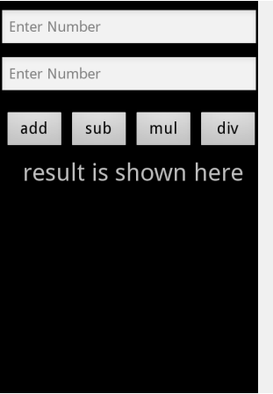

<?xml version=*"1.0"* encoding=*"utf-8"*?>

<LinearLayout xmlns:android=*"http://schemas.android.com/apk/res/android"*

android:layout_width=*"fill_parent"*

android:layout_height=*"fill_parent"*

android:orientation=*"vertical"* >

<EditText

android:id=*"@+id/num1"*

android:hint=*"Enter Number"*

android:layout_marginTop=*"10dp"*

android:inputType=*"number"*

android:layout_width=*"match_parent"*

android:layout_height=*"wrap_content"* />

<EditText

android:id=*"@+id/num2"*

android:hint=*"Enter Number"*

android:layout_marginTop=*"10dp"*

android:inputType=*"number"*

android:layout_width=*"match_parent"*

android:layout_height=*"wrap_content"* />

<LinearLayout

android:id=*"@+id/linearLayout1"*

android:layout_width=*"match_parent"*

android:layout_height=*"wrap_content"*

android:layout_marginTop=*"20dp"* >

<Button

android:id=*"@+id/add"*

android:layout_width=*"0dp"*

android:layout_height=*"wrap_content"*

android:layout_marginLeft=*"5dp"*

android:layout_weight=*"1"*

android:text=*"add"*

android:textSize=*"20dp"* />

<Button

android:id=*"@+id/sub"*

android:layout_width=*"0dp"*

android:layout_height=*"wrap_content"*

android:layout_marginLeft=*"5dp"*

android:layout_weight=*"1"*

android:text=*"sub"*

android:textSize=*"20dp"* />

<Button

android:id=*"@+id/mul"*

android:layout_width=*"0dp"*

android:layout_height=*"wrap_content"*

android:layout_marginLeft=*"5dp"*

android:layout_weight=*"1"*

android:text=*"mul"*

android:textSize=*"20dp"* />

<Button

android:id=*"@+id/div"*

android:layout_width=*"0dp"*

android:layout_height=*"wrap_content"*

android:layout_marginLeft=*"5dp"*

android:layout_weight=*"1"*

android:text=*"div"*

android:textSize=*"20dp"* />

</LinearLayout>

<TextView

android:id=*"@+id/ans"*

android:layout_gravity=*"center"*

android:layout_marginLeft=*"5dp"*

android:textSize=*"30dp"*

android:layout_marginTop=*"10dp"*

android:layout_width=*"wrap_content"*

android:layout_height=*"wrap_content"*

android:text=*"result is shown here"* />

</LinearLayout>

**Activity.Java**

**package** com.cal;

**import** android.app.Activity;

**import** android.os.Bundle;

**import** android.view.View;

**import** android.widget.Button;

**import** android.widget.EditText;

**import** android.widget.TextView;

**public** **class** CalculatorActivity **extends** Activity {

EditText no1,no2;

TextView ans;

**int** num1,num2;

@Override

**public** **void** onCreate(Bundle savedInstanceState) {

**super**.onCreate(savedInstanceState);

setContentView(R.layout.*main*);

no1 = (EditText) findViewById(R.id.*num1*);

no2 = (EditText) findViewById(R.id.*num2*);

ans = (TextView) findViewById(R.id.*ans*);

Button btnAdd = (Button) findViewById(R.id.*add*);

Button btnSubtract = (Button) findViewById(R.id.*sub*);

Button btnMultiply = (Button) findViewById(R.id.*mul*);

Button btnDivide = (Button) findViewById(R.id.*div*);

btnAdd.setOnClickListener(**new** View.OnClickListener() {

**public** **void** onClick(View view) {

performOperation('+');

}

});

btnSubtract.setOnClickListener(**new** View.OnClickListener() {

**public** **void** onClick(View view) {

performOperation('-');

}

});

btnMultiply.setOnClickListener(**new** View.OnClickListener() {

**public** **void** onClick(View view) {

performOperation('*');

}

});

btnDivide.setOnClickListener(**new** View.OnClickListener() {

**public** **void** onClick(View view) {

performOperation('/');

}

});

}

**private** **void** performOperation(**char** operation) {

String num1Str = no1.getText().toString();

String num2Str = no2.getText().toString();

**if** (!num1Str.isEmpty() && !num2Str.isEmpty()) {

**double** num1 = Double.*parseDouble*(num1Str);

**double** num2 = Double.*parseDouble*(num2Str);

**double** result = 0;

**switch** (operation) {

**case** '+':

result = num1 + num2;

**break**;

**case** '-':

result = num1 - num2;

**break**;

**case** '*':

result = num1 * num2;

**break**;

**case** '/':

**if** (num2 != 0) {

result = num1 / num2;

} **else** {

ans.setText("Cannot divide by zero");

**return**;

}

**break**;

}

ans.setText("Result: " + result);

} **else** {

ans.setText("Please enter valid numbers");

}

}

}

**Output**

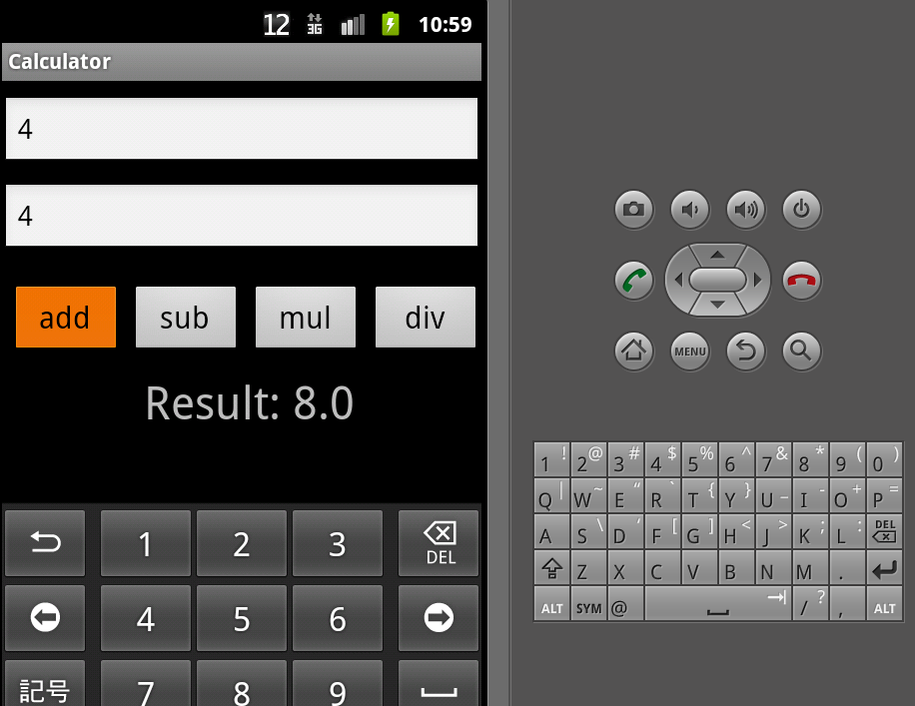

**3.Login Page**

**Design:**

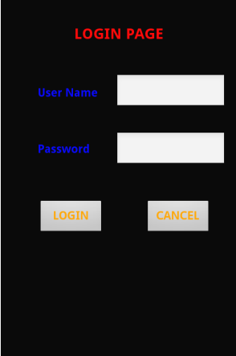

**Xml Code:**

?xml version=*"1.0"* encoding=*"utf-8"*?>

<LinearLayout xmlns:android=*"http://schemas.android.com/apk/res/android"*

android:layout_width=*"fill_parent"*

android:layout_height=*"fill_parent"*

android:orientation=*"vertical"* >

<RelativeLayout

android:id=*"@+id/relativeLayout1"*

android:layout_width=*"match_parent"*

android:layout_height=*"match_parent"* >

<TextView

android:id=*"@+id/textView1"*

android:layout_width=*"wrap_content"*

android:layout_height=*"wrap_content"*

android:layout_alignParentTop=*"true"*

android:layout_centerHorizontal=*"true"*

android:layout_marginTop=*"36dp"*

android:text=*"LOGIN PAGE"*

android:textColor=*"#ff0000"*

android:textSize=*"20dp"*

android:textStyle=*"bold"* />

<TextView

android:id=*"@+id/textView2"*

android:layout_width=*"wrap_content"*

android:layout_height=*"wrap_content"*

android:layout_alignParentLeft=*"true"*

android:layout_below=*"@+id/textView1"*

android:layout_marginLeft=*"50dp"*

android:layout_marginTop=*"58dp"*

android:text=*"User Name"*

android:textColor=*"#0000ff"*

android:textSize=*"15dp"*

android:textStyle=*"bold"* />

<EditText

android:id=*"@+id/un"*

android:layout_width=*"wrap_content"*

android:layout_height=*"wrap_content"*

android:layout_below=*"@+id/textView1"*

android:layout_marginLeft=*"24dp"*

android:layout_marginTop=*"42dp"*

android:layout_toRightOf=*"@+id/textView2"*

android:width=*"150dp"* />

<EditText

android:id=*"@+id/pas"*

android:layout_width=*"wrap_content"*

android:layout_height=*"wrap_content"*

android:layout_alignLeft=*"@+id/un"*

android:layout_below=*"@+id/un"*

android:layout_marginTop=*"30dp"*

android:width=*"150dp"* />

<TextView

android:id=*"@+id/textView3"*

android:layout_width=*"wrap_content"*

android:layout_height=*"wrap_content"*

android:layout_alignLeft=*"@+id/textView2"*

android:layout_alignTop=*"@+id/pas"*

android:layout_marginTop=*"14dp"*

android:text=*"Password"*

android:textColor=*"#0000ff"*

android:textSize=*"15dp"*

android:textStyle=*"bold"* />

<Button

android:id=*"@+id/login"*

android:layout_width=*"wrap_content"*

android:layout_height=*"wrap_content"*

android:layout_alignLeft=*"@+id/textView3"*

android:layout_below=*"@+id/pas"*

android:layout_marginTop=*"44dp"*

android:text=*"LOGIN"*

android:textColor=*"#ffa500"*

android:textSize=*"15dp"*

android:textStyle=*"bold"*

android:width=*"90dp"* />

<Button

android:id=*"@+id/cancel"*

android:layout_width=*"wrap_content"*

android:layout_height=*"wrap_content"*

android:layout_alignRight=*"@+id/pas"*

android:layout_alignTop=*"@+id/login"*

android:layout_marginRight=*"20dp"*

android:text=*"CANCEL"*

android:textColor=*"#ffa500"*

android:textSize=*"15dp"*

android:textStyle=*"bold"*

android:width=*"90dp"* />

</RelativeLayout>

</LinearLayout>

**Java Code:**

package com.hh;

import android.app.Activity;

import android.content.Intent;

import android.os.Bundle;

import android.view.View;

import android.widget.Button;

import android.widget.EditText;

import android.widget.Toast;

public class HhActivity extends Activity {

Button b1, b2;

EditText ed1, ed2;

/** Called when the activity is first created. */

@Override

public void onCreate(Bundle savedInstanceState) {

super.onCreate(savedInstanceState);

setContentView(R.layout.main);

ed1 = findViewById(R.id.un);

ed2 = findViewById(R.id.pas);

b1 = findViewById(R.id.login);

b1.setOnClickListener(new View.OnClickListener() {

public void onClick(View v) {

if (ed1.getText().toString().equals("hi") && ed2.getText().toString().equals("mas")) {

Toast.makeText(HhActivity.this, "Login Success",

Toast.LENGTH_SHORT).show();

} else {

// If incorrect, show a toast message

Toast.makeText(HhActivity.this, "Incorrect username or password",

Toast.LENGTH_SHORT).show();

}

}

});

b2 = findViewById(R.id.cancel);

b2.setOnClickListener(new View.OnClickListener() {

public void onClick(View v) {

finish();

}

});

}

}

**4. Login Page with different Layouts**

**Main.xml**



<?xml version=*"1.0"* encoding=*"utf-8"*?>

<LinearLayout xmlns:android=*"http://schemas.android.com/apk/res/android"*

android:layout_width=*"fill_parent"*

android:layout_height=*"fill_parent"*

android:orientation=*"vertical"* >

<RelativeLayout

android:id=*"@+id/relativeLayout1"*

android:layout_width=*"match_parent"*

android:layout_height=*"match_parent"* >

<TextView

android:id=*"@+id/textView1"*

android:layout_width=*"wrap_content"*

android:layout_height=*"wrap_content"*

android:layout_alignParentTop=*"true"*

android:layout_centerHorizontal=*"true"*

android:layout_marginTop=*"36dp"*

android:text=*"LOGIN PAGE"*

android:textColor=*"#ff0000"*

android:textSize=*"20dp"*

android:textStyle=*"bold"* />

<TextView

android:id=*"@+id/textView2"*

android:layout_width=*"wrap_content"*

android:layout_height=*"wrap_content"*

android:layout_alignParentLeft=*"true"*

android:layout_below=*"@+id/textView1"*

android:layout_marginLeft=*"50dp"*

android:layout_marginTop=*"58dp"*

android:text=*"User Name"*

android:textColor=*"#0000ff"*

android:textSize=*"15dp"*

android:textStyle=*"bold"* />

<EditText

android:id=*"@+id/un"*

android:layout_width=*"wrap_content"*

android:layout_height=*"wrap_content"*

android:layout_below=*"@+id/textView1"*

android:layout_marginLeft=*"24dp"*

android:layout_marginTop=*"42dp"*

android:layout_toRightOf=*"@+id/textView2"*

android:width=*"150dp"* />

<EditText

android:id=*"@+id/pas"*

android:layout_width=*"wrap_content"*

android:layout_height=*"wrap_content"*

android:layout_alignLeft=*"@+id/un"*

android:layout_below=*"@+id/un"*

android:layout_marginTop=*"30dp"*

android:width=*"150dp"* />

<TextView

android:id=*"@+id/textView3"*

android:layout_width=*"wrap_content"*

android:layout_height=*"wrap_content"*

android:layout_alignLeft=*"@+id/textView2"*

android:layout_alignTop=*"@+id/pas"*

android:layout_marginTop=*"14dp"*

android:text=*"Password"*

android:textColor=*"#0000ff"*

android:textSize=*"15dp"*

android:textStyle=*"bold"* />

<Button

android:id=*"@+id/login"*

android:layout_width=*"wrap_content"*

android:layout_height=*"wrap_content"*

android:layout_alignLeft=*"@+id/textView3"*

android:layout_below=*"@+id/pas"*

android:layout_marginTop=*"44dp"*

android:text=*"LOGIN"*

android:textColor=*"#ffa500"*

android:textSize=*"15dp"*

android:textStyle=*"bold"*

android:width=*"90dp"* />

<Button

android:id=*"@+id/cancel"*

android:layout_width=*"wrap_content"*

android:layout_height=*"wrap_content"*

android:layout_alignRight=*"@+id/pas"*

android:layout_alignTop=*"@+id/login"*

android:layout_marginRight=*"20dp"*

android:text=*"CANCEL"*

android:textColor=*"#ffa500"*

android:textSize=*"15dp"*

android:textStyle=*"bold"*

android:width=*"90dp"* />

</RelativeLayout>

</LinearLayout>

**First.Xml**

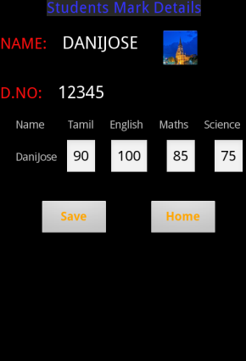

<?xml version="1.0" encoding="utf-8"?>

<LinearLayout

xmlns:android="http://schemas.android.com/apk/res/android"

android:layout_width="match_parent"

android:layout_height="match_parent"

android:orientation="vertical">

<LinearLayout

android:id="@+id/linearLayout1"

android:layout_width="match_parent"

android:layout_height="wrap_content"

android:orientation="vertical">

<TextView

android:id="@+id/textView1"

android:layout_width="wrap_content"

android:layout_height="wrap_content"

android:layout_marginLeft="60dp"

android:layout_marginRight="60dp"

android:text="Students Mark Details"

android:textColor="#0e0eff"

android:textSize="20dp" />

</LinearLayout>

<LinearLayout

android:id="@+id/linearLayout2"

android:layout_width="match_parent"

android:layout_height="wrap_content" >

<TextView

android:id="@+id/textView2"

android:layout_width="wrap_content"

android:layout_height="wrap_content"

android:text="NAME:"

android:textSize="20dp"

android:textColor="#ff0e0e"

android:layout_marginTop="20dp"/>

<TextView

android:id="@+id/textView3"

android:layout_width="wrap_content"

android:layout_height="wrap_content"

android:text="DANIJOSE"

android:layout_marginTop="20dp"

android:layout_marginLeft="20dp"

android:textAppearance="?android:attr/textAppearanceLarge" />

<ImageView

android:id="@+id/imageView1"

android:layout_width="wrap_content"

android:layout_height="wrap_content"

android:layout_marginLeft="30dp"

android:layout_marginTop="15dp"

android:src="@drawable/a" />

</LinearLayout>

<LinearLayout

android:id="@+id/linearLayout3"

android:layout_width="match_parent"

android:layout_height="wrap_content" >

<TextView

android:id="@+id/textView4"

android:layout_width="wrap_content"

android:layout_height="wrap_content"

android:text="D.NO:"

android:layout_marginTop="20dp"

android:textSize="20dp"

android:textColor="#ff0e0e" />

<TextView

android:id="@+id/textView5"

android:layout_width="wrap_content"

android:layout_height="wrap_content"

android:text="12345"

android:layout_marginTop="20dp"

android:layout_marginLeft="20dp"

android:textAppearance="?android:attr/textAppearanceLarge" />

</LinearLayout>

<TableLayout

android:id="@+id/tableLayout1"

android:layout_width="match_parent"

android:layout_height="wrap_content">

<TableRow

android:id="@+id/tableRow1"

android:layout_width="wrap_content"

android:layout_height="wrap_content">

<TextView

android:id="@+id/textView6"

android:layout_width="wrap_content"

android:layout_height="wrap_content"

android:text="Name"

android:layout_marginTop="20dp"

android:layout_marginLeft="20dp" />

<TextView

android:id="@+id/textView7"

android:layout_width="wrap_content"

android:layout_height="wrap_content"

android:text="Tamil"

android:layout_marginTop="20dp"

android:layout_marginLeft="30dp" />

<TextView

android:id="@+id/textView8"

android:layout_width="wrap_content"

android:layout_height="wrap_content"

android:text="English"

android:layout_marginTop="20dp"

android:layout_marginLeft="20dp" />

<TextView

android:id="@+id/textView9"

android:layout_width="wrap_content"

android:layout_height="wrap_content"

android:text="Maths"

android:layout_marginTop="20dp"

android:layout_marginLeft="20dp" />

<TextView

android:id="@+id/textView10"

android:layout_width="wrap_content"

android:layout_height="wrap_content"

android:text="Science"

android:layout_marginTop="20dp"

android:layout_marginLeft="20dp" />

</TableRow>

<TableRow

android:id="@+id/tableRow2"

android:layout_width="wrap_content"

android:layout_height="wrap_content" >

<TextView

android:id="@+id/textView11"

android:layout_width="wrap_content"

android:layout_height="wrap_content"

android:layout_marginLeft="20dp"

android:text="DaniJose"

android:layout_marginTop="10dp" />

<EditText

android:id="@+id/editText2"

android:layout_width="wrap_content"

android:layout_height="wrap_content"

android:layout_marginLeft="10dp"

android:layout_marginTop="10dp"

android:text="90" />

<EditText

android:id="@+id/editText1"

android:layout_width="wrap_content"

android:layout_height="wrap_content"

android:layout_marginLeft="15dp"

android:layout_marginTop="10dp"

android:text="100" >

<requestFocus />

</EditText>

<EditText

android:id="@+id/editText3"

android:layout_width="wrap_content"

android:layout_height="wrap_content"

android:layout_marginLeft="20dp"

android:layout_marginTop="10dp"

android:text="85" />

<EditText

android:id="@+id/editText4"

android:layout_width="wrap_content"

android:layout_height="wrap_content"

android:layout_marginLeft="20dp"

android:layout_marginTop="10dp"

android:text="75"/>

</TableRow>

</TableLayout>

<LinearLayout

android:id="@+id/linearLayout4"

android:layout_width="match_parent"

android:layout_height="wrap_content" >

<Button

android:id="@+id/Save"

android:layout_width="wrap_content"

android:layout_height="wrap_content"

android:text="Save"

android:layout_marginLeft="50dp"

android:layout_marginTop="30dp"

android:textColor="#ffa500"

android:textSize="15dp"

android:textStyle="bold"

android:width="90dp" />

<Button

android:id="@+id/first"

android:layout_width="wrap_content"

android:layout_height="wrap_content"

android:text="Home"

android:layout_marginLeft="50dp"

android:layout_marginTop="30dp"

android:textColor="#ffa500"

android:textSize="15dp"

android:textStyle="bold"

android:width="90dp" />

</LinearLayout>

</LinearLayout>

**Activity.Java**

package com.hh;

import android.app.Activity;

import android.content.Intent;

import android.os.Bundle;

import android.view.View;

import android.widget.Button;

import android.widget.EditText;

import android.widget.Toast;

public class HhActivity extends Activity {

Button b1, b2;

EditText ed1, ed2;

/** Called when the activity is first created. */

@Override

public void onCreate(Bundle savedInstanceState) {

super.onCreate(savedInstanceState);

setContentView(R.layout.main);

ed1 = findViewById(R.id.un);

ed2 = findViewById(R.id.pas);

b1 = findViewById(R.id.login);

b1.setOnClickListener(new View.OnClickListener() {

public void onClick(View v) {

if (ed1.getText().toString().equals("hi") && ed2.getText().toString().equals("mas")) {

Intent in = new Intent(HhActivity.this, login.class);

startActivity(in);

} else {

// If incorrect, show a toast message

Toast.makeText(HhActivity.this, "Incorrect username or password",Toast.LENGTH_SHORT).show();

}

}

});

b2 = findViewById(R.id.cancel);

b2.setOnClickListener(new View.OnClickListener() {

public void onClick(View v) {

finish();

}

});

}

}

**Login.java**

package com.hh;

import android.app.Activity;

import android.content.Intent;

import android.os.Bundle;

import android.view.View;

import android.widget.Button;

import android.widget.Toast;

public class login extends Activity {

/** Called when the activity is first created. */

public void onCreate(Bundle savedInstanceState) {

super.onCreate(savedInstanceState);

setContentView(R.layout.first);

Button b11, b22;

b11 = findViewById(R.id.Save);

b11.setOnClickListener(new View.OnClickListener() {

public void onClick(View view) {

// Perform actions when the "Save" button is clicked

// For now, just show a toast message

Toast.makeText(login.this, "Data Saved", Toast.LENGTH_SHORT).show();

}

});

b22 = findViewById(R.id.first);

b22.setOnClickListener(new View.OnClickListener() {

public void onClick(View view) {

// Navigate back to the HhActivity when the "Home" button is clicked

Intent in = new Intent(login.this, HhActivity.class);

startActivity(in);

}

});

}

}

**AndroidManifest.xml**

<?xml version=*"1.0"* encoding=*"utf-8"*?>

<manifest xmlns:android=*"http://schemas.android.com/apk/res/android"*

package=*"com.hh"*

android:versionCode=*"1"*

android:versionName=*"1.0"* >

<uses-sdk android:minSdkVersion=*"10"* />

<application

android:allowBackup=*"true"*

android:icon=*"@drawable/ic_launcher"*

android:label=*"@string/app_name"* >

<activity

android:name=*".HhActivity"*

android:label=*"@string/app_name"* >

<intent-filter>

<action android:name=*"android.intent.action.MAIN"* />

<category android:name=*"android.intent.category.LAUNCHER"* />

</intent-filter>

</activity>

<activity android:name=*".login"*></activity>

</application>

</manifest>

**Output**

