For each element of first row or first column get cofactor of those elements and then multiply the element with the determinant of the corresponding cofactor, and finally add them with alternate signs. As a base case the value of determinant of a 1*1 matrix is the single value itself.

**Cofactor** of an element, is a matrix which we can get by removing row and column of that element from that matrix.

**Determinant of 2 x 2 Matrix:**

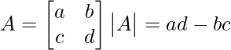

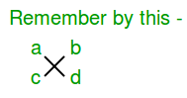

**Determinant of 3 x 3 Matrix:**   
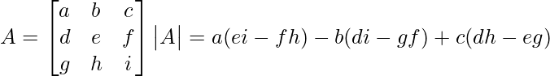

1. #include<stdio.h>
2. int main ( )
3. {
4. int a[3][3], i, j;
5. long determinant;
6. printf("Enter the 9 elements of matrix: ");
7. for(i = 0 ;i < 3;i++)
8. for(j = 0;j < 3;j++)
9. scanf("%d", &a[i][j]);
10. printf("\nThe matrix is\n");
11. for(i = 0;i < 3; i++)
12. {
13. printf("\n");
14. for(j = 0;j < 3; j++)
15. printf("%d\t", a[i][j]);
16. }
17. determinant = a[0][0] * ((a[1][1]*a[2][2]) - (a[2][1]*a[1][2])) -a[0][1] * (a[1][0] * a[2][2] - a[2][0] * a[1][2]) + a[0][2] * (a[1][0] * a[2][1] - a[2][0] * a[1][1]);
18. printf("\nDeterminant of 3X3 matrix: %ld", determinant);
19. return 0;
20. }

***After compiling the program will look something like this!***

1. $ gcc determinant.c -o determinant
2. $ ./determinant
4. Enter the 9 elements of matrix: 1 2 3 4 5 1 2 3 4
5. The matrix is
7. 1 2 3
8. 4 5 1
9. 2 3 4
10. Determinant of 3X3 matrix: -5