Abstract

Personal financial status analysis is a daily income and expense management system which is specially designed for non- salaried and salaried person for keeping track of their daily expenditure with easy and effective way through computerized system which tends to eliminate manual paper works. It will also manage records in systematic way and user can access the stored data conveniently. I have tried to design the project in such way that user may not have any difficulty in using this application without much effort. This mobile application can be really used by end users who have Android running devices with them. This application will also have a feature which will help user stay on budget because it based on budget and expenses rules. Personal Financial Status Analysis application will generate report immediately to show Expense on the budget via a graphical representation. There was a feature which will distribute user’s income and expenses in different categories suitable for the user. An expense history will also be provided in application.
Table of Contents
Table of Contents 2

1. Introduction 3

2. MOTIVATION 5

3. PROBLEM STATEMENT 5

3.1. OBJECTIVE 5

3.2. rELATED WORK 5

3.3. METHODOLOGY 5

4. iMPLEMENTATION 5

5. Design Specification 10

6. Testing 11

7. Discussion 12

8. CONCLUSION 12

- Introduction
Money is the most valuable portion of our daily life and without money we will not last one day in the earth. So uses the daily expense tracker application is important to load happy family. In life cycle of human after birth the need of materials and belongings is obvious. In order to fulfil our needs and desire we buy goods. The rule of earth is that you must have money in order to buy desired good. So in this way the process of earning and spending goes on in our life. People in order to track their expenses use traditional paper system to keep the record of their income and expenditures. This type of traditional system is burdensome and takes more time. So there must be a management system which must help us to manage our daily earnings and expenses easily, and also helps us to analyze records efficiently. So we figured out a way to eliminate the traditional system with digital, portable, easier and simple way to record these data in just few clicks with our Android application called “Personal Finance”. This application helps the user to avoid unexpected expenses and bad financial situation, will save a lot of time and provide a responsible lifestyle. This system is with XML, JAVA, SQLite database, Android Studio are used to develop the system.

  - Motivation
The motivation to work in this project is actually our real-life experience. As a user We face many difficulties in our daily life. In our daily life money is the most important portion and without we cannot last one day in the earth but if we keep on track all financial data then we can be overcome this problem. Most of the people cannot analysis their financial expense and income one way the face in money crisis and depression. This situation motivates to make an android app to tracking all financial activities. Using the Daily Expense Tracker user can be tracking expense day to day and making life tension free. Some of the concerns maintaining a personal expense is a BIG problem, in daily expenses many times we don’t know where the money goes. Some of the conventional methods used to tackle this problem in normal circumstances are like making use of a sticky notes by common users, Proficient people deals with this kind of problems by using spreadsheets to record expense and using a ledger to maintains the large amounts data by especially by expert people. As this shows that it is various methods used by different people. This makes using this data contrary. There is still complication in areas like there is no assurance for data compatible, there are chances of crucial inputs can be missed and the manual errors may sneak in.

  - Problem Statement
Many organizations have their own system to record their income and expenses, which they feel is the main key point of their business progress. It is good habit for a person to record daily expenses and earning but due to unawareness and lack of proper applications to suit their privacy, lacking decision making capacity people are using traditional note keeping methods to do so. Due to lack of a complete analysis and tracking system, there is a constant overload to rely on the daily entry of the expenditure and total budget till the end of the month.

  - Objectives
The aim and objective of the project is to analysis and fully manage and keep tracking the expenses and income. The following is the benefits that come with the Personal finance mobile app -
- Minimize manual effort with daily record of expenditures and incomes.
- Immediate and easy retrieval of report.
- Secured and transparent data.
- Overview of budgets and transactions.
- Help in decision making with related results.
- Help in preparing wish list for pre planning expenses.

This application is very simple and user-friendly application for the common people , there are no login and signup options, The main goal of the project is to make the application offline based and perform more tasks in short period of time and very simple to used.

- Related Work
We found various similar applications that have already been developed. Unlike all those application Personal Finance provides features like budget based expense management. In order to complete this task, I have used Android platform to build a portable, handy application that can run in Android phone. Therefore I have used Android studio to build the application. The major language we used for scripting was Java and XML for producing better simple easy to use layout, and used SQLite to implement database.
After discussing our application functions and comparing them to other existing applications, some features were found lacking. This is a new application that will attract the public user through its features and simple to use case.
- Methodology
Having a proper track to our finance helps us to organize our finance which is actually a very difficult task. Looking through our expenses at regular interval allow us to review our spending habit. Writing records of our expense in paper is a traditional way. In the world driven by technology, it is not a right measure or choice indeed. It is difficult to relate our present expenses with past when data need to be reviewed and it is even not secure. So with this particular application Personal Finance mobile application, we have tried to feature several concepts that the user can fully track all of his/her expense as compared to present system in practice. This mobile application is a technology driven approach where user has to log in to track their spending and earnings based on there budget.
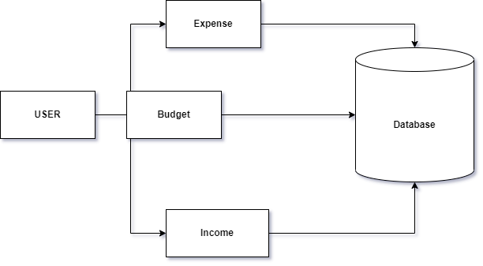
Figure 1 Block Diagram
- Implementation
This application user is provided with three options for data entry namely – Income, Expense and Budget for of estimation. If he/she selects income or expense he/she would be provided with its types and subtypes. For Budget list only budget note and amount can be inserted. These data would be saved onto database according to their respective category. The saved data can later be altered if the user wants to do so. Altering here means adding description, changing wish list updating data etc. User can also view the result. They can also filter result to see the required content only.
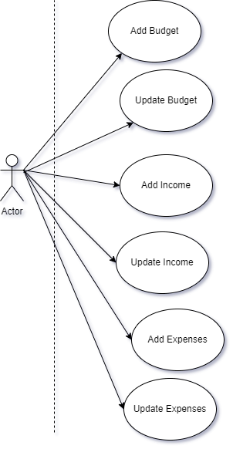
Figure 2 - Use case diagram

Name | Add Budget
Actor | User
Primary Path | - User can add budget
Exceptional Path | - Add budget is required

Figure 3 Description of use case for add budget.

Name | Add Income
Actor | User
Primary Path | - User can add income
Exceptional Path | - Add income is required

Figure 4 Description of use case for add income.

Name | Add Expense
Actor | User
Primary Path | - User can add expense
Exceptional Path | - Add expense is required

Figure 5 Description of use case for add expense.

Name | Update Budget
Actor | User
Primary Path | - User can update budget
Exceptional Path | - Update budget is not required

Figure 6 Description of use case for add budget.

Name | Update Income
Actor | User
Primary Path | - User can update income
Exceptional Path | - Update income is not required

Figure 7 Description of use case for add income.

Name | Update Expense
Actor | User
Primary Path | - User can update expense
Exceptional Path | - Update expense is not required

Figure 8 Description of use case for add expense.
Users can enter their budget expense, which is recorded by system under right category. Multiple data can be saved by every single user. The same process applies for income. Upon successful data save system assures users about the action. User can also save their wish list and do have right to modify them in future if necessary.
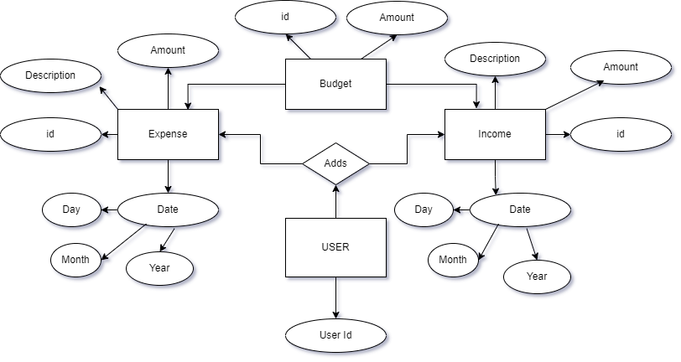
Figure 9 ERD (Entity Relationship Diagram) Of Financial Manager

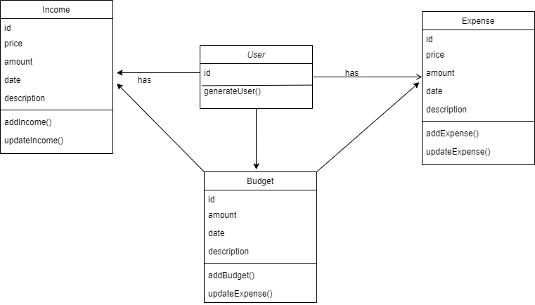

Figure 10 Design Class Diagram
- Design Specification
Android Studio is a great platform for building any android application. It is much more efficient. Android is a system developed by Google and is a mobile operating system. It is designed primarily for touch screen mobiles such as smart phones and tablets. It has many library functions that will help a user to easily create applications.
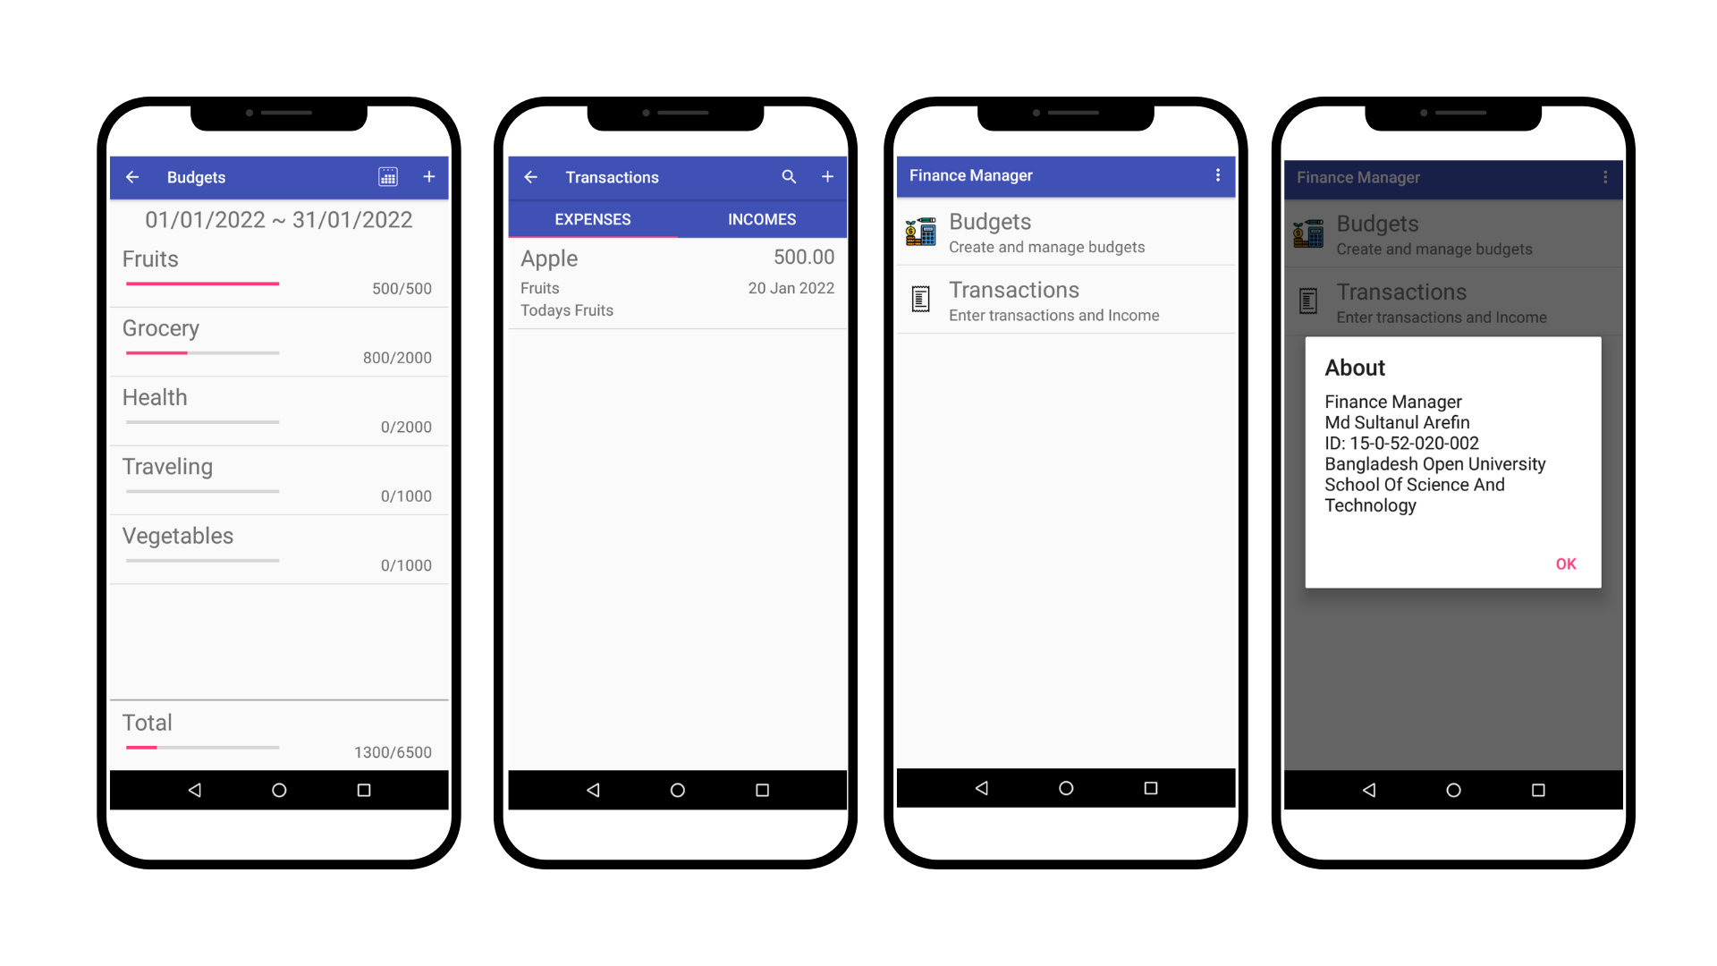
The front in design plays an important role for any application. This has a lot to do with making the user-friendly with the interface. I used in front-end design in XML Below is the interface for our users.
Mobile Application Design UI

Testing
Testing mobile app is an integral part of the app development process. By running tests against app consistently, it can verify that the app's correctness, functional behaviour, and usability before you release it publicly. Testing is a process of executing a program with the intent of finding an error.
6.1 Testing objective:
- Rapid feedback on failures.
- Early failure detection in the development cycle.
- Safer code refactoring, allowing you to optimize code without worrying about regressions.
- Stable development velocity, helping you minimizes technical debt.
- A good test case is one that has a high probability of finding an as yet undiscovered error.
- A successful test is one that uncovers an as-yet-discovered error.
6.2 Test case:
Test case id | Purpose | Test case | Result
#1 | Inserting data | Create budget with value | Ok
#2 | Inserting data | Create an transaction(Income) | Ok
#3 | Updating data | Update income note | Ok
#4 | Inserting data | Inserting Expense with number value | Ok
#5 | Updating Data | Updating Expenses with string value | Not Ok
Figure 11 Test case analyses

Discussion

7.1 Limitations:
The android project assists well to record the income and expenses in general for analysis of personal finance.
However, this android application project has some limitations:
- The application is unable to maintain the backup of data once it is
uninstalled.
- This application does not provide any decision capability.

7.2 Future Scope:
To further enhance the capability of this application, the following features to be incorporated into the system:
- Bengali language interface.
- Provide backup and recovery of data.
- Online data storage capability.

Conclusion

First of all, I gained great skills in android mobile application development. I also learned how to use a lot of the components in Android Studio such as the debugger, and also learned XML which i didn't know much at earlier. Finally, this project allowed me to use SQLite skills acquired during our studies. I have been able to complete our project according to my plan in the given timeline. Furthermore, now we know much more about the Android platform, java and the SQLite query.

