TUGAS PERTEMUAN 10 DASAR PEMROGRAMAN

Nama: Sultan Ahmad Alfaza
Kelas: TI – 1C
NIM: 264107020073

Latihan Soal 1a
Pseudocode:
PROGRAM
J8_Latihan1a

DEKLARASI
n: int = 5
ALGORITMA
FOR i = n TO i > 0 STEP i-- DO
FOR j = 0 TO j < i STEP j++ DO
print “*”
END FOR
print “\n”
END FOR

Program:
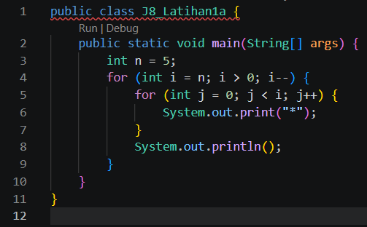
Flowchart:
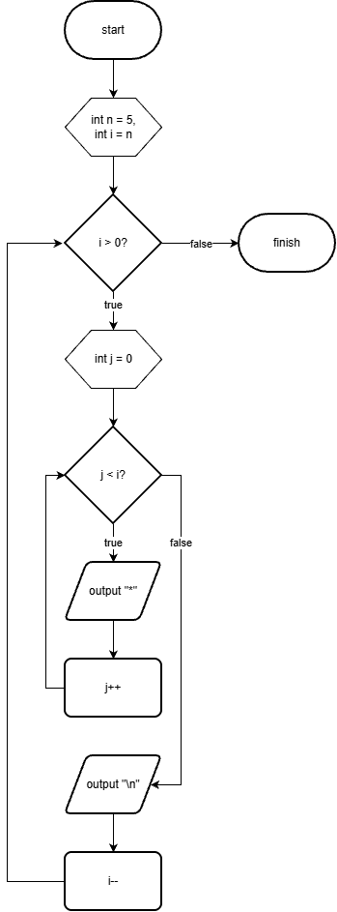
Latihan Soal 1b
Pseudocode:
PROGRAM
J8_Latihan1b

DEKLARASI
n : int = 5
ALGORITMA
FOR i = 1 TO i <= n STEP i++ DO
FOR j = 0 TO j < n - i STEP j++ DO
print “ ”
END FOR
FOR j = 0 TO j < i STEP j++ DO
print “*”
END FOR
print “\n”
END FOR

Program:
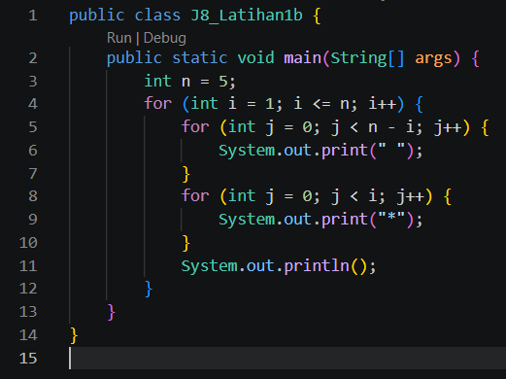
Flowchart:
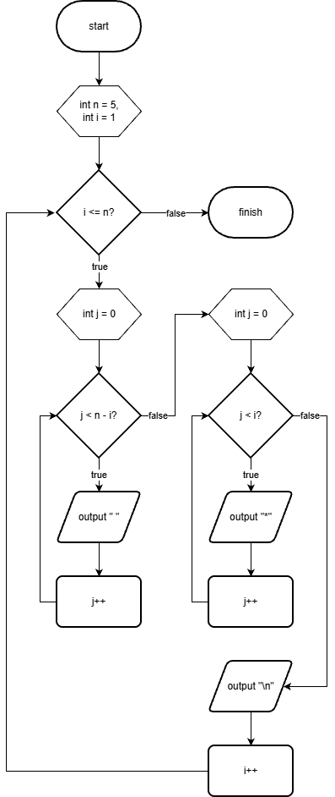

Latihan Soal 2
Pseudocode:
PROGRAM
J8_Latihan2

DEKLARASI
n : int = 5
ch : char = ‘a’

ALGORITMA
FOR i = 1 TO i <= n STEP i++ DO
FOR j = 0 TO j < n - i STEP j++ DO
print “ ”
END FOR
FOR j = 0 TO j < i * 2 - 1 STEP j++ DO
print ch
ch++
END FOR
print “\n”
END FOR

Program:
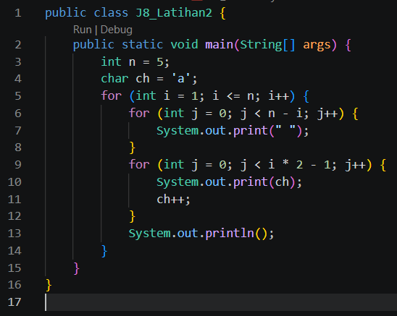
Flowchart:
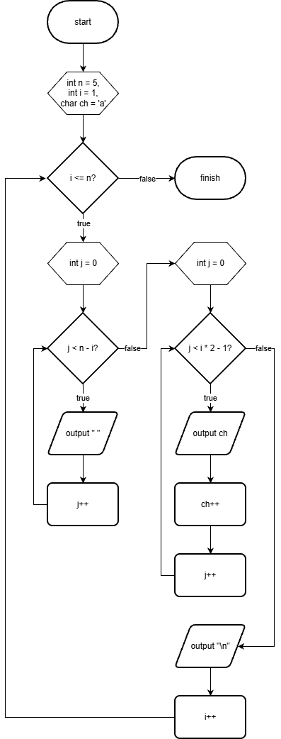
Latihan Soal 3
Pseudocode:
PROGRAM
J8_Latihan3

DEKLARASI
n : int = 5
jumlah : int

ALGORITMA
FOR i = 1 TO i <= n STEP i++ DO
print “n = “ + i + “ -> jumlah kuadrat = “
jumlah = 0
FOR j = 1 TO j <= i STEP j++ DO
print “ ”
jumlah += j*j
IF i == 1 THEN
Break
END IF
print j*j
IF j < i THEN
print “ + “
ELSE
print “ = “
END IF
END FOR
print “\n”
END FOR

Program:
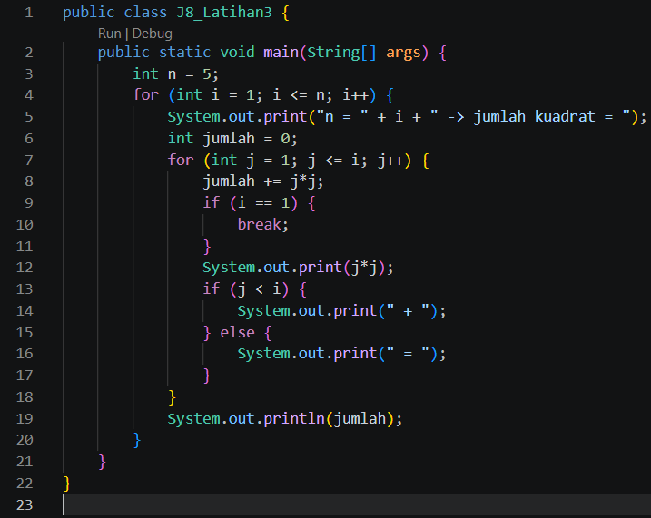
Flowchart:
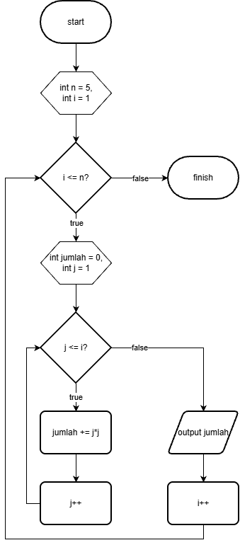
Latihan Soal 4
Pseudocode:
PROGRAM
J8_Latihan4

DEKLARASI
totalKeseluruhan : int
banyakProduk : int
jumlahHari : int
totalPerProduk : int
rata : double
jumlah : int

ALGORITMA
totalKeseluruhan = 0
input banyakProduk
input jumlahHari
produk = 1
WHILE produk <= banyakProduk DO
totalPerProduk = 0
rata = 0
FOR hari = 1 TO hari <= jumlahHari STEP hari++ DO
DO
input jumlah
WHILE jumlah < 0
totalPerProduk += jumlah
rata += jumlah
END FOR
rata /= jumlahHari
print totalPerProduk, rata
print “\n”
totalKeseluruhan += totalPerProduk
produk++
END FOR
print totalKeseluruhan

Program:
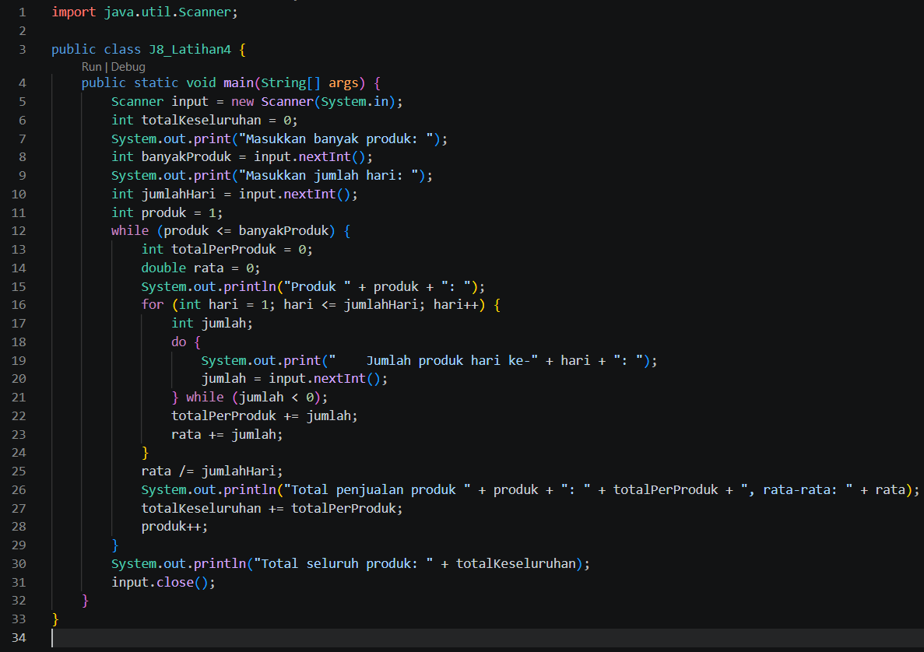
Flowchart:
