TUGAS PERTEMUAN 7 DASAR PEMROGRAMAN

Nama: Sultan Ahmad Alfaza
Kelas: TI – 1C
NIM: 264107020073

Latihan Soal 1
Pseudocode:
PROGRAM
PerhitunganTarifLaundry

DEKLARASI
totalCucian : int
tarifPerKg : int
totalBiaya : int

ALGORITMA
input totalCucian
IF (totalCucian < 3) THEN
tarifPerKg = 7000
ELSE IF (totalCucian <= 6) THEN
tarifPerKg = 6000
ELSE
tarifPerKg = 5000
END IF
totalBiaya = tarifPerKg * totalCucian
output tarifPerKg, totalBiaya

Latihan Soal 2
Flowchart:
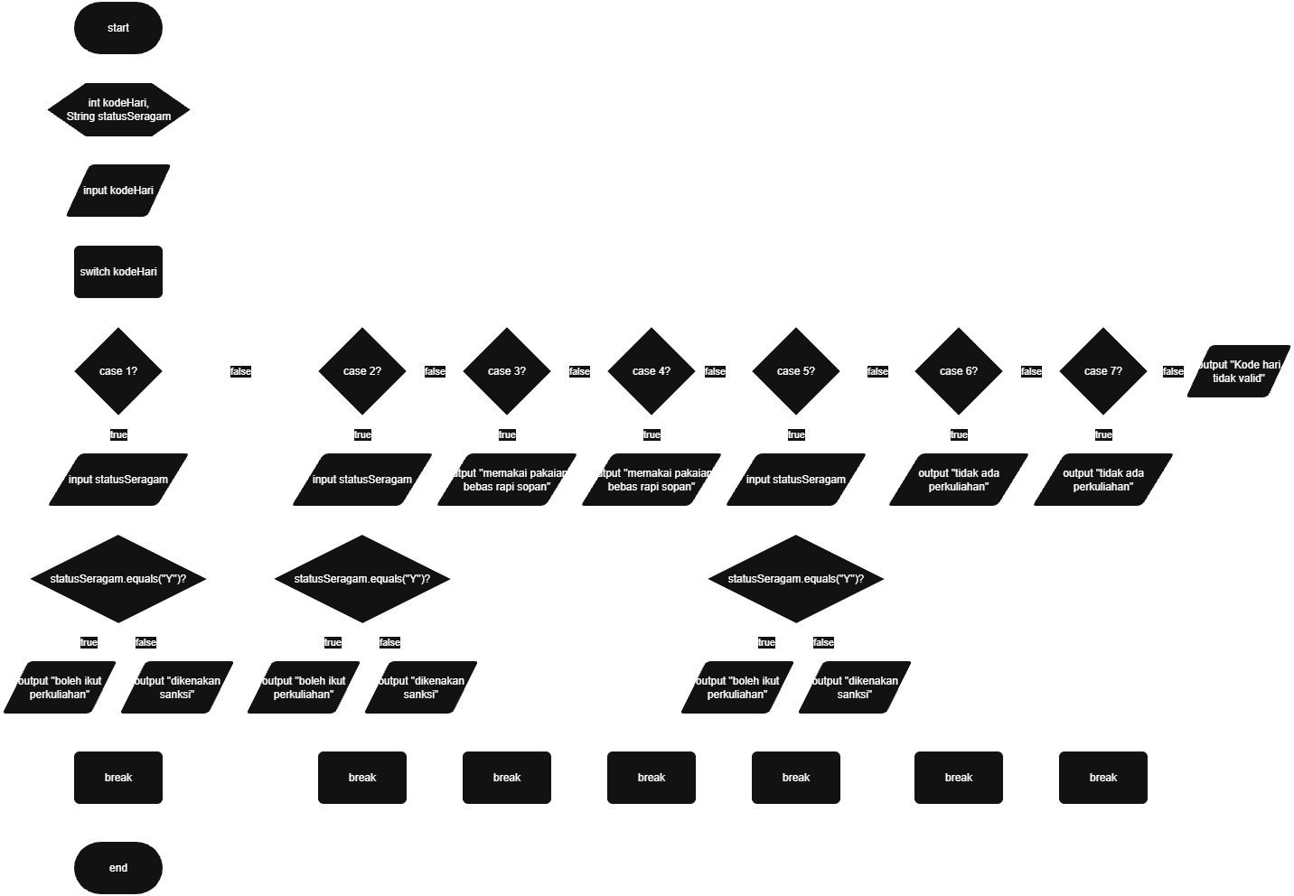

Latihan Soal 3
Flowchart:
