**MODEL OF ADAPTIVE PLATFORM BASED ON ARTIFICIAL INTELLIGENCE FOR PERSONALIZATION OF EDUCATIONAL PROCESS**

*Spirina Yelena Aleksandrovna*

*Kazimova Dinara Ashubasarovna*

*Kopbalina Saltanat Serikovna*

*Tursyngaliyeva Gulim Nurlanovna*

*Karaganda Buketov University, Karagandy, Kazakhstan*

[*sea_spirina@mail.ru*](mailto:sea_spirina@mail.ru)

[*dinkaz73@mail.ru*](mailto:dinkaz73@mail.ru)

[*kopbalina@mail.ru*](mailto:kopbalina@mail.ru)

[*gulim_tursyngali@mail.ru*](mailto:gulim_tursyngali@mail.ru)

With the rapid development of digital technologies and the introduction of artificial intelligence (AI) in various spheres of activity, there is a significant transformation of the education system. Modern challenges, such as the individualization of learning, the growth of information volumes, the need to develop flexible skills, and increased student motivation, require new approaches to the organization of the educational process [1]. One of the most promising directions is the creation of adaptive educational platforms that can adjust to the peculiarities, interests and level of training of each student [2].

Artificial intelligence provides unique opportunities for the implementation of personalized learning: intelligent data analysis, automatic determination of knowledge level, formation of individual trajectories, and adaptation of content in real time. However, in modern educational practice, AI tools are used in a fragmented manner, often do not take into account the pedagogical principles of adaptability, and do not have a flexible architecture for integration into different learning environments [3]. In addition, there is a shortage of full-fledged models that would combine AI algorithms and didactic principles of personalization.

The development of an adaptive platform model based on AI will allow us to overcome these limitations, providing deeper personalization of the educational process, increasing its efficiency and quality. This is especially relevant for higher education, where it is necessary to take into account not only the level of students' training, but also their professional interests, individual development trajectories, and teachers' readiness to use digital technologies [4].

To implement the grant project funded by the Ministry of Education and Science of the Republic of Kazakhstan titled ***IRN AR23487789 «Artificial Intelligence Technologies for the Implementation of Adaptive Personalized Learning in Higher Education»*,** the development of an intelligent adaptive platform called **«Intellectual Tutor»**for ICT and education faculty and students is underway.

At the problem analysis stage, we conducted surveys and an online questionnaire of 111 teachers and 657 students from six leading universities in the Republic of Kazakhstan to identify their attitudes toward and requirements for a digital platform designed to support adaptive personalized learning in higher education. The results showed that the respondents (86.5% of teachers and more than 60% of students) understand and positively assess the potential of AI tools in education and the benefits of personalized learning. However, a majority of teachers (more than 50%) face limitations in using AI applications in their teaching activities. Respondents (79.1% of teachers and 43% of students) expressed a positive attitude toward the development of a university-based adaptive platform and confirmed its relevance.

At the design stage of the adaptive platform, its structure was developed based on the preferences and suggestions of both teachers and students.

The foundation of adaptive learning lies in a personalized approach to each student, where educational materials are offered in accordance with the learner’s individual abilities and needs [5]. For the student, adaptation means receiving content tailored to their age, capabilities, and level of knowledge [6].

Figure 1 shows the structural diagram of the adaptive platform «Intellectual Tutor», which is planned for future implementation at E.A. Buketov Karaganda University.

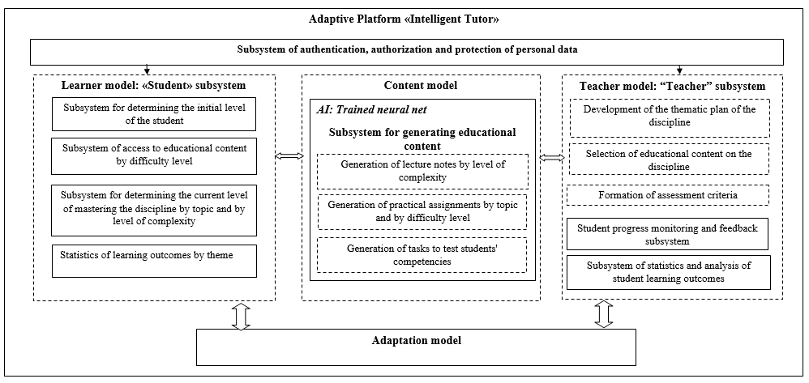Figure 1. Structural diagram of the adaptive platform «Intellectual Tutor»

**The adaptation model** performs adaptation of the student's learning process, starting from knowledge diagnostics, selection of materials by difficulty levels, progress tracking, to monitoring of results and making adjustments to the learning trajectory. This allows the system to personalize learning as effectively as possible, improving its efficiency and convenience for each student.

**The student model** within the adaptive platform «Intellectual Tutor» is represented by the **«Student»** subsystem and enables both personalization of the learning process and management of the individual educational trajectory. This model consists of four subsystems:

* **The Subsystem for Determining the Student's Initial Level** is responsible for diagnosing the student's baseline knowledge. The results obtained are used to generate an individual learning path based on the appropriate level of complexity.
* **The Subsystem for Access to Educational Content by Level of Complexity** provides access to learning materials tailored to the student’s level of preparation. This subsystem includes adaptive content selection algorithms that ensure the delivery of tasks and materials aligned with the learner’s preparedness and current performance.
* **The Subsystem for Assessing Current Mastery by Topic and Complexity Level** monitors and analyzes the student's learning progress, identifying gaps in understanding. It tracks which topics have been successfully mastered and which require further review.
* **The Subsystem for Learning Outcome Statistics by Topic** performs continuous assessment of learning results. It includes mechanisms for collecting and analyzing statistical data on completed topics and evaluating the dynamics of student progress.

*The* ***domain model*** is represented by a subsystem for generating educational content using an artificial neural network. This neural network enables the generation of lecture notes categorized by levels of complexity based on PDF-format materials uploaded by the instructor. It also generates practical exercises and assessment tasks for evaluating students’ learning outcomes, organized by topic and complexity level, as well as the degree of mastery of the educational material.

The ***teacher model*** («Instructor» subsystem) implements the key functions of the instructor in designing the course curriculum, including: 1) defining the thematic structure of the course and determining the sequence and logic of content delivery; 2) selecting appropriate educational content for the discipline; 3) establishing criteria for assessing learning outcomes. Additionally, the instructor is provided with functionality for monitoring student performance and delivering feedback, allowing for the tracking of students' learning results, progress monitoring, and the provision of personalized recommendations. The **student performance analytics subsystem** processes personal data related to student academic performance.

The subsystems of the adaptive platform «Intellectual Tutor» developed at KBU will enable academic personalization and allow for the adaptation of educational content in accordance with task complexity for each student. The platform supports the generation of concise summaries in a user-friendly format, as well as knowledge diagnostics by topic and the elimination of learning gaps.

For instructors, the platform provides functionality to automatically generate assignments, quizzes, and short summaries at varying levels of complexity based on the uploaded course syllabus and PDF-based instructional materials (lectures, textbooks, etc.). It also supports the evaluation of written assignments in the discipline and delivers analytical insights about student performance.

The results of this research offer practical evidence for the relevance of using AI and adaptive platforms to personalize learning in higher education. They also highlight key issues and challenges that need to be addressed in the development process of such adaptive systems.

Overall, the development of an adaptive educational platform for university students will enable academic personalization, allowing educational content to be tailored to each student based on task complexity. The platform will also facilitate the generation of concise summaries in a convenient format, as well as topic-specific knowledge diagnostics and the elimination of learning gaps.

For instructors, the platform will provide the ability to automatically generate assignments, tests, and concise summaries at various complexity levels based on the uploaded course syllabus and PDF-format instructional materials (such as lectures and textbooks). Additionally, it will support the assessment of written work and offer analytical insights into student performance.

The creation of an intelligent adaptive educational platform will contribute to enhancing the digital competence of all participants in the educational process.

*Funding Information.*This research is funded by the Committee of Science of the Ministry of Science and Higher Education of the Republic of Kazakhstan (Grant No. AP23487789: «Artificial Intelligence Technologies for the Implementation of Adaptive Personalized Learning in Higher Education»).

*References*

1. Концепция развития высшего образования и науки в Республике Казахстан на 2023 - 2029 годы. [Электронный ресурс]. *adilet.zan.kz* - URL: <https://adilet.zan.kz/rus/docs/P2300000248> (Дата обращения 08.11.2024)

2. Максимова М.В., Фролова О.В., Этуев Х.Х., Александрова Л.Д. Адаптивное персонализированное обучение: внедрение современных технологий в высшем образовании// Информатика и образование. – 2023. - 38(4). – С.14–27. DOI: 10.32517/0234-0453-2023-38-4-14-27

3. Добрица В.П., Горюшкин Е.И. Применение интеллектуальной адаптивной платформы в образовании// Auditorium.- 2019. - №1 (21). URL: <https://cyberleninka.ru/article/n/primenenie-intellektualnoy-adaptivnoy-platformy-v-obrazovanii>

4. Спирина Е.А., Казимова Д.А., Копбалина С.С., Турсынгалиева Г.Н., Турмуратова Д.А. К вопросу об интеграции искусственного интеллекта в систему высшего образования: мнение преподавателей// Вестник Карагандинского университета. - 2024. - Т. 29, № 4(116). — С. 136-145. <https://doi.org/10.31489/2024Ped4/136-145>

5. Hsu C.K., Hwang G.J., Chang C.K. Development of a reading material recommendation system based on a knowledge engineering approach // Computers & Education. 2010. Vol. 55. № 1. P. 76–83.

6. FitzGerald E., Jones A., Kucirkova N., Scanlon E. A literature synthesis of personalised technology-enhanced learning: what works and why // Research in Learning Technology. 2018. Vol. 26.