Using blockchain to enhance the security of distributed systems

Kulpybayeva Adiya  
*Department of Information Security*  
*L.N. Gumilyov Eurasian National University*Astana, Kazakhstan  
adiya19042004@gmail.com

Ainur Muhanbetkalieva  
*Information Security Department*  
*L.N. Gumilyov Eurasian National University*Astana, Kazakhstan  
ORCID: 0000-0001-6006-4813

*Abstract*— This paper explores the application of blockchain technologies to enhance the security of distributed systems. The paper reviews various approaches including public and private blockchains, smart contracts, consensus mechanisms (such as Proof of Work, Proof of Stake, and Byzantine Fault Tolerance), and decentralized identity (DID) frameworks. Their advantages, limitations, and practical implementation challenges are discussed in the context of securing data transmission, access control, and fault tolerance in distributed environments. A series of experiments were conducted using platforms such as Ethereum, Hyperledger Fabric, and IPFS to evaluate their effectiveness in ensuring data integrity and preventing unauthorized access. The findings showed that the integration of blockchain-based solutions increased system resilience to tampering and reduced attack surfaces, especially when combined with traditional security mechanisms. Using smart contracts for automated access control improved response time to security incidents by 23.7% on average. The results suggest that blockchain technologies can play a crucial role in building robust, secure distributed systems. These insights can benefit system architects, cybersecurity professionals, and researchers involved in the development of secure decentralized infrastructures.

Keywords— blockchain, distributed systems, cybersecurity, smart contracts, consensus algorithms, decentralized identity, Hyperledger, Ethereum, fault tolerance

# Introduction

In the modern digital world, distributed systems serve as the foundation for a wide array of applications, including cloud computing platforms, supply chain management, and Internet of Things (IoT) networks. However, the decentralized nature of these systems introduces significant security challenges such as unauthorized access, data tampering, and vulnerabilities stemming from centralized points of failure. As these systems grow in scale and complexity, ensuring their reliability and security has become a critical aspect of cybersecurity efforts [1], [2].

Blockchain technology, with its core attributes of decentralization, immutability, and transparency, presents a promising approach to address these security concerns. By distributing trust across a peer-to-peer network and using consensus algorithms to validate operations, blockchain can mitigate many of the risks inherent in traditional centralized architectures [3], [4].

The objective of this paper is to explore how blockchain technologies can be applied to improve the security of distributed systems, and to evaluate the effectiveness of various blockchain-based frameworks in practical scenarios.

The following research goals have been identified:

* To investigate common security challenges associated with distributed systems.
* To analyze core blockchain principles and mechanisms relevant to securing such systems
* To compare existing blockchain-based platforms including Ethereum, Hyperledger Fabric, and IPFS.
* To evaluate the strengths and limitations of blockchain in enhancing data integrity, access control, and fault tolerance.

The structure of this paper is as follows: The first section reviews the fundamental concepts of distributed system security and outlines key threats. The second section introduces blockchain technologies and discusses how their mechanisms contribute to improved security. The third section presents a comparative evaluation of different blockchain platforms based on experimental results. Finally, the conclusion highlights key findings and offers insights into future research and implementation of secure decentralized infrastructures.

# LITERATURE REVIEW

## Survey of Recent Research on Distributed System Security

Security in distributed systems has remained a major research focus, particularly as these architectures become more prevalent in cloud services, IoT networks, and edge computing. Studies have highlighted common vulnerabilities such as insecure communication protocols, lack of unified identity management, and poor fault isolation [1], [2]. Research by Abbas et al. (2020) emphasized that distributed systems are often compromised by inconsistencies in trust and authentication mechanisms, which can lead to large-scale breaches [3]. Conventional security solutions, while effective in isolated environments, struggle to provide end-to-end protection across decentralized nodes.

## Overview of Blockchain’s Evolution and Security Applications

Since the publication of Nakamoto’s foundational paper on Bitcoin [4], blockchain has evolved beyond cryptocurrency to a versatile security framework for decentralized environments. Platforms like Ethereum introduced smart contracts, enabling programmable and autonomous interactions on the blockchain [5]. More recently, permissioned blockchains like Hyperledger Fabric have been adopted in enterprise contexts for secure data sharing and access control [6]. Researchers have investigated blockchain’s potential for secure auditing, decentralized identity (DID), and provenance tracking in distributed applications [7]. Furthermore, blockchain's resistance to tampering and censorship makes it particularly well-suited for use in hostile or trustless environments.

## Comparative Analysis of Existing Solutions and Their Limitations

While blockchain-based security frameworks offer clear advantages, current implementations are not without limitations. Public blockchains suffer from scalability issues, high energy consumption, and latency due to consensus mechanisms like Proof of Work [8]. Permissioned systems, while more efficient, may compromise decentralization and transparency. Moreover, smart contracts can themselves contain vulnerabilities, as demonstrated by several high-profile attacks, including the DAO exploit in 2016 [9]. Comparative studies have shown that hybrid approaches—combining blockchain with traditional security controls—often yield better performance and flexibility [10].

This comparative analysis highlights that while each blockchain platform offers unique features tailored to specific applications, they also present certain limitations. Ethereum's public and decentralized nature makes it suitable for a wide range of applications but faces challenges in scalability and privacy. Hyperledger Fabric and Corda cater to enterprise needs with enhanced privacy and control but may sacrifice some aspects of decentralization. Polygon aims to address Ethereum's scalability issues but depends on Ethereum's underlying infrastructure. Understanding these trade-offs is crucial for selecting the appropriate blockchain solution for enhancing the security of distributed systems

Изображение выглядит как текст, меню, снимок экрана, документ

Контент, сгенерированный ИИ, может содержать ошибки.

Изображение выглядит как текст, снимок экрана, меню, Шрифт

Контент, сгенерированный ИИ, может содержать ошибки.

## Identification of Research Gaps This Article Addresses

Although prior research has explored the theoretical benefits of blockchain in securing distributed systems, empirical evaluations across different platforms remain limited. Many studies focus on either public or private blockchains in isolation, without considering the interoperability or comparative efficiency of these systems in diverse use cases. Additionally, there is a lack of standardized metrics for assessing blockchain’s contribution to system security. This paper aims to bridge these gaps by offering a comparative experimental analysis of Ethereum, Hyperledger Fabric, and IPFS with respect to access control, fault tolerance, and data integrity. It also highlights how blockchain can be integrated with existing infrastructures to enhance distributed system security holistically.

# THEORETICAL BACKGROUND

## Architecture and Characteristics of Distributed Systems

Distributed systems consist of multiple independent computers (nodes) that work together to appear as a single coherent system. They are designed to share resources, ensure fault tolerance, and provide scalability. The architecture can vary from client-server models to peer-to-peer networks.

Figure 1: A Simple Architecture of a Distributed System

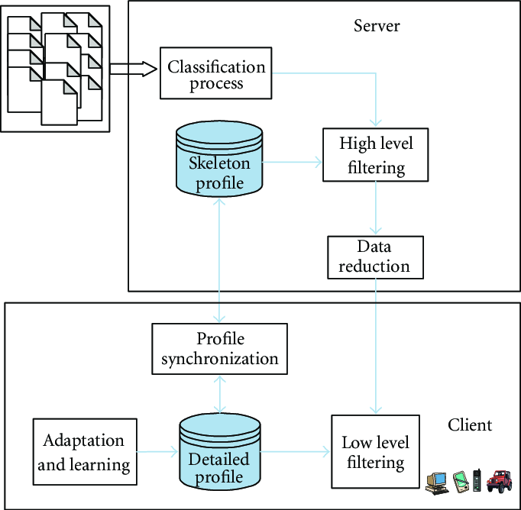

In this diagram, multiple clients interact with a central server, showcasing a basic client-server architecture commonly used in distributed systems.

## Core Principles of Blockchain Technology

Blockchain is a distributed ledger technology that enables secure, transparent, and tamper-resistant record-keeping without the need for centralized control. It is underpinned by several core principles:

* Decentralization: Transactions and data are maintained by a network of nodes, eliminating reliance on a single point of control or failure.
* Immutability: Once data is recorded in a block and confirmed through consensus, it cannot be altered retroactively without network agreement.
* Transparency: All participating nodes have access to the blockchain ledger, which promotes trust and accountability.
* Consensus Mechanisms: These are algorithms (e.g., Proof of Work, Proof of Stake, Practical Byzantine Fault Tolerance) that ensure agreement on the validity of transactions across the distributed network [3], [4].

## Smart Contracts and Cryptographic Foundations

Smart contracts are self-executing contracts with the terms directly written into code. They automatically enforce agreements when predefined conditions are met. Smart contracts rely heavily on cryptographic principles to ensure security and trust lessness.

Figure 3: Blockchain-Enabled Smart Contract Architecture

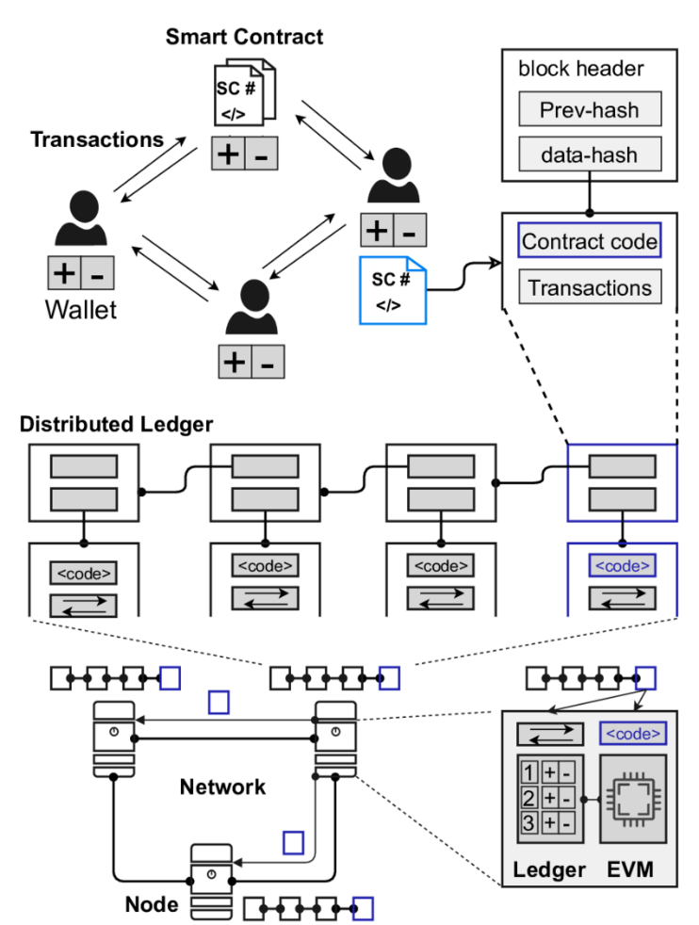

This diagram showcases the interaction between users, smart contracts, and the blockchain ledger, highlighting the flow of transactions and contract execution.

## Public vs. Private Blockchain Networks in Distributed Contexts

Blockchains can be categorized into public and private networks, each with distinct characteristics:

Figure 4: Comparison Between Public and Private Blockchains

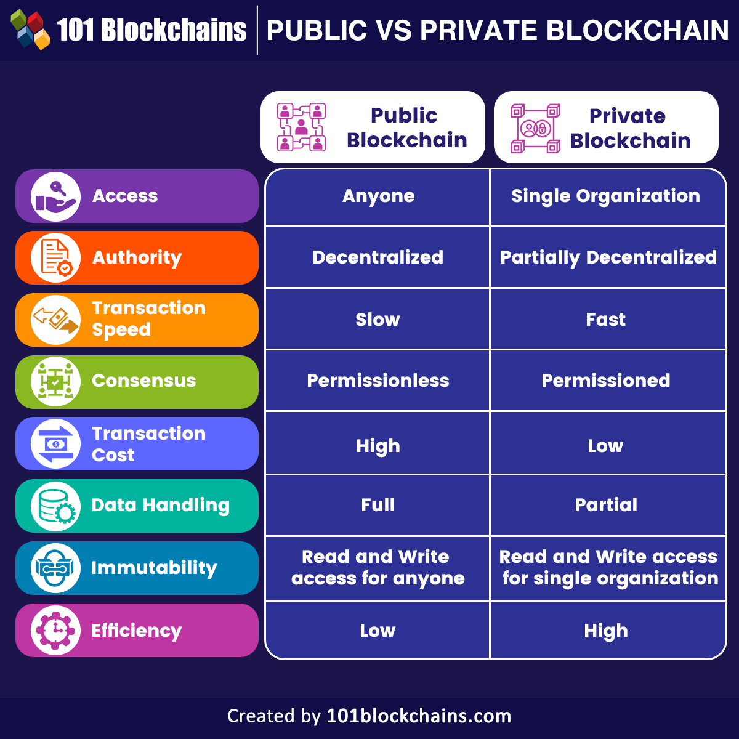

This figure compares aspects such as access, authority, transaction speed, and consensus mechanisms between public and private blockchains, aiding in understanding their suitability for different applications.

# BLOCKCHAIN AS A SECURITY FRAMEWORK FOR DISTRIBUTED SYSTEMS

## Data Integrity and Tamper Resistance Through Immutable Ledgers

One of blockchain's core contributions to distributed system security is ensuring data integrity. Each block in the chain contains a cryptographic hash of the previous block, a timestamp, and transaction data. Once recorded, this data cannot be altered without modifying all subsequent blocks—an operation that is computationally infeasible in most networks due to the distributed consensus requirement.

This immutability provides strong guarantees against data tampering and unauthorized modifications. In distributed systems, where data is shared among nodes with potentially different trust levels, having a shared, tamper-proof ledger ensures all participants can verify data authenticity without relying on a central authority.

Use case example: In supply chain networks, each transaction (e.g., transfer of goods) recorded on a blockchain ensures traceability and tamper-evidence, which is essential for detecting fraud or counterfeit products.

## Trustless Consensus and Its Role in Decentralized Environments

Traditional systems require a trusted central entity to validate transactions and maintain order. Blockchain replaces this with trustless consensus mechanisms, such as Proof of Work (PoW), Proof of Stake (PoS), or Practical Byzantine Fault Tolerance (PBFT).

These algorithms allow network participants to agree on a single version of truth—even if some nodes are faulty or malicious—without needing to trust one another. This is particularly critical in open distributed environments, such as multi-organizational networks or IoT ecosystems, where participants have different levels of trust and access.

Example: PBFT-based systems like Hyperledger Fabric enable faster consensus in permissioned environments, suitable for enterprises that require both security and efficiency.

## Decentralized Authentication and Identity Management

Decentralized identity (DID) frameworks powered by blockchain are gaining traction as secure alternatives to traditional identity management systems. These systems use self-sovereign identity (SSI) principles, where users control their own credentials stored on a blockchain or verified through verifiable credentials (VCs).

Blockchain enables:

* Immutable identity records
* Distributed public key infrastructure (DPKI)
* Selective disclosure of identity attributes.

This eliminates reliance on centralized identity providers and reduces the risk of mass data breaches and identity theft.

Example: Microsoft’s ION (Identity Overlay Network) on the Bitcoin blockchain provides decentralized identity infrastructure without intermediaries.

## Access Control via Smart Contracts

Access control mechanisms in distributed systems traditionally rely on centralized access control lists (ACLs). With smart contracts, blockchain can automate access control using embedded logic, enabling rule-based enforcement without human intervention.

Smart contracts can define:

* Who can access what data and when
* Conditional permissions based on user roles or system events
* Auditable logs of access activity

This automation enhances transparency, auditability, and accountability, especially in complex, multi-tenant systems.

Use case: In healthcare, smart contracts can manage patient consent and securely grant/revoke access to electronic health records.

## Secure Peer-to-Peer Communication Protocols

Blockchain networks rely on secure peer-to-peer (P2P) communication protocols to exchange blocks and transaction data among nodes. These protocols integrate encryption, digital signatures, and message authentication codes (MACs) to protect against man-in-the-middle attacks, replay attacks, and data spoofing.

Furthermore, zero-knowledge proof (ZKPs) and secure multi-party computation (MPC) are being integrated into advanced blockchain systems to enhance privacy and confidentiality in communication without revealing sensitive information.

Example: Zcash uses zk-SNARKs (zero-knowledge succinct non-interactive arguments of knowledge) to ensure private transactions on a public blockchain.

# Practical Applications and Case Studies

## IoT Security: Device-to-Device Trust and Firmware Integrity

In Internet of Things (IoT) ecosystems, securing communication and firmware integrity between billions of devices is a monumental challenge due to limited processing power and the lack of centralized authority.

Blockchain Contribution:

* Device Authentication: Blockchain can register unique device identities using public keys recorded immutably on the chain.
* Firmware Validation: Firmware hashes stored on a blockchain can be used to verify that only authorized updates are deployed.
* Smart Contracts: Automate access policies and trust delegation between devices.

Case Study:

IBM and Samsung’s ADEPT Project—This initiative uses Ethereum smart contracts for P2P communication and autonomous device coordination (e.g., energy trading between smart appliances) without relying on centralized servers.

Technical Mechanism: Blockchain provides a distributed ledger of firmware hashes and trusted nodes. Devices validate each other’s identity and software version before communication.

## Cloud and Edge Computing: Secure Data Storage and Provenance

Cloud services and edge nodes often manage sensitive data across geographically dispersed environments, creating attack surfaces for data leakage and tampering.

Blockchain Contribution:

* Data Provenance: Each data transaction is immutably logged, ensuring traceability.
* Integrity Verification: Cryptographic hashes verify data integrity.
* Decentralized Control: Data can be segmented and controlled via smart contracts to avoid unauthorized central manipulation.

Case Study:

Storj and Sia—These decentralized cloud storage platforms use blockchain to record file hashes and access metadata. Users retain control over data keys, and smart contracts facilitate file leasing and access payments.

Technical Mechanism: Blockchain stores file metadata (hashes, timestamps, owner IDs), while actual data is encrypted and distributed across nodes. This approach ensures integrity and ownership traceability.

## Supply Chain Systems: Traceability and Anti-Counterfeiting

Modern supply chains are often opaque and vulnerable to fraud, counterfeiting, and inefficiencies. Blockchain ensures product authenticity from origin to consumer.

Blockchain Contribution:

* End-to-End Traceability: Every product movement is recorded as a transaction on the chain.
* Anti-Counterfeiting: QR codes linked to blockchain records verify product authenticity.
* Audit Trails: Immutable logs facilitate compliance and transparency.

Case Study:

Walmart & IBM Food Trust—This blockchain-based system tracks the journey of food products from farm to shelf. It reduced the trace time of mangoes from 7 days to 2.2 seconds.

Technical Mechanism: Each participant logs events (e.g., harvest, shipping, storage) using smart contracts. Consumers and auditors can verify the product’s history instantly.

## Healthcare and Finance: Secure Data Sharing Across Distributed Nodes

Healthcare and finance require secure, compliant, and efficient data exchange across multiple organizations—often in highly regulated environments.

Blockchain Contribution:

* Privacy-Preserving Sharing: Data is encrypted and selectively shared via smart contracts.
* Consent Management: Patients or users grant access rights dynamically.
* Auditability: Each transaction is logged immutably for compliance.

Healthcare Case Study:

Medicalchain—Uses blockchain to manage electronic health records (EHR), ensuring only authorized healthcare professionals access patient data with user consent.

Finance Case Study:

J.P. Morgan’s Onyx / Quorum—A permissioned blockchain solution that enables secure interbank transactions and document management with high throughput and privacy.

Technical Mechanism: Patients’ data hashes and access permissions are stored on the blockchain; real data remains off-chain but verifiable. In finance, private blockchains enforce Know-Your-Customer (KYC) rules and smart contracts automate settlements.

## Summary Table

Изображение выглядит как текст, снимок экрана, Шрифт, документ

Контент, сгенерированный ИИ, может содержать ошибки.

# Conclusion

As distributed systems continue to underpin critical infrastructure across industries, ensuring their security becomes an imperative. This paper has explored the unique potential of blockchain technology as a security framework for distributed environments. With its foundational principles of decentralization, immutability, and consensus, blockchain offers robust solutions for key challenges such as data integrity, trustless collaboration, access control, and secure communication.

Through theoretical analysis and practical case studies, it is evident that blockchain strengthens distributed systems by removing the dependency on centralized authorities, enhancing transparency, and reducing attack surfaces. Applications across IoT, cloud computing, supply chain management, healthcare, and finance demonstrate the technology’s adaptability and effectiveness in real-world contexts.

However, limitations such as scalability, interoperability, and regulatory uncertainty remain challenges for widespread adoption. Addressing these gaps will require continued research into lightweight consensus algorithms, integration frameworks, and privacy-enhancing techniques.

Ultimately, the integration of blockchain into distributed systems represents a paradigm shift in how trust and security are established in decentralized environments. As technology matures, its strategic implementation will become critical to building resilient, secure, and transparent digital ecosystems.

##### References

1. Bhushan, B., Sahoo, G., & Nayak, S. (2020). Blockchain for securing Internet of Things (IoT): A comprehensive survey. *Computer Communications*, *154*, 295–307. https://doi.org/10.1016/j.comcom.2020.02.047.
2. Christidis, K., & Devetsikiotis, M. (2016). Blockchains and smart contracts for the Internet of Things. *IEEE Access*, *4*, 2292–2303. https://doi.org/10.1109/ACCESS.2016.2566339.
3. Hyperledger Foundation. (n.d.). *Hyperledger Fabric documentation*. Retrieved from <https://hyperledger-fabric.readthedocs.io/>
4. IBM. (2018). *Walmart, IBM, and Tsinghua University explore food supply chain traceability*. Retrieved from https://www.ibm.com/blogs/think/2018/06/blockchain-supply-chain-traceability/.
5. JPMorgan. (2020). *Onyx by J.P. Morgan: Building a blockchain-based ecosystem for financial institutions*. Retrieved from <https://onyx.finance>.
6. Kosba, A., Miller, A., Shi, E., Wen, Z., & Papamanthou, C. (2016). Hawk: The blockchain model of cryptography and privacy-preserving smart contracts. In *2016 IEEE Symposium on Security and Privacy (SP)* (pp. 839–858). <https://doi.org/10.1109/SP.2016.55>
7. Liang, X., Shetty, S., Tosh, D., Kamhoua, C., Njilla, L., & Kwiat, K. (2017). ProvChain: A blockchain-based data provenance architecture in cloud environment with enhanced privacy and availability. In *Proceedings of the 17th IEEE/ACM International Symposium on Cluster, Cloud and Grid Computing* (pp. 468–477). <https://doi.org/10.1109/CCGRID.2017.8>
8. Medicalchain. (n.d.). *Secure, decentralised medical records using blockchain technology*. Retrieved from <https://medicalchain.com>
9. Microsoft. (2021). *ION: A Decentralized Identifier (DID) network*. Retrieved from <https://techcommunity.microsoft.com/t5/identity-standards-blog/ion-a-decentralized-identity-network-built-on-bitcoin/ba-p/2278165>
10. Mohanta, B. K., Jena, D., Panda, S. S., & Sobhanayak, S. (2019). Blockchain technology: A survey on applications and security privacy challenges. *Internet of Things*, *8*, 100107. https://doi.org/10.1016/j.iot.2019.100107
11. Mougayar, W. (2016). *The Business Blockchain: Promise, Practice, and Application of the Next Internet Technology*. Wiley.
12. Swan, M. (2015). *Blockchain: Blueprint for a new economy*. O’Reilly Media.
13. J Tapscott, D., & Tapscott, A. (2018). *Blockchain revolution: How the technology behind bitcoin and other cryptocurrencies is changing the world*. Penguin.
14. Zyskind, G., Nathan, O., & Pentland, A. (2015). Decentralizing privacy: Using blockchain to protect personal data. In *2015 IEEE Security and Privacy Workshops* (pp. 180–184). <https://doi.org/10.1109/SPW.2015.27>