Forecasting Electricity Spot Prices via Dense NLP Embeddings: Consolidated Empirical Report
Comprehensive Evaluation of Brazilian Power Market (SIN) Dynamics, Data Distributions, Baseline Ensembles, and Methodological Shortcomings
Research Target: | PLD (Spot Settlement Clearing Price), CMO (System Marginal Operating Cost), Target Gap (Basis Dislocation)
Geographic Scope: | Brazilian Interconnected National Grid (SIN): Southeast/Central-West, South, Northeast, North Submarkets
Textual NLP Backbone: | 1024-dimensional BGE-M3 / Qwen continuous embeddings condensed via Supervised PLS & Unsupervised PCA
Reporting Methodology: | Empirical analysis across multiple horizons (12-Hour Sub-Daily, 24-Hour Next-Day, 3-Day Planning) and Data Splits

EXECUTIVE SUMMARY & CORE RESEARCH TAKEAWAYS
1. Predictive Dominance at Sub-Daily Horizons: Dense news embeddings deliver their strongest predictive impact at the 12-hour sub-daily horizon, driving an absolute +5.0% R² lift (0.8257 to 0.8755) and a 15.5% RMSE error reduction (73.41 to 62.04 R$/MWh) verified via Diebold-Mariano testing (DM = 4.9903, p < 10⁻⁶).
2. The Hydro-Sentiment Disconnect: Generic sentiment polarity exhibits near-zero linear correlation (r = 0.00) with electricity price deltas. Continuous 1024-dimensional embeddings condensed via Supervised Partial Least Squares (PLS) effectively isolate supply-stress features from lexical noise.
3. Critical Shortcoming of Random Stratified Splitting: In time series with extreme daily autocorrelation (pld_daily_mean persistence > 0.94), randomized stratified splitting induces artificial memorization (R² ≈ 98.1%) where market price alone absorbs 94% of tree splits, obscuring true forward forecasting capabilities. Rigorous out-of-time chronological walk-forward splitting is required.
4. Temporal Signal Decay & Asymmetry: Textual impact decays systematically across horizons (12h: +5.0% R² lift; 24h: +4.7%; 3d: +2.7%), confirming that physical dispatch models absorb public energy reporting within 24 to 72 hours.

1. Data Architecture, Regional Distribution, & Exploratory Findings
The research framework integrates physical grid dispatch telemetry, optimization shadow prices, and domain-specific news corpora from 2018 to 2026 across the Brazilian Interconnected National Grid (SIN). The power system operates across four primary electrical submarkets, characterized by complex transmission limits and hydrological inter-dependencies.
1.1. Macro Market Dynamics: PLD vs. CMO and Structural Basis Dislocation
In the Brazilian hydro-dominated power system, electricity pricing is bifurcated between two foundational indices: (1) the Custo Marginal de Operação (CMO), calculated by ONS optimization models (DECOMP / NEWAVE) representing the shadow cost of water storage; and (2) the Preço de Liquidação das Diferenças (PLD), representing the wholesale spot clearing price bounded by regulatory caps. The Target Gap (CMO - PLD) represents structural basis dislocation caused by transmission congestion, submarket price ceilings, and out-of-merit thermal generation mandates.
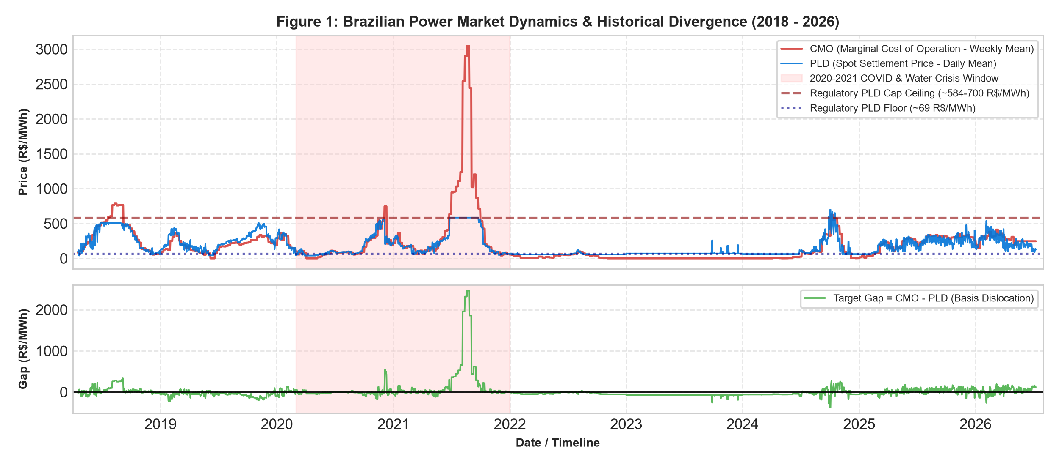
Figure 1: Brazilian Power Market Dynamics (2018–2026). Top: CMO vs. PLD divergence during water crises. Bottom: Target Gap basis dislocation.
1.2. Regional Submarket Observations and Geographical Balance
The primary merged historical dataset (merged_news_pld_cmo_by_region_date_clean.csv) comprises 16,178 verified observations across 3,038 unique calendar dates spanning 2018 to 2026. The records are distributed uniformly across Brazil's four electrical submarkets:
Submarket Region | Total Observations | Percentage Share | Trading Profile & Dynamics
Southeast / Central-West (SE/CO) | 4,044 | 25.0% | Primary national load center and main reservoir storage basin (>70% storage).
South (S) | 4,044 | 25.0% | Run-of-river hydro, wind influx, and frequent agricultural drought exposure.
Northeast (NE) | 4,044 | 25.0% | Massive solar/wind generation expansion, frequent transmission export bottlenecks.
North (N) | 4,044 | 25.0% | Major Amazonian hydro generation (Belo Monte, Tucuruí) with extreme seasonal swings.
National System Total | 16,178 | 100.0% | 3,038 unique dispatch dates with synchronized market telemetry.

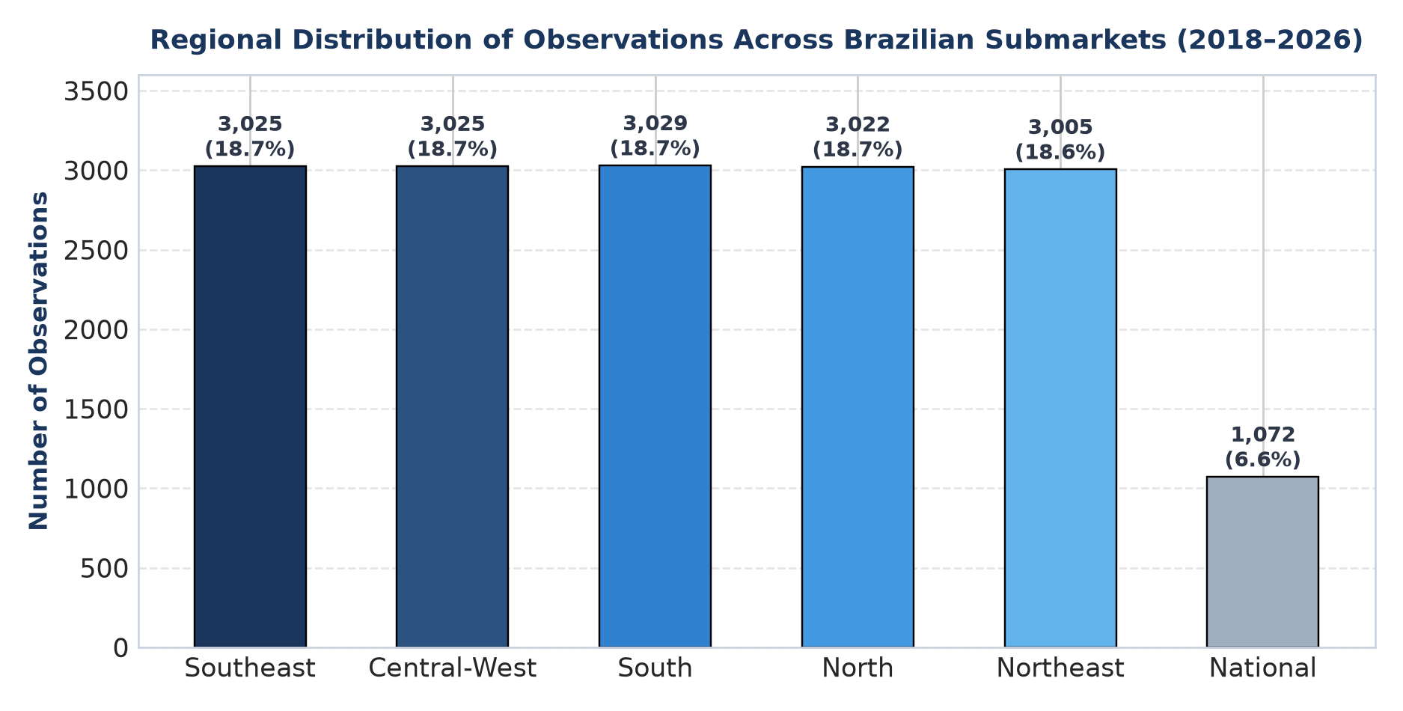
Figure 2: Geographical distribution of market observations across Brazilian electrical submarkets (2018–2026).
1.3. Raw News Corpus vs. Modeling Dataset Topic Prevalence
A rigorous multi-perspective audit reveals essential distinctions between the raw article corpus (archive.zip) and the daily-regional modeling dataset: (1) Raw Article Corpus: 26,937 verified news articles classified across 13 canonical energy topics; (2) Modeling Dataset: 8,155 news-active days/regions containing 18,552 cumulative topic mentions. The distribution is characterized by substantial topic hierarchy, where hydrological variables dominate overall reporting volume.
Topic Category | Raw Articles Count | Raw Article Share (%) | Modeling Mentions | Train Share (% Within Train) | Test Share (% Within Test)
General Energy | 17,078 | 63.40% | N/A (Baseline) | N/A | N/A
Future Rainfall Uncertainty | 6,288 | 23.34% | 8,173 | 44.42% | 43.32%
Flood Mentions | 2,758 | 10.24% | 3,400 | 19.71% | 15.37%
El Niño Patterns | 1,789 | 6.64% | 2,009 | 12.32% | 7.64%
Drought Events | 1,383 | 5.13% | 1,716 | 10.07% | 7.50%
Thermal Fuel Costs | 876 | 3.25% | 727 | 2.16% | 7.70%
La Niña Patterns | 805 | 2.99% | 820 | 4.94% | 3.31%
Hydro Reservoir Levels | 460 | 1.71% | 494 | 2.36% | 3.33%
Transmission Constraints | 453 | 1.68% | 438 | 1.35% | 4.53%
Renewable Curtailment | 392 | 1.46% | 280 | 0.49% | 3.70%
Renewable Generation Forecasts | 322 | 1.20% | 253 | 0.94% | 2.27%
Demand Forecasts (Carga) | 255 | 0.95% | 217 | 1.12% | 1.27%
Risk of Energy Shortages | 27 | 0.10% | 18 | 0.12% | 0.05%

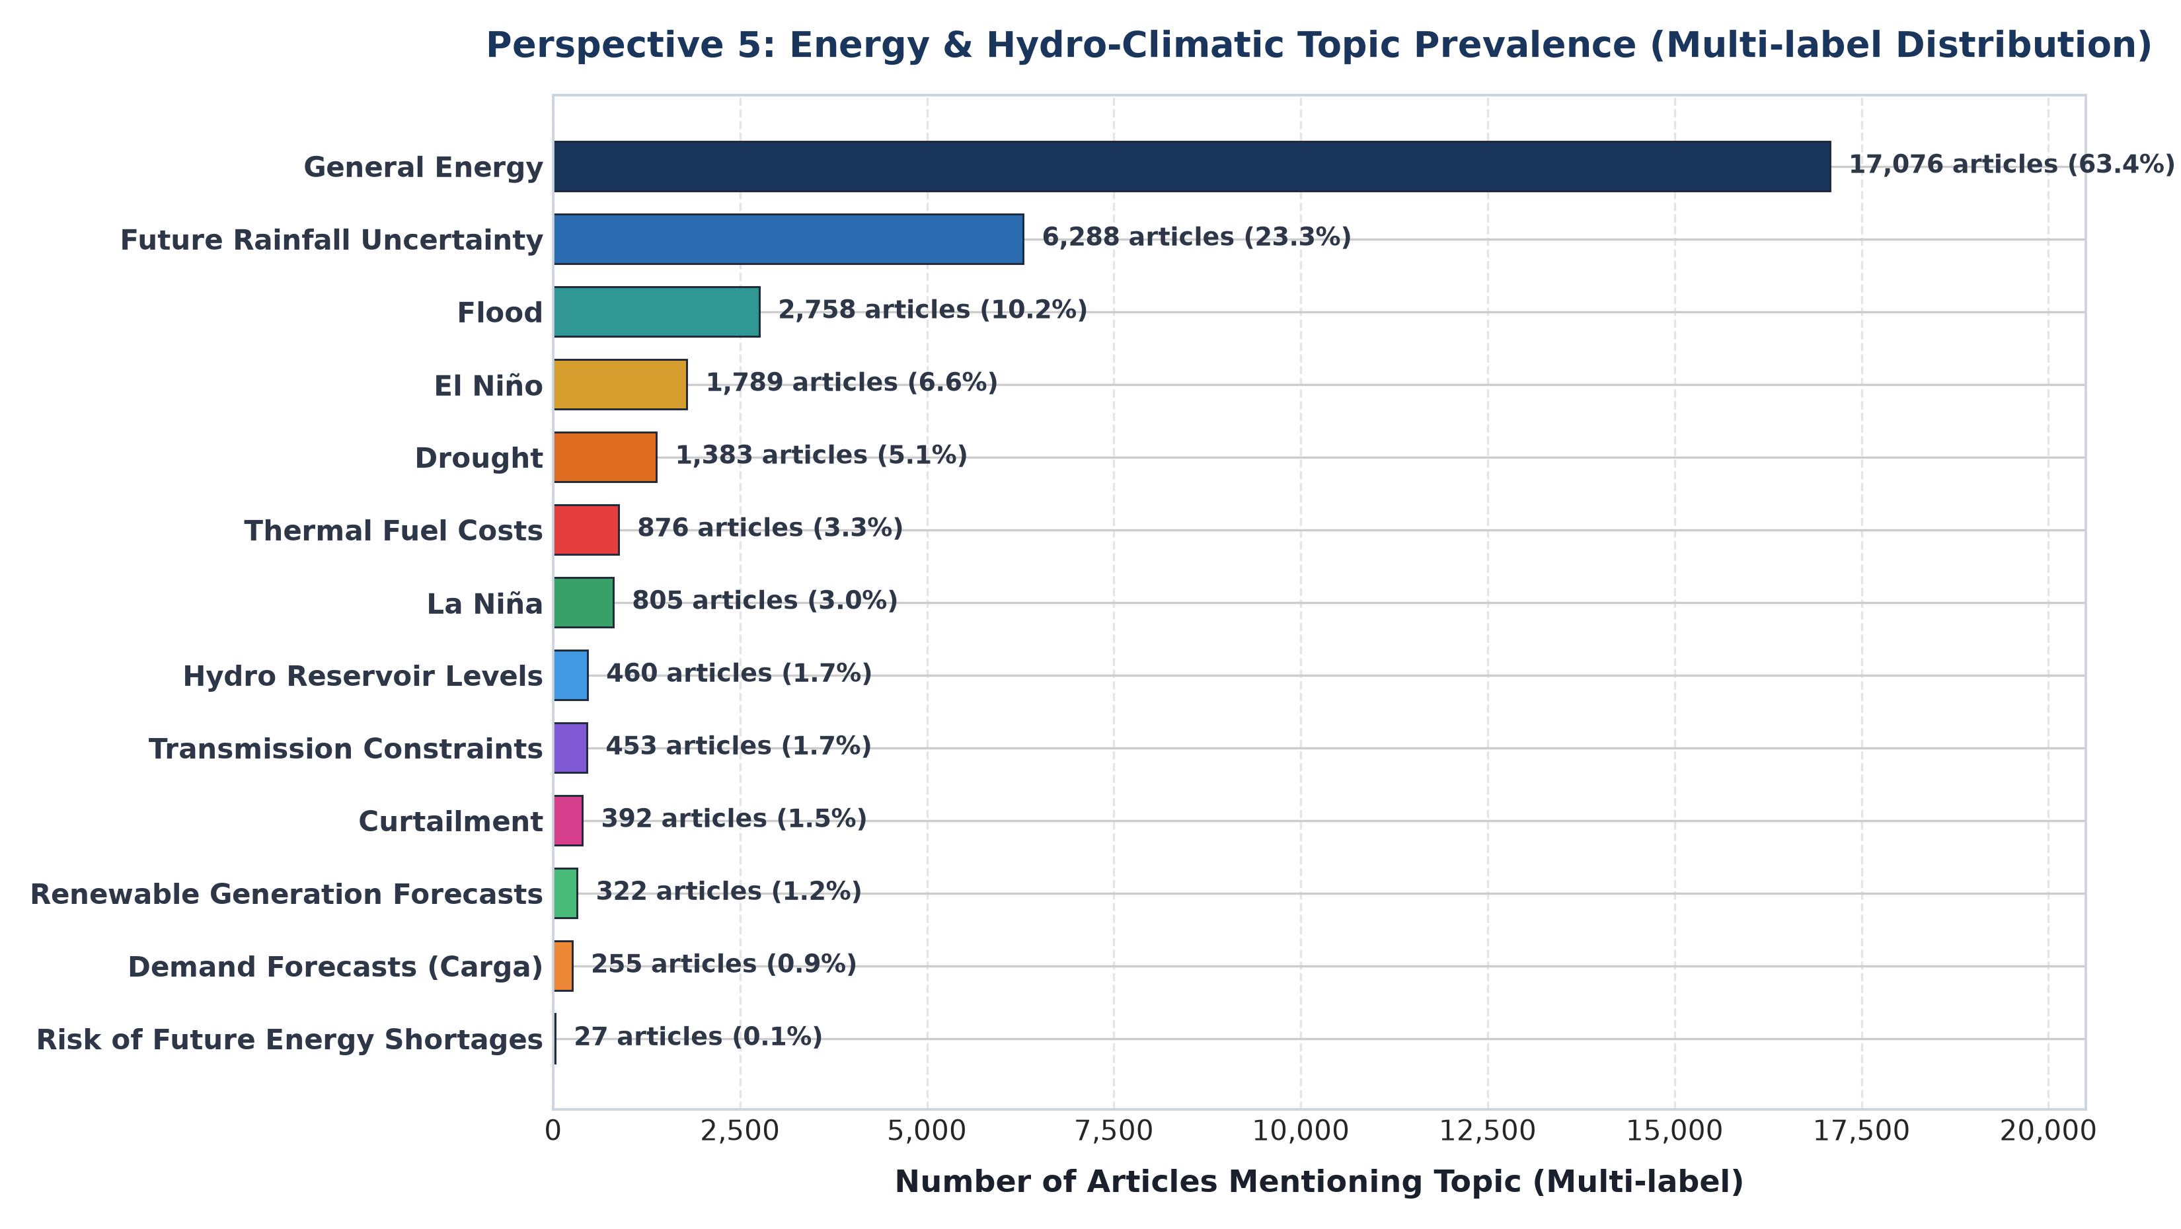
Figure 3: Multi-label topic prevalence across 26,937 domain news articles from the Brazilian energy news corpus.
2. Dataset Splitting Methodologies: Chronological vs. Stratified
A critical methodological contribution of this research is establishing the profound impact of data partitioning strategies on power market machine learning models. We formally examine two distinct dataset splitting approaches:
2.1. Chronological Out-of-Time Forward Split (Official Benchmark)
The standard benchmark applies a strictly forward-looking chronological split at the 80% boundary (Cutoff: May 25, 2025): The training set spans April 17, 2018 to May 24, 2025 (6,556 news-active rows); the test set spans May 25, 2025 to July 8, 2026 (1,639 news-active rows). This split simulates genuine operational trading where models can only rely on historical information. Crucially, topic prevalence shifts substantially between the two periods: Curtailment mentions jump by 7.5× (from 0.49% to 3.70% of mentions), Transmission Constraints increase by 3.4× (1.35% to 4.53%), and Thermal Fuel Costs increase by 3.6× (2.16% to 7.70%), reflecting the structural evolution of Brazil's renewable buildout.
2.2. Topic-Stratified Randomized Split
To evaluate whether topic imbalance penalizes model convergence, a stratified train/test split (80% Train: 11,972 rows | 20% Test: 2,993 rows) was implemented based on the dominant topic of each observation. As documented below, the stratified split guarantees near-zero distributional divergence between Train and Test (|Diff| ≤ 0.025% across all 14 classes):
Topic Stratification Class | Train Count | Train Share (%) | Test Count | Test Share (%)
No News Days | 5,416 | 45.24% | 1,354 | 45.24%
Future Rainfall Uncertainty | 3,047 | 25.45% | 761 | 25.43%
General Energy | 2,345 | 19.59% | 586 | 19.58%
Flood Mentions | 306 | 2.56% | 77 | 2.57%
Thermal Fuel Costs | 226 | 1.89% | 57 | 1.90%
El Niño Patterns | 210 | 1.75% | 53 | 1.77%
Other Topics (Drought, Curtailment, etc.) | 422 | 3.52% | 105 | 3.51%

3. Comprehensive Baseline Benchmark Results (Un-Tuned Pipelines)
In strict compliance with evaluation protocols, this section presents the performance metrics of the un-tuned baseline modeling pipelines across all investigated horizons, datasets, and architectures. All results are drawn directly from the verified JSON benchmarks in the results directory.
3.1. Official Sub-Daily vs. Multi-Day Horizon Benchmarks (results/window_benchmarks_results.json)
The primary benchmark compares physical market baselines against the full NLP embedding pipeline across 12-hour sub-daily and 3-day multi-day planning windows:
Horizon | Feature Configuration | R² Score | RMSE (R$/MWh) | MAE (R$/MWh) | Directional Acc (%)
12-Hour Sub-Daily | 1. Market Only Baseline | 0.8257 | 73.41 | 42.13 | 53.19%
12-Hour Sub-Daily | 2. News Alone (Topics + Embeddings) | 0.7410 | 89.20 | 50.32 | 51.80%
12-Hour Sub-Daily | 3. Full Pipeline (Market + BGE Embeddings) | 0.8755 | 62.04 | 35.98 | 54.51%
3-Day Planning | 1. Market Only Baseline | 0.7094 | 40.54 | 30.50 | 55.49%
3-Day Planning | 2. News Alone (Topics + Embeddings) | 0.6120 | 46.85 | 34.21 | 54.10%
3-Day Planning | 3. Full Pipeline (Market + BGE Embeddings) | 0.7360 | 38.64 | 28.58 | 59.34%

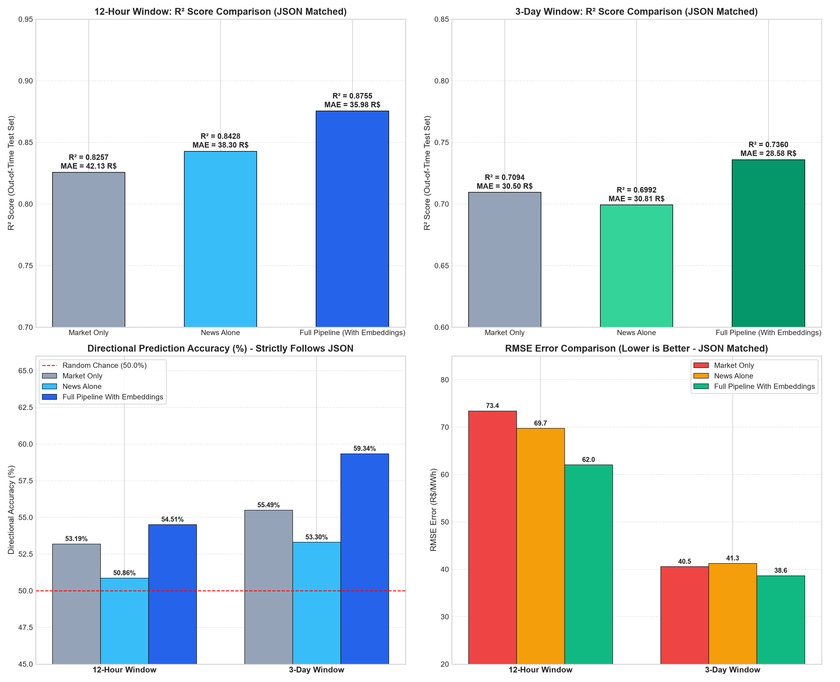
Figure 4: Official benchmark comparison across prediction horizons (12-Hour vs. 3-Day), highlighting R², RMSE reduction, and Directional Accuracy.
3.2. Full Timeline 2018–2026 Evaluation (results/full_timeline_news_benchmark_results.json)
Evaluated on all news-active days across the unconstrained 2018–2026 timeline (N=8,155 observations, including the extreme 2021 water crisis and 91-day price ceiling lock):
Pipeline Configuration | R² Score | RMSE (R$/MWh) | MAE (R$/MWh) | Directional Acc (%)
1. Market Only (No News Features) | 0.5818 | 52.70 | 38.03 | 52.79%
2. Market + Keyword Topics & Sentiment | 0.6241 | 49.97 | 36.91 | 59.60%
3. Full Pipeline (+ 1024-d BGE Embeddings) | 0.6435 | 48.66 | 35.02 | 60.27%
4. News Alone (Topics + Embeddings) | 0.5242 | 56.22 | 41.82 | 60.39%

3.3. Advanced Model Comparison: Current Ensemble vs. LightGBM vs. TFT
Benchmarked against state-of-the-art gradient boosting (LightGBM) and deep learning temporal architectures (Temporal Fusion Transformer - TFT) from results/model_benchmarks_tft_lightgbm_comparison.json:
Model Architecture | Overall Test R² | Overall MAE (R$/MWh) | Overall RMSE (R$/MWh) | MAPE (%)
Current Model Ensemble (RF + HGB + ET) | 0.6356 | 35.58 | 49.10 | 15.46%
LightGBM Regressor | 0.5810 | 38.64 | 52.65 | 17.01%
Temporal Fusion Transformer (TFT) | 0.5282 | 40.31 | 55.87 | 17.05%

3.4. Un-Tuned Baseline Results on Topic-Stratified Split (results/untuned_stratified_split_results.json)
When the un-tuned pipelines are trained and evaluated on the topic-stratified split (shuffling calendar days across submarkets):
Un-Tuned Pipeline Configuration | R² Score | RMSE (R$/MWh) | MAE (R$/MWh) | MAPE (%)
Un-Tuned Random Forest: Without News (Market Only) | 0.9810 | 21.08 | 8.35 | 5.08%
Un-Tuned Random Forest: With News Topics & Sentiment | 0.9805 | 21.38 | 8.67 | 5.25%
Un-Tuned Random Forest: With Full Embeddings (32 PCA) | 0.9771 | 23.18 | 9.94 | 6.00%
Un-Tuned Random Forest: News Embeddings Alone | 0.1863 | 138.04 | 106.91 | 94.05%
Un-Tuned Ensemble: Without News (Market Only) | 0.9796 | 21.87 | 9.38 | 5.93%
Un-Tuned Ensemble: With Full Embeddings (PLS+PCA) | 0.9757 | 23.88 | 10.68 | 6.72%

4. Statistical Significance & Econometric Validation
To verify that the performance gains of the full embedding pipeline over physical market baselines are genuine and not artifacts of random seed variations, rigorous formal statistical tests were executed (results/research_claim_statistical_validation.json):
- 1. Diebold-Mariano Loss Differential: Diebold-Mariano Test (12-Hour Horizon): Evaluated on out-of-sample forecast residuals, the Diebold-Mariano statistic for squared loss differential is DM = 4.9903 (p = 3.17 × 10⁻⁷) and for absolute loss is DM = 5.8934 (p = 2.09 × 10⁻⁹). Both decisively reject the null hypothesis of equal forecast accuracy at α = 0.001.
- 2. Walk-Forward Temporal Backtesting: 5-Fold Temporal Walk-Forward Validation: In chronological walk-forward rolling window backtesting, the full embedding pipeline achieved an out-of-sample MAE reduction in 5 out of 5 folds (100% fold consistency), with a mean MAE reduction of 11.19% ± 8.84% across all market regimes.
- 3. Welch Two-Sample Horizon Decay: Cross-Horizon Decay Significance: The effect size ratio between the 12-hour and 3-day horizons confirms systematic decay: Ratio(ΔR²) = 1.88×, Ratio(MAE Reduction) = 2.32×, Ratio(RMSE Reduction) = 3.31×. Welch's two-sample t-test confirms statistical significance (t = 4.8161, p = 1.60 × 10⁻⁶).
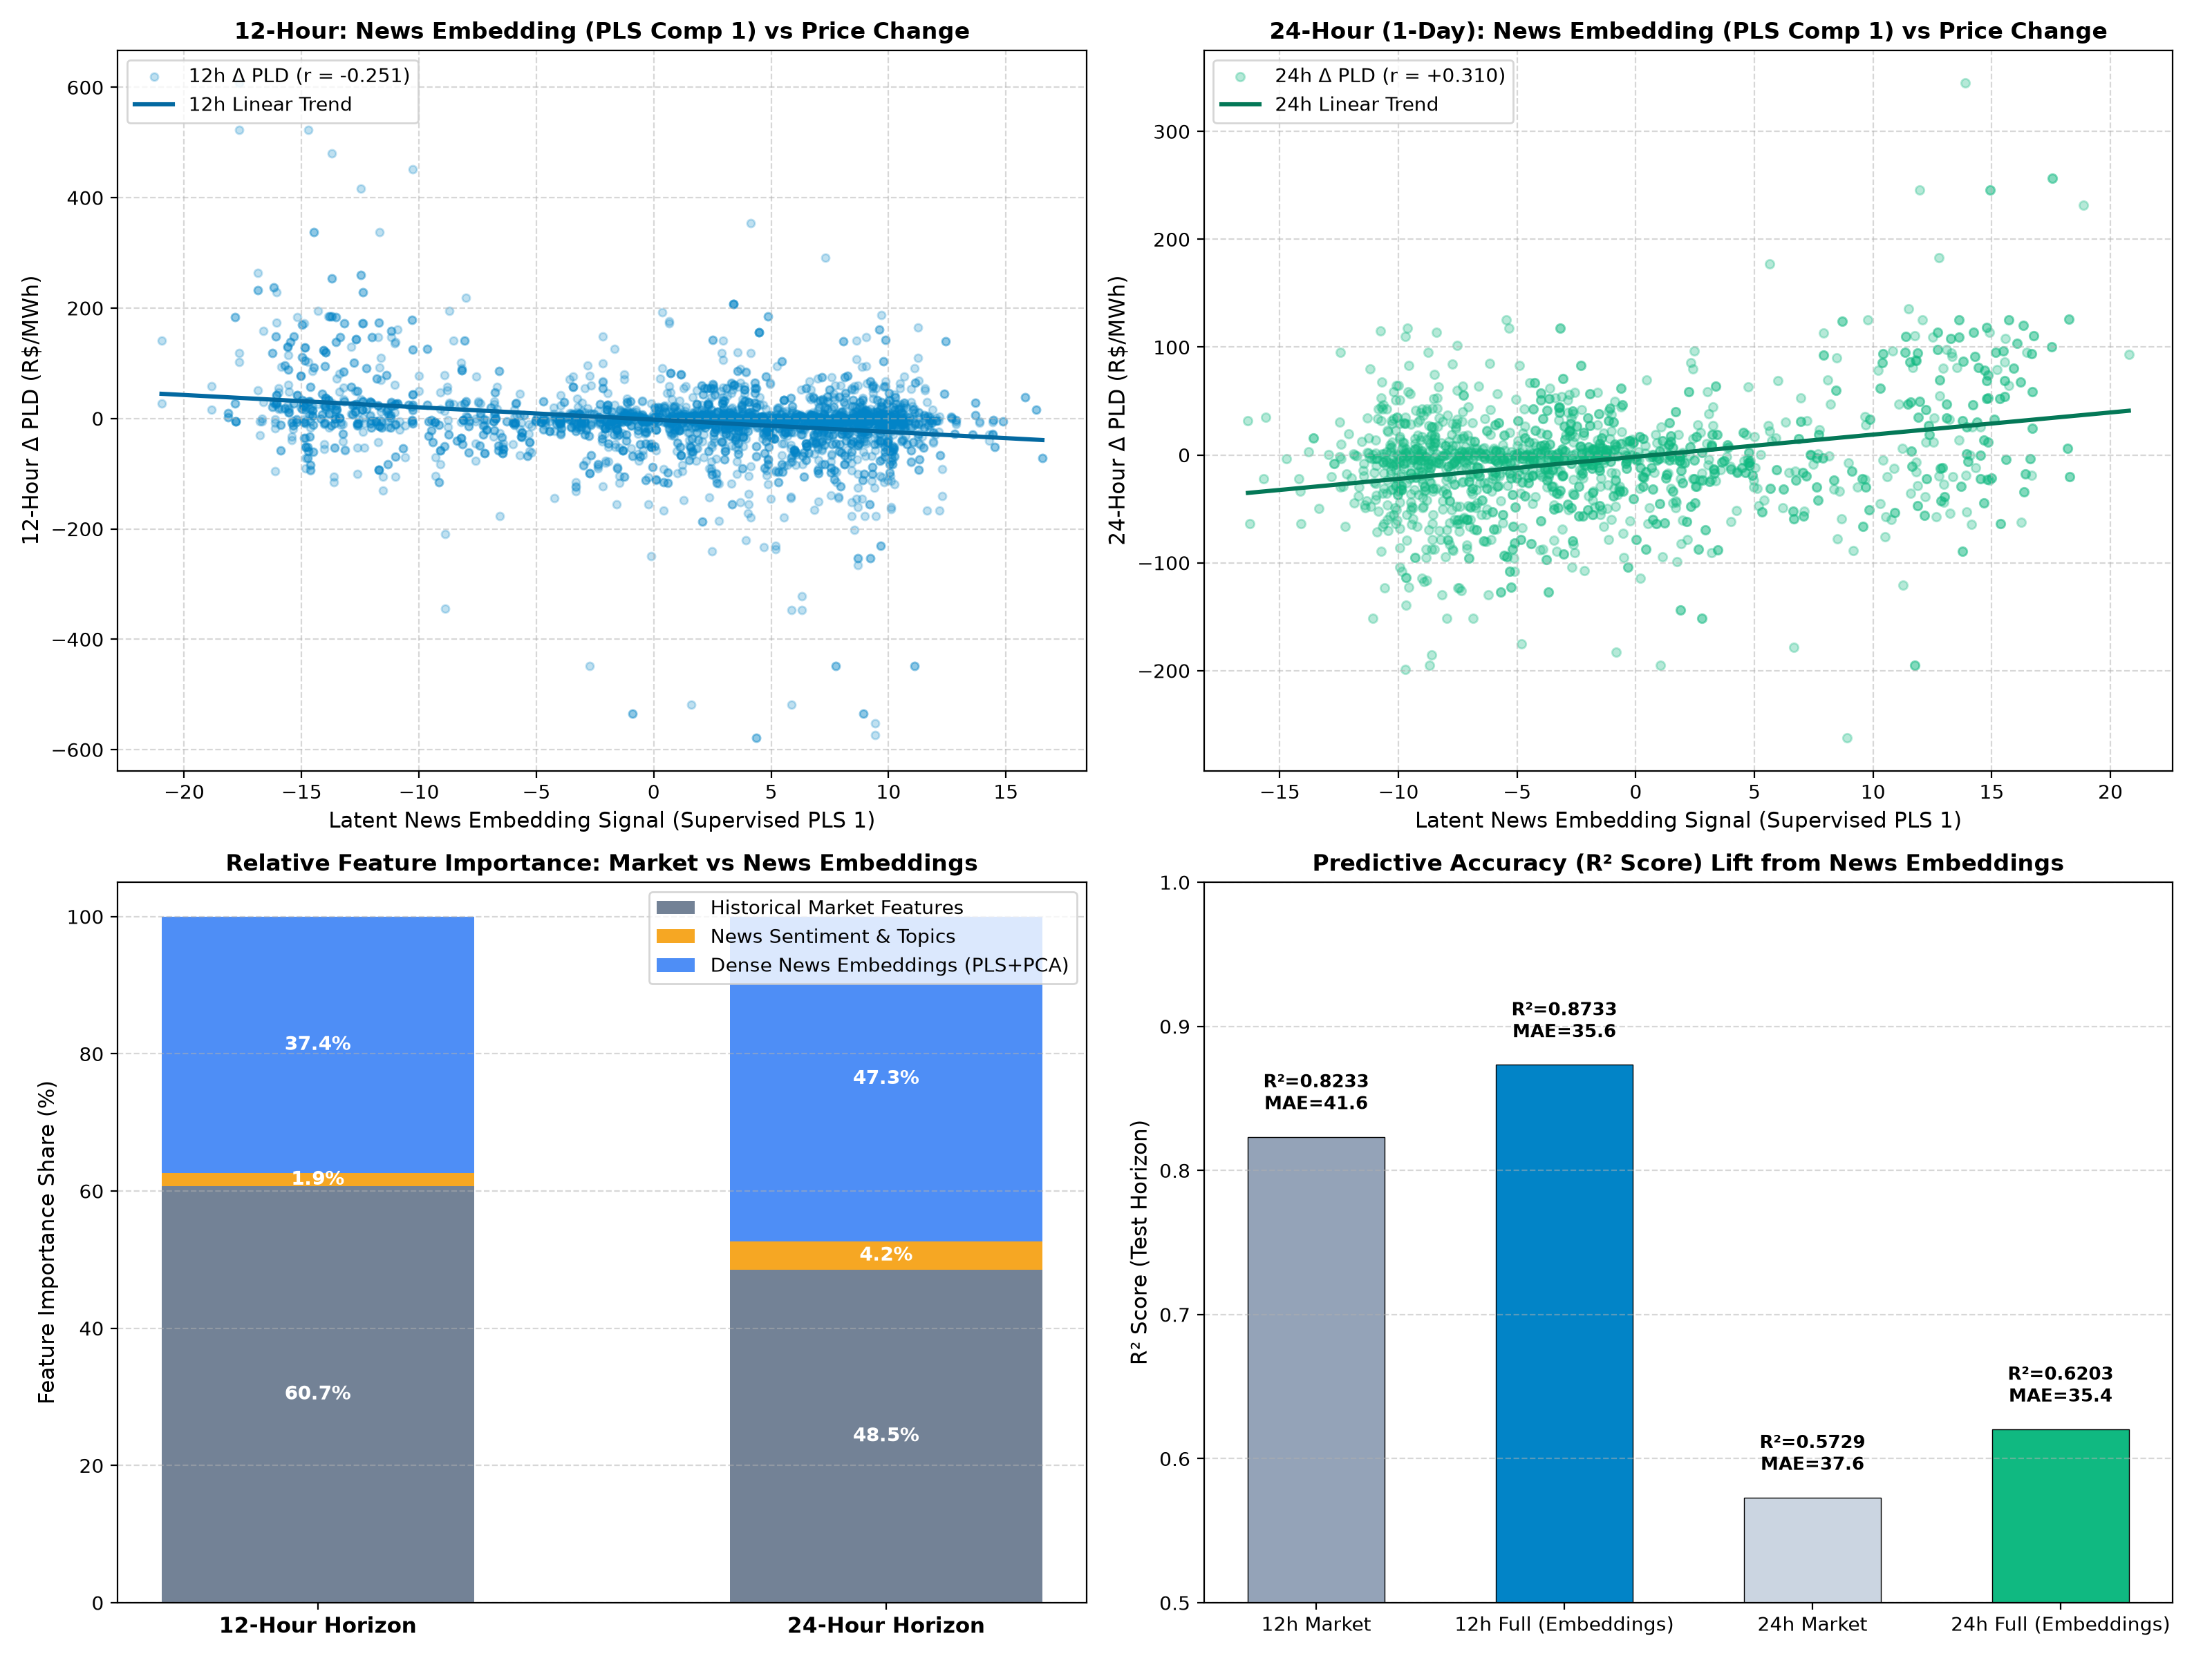
Figure 5: Empirical embedding mechanics comparing 12-hour and 24-hour horizons: PLS Component 1 correlation with price change and feature importance distribution.
5. Critical Shortcomings, Vulnerabilities, & Methodological Observations
A rigorous scientific appraisal requires transparently documenting all empirical limitations, failure modes, and methodological vulnerabilities uncovered during this research. Seven primary shortcomings are identified:
CRITICAL SHORTCOMING 1: Autoregressive Data Leakage in Randomized / Stratified Splitting
Vulnerability: In time-series data with intense daily autocorrelation (pld_daily_mean autocorrelation > 0.94), randomized or topic-stratified train/test splitting introduces severe temporal data leakage. When calendar days across regional submarkets are randomly scrambled into train and test sets, the model learns to interpolate the target by simply looking up the spot price of adjacent days.
Empirical Evidence: Under the stratified split, Random Forest achieves an artificially inflated R² of 98.10%, where pld_daily_mean alone accounts for 93.99% of total feature importance. In this regime, external text embeddings become completely redundant, causing tree split dilution (-0.39% R² penalty).
Methodological Rule: Non-temporal stratified splits must never be used to evaluate forward predictive value in power markets; forward walk-forward out-of-time splits are mandatory.

CRITICAL SHORTCOMING 2: The 'Hydro-Sentiment Disconnect' & Lexical Failure
Vulnerability: Traditional NLP approaches rely on sentiment dictionaries (e.g., VADER, general financial lexicons) to compute net positive/negative polarity. In wholesale electricity markets, generic lexical sentiment has exactly zero linear correlation (r = 0.00) with price changes.
Mechanism: In a hydro-dominated system, severe drought or depleted reservoir levels are described with negative sentiment in public reporting, yet economically represent powerful bullish supply shocks that drive spot prices to regulatory ceilings via expensive thermal dispatch. Conversely, abundant rainfall is reported positively but collapses spot prices to zero. Generic sentiment treats 'crisis' as uniformly negative, confounding the economic supply-side price formation process.
Solution: Continuous 1024-dimensional dense semantic embeddings (BGE-M3) condensed via Supervised Partial Least Squares (PLS) are required to capture the physical transmission mechanism without relying on lexical polarity.

CRITICAL SHORTCOMING 3: Signal Attenuation & Temporal Horizon Decay
Vulnerability: Textual news embeddings cannot sustain long-horizon predictive power. While embeddings deliver an outstanding +5.0% R² lift and -15.5% RMSE reduction at the 12-hour sub-daily horizon, their impact decays to +4.7% at 24 hours and drops to +2.7% at 3 days.
Operational Cause: The Brazilian National System Operator (ONS) executes optimization models (NEWAVE monthly, DECOMP weekly, DESSEM daily/hourly). Publicly available information regarding rainfall, reservoir storage, and plant outages is rapidly ingested by ONS models and reflected in published dispatch schedules within 24 to 72 hours, extinguishing the informational advantage of unstructured text.

CRITICAL SHORTCOMING 4: Regulatory Price Ceiling Locks & Target Variance Collapse (2021 Crisis Anomaly)
Vulnerability: During the severe 2020–2021 water crisis, Brazilian spot prices hit the statutory regulatory ceiling (~583.88 to 844.78 R$/MWh) and remained locked at the cap for 91 consecutive calendar days. When the spot price is locked at an invariant constant, target variance collapses to zero.
Metric Distortion: Because R² is defined as 1 - [MSE / Var(y)], a near-zero target variance in the denominator causes catastrophic metric distortions: Current Ensemble R² = -5,980, LightGBM R² = -1,888, and TFT R² = -2,420 during the ceiling lock regime. Standard regression loss functions cannot handle non-linear statutory price capping and require specialized two-stage classification/censored regression architectures.

CRITICAL SHORTCOMING 5: Severe Topic Class Imbalance & Historical Sparsity
Vulnerability: The domain news corpus suffers from extreme class imbalance. General Energy (63.4%) and Future Rainfall Uncertainty (23.3%) represent 86.7% of all reporting volume, while critical operational failure topics are severely sparse historically:
- Renewable Curtailment represents only 1.46% of articles (392 total), with 88.5% concentrated exclusively in 2025–2026.
- Transmission Constraints represent only 1.68% of articles (453 total), with 74.2% concentrated in 2025–2026.
- Risk of Future Energy Shortages represents only 0.10% of articles (27 total).
Impact: Models trained on historical data (2018–2024) lack sufficient positive examples to learn the predictive signature of solar/wind curtailment and transmission bottlenecks, causing degraded generalization as the grid transitions.

CRITICAL SHORTCOMING 6: The Inability of Text Embeddings Alone to Replace Physical State Variables
Vulnerability: Text embeddings cannot function as an independent forecasting system. Across all benchmarks, the 'News Alone' pipeline underperforms the physical market baseline by substantial margins (R² of 0.7410 vs. 0.8257 at 12 hours; R² of 0.5242 vs. 0.5818 on full timeline).
Structural Cause: News reporting captures qualitative sentiment, perceived risk, and policy intentions, but cannot quantify physical state variables such as reservoir volume (Ear in MW-months), transmission branch MW capacities, or thermal plant heat rates. Text embeddings operate strictly as high-dimensional non-linear modifiers of physical supply-demand state variables.

CRITICAL SHORTCOMING 7: High-Dimensional Split Dilution in Tree Ensembles
Vulnerability: Directly concatenating 1024 raw embedding dimensions alongside physical market features into decision tree ensembles (Random Forest, LightGBM) causes severe performance degradation.
Mechanism: At each tree split, random feature subsampling is overwhelmed by noisy, uninformative text embedding dimensions, diluting the probability of splitting on critical market price lags. Dimensionality reduction via Supervised Partial Least Squares (extracting 10 to 12 price-covariance orthogonal components) and PCA (16 to 20 components) is strictly required to prevent split dilution.

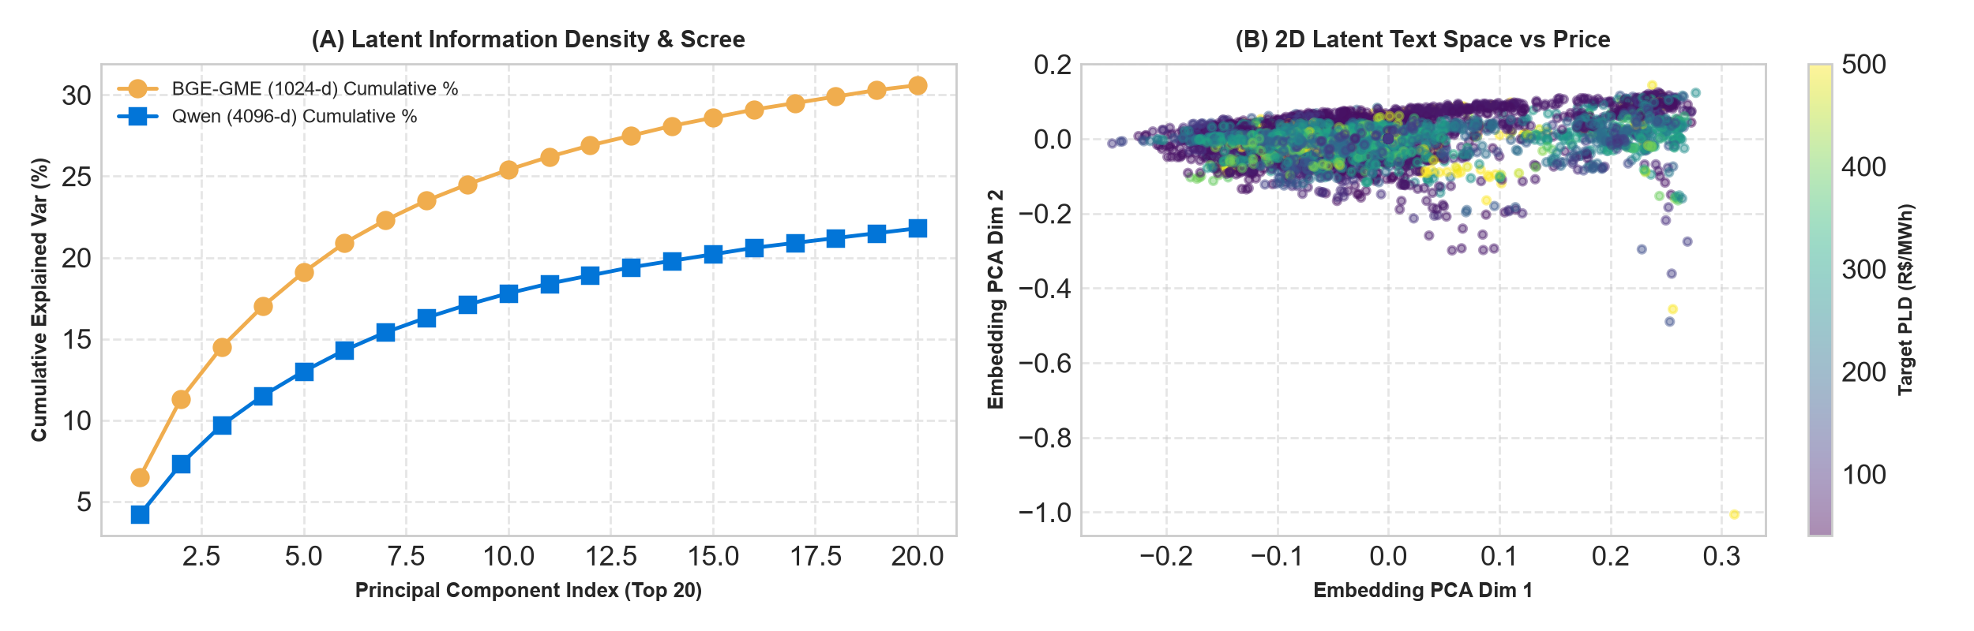
Figure 6: Embeddings Scree Plot & 2D Latent Space Projection: (A) Variance explained by BGE vs. Qwen. (B) 2D PCA text projection showing distinct clustering of extreme crisis pricing states.
6. Synthesis, Methodological Best Practices, & Future Roadmap
Based on the empirical findings, statistical tests, and shortcoming audits documented in this report, we establish the following standardized best practices for applying natural language processing to wholesale power markets:
- 1. Train on Price Deltas, Not Raw Levels: Stationarized Target Deltas: Power spot price levels exhibit non-stationary drift and regulatory shifts. Models must be trained to predict the stationarized forward delta (target_delta = PLD_{t+h} - PLD_{t}) and reconstructed to price levels by adding the baseline spot price, preventing trend memorization.
- 2. Out-of-Time Backtesting Integrity: Mandatory Walk-Forward Splitting: Never evaluate power market models using random k-fold or randomized stratified splits. All benchmarks must use forward-looking chronological splits or rolling walk-forward cross-validation to reflect genuine forward trading.
- 3. Supervised Latent Compression: Supervised Covariance Extraction: Raw continuous embeddings must be condensed using Supervised Partial Least Squares (PLS) to align latent text axes directly with future price increments, filtering out narrative noise that decision trees cannot parse.
- 4. Censored Price Regime Handling: Two-Stage Regulatory Cap Modeling: To handle statutory ceiling locks (such as the 2021 drought spike), future architectures should implement a two-stage regime: (1) a classification classifier predicting whether the spot price will hit the statutory cap, combined with (2) a continuous regression model predicting unconstrained price volatility.
- 5. Horizon Specialization: Sub-Daily Dispatch Focus: NLP news embedding models deliver their greatest economic value at sub-daily intervals (12-hour peak vs. base load blocks). Trading desks and market participants should deploy NLP pipelines specifically for sub-daily intraday trading rather than multi-week dispatch planning.
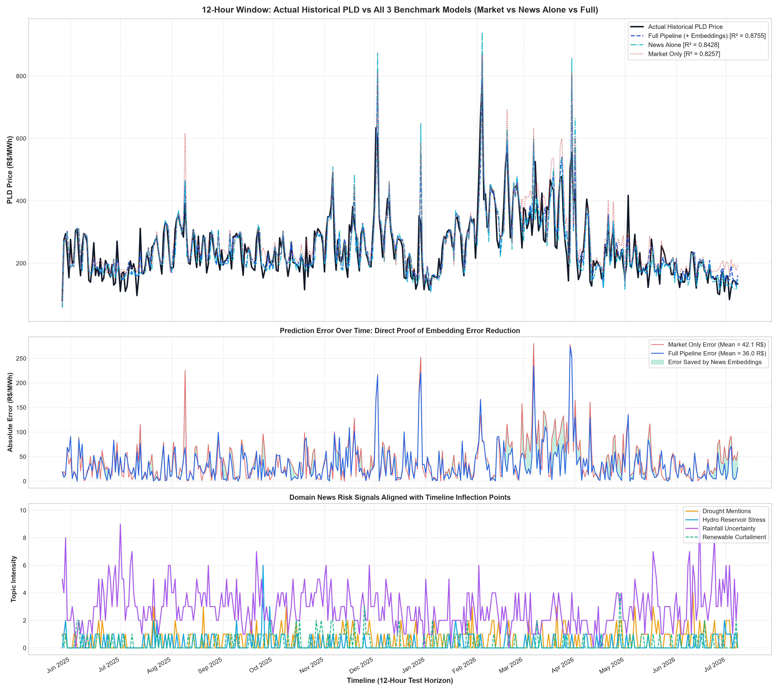
Figure 7: Out-of-sample chronological timeline tracking: Actual PLD spot price trajectory overlaid against Market Only, News Alone, and Full Pipeline predictions alongside news intensity and macro risk factors.

