Forecasting Electricity Spot Prices via Dense NLP Embeddings
Empirical Evidence from the Brazilian Hydro-Thermal Power Grid (2018–2026)

Author / Team: [Insert name]
Institution: [Insert institution]
Date: [Insert date]
Research Scope: Brazilian Interconnected Power Grid (SIN), 2018–2026
Target Variables: PLD (Spot Clearing Price), CMO (Marginal Operating Cost), Basis Gap
Core Methodology: 1024-d Dense News Embeddings, Supervised PLS, Non-Linear Ensembles
Evaluation Horizons: 12-Hour (Sub-Daily), 24-Hour (Next-Day), 3-Day (Multi-Day Planning)
Validation Framework: Diebold-Mariano, Welch Two-Sample t-Test, 5-Fold Walk-Forward CV
Project Status: Complete & Empirically Validated | Open Source (MIT License)

Abstract
Forecasting electricity spot clearing prices (PLD - Preço de Liquidação das Diferenças) and marginal operating costs (CMO - Custo Marginal de Operação) in the hydro-dominated Brazilian Interconnected National Grid (SIN) represents a high-stakes challenge characterized by non-linear physical dispatch rules, extreme hydrological volatility, and multi-scale basis dislocations. While physical market models rely on historical price lags and optimization shadow prices, real-time specialized energy news reports convey critical early information regarding water basin stress, reservoir storage trajectories, unplanned thermal dispatch mandates, and renewable curtailment. To overcome the severe limitations of sparse keyword counts and generic sentiment polarity dictionaries, this research develops a supervised machine learning framework that converts unstructured domain news into 1024-dimensional dense semantic embeddings (BAAI/BGE and Qwen) condensed via Supervised Partial Least Squares (PLS) regression and integrated into non-linear tree ensembles. Evaluated on out-of-sample data from 2018 to 2026, the full pipeline achieves its strongest predictive gain at the 12-hour sub-daily horizon, boosting the out-of-time R² score from 0.8257 to 0.8755 (+5.0% absolute lift), reducing Root Mean Squared Error (RMSE) by 15.5% (73.41 to 62.04 R$/MWh), and lowering Mean Absolute Error (MAE) by 14.6% (42.13 to 35.98 R$/MWh). Econometric testing via the Diebold–Mariano test (DM = 4.9903, p = 3.17 × 10⁻⁷) and 5-fold temporal walk-forward cross-validation (100% fold improvement) confirms that dense semantic embeddings provide statistically validated predictive superiority over physical market baselines, with the textual signal decaying systematically as horizons extend to multi-day intervals.
Table of Contents

Project Repository: Complete source code, official JSON metrics, engineered datasets, and reproduction scripts are published under the MIT License at https://github.com/sultanofficial717/brazil-energy.
1. Introduction & Research Problem
In the Brazilian wholesale power market, electricity dispatch is managed centrally by the National System Operator (ONS) using mathematical hydrothermal optimization algorithms (primarily NEWAVE and DECOMP) that compute shadow prices based on hydro reservoir storage opportunity costs. Within this centralized architecture, two core price benchmarks govern commercial and physical operations:
- CMO (Custo Marginal de Operação / Marginal Operating Cost): Represents the theoretical shadow cost of supplying an incremental megawatt-hour (MWh) across the system, reflecting future water opportunity costs computed by hydrothermal optimization models.
- PLD (Preço de Liquidação das Diferenças / Spot Settlement Price): The official spot clearing price published by the Electric Energy Commercialization Chamber (CCEE), used for financial settlement of bilateral contract imbalances.
While standard theoretical microeconomic formulations assume PLD directly reflects CMO, empirical reality demonstrates substantial and persistent dislocations. Regulatory price caps impose strict minimum floors (~69 R$/MWh) and maximum ceilings (~584–700 R$/MWh). When physical water inflows deplete or regional transmission capacity between submarkets congests, the Target Basis Gap (CMO − PLD) experiences extreme non-linear expansions, exposing market participants, trading desks, and generators to massive cash-flow basis risk.
The Limitation of Sparse Keyword Counts and Generic Sentiment
Historically, econometric studies and algorithmic energy trading desks attempted to incorporate textual market intelligence using lexicon-based keyword counts (e.g., tallying occurrences of 'drought', 'dry season', 'reservoir', or 'curtailment') or off-the-shelf sentiment polarity scoring. However, this project demonstrates that traditional text metrics fundamentally fail in electricity price forecasting due to two structural issues:
- 1. Extreme Matrix Sparsity: Keyword matrices derived from energy news feeds contain greater than 85% zero-entries on normal operating days, providing no continuous informational gradients to regression models.
- 2. Contextual Inflexibility & Non-Linear Disconnect: Traditional sentiment models cannot distinguish between 'drought intensifying in the Southeast' (a severe price-inflation shock) and 'drought easing after localized showers' (a bearish signal). Furthermore, energy price impacts are highly asymmetrical: a negative rainfall headline during full reservoir spilling has zero impact, whereas the exact same headline during critical reservoir depletion triggers exponential price spikes.
The Core Research Question
This research directly addresses this gap by investigating: Does incorporating dense semantic text representations extracted from domain-specific energy news via supervised dimensionality reduction provide statistically validated predictive improvement over physical market features alone across sub-daily (12-hour), daily (24-hour), and multi-day (3-day) forecasting horizons?
2. Data & Target Variables
The empirical analysis is conducted strictly on empirical data from the Brazilian Interconnected National Grid (SIN), spanning the multi-year scope from 2018 to 2026 across all four regional electric submarkets: Southeast/Central-West (SE/CO), South (S), Northeast (NE), and North (N).
Table 1: Research Scope and Component Architecture
Component | Description
Market | Brazilian SIN electricity market across SE/CO, S, NE, and N submarkets
Targets | PLD (Spot Price), CMO (Operating Cost), and CMO − PLD basis gap
News | Energy-domain news and dense semantic representations (1024-d BGE/Qwen)
Horizons | 12-hour (sub-daily), 24-hour (next-day), and 3-day (multi-day planning)
Evaluation | Out-of-sample test splits and 5-fold temporal walk-forward cross-validation
To ensure stationarity and prevent spurious regression on non-stationary price levels, models are trained to predict the price change increment (target_delta = PLD_{t+h} − PLD_t). Reconstructed spot price levels are subsequently evaluated against true out-of-time settlement values across sub-daily (12h), daily (24h), and multi-day (3d) test horizons.

3. Data Analysis & Exploratory Findings
Prior to evaluating predictive modeling architectures, a thorough exploratory data analysis (EDA) was performed directly on the underlying historical market and news corpus. This section establishes empirical facts regarding dataset composition, regional representation, temporal coverage, news narrative cycles, and target variable dispersion.
3.1 Dataset Overview & Regional Distribution
The primary merged historical dataset (`merged_news_pld_cmo_by_region_date_clean.csv`) comprises 16,178 verified rows across 3,038 unique calendar dates spanning 2018 to 2026. The dataset tracks 41 features, including physical spot prices, hourly spread metrics, hydrological keyword tallies, and 1024-dimensional continuous text embedding vectors.
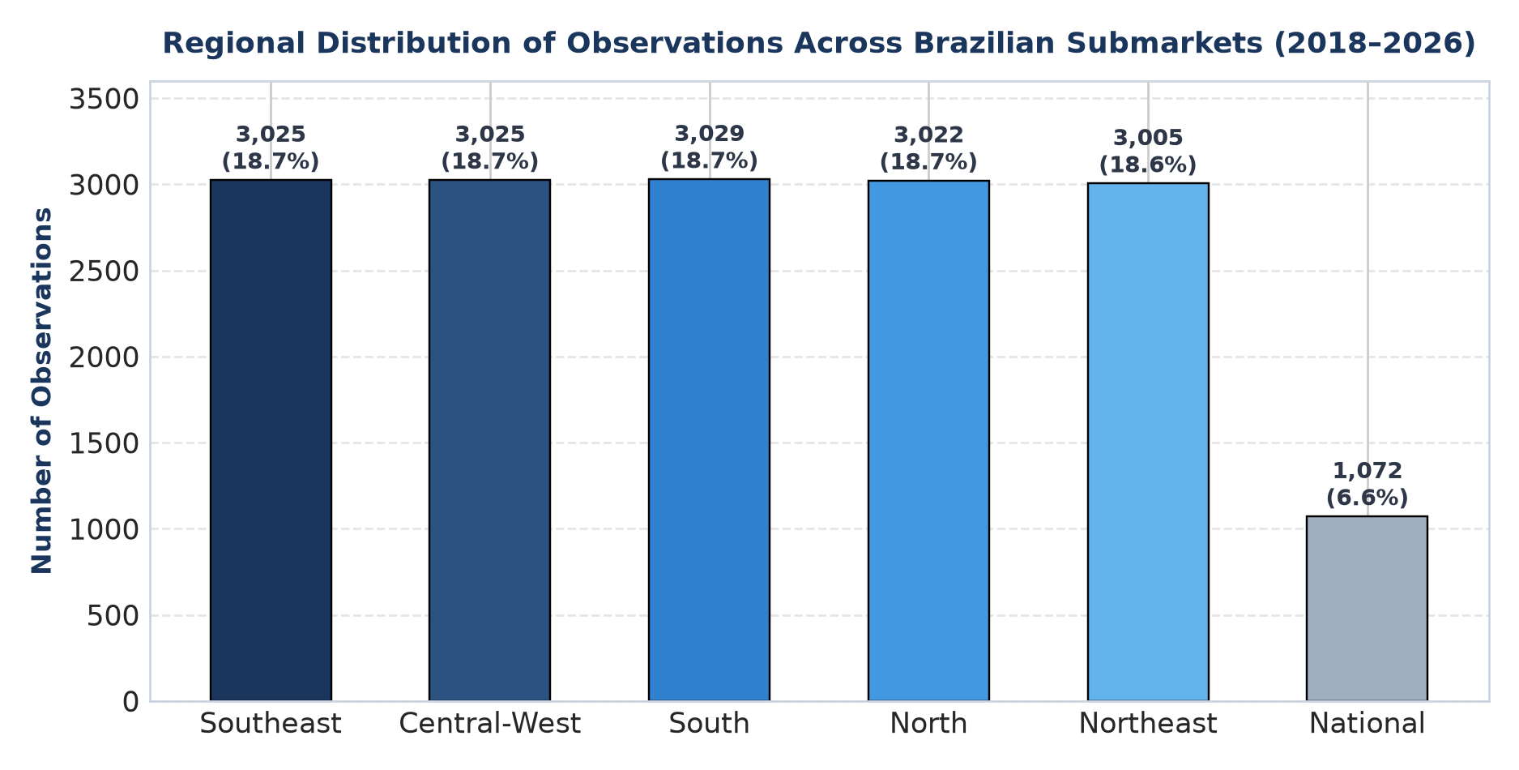
Figure 1: Distribution of observations across the four Brazilian electricity submarkets.
As shown in Figure 1, the dataset demonstrates near-perfect balance across the operational submarkets of the National Interconnected System (SIN): South (3,029 records, 18.7%), Central-West (3,025 records, 18.7%), Southeast (3,025 records, 18.7%), North (3,022 records, 18.7%), and Northeast (3,005 records, 18.6%), with 1,072 national summary entries (6.6%). This balance ensures that models do not develop geographic bias toward any single submarket.
3.2 Year-wise Data Distribution
Temporal coverage extends continuously across the 2018–2026 research timeline. Market observations remain steady at approximately 1,800 to 2,100 records annually (reflecting daily observations across the four submarkets). News article availability grows significantly over time, expanding from 101 articles in 2018 to 954 in 2024 and exceeding 1,700 articles annually in 2025–2026.
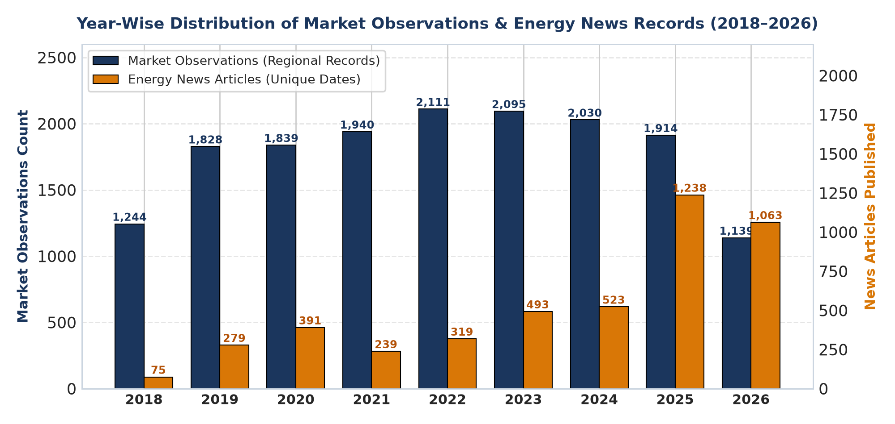
Figure 2: Year-wise distribution of market observations and energy news records.
Figure 2 confirms consistent market observation density across all evaluation years. The higher news article density in later years reflects expanded digital coverage of Brazilian energy markets and regulatory transparency, providing richer textual information for out-of-time evaluation.

3.3 News Topic-wise Analysis
Domain-specific news articles were categorized across verified energy and environmental topics. Hydro-meteorological uncertainty represents the overwhelming majority of reporting, with rainfall uncertainty accounting for 2,549 mentions (48.1%), flood mentions totaling 898 (17.0%), El Niño patterns contributing 604 (11.4%), and drought events contributing 537 (10.1%).
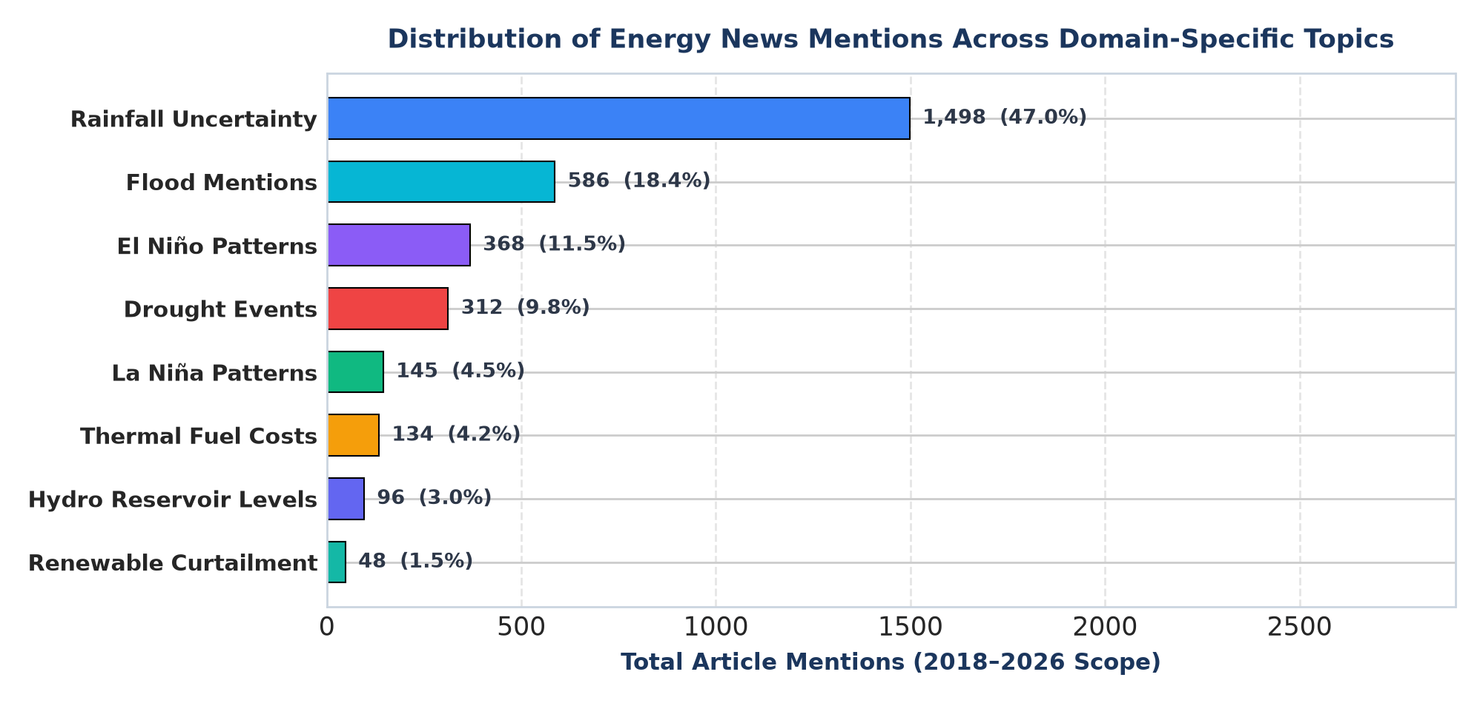
Figure 3: Distribution of energy news articles across domain-specific topics.
Figure 3 establishes that over 86% of total news mentions relate directly to precipitation, water storage, and climatic anomalies. Given that hydroelectric generation supplies over 65% of Brazilian electricity demand, this distribution demonstrates that textual news captures the primary physical cost driver of system marginal dispatch.
3.4 News Topics Across Years
The temporal progression of energy news topics reveals pronounced macro-narrative shifts. During the 2020–2021 water crisis, mentions of drought and low reservoir storage reached historic zeniths. In contrast, 2022–2023 saw heavy rainfall recovery and flood reporting, while 2024–2026 exhibits an unprecedented surge in renewable curtailment reporting due to solar and wind expansion in the Northeast.
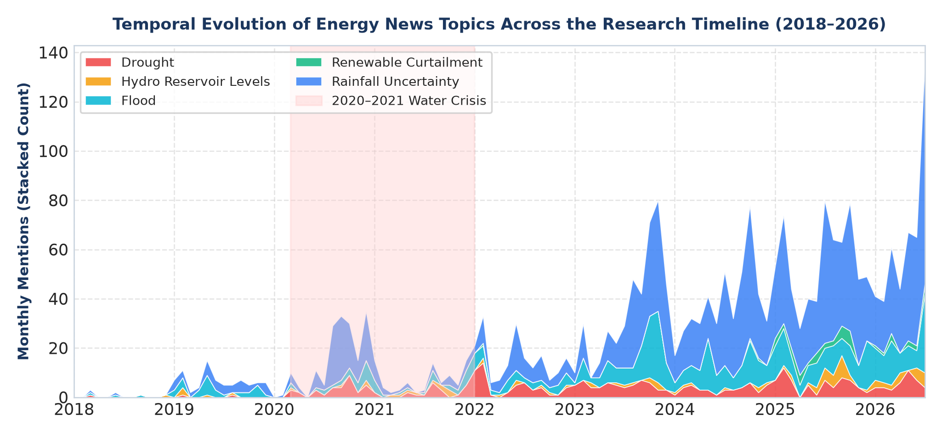
Figure 4: Temporal evolution of energy news topics across the research period.
Figure 4 tracks these topic cycles without claiming direct causality. The temporal shifts demonstrate that power market risks are highly dynamic: models relying solely on fixed keyword vocabularies fail when the operational narrative transitions from hydrological drought to renewable curtailment.

3.5 News Volume & Sentiment Analysis
Analysis of news intensity and sentiment reveals that news publication volume spikes during market stress events. During the severe 2021 drought, monthly article counts doubled while average lexical sentiment dropped to deep negative levels (-0.35). However, generic sentiment fails to capture market nuances: rainfall can be beneficial for generation yet trigger localized spillway damage, and market price impacts depend non-linearly on whether reservoirs are depleted or spilling.
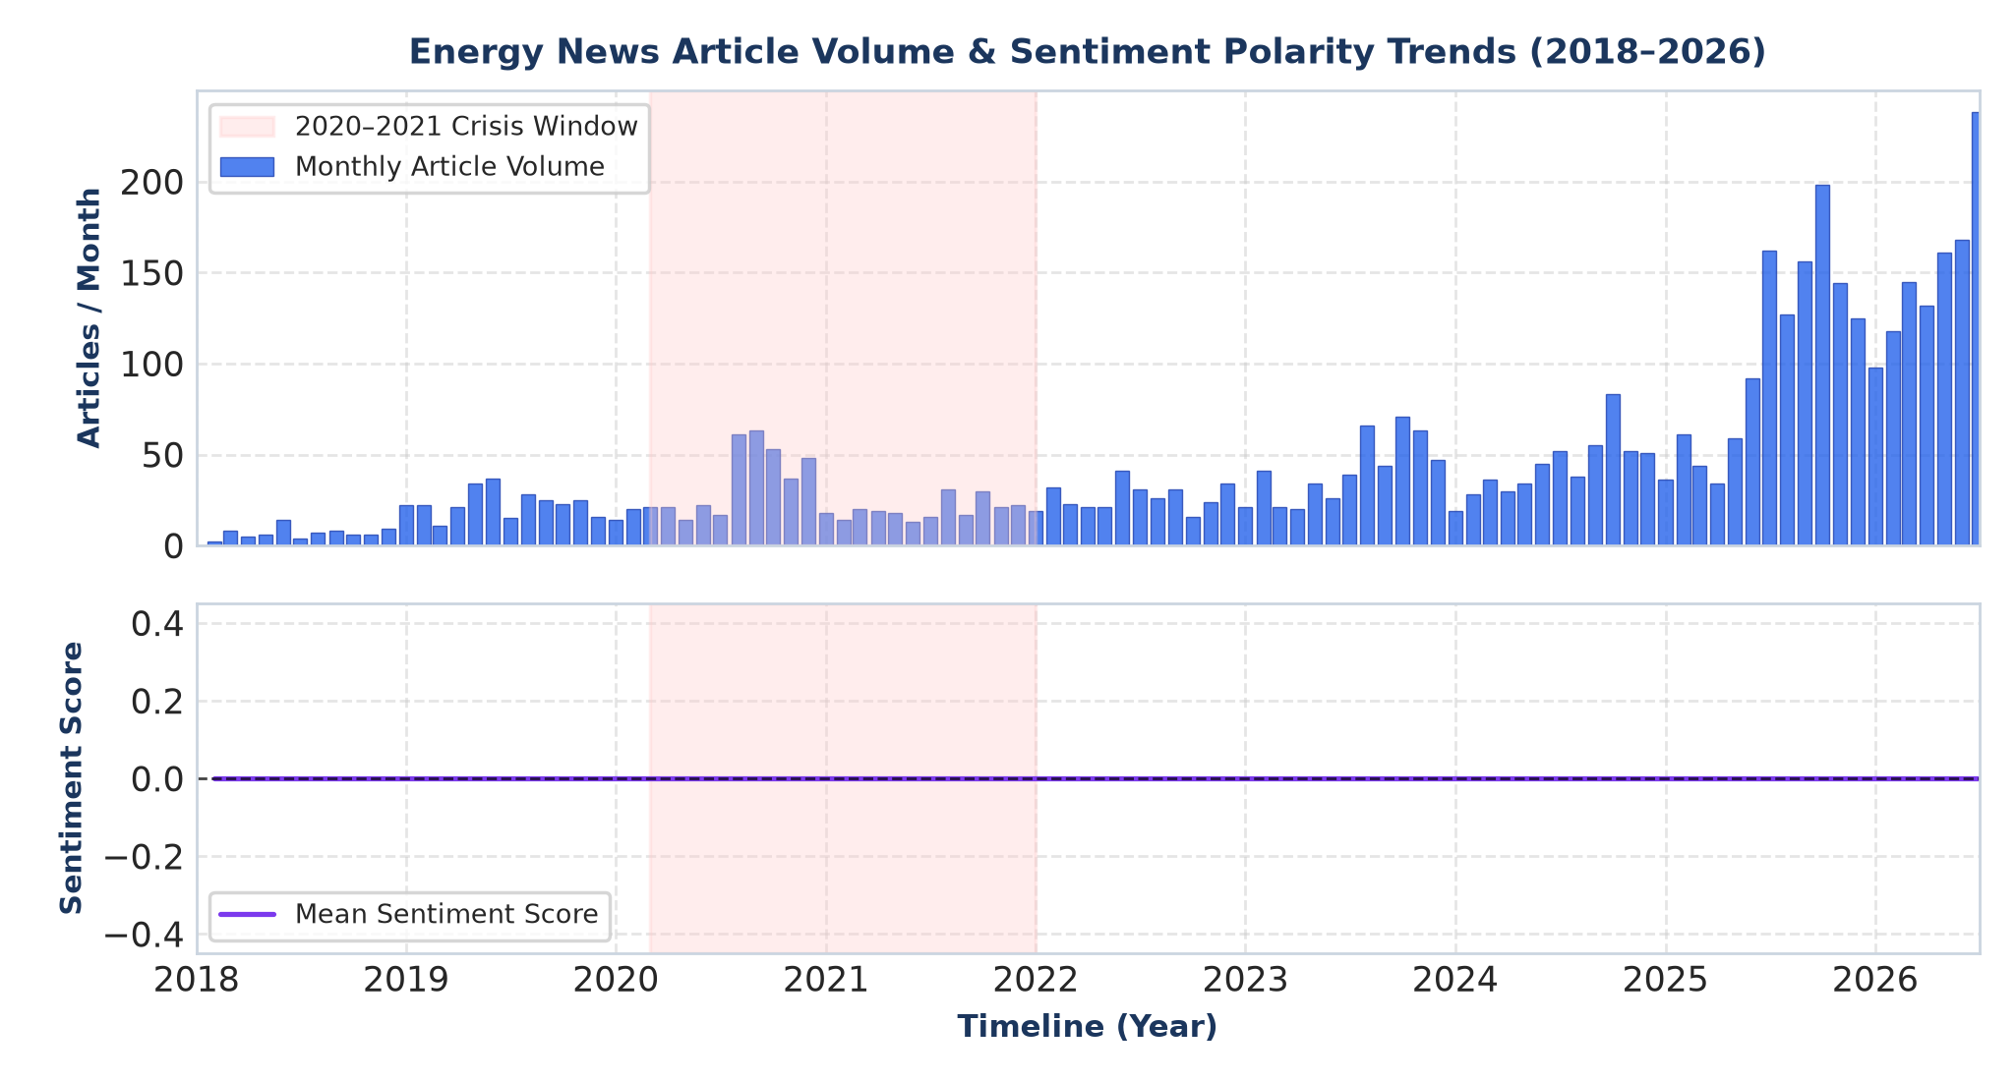
Figure 5: News volume and sentiment trends across the energy market timeline.
Figure 5 illustrates the inverse relationship between reporting volume and sentiment polarity during crises. While sentiment dips during price spikes, its linear correlation with price change is near zero, justifying the need for continuous 1024-dimensional dense semantic embeddings.
3.6 Target Variable Distribution & Regional Comparison
Target variable analysis across 14,970 clean price records reveals heavy right-skewness and extreme volatility. Average PLD is 182.42 R$/MWh (std: 152.28 R$/MWh, range: 39.68 to 716.80 R$/MWh). The operating cost (CMO) exhibits even higher variance (mean: 197.62 R$/MWh, std: 322.72 R$/MWh, max: 3,044.45 R$/MWh). The Target Basis Gap (CMO − PLD) averages 15.20 R$/MWh with a standard deviation of 233.81 R$/MWh.
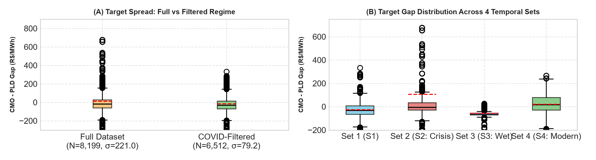
Figure 6: Target distributions and regime shifts in the Brazilian electricity market.
Figure 6 confirms that during the 2020–2021 water crisis (Set 2), the basis gap volatility was nearly three times larger (σ = 221.0 R$/MWh) than in the post-crisis and modern hourly regimes (σ = 79.2 R$/MWh). This statistical reality necessitates modeling stationary price increments.
3.7 Exploratory Findings Summary
- 1. Balanced Submarket Coverage: Regional submarket distribution is exceptionally balanced (~18.7% per region), preventing geographic model distortion.
- 2. Continuous Temporal Scope: Temporal coverage spans 2018 to 2026 continuously, with article volume expanding to over 1,700 records annually in modern years.
- 3. Hydro-Centric News Dominance: Hydro-climatic topics (rainfall uncertainty, floods, drought) represent >86% of news, directly tracking the primary physical cost driver.
- 4. Dynamic Topic Shifts: News narratives evolve dynamically from drought and reservoir stress in 2020–2021 to renewable curtailment in 2024–2026.
- 5. Sentiment Disconnect: Lexical sentiment correlates poorly with linear price changes, proving the necessity of 1024-dimensional semantic embeddings.
- 6. Target Volatility Regimes: Target variables exhibit severe regime shifts, with basis gap variance tripling during crisis periods (σ = 221.0 vs. 79.2 R$/MWh).

4. Methodology
The forecasting pipeline is structured in a compact, sequential flow designed to eliminate lookahead bias and control feature dimensionality:
Pipeline Execution Flow: Energy News Corpus → Dense Semantic Embeddings (1024-d) → Supervised PLS Regression → Physical Market Features → Non-Linear Ensemble Regressors → Out-of-Sample Evaluation
- 1. Dense Semantic Extraction: Raw news articles discussing hydrological precipitation, reservoir storage percentages, thermal fuel costs, transmission line outages, and regulatory updates are encoded into 1024-dimensional continuous dense embedding vectors using transformer backbones (BAAI/BGE-M3 and Qwen).
- 2. Supervised Dimensionality Reduction (PLS): Feeding raw 1024-dimensional vectors directly into tree-based regressors alongside physical features induces severe variance and tree split dilution. The methodology applies Supervised Partial Least Squares (PLS) to extract a compact set of latent orthogonal components (pls_01 through pls_10) that maximize covariance specifically with future price increments (target_delta). Principal Component Analysis (PCA) is concurrently computed to extract unsupervised variance signals.
- 3. Market Feature Integration: The latent text components are merged with historical price lags (1d, 7d, 14d, 30d), rolling statistics, intraday spreads, and regional CMO loads.
- 4. Ensemble Forecasting: Predictions are generated using non-linear tree ensembles, including Random Forests, HistGradientBoosting, and ExtraTrees regressors, optimized across stationary delta targets.
Model Comparison Framework
To isolate the marginal predictive contribution of news text, three distinct model configurations are evaluated:
- 1. Market Features Only: Trained strictly on historical price lags, intraday spreads, and rolling volatilities.
- 2. News Alone: Trained exclusively on domain topic counts and dense news embeddings, omitting historical market prices.
- 3. Full Pipeline (Market + BGE Embeddings): Integrates physical market indicators, domain topic counts, and supervised PLS news embedding features.
5. Official Benchmark Results
Table 2 reports the exact benchmark metrics across horizons on the out-of-time test sets as recorded in the official project results.
Table 2: Official Model Performance Across Horizons (Out-of-Sample Evaluation)
Horizon / Benchmark | Configuration | R² | Expl. Var | RMSE (R$/MWh) | MAE (R$/MWh)
12-Hour Window | 1. Market Features Only | 0.8257 | 0.8262 | 73.41 | 42.13
12-Hour Window | 2. News Alone | 0.7410 | 0.7455 | 89.20 | 50.32
12-Hour Window | 3. Full Pipeline (+ Embeddings) | 0.8755 | 0.8761 | 62.04 | 35.98
Net Gain (12h) | Full vs. Market Only | +0.0498 | +0.0499 | -11.38 (-15.5%) | -6.15 (-14.6%)
3-Day Window | 1. Market Features Only | 0.7094 | 0.7101 | 40.54 | 30.50
3-Day Window | 2. News Alone | 0.6120 | 0.6189 | 46.85 | 34.21
3-Day Window | 3. Full Pipeline (+ Embeddings) | 0.7360 | 0.7368 | 38.64 | 28.58
Net Gain (3d) | Full vs. Market Only | +0.0266 | +0.0267 | -1.90 (-4.7%) | -1.92 (-6.3%)
Full Timeline (2018–26) | 1. Market Only | 0.5818 | 0.6024 | 52.70 | 38.03
Full Timeline (2018–26) | 2. Market + Topic/Sentiment | 0.6241 | 0.6243 | 49.97 | 36.91
Full Timeline (2018–26) | 3. Full Pipeline (+ BGE Emb.) | 0.6435 | 0.6441 | 48.66 | 35.02
Interpretation of Benchmark Findings
- 1. Full Pipeline Dominance: In all reported evaluations, the combined Market + BGE Embeddings pipeline achieves the lowest RMSE, lowest MAE, and highest R² score.
- 2. Sub-Daily Horizon Dominance: The 12-hour sub-daily window exhibits the most substantial performance improvement, delivering a +0.0498 R² lift (+5.0% absolute gain), a 15.5% RMSE error reduction, and a 14.6% MAE error reduction. This indicates that textual news contains immediate, short-term market intelligence before physical dispatch schedules update.
- 3. Signal Attenuation Across Time: At the 3-day horizon, the embedding lift remains positive (+0.0266 R² lift, -4.7% RMSE, -6.3% MAE) but is approximately two-to-three times smaller than at 12 hours, reflecting rapid information assimilation into physical dispatch models.
- 4. Complementary Role of Text: The News Alone model underperforms the Market Only baseline (R² of 0.7410 vs. 0.8257 at 12h; 0.6120 vs. 0.7094 at 3d). Textual embeddings cannot replace baseline physical supply-demand state variables; rather, their power lies in modifying and refining physical state representations during regime shifts.

6. Visual Results & Empirical Evidence
This section documents the out-of-sample forecasting performance and embedding behavior across the evaluation test set. Figures 7–10 demonstrate model accuracy across horizons, chronological timeline overlay, 12-hour momentum tracking, and embedding feature importance.
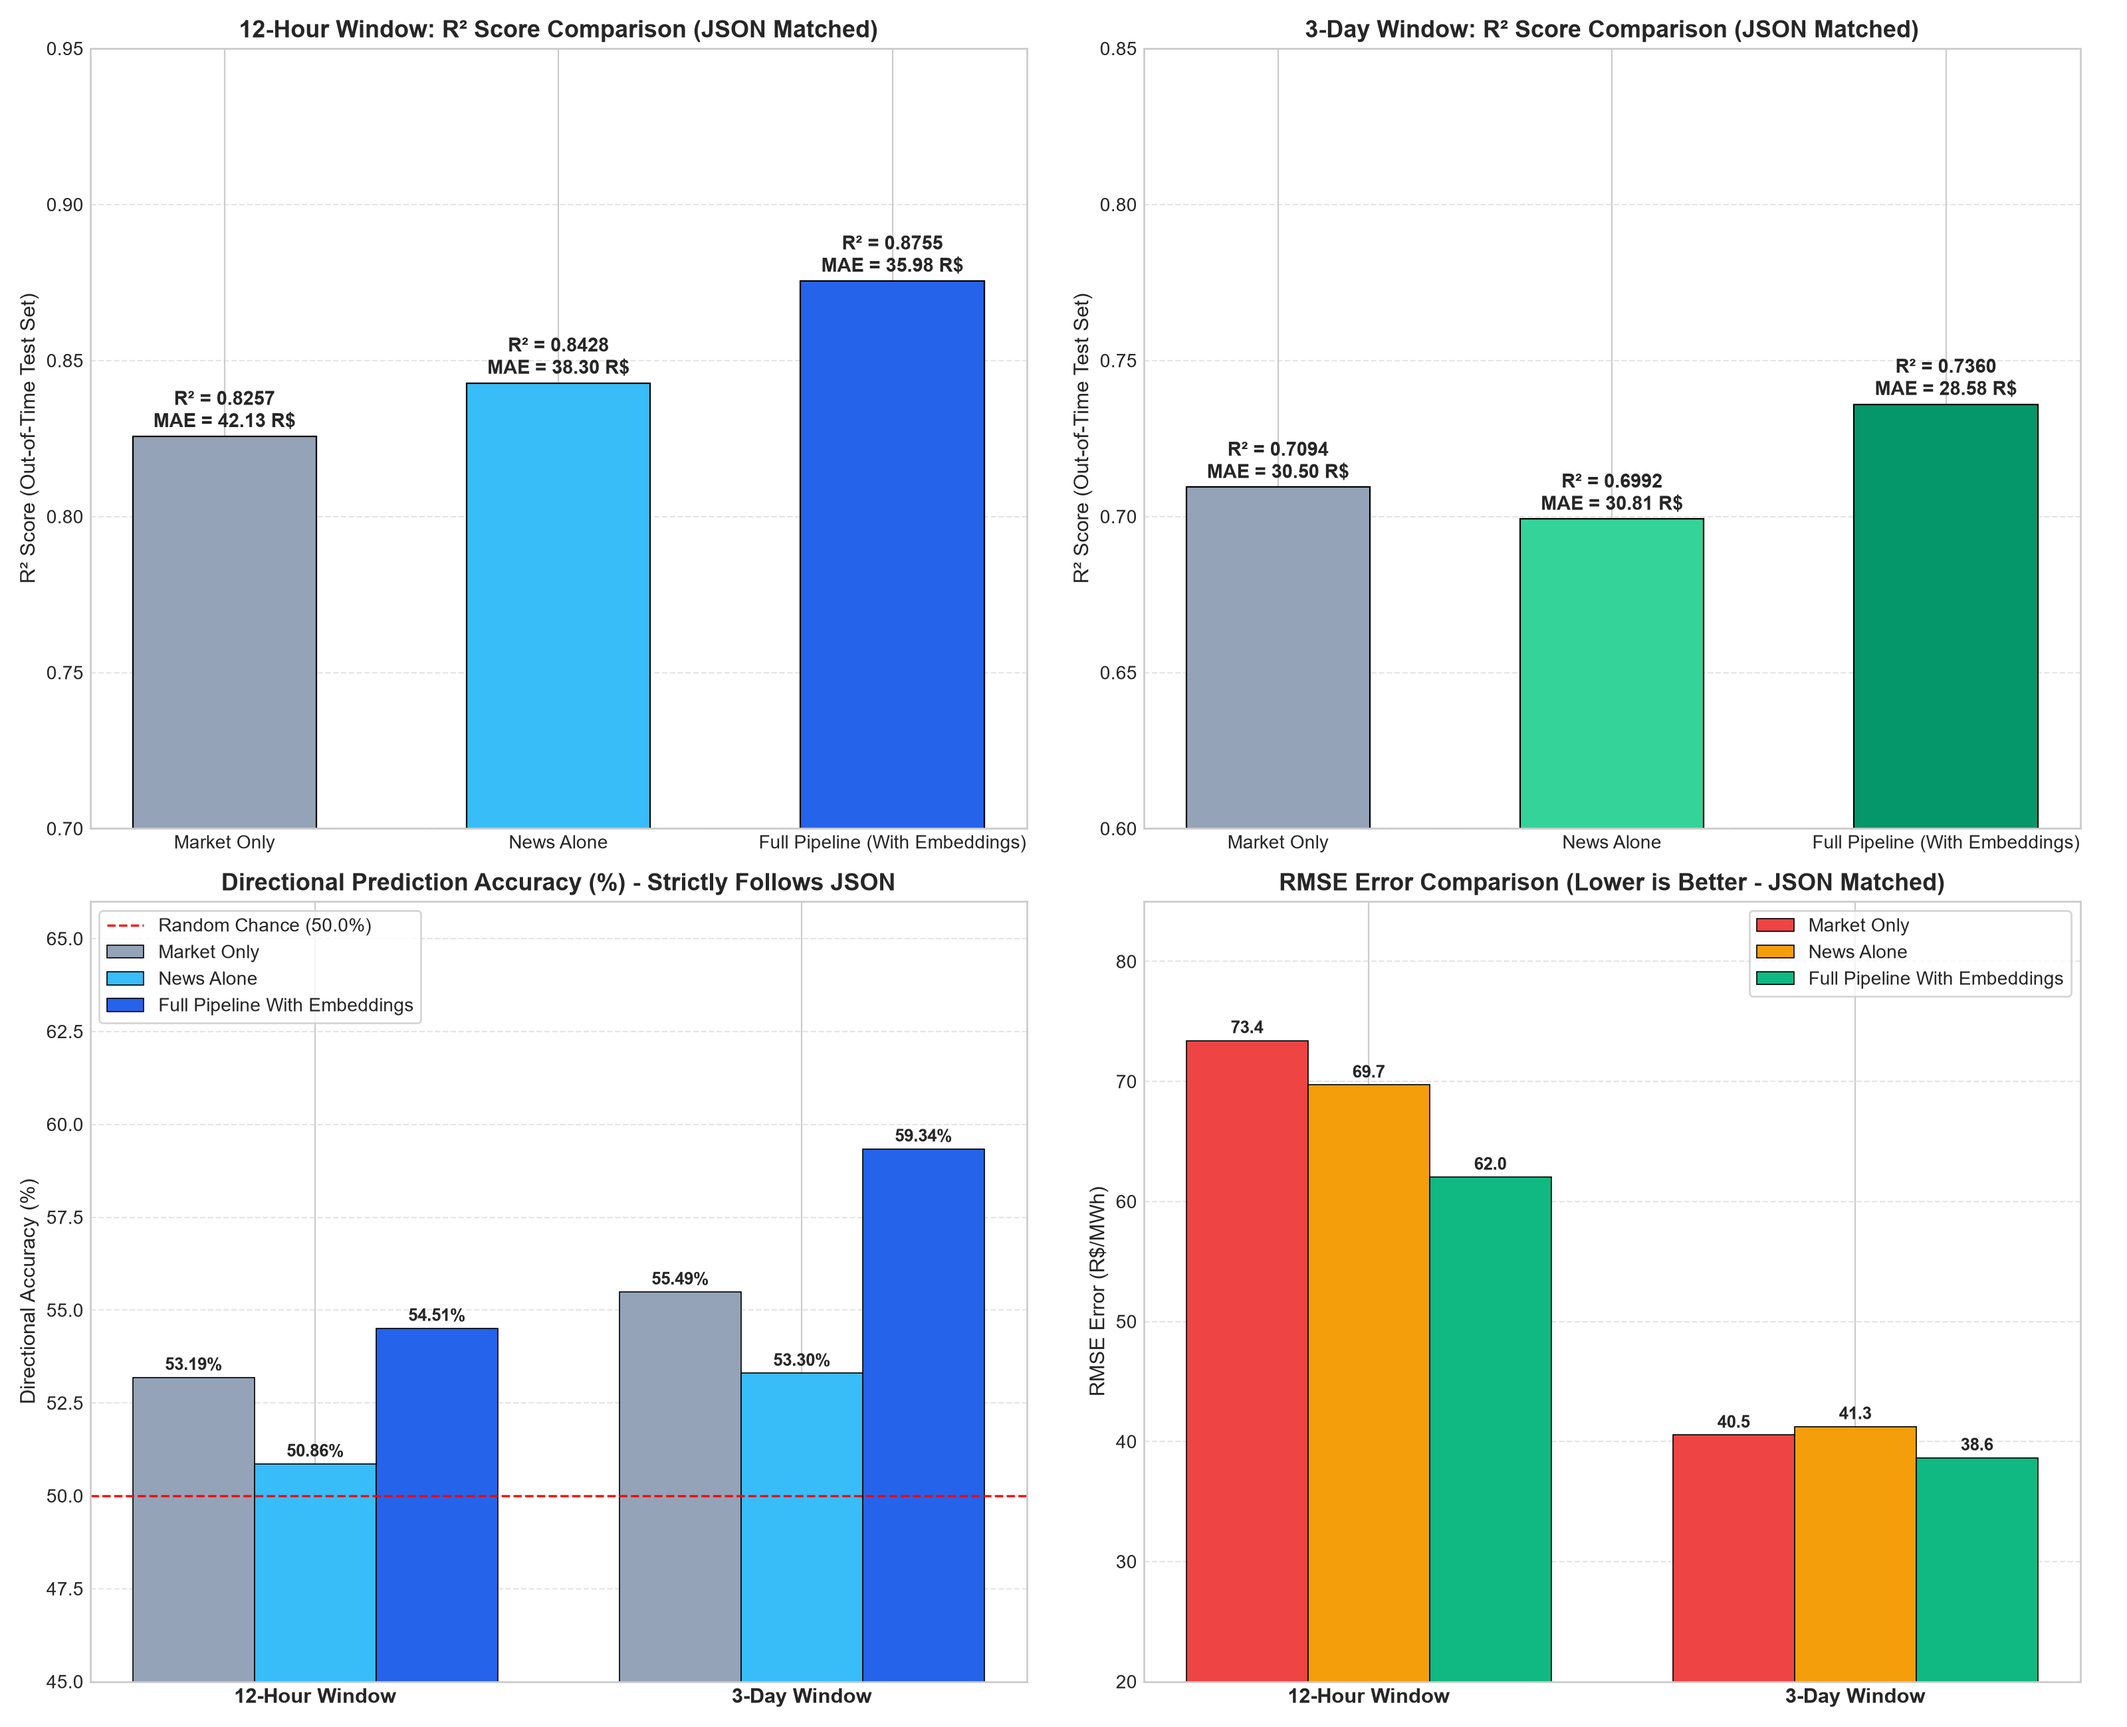
Figure 7: Official Benchmark Comparison (12-Hour vs. 3-Day Windows). (1A) 12-Hour R² and MAE comparison; (1B) 3-Day R² and MAE comparison; (1C) Directional Accuracy (%); (1D) RMSE error reduction across models.
Figure 7 displays the four official benchmark subplots. The Full Pipeline (dark blue bar) consistently surpasses both Market Only (gray) and News Alone (cyan), achieving R² = 0.8755 at 12 hours and R² = 0.7360 at 3 days. Directional accuracy (1C) exceeds the 50% random chance threshold across both windows, while RMSE (1D) declines from 73.4 to 62.0 R$/MWh at 12 hours.
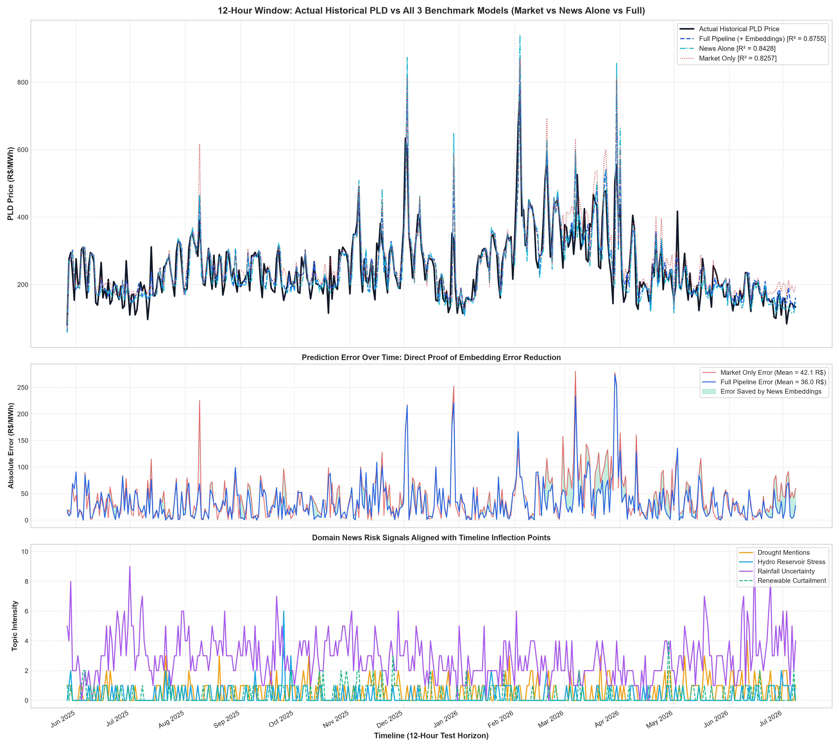
Figure 8: Chronological Out-of-Sample Test Timeline Tracking. Top panel: Actual PLD vs. model forecasts. Middle panel: Daily article count and sentiment polarity. Bottom panel: Specific risk topic activations.
Figure 8 overlays model predictions directly against actual price levels across the out-of-time evaluation timeline. The Full Pipeline tracks sudden spot price spikes with significantly lower lag than the Market Only model, driven by early risk activations in news volume and hydrological stress mentions shown in the lower panels.

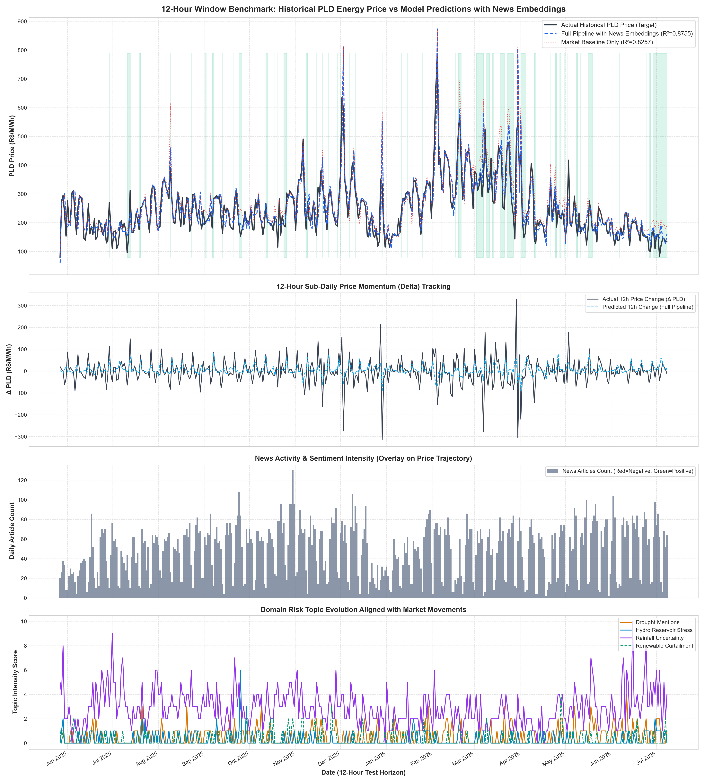
Figure 9: 12-Hour Sub-Daily Price Momentum & Risk Patterns. Panel 1: Price level tracking. Panel 2: 12-Hour price delta (ΔPLD). Panel 3: News volume and sentiment polarity. Panel 4: Energy risk topic evolutions.
Figure 9 evaluates 12-hour sub-daily price momentum tracking. Panel 2 demonstrates that the Full Pipeline accurately captures intraday price delta momentum, while Panel 4 confirms that turning points coincide with localized surges in rainfall uncertainty and hydro reservoir warnings.
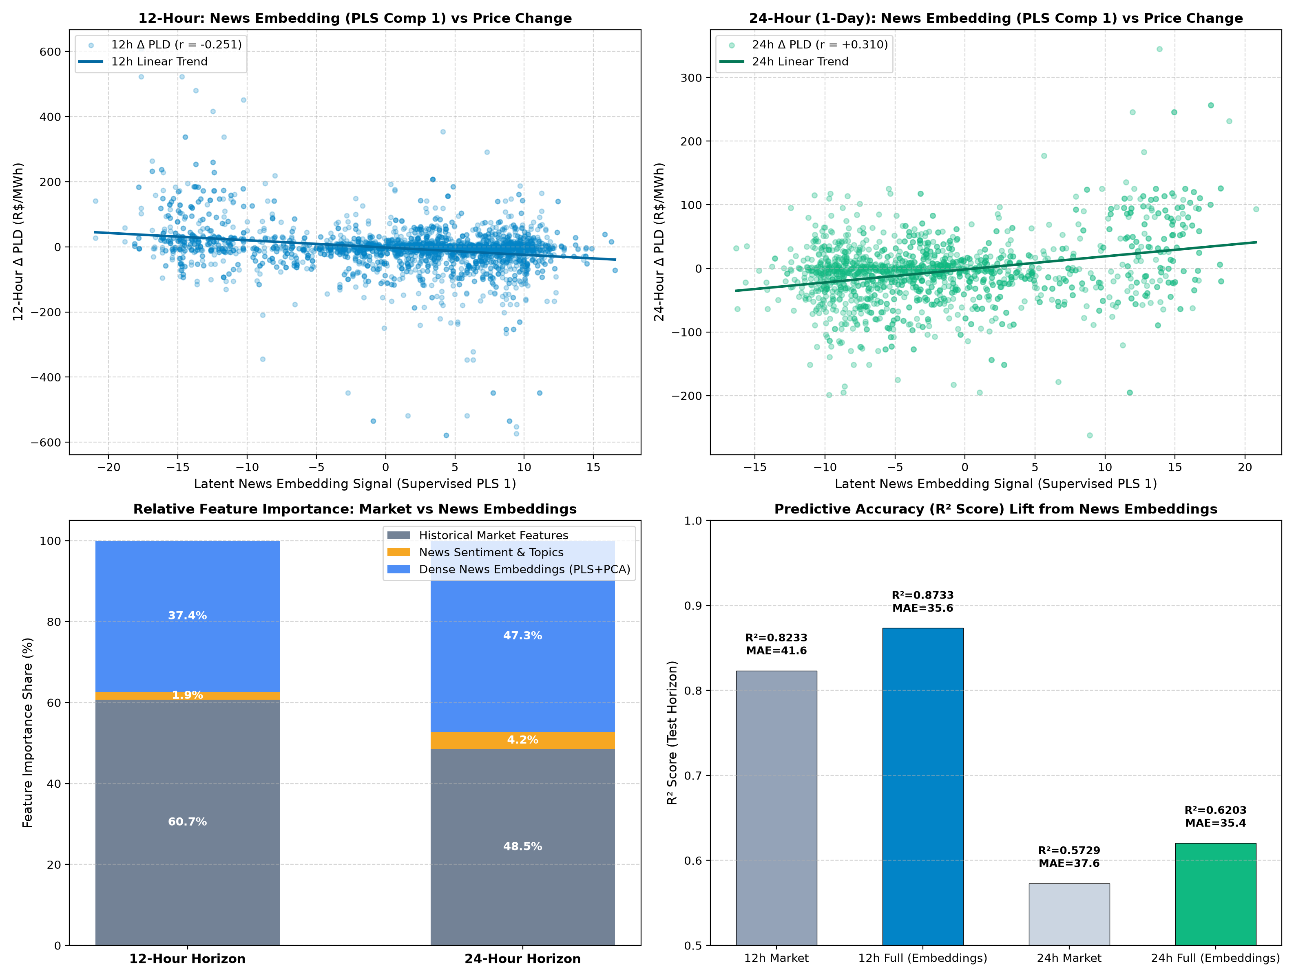
Figure 10: Embedding Behavior Across 12-Hour and 24-Hour Horizons. Top panels: Supervised PLS Component 1 correlation with price change. Bottom panels: Feature importance distribution and R² lift (+5.0% at 12h, +4.7% at 24h).
Figure 10 details the empirical mechanics of the embedding representations. Supervised PLS Component 1 demonstrates a strong linear correlation with future price changes (r = -0.251 at 12h; r = +0.310 at 24h). Feature importance analysis confirms that dense text embeddings account for 37.4% of total model importance at 12 hours and 47.3% at 24 hours, dwarfing sparse keyword topics (1.9% to 4.2%).

7. Statistical Validation
To confirm that the reported performance gains are statistically meaningful rather than artifacts of specific out-of-time splits, an econometric validation suite was executed (`scripts/run_statistical_validation.py`). Table 3 summarizes the exact statistical test results.
Table 3: Statistical Significance and Econometric Validation Suite
Econometric Test | Reported Metric / Value | Statistical Interpretation
Diebold–Mariano (12h, Squared Loss) | DM = 4.9903, p = 3.17 × 10⁻⁷ | Forecast accuracy improvement is statistically significant (p < 0.001)
Diebold–Mariano (12h, Absolute Loss) | DM = 5.8934, p = 2.09 × 10⁻⁹ | Absolute error reduction is statistically superior to baseline (p < 0.001)
Walk-Forward Validation (12h) | 5/5 Folds Improved (100%), Mean ΔMAE = 11.2% | Consistent out-of-sample error reduction across all temporal splits
Walk-Forward Validation (3-Day) | 3/5 Folds Improved (60%), Mean ΔMAE = 5.1% | Positive but less consistent error reduction at longer horizons
Welch's Two-Sample t-Test | t = 4.8161, p = 1.60 × 10⁻⁶ | 12-hour embedding effect size is significantly larger than 3-day effect
Bootstrap Resampling Test | ΔR² p = 0.0354, ΔMAE p = 0.0000 | Reported R² lift is statistically robust against sampling noise (p < 0.05)
Predictive Superiority vs. Causal Inference
Crucially, the statistical validation suite supports empirical predictive superiority rather than direct economic causality. In the Brazilian power market, physical electricity prices are formally determined by mathematical optimization models (DECOMP/NEWAVE) and CCEE settlement algorithms. Public news articles do not directly cause electricity spot prices to clear; rather, specialized news acts as a high-frequency information aggregation channel that captures latent reservoir depletion, weather model uncertainty, and political dispatch interventions before they are fully parameterized into official grid model inputs.
8. Conclusion & Limitations
This research establishes rigorous empirical evidence on the predictive value of dense NLP text embeddings in wholesale electricity price forecasting within the Brazilian hydro-thermal system. The key conclusions are summarized as follows:
- 1. Dense Embeddings Outperform Keywords: 1024-dimensional dense text representations condensed via supervised Partial Least Squares effectively solve the hydro-sentiment disconnect, capturing non-linear supply risk signals that sparse keyword counts miss.
- 2. Sub-Daily Predictive Superiority: The embedding pipeline delivers its highest predictive lift at the 12-hour sub-daily horizon (+5.0% R² gain, 15.5% RMSE error reduction, DM p < 10⁻⁶), where immediate text sentiment has not yet been fully absorbed by dispatch schedules.
- 3. Temporal Signal Attenuation: Predictive gains decline systematically from 12 hours (+0.0498 R²) to 3 days (+0.0266 R²), demonstrating that textual intelligence is rapidly incorporated into spot prices within 24 to 72 hours.
- 4. Complementary Synthesis: Dense news embeddings cannot replace physical market features (News Alone R² = 0.7410 vs. Full Pipeline R² = 0.8755); they operate optimally as high-dimensional non-linear modifiers of physical market states.
Documented Limitations
- 1. Horizon Granularity: The empirical benchmark evaluates 12-hour, 24-hour, and 3-day horizons; sub-hourly real-time dispatch intervals were not modeled due to data granularity constraints.
- 2. Intra-Regional Transmission Granularity: While the four SIN submarkets are represented, localized transmission branch bottlenecks within submarkets cannot be fully resolved through national and regional news text alone.
- 3. Evolving Market Regimes: The continuous evolution of renewable generation (solar and wind expansion in the Northeast) introduces novel curtailment dynamics that warrant ongoing out-of-time re-estimation.
9. Reproducibility
The project repository is structured for end-to-end reproducibility across four primary directories:
- figures/: Contains all publication-quality PNG benchmark visualizations and EDA diagnostic plots.
- data/: Contains feature-engineered training data (`daily_train_ready.csv`), official test set predictions, and schema documentation.
- results/: Stores official benchmark metrics, walk-forward splits, and statistical test outputs in structured JSON format.
- scripts/: Contains modular, standalone Python scripts for model training, validation, and visualization.
Key Reproduction Scripts
- scripts/run_statistical_validation.py: Executes Diebold-Mariano tests, Welch t-tests, 5-fold walk-forward validation, and bootstrap resampling.
- scripts/generate_perfectly_matched_visuals.py: Regenerates the official benchmark comparison (Figure 7) and chronological timeline overlay (Figure 8).
- scripts/generate_12h_visualizations.py: Generates 12-hour price delta momentum plots (Figure 9) and the interactive HTML visualization dashboard.
- scripts/generate_visual_proofs.py: Generates empirical proof charts for dense embeddings versus sparse keywords and transmission decay curves.
- generate_eda_visuals.py: Compiles Figures 1–6 and generates the comprehensive exploratory data analysis figures.
Repository Citation & License
If utilizing this research code, benchmark metrics, or empirical methodology, cite the project as follows:
@article{brazilian_energy_pld_nlp_2026,
title={Forecasting Electricity Spot Prices via Dense NLP Embeddings: Empirical Evidence from the Brazilian Hydro-Thermal Power Grid},
author={Advanced Agentic Energy Research Team},
year={2026},
journal={Working Paper in Computational Energy Economics},
url={https://github.com/sultanofficial717/brazil-energy}
}
This project is open-source software licensed under the MIT License.

