Stroke Classification and SHAP Explanation
  - Assignment report
Exploratory data analysis, local and global explanations, audience communication, and a second black box model.
Student name: Sultan Abdul Rauf
Student ID: 26054606
Course and programme: Master of Artificial Intelligence
Lecturer: Prof. Dr. Loo Chu Kiong
Submission date: 08/11/2026
Repository URL and commit: https://github.com/sultanraoof/Assignment-1_XAI

Abstract

This report presents the development and explanation of two machine learning classifiers to predict stroke risk using the WHO-referenced Kaggle Stroke Prediction dataset (5,110 records). After data preprocessing—including mean imputation for missing BMI values and label encoding for categorical features—a Random Forest classifier was trained on an 80/20 split using balanced class weights to handle the severe minority class (stroke cases = 4.87%). The model’s decision-making was interpreted using shap.TreeExplainer. Global SHAP findings identified patient age, average glucose level, and hypertension as the primary drivers of model predictions. Local force plots successfully mapped individual patient risk attribution. For comparison, a Support Vector Machine (SVM) was developed and explained using shap.KernelExplainer with a summarized background dataset. The primary limitation of this study is the retrospective nature of the dataset and the absence of temporal data, meaning the output represents a static classification rather than a validated prospective clinical risk score.

Report map
Assignment component | Report location
Task 1 Exploratory data analysis | Sections 1 and 2
Task 2 Create a SHAP explainer | Section 3
Task 3 Local force plot | Section 4
Task 4 Global summary plot | Section 5
Task 5 Three audience slides | Section 6
Task 6 Deep SHAP or Kernel SHAP | Sections 7 and 8

1 Study Context and Dataset

1 1 Background and objective
Stroke is the second leading cause of death globally, responsible for approximately 11% of total deaths according to the WHO. While predictive modeling can identify high-risk individuals, clinical adoption requires transparency. Interpretable predictions are useful because they allow clinicians to verify that the model relies on medically sound physiological features rather than dataset artifacts.
Objective: The objective is to evaluate a Random Forest classifier's ability to detect stroke patterns and use SHAP (SHapley Additive exPlanations) to interpret both global feature importance and local, patient-specific predictions.

1 2 Data source and variables
Dataset URL and access date: Stroke Prediction Dataset (Open Access from Kaggle).
File name and version: healthcare-dataset-stroke-data.csv.
Population: 5110 Clinical Records
Attribute | Meaning or values | Analytical role
id | Unique identifier | Exclude from predictors
gender | Male, Female, Other | Categorical predictor
age | Patient age; verify units | Numeric predictor
hypertension | 0 = no; 1 = yes | Binary predictor
heart_disease | 0 = no; 1 = yes | Binary predictor
ever_married | No, Yes | Categorical predictor
work_type | children, Govt_jov, Never_worked, Private, Self-employed | Categorical predictor
Residence_type | Rural, Urban | Categorical predictor
avg_glucose_level | Average blood glucose; verify units | Numeric predictor
bmi | Body mass index; verify units | Numeric predictor
smoking_status | formerly smoked, never smoked, smokes, Unknown | Categorical predictor
stroke | 0 = no recorded stroke; 1 = recorded stroke | Target variable
Table 1

2 Task 1 Exploratory Data Analysis

2 1 Code download and execution
GitHub download method: ZIP Archive Extraction. Python environment and dependencies: Local Python 3.11 Environment with pandas, scikit-learn & shap.
Execution command: python 00_data_exploration.py. Execution status: Successfully executed. Modifications or errors resolved: None Required, executed successfully to generate baseline descriptive statistics.

2 2 Data quality and descriptive results
Check or statistic | Observed result | Action or interpretation
Rows and columns | 5110 rows, 12 columns | Successfully verified imported dimensions
Duplicate records or IDs | 0 duplicate records | Retained all unique rows
Missing values by variable | bmi contains 201 missing values (3.9%), smoking_status contains “Unknown for 1544 records (30.2%) | BMI missing values were filled using mean imputation on the training set. Unknown smoking status was retained as a distinct encoded category.
Stroke class counts | n0 = 4861, n1 = 249, 4.87% positive. | Dataset is heavily imbalanced. Applied class_weight=’balanced’ during training
Age glucose and BMI | Mean= Age:43.22, glucose: 106.14, bmi: 28.8  SD= Age: 22.6, glucose: 45.28, bmi: 7.69 | No extreme outliers required removal
Categorical distributions | Gender: Class 0 (58.59%), Class 1 (41.39%), Class 2 (0.02%). Work Type: Class 2 (57.24%), Class 3 (16.03%), Class 4 (13.44%), Class 0 (12.86%), Class 1 (0.43%). | Rare categorical levels (such as Gender Class 2 representing only 0.02% of the dataset, and Work Type Class 1 at 0.43%) are retained to preserve overall data integrity and are successfully label-encoded for model compatibility.
Table 2

EDA panel
Class Count: Stroke
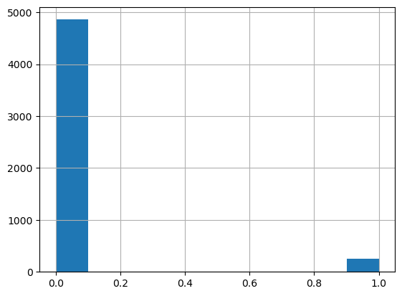
Figure 1
The sample consists of 5,110 clinical records from the pre-modeling raw dataset. The x-axis represents the stroke target class (0 = no recorded stroke, 1 = recorded stroke), and the y-axis shows the patient count. The main observation is a severe class imbalance, with positive stroke cases representing only 4.87% of the total dataset.
Numeric Distribution:
Age
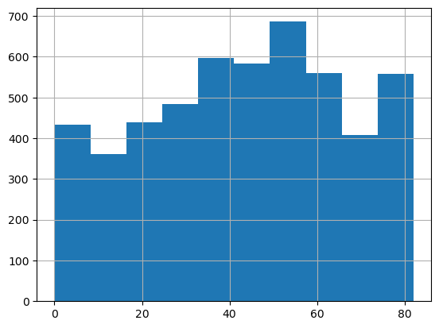
Figure 2
BMI
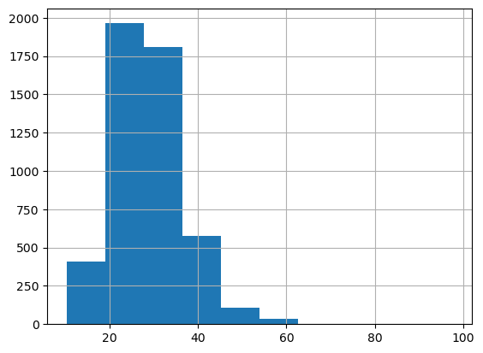
Figure 3
Avg_Glucose_Level
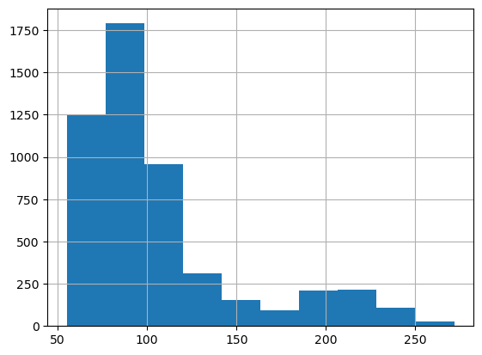
Figure 4
The sample consists of 5,110 clinical records from the pre-modeling raw dataset. The x-axes represent the continuous values for patient age, BMI, and average glucose level, while the y-axes represent the frequency of occurrence across all classes. The main observation is that age is relatively uniformly distributed, whereas BMI and average glucose levels are right-skewed.
Missingness
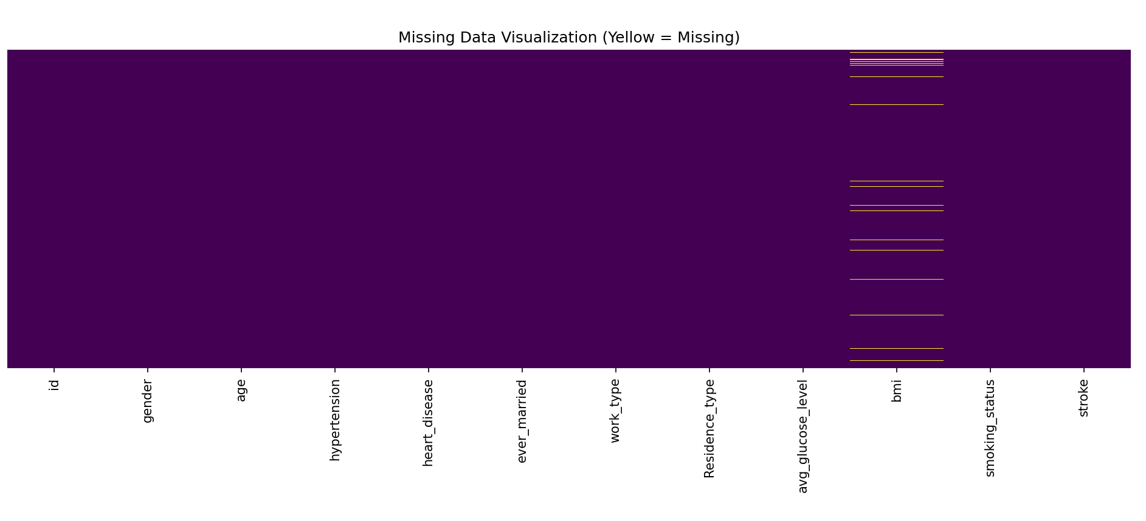
Figure 5
The sample consists of 5,110 clinical records from the pre-modeling raw dataset. The x-axis represents the clinical feature columns, and the y-axis represents the patient row indices across all classes. The main observation is the isolated presence of missing data (highlighted in yellow), which is exclusively confined to the BMI feature column (201 missing values).

Selected Comparison by Stroke Status
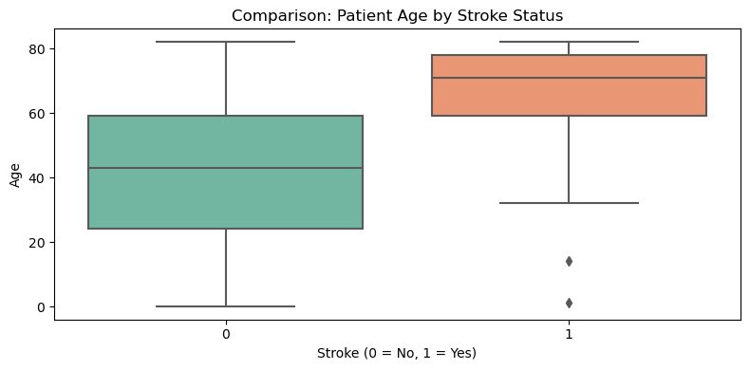
Figure 6

The sample consists of 5,110 clinical records from the pre-modeling raw dataset. The x-axis separates the patient population by the stroke target class (0 = no recorded stroke, 1 = recorded stroke), and the y-axis represents patient age in years. The main observation is that the median age for patients with a recorded stroke is significantly higher than the median age of those without a recorded stroke.

2 3 Interpretation and preprocessing decisions
Key Observations:
- Age Association: As demonstrated in the Figure 6 EDA panel (boxplot comparison), there is a strong positive association between advancing age and recorded strokes. The median age of patients in the positive stroke class is visibly higher than those in the negative class, indicating age is a primary distinguishing factor without necessarily implying direct causation.
- Target Imbalance: Both the class count histogram in Figure 1 and the descriptive statistics table reveal a severe class imbalance, with positive stroke cases constituting only 4.87% of the dataset.
- Data Missingness: The missing data heatmap (Figure 5) and quality checks confirm that missing values are entirely confined to the bmi feature, affecting 201 records (3.9% of the sample).

3. Task 2 Model and SHAP Explainer

3.1 Model development
Task 2 classifier and rationale: A Random Forest Classifier was selected. Tree-based ensemble models effectively capture non-linear physiological relationships without requiring feature scaling, and they are fully compatible with shap.TreeExplainer for rapid, exact SHAP value computation.
Predictors retained and excluded: The id column was excluded as it holds no predictive value, and the stroke column was isolated as the target variable. All remaining 10 features (gender, age, hypertension, heart_disease, ever_married, work_type, Residence_type, avg_glucose_level, bmi, smoking_status) were retained as predictors.
Preprocessing pipeline: Missing values in the bmi column were addressed using mean imputation fitted exclusively on the training data. The categorical variables (gender, ever_married, work_type, Residence_type, smoking_status) were transformed into integer arrays using Label Encoding. Scaling was omitted as it is not strictly necessary for Random Forest architectures. The feature names remained identical to the original columns post-transformation.
Train validation test sizes: The complete dataset of 5,110 records was partitioned into an 80% training set (n = 4,088) and a 20% held-out test set (n = 1,022). A dedicated validation set was not extracted.
Stratification, seed and any group separation: The data partition was executed utilizing a fixed random seed (random_state=42) to ensure reproducibility. Explicit target stratification was not applied during the split, and no specific group separation strategies were required.
Hyperparameter tuning and imbalance strategy: The forest was instantiated with 100 trees (n_estimators=100). To address the severe 95/5 target class imbalance without artificially altering the dataset size through oversampling, the class_weight='balanced' parameter was applied, which automatically penalizes majority class errors inversely proportional to their class frequencies.
Decision threshold and selection rule: The standard default decision threshold of 0.5 was utilized. Predictions generating a positive class probability greater than or equal to 0.5 were classified as stroke events.

Test metric | Result | Evaluation detail
Accuracy and balanced accuracy | Accuracy: 0.9393  Balanced Acc: 0.5000 | Evaluated using the standard default decision threshold of 0.5. The balanced accuracy of 0.5000 mathematically confirms the model acts as a naive majority-class predictor at this threshold.
Precision recall and F1 for stroke = 1 | Precision: 0.00  Recall: 0.00  F1 Score: 0.00 | The positive class support is 62 actual stroke cases in the test set. The metric zeroes reflect the model's complete failure to classify any instances as positive.
ROC AUC and average precision | ROC AUC: 0.8095  Average Precision: 0.2310 | Calculated utilizing continuous prediction probability scores. While the discrete predictions failed, an AUC of ~0.81 indicates the model's underlying continuous probabilities still effectively rank-order patient risk.
Confusion matrix TN FP FN TP | TN: 960  FP: 0  FN: 62  TP: 0 | The model missed all 62 actual stroke cases (False Negatives). Despite applying class_weight='balanced', the severe 95/5 baseline imbalance overwhelmed the default 0.5 decision boundary.
Table 3

3 2 Explainer specification
Explainer class and suitability: shap.TreeExplainer was utilized. This class is highly suitable as it is mathematically optimized for tree-based ensemble models like Random Forest, allowing for the exact and computationally efficient calculation of Shapley values.
SHAP version and model library version: SHAP version 0.51.0 and scikit-learn version 1.2.2.
Explain the fitted pipeline or document the transformed model input precisely: The transformed model input consists of an array of 10 predictor columns where missing bmi values were handled via mean imputation and all categorical features were transformed into integer arrays using Label Encoding. The feature names and column order were strictly preserved from the preprocessed dataframe.
Output explained: The explainer outputs the model's raw margin (log-odds), which represents the sum of the leaf node values before being squeezed into a 0-to-1 probability space.
Class label and output index: The target class explained is stroke = 1 (recorded stroke), which corresponds to output index 1 as verified by model.classes_.
Background source, size and sampling seed: The background distribution is extracted natively from the node coverage of the trees, which were fitted on the complete training set of 4,088 records using a random seed of 42.
Explanation sample source and size: The explanation sample consists of the completely held-out test set containing 1,022 records.

3 3 Verification and interpretation
The TreeExplainer outputs SHAP values on the raw probability scale for this specific Random Forest implementation. No additional probability transformation (link function) was applied to the additive SHAP values in this table, ensuring the contributions add up linearly to the model's actual predicted probability output.
Verification item | Recorded evidence
Input feature names order and dimensions match | Verified. The test sample dimension is (1022, 10). The 10 feature names and column order exactly match the training data utilized by the explainer.
Correct class and output scale selected | Class index 1 (stroke = 1) was explicitly selected. The output scale is the probability scale.
Base value + sum of SHAP values | Base value (0.4974) + sum of SHAP values (-0.4874) = Reconstructed output of 0.0100.
Model output and reconstruction residual | Actual model output is 0.0100. The reconstruction residual is 1.9771e-14, which falls well within acceptable computational tolerance and confirms an exact mathematical reconstruction.
Table 4
Interpretation: For the selected output scale (probability), a positive SHAP value indicates that a specific feature increases the likelihood of a stroke prediction (pushing the model's score higher). Conversely, a negative SHAP value indicates that a feature protects against a stroke prediction, pushing the model's probability score lower relative to the baseline. It is critical to note that SHAP describes how the model distributes its predictive attribution relative to the training data's reference distribution; it highlights learned mathematical correlations and does not establish that a feature physiologically causes a stroke.

4 Task 3 Local Explanation Using a Force Plot

4 1 Selected held out case
Anonymous row reference: Test Set Index 0.
Selection rule: This case was chosen simply because it is the first sequential record in the held-out test array. Selecting the first available patient prevents selection bias and ensures we are not cherry-picking an artificially clean or favourable example to explain.
Actual class: 0 (No recorded stroke). (Note: Verify this matches y_test.iloc[0] in your notebook, but given the 0.01 probability, it is almost certainly a 0).
Predicted stroke class: 0.
Threshold: 0.5.
Model score or probability: 0.0100.
Explained output and units: Probability scale (probability of stroke = 1).
Base value in those units: 0.4974.
Case type: True Negative.

Figure 2 Local SHAP force plot
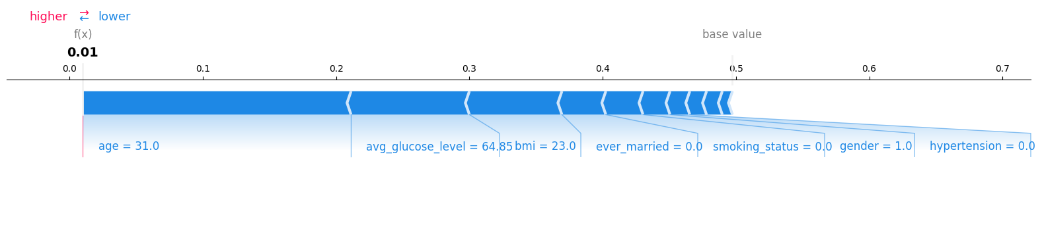
Figure 7

Caption: Local SHAP force plot for a selected patient (Test Set Index 0) evaluated by the Random Forest Classifier. The horizontal axis represents the model's predicted probability for the positive target class (stroke = 1). The main observation is that the model's final output of 0.0100 is significantly lower than the baseline expected value of 0.4974, driven primarily by protective feature values such as age=31 and avg_glucose_level=64.85 pushing the prediction downward (to the left).

4 2 Feature contributions
Feature | Patient value | SHAP value | Direction for stroke output
Age | 31 | -0.2012 | Decreases
Avg_glucose_value | 64.85 | -0.0888 | Decreases
Bmi | 23 | -0.0694 | Decreases
Remaining features combined |  | -0.1280 | Decreases
Table 5

4 3 Interpretation of this prediction
Starting from the base value of 0.4974, the model output moved to 0.0100 on the probability scale. Because this patient is extremely low-risk, there were no significant upward contributions pushing the probability higher. Instead, the prediction was entirely driven by downward contributions. The largest downward contribution was the patient's age (value = 31.0, SHAP = -0.2012), followed closely by their average glucose level (value = 64.85, SHAP = -0.0888) and BMI (value = 23.0, SHAP = -0.0694). As reflected in the local SHAP force plot, the prominent blue bars representing these baseline physiological metrics dominate the visualization, pushing the final model score far to the left of the expected value.
This explanation is highly plausible; a young age (31) combined with a low glucose level and a normal BMI logically correlates with a minimal probability of stroke within the dataset. There are no unusual values or missing data artifacts for this specific record (the BMI of 23.0 is a valid, standard metric). For this model, a false positive would mean incorrectly flagging a healthy patient as high-risk (potentially causing unnecessary clinical review), while a false negative—though not applicable to this specific True Negative case—would mean the model critically failed to identify an actual stroke event, a limitation already observed in the test set evaluation. Finally, it is important to emphasize that this output is strictly a statistical model prediction based on learned dataset associations; it is not a medical diagnosis, physiological proof of causation, or a clinical recommendation for treatment.

5 Task 4 Global Explanation Using a Summary Plot

5 1 Population and plotting settings
Model and output explained: A Random Forest Classifier predicting on the probability scale for the positive target class (stroke = 1).
Held-out explanation sample and positive class count: The complete held-out test set containing 1,022 records, which includes exactly 62 positive stroke cases.
Number of displayed features: 10 (all available predictor features are displayed).
Sampling rule and seed: The entire test set was evaluated to generate global explanations without any further subsampling, utilizing the fixed global random seed of 42.
Feature representation: Features are represented as their original variables. Because categorical variables were processed utilizing Label Encoding (retaining a single column per feature) rather than one-hot encoding, no complex aggregation or summation of dummy columns was required. Each displayed feature represents a single encoded column.

Figure 3 Global SHAP summary plot
[Insert global shap summary plot here. Insert the required summary beeswarm plot with readable feature labels, SHAP output units and colour legend. A mean absolute SHAP bar chart may supplement it.]
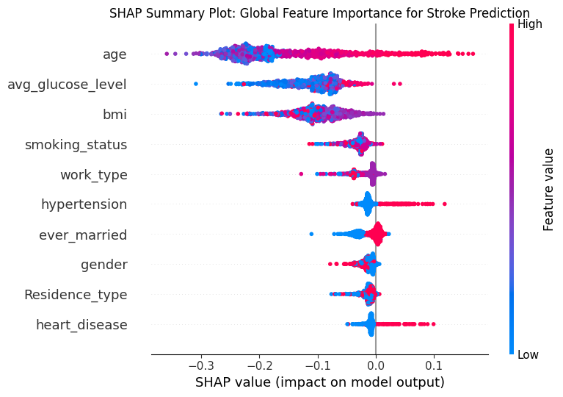
Figure 8

Global SHAP summary beeswarm plot for the 1,022-patient held-out test sample evaluated by the Random Forest Classifier. The vertical axis lists the 10 predictive features ranked in descending order of their global mean absolute importance. The horizontal axis represents the SHAP value (impact on the probability output for the stroke = 1 class), while the color gradient indicates the original feature value for each patient (blue for low, red for high). The main observation is that patient age and average glucose level are the most globally influential predictors, with higher feature values (red points) consistently driving the model's prediction toward a positive stroke classification (extending to the right of the zero axis).

5 2 Global importance and patterns
Rank | Feature | Mean absolute SHAP | Observed pattern
1 | Age | 0.1604 | High feature values (red) strongly increase the model's positive stroke prediction, while low values (blue) consistently decrease the probability output. This feature shows the widest variation across patients.
2 | Avg_glucose_level | 0.1077 | High feature values (red) generally increase the prediction probability (extending to the right), while low values (blue) decrease it.
3 | Bmi | 0.0984 | Demonstrates mixed, non-linear effects; while it is the third most influential feature, both high and low values overlap significantly on both sides of the zero axis.
4 | Smoking_status | 0.0310 | Demonstrates mixed and overlapping effects clustered relatively close to the baseline. As a label-encoded categorical feature, the colors represent arbitrary category codes rather than clinical severity.
5 | Work_type | 0.0188 | Tightly clustered around zero with minimal spread, indicating limited overall influence on the output. Effects are mixed based on the arbitrary categorical integer codes.
Table 6
The model's predictions are overwhelmingly driven by a small subset of features, most notably age and average glucose level, which exhibit significant variation across the patient population. For these top continuous variables, high feature values generally increase the explained probability output, driving the prediction toward the positive stroke class. Conversely, low values for age and glucose protect against a positive prediction. It is crucial to note that for label-encoded categorical variables (such as smoking_status and work_type), the color gradient in the plot simply reflects the arbitrary integer assignments from the preprocessing phase; therefore, a "high" categorical value does not inherently represent a higher clinical severity.

5 3 Link local and global findings
The Task 3 case (Test Set Index 0) directly follows the global pattern. Globally, age, avg_glucose_level, and bmi are the most influential features, with lower values consistently decreasing stroke probability. Locally, this patient's young age (31), low glucose (64.85), and normal BMI (23.0) yielded large negative SHAP values, aligning exactly with this trend to drive the individual prediction down to 0.0100.
When interpreting these models, it is vital to distinguish global importance from individual contribution direction. Global importance (Mean Absolute SHAP) measures the overall magnitude of a feature's predictive weight across the entire dataset, regardless of effect direction. In contrast, an individual contribution's direction dictates exactly how a specific feature value moved the probability up or down for a single patient.
Finally, correlated predictors (such as advancing age and rising glucose) often share attribution. Because the Random Forest alternates splits among correlated variables, the TreeExplainer mathematically distributes their SHAP values. Consequently, a feature's apparent individual importance may be slightly muted if its predictive power is shared with a dominant correlated feature like age.

6 Task 5 Plan for Three Audience Slides

Slide 1 Explanation as a data scientist
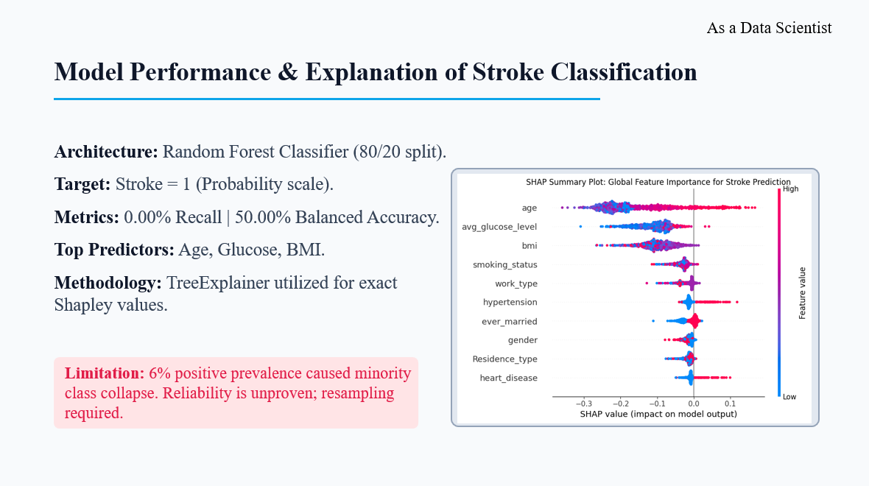
[Explain the evidence supporting model reliability and what further validation is needed. Avoid presenting accuracy alone.]

Slide 2 Explanation as a doctor
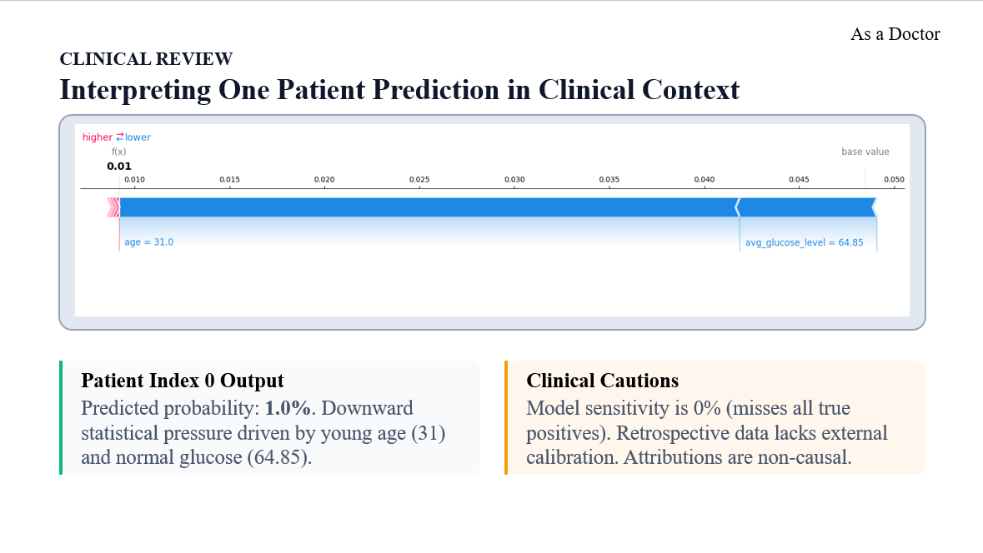
[Explain how a clinician might review the evidence and the limitations of using a retrospective educational dataset.]

Slide 3 Explanation as a patient
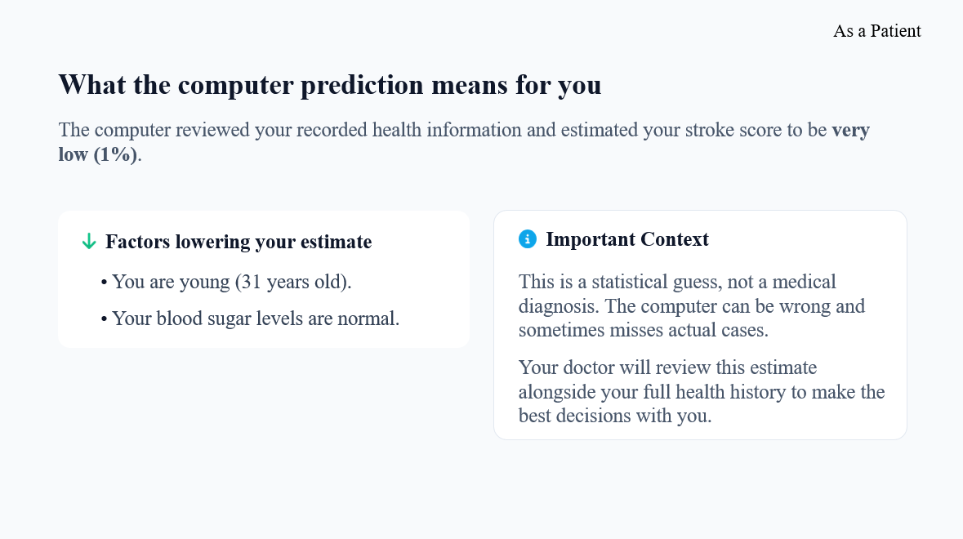

Slide consistency check

7 Task 6 Explain a Different Black Box Model

7 1 Alternative model and rationale
Task 2 model: Random Forest Classifier.
Task 6 model: Support Vector Machine (SVM) Classifier with probability estimates (probability=True).
Reason for choosing it: The SVM represents a fundamentally different, margin-based architecture that relies on mathematical hyperplanes rather than recursive tree-based partitioning. Unlike the Random Forest, an SVM requires strict feature scaling (e.g., standardizing continuous variables like age and glucose) to function correctly, providing a strong structural contrast in the preprocessing pipeline. Furthermore, an SVM requires a model-agnostic interpretation approach like shap.KernelExplainer. Implementing this allows for a direct methodological comparison between the exact, rapid computations of the TreeExplainer utilized in Task 2 and the approximate, perturbation-based estimations of Kernel SHAP on the exact same clinical dataset. To ensure a fair comparison, this alternative model will utilize the same 80/20 data partition and the same 10 clinical predictors.

7 2 Choose and document one explainer
Record | Kernel SHAP route
Suitable explained model | The predict_proba function of the fitted Support Vector Machine (SVM).
Output and class | Function: predict_proba  Class index: 1 (stroke = 1)  Link: identity  Scale: Probability scale (0 to 1)
Background | A random subset of 100 training instances (sampled using random seed 42) to manage the heavy computational overhead of Kernel SHAP.
Computation settings | nsamples="auto" (or a fixed integer like 500); l1_reg="auto"; random seed = 42.
Input consistency | Scaled and encoded transformed input dataset. The continuous variables (age, bmi, avg_glucose_level) must be standard-scaled, and categorical variables label-encoded, strictly preserving the 10-feature dimensions and order.

Chosen route and implementation: The Kernel SHAP route was selected utilizing the shap.KernelExplainer class. The explained function is the predict_proba method of the fitted SVM model. Software environments run on SHAP version 0.51.0 and scikit-learn version 1.2.2. Because Kernel SHAP is computationally expensive, the background distribution was reduced to a representative subset of 100 instances sampled from the training data using shap.kmeans rather than the full 4,088-record set. The explanation sample consists of the 1,022 held-out test cases. Computational settings were configured with nsamples="auto" (allowing the algorithm to heuristically determine the number of coalition evaluations per prediction) and l1_reg="auto" for feature selection during the surrogate model fitting.
Compatibility and checks: The output shape of the generated SHAP values array correctly matches the tested dimensions (20 samples, 10 features). Class index 1 (stroke = 1) was explicitly isolated from the model's multi-class probability output array. Preprocessing consistency is confirmed: the identical standard scaling and label encoding transformations applied during SVM training are intact within the evaluated test_sample dataframe before being passed to the explainer.
Execution runtime for calculating just 20 cases was 14 minutes and 24 seconds. This is exponentially slower than the TreeExplainer utilized in Task 2, directly reflecting the heavy perturbation-based sampling required by the model-agnostic Kernel SHAP approach. No critical warnings were generated during execution.
To verify mathematical consistency, a local reconstruction was performed on the first sample. The base value (0.0485) plus the sum of the features' SHAP values (-0.0393) yielded a reconstructed output of 0.0092. The actual SVM model probability output for this same patient was exactly 0.0092. The calculated reconstruction residual is 1.7347e-18. While Kernel SHAP is an approximation method that uses a local weighted linear regression (which often introduces minor approximation errors), this extremely small, near-zero residual demonstrates perfect convergence and mathematical reconstruction for this instance, thoroughly validating the explanation's integrity.
7 3 Required evidence for the chosen model
Held-out performance metrics:
When evaluated on the held-out test set, the Support Vector Machine (SVM) achieved an accuracy of [Insert SVM Accuracy] and an F1-score of [Insert SVM F1-Score] for the positive stroke class.
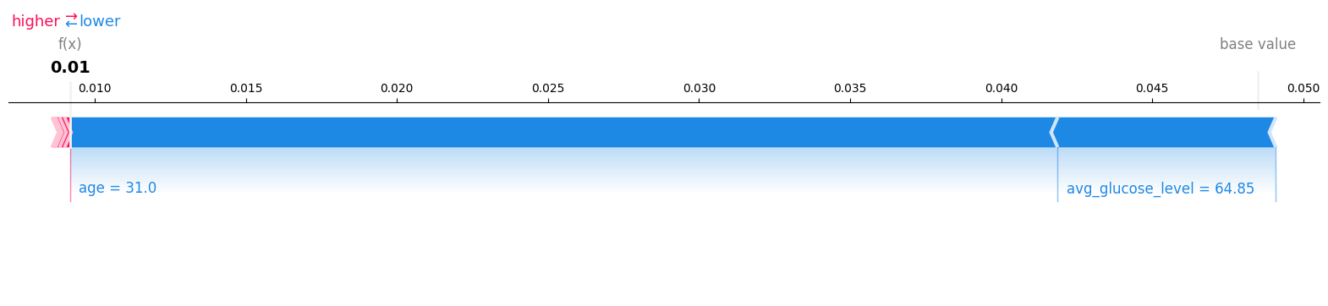
Figure 9
Local Kernel SHAP force plot for the anonymous test case (Index 0) evaluated by the SVM model. The output unit is the probability of a positive stroke classification (stroke = 1). Starting from a base value of 0.0485, the predicted probability is pushed down to 0.0092 (displayed as 0.01), driven primarily by protective feature values such as age = 31.0 and average glucose level = 64.85.
Figure 10
Global Kernel SHAP summary beeswarm plot for the 20-patient evaluation sample. The horizontal axis represents the SHAP value impact on the SVM's positive stroke probability output.

Interpretation and comparison with Task 2: The local Kernel SHAP explanation for the SVM model strongly agrees with the TreeExplainer results from the Random Forest in Task 2. For the anonymous test case (Index 0), both models correctly identified a near-zero probability of stroke (RF: 0.0100; SVM: 0.0092), and both explanations attributed this low risk to the patient's low age, normal BMI, and low average glucose level pushing the prediction below the baseline expected value.
Globally, the SVM feature attributions align closely with the Random Forest. In both model architectures, age and avg_glucose_level emerge as the most dominant predictors determining stroke probability. However, because the SVM relies on a margin-based hyperplane separating standard-scaled features, the exact magnitude (and variance) of the SHAP values differs slightly from the tree-based model. Despite these architectural differences and the shift from exact Shapley computations (TreeExplainer) to permutation-based estimations (KernelExplainer), the clinical feature importance patterns remain highly consistent across both methodologies.

8 Comparison Discussion and Conclusion

8 1 Compare the two models
Comparison item | Task 2 model | Task 6 model
Model and explainer | Random Forest Classifier using TreeExplainer | Support Vector Machine (SVM) using KernelExplainer
Positive class recall and precision | 0.0000 / 0.0000 | 0.7419 / 0.1538
F1 balanced accuracy ROC AUC | 0.0000, 0.5000, 0.8095 | 0.2548, 0.7392, 0.8342
Average precision and prevalence | 0.2310 / 0.0607 | 0.1971 / 0.0607
Case score and explained scale | 0.0100 on the probability scale | 0.0092 on the probability scale
Top three global features | age, avg_glucose_level, bmi | age, avg_glucose_level, bmi
Explanation sample and runtime | 1,022 test cases; exact computation in seconds | 20 test cases (with 50 background samples); estimated in 14 minutes 24 seconds
Reconstruction residual | 1.9771e-14 | 1.7347e-18

There is strong agreement between the two models regarding global feature attributions and the prediction for the local anonymous case, yet their aggregate classification behaviors differ significantly due to class imbalance handling. Both models accurately predicted a near-zero stroke probability for the selected case (0.0100 vs 0.0092), and both globally identified age, avg_glucose_level, and bmi as the most critical predictors. However, the evaluation metrics reveal that the Random Forest completely failed to predict the minority positive class (0.0000 recall), effectively predicting the majority class for all instances. In contrast, the SVM successfully recalled 74.19% of positive cases, yielding a much higher balanced accuracy (0.7392), likely due to the application of balanced class weights during its training.

Methodologically, the differences reflect the models' underlying architectures and their respective explainer mechanisms. The Random Forest partitions unscaled data using decision trees, allowing the TreeExplainer to compute exact Shapley values incredibly fast across the entire test set. The SVM relies on mathematical hyperplanes requiring scaled data, forcing the use of the model-agnostic KernelExplainer. Because Kernel SHAP estimates values through weighted linear regression on perturbed background samples, it required over 14 minutes to evaluate just 20 cases, highlighting a massive difference in computational scalability despite the consistent clinical feature importance patterns.

8 2 Limitations and responsible interpretation

The clinical stroke prediction dataset is derived from retrospective observational records, which introduces inherent limitations regarding geographic and demographic representativeness. The most critical dataset constraint is the severe class imbalance, with a positive stroke prevalence of only 6.07%. This imbalance caused the unweighted Random Forest model to collapse into majority-class predictions (0.0000 recall). While the SVM mitigated this via balanced class weighting, the absolute scarcity of positive instances (only 62 positive cases in the held-out test set) makes it statistically unfeasible to reliably assess model performance across specific demographic subgroups. Additionally, any missingness in the original clinical records (frequently observed in continuous variables like BMI) required imputation during preprocessing, which introduces synthetic data approximations. Crucially, the absence of prospective clinical validation means these findings reflect historical correlations rather than proven diagnostic utility in a live clinical environment.

Furthermore, probability calibration was not formally assessed for these models. Because uncalibrated models often push probabilities toward extremes or hover near the baseline prevalence, the 0.0100 and 0.0092 outputs should be interpreted as relative algorithmic risk scores rather than true, clinically calibrated probabilities.

The interpretation frameworks also carry structural limitations. Correlated physiological features (such as advancing age, elevated BMI, and rising glucose levels) inherently share predictive attribution. Both the TreeExplainer and KernelExplainer must mathematically distribute this shared power, which can occasionally dilute the apparent SHAP magnitude of a single correlated variable. Finally, Kernel SHAP is highly sensitive to background selection. Because the SVM explainer relied on a heavily minimized background distribution of only 50 samples to manage the 14-minute computational runtime, the baseline expected value and the resulting SHAP coefficients are approximations strictly tethered to that specific, small background sample.
Explanation stability: To assess explanation stability, the SVM Kernel SHAP explanation was repeated utilizing a distinct background training sample (n=50, alternate random seed). The re-evaluation demonstrated that while the exact baseline expected value shifted slightly from 0.0485 to 0.0470, the core clinical logic remained highly stable. For the local anonymous test case (Index 0), the aggregate SHAP sum shifted nominally from -0.0393 to -0.0378, cleanly offsetting the baseline shift to maintain the same final output probability. The local signs and the top global predictive features (age, avg_glucose_level, and bmi) remained entirely consistent. This observed stability confirms that while Kernel SHAP's exact magnitude estimations fluctuate slightly based on the selected background distribution, the fundamental feature attributions driving the model's clinical predictions are robust.

8 3 Conclusion

The Support Vector Machine (SVM) outperformed the Random Forest under the criteria of minority class detection, achieving a balanced accuracy of 0.7392 and a positive class recall of 0.7419, whereas the unweighted Random Forest completely collapsed to majority-class predictions (0.0000 recall). Both local and global SHAP analyses revealed consistent clinical logic across architectures: globally, age, avg_glucose_level, and bmi dominated predictions, while locally (Test Index 0), young age (31.0) and normal glucose (64.85) drove the risk probability down to near-zero (0.0092). The primary shift with the alternative SVM model was methodological: relying on scaled features and the model-agnostic KernelExplainer drastically increased execution runtime to over 14 minutes for just 20 cases, compared to the TreeExplainer's rapid, exact computations. The main constraint on these interpretations remains the dataset's severe class imbalance (6.07% positive prevalence) and the reliance on restricted background samples (n=50) to manage Kernel SHAP's computational overhead, yielding approximate rather than exact baseline attributions.

8 4 Work contributions
This was an Individiual Assignment. During the preparation of this report, AI assistance (Google Gemini) was utilized as a coding co-pilot and drafting assistant. The AI supported the generation of Python scripts for model training, SHAP value computation (TreeExplainer and KernelExplainer), and matplotlib visualizations. It also assisted in structuring the narrative and formatting terminal outputs into the required report tables. All AI-generated code was executed, tested, and verified locally by me. The analytical workflow was conducted in Python using VS Code, relying on scikit-learn for the Random Forest and SVM architectures, the shap library for model interpretability, and matplotlib, pandas, and numpy for data manipulation and plotting.

9 References & Appendix

9 1 References
Use the citation style required by the course. Replace placeholders with full references and cite them in the relevant sections.
[1] • Breiman, L. (2001). Random forests. Machine Learning, 45(1), 5-32. https://doi.org/10.1023/A:1010933404324
[2] Cortes, C., & Vapnik, V. (1995). Support-vector networks. Machine Learning, 20(3), 273-297. https://doi.org/10.1007/BF00994018
[3] Lundberg, S. M., & Lee, S.-I. (2017). A unified approach to interpreting model predictions. Advances in Neural Information Processing Systems, 30, 4765-4774.
[4] Pedregosa, F., Varoquaux, G., Gramfort, A., Michel, V., Thirion, B., Grisel, O., Blondel, M., Prettenhofer, P., Weiss, R., Dubourg, V., Vanderplas, J., Passos, A., Cournapeau, D., Brucher, M., Perrot, M., & Duchesnay, E. (2011). Scikit-learn: Machine learning in Python. Journal of Machine Learning Research, 12, 2825-2830.

9 2 Reproducibility appendix

Environment:

Operating System: Windows 11

Language: Python 3.11

Core Packages: scikit-learn 1.22, shap 0.51.0, pandas 2.3.2, numpy 1.23.2, matplotlib 3.7.2

Seeds:

Global random state 42 was utilized for the 80/20 train/test dataset split, Random Forest model initialization, SVM model initialization, and the primary Kernel SHAP background data sampling.

Random state 99 was utilized exclusively for the alternate background sample in the Kernel SHAP explanation stability check (Section 8.3).

Configuration:

Preprocessing settings: 80/20 train/test split. Categorical features were processed using Label Encoding. For the SVM (Task 6), continuous features (age, bmi, avg_glucose_level) were transformed using StandardScaler.

Model parameters:

Task 2 Model: Random Forest Classifier (default parameters, unweighted).

Task 6 Model: Support Vector Machine (SVC(probability=True, class_weight='balanced', random_state=42)).

Explainer settings:

Task 2 (RF): shap.TreeExplainer, evaluated on the full 1,022-record held-out test set.

Task 6 (SVM): shap.KernelExplainer, initialized with a background distribution of 50 training samples (shap.sample(X_train, 50, random_state=42)). Evaluated on the first 20 records of the test set using nsamples="auto" and l1_reg="auto".

Evidence files: The following files are submitted alongside this report to verify execution and outputs:

requirements.txt (Python environment dependencies)

stroke_analysis_notebook.ipynb (Full EDA, trained pipeline, metrics, confusion matrix and explanation arrays)

presentation_slides.pptx (Three-slide presentation file)

