**Fifa 17 case study**

**Scenario:**

Fifa is one of the most popular games out there today, with thousands of players buying the new release every year and playing it in various platforms, among which play station, the Xbox and personal computer are the most common ones. There are also global scale manager mode tournaments held across the world with huge money price and other prices as well.

The president of EA Sports( the company that currently hold the Fifa contract to makes games using real player names and club names and logos) recently announced a huge Manager mode tournament just Days after the release of the new Fifa 17.

**Manager Mode:**

A game mode in fifa where you can act as an manager of a club of your choosing and portray a real life scenario, where you can buy, sell and train players a s per your wish. To make this mode more real, this mode allows a manager to train players which can increase their potential rating to a certain level, which is higher then what the original card is. The winner is decided after a number of wins, and also you’re potential as a manager of being able to buy and train good players is essential.

The marketing head of Stuti Sports, a E-gaming company where you work as a junior data analyst, approaches you and tells you that Stuti Sports is also sending a team representing Stuti sports to this tournament, the marketing head believes that winning this tournament is a great way to market the company, as they will be beating the big companies and hence Stuti sports can attract a lot of customers. The head believes that it is essential to analyze the fifer 17 data to win this tournament. He assigns you the task of finding out trends and hence giving three suggestions to the players of Team Stuti to buy good players and hence bring the trophy home.

**MY APPROACH:**

I have used the six steps of the data analysis program, learned throughout the 8 courses in the Google data analytics course to analyze the data and answer important questions**: ASK, PREPARE, PROCESS ANALYZE, SHARE AND ACT.**

**# the Ask Phase:**

In this phase, I asked myself questions like what should be the matters to consider to guide the team members towards the correct direction, but also not give out to much as to be considered cheating , to guide my analysis and the next steps of my analysis. As a junior data analyst, working for Stuti sports, my goal is to provide useful recommendations to the team member so that they can do well in the upcoming tournament.

**# The Prepare Phase:**

I download the data set as a zip file, and unzipped it. Then I stored it in an appropriate place in my machine, with a proper name. I looked at the data and considering the fact that the data set was not that big and realizing the relevance of a pivot table for my analysis I decided to use spreadsheet as my primary tool for this project.

**# the process phase:**

In this phase, I started working with my data to understand it better. I imported the csv file in a brand new spreadsheet. First and foremost for safety reasons I made a copy of the excel file then started with the basic processing by expanding the columns so that I could better read and understand the column headers and the data inside them better. I identified some columns that were not going to be used in my analysis such as club logo, but were taking up unnecessary width in my spreadsheet and hence I removed them. I used tools such as remove duplicates and conditional formatting to run an initial phase of data cleaning. Then I also made sure that the fields containing dates, like the signed_on fields had the same format and that the data type was correct. I imported the data in Microsoft SQL then to run a double check on my data. After ensuring that my data set had no null values and no duplicates, I exported the data back into excel.

**# The Analyze phase:**

I made a new field called overall growth, and the values were found out by subtracting initial rating with the potential rating of the player. Then I used the sort functionality of the spreadsheet to sort my data, in descending order based on the potential growth of the various players. I then used the pivot table, where I created tables that better helped me understand trends and come up with a guideline to buy better players for the manage mode of the game. I then moved to tableau, to create visuals that would further help me understand trends in the data that could help answer the question in hand.

**Share:**

I created the following visualizations in tableau. It was nice seeing patterns that I had seen in the spreadsheet using pivot tables through visualizations, and it further confirmed my analysis as well.

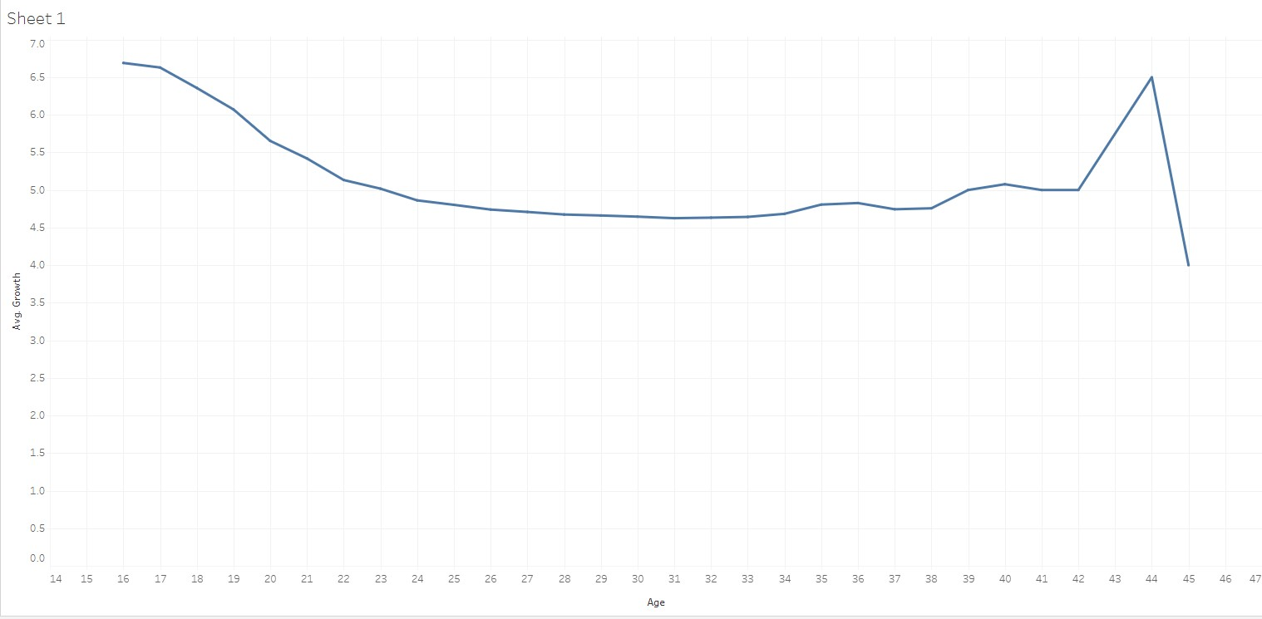

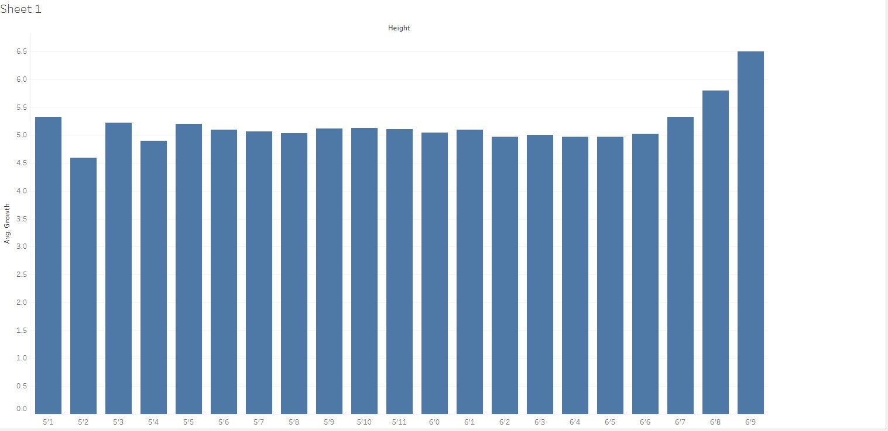

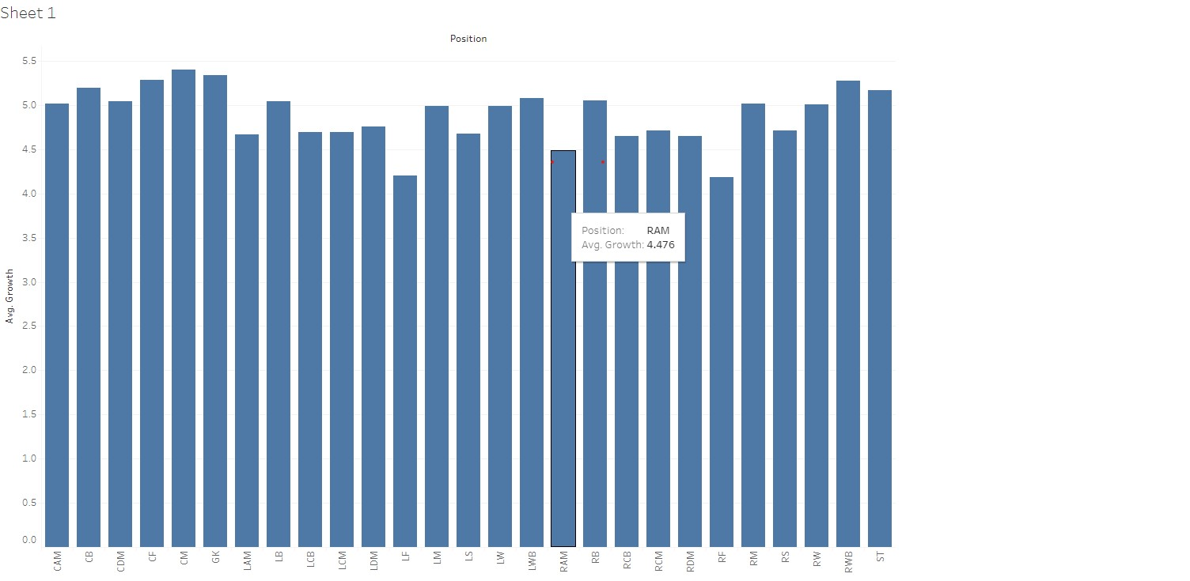

**Act:**

In this phase I was supposed to share my findings and recommendations with the supervisor:

KEY FINDINGS:

1. Age Plays a key factor, and normally players with age 15-18 and 42-44 have the highest average growth rate. This is possible because for the youngsters they have the potential of training the hardest because of the young age, fresh legs and players from the age range of 42-44 because they only play a limited deal of time and get ample rest.

1. Fifa also puts emphasize on height, especially players from 6’6 to 6’9 have the highest growth rate. This can be possible as fifa might be giving high ratings for tall players in the fields of physicality and heading which adds to the overall growth.
2. The position is also essential. Fifa and football in general glorifies the attacking and midfield positions whereas the defenders are not given enough credit, and players with the most potential growth and normally attackers.

Suggestions:

1. Buy players that are in the age range of 15-18, as they have the highest potential growth and also because they are young can remain in your fifa team for a longer period of time. This is a better option that buying the 42-44 year old players as they only have a few seasons until retiring.
2. Try to buy Players that are tall.
3. When buying a player with the intention of training him, buy attacking players and rather buy well known players rather than buying and training players for the defensive positions.

I am confident that if these suggestions are followed while buying players for the manager mode Team, the team representing StutI Sports can win the tournament.