LEN JENSEN’S PERFORMANCE IN CHARLESTON AND GREENVILLE 
Analyst: Sultan Simsek
Region: South Carolina
How did the region perform from 2022 -2025?

Greenville
$4.62 per capita
Pop: 72.9k H/Inc: $71.4k

Top 5 products in South Carolina…
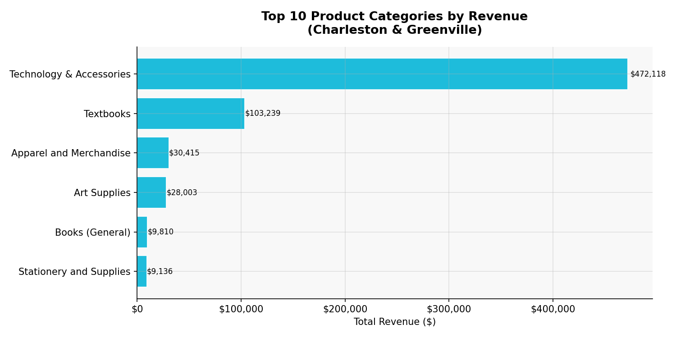
This is how much revenue we generated….
$648,812
Grand Total

+68.5%
Y-o-Y
+7.1%
Grv M-o-M
+38.0%
Chr M-o-M

Charleston
$2.02 per capita
Pop: 154k H/Inc: $92k

Trend in 4 years…
…where these 5 products drove the increases and decreases in revenue
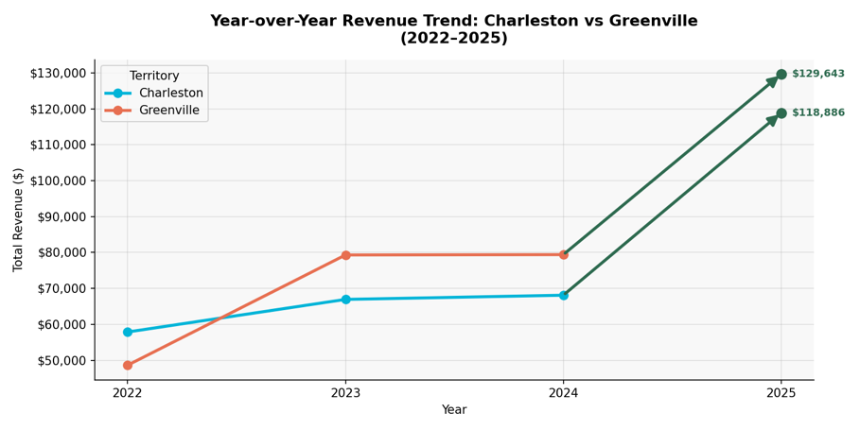
Tech & Acces | ASUS VivoB S15 | $900524.0 Stati & Supp | Sakura Pens | $221.76

Category | Product | Revenue Category | Product | Revenue

Tech & Acces | MSI Creator Z16 | $1199316.0 Books(Gen) | Your Money..| $447.92

Tech & Acces | HP Pavilion 14 | $913919.76 Books(Gen) | Verity | $305.4

Tech & Acces | App MacB Air | $1003136.8 Books(Gen) | DK Eyewitn..| $346.12

Tech & Acces| App MacB Pro | $1082151.0 Stati & Supp | Magne. Clips | $354.24

