Contents

Acknowledgment i

Vision And Mission ii

Abstract iii

List of Figures vi

1 INTRODUCTION 1

1.1 PROBLEM STATEMENT 2

1.2 MOTIVATION 2

1.3 RELEVANCE 3

2 BACKGROUND THEORY 4

2.1 EVOLUTION OF VEHICLE INDICATION SYSTEM 4

2.2 ROLE OF IoT IN MODERN VEHICLES 5

2.3 BENEFITS AND CHALLENGES OF AIS AND NPIS 5

3 LITERATURE REVIEW 6

3.1 Design of Semi-Automatic Signal Indicator For Two Wheeler by Harshitha V

(2017) . . . . . . . . . . . . . . . . . . . . . . . . . . . . . . . . . . . . . . . 6

3.1.1 Advantages: . . . . . . . . . . . . . . . . . . . . . . . . . . . . . . . . 7

3.1.2 Disadvantages: . . . . . . . . . . . . . . . . . . . . . . . . . . . . . . 7

3.2 Vehicle navigation system turn indicator by James Walker (2015) . . . . . . . 8

3.2.1 Advantages: . . . . . . . . . . . . . . . . . . . . . . . . . . . . . . . . 9

3.2.2 Disadvantages: . . . . . . . . . . . . . . . . . . . . . . . . . . . . . . 9

1. PROPOSED MODEL 11
2. METHODOLOGY 13
   1. COMPONENTS . . . . . . . . . . . . . . . . . . . . . . . . . . . . . . . . . 15
      1. RF Receiver . . . . . . . . . . . . . . . . . . . . . . . . . . . . . . . 15
      2. MPU 6050 GYRO . . . . . . . . . . . . . . . . . . . . . . . . . . . . 15
      3. RF TRANSMITTER . . . . . . . . . . . . . . . . . . . . . . . . . . . 16
      4. NODE MCU MODULE . . . . . . . . . . . . . . . . . . . . . . . . . 17
      5. PUSH BUTTONS . . . . . . . . . . . . . . . . . . . . . . . . . . . . 18
      6. RELAY . . . . . . . . . . . . . . . . . . . . . . . . . . . . . . . . . . 19
      7. BUZZER . . . . . . . . . . . . . . . . . . . . . . . . . . . . . . . . . 20
      8. 16VL LCD DISPLAY . . . . . . . . . . . . . . . . . . . . . . . . . . 21
3. RESULT 22
4. CONCLUSION 25

References 27

List of Figures

4.1 Block diagram of proposed system . . . . . . . . . . . . . . . . . . . . . . . . 12

* 1. RF Receiver . . . . . . . . . . . . . . . . . . . . . . . . . . . . . . . . . . . . 15
  2. MPU 6050 GYRO . . . . . . . . . . . . . . . . . . . . . . . . . . . . . . . . 16
  3. RF Transmitter . . . . . . . . . . . . . . . . . . . . . . . . . . . . . . . . . . 17
  4. Node MCU module . . . . . . . . . . . . . . . . . . . . . . . . . . . . . . . . 18
  5. Push Buttons . . . . . . . . . . . . . . . . . . . . . . . . . . . . . . . . . . . 19
  6. Relay . . . . . . . . . . . . . . . . . . . . . . . . . . . . . . . . . . . . . . . 20
  7. Buzzer . . . . . . . . . . . . . . . . . . . . . . . . . . . . . . . . . . . . . . . 20
  8. 16VL LCD DISPLAY . . . . . . . . . . . . . . . . . . . . . . . . . . . . . . 21
  9. Automatic Indicator System . . . . . . . . . . . . . . . . . . . . . . . . . . . 24
  10. No Parking Indication System . . . . . . . . . . . . . . . . . . . . . . . . . . 24

Chapter 1

# INTRODUCTION

In an era of rapid technological advancements, the transportation sector is undergoing a transformative shift, with innovations aimed at improving road safety, reducing accidents, and optimizing traffic flow. Among these innovations, two systems have emerged as key contributors to safer roadways: the Automatic Indicator System (AIS) and the No Parking Indication System (NPIS). The Automatic Indicator System (AIS) improves safety by providing dynamic and automatic signaling of turn indications, ensuring that drivers are consistently aware of nearby vehicles’ intentions. According to the National Highway Traffic Safety Administration (NHTSA), improper signaling is responsible for approximately 2.5% of all accidents in the U.S. annually, contributing to thousands of collisions during lane changes, turns, or merges. By eliminating human error associated with manual signaling, AIS helps reduce the risk of accidents in these critical driving moments. A study by the European Road Safety Data Centre (ERSDC) also showed that automatic signaling technologies like AIS could reduce lane-change accidents by up to 20%, underscoring their effectiveness in preventing

collisions.

On the other hand, the No Parking Indication System (NPIS) serves as an effective solution for urban areas plagued by illegal parking, which often leads to traffic congestion, emergency vehicle delays, and unsafe road conditions. A study from the Urban Mobility Report found that illegal parking contributes to approximately 30% of traffic congestion in major cities. NPIS utilizes sensors and GPS technology to detect illegal parking in real-time, sending immediate alerts to both drivers and enforcement authorities. This helps maintain clear lanes, improves traffic flow, and reduces the risk of obstruction-related accidents. For instance, in cities like San

1

INTEGRATING TECHNOLOGY FOR SAFER ROADS : THE IMPACT OF AIS AND

### NPIS

Francisco, the implementation of real-time monitoring systems has already reduced emergency response times by up to 10%, while also alleviating traffic bottlenecks caused by improperly parked vehicles.

By leveraging these technologies, both AIS and NPIS significantly enhance road safety, reduce congestion, and help create more efficient, safer urban environments.

## 1.1 PROBLEM STATEMENT

Traditional vehicle indication systems, which often rely on manual operation, are prone to human error, delayed responses, and inefficiencies. These shortcomings contribute to a higher risk of road accidents, inadequate traffic management, and poor vehicle monitoring. To address these issues, there is a need for an advanced, automated vehicle indication system that utilizes IoT technology to provide real-time data and improve communication between vehicles, thereby enhancing road safety and traffic efficiency.

## 1.2 MOTIVATION

Considering the case of San Francisco, where both AIS and NPIS technologies are being integrated into the city’s smart transportation infrastructure. In 2019, San Francisco reported that illegal parking was a major contributor to traffic congestion, accounting for over 25% of delays in some of the city’s busiest districts, particularly near medical facilities and transit hubs. Emergency vehicles, such as ambulances and fire trucks, often faced significant delays due to improperly parked cars blocking narrow streets, resulting in slower response times that could endanger lives. According to the San Francisco Fire Department, emergency response times in some high-traffic areas were delayed by an average of 4–6 minutes, which is a critical factor in life-threatening situations.

By deploying the No Parking Indication System (NPIS), which uses real-time data from GPSenabled sensors and cameras to monitor parking in these areas, the city was able to alert drivers and enforcement officers immediately when illegal parking occurred. Enforcement was streamlined, with a significant reduction in the time it took for officers to issue fines and clear blocked lanes. As a result, emergency response times dropped by 10% across the city, and

Dept. of ECE, ASIET 2 traffic congestion decreased by 15

Meanwhile, the Automatic Indicator System (AIS) was rolled out on the city’s more congested arterial roads, automatically signaling lane changes and turn intentions for vehicles equipped with the system. Within the first year, AIS contributed to a 20% decrease in lanechange collisions on these roads, improving traffic flow and reducing the number of rearend accidents caused by sudden, unsignaled lane changes.

## 1.3 RELEVANCE

The relevance of an automated vehicle indication system using IoT is underscored by several factors. The rapid advancements in IoT technology provide a robust foundation for implementing sophisticated vehicle indication systems. Moreover, smart city initiatives increasingly require efficient and safe urban transportation solutions. Additionally, growing safety regulations and standards demand more reliable and automated systems in vehicles. Furthermore, modern consumers expect advanced safety features in their vehicles, making such systems highly valuable in the automotive industry. Both the AIS and NPIS systems are integral to the realization of smart cities and the achievement of sustainable urban mobility. They enhance road safety, optimize traffic flow, and reduce congestion, all while contributing to the environmental and economic sustainability of urban environments. These systems, by utilizing advanced technologies like real-time data collection, sensors, and GPS, are key to modernizing cities in ways that are both effective and aligned with global sustainability goals.

Chapter 2

# BACKGROUND THEORY

## 2.1 EVOLUTION OF VEHICLE INDICATION SYSTEM

The evolution of vehicle indication systems has seen significant advancements, from basic mechanical signals operated manually to sophisticated electronic and AI-powered systems. Initially, drivers relied on hand signals or simple mechanical indicators, such as lever-operated turn signals, which were often prone to human error. As technology advanced, electronic indicators replaced these manual systems, offering improved reliability, visibility, and ease of use, especially in low-light conditions. However, even with these advancements, traditional systems still relied on driver input, which could result in errors or delays, especially in critical moments such as lane changes or turns.

In recent years, the integration of connected vehicle technology and artificial intelligence (AI) has further revolutionized vehicle indication systems. Connected vehicle technology allows vehicles to communicate with each other and with traffic infrastructure (vehicletovehicle and vehicle-to-infrastructure communication), enabling the automatic sharing of critical data. This communication facilitates the automatic activation of indicators in response to the movement of the vehicle or nearby traffic conditions, reducing human error. For example, AIpowered traffic systems can now analyze traffic patterns in real time and automatically adjust vehicle indications based on the situation, such as notifying a driver about a pending lane change or adapting turn signals based on vehicle speed and position.

4

## 2.2 ROLE OF IoT IN MODERN VEHICLES

The Internet of Things (IoT) allows devices to communicate and share data in real-time, enhancing vehicle functions like navigation, diagnostics, and safety. By integrating IoT with vehicle indication systems, signals and alerts can be automated, reducing the need for manual input and improving safety and efficiency. Essential components include sensors for detecting vehicle parameters, communication modules for data exchange, central processing units for data processing, and actuators for activating indication systems

## 2.3 BENEFITS AND CHALLENGES OF AIS AND NPIS

The Automated Indicator System (AIS) and No Parking Indication System (NPIS) offer significant benefits in enhancing road safety and traffic management. AIS improves road safety by automating turn signaling, reducing human error, and enhancing communication between vehicles, leading to fewer accidents and smoother traffic flow. Similarly, NPIS helps reduce congestion by providing real-time information on parking availability and detecting illegal parking, ensuring clearer lanes and better emergency vehicle access. It also promotes compliance with parking regulations and improves enforcement efficiency. However, both systems face challenges, including technical reliability, high installation and maintenance costs, and potential privacy concerns. AIS relies on sensor accuracy and can be affected by weather conditions, while NPIS may produce false positives or miss violations due to sensor limitations. Additionally, widespread adoption requires public acceptance, as drivers may be wary of automated systems or the fines associated with parking violations. Despite these challenges, both technologies have the potential to significantly improve urban road safety and efficiency.

Chapter 3

# LITERATURE REVIEW

## 3.1 Design of Semi-Automatic Signal Indicator For Two Wheeler by

Harshitha V (2017)

The design of semi-automatic signal indicator systems for two-wheelers has garnered attention due to their potential to improve road safety. Traditionally, two-wheeler riders rely on manually operated turn signals, which can lead to accidents caused by forgetfulness, distractions, or negligence in following traffic rules. The semi-automatic signal indicator aims to address this issue by automating certain aspects of the signaling process, thereby reducing the likelihood of signaling errors. This system uses sensors to detect turning or lane-changing motions, automatically activating the turn signal without rider intervention. However, the system still requires the rider to deactivate the signal after completing the maneuver. In this system, sensors detect when the rider is preparing to make a turn or change lanes. Upon detecting the intended maneuver, the system activates the signal automatically. However, the rider

6

retains the responsibility of ensuring the signal is deactivated after completing the maneuver.

This semi-automatic approach addresses some of the critical issues associated with human error in signaling while still allowing the rider to maintain control over the system. Research on such systems has demonstrated the potential to reduce accidents caused by forgotten or improperly used indicators. For instance, studies in automotive safety have shown that systems that automatically trigger turn signals during lane changes reduce accidents by improving communication between vehicles, a concept that could be adapted for two-wheelers.

3.1.1 Advantages:

* Enhanced Safety: By automating signal activation, the system minimizes the risk of accidents caused by forgotten or delayed signals, especially in situations where riders are distracted or in a rush.
* Ease of Use: Riders are relieved from having to manually activate the signal, reducing the cognitive load and making the riding experience safer.

3.1.2 Disadvantages:

* High Cost: The addition of sensors and other electronic components

increases the overall cost of the system, making it less accessible for many riders, especially in cost-sensitive markets.

INTEGRATING TECHNOLOGY FOR SAFER ROADS : THE IMPACT OF AIS AND

#### NPIS

* Manual Deactivation: Despite the automation in activation, the rider still must deactivate the signal manually, which can lead to errors and confusion if not properly done.
* Lack of Navigation Integration: The absence of an integrated navigation system limits the system’s ability to predict turns and automatically adjust signaling based on upcoming road conditions, reducing its overall effectiveness in complex traffic environments.

3.2 Vehicle navigation system turn indicator by James Walker

### (2015)

3.2.1 Advantages:

* Simplicity and Economy: Utilizing pre-existing turn signals within vehicles eliminates the need for additional indicators or complex indicator systems, leading to cost savings and streamlined manufacturing processes.
* Enhanced Notification: By incorporating both internal and external turn signals, the navigation system ensures that occupants of the vehicle and nearby vehicles are adequately informed about upcoming turns, thereby enhancing overall road safety.
* Improved Visibility: The potential integration of heads- up displays offers a significant advantage by placing turn notifications directly within the line of sight of the vehicle occupants, minimizing distractions and improving

visibility.

3.2.2 Disadvantages:

INTEGRATING TECHNOLOGY FOR SAFER ROADS : THE IMPACT OF AIS AND

NPIS • Dependency on Pre-existing Signals: While leveraging pre- existing turn signals simplifies the implementation process, it may limit the flexibility and customization options of the navigation system, potentially restricting its adaptability to different vehicle models or configurations.

* Limited Scope: The review primarily focuses on the utilization of preexisting turn signals and heads-up displays, potentially overlooking Alternative technologies or approaches that could further enhance turn

notification capabilities.

Chapter 4

PROPOSED MODEL

Each component in the system was chosen based on its role in simplifying the design, meeting the system’s requirements, and being cost-effective. The MPU6050 provides essential motion sensing data for detecting bike orientation, while the Arduino UNO offers an easy-touse microcontroller for handling inputs, sensor data, and outputs. The relay enables the control of high-power indicator lights, and the LCD display provides useful user feedback. Finally,

11

INTEGRATING TECHNOLOGY FOR SAFER ROADS : THE IMPACT OF AIS AND

### NPIS

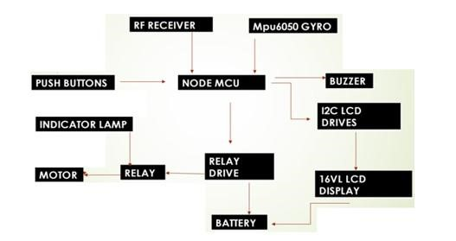

Figure 4.1: Block diagram of proposed system

the push buttons offer manual control for turning on and off the indicators. Together, these components create an efficient, reliable, and cost-effective automatic indicator system for the bike.

The proposed system is already designed for a motorcycle, as it uses a simple set of indicators (left and right), turn-off functionality, and motion detection via the gyroscope (MPU6050). The relatively smaller, more straightforward setup is ideal for motorcycles with basic controls.Unlike motorcycles, cars have separate indicator lights on each side and may also have indicators on the rearview mirrors or at the front. The system can be extended to control more indicator lights, with additional relays to handle the higher current demand.The MPU6050 can be placed inside the car, possibly in the dashboard or near the vehicle’s center of gravity, to detect turning motions effectively. However, care must be taken in calibration for detecting turns, as cars have a different turning radius and motion dynamics compared to bikes.For larger vehicles like buses and trucks,

Chapter 5

Dept. of ECE, ASIET 12

METHODOLOGY

The system operates in two primary modes:

1. Timer-Based Mode:

* In this mode, when a rider manually activates a turn signal, the microcontroller records the time.
* If the indicator remains on for too long, the system will automatically turn off the indicator after a defined time interval. This ensures that the indicator is not left on unintentionally, which can cause confusion for other road users.

Scenario 1: Normal Operation

* Test: Manually activate the left or right indicator and keep it on for the maximum time interval.
* Expected Outcome: The system should automatically turn off the indicator after the defined time (e.g., 30 seconds), ensuring it doesn’t remain active unintentionally.
* Metrics: Measure the time from activation to automatic turn-off. The system should turn off the indicator after the preset time interval without any delays or errors.

Scenario 2: Indicator Activation and Deactivation

* Test: Manually activate the indicator and turn it off manually before the timer expires.

13

* Expected Outcome: The system should allow the user to manually turn off the indicator before the automatic turn-off function is triggered.
* Metrics: Measure the responsiveness of the system to user input (button press). The indicator should turn off immediately when the user presses the ”Turn Off” button.

INTEGRATING TECHNOLOGY FOR SAFER ROADS : THE IMPACT OF AIS AND

### NPIS

2. Gyroscope-Based Mode:

* In this mode, the system uses the MPU6050 gyroscope sensor to detect the orientation of the bike. When the bike begins to turn, the sensor detects the change in angle and activates the corresponding indicator.
* Once the turn is completed, and the bike returns to its original orientation the system automatically turns off the indicator.

Scenario 1: Normal Turn Detection

* Test: Initiate a smooth left or right turn at a constant speed.
* Expected Outcome: The system should detect the turn via the gyroscope sensor, activate the corresponding indicator, and then automatically turn off the indicator once the turn is completed (i.e., when the bike returns to its original orientation).
* Metrics: Evaluate the accuracy of the gyroscope-based turn detection and the time taken for the indicator to turn off after completing the turn. The system should detect the turn with minimal delay (typically within 1-2 seconds of the turn starting) and turn off the indicator within 1-2 seconds after returning to the original orientation.

Scenario 2: Abrupt or Sharp Turn

* Test: Perform a sharp, abrupt turn or maneuver (such as a U-turn or quick lane change). • Expected Outcome: The system should still detect the turn, activate the indicator, and turn it off once the bike has completed the turn, returning to its initial orientation.
* Metrics: Assess the system’s ability to detect abrupt turns and correctly switch off the indicator. The system should handle these maneuvers without failing to deactivate the indicator.

Dept. of ECE, ASIET 14

### 5.1 COMPONENTS

5.1.1 RF Receiver

An RF (Radio Frequency ) receiver is a device or circuit that is designed to receive and demodulate radio frequency signals . It is an essential component in wireless communication systems and is used to capture and extract information from RF signals transmitted by a corresponding RF transmitter . The RF receiver operates by receiving electromagnetic waves in the RF spectrum and converting them into usable electrical signals.

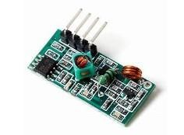

Figure 5.1: RF Receiver

5.1.2 MPU 6050 GYRO

The MPU-6050 is a commonly used integrated circuit (IC) that combines a three-axis gyroscope and a three-axis accelerometer in a single package. It is often referred to as a gyro or gyroscope sensor due to its primary function of measuring angular velocity and motion. The MPU6050 gyro is designed to detect rotational movements and changes in orientation. It uses a Micro Electro mechanical System (MEMS) technology, which employs microscopic sensors and circuitry to accurately measure angular velocity along the three axes (X, Y, and Z).

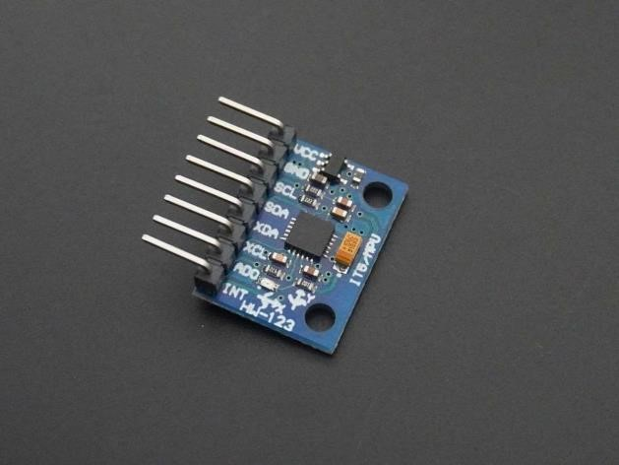

Figure 5.2: MPU 6050 GYRO

5.1.3 RF TRANSMITTER

An RF (Radio Frequency) transmitter is an electronic device that generates and transmits radio waves carrying information or signals wirelessly through the air. It is commonly used in communication systems to transmit data, audio, video, or control signals over a certain range. RF transmitters are essential components in wireless communication systems, providing a means to transmit information wireless over a certain range. Their versatility, efficiency, and ability to carry various types of signals make them integral in modern communication technologies and applications.

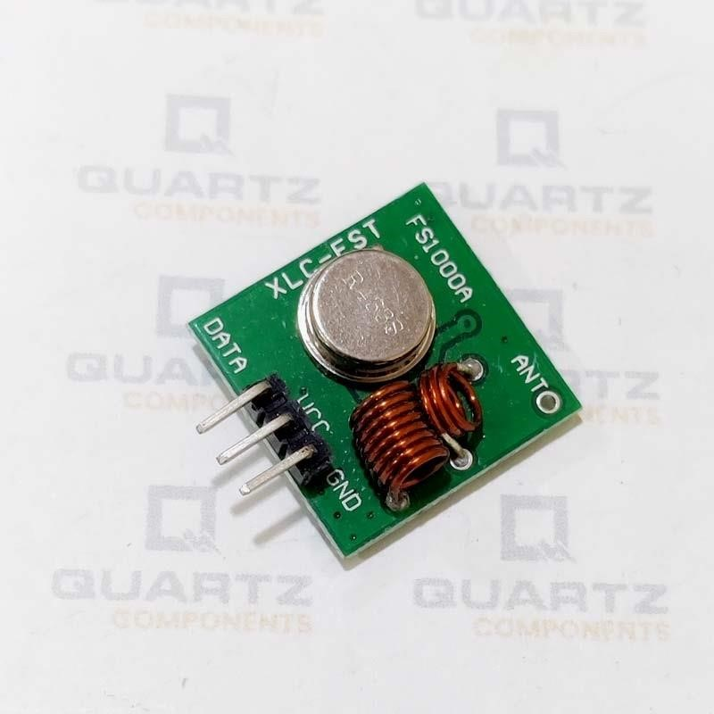

Figure 5.3: RF Transmitter

5.1.4 NODE MCU MODULE

The Node MCU module is a popular development board based on the ESP8266 micro controller. It is designed to provide an easy-to-use platform for building Internet of Things (IoT) projects and applications. The Node MCU module combines the ESP8266 chip with a programmable firmware and a set of input/output (I/O) pins, making it versatile and suitable for a wide range of IoT applications. The Node MCU module is widely used by hobbyists, makers and developers for prototyping and building IoT projects. Its affordability, Wi-Fi connectivity and ease of use make it a popular choice for projects involving home automation, remote sensing, data logging and internet-based control systems.

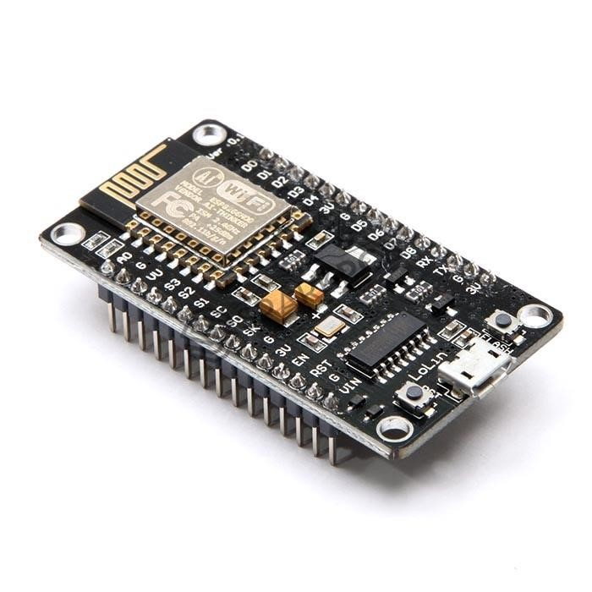

Figure 5.4: Node MCU module

5.1.5 PUSH BUTTONS

Push buttons are simple, yet essential components used in various electrical and electronic systems. They are mechanical switches that are typically actuated by pressing a button or a plunger, hence the name ”push button.” These buttons are commonly found in control panels, machines, appliances, and user interfaces where manual input or control is required. The primary function of a push button is to establish or interrupt an electrical circuit when pressed. When the button is in its resting state, the circuit remains open, and no current flows through it. However, when the button is pushed, it closes the circuit, allowing current to flow and triggering the intended action or response.

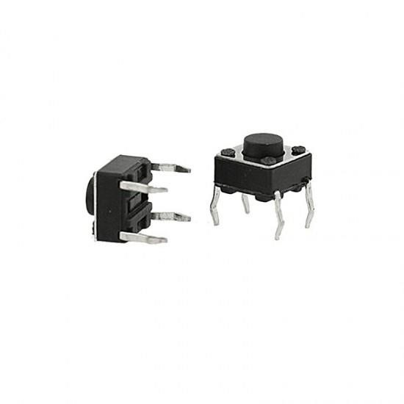

Figure 5.5: Push Buttons

5.1.7 BUZZER

A buzzer is an electronic audio signaling device that produces a continuous or intermittent sound to provide audible alerts or indications. It is a simple, yet effective component commonly used in various applications, including alarm systems, notification systems, electronic games, and electronic devices that require audio feedback. Buzzers are widely used in different industries and applications where audible alerts or indications are necessary.



Figure 5.7: Buzzer

5.1.8 16VL LCD DISPLAY

It seems that the term ”16VL LCD display” is not a standard or widely recognized designation. However, I can provide some general information about LCD displays and their common features. LCD stands for Liquid Crystal Display, which is a flat panel display technology widely used in electronic devices. It utilizes liquid crystals to create images or text by manipulating the light passing through them.

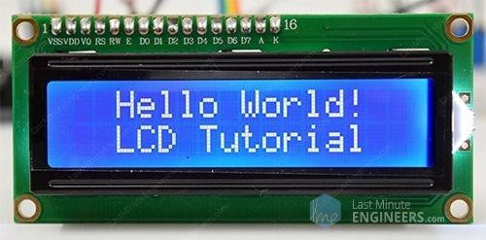

Figure 5.8: 16VL LCD DISPLAY

Chapter 6

RESULT

The prototype model of Automatic Indicator System (AIS) and No Parking Indication System (NPIS) developed in two units. One is placed on the two wheeler for indicator and other one is placed on the no parking zone as shown. In indicator units (AIS) consists of two LED lights which is programmed by turn ON for turn the respective angle of degree and it OFF if again comes to its original position. In NPIS consists of RF (Radio Frequency) transmitter which send signal to vehicle and received if bike entered into no parking zone, otherwise it will not receive any signal.

The response time refers to the time it takes for the system to react to a signal.For example, when the vehicle enters the no-parking zone, the system should detect this and trigger the appropriate indicator or action.The system’s response time for detecting entry into the noparking zone and turning on/off the indicators should ideally be in the range of 100 ms to 500 ms. This includes the time taken for the RF signal to be transmitted from the NPIS to the bike (AIS unit), processed by the receiver, and the LED light response.

The AIS and NPIS system could be integrated with other smart city technologies, such as smart parking systems, traffic management systems, or vehicle tracking technologies.For largescale urban deployment, the system needs to be interoperable with other systems (e.g., smart traffic lights, city-wide sensor networks).Develop the system with open APIs or standardized communication protocols to allow integration with other city infrastructure. The system could

22

INTEGRATING TECHNOLOGY FOR SAFER ROADS : THE IMPACT OF AIS AND

### NPIS

even provide data to authorities or users regarding parking zone usage, traffic density, or violation alerts.

The system’s overall power efficiency can be optimized by:

* Using low-power microcontrollers (MCUs) and efficient RF communication protocols (like Bluetooth Low Energy (BLE) or LoRa).
* Sleep mode: Both the AIS and NPIS can be designed to enter sleep modes when not actively in use, drastically reducing power consumption.

Dept. of ECE, ASIET 23 INTEGRATING TECHNOLOGY FOR SAFER ROADS : THE IMPACT OF AIS AND

NPIS

Figure 6.2: No Parking Indication System

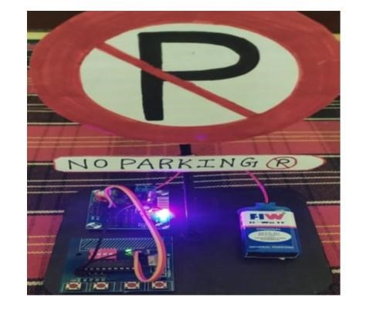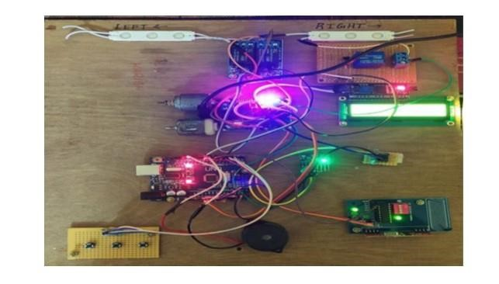

Dept. of ECE, ASIET 24

Chapter 7

CONCLUSION

Incorporating Artificial Intelligence (AI) into the system could significantly improve its ability to predict traffic flow and adjust indicator signals accordingly. AI can analyze real-time traffic data, patterns, and environmental conditions to optimize signaling, prevent unnecessary alerts, and dynamically adjust the behavior of the system based on current traffic conditions. The widespread adoption of such innovative systems holds the potential to transform urban

25

INTEGRATING TECHNOLOGY FOR SAFER ROADS : THE IMPACT OF AIS AND

### NPIS

mobility, reduce traffic-related accidents, and improve overall public safety. By promoting more responsible driving and efficient use of public spaces, these technologies can significantly enhance the quality of life in urban areas, fostering safer, smarter, and more sustainable communities for the future.

Dept. of ECE, ASIET 26

References

1. D. Balaji, S. Harish and S. Jagankumar, ”Smart Indicator and Parking Identification in Two Wheelers,” 2023 International Conference on System, Computation, Automation and Networking (ICSCAN), PUDUCHERRY, India, 2023.
2. Yuan G, Zhang Z and ShangGuan W, 2008 - “Research and Design of GIS in Vehicle Monitoring System” International Conference on Internet Computing in Science and Engineering. 223-228.
3. Zechun Huang ,Dingfa Huang, Zhu Xu and Zhigen Xu, 2011 - “GPS Vehicle Positioning Monitoring System Integrated with CORS and Mobile GIS” International Conference of Environmental Science and Information Application Technology (Elsevier) 10 2498-2504.
4. Khalifa A. Salim and Ibrahim Mohammed Idrees, 2013 - “Design and Implementation of Web-Based GPS-GPRS Vehicle Tracking System” International Journal of Computer Science Engineering Technology 3(12) pp. 443-448.
5. Mahesh Kadibagil and Guruprasad H S, 2014 – “Position Detection and Tracking System”

International Journal of Computer Science and Information Technology and Security 40 6773.

1. Abhirup Khanna, Rishi Anand, “IoT based Smart Parking System”, International Conference on Internet of Things and Applications (IOTA) Maharashtra Institute of Technology, Pune,2016.

27