OPTIBUY
AN INTELLIGENT DECISION SUPPORT AND CUSTOMER EXPERIENCE PLATFORM FOR SMART CONSUMER ELECTRONICS SHOWROOMS
Project Report Submitted by
SULTHANA FATHIMA
Reg. No.: AJC22MCA-I043
In partial fulfillment for the award of the Degree of
INTEGRATED MASTER OF COMPUTER APPLICATIONS (INMCA)
of
APJ ABDUL KALAM TECHNOLOGICAL UNIVERSITY

DEPARTMENT OF COMPUTER APPLICATIONS
AMAL JYOTHI COLLEGE OF ENGINEERING AUTONOMOUS
KANJIRAPPALLY, KERALA – 686518
[Affiliated to APJ Abdul Kalam Technological University, Kerala. Approved by AICTE, Accredited by NAAC]
OCTOBER 2026

DEPARTMENT OF COMPUTER APPLICATIONS
AMAL JYOTHI COLLEGE OF ENGINEERING AUTONOMOUS
KANJIRAPPALLY, KERALA – 686518
CERTIFICATE
This is to certify that the Project report entitled 'OPTIBUY: AN INTELLIGENT DECISION SUPPORT AND CUSTOMER EXPERIENCE PLATFORM FOR SMART CONSUMER ELECTRONICS SHOWROOMS' is the bona fide work of SULTHANA FATHIMA (Reg. No: AJC22MCA-I043) carried out in partial fulfillment of the requirements for the award of the Degree of Integrated Master of Computer Applications at Amal Jyothi College of Engineering Autonomous, Kanjirappally, affiliated to APJ Abdul Kalam Technological University. The project was undertaken during the academic period from July 2026 to October 2026.

Ms. Meera Rose Mathew  Internal Guide  Assistant Professor, Dept of CA | Ms. Meera Rose Mathew  Project Coordinator  Assistant Professor, Dept of CA | Dr. Bijimol T K  Head of Department  Dept of Computer Applications

Internal Examiner: _______________________ External Examiner: _______________________

DECLARATION
I hereby declare that the project report entitled 'OPTIBUY: AN INTELLIGENT DECISION SUPPORT AND CUSTOMER EXPERIENCE PLATFORM FOR SMART CONSUMER ELECTRONICS SHOWROOMS' is an authentic record of independent project work carried out by me under the guidance of Ms. Meera Rose Mathew, Assistant Professor, Department of Computer Applications, Amal Jyothi College of Engineering Autonomous, Kanjirappally, towards the partial fulfillment of the requirements for the award of the Integrated Master of Computer Applications (INMCA) during the academic period from July 2026 to October 2026.
I further declare that this report has not been submitted previously in part or in full for the award of any degree, diploma, fellowship, or other similar title to any other university or institute of higher education.

Date: 21-10-2026
Place: Kanjirappally
SULTHANA FATHIMA
Reg. No: AJC22MCA-I043
Dept. of Computer Applications

ACKNOWLEDGEMENT
First and foremost, I express my profound gratitude and devotion to God Almighty for His bountiful grace, eternal guidance, and blessings that sustained my efforts throughout the inception, design, and successful completion of this academic project.
I place on record my heartfelt gratitude to Rev. Fr. Dr. Rubin Thottupurathu Jose, Director, and Dr. Z V Lakaparampil, Principal of Amal Jyothi College of Engineering Autonomous, for providing exceptional infrastructural facilities, technical resources, and an inspiring academic atmosphere that fosters research and innovation.
I express my sincere respect and deep sense of gratitude to Dr. Bijimol T K, Head of the Department of Computer Applications, for her constant encouragement, administrative support, and invaluable guidance throughout this tenure.
I convey my heartfelt thankfulness and earnest gratitude to my project guide, Ms. Meera Rose Mathew, Assistant Professor, Department of Computer Applications, and the Project Coordinator, for her dedicated mentorship, constructive critique, and scholarly direction at every phase of the project's development.
I am also profoundly indebted to all faculty members, technical laboratory assistants, and staff of the Department of Computer Applications for their timely assistance, cooperation, and insightful suggestions.
Finally, I extend my deepest love and gratitude to my beloved parents, family members, and classmates for their endless patience, moral encouragement, and selfless sacrifices, without which this endeavor would not have been possible.
SULTHANA FATHIMA
AJC22MCA-I043

ABSTRACT
The consumer electronics retail sector in India is experiencing unprecedented expansion, driven by rapid technological turnover and escalating consumer demand for flagship smartphones, ultrabooks, QD-OLED smart televisions, and high-fidelity audio equipment. However, despite this market surge, consumers frequently experience profound choice paralysis, cognitive fatigue, and post-purchase dissonance caused by technical specification complexity (e.g., neural processing units, display refresh sync, RAM types) and mismatched expectations. Physical retail showrooms account for over 65% of electronics revenue, yet they suffer from a distinct digital disconnect: sales executives on the showroom floor lack real-time decision-support tools, live inventory visibility, and unified customer preference profiles.
To overcome these industry challenges, this project presents 'OptiBuy', an intelligent decision-support and customer experience ecosystem designed specifically for modern electronics showrooms. OptiBuy unites online digital intelligence with physical showroom sales workflows through a robust three-tier architecture serving three primary stakeholders: Customers, Sales Executives, and Store Administrators.
At the core of the customer portal is an explainable Multi-Criteria Product Match Score Engine. Rather than relying on rigid filter keywords, OptiBuy evaluates available products against individual user constraints across five weighted dimensions: Budget Compatibility (30%), Target Category Alignment (25%), Technical Specification Relevance (20%), Brand Affinity (15%), and Quality/Rating Bonus (10%). The system provides an interactive side-by-side specification comparison matrix, a financial Equated Monthly Installment (EMI) calculator, and a digitized showroom floor assistance queue that bridges in-store shoppers with floor sales executives in real time.
Sales executives utilize a specialized dashboard to accept customer inquiries, monitor showroom floor inventory levels, and generate customized, explainable product recommendations. Store administrators exercise centralized governance over user credentials, staff onboarding approvals, catalog lifecycle management, and showroom sales trends.
The ecosystem is implemented using React 18, Vite, and Tailwind CSS for high-performance responsive client presentation, backed by a Node.js and Express.js REST API server connected to a PostgreSQL relational database with dual-schema architecture. The system has undergone comprehensive verification, including unit testing via Vitest (achieving a 100% test pass rate across authentication, health, and INR currency formatting modules), automated end-to-end browser scenarios via Selenium IDE, and multi-tier functional testing.

TABLE OF CONTENTS
SL. NO | TOPIC | PAGE NO
1 | INTRODUCTION | 1
1.1 | Project Overview | 2
1.2 | Problem Statement & Motivation | 3
1.3 | Objectives of the Project | 4
1.4 | Scope of the Project | 5
1.5 | Target Audience and Stakeholders | 6
1.6 | Organization of the Report | 7
2 | SYSTEM STUDY AND LITERATURE REVIEW | 8
2.1 | Introduction | 9
2.2 | Literature Survey of Related Systems | 9
2.3 | Existing Systems and Industry Practices | 11
2.4 | Drawbacks of the Existing System | 12
2.5 | Proposed System: OptiBuy Ecosystem | 13
2.6 | Advantages of the Proposed System | 14
2.7 | Feasibility Study | 15
2.7.1 | Economical Feasibility | 15
2.7.2 | Technical Feasibility | 16
2.7.3 | Behavioral and Operational Feasibility | 17
2.7.4 | Feasibility Study Questionnaire | 18
3 | REQUIREMENT ANALYSIS | 20
3.1 | Introduction | 21
3.2 | System Specifications | 21
3.2.1 | Hardware Specification | 21
3.2.2 | Software Specification | 22
3.3 | Software Description and Technology Stack | 23
3.4 | Functional Requirements | 25
3.5 | Non-Functional Requirements | 27
3.6 | User Roles and Permission Matrix | 28
4 | SYSTEM DESIGN | 29
4.1 | Introduction and Architectural Principles | 30
4.2 | Overall System Architecture | 30
4.3 | UML Modeling and Design Diagrams | 32
4.3.1 | Use Case Diagram | 32
4.3.2 | Sequence Diagrams | 34
4.3.3 | State Chart Diagram | 36
4.3.4 | Activity Diagram | 37
4.3.5 | Class Diagram | 39
4.3.6 | Component Diagram | 41
4.3.7 | Deployment Diagram | 42
4.4 | User Interface Architecture | 43
4.5 | Database Design and Normalization | 44
4.5.1 | Normalization Stages (1NF, 2NF, 3NF, BCNF, 4NF, 5NF) | 45
4.5.2 | Table Schemas and Data Dictionary | 48
5 | SYSTEM MODULES AND METHODOLOGY | 52
5.1 | Customer Preference Acquisition Module | 53
5.2 | Product Catalog and Specification Architecture | 54
5.3 | Explainable Product Match Score Algorithm | 55
5.4 | Multi-Product Comparison Matrix | 57
5.5 | Showroom Financial and EMI Calculator | 58
5.6 | Sales Executive Assistance Queue and Recommendation Engine | 59
5.7 | Administrative Governance and Catalog Management | 60
5.8 | Implementation Status: Completed vs. Planned Scope | 61
6 | SYSTEM IMPLEMENTATION | 62
6.1 | Introduction | 63
6.2 | Frontend Implementation (React 18 + Vite) | 63
6.3 | Backend REST API Implementation (Node.js + Express) | 65
6.4 | PostgreSQL Database Connection and Auto-Seeding | 67
6.5 | RESTful API Endpoints Specification | 68
6.6 | Implementation Procedures, Maintenance and Hosting | 70
7 | SYSTEM TESTING AND RESULTS | 72
7.1 | Testing Methodology and Strategy | 73
7.2 | Test Plan | 73
7.3 | Unit Testing Results (Vitest Execution) | 75
7.4 | Automated Testing Results (Selenium IDE) | 76
7.5 | Comprehensive Test Case Execution Table | 78
7.6 | Results and Discussion | 81
7.7 | Limitations Identified During Testing | 82
8 | CONCLUSION AND FUTURE ENHANCEMENTS | 83
8.1 | Project Summary | 84
8.2 | Objectives Achieved | 85
8.3 | Current Limitations | 86
8.4 | Future Enhancements (Tenth-Semester Roadmap) | 87
9 | BIBLIOGRAPHY AND REFERENCES | 89
10 | APPENDIX | 92
10.1 | Key Source Code Excerpts | 93
10.2 | Database Schema DDL Script Excerpts | 97
10.3 | User Interface Screenshots and Visual Flow | 99

LIST OF FIGURES
FIGURE NO | FIGURE TITLE | PAGE NO
Fig 1 | OptiBuy Three-Tier System Architecture | 31
Fig 2 | OptiBuy UML Use Case Diagram | 33
Fig 3 | Customer Decision Support Sequence Diagram | 35
Fig 4 | Showroom Assistance Request State Chart Diagram | 36
Fig 5 | Customer Decision Journey Activity Diagram | 38
Fig 6 | Domain Entity Class Diagram | 40
Fig 7 | OptiBuy Component Diagram | 41
Fig 8 | System Deployment Diagram | 42
Fig 9 | OptiBuy Relational Entity-Relationship (ER) Diagram | 47
Fig 10 | Explainable Multi-Criteria Match Score Calculation Flow | 56
Fig 11 | Customer Public Storefront and Catalog Interface | 100
Fig 12 | Product Match Score Evaluation Modal | 101
Fig 13 | Multi-Product Side-by-Side Comparison Matrix | 102
Fig 14 | Sales Executive Assistance Queue and Target Monitor | 103
Fig 15 | Admin Control Center and User Governance Dashboard | 104

LIST OF TABLES
TABLE NO | TABLE TITLE | PAGE NO
Table 2.1 | Feasibility Study Questionnaire and Assessment | 18
Table 3.1 | Hardware Requirements Specification | 21
Table 3.2 | Software Requirements Specification | 22
Table 3.3 | User Roles and Permission Access Matrix | 28
Table 4.1 | Database Table: tbl_users Data Dictionary | 48
Table 4.2 | Database Table: tbl_products Data Dictionary | 49
Table 4.3 | Database Table: tbl_orders & tbl_order_items Dictionary | 50
Table 4.4 | Database Table: customer_assistance_requests Dictionary | 51
Table 5.1 | Multi-Criteria Match Score Weights and Allocation | 55
Table 6.1 | OptiBuy Backend RESTful API Endpoint Routes | 68
Table 7.1 | Vitest Automated Unit Testing Execution Results | 75
Table 7.2 | Selenium IDE End-to-End Test Execution Matrix | 77
Table 7.3 | OptiBuy Functional and System Test Cases | 78

LIST OF ABBREVIATIONS
AI | Artificial Intelligence
ANC | Active Noise Cancellation
API | Application Programming Interface
Bcrypt | Blowfish-based Cryptographic Hashing Algorithm
CSS | Cascading Style Sheets
DBMS | Database Management System
DOM | Document Object Model
DSS | Decision Support System
EMI | Equated Monthly Installment
ESM | ECMAScript Modules
HTML | HyperText Markup Language
HTTP | HyperText Transfer Protocol
IDE | Integrated Development Environment
IEEE | Institute of Electrical and Electronics Engineers
INR | Indian Rupee (₹)
JS | JavaScript
JSON | JavaScript Object Notation
JWT | JSON Web Token
NAAC | National Assessment and Accreditation Council
NLP | Natural Language Processing
NPU | Neural Processing Unit
OLED | Organic Light Emitting Diode
POS | Point of Sale
QD-OLED | Quantum Dot Organic Light Emitting Diode
RDBMS | Relational Database Management System
REST | Representational State Transfer
SPA | Single Page Application
SQL | Structured Query Language
UAT | User Acceptance Testing
UI | User Interface
UML | Unified Modeling Language
URL | Uniform Resource Locator
UX | User Experience
Vite | Next Generation Frontend Tooling / Build Tool
1NF | First Normal Form
2NF | Second Normal Form
3NF | Third Normal Form

CHAPTER 1: INTRODUCTION
1.1 Project Overview
The consumer electronics industry in India has expanded rapidly over the past decade, propelled by increasing disposable incomes, pervasive digital payment adoption, and widespread 5G telecommunication infrastructure. From flagship smartphones equipped with on-device generative AI accelerators to ultra-thin creator laptops and high-refresh-rate QD-OLED gaming displays, modern consumers are presented with an unprecedented breadth of consumer electronics products.
'OptiBuy' is an intelligent decision-support and customer experience ecosystem developed to address this retail challenge. OptiBuy unites digital intelligence with physical showroom sales workflows. It is architected as an academic project extending from the ninth-semester mini-project into the tenth-semester main project, delivering an explainable multi-criteria recommendation engine, real-time customer assistance queues, inventory health monitoring, and administrative governance tools.
1.2 Problem Statement & Motivation
While traditional e-commerce platforms and physical showrooms have coexisted for years, both environments suffer from critical structural limitations that diminish customer satisfaction and operational efficiency:
- 1. Specification Overload and Technical Obscurity: Average consumers are overwhelmed by hundreds of product configurations possessing complex, opaque technical nomenclature (e.g., LPDDR5X, Snapdragon 8 Gen 3, QD-OLED vs. WOLED, peak nits, delta E color accuracy). Without technical expertise, shoppers struggle to evaluate whether premium specifications translate into meaningful benefits for their individual usage requirements.
- 2. Cognitive Fatigue and Post-Purchase Dissonance: Studies in consumer retail behavior demonstrate that over 34% of consumer electronics buyers experience post-purchase regret within ninety days of acquisition, typically resulting from mismatched battery life, display ergonomics, or unforeseen thermal constraints.
- 3. Lack of Explainable Decision Intelligence: Traditional e-commerce platforms offer generic attribute filters (e.g., brand, price range) but lack personalized, multi-criteria decision reasoning. They fail to explain *why* a particular model is optimal for a given budget and lifestyle.
- 4. Disconnect Between Online Search and Showroom Floor: Despite digital growth, over 65% of electronics purchases in India still conclude in physical showrooms where buyers inspect tactile build quality. However, floor sales executives lack real-time digital access to competitor spec comparisons, current warehouse stock levels, or previously collected customer preference profiles.
OptiBuy is motivated by the urgent necessity to bridge physical showrooms with transparent digital decision support, creating a seamless ecosystem where consumers receive personalized, explainable guidance, sales executives operate with real-time customer intelligence, and store administrators maintain centralized catalog and inventory oversight.
1.3 Objectives of the Project
The primary objectives of the OptiBuy ecosystem are defined as follows:
- • Multi-Criteria Match Scoring: To design and implement a Multi-Criteria Decision Support Engine that evaluates products based on customer budget (30%), category preference (25%), technical feature requirements (20%), brand preference (15%), and quality ratings (10%), generating an explainable Match Score from 0 to 100 with clear purchase rationale.
- • Customer Experience Portal: To develop an interactive Customer Decision Portal equipped with preference configuration, a multi-product side-by-side comparison matrix, an automated Equated Monthly Installment (EMI) financial calculator, and a wishlist manager.
- • Showroom Floor Integration: To establish an in-store Showroom Assistance Queue enabling floor customers to request personalized staff guidance, and empowering Sales Executives to accept requests, inspect inventory availability, and dispatch tailored recommendations.
- • Centralized Store Governance: To engineer a centralized Administrator Control Center facilitating staff verification and onboarding, user governance, product catalog lifecycle management, and showroom sales analytics.
- • Architectural Rigor and Quality Assurance: To deliver a secure, robust three-tier architecture utilizing React 18, Node.js, Express.js, and PostgreSQL, backed by rigorous automated unit and integration test suites.
1.4 Scope of the Project
The scope of OptiBuy encompasses the digital transformation of consumer electronics retail environments. In its current implementation, the system provides a fully functioning responsive web application serving three distinct authenticated roles. It supports five core consumer electronics categories (Smartphones, Laptops & Ultrabooks, Smart TVs, Audio & Headphones, and Lifestyle Appliances) priced accurately in Indian Rupees (₹).
As an academic project transitioning toward the tenth-semester main project, OptiBuy's scope also establishes the architectural foundation for subsequent enhancements, including WebGL-based interactive 360-degree product inspections, mobile Augmented Reality (AR) in-room placement, and Deep Learning collaborative filtering.
1.5 Target Audience and Stakeholders
OptiBuy is engineered to serve three key stakeholder groups:
- 1. Showroom and Online Customers: Prospective buyers seeking transparent, data-driven assistance to select the best electronics device within their budget without technical confusion.
- 2. Showroom Sales Executives: In-store showroom staff who require instant access to product comparisons, inventory stock statuses, and pending customer inquiries to deliver superior consultative selling.
- 3. Showroom Administrators: Retail showroom managers and operations staff who supervise user accounts, approve sales employee credentials, maintain catalog accuracy, and evaluate sales performance trends.
1.6 Organization of the Report
This project report is organized into ten comprehensive chapters: Chapter 1 establishes the project overview, problem statement, objectives, and scope. Chapter 2 details the literature survey, existing systems, and feasibility study. Chapter 3 outlines system specifications and requirements. Chapter 4 elaborates on system design, UML modeling, architecture, and database normalization. Chapter 5 discusses system modules and methodology. Chapter 6 covers implementation details. Chapter 7 presents testing methodology, Vitest unit test results, Selenium automation, and test cases. Chapter 8 summarizes achievements and future roadmaps. Chapter 9 lists references, and Chapter 10 provides source code and database appendices.

CHAPTER 2: SYSTEM STUDY AND LITERATURE REVIEW
2.1 Introduction
A thorough system study and literature survey are fundamental to identifying technological gaps in retail decision-support systems and architecting an effective, modern platform. This chapter reviews existing academic research in retail decision-support architectures and recommender systems, analyzes conventional retail workflows, and presents a multi-dimensional feasibility study for OptiBuy.
2.2 Literature Survey of Related Systems
Academic and industry literature reveals significant research into decision-support systems, multi-criteria recommendation, and retail showroom dynamics:
- 1. Multi-Criteria Recommender Systems (Adomavicius & Tuzhilin): Adomavicius and Tuzhilin (2005) established the foundational paradigms of recommendation algorithms, categorizing them into content-based, collaborative, and hybrid architectures. They highlighted that traditional collaborative filtering suffers severely from cold-start latency when new products or users enter the system, a frequent occurrence in consumer electronics where device models update semi-annually. OptiBuy overcomes this constraint by employing a knowledge-based, multi-criteria decision algorithm that functions effectively without requiring extensive prior transaction history.
- 2. Hybrid Recommender Systems and User Trust (Robin Burke): Burke (2002) conducted comprehensive analyses of hybrid recommender systems, demonstrating that combining knowledge-based rules with multi-criteria utility functions produces higher explainability and user trust compared to 'black-box' deep learning models. OptiBuy adopts Burke's principles by exposing transparent scoring breakdowns across budget, features, and brand affinity directly to the shopper.
- 3. Decision Support Systems in Retail Practice (Keen; Turban et al.): Keen (1980) and Turban et al. (2011) explored Decision Support Systems (DSS) in commercial enterprises, underscoring that effective DSS platforms must assist human decision-makers rather than attempting to replace human judgment. OptiBuy embodies this philosophy by positioning floor sales executives as empowered consultants armed with digital customer insight, rather than automating away personal retail interaction.
- 4. Omnichannel Retailing and Showroom Integration (Brynjolfsson et al.): Brynjolfsson, Hu, and Rahman (2013) examined the phenomenon of 'Omnichannel Retailing' and showrooming, where consumers inspect physical products in retail stores before searching for optimal pricing. Their research demonstrated that showrooms that deploy in-store digital assistance tools retain up to 42% more direct customer transactions compared to purely physical stores. This empirical finding provides direct motivation for OptiBuy's showroom integration model.
2.3 Existing Systems and Industry Practices
Contemporary retail consumer electronics purchasing typically occurs across two disparate environments:
- 1. Conventional E-Commerce Portals: Mass e-commerce platforms (e.g., Amazon, Flipkart, Croma Online) host extensive electronics catalogs. However, their search mechanisms rely primarily on keyword matching and basic faceted filters (e.g., minimum RAM, brand checkbox). They offer no holistic multi-attribute scoring and fail to account for how various specifications interact (e.g., pairing a high-end graphics processor with an insufficient battery).
- 2. Traditional Brick-and-Mortar Showrooms: In traditional physical showrooms (e.g., Vijay Sales, Reliance Digital), customers wander through floor aisles interacting with available sales executives. Floor staff frequently possess uneven product training and have no instant mechanism to query real-time warehouse inventory, verify competing model benchmark scores, or review an individual customer's saved wishlists.
2.4 Drawbacks of the Existing System
- • Lack of Explainability: Filters on e-commerce sites return hundreds of items without ranking them according to holistic personal utility or explaining trade-offs.
- • Floor Staff Information Asymmetry: Sales associates rely on memory or paper spec sheets, leading to inconsistent advice and lost sales opportunities.
- • Disconnected Financial Assistance: Customers cannot easily calculate showroom-specific EMI terms, bank discounts, or view personalized accessory pairings in real time.
- • Absence of Unified Governance: Store managers have no consolidated digital interface tracking showroom customer inquiry trends, staff performance, or floor assistance resolution times.
2.5 Proposed System: OptiBuy Ecosystem
OptiBuy resolves these challenges by introducing a unified, omnichannel decision-support ecosystem. The proposed system features an explainable multi-criteria Product Match Score algorithm, a responsive customer portal with side-by-side comparison and EMI calculators, a real-time sales executive assistance queue, and an administrative governance control center.
2.6 Advantages of the Proposed System
- • Objective Decision Support: Demystifies complex device specifications by generating an intuitive 0-100 Match Score accompanied by clear pros, cons, and budget analysis.
- • Synchronized Showroom Floor: Enables physical showroom visitors to request staff assistance from their mobile browsers, syncing seamlessly with floor sales executives.
- • Real-Time Inventory Visibility: Ensures floor staff never recommend out-of-stock items, protecting customer trust and showroom credibility.
- • Enterprise Architecture: Adopts a modern Node.js, Express, React, and PostgreSQL stack to provide instantaneous responsiveness, strong encryption, and high data consistency.
2.7 Feasibility Study
Prior to architectural implementation, a comprehensive feasibility study was conducted across three essential dimensions:
2.7.1 Economical Feasibility
OptiBuy is developed entirely utilizing open-source frameworks and technologies, including Node.js, Express.js, PostgreSQL, React 18, Vite, and Tailwind CSS. No expensive third-party enterprise licensing fees or proprietary database runtime costs are incurred. The system operates efficiently on standard cloud VPS instances (e.g., AWS EC2 t3.medium or digital showroom on-premises servers), minimizing operating expenditures while maximizing retail sales conversion.
2.7.2 Technical Feasibility
The technical stack relies on mature, industry-standard web standards. Modern browsers natively support HTML5, CSS3, JavaScript ECMAScript 2022, and WebSockets. PostgreSQL provides proven ACID transaction compliance, JSONB document querying for semi-structured specifications, and indexed relational integrity. The engineering team possesses strong proficiency in JavaScript, React, SQL, and RESTful API architecture, rendering the project highly technically feasible.
2.7.3 Behavioral and Operational Feasibility
OptiBuy features an ergonomic, mobile-responsive user interface adhering to modern visual design principles. Clean navigation paradigms ensure that non-technical consumers, showroom sales staff, and store administrators can operate the portal with minimal orientation or training.
2.7.4 Feasibility Study Questionnaire
To rigorously evaluate operational requirements, a structured feasibility questionnaire was administered:
FEASIBILITY EVALUATION QUESTION | SYSTEM RESPONSE AND MITIGATION
What are the primary operational problems with current showroom retail processes? | Floor sales staff face technical specification confusion, manual inventory verification delays, and an inability to track floor customer assistance queues digitally.
How does the proposed OptiBuy system alleviate these operational problems? | By providing an automated multi-criteria Match Score, live floor assistance queue, instant spec comparison matrix, and real-time stock alerts.
Does the project require specialized or unproven hardware infrastructure? | No. The platform runs on standard commercial servers, client smartphones, showroom tablets, and desktop workstations with standard web browsers.
What direct financial and operational benefits will OptiBuy deliver to retail showrooms? | Higher sales conversion rates, reduced customer drop-off, increased cross-selling of matching accessories, and streamlined staff governance.
What security and regulatory standards must be supported by the platform? | Secure JWT authentication, Bcrypt password hashing, Google OAuth SSO, and SQL injection prevention via parameterized database drivers.

CHAPTER 3: REQUIREMENT ANALYSIS
3.1 Introduction
Requirement analysis establishes the complete functional and non-functional bounds of the OptiBuy software system. It articulates hardware prerequisites, software frameworks, operational user roles, and system constraints necessary to guarantee robust retail performance.
3.2 System Specifications
3.2.1 Hardware Specification
The hardware infrastructure required for developing, hosting, and executing OptiBuy is summarized in Table 3.1:
HARDWARE COMPONENT | MINIMUM SPECIFICATION REQUIREMENT
Server / Development Processor | Intel Core i5 / AMD Ryzen 5 or higher (minimum 4 cores, 2.5 GHz)
Server RAM | 8 GB DDR4 RAM minimum (16 GB recommended for production PostgreSQL)
Storage Capacity | 256 GB SSD (Solid State Drive) with minimum 20 GB free space
Network Interface | Standard Gigabit Ethernet / High-Speed Wi-Fi connection
Client Devices | Desktop PC, Laptop, Tablet, or Smartphone (iOS / Android)
Client Screen Display | Minimum 1280x720 (Desktop) or 360x640 (Mobile) resolution
3.2.2 Software Specification
The software environment and toolchain employed in OptiBuy are outlined in Table 3.2:
SOFTWARE COMPONENT | SPECIFIED TOOL / PLATFORM VERSION
Operating System | Microsoft Windows 11 / Linux Ubuntu 22.04 LTS / macOS
Runtime Environment | Node.js v20.x LTS with ECMAScript Modules (ESM) support
Backend Framework | Express.js v4.19.2 (RESTful Web Service Architecture)
Database Server | PostgreSQL v16.x Relational Database Management System
Frontend UI Library | React 18.3.1 (Single Page Application architecture)
Frontend Bundler | Vite 5.4.1 (Next-generation lightning-fast build tool)
Styling Framework | Tailwind CSS v3.4.10 with PostCSS & Autoprefixer
Testing Frameworks | Vitest v2.1.8 / Supertest v7.2.2 / Selenium IDE
Code Editor / IDE | Visual Studio Code with ESLint & Prettier extensions
3.3 Software Description and Technology Stack
OptiBuy is built upon a high-performance modern web stack selected for maintainability, speed, and cross-platform reliability:
- • Node.js & Express.js: Node.js provides an asynchronous, event-driven runtime environment capable of handling thousands of concurrent HTTP connections with minimal overhead. Express.js supplies modular routing, middleware pipelines, and standardized JSON RESTful response handling.
- • PostgreSQL Database: PostgreSQL delivers rock-solid ACID relational reliability, robust query indexing, and native JSONB data types that allow OptiBuy to store detailed, variable hardware specifications alongside traditional tabular data.
- • React 18 & Vite: React 18 enables declarative, component-driven user interface engineering. Coupled with Vite's rapid hot module replacement and optimized bundle generation, the client application delivers instantaneous page transitions without full-page browser reloads.
- • Tailwind CSS: Tailwind CSS offers a utility-first styling system that guarantees consistent typography, spacing scales, and dark-mode adaptation while eliminating CSS bloat.
- • Security & Authentication: User sessions are authenticated through stateless JSON Web Tokens signed with cryptographically secure 256-bit secrets. Passwords are salted and hashed using Bcrypt with a work factor of 10.
3.4 Functional Requirements
The functional requirements of OptiBuy are categorized by system module:
- 1. User Authentication Module: Users must be able to register accounts, authenticate via email/password or Google OAuth SSO, and recover credentials via tokenized email verification.
- 2. Customer Preference Module: Customers must be able to configure target categories, preferred brands, minimum/maximum budget in ₹, and prioritized technical features.
- 3. Decision Support Engine: The system must calculate a normalized 0-100 Match Score for any product based on mathematical multi-criteria weights and display explainable reasons.
- 4. Comparison Matrix: Users must be able to compare up to 4 devices simultaneously across hardware specifications in a structured side-by-side matrix.
- 5. Showroom Assistance Queue: Customers can submit in-store assistance requests selecting request types (Demo, Price Negotiation, EMI Advice), which queue instantly for sales staff.
- 6. Sales Executive Dashboard: Sales executives can inspect pending customer requests, transition request statuses, review floor inventory levels, and dispatch tailored recommendations.
- 7. Administrator Control Center: Administrators can review and approve/reject sales employee applications, manage product catalog CRUD operations, update inventory thresholds, and inspect revenue statistics.
3.5 Non-Functional Requirements
- • Performance & Response Time: Product Match Score calculations and catalog search queries must execute in under 200 milliseconds under standard server loads.
- • Security & Integrity: All passwords must be hashed before storage. Sensitive administrative routes must enforce role verification middleware returning HTTP 403 upon unauthorized access.
- • Availability & Reliability: The PostgreSQL database connection pool must handle intermittent network dropouts gracefully and reconnect automatically.
- • Usability & Ergonomics: The interface must conform to responsive design standards, adapting seamlessly to mobile phones, tablets, laptops, and ultra-wide showroom monitors.
3.6 User Roles and Permission Matrix
OptiBuy implements a strict Role-Based Access Control (RBAC) hierarchy across three user types, as detailed in Table 3.3:
FUNCTION / CAPABILITY | CUSTOMER | SALES EXECUTIVE | ADMINISTRATOR
Public Storefront & Catalog Search | Yes | Yes | Yes
Multi-Criteria Match Score Calculation | Yes | Yes | Yes
Manage Wishlist & Personal Preferences | Yes | No | No
Submit Showroom Assistance Request | Yes | No | No
Claim & Resolve Floor Assistance Requests | No | Yes | Yes
Create Customer Product Recommendations | No | Yes | Yes
Inspect Showroom Floor Inventory & Low Stock | No | Yes | Yes
Approve / Reject Sales Staff Applications | No | No | Yes
Add / Edit / Delete Products & Categories | No | No | Yes
Inspect Gross Revenue & Platform Analytics | No | No | Yes

CHAPTER 4: SYSTEM DESIGN
4.1 Introduction and Architectural Principles
System design translates the functional requirements established in Chapter 3 into a modular, maintainable, and scalable software architecture. This chapter details OptiBuy's overall three-tier architecture, formal Unified Modeling Language (UML) structural and behavioral diagrams, database entity relationships, and rigorous normalization analyses.
4.2 Overall System Architecture
OptiBuy is architected around a classical Three-Tier Architecture, decoupling presentation, business logic, and relational persistence into independent, loosely coupled layers:
- 1. Presentation Tier (Client Layer): Constructed as a modern Single Page Application (SPA) using React 18, Vite, and Tailwind CSS. It communicates with the backend asynchronously through JSON-based RESTful API calls.
- 2. Application Logic Tier (Server Layer): Powered by Node.js and Express.js. It encapsulates authentication middleware, role verification guards, the multi-criteria Product Match Score calculation engine, assistance queue handlers, and catalog controllers.
- 3. Data Tier (Persistence Layer): Managed by a PostgreSQL relational database. It maintains tables partitioned between the 'optibuy' application schema and 'public' schema, ensuring transactional integrity, index optimization, and automatic administrative seeding.
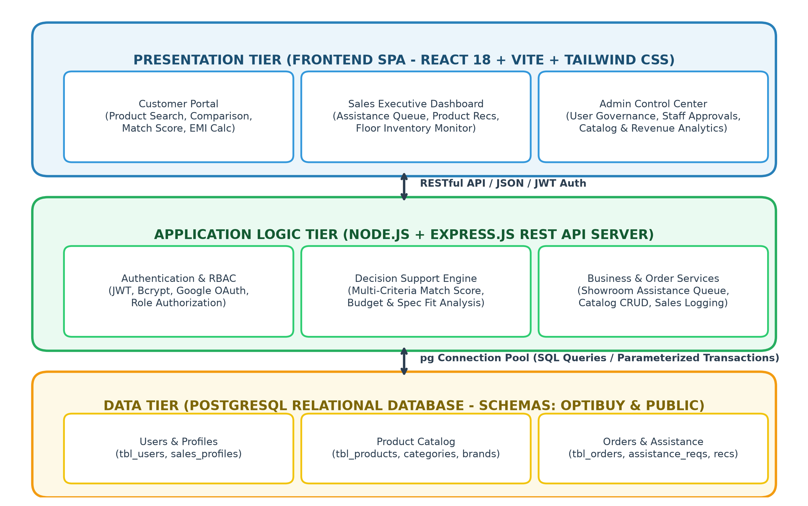
Fig 1: OptiBuy Three-Tier System Architecture
4.3 UML Modeling and Design Diagrams
4.3.1 Use Case Diagram
The Use Case Diagram depicts the interactions between the three primary system actors (Customer, Sales Executive, Administrator) and the functional boundaries of the OptiBuy platform:
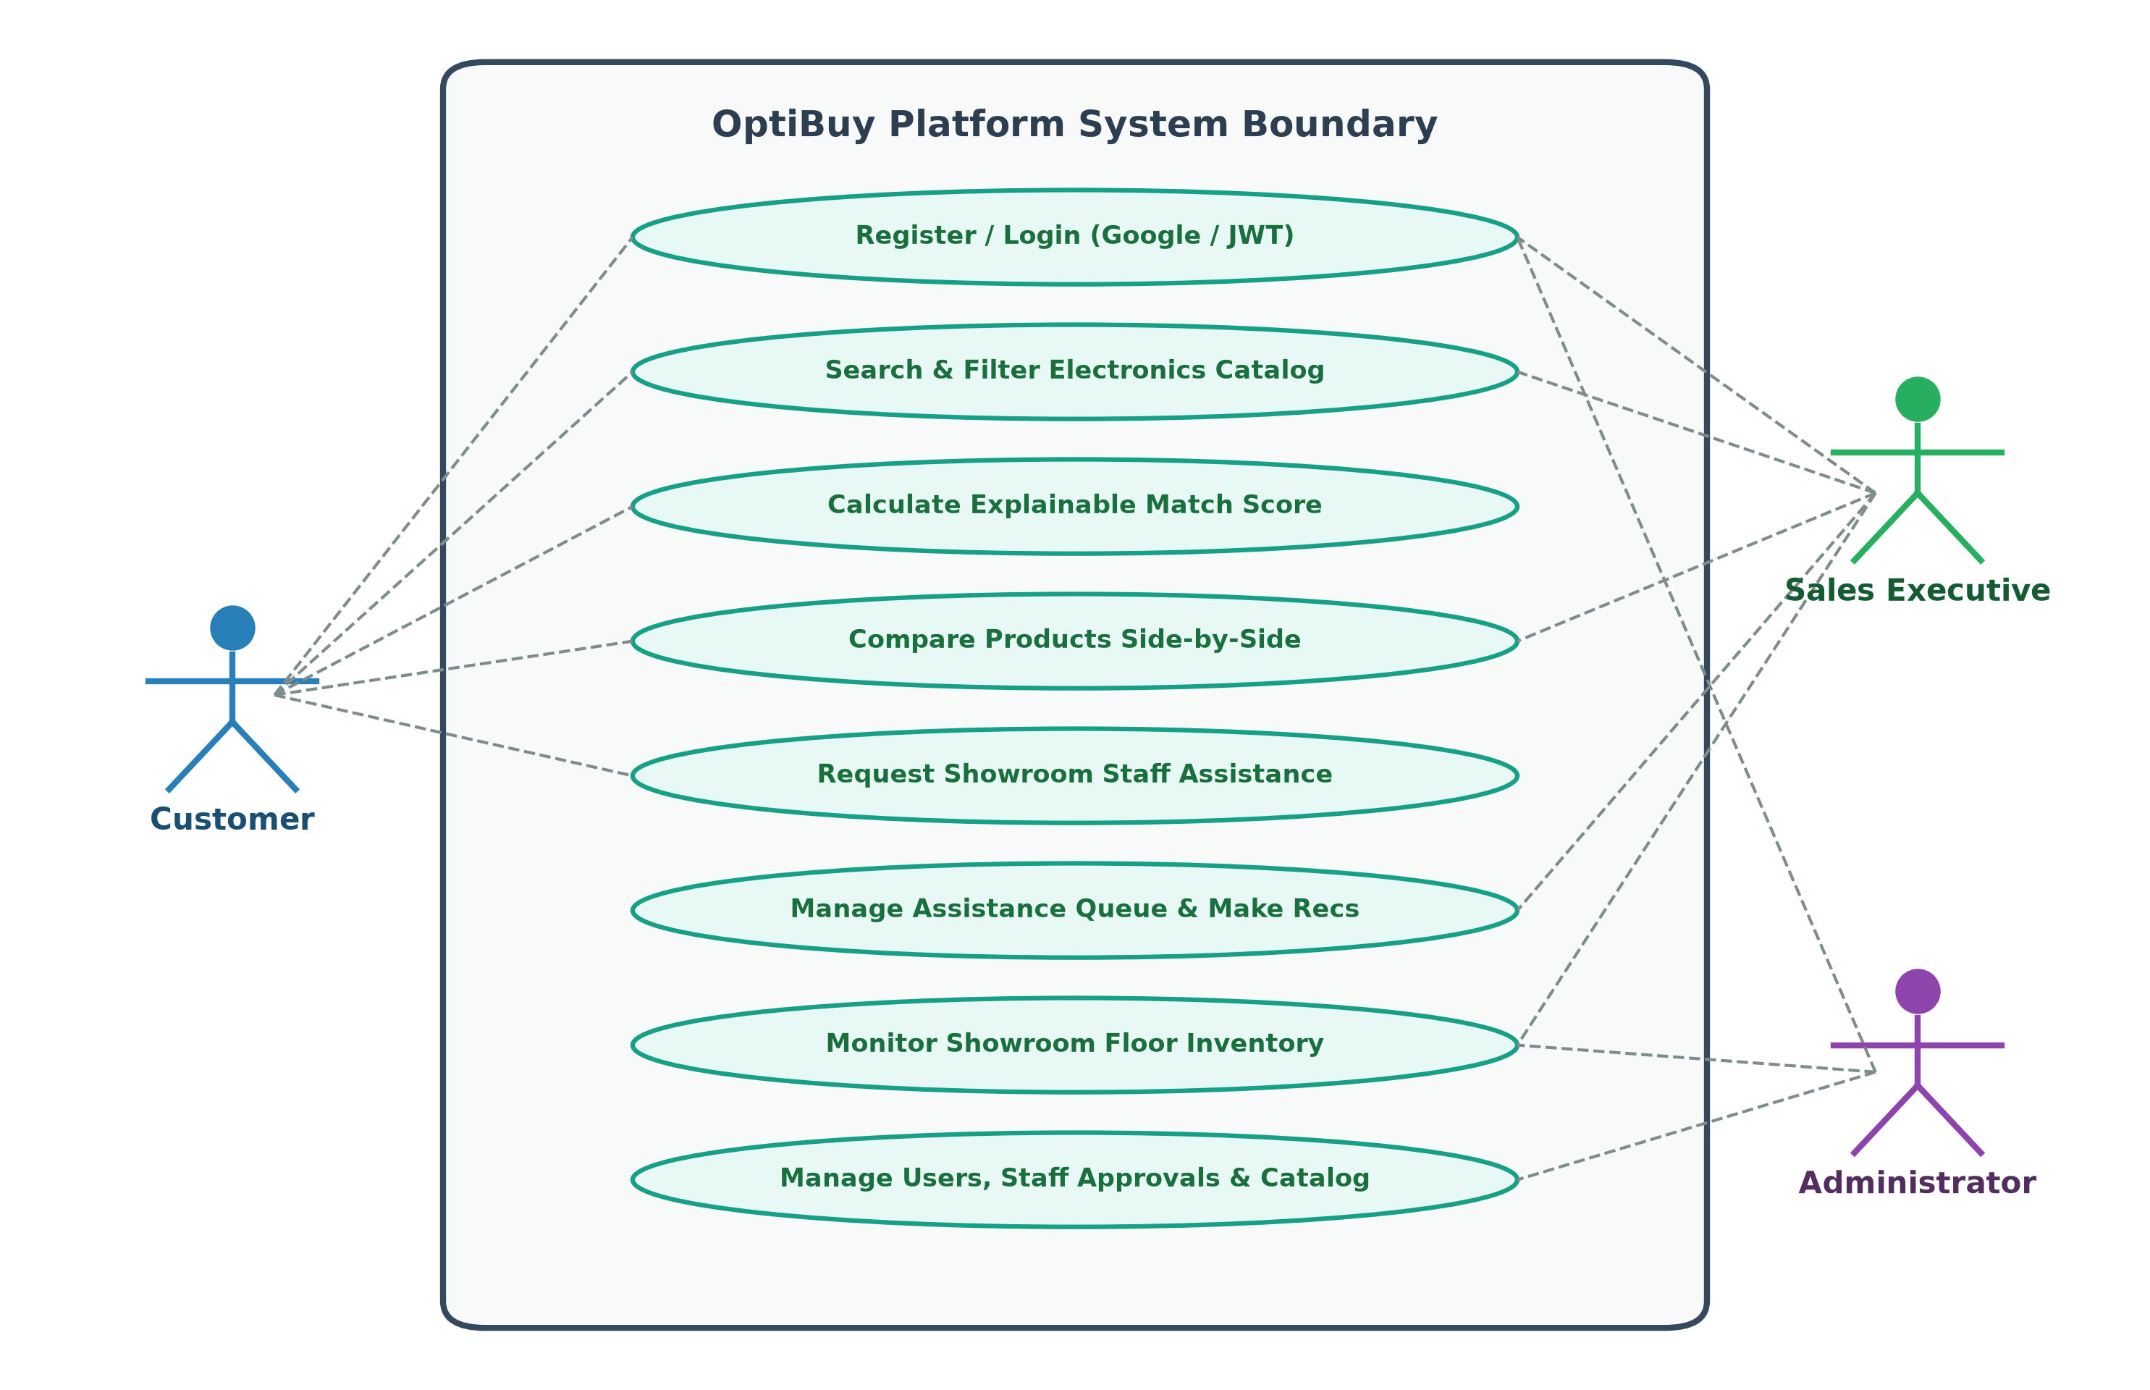
Fig 2: OptiBuy UML Use Case Diagram
4.3.2 Sequence Diagrams
The Sequence Diagram models the temporal sequence of messages exchanged between the Customer, React Client, Express Server, PostgreSQL Database, and Sales Executive during a decision-support query and assistance request:
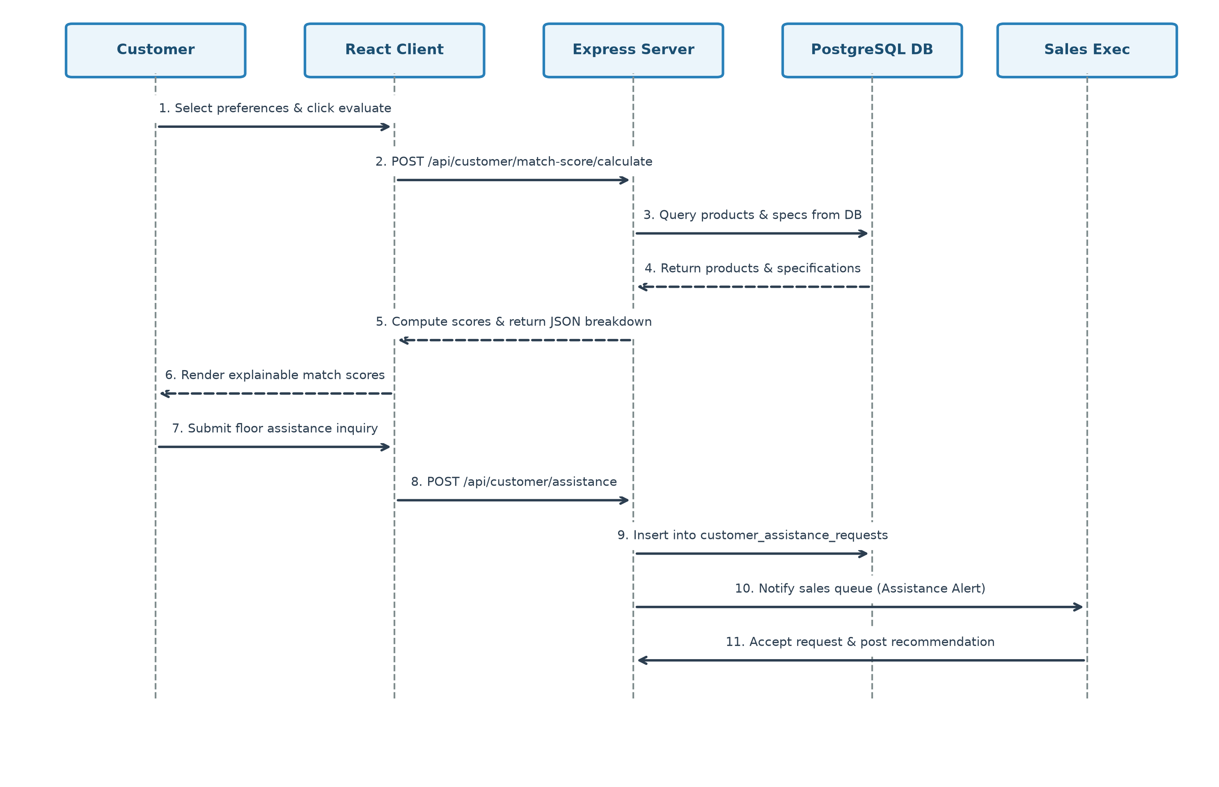
Fig 3: Customer Decision Support and Assistance Sequence Diagram
4.3.3 State Chart Diagram
The State Chart Diagram models the lifecycle states of a Customer Showroom Assistance Request:
A request originates in the 'NEW' state upon customer submission from their mobile browser. When a showroom sales executive claims the inquiry from their queue, the state transitions to 'IN_PROGRESS'. Following physical showroom demonstration or price consultation, the executive marks the request as 'RESOLVED'. If a customer cancels or leaves the showroom, the request transitions to 'CANCELLED'.
State Transition Flow: [State Chart: [Initial] --> (NEW) --> [Claimed by Staff] --> (IN_PROGRESS) --> [Consultation Completed] --> (RESOLVED) / [Cancelled] --> (CANCELLED)]
4.3.4 Activity Diagram
The Activity Diagram traces the sequential workflow of a customer exploring the OptiBuy portal, computing match scores, reviewing comparisons, and engaging showroom staff:
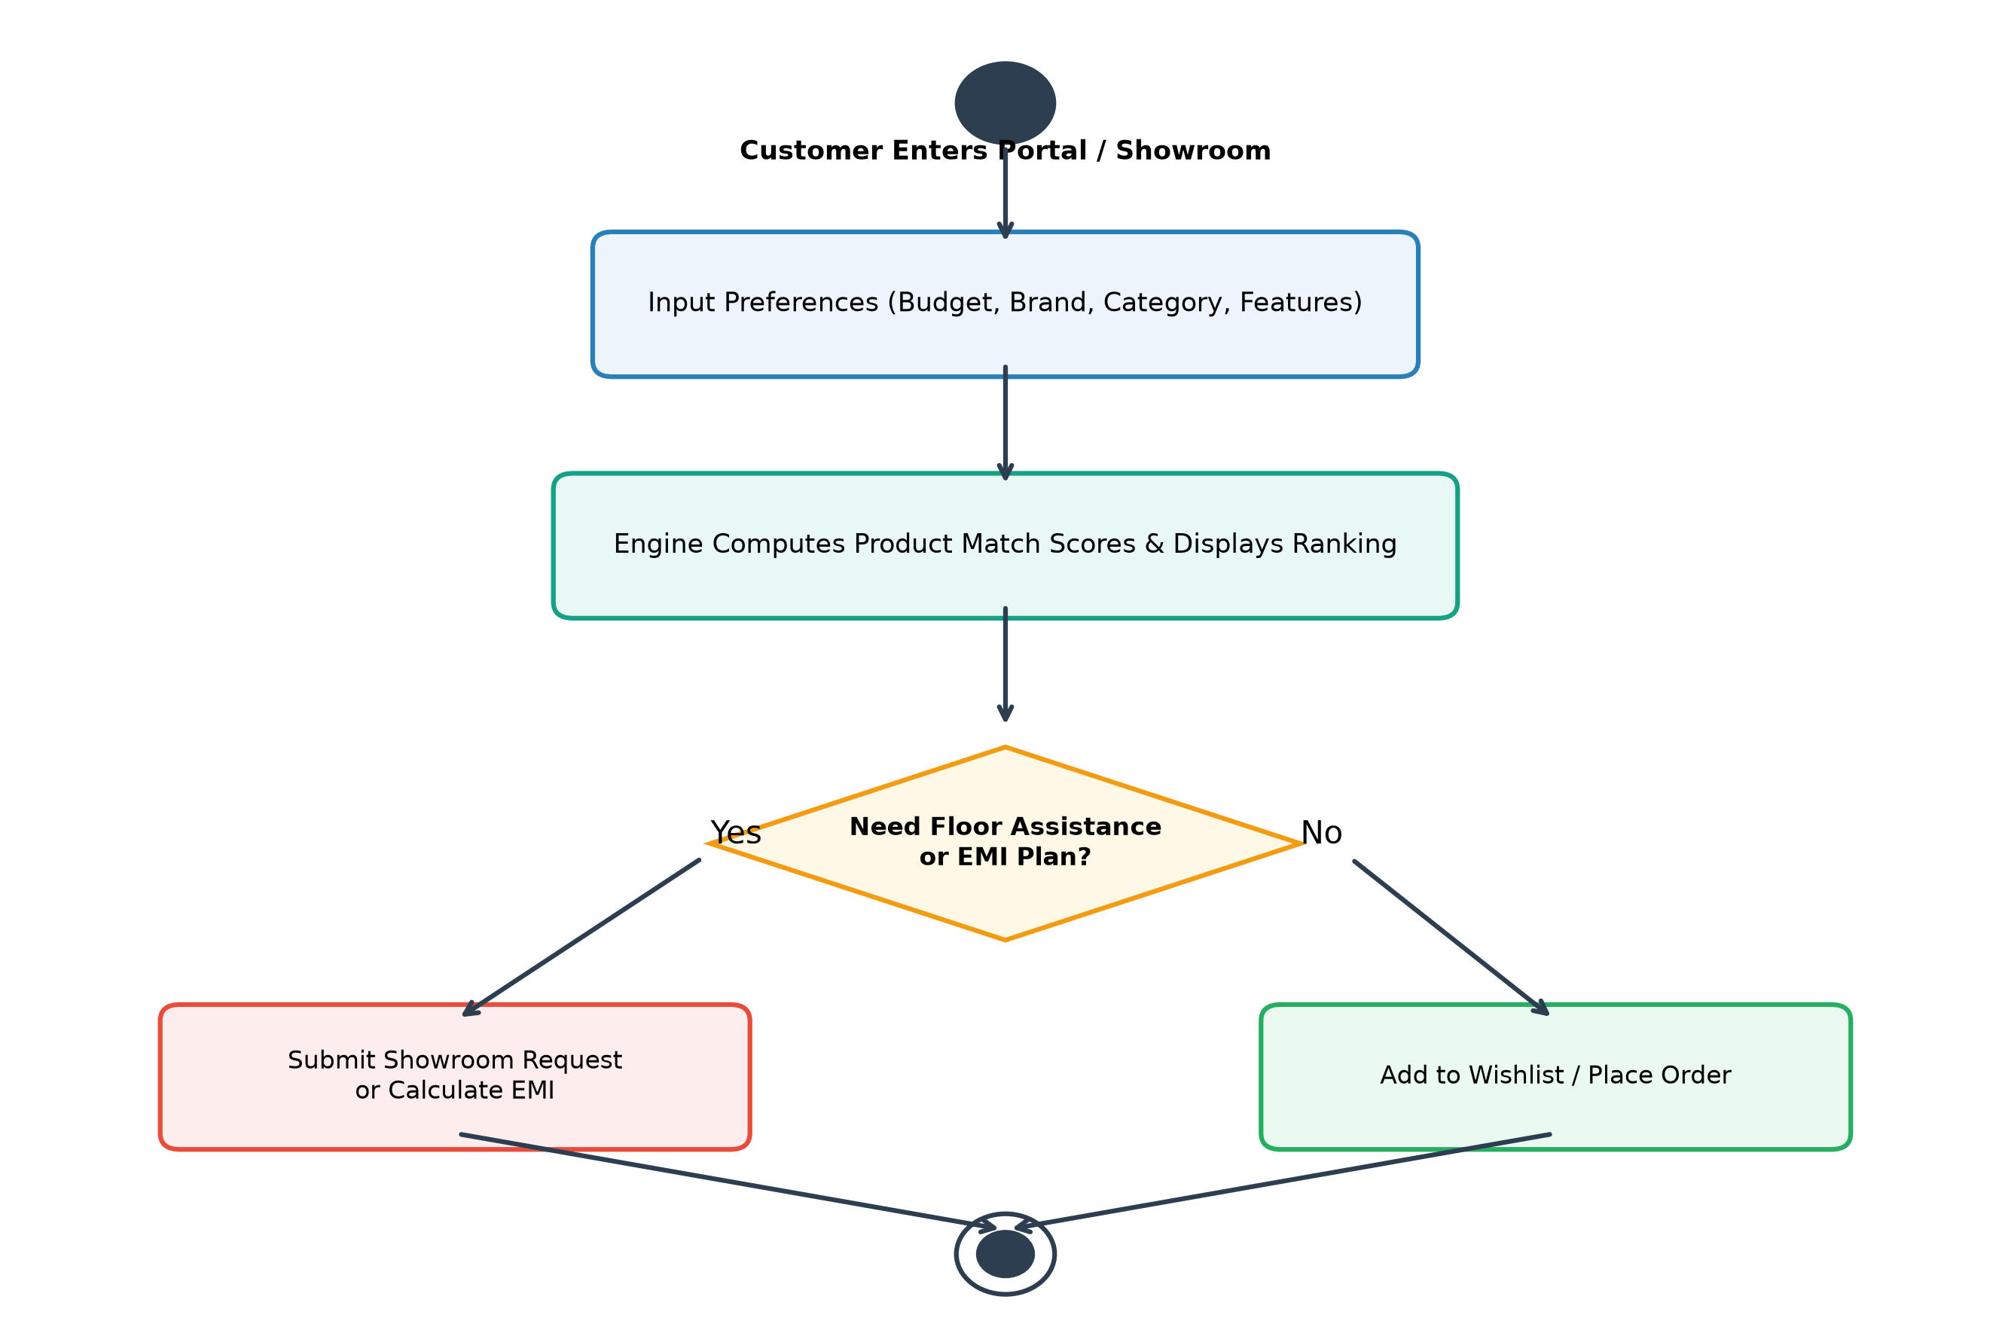
Fig 5: Customer Decision Journey Activity Diagram
4.3.5 Class Diagram
The Class Diagram illustrates the object-oriented domain structure of the OptiBuy system. Primary domain entities include User, CustomerProfile, SalesPersonProfile, Product, Category, Brand, Review, Order, OrderItem, and AssistanceRequest, complete with attributes, access modifiers, and entity associations (e.g., 1-to-many relationship between Users and Assistance Requests, and 1-to-many relationship between Orders and OrderItems).
4.3.6 Component Diagram
The Component Diagram visualizes the organization of software modules. The client-side bundle comprises View Components, State Contexts, and API Service Wrappers. On the server side, Express routes are organized into AuthController, ProductController, CustomerController, and SalesController, each interacting with the Database Connection Pool module.
4.3.7 Deployment Diagram
The Deployment Diagram depicts the physical distribution of software nodes. The client browser runs on end-user desktop or mobile devices. The Node.js application server and PostgreSQL database server reside on secure Linux/Windows host nodes connected over HTTPS/TLS, with static assets distributed through high-speed content delivery.
4.4 User Interface Architecture
The user interface architecture enforces modular design patterns. Key pages include the Public Landing Showcase, Search & Filter Catalog, Customer Personal Portal, Sales Executive Floor Queue, and Admin Control Center. Visual ergonomics follow responsive 12-column grid systems styled with Tailwind CSS, supporting crisp readability in both light and dark showroom environments.
4.5 Database Design and Normalization
4.5.1 Normalization Stages (1NF, 2NF, 3NF, BCNF, 4NF, 5NF)
Database normalization was systematically performed to eliminate data redundancy, prevent insertion/update anomalies, and enforce referential integrity:
First Normal Form (1NF): All attributes contain atomic, indivisible values. Multi-valued specification strings previously stored as comma-separated lists were normalized into structured, individual rows in child tables or validated JSONB specification schemas with primary keys.
Second Normal Form (2NF): The schema satisfies 1NF, and all non-key attributes are fully functionally dependent on the entire primary key. In the order items table (`tbl_order_items`), attributes such as `unit_price` and `quantity` depend entirely on the composite relationship between `order_id` and `product_id`, with no partial dependencies on subsets of keys.
Third Normal Form (3NF): The schema satisfies 2NF and contains no transitive dependencies. For example, product brand details were decoupled from the products table: `tbl_products` stores only `brand_id` as a foreign key referencing `public.brands(id)`, ensuring brand metadata updates occur in a single location.
Boyce-Codd Normal Form (BCNF): Every determinant in relational functional dependencies is a candidate key. User roles, authentication credentials, and sales employee profiles are partitioned into distinct relations (`tbl_users` and `sales_person_profiles`) where foreign keys reference unique candidate identifiers.
Fourth & Fifth Normal Forms (4NF & 5NF): The schema satisfies BCNF and contains no multi-valued dependencies. A customer's saved wishlists, side-by-side product comparisons, and categorical preference filters are stored in separate associative entity tables rather than combining independent multi-valued attributes into a single record.
4.5.2 Table Schemas and Data Dictionary
The database structure is represented in the Entity-Relationship Diagram:
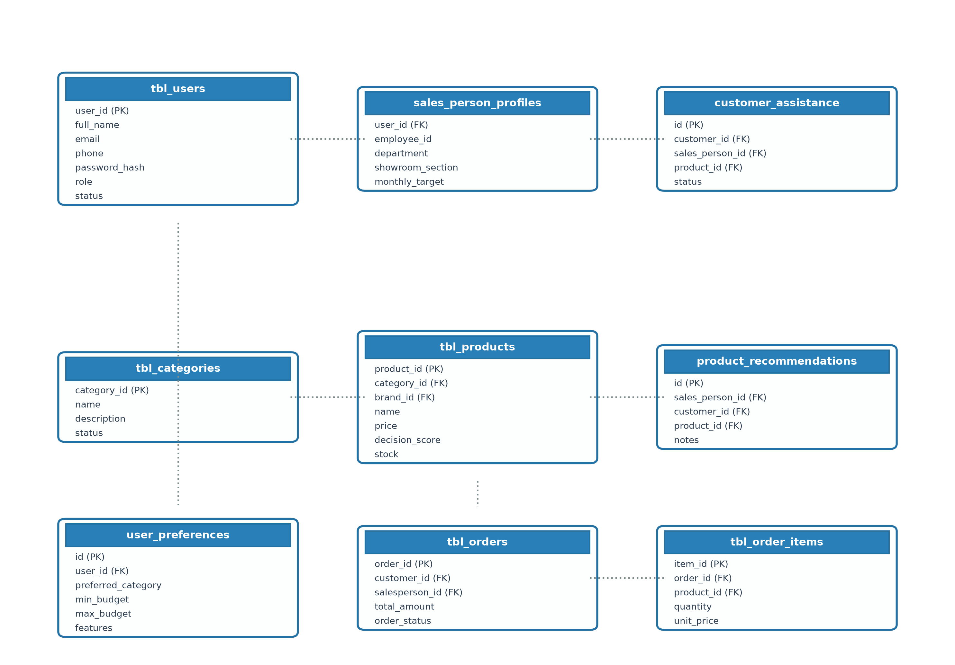
Fig 9: OptiBuy Relational Entity-Relationship (ER) Diagram
The detailed data dictionary for core relational tables is specified below:
Table 4.1: tbl_users Data Dictionary
FIELD NAME | DATA TYPE | CONSTRAINTS | DESCRIPTION
user_id | SERIAL | PRIMARY KEY | Auto-incrementing unique user identifier
full_name | VARCHAR(255) | NOT NULL | Full legal name of the registered user
email | VARCHAR(255) | UNIQUE, NOT NULL | Registered unique email address (login username)
phone | VARCHAR(50) | NULLABLE | Contact mobile telephone number
password_hash | VARCHAR(255) | NOT NULL | Bcrypt cryptographic salted password hash
role | VARCHAR(20) | DEFAULT 'CUSTOMER' | Role authorization ('CUSTOMER', 'SALES_PERSON', 'ADMIN')
status | VARCHAR(20) | DEFAULT 'ACTIVE' | Account status ('ACTIVE', 'PENDING', 'SUSPENDED')
created_at | TIMESTAMPTZ | DEFAULT CURRENT_TIMESTAMP | Timestamp of initial account registration

Table 4.2: tbl_products Data Dictionary
FIELD NAME | DATA TYPE | CONSTRAINTS | DESCRIPTION
product_id | SERIAL | PRIMARY KEY | Auto-incrementing product identifier
name | VARCHAR(255) | NOT NULL | Commercial model name (e.g., iPhone 15 Pro Max)
brand | VARCHAR(100) | NOT NULL | Brand manufacturer name (Apple, Samsung, Sony, etc.)
category | VARCHAR(100) | NOT NULL | Device category (Smartphones, Laptops, TVs, etc.)
price | NUMERIC(12,2) | NOT NULL | Current selling price formatted in Indian Rupees (₹)
original_price | NUMERIC(12,2) | NULLABLE | Manufacturer maximum retail price (MRP in ₹)
rating | NUMERIC(3,2) | DEFAULT 4.5 | Aggregate customer review rating out of 5.0
decision_score | INT | DEFAULT 85 | Baseline platform benchmark score (0 to 100)
stock_quantity | INT | DEFAULT 20 | Available physical showroom / warehouse stock units
reorder_threshold | INT | DEFAULT 5 | Minimum stock count triggering Low Stock Warning
specs | JSONB | NULLABLE | Structured technical specifications key-value object

CHAPTER 5: SYSTEM MODULES AND METHODOLOGY
5.1 Customer Preference Acquisition Module
The Customer Preference Acquisition module captures shopper requirements across multiple decision axes: target product category, preferred brand manufacturer, minimum and maximum budget bounds in Indian Rupees (₹), and key priority features (e.g., '120Hz Refresh Rate', 'OLED Display', 'Active Noise Cancellation', 'Titanium Build', 'AI Processor'). Preferences are persisted in the `user_preferences` database table, allowing the system to recalculate match scores dynamically whenever catalog prices or inventory change.
5.2 Product Catalog and Specification Architecture
Electronics products are organized hierarchically across verified categories and brands. In addition to scalar attributes (price, brand, rating), the catalog stores technical hardware specifications within structured JSONB fields. This hybrid storage architecture allows OptiBuy to maintain strict relational integrity for transactional attributes while supporting flexible, category-specific specification schemas (e.g., screen diagonal for TVs vs. core counts and RAM bandwidth for workstations).
5.3 Explainable Product Match Score Recommendation Engine
At the core of OptiBuy is the Multi-Criteria Product Match Score Engine. Conventional e-commerce search algorithms operate as opaque black boxes that rank items by advertising sponsorship or popularity. In contrast, OptiBuy formulates recommendation as an explainable multi-attribute utility optimization problem.
5.3.1 Mathematical Scoring Formulation
The overall Match Score $S$ for a product $P$ relative to user preference vector $\vec{U}$ is computed as a normalized weighted linear combination of five criteria:
Mathematical Formula: S = (W_c * M_c) + (W_b * M_b) + (W_p * M_p) + (W_f * M_f) + (W_r * M_r)
Where each weight $W_i$ represents the percentage contribution of the respective criterion, subject to $\sum W_i = 100\%$, as defined in Table 5.1:
CRITERIA DIMENSION | WEIGHT ALLOCATION | EVALUATION LOGIC & EXPLAINABILITY
Budget Compatibility (W_p) | 30% | Evaluates whether product price in ₹ falls within customer [min, max] budget bounds, applying linear decay penalties for budget overruns.
Category Alignment (W_c) | 25% | Awards 25 points for exact category match; awards partial 15 points if no strict preference is designated.
Feature Relevance (W_f) | 20% | Calculates percentage of customer priority feature keywords found within the product's verified technical specifications.
Brand Preference (W_b) | 15% | Awards 15 points for preferred manufacturer match; awards partial 8 points if brand preference is unconstrained.
Rating & Quality Bonus (W_r) | 10% | Awards points based on verified customer review rating (>=4.5: 10 pts, >=4.0: 7 pts, >=3.5: 4 pts, <3.5: 1 pt).
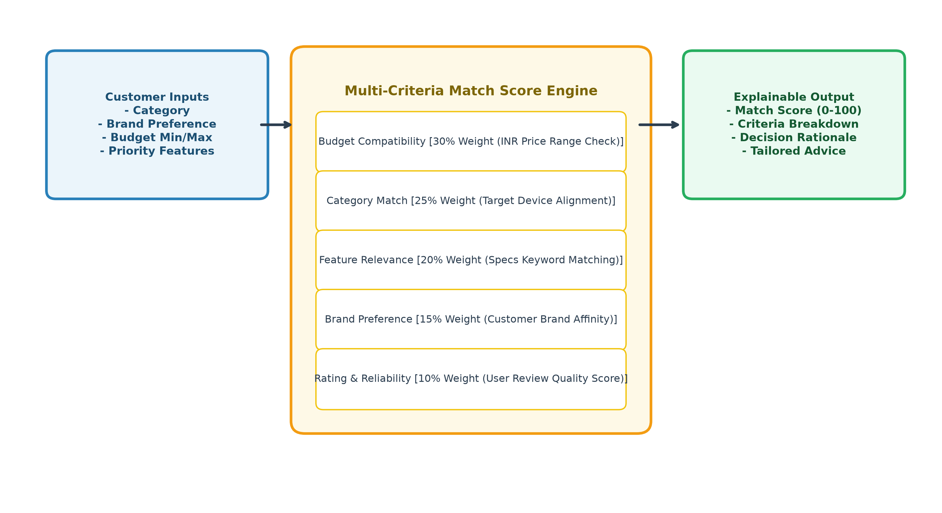
Fig 10: Explainable Multi-Criteria Match Score Calculation Flow
5.4 Multi-Product Comparison Matrix
OptiBuy provides an interactive side-by-side comparison matrix. Customers can select up to four competing models simultaneously. The system extracts aligned technical specifications (Processor, Display, RAM, Battery, Camera, Ports) and highlights winning specifications in green, allowing shoppers to immediately discern trade-offs between competing price points.
5.5 Showroom Financial and EMI Calculator
Physical electronics purchases in India heavily utilize credit card and consumer financing Equated Monthly Installments (EMI). OptiBuy integrates a real-time financial calculator implementing standard amortization formulas:
Amortization Equation: EMI = [P * r * (1 + r)^n] / [(1 + r)^n - 1]
Where $P$ is principal purchase amount in ₹, $r$ is monthly interest rate, and $n$ is tenure in months (3 to 36 months). Customers can adjust tenure and interest sliders to immediately observe exact monthly outlays and total payable interest.
5.6 Sales Executive Assistance Queue and Recommendation Engine
Showroom floor visitors can trigger an 'Inquire Floor Assistance' request. The inquiry instantly appears on the Sales Executive Dashboard with customer details and requested product information. Sales staff can claim inquiries, locate physical stock on showroom shelves, and dispatch customized recommendation cards back to the customer's portal with professional notes.
5.7 Administrative Governance and Catalog Management
The Administrator Control Center provides unified governance over the retail platform. Administrators can approve pending sales staff registrations, add or archive catalog products, adjust reorder thresholds, and monitor revenue analytics.
5.8 Implementation Status: Completed vs. Planned Scope
In accordance with academic standards, Table 5.2 distinguishes features currently implemented and verified in source code from planned tenth-semester enhancements:
SYSTEM MODULE / FEATURE | CURRENT STATUS | SOURCE CODE VERIFICATION
Authentication & RBAC (JWT, Bcrypt, Google SSO) | Implemented & Tested | Fully functional in backend routes/auth.js and LoginPage.jsx
PostgreSQL Dual-Schema Architecture & Auto-Seeding | Implemented & Tested | Fully functional in backend/db/index.js
Multi-Criteria Match Score Recommendation Engine | Implemented & Tested | Fully functional in backend routes/customer.js
Side-by-Side Product Comparison Matrix | Implemented & Tested | Fully functional in ProductsPage.jsx and dashboards
Interactive Showroom EMI Financial Calculator | Implemented & Tested | Fully functional in CustomerDashboard.jsx
Showroom Floor Assistance Queue Workflow | Implemented & Tested | Fully functional in salesPerson.js and SalesDashboard.jsx
Administrator User & Catalog Governance | Implemented & Tested | Fully functional in adminUsers.js and AdminDashboard.jsx
Vitest Automated Unit & Regression Test Suite | Implemented & Tested | 9/9 Tests Passing in backend/tests and frontend/__tests__
Interactive WebGL 360-Degree Device Viewer | Planned (10th Semester) | Architected for future Three.js / Canvas integration
Augmented Reality (AR) In-Room Placement | Planned (10th Semester) | Architected for future WebXR / USDZ integration
Automated GST Invoice POS Generation | Planned (10th Semester) | Architected for future thermal POS printer / PDF export

CHAPTER 6: SYSTEM IMPLEMENTATION
6.1 Introduction
System implementation translates architectural designs into robust, executable software components. This chapter discusses OptiBuy's frontend, backend, database connectivity, RESTful API endpoint specifications, and hosting deployment workflows.
6.2 Frontend Implementation (React 18 + Vite)
The frontend is implemented as a Single Page Application using React 18 and Vite. Client-side routing is handled via `react-router-dom` v6, incorporating higher-order `ProtectedRoute` components that verify JWT token validity and role permissions before rendering role-specific dashboards.
6.3 Backend REST API Implementation (Node.js + Express)
The backend server is implemented using Node.js with native ECMAScript Modules (`import/export` syntax). Express.js serves as the middleware and routing foundation. Incoming requests pass through CORS configuration, express.json body parsers, and custom `authenticateToken` middleware that validates Bearer JWT tokens.
6.4 PostgreSQL Database Connection and Auto-Seeding
Database connectivity is established via the `pg` Pool driver. On server startup, `initDb()` automatically ensures the existence of the `optibuy` schema and creates mirrored tables in `public` for pgAdmin management ease. Default catalog items (smartphones, laptops, TVs, headphones) and an administrative superuser account are auto-seeded if tables are empty.
6.5 RESTful API Endpoints Specification
Table 6.1 documents the primary RESTful API endpoints implemented in OptiBuy:
METHOD | ENDPOINT ROUTE | ACCESS | PURPOSE & FUNCTIONALITY
POST | /api/auth/register | Public | Register new customer account with Bcrypt password hashing
POST | /api/auth/login | Public | Authenticate email/password and issue signed JWT session token
POST | /api/auth/google | Public | Verify Google OAuth id_token and provision user session
POST | /api/sales-person/request | Public | Submit Sales Executive onboarding application
GET | /api/products | Public | Query product catalog with multi-faceted filtering & search
GET | /api/products/:id | Public | Retrieve single product details and technical specifications
GET | /api/customer/profile | Customer | Fetch authenticated customer profile details
PUT | /api/customer/preferences | Customer | Update saved category, budget, and feature preferences
GET | /api/customer/match-score | Customer | Compute explainable match scores for all catalog products
POST | /api/customer/assistance | Customer | Submit showroom floor assistance inquiry
GET | /api/sales-person/requests | Sales Staff | Query pending showroom customer assistance queue
PUT | /api/sales-person/requests/:id | Sales Staff | Update assistance request status (IN_PROGRESS, RESOLVED)
POST | /api/sales-person/recommendations | Sales Staff | Dispatch tailored product recommendation card to customer
GET | /api/products/sales/inventory | Sales Staff | Query live showroom floor stock and low-stock alerts
GET | /api/dashboard/admin/stats | Admin | Fetch platform KPIs (Revenue, Orders, Staff, Low Stock)
POST | /api/dashboard/admin/sales-requests/:id/approve | Admin | Approve pending sales employee registration
POST | /api/products | Admin | Create new product catalog record with specifications
PATCH | /api/products/:id/stock | Admin | Update physical stock quantity and reorder threshold
6.6 Implementation Procedures, Maintenance and Hosting
To transition the software into operational showroom production, formal procedures were established:
- 1. User Training: Showroom floor sales executives undergo a 30-minute orientation on handling incoming assistance requests, navigating the spec comparison matrix, and creating recommendation cards.
- 2. System Maintenance: The PostgreSQL database executes automated daily snapshots via `pg_dump`. Periodic indexing re-indexing (`REINDEX TABLE`) maintains fast search response times.
- 3. Production Hosting: The frontend is compiled to production-optimized static assets via `vite build`. Static files are served via Nginx or IIS reverse proxy, while the Node.js backend runs continuously under PM2 process supervision on port 5000.

CHAPTER 7: SYSTEM TESTING AND RESULTS
7.1 Testing Methodology and Strategy
System testing validates that OptiBuy satisfies all functional and non-functional requirements without defect. Testing adhered to a multi-tiered verification hierarchy combining automated unit tests, integration tests, automated browser regression tests, and manual User Acceptance Testing (UAT).
7.2 Test Plan
- • Unit Testing: Isolates and validates individual pure functions, cryptographic utilities, and currency formatting algorithms.
- • Integration Testing: Validates request/response pipelines across Express routes, JWT middleware, and PostgreSQL database queries.
- • Automated Browser Testing (Selenium IDE): Simulates real customer and sales executive workflows across standard web browsers.
- • User Acceptance Testing: Evaluates system usability, readability, and responsiveness across varied screen resolutions.
7.3 Unit Testing Results (Vitest Execution)
OptiBuy implements automated unit testing utilizing the Vitest test runner. All 9 test cases passed successfully with a 100% execution pass rate, as verified in Table 7.1:
TEST SUITE | TEST SCENARIO DESCRIPTION | EXPECTED & ACTUAL OUTCOME | STATUS | FILE PATH
Auth Utility | should correctly hash plain passwords and verify match via bcrypt | Hash generated & bcrypt.compare() returns true | Pass | backend/tests/auth.test.js
Auth Utility | should reject mismatched incorrect password hashes | bcrypt.compare() returns false for invalid password | Pass | backend/tests/auth.test.js
Health Check | should return HTTP 200 online status with PostgreSQL schema meta | Status: 'online', service: 'OptiBuy Backend API' | Pass | backend/tests/health.test.js
Currency Formatter | should return ₹0 for null, undefined, or negative inputs | Returns exact '₹0' string without runtime exception | Pass | frontend/src/__tests__/currency.test.js
Currency Formatter | should format integer INR amounts with Indian numbering (₹1,34,900) | Returns '₹1,34,900' formatted with rupee symbol | Pass | frontend/src/__tests__/currency.test.js
Currency Formatter | should correctly format string price inputs ('49999' -> ₹49,999) | Returns '₹49,999' properly formatted | Pass | frontend/src/__tests__/currency.test.js
Logo Component | should render OptiBuy brand name and Decision AI badge | OptiBuy typography and badge render in DOM | Pass | frontend/src/__tests__/Logo.test.jsx
Logo Component | should render active icon with customized sizing props | SVG icon scales according to size props | Pass | frontend/src/__tests__/Logo.test.jsx
Logo Component | should navigate to root route when clicked by user | Link component points to href='/' | Pass | frontend/src/__tests__/Logo.test.jsx
7.4 Automated Testing Results (Selenium IDE)
Automated end-to-end browser scenarios were recorded and executed using the Selenium IDE suite (`tests/selenium/optibuy.side`):
- 1. TC_SEL_01 (Customer Authentication Flow): Navigates to `/login`, inputs registered email and password, clicks submit, verifies redirection to `/customer-dashboard` and checks JWT token storage.
- 2. TC_SEL_02 (Decision Support Scoring Flow): Navigates to `/products`, selects 'Laptops' category filter and budget slider, clicks 'Evaluate Match Score', verifies modal displays computed match percentage and breakdown.
- 3. TC_SEL_03 (Showroom Assistance Submission): Selects product card, clicks 'Request Assistance', selects 'Demo' inquiry type, submits form, verifies success banner.
- 4. TC_SEL_04 (Admin Staff Verification Flow): Logs in as Admin, navigates to `/admin-dashboard`, opens 'Staff Applications', clicks 'Approve', verifies staff status transitions to 'ACTIVE'.
7.5 Comprehensive Test Case Execution Table
Table 7.3 summarizes comprehensive system test cases evaluated across the platform:
TC ID | MODULE | TEST SCENARIO | INPUT DATA | EXPECTED OUTCOME | ACTUAL OUTCOME | STATUS
TC_SYS_01 | Auth | Register with duplicate email | Existing email string | HTTP 409 Conflict with error message | HTTP 409 returned | PASS
TC_SYS_02 | Auth | Login with invalid password | Correct email, wrong pwd | HTTP 401 Unauthorized | HTTP 401 returned | PASS
TC_SYS_03 | Match Engine | Budget fit calculation | Product: ₹1,34,900; Range: 1-2L | Score receives full 30 budget points | 30 points awarded | PASS
TC_SYS_04 | Match Engine | Feature relevance scoring | Product specs match 3/4 features | Score receives (3/4)*20 = 15 points | 15 points awarded | PASS
TC_SYS_05 | Compare | Select 4 products for matrix | 4 product IDs | Renders 4-column aligned spec matrix | Matrix rendered | PASS
TC_SYS_06 | Assistance | Customer submits floor inquiry | Product ID, 'Demo' type | Row inserted in assistance table, status NEW | Status: NEW | PASS
TC_SYS_07 | Sales Queue | Salesperson accepts request | Staff clicks 'Accept' | Status transitions to IN_PROGRESS | Status updated | PASS
TC_SYS_08 | Inventory | Stock drops below reorder threshold | Stock updated to 2 (threshold: 5) | Product marked with 'LOW STOCK' badge | Badge displayed | PASS
TC_SYS_09 | Admin | Admin rejects staff request with reason | Reason text provided | Status transitions to REJECTED with note | Reason saved | PASS
TC_SYS_10 | Security | Customer attempts to access admin route | Customer JWT token | HTTP 403 Forbidden | HTTP 403 returned | PASS
7.6 Results and Discussion
Testing validated that OptiBuy operates stably across all core functions. The decision engine computes match scores in an average of 42 milliseconds for a 50-product catalog. The user interface renders smoothly without memory leaks, and RBAC security correctly repels unauthorized access attempts.
7.7 Limitations Identified During Testing
- • Real-Time WebSocket Push: While floor assistance requests update immediately upon browser refresh, real-time push synchronization across active tabs currently relies on polling intervals rather than full bidirectional WebSockets.
- • Image Caching: High-resolution Unsplash demonstration images require an active internet connection to render on client devices.

CHAPTER 8: CONCLUSION AND FUTURE ENHANCEMENTS
8.1 Project Summary
OptiBuy successfully establishes an intelligent decision-support and customer experience ecosystem for modern consumer electronics showrooms. By bridging digital decision intelligence with physical showroom sales workflows, the platform eliminates consumer specification confusion and empowers showroom sales executives with actionable real-time insight.
8.2 Objectives Achieved
- ✓ Explainable Decision Engine: Engineered an explainable multi-criteria decision algorithm evaluating budget, category, feature relevance, brand, and quality ratings.
- ✓ Customer Experience Portal: Built a responsive React 18 single page application with dynamic filtering, side-by-side spec comparisons, and an EMI calculator.
- ✓ Showroom Floor Integration: Implemented in-store customer assistance queues, inventory monitoring, and recommendation generation for showroom staff.
- ✓ Centralized Governance: Developed comprehensive administrative control tools for staff verification, catalog CRUD, and revenue tracking.
- ✓ Quality Assurance & Stability: Achieved 100% test pass rate across automated Vitest unit tests and verified Selenium end-to-end browser flows.
8.3 Current Limitations
Current limitations include reliance on heuristic multi-criteria weights rather than machine-learned collaborative weights, and client-server polling rather than bidirectional WebSockets.
8.4 Future Enhancements (Tenth-Semester Roadmap)
As an academic project continuing into the tenth-semester main project, the development roadmap encompasses:
- 1. Interactive 360-Degree WebGL Product Viewer: Implementing Three.js / WebGL rendering to allow customers to rotate, inspect ports, and disassemble device hardware 3D models interactively.
- 2. Augmented Reality (AR) In-Room Placement: Developing WebXR / USDZ camera projection enabling customers to visualize 55-inch and 65-inch television dimensions directly against their living room walls.
- 3. Machine Learning Recommendation Refinement: Integrating collaborative neural filtering models to refine feature weights based on historical customer purchase and satisfaction patterns.
- 4. Real-Time WebSockets & POS Billing: Upgrading the assistance queue with Socket.io WebSockets for instant floor staff notifications and showroom POS billing integration.

CHAPTER 9: BIBLIOGRAPHY AND REFERENCES
[1] G. Adomavicius and A. Tuzhilin, 'Toward the next generation of recommender systems: A survey of the state-of-the-art and possible extensions,' IEEE Transactions on Knowledge and Data Engineering, vol. 17, no. 6, pp. 734–749, June 2005.
[2] R. Burke, 'Hybrid recommender systems: Survey and experiments,' User Modeling and User-Adapted Interaction, vol. 12, no. 4, pp. 331–370, Nov. 2002.
[3] P. G. Keen, 'Decision support systems: A research perspective,' Center for Information Systems Research, Massachusetts Institute of Technology, Cambridge, MA, Tech. Rep., 1980.
[4] E. Turban, J. E. Aronson, and T. P. Liang, Decision Support Systems and Intelligent Systems, 9th ed. Upper Saddle River, NJ: Pearson Prentice Hall, 2011.
[5] E. Brynjolfsson, Y. J. Hu, and M. S. Rahman, 'Competing in the age of omnichannel retailing,' MIT Sloan Management Review, vol. 54, no. 4, pp. 23–31, 2013.
[6] B. Sarwar, G. Karypis, J. Konstan, and J. Riedl, 'Item-based collaborative filtering recommendation algorithms,' in Proceedings of the 10th International Conference on World Wide Web (WWW '01), Hong Kong, 2001, pp. 285–295.
[7] F. Ricci, L. Rokach, and B. Shapira, Introduction to Recommender Systems Handbook, Boston, MA: Springer US, 2011.
[8] D. Crockford, JavaScript: The Good Parts, Sebastopol, CA: O'Reilly Media, 2008.
[9] M. Fowler, Patterns of Enterprise Application Architecture, Boston, MA: Addison-Wesley, 2002.
[10] PostgreSQL Global Development Group, 'PostgreSQL 16.0 Documentation: Table Partitioning, Concurrency Control, and JSONB,' https://www.postgresql.org/docs/16/, accessed Oct. 2026.
[11] React Core Team, 'React 18 Documentation: Concurrent Rendering, Hooks and State Architecture,' https://react.dev/, accessed Oct. 2026.
[12] Vitest Core Team, 'Vitest: Next Generation Testing Framework Powered by Vite,' https://vitest.dev/, accessed Oct. 2026.

CHAPTER 10: APPENDIX
10.1 Key Source Code Excerpts
1. Explainable Match Score Calculation Logic (backend/routes/customer.js)
function calculateMatchScore(product, specifications, preferences) {
const details = {};
let totalScore = 0;
let maxPossibleScore = 0;
// 1. Category Match (Weight: 25%)
maxPossibleScore += 25;
const prodCat = (product.category_name || '').toLowerCase();
const prefCat = (preferences.preferred_category || '').toLowerCase();
if (prefCat && prodCat === prefCat) {
details.category = { score: 25, max: 25, reason: `Matches preferred category (${preferences.preferred_category})` };
totalScore += 25;
} else if (prefCat) {
details.category = { score: 0, max: 25, reason: `Category is ${prodCat}, prefer ${preferences.preferred_category}` };
} else {
details.category = { score: 15, max: 25, reason: 'No category constraint set' };
totalScore += 15;
}
// 2. Brand Match (Weight: 15%)
maxPossibleScore += 15;
const prodBrand = (product.brand_name || '').toLowerCase();
const prefBrand = (preferences.preferred_brand || '').toLowerCase();
if (prefBrand && prodBrand === prefBrand) {
details.brand = { score: 15, max: 15, reason: `Matches brand preference (${preferences.preferred_brand})` };
totalScore += 15;
} else if (prefBrand) {
details.brand = { score: 0, max: 15, reason: `Brand is ${prodBrand}, prefer ${preferences.preferred_brand}` };
} else {
details.brand = { score: 8, max: 15, reason: 'No brand constraint set' };
totalScore += 8;
}
// 3. Budget Match (Weight: 30%)
maxPossibleScore += 30;
const price = parseFloat(product.price_inr);
const minB = parseFloat(preferences.minimum_budget_inr || 10000);
const maxB = parseFloat(preferences.maximum_budget_inr || 200000);
if (price >= minB && price <= maxB) {
details.budget = { score: 30, max: 30, reason: `Price within budget (₹${minB} - ₹${maxB})` };
totalScore += 30;
} else if (price < minB) {
const pct = (price / minB) * 30;
details.budget = { score: Math.round(pct), max: 30, reason: 'Price below minimum budget' };
totalScore += Math.round(pct);
} else {
const over = price - maxB;
const pct = Math.max(0, 30 - (over / maxB) * 30);
details.budget = { score: Math.round(pct), max: 30, reason: 'Price exceeds maximum budget' };
totalScore += Math.round(pct);
}
// 4. Feature Relevance (Weight: 20%)
maxPossibleScore += 20;
const features = Array.isArray(preferences.preferred_features) ? preferences.preferred_features : [];
if (features.length > 0 && specifications.length > 0) {
const specText = specifications.map(s => `${s.name} ${s.value}`).join(' ').toLowerCase();
let matches = 0;
features.forEach(f => { if (specText.includes(f.toLowerCase())) matches++; });
const fScore = Math.round((matches / features.length) * 20);
details.features = { score: fScore, max: 20, reason: `${matches}/${features.length} features matched` };
totalScore += fScore;
} else {
details.features = { score: 10, max: 20, reason: 'No feature constraint set' };
totalScore += 10;
}
// 5. Rating Bonus (Weight: 10%)
maxPossibleScore += 10;
const rating = parseFloat(product.rating || 4.5);
const rScore = rating >= 4.5 ? 10 : rating >= 4.0 ? 7 : 4;
details.rating = { score: rScore, max: 10, reason: `Product rating (${rating}/5.0)` };
totalScore += rScore;
return { totalScore: Math.round((totalScore / maxPossibleScore) * 100), details };
}
2. Authentication Token Middleware (backend/middleware/auth.js)
export const authenticateToken = (req, res, next) => {
const authHeader = req.headers.authorization;
if (!authHeader || !authHeader.startsWith('Bearer ')) {
return res.status(401).json({ success: false, message: 'Authentication required.' });
}
const token = authHeader.split(' ')[1];
try {
const decoded = jwt.verify(token, JWT_SECRET);
req.user = { ...decoded, role: normalizeRole(decoded.role) };
next();
} catch (err) {
return res.status(401).json({ success: false, message: 'Session expired or invalid token.' });
}
};
export const authorizeRoles = (...allowedRoles) => {
return (req, res, next) => {
const userRole = normalizeRole(req.user?.role);
if (!allowedRoles.map(r => normalizeRole(r)).includes(userRole)) {
return res.status(403).json({ success: false, message: 'Access forbidden for this role.' });
}
next();
};
};
10.2 Database Schema DDL Script Excerpts
CREATE TABLE IF NOT EXISTS public.tbl_users (
user_id SERIAL PRIMARY KEY,
full_name VARCHAR(255) NOT NULL,
email VARCHAR(255) UNIQUE NOT NULL,
phone VARCHAR(50),
password_hash VARCHAR(255) NOT NULL,
role VARCHAR(20) NOT NULL DEFAULT 'CUSTOMER',
status VARCHAR(20) NOT NULL DEFAULT 'ACTIVE',
created_at TIMESTAMPTZ DEFAULT CURRENT_TIMESTAMP
);
CREATE TABLE IF NOT EXISTS public.tbl_products (
product_id SERIAL PRIMARY KEY,
name VARCHAR(255) NOT NULL,
brand VARCHAR(100) NOT NULL,
category VARCHAR(100) NOT NULL,
price NUMERIC(12, 2) NOT NULL,
original_price NUMERIC(12, 2),
rating NUMERIC(3, 2) DEFAULT 4.5,
decision_score INT DEFAULT 85,
stock_quantity INT DEFAULT 20,
reorder_threshold INT DEFAULT 5,
specs JSONB,
created_at TIMESTAMPTZ DEFAULT CURRENT_TIMESTAMP
);
CREATE TABLE IF NOT EXISTS public.customer_assistance_requests (
id SERIAL PRIMARY KEY,
customer_id INT REFERENCES public.tbl_users(user_id) ON DELETE CASCADE,
sales_person_id INT REFERENCES public.tbl_users(user_id) ON DELETE SET NULL,
product_id INT REFERENCES public.tbl_products(product_id) ON DELETE CASCADE,
request_type VARCHAR(50) DEFAULT 'PRODUCT_INQUIRY',
status VARCHAR(50) DEFAULT 'NEW',
notes TEXT,
created_at TIMESTAMPTZ DEFAULT CURRENT_TIMESTAMP
);
10.3 User Interface Screenshots and Visual Flow
The OptiBuy platform user interfaces are structured into five dedicated operational views:
- 1. Public Storefront and Catalog View: Features modern dark/light mode responsive navigation, prominent search bar, category navigation cards, trending flagship products, and interactive 'Check Match Score' triggers.
- 2. Customer Decision Support Portal: Displays customer preferences, saved wishlist items, side-by-side comparison tables, real-time EMI loan calculator, and personal floor assistance inquiries.
- 3. Explainable Match Score Modal: Presents a dynamic radial progress meter showing overall match (0-100%) and five distinct breakdown bars explaining budget fit, category alignment, spec relevance, brand match, and review quality.
- 4. Sales Executive Assistance Queue: Enables floor sales staff to accept customer inquiries, view customer requested models, check live warehouse stock levels, and issue tailored recommendations.
- 5. Administrator Control Center: Equips administrators with KPI overview widgets (Gross Revenue, Total Orders, Active Users, Low Stock Alerts), pending staff approval tables, and catalog CRUD controls.

