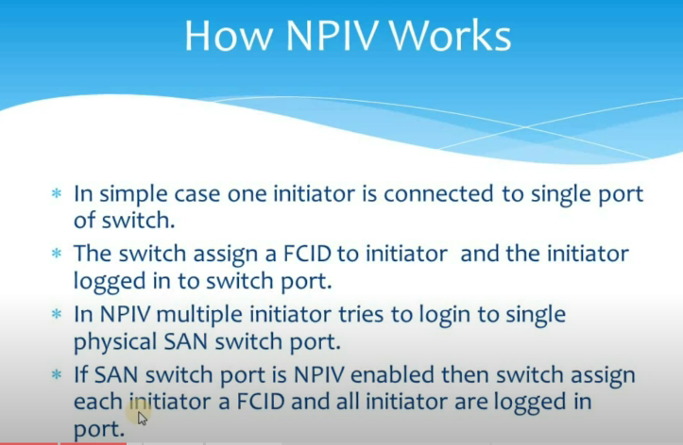
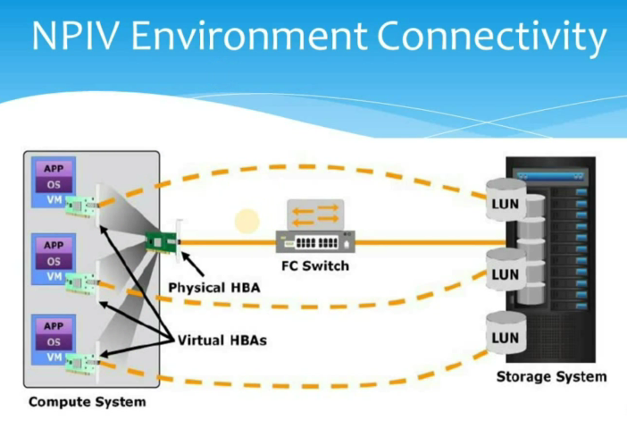
Separate FCID will be allocated for Virtual HBA through Physical HBA.
While allocating luns, need to use Virtual HBA’s for zoning

