zoZoning in Brocade.

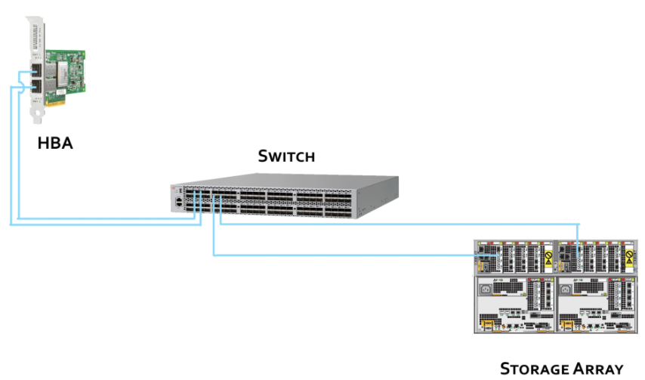
Switch Port 1 – HBA1 – 20:00:00:11:0a:02:29:b1
Switch Port 2 – HBA2 – 20:00:00:11:0a:02:29:b2
Switch Port 12 – Storage Array port1 – 50:01:10:80:00:ad:33:e8
Switch Port 13 – Storage Array port2 – 50:02:10:80:00:ac:f5:54

Basics of Zoning
Each device in a fiber channel fabric will have a unique Word Wide Name (WWN). WWN is a unique identifier which is burned into the hardware. Each vendor gets their own identifier. It is a 64-bit address. It is similar to an MAC address that you find in a NIC. There are two types of WWNs,
- Word Wide Node Name (WWNN)
- Word Wide Port Name (WWPN)

switch:admin> switchshow
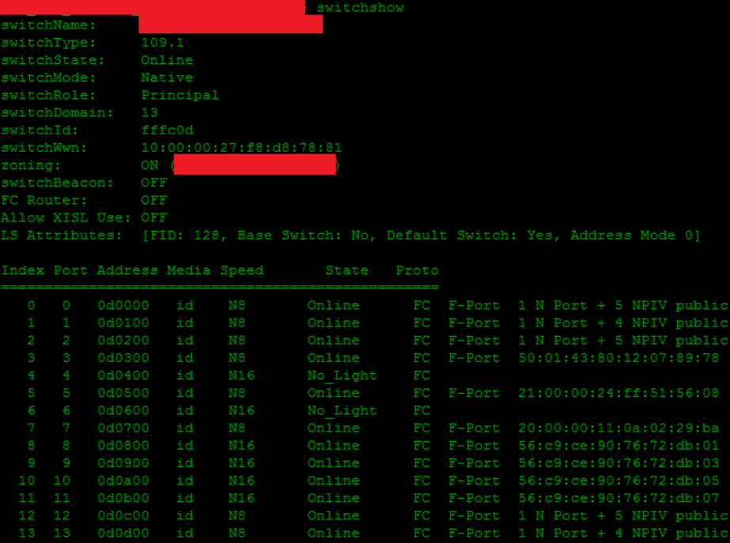

Brocade Switch Zoning Steps
Step 1: First assign alias names for WWPN’s of HBA(Hosts) and Storage array.
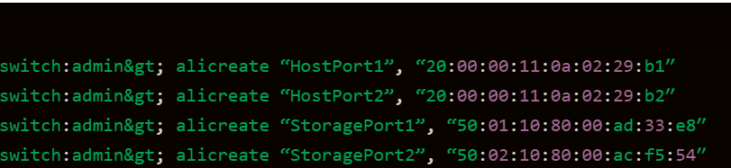
Alias names are created for easy understanding of admin.
Hostport1 is the name of WWPN 20:00:00:11:0a:02:29:b1.(HBA host).
->To check the alias name run.
Cmd: alishow “HostPort1” or alishow -i
Step 2: Now we are going to create two zones with two aliases
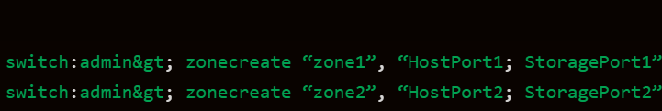
1.Here we created zone1 and assigned Hostport1 and storagePort1 to it.
2.Here we created zone2 and assigned Hostport2 and storagePort2 to it.
Step3 : Now create zone configurations and zones to it.
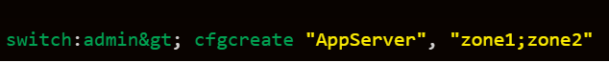
As we can see here the ports are already in the zone and we are assigning those zone to “AppServer” cfg
Next step is to keep cfg in enable state.
Step 4: Final step Enabling the cfg
aliAdd | Add a member to a zone alias
aliCopy | Copy a zone alias
aliCreate | Create a zone alias
aliDelete | Delete a zone alias
aliRemove | Remove a member from a zone alias
aliRename | Rename a zone alias
aliShow | Print zone alias information
cfgAdd | Add a member to a configuration
cfgCopy | Copy a zone configuration
cfgCreate | Create a zone configuration
cfgDelete | Delete a zone configuration
cfgRemove | Remove a member from a configuration
cfgRename | Rename a zone configuration
cfgShow | Print zone configuration information
zoneAdd | Add a member to a zone
zoneCopy | Copy a zone
zoneCreate | Create a zone
zoneDelete | Delete a zone
zoneRemove | Remove a member from a zone
zoneRename | Rename a zone
zoneShow | Print zone information
cfgClear | Clear all zone configurations
cfgDisable | Disable a zone configuration
cfgEnable | Enable a zone configuration
cfgSave | Save zone configurations in flash
cfgSize | Print size details of zone database
cfgActvShow | Print effective zone configuration
cfgTransAbort | Abort zone configuration transaction

