### Highlights

* Results-oriented
* Rapid growing
* Creative
* Revenue generation
* Operability and commitment
* Responsible
* Good manners

### Education

Bachelor of Software Engineering: 2018 - 2022

University of Information Techologies, Tashkent

### Skills & Years

* Html, Css, Js: 2+
* Git, Jquery, Scss: 1+
* Figma, PS: 1+
* TS, React, Redux: 1-
* GraphQL, REST, TDD: 1-
* Webpack, 3js, Next js: 1-
* Experience: Node js, MySql, Php, Linux

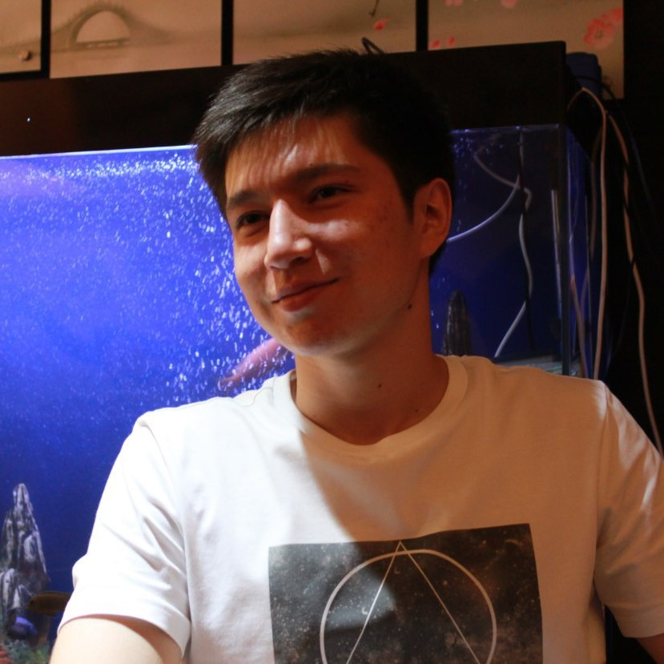

**React Front End Developer** heavily influenced by interactions, UI and UX. Working with web development since 2019, gravitating around design, animations and code. Addicted to music, sports, and games.

### Experience

02/2020 → now

**PROWEB.uz**

**Front End Developer and Teacher**

**Web studio and Education center**, Tashkent - Uzbekistan

* Web design in HTML, CSS.
* Work with developers via GIT. Project in pure JS, SCSS and GULP.
* Administrator in coworking zone.
* Teaching: HTML, CSS, SCSS, GULP, PUG, JS, JQUERY, GIT, BEM.

02/2021

**TeamPro.uz**

**Web layout designer**

**Web studio,** New York

* Making responsive cross-platform layouts in HTML, CSS and Tailwind CSS.

04/2021 → now

**Freelancing**

**Web Applications**

* Send customer info to telegram bot Node.js
* Start-up textile project Next.js, Redux, Typescript, module SCSS.

Sultonbek Nazarov

+998 (90) 997-91-79

kingsulton45@gmail.com