ScholarMatch AI

A Project Based Learning Report Submitted in partial fulfilment of the requirements for the award of the degree

of

Bachelor of Technology
in The Department of Computer Science and Engineering
25CS2103E – DATA STRUCTURES AND ALGORITHMS - 3

Submitted by

2510030060 – S.Sahasra Reddy
2510030206 – Koppolu Swathi
2510030253 – Kuchi Chethana
2510030113 – Dasari Vaishnavi
Under the guidance of
Dr. Punna Rao Vuyyuru

Department of Computer Science and Engineering
Koneru Lakshmaiah Education Foundation, Aziz Nagar Aziz Nagar – 500075
October – 2026

CERTIFICATE

This is to certify that the Project Based Learning report entitled “ScholarMatch AI” is submitted by the student(s) listed on the title page in partial fulfilment of the academic requirements for the award of the Bachelor of Technology degree.

The report documents a software prototype for research-paper discovery and reviewer allocation. The technical descriptions are based on the project materials reviewed, and the report distinguishes source inspection and supplied application screenshots from runtime tests that were not independently repeated for this document.

Project Guide Head of the Department

Name: Dr. Punna Rao Vuyyuru Name: Dr. Sumalakshmi C H

Signature: Signature:

Date: Date:

DECLARATION

We declare that this report entitled “ScholarMatch AI” has been prepared as part of the Project Based Learning curriculum. It describes the project structure, application interfaces, research-paper discovery workflow, reviewer-allocation methods, and allocation-history features based on the project materials reviewed.

We have distinguished implementation details visible in the source and supplied application screenshots from tests or performance results that were not independently verified for this report. No unverified performance metrics are presented as measured results. External datasets, services, libraries, and technical references used in the project are acknowledged in the report where applicable.

S. Sahasra Reddy - 2510030060 Signature:

Koppolu Swathi - 2510030206 Signature:

Kuchi Chethana - 2510030253 Signature:

Dasari Vaishnavi - 2510030113 Signature:

Place: Date:

ACKNOWLEDGEMENT

We express our sincere gratitude to our project guide and the Department of [Department Name] for providing the opportunity to undertake this Project Based Learning activity and for the academic guidance and feedback that support the development of this work.

We also acknowledge the contributions of the project team in developing and reviewing the ScholarMatch AI application, preparing the research-paper search and reviewer-allocation workflows, and documenting the technical architecture and available application evidence. We are grateful to the maintainers of the open-source tools, libraries, and scholarly metadata services on which the prototype relies.

Abstract

ScholarMatch AI is a web application intended to support research-paper discovery and reviewer allocation. The implementation combines a React and Vite frontend with a FastAPI backend, OpenAlex-based paper metadata retrieval, text-similarity calculations, graph algorithms for allocation, and PostgreSQL persistence for allocation history.
The research-search interface supports normal topic search and keyword filtering using Knuth–Morris–Pratt (KMP). Reviewer allocation compares paper titles and abstracts with reviewer research interests using TF-IDF vectors and cosine similarity. One allocation path uses maximum bipartite matching, while a capacity-aware path models reviewer capacities as a maximum-flow network solved with Edmonds–Karp.
The report documents the source structure and the application screens supplied by the project team. The included screenshots show the search interface, KMP results, reviewer allocation, allocation history, and individual allocation details. Runtime results and performance metrics are not inferred where no test evidence is available.
Keywords: research-paper discovery, reviewer allocation, OpenAlex, FastAPI, React, TF-IDF, cosine similarity, KMP, bipartite matching, maximum flow, PostgreSQL.

List of Figures

Figure 1.1 Problem-to-solution overview Figure 2.1 High-level system architecture Figure 2.2 Research search request flow Figure 2.3 KMP keyword filtering flow
Figure 2.4 TF-IDF and cosine-similarity workflow Figure 2.5 Maximum bipartite matching model Figure 2.6 Capacity allocation flow network Figure 2.7 Allocation-history data flow
Figure C.1–C.14 Application screenshots: dashboard, search, allocation, history and details
Figure D.1–D.6 Mind maps and technical workflow diagrams added in this revision

List of Tables

Table 1.1 Project objectives and evidence
Table 2.1 Technology stack
Table 2.2 Functional requirements Table 2.3 Non-functional requirements Table 2.4 API endpoint summary Table 2.5 Main database entities Table 3.1 Source modules reviewed
Table 4.1 Test plan and actual evidence status
Table 4.2 Reported external navigation: expected behaviour
Table 5.1 Limitations and future work

Table of Contents
Certificate 2
Declaration 3
Acknowledgement 4
Abstract 5
List of Figures 6
List of Tables 7
- INTRODUCTION 9
- METHODOLOGY 11
- EXPERIMENTS 15
- RESULTS 17
- CONCLUSION AND FUTURE WORK 19
REFERENCES 20
APPENDIX A — API SUMMARY 21
APPENDIX B — SOURCE INVENTORY 22
APPENDIX D — MIND MAPS AND WORKFLOWS 23–26
APPENDIX C — APPLICATION SCREENSHOTS 27–33

INTRODUCTION

Background
Research workflows often require papers to be discovered from large scholarly indexes and then routed to reviewers whose subject interests are relevant to the paper. Manual search and assignment can require repeated browsing, comparison of titles and abstracts, and tracking of who reviewed what. A small decision-support application can centralize these steps, make search results easier to inspect, and provide a repeatable method for proposing assignments.

Project overview
ScholarMatch AI is implemented as a browser-based client-server application. The frontend presents the research-search form, reviewer-allocation forms, and allocation-history views. The backend exposes HTTP endpoints through FastAPI. OpenAlex is used as the external scholarly metadata source. PostgreSQL is used by the history service to persist allocation runs and their results. The codebase also includes separate algorithm modules for KMP string matching, TF-IDF cosine similarity, bipartite matching, and Edmonds–Karp maximum flow.

Problem statement
The project addresses the practical need to retrieve research papers by topic and assist allocation of those papers to reviewers based on textual relevance and workload constraints. The implementation provides a heuristic allocation mechanism; it does not establish that the assignments are academically optimal or free of conflicts of interest. The current source should be understood as a decision-support prototype whose results require human review.

Objectives

Objective | Evidence in inspected source
Retrieve research-paper metadata | OpenAlex service and GET /papers endpoint
Filter search results by a keyword | KMP helper and GET /papers/keyword endpoint
Match papers with reviewers | TF-IDF/cosine similarity and bipartite matching service
Respect reviewer capacity | Capacity allocation using Edmonds–Karp maximum flow
Persist allocation history | PostgreSQL history service
Summarize allocation totals | Analytics endpoint aggregates saved allocation runs

  - Scope and target users
The observed scope includes topic search, optional KMP keyword filtering, user-entered reviewer interests and capacities, allocation result presentation, CSV export in the allocation UI, and history/analytics access. Typical users are project demonstrators, academic coordinators, or researchers testing reviewer-allocation ideas. Authentication and role-based authorization were not evidenced in the inspected files, and the report does not claim they exist.

Significance and report organization
The project brings search, text comparison, graph-based allocation, and history into one interface. Chapter 2 describes the methodology and architecture; Chapter 3 records experiments and reproducible test plans; Chapter 4 discusses source-derived findings and current evidence; Chapter 5 summarizes conclusions and future work.

INTRODUCTION — SYSTEM CONTEXT

Existing approach and limitations
A manual approach typically involves searching a scholarly index, opening candidate papers, comparing their topics against reviewer expertise, and tracking assignments in separate files. This can be understandable for small workloads but becomes difficult to repeat consistently. ScholarMatch AI combines these steps into a single workflow. The application still depends on external service availability, user-supplied reviewer-interest descriptions, and a lexical similarity heuristic.

Proposed solution
The proposed solution uses OpenAlex to retrieve paper metadata, KMP to filter retrieved text, TF-IDF/cosine similarity to estimate paper-reviewer relevance, and graph algorithms to allocate papers. The normal matching path seeks a one-to-one maximum matching. The capacity path allows multiple papers per reviewer up to a configured capacity. PostgreSQL records run-level totals and individual assignment outcomes for later inspection.

Constraints and assumptions
The frontend currently points to http://127.0.0.1:8000, so the browser expects a backend reachable at that address. CORS in backend/main.py permits only http://localhost:5173. Running the frontend on a different port or hostname may require a configuration change. The KMP endpoint fetches a limited set of topic results before filtering, so its search is bounded by the fetched subset rather than the full scholarly corpus.

Problem-to-solution overview
Figure 1.1 is a conceptual summary derived from the modules observed in the source. It describes the implemented workflow, not a measured performance claim.

Problem | Implemented response | Boundary
Finding relevant papers | OpenAlex topic search | Depends on upstream API and returned records
Narrowing topic results | KMP title/abstract filter | Filters a fetched subset
Estimating reviewer relevance | TF-IDF and cosine similarity | Lexical heuristic; not a trained semantic model
Allocating under constraints | Bipartite matching or maximum flow | No conflict-of-interest check evidenced
Reviewing previous runs | PostgreSQL history and analytics | Database configuration must be valid

SUPPLEMENTARY EXPLANATION — INTRODUCTION

Project context and intended users
ScholarMatch AI is positioned as a decision-support tool for academic review workflows. A research coordinator may need to find papers around a topic, shortlist items for review, and distribute the shortlisted papers among reviewers. When these activities are handled in separate browser tabs and spreadsheets, the coordinator must repeatedly copy information, compare expertise descriptions manually, and maintain a separate record of previous decisions. Bringing discovery, allocation, and history into one interface reduces that switching cost and gives the workflow a consistent place to start.

Scope of the problem
The problem is not simply finding a paper whose title contains a particular word. Search results must be inspectable, reviewer interests must be represented in a form that can be compared, and assignments must respect the chosen allocation rule. ScholarMatch AI addresses these parts as connected but distinct tasks. Search retrieves candidate metadata; keyword filtering narrows the retrieved set; similarity scoring estimates textual relatedness; graph algorithms convert eligible relationships into assignments; and history records outcomes for later review.

Decision support rather than automatic academic judgement
The system should be interpreted as an aid to a human coordinator, not as a replacement for editorial judgement. A text-similarity score can indicate shared vocabulary, but it cannot by itself confirm subject expertise, availability, independence, or the absence of a conflict of interest. The coordinator remains responsible for examining the paper and reviewer context before accepting a proposed match. This distinction is important when describing the value of the prototype: it structures a repetitive workflow and makes its computational steps more explicit, while leaving the final decision with the responsible person.

Success criteria
A useful evaluation should consider more than whether a page renders. Search quality includes whether metadata fields are mapped consistently and whether empty or unavailable abstracts are handled safely. Allocation quality includes whether each paper is assigned at most once, whether reviewer capacity is respected in the capacity-aware path, and whether unassigned papers are reported rather than silently dropped. Traceability includes whether saved runs can be retrieved with their totals and paper-level details. These criteria form a practical basis for the test plan described later in the report.

METHODOLOGY

Development methodology
This report uses a source-first analysis methodology: identify the project files, trace user-facing workflows into backend routes and services, inspect algorithm modules and persistence operations, and separate directly observed code from behavior that requires execution. The uploaded archive contains a frontend and backend source tree plus bundled dependencies. The project-owned inventory used for this report contains 46 files after excluding virtual-environment, node_modules, cache, and Git internals.

Technology stack

Layer | Technology / component | Role
Frontend | React 19, Vite | Interactive client interface and local development server
Frontend utilities | Axios, React Router, Tailwind CSS, Lucide React, Recharts | HTTP requests, routing, styling, icons, charting dependency
Backend | Python, FastAPI, Uvicorn | HTTP API and request handling
External data | OpenAlex Works API | Scholarly work metadata
Persistence | PostgreSQL, psycopg2 | Allocation run and result storage
Text processing | scikit-learn TF-IDF and cosine similarity | Lexical relevance scoring
Algorithms | KMP, bipartite matching, Edmonds–Karp | Keyword filtering and allocation

  - System architecture
The browser communicates with FastAPI through Axios. The backend routes separate paper search from allocation. The OpenAlex service calls the upstream Works endpoint and maps records into a frontend-friendly shape. Allocation services call algorithm modules and the history service writes completed runs to PostgreSQL. The frontend renders results and requests saved history through dedicated endpoints.
Figure 2.1 should be read as a source-derived architecture diagram. No authentication service, deployed cloud service, or trained ML model is included because the inspected source did not establish those components.

METHODOLOGY — RESEARCH SEARCH

Research-paper retrieval
The papers router defines GET /papers with a required query string and a limit constrained between 1 and 50. The OpenAlex service calls https://api.openalex.org/works using search and per_page parameters and a 15-second request timeout. It maps each result into fields including identifier, title, authors, publication year, DOI, citation count, OpenAlex URL, and abstract.
OpenAlex provides abstracts as an inverted index in the records handled by this service. The reconstruction helper reverses the index by assigning words to their listed positions and then joins words in ascending position order. If an inverted index is absent, the abstract is returned as an empty string.

Keyword filtering with KMP
The keyword endpoint requires both a topic query and a keyword. It fetches up to 50 works for the topic, then passes the results to the keyword-search service. The service lowercases the keyword, paper title, and abstract, and runs KMP on title and abstract. It returns matching papers with counts of title and abstract matches, then applies the requested output limit.
KMP builds a longest-prefix-suffix (LPS) array so that a mismatch can reuse information about the pattern prefix rather than restarting every comparison from the beginning. This is a deterministic string-search algorithm. Its effectiveness here depends on the quality and availability of titles and abstracts supplied by OpenAlex.

External navigation and DOI links
The research UI includes a helper that normalizes DOI values. A DOI.org URL is retained; a Springer URL is converted to a DOI.org path; and a bare identifier beginning with “10.” is prefixed with https://doi.org/. The result card uses href={doiUrl} and target="_blank". Consequently, clicking the DOI/publication link intentionally opens an external destination in a new tab.
The inspected form submit handler calls the local backend search function and places returned papers in component state. It does not directly assign window.location. If the external site opens immediately on pressing Search, without clicking a result link, that behavior remains unexplained by the inspected handler and needs browser Network/Console inspection of the actual running build.

METHODOLOGY — REVIEWER ALLOCATION

Text representation and similarity
The cosine-similarity helper uses scikit-learn TfidfVectorizer to represent two text strings as TF-IDF vectors. It then calculates cosine similarity and rounds the score to four decimal places. Empty strings return 0.0. TF-IDF emphasizes terms that are relatively informative in the pair of documents; cosine similarity estimates the angle-based similarity between their vectors.
This approach is lightweight and explainable, but it is primarily lexical. Similar concepts expressed with different vocabulary may receive low similarity, while shared generic terms may contribute to similarity. The inspected code does not use a pretrained embedding model, supervised training, or an evaluated relevance benchmark.

Normal allocation by bipartite matching
The paper-allocation service constructs a bipartite graph. Each paper is represented by a left-side vertex and each reviewer by a right-side vertex. An edge is created when cosine similarity meets the default threshold of 0.1. The maximum-bipartite-matching function uses recursive reassignment to seek the largest number of paper-reviewer pairs without assigning the same reviewer more than once.
The matching path returns assignment objects with paper identifier/title, reviewer identifier/name, and similarity score. Because the matching implementation limits each reviewer to one paper, this method is suited to one-to-one matching rather than workload distribution with multiple assignments per reviewer.

Capacity allocation by maximum flow
The capacity allocation service creates a directed flow network with a source, one node per paper, one node per reviewer, and a sink. Source-to-paper edges have capacity one; compatible paper-to-reviewer edges have capacity one; reviewer-to-sink edges use the configured reviewer capacity. Edmonds–Karp finds augmenting paths by breadth-first search over the residual graph until no augmenting path remains.
The service reconstructs assignments from used paper-reviewer edges and lists papers that remain unassigned. This path allows one reviewer to receive multiple papers up to capacity. It is a different allocation strategy from the one-to-one bipartite matching route.

METHODOLOGY — DATABASE AND API

Database persistence
The database connection helper reads DB_HOST, DB_NAME, DB_USER, DB_PASSWORD and DB_PORT from environment variables. The history service inserts a row into allocation_runs, obtains the generated run identifier, and writes assignment and unassigned records to allocation_results. It commits the transaction after writing the run and its details and rolls back if an exception occurs.

Entity | Fields evidenced by history SQL | Purpose
allocation_runs | id, method, total_assigned, total_unassigned, created_at | One row per allocation run
allocation_results | id, run_id, paper_id, paper_title, reviewer_id, reviewer_name, similarity_score, status | One row per assigned or unassigned paper

Two near-identical connection modules are present: backend/database.py and backend/db_connection.py. This duplication can be consolidated to reduce maintenance risk. The ZIP contains backend/.env; secret values are deliberately not reproduced here. If its database password is real and the archive was shared outside the intended group, rotate it.

API endpoint summary

Method | Path | Purpose
GET | / | Backend welcome/status response
GET | /health | Health response
GET | /papers?query=...&limit=... | Search OpenAlex works
GET | /papers/keyword?query=...&keyword=...&limit=... | Filter topic results using KMP
POST | /allocation/matching | Normal matching allocation
POST | /allocation/capacity | Capacity-based allocation
GET | /allocation/history | List previous runs
GET | /allocation/history/{run_id} | Return one run and its results
GET | /allocation/analytics | Aggregate run and assignment totals

  - Configuration
The frontend API base is hard-coded to http://127.0.0.1:8000. The backend CORS allowlist contains http://localhost:5173 only. A different Vite port, host name, or deployment domain may fail cross-origin requests. The inspected OpenAlex request sends search and per_page parameters and does not pass an API key. This is a conclusion about the inspected request path, not proof about every deployment environment.

SUPPLEMENTARY EXPLANATION — METHODOLOGY

Separation of responsibilities
The project structure separates the browser interface from the API and separates API routing from service and algorithm code. This organization helps keep user interaction concerns out of the algorithm implementations. The frontend gathers search terms and allocation inputs, sends requests, and displays results. FastAPI validates incoming parameters and directs requests to the appropriate service. The services perform upstream retrieval, text processing, allocation, and history operations. This separation also makes the components easier to test independently: a
string-matching helper can be tested with fixed strings, while a route can be tested for request validation and response shape.

Search and metadata normalization
External scholarly APIs may return records with different optional fields or data structures. Normalizing each result into a predictable application structure allows the frontend to render titles, authors, year, citation count, and DOI links without needing to understand the upstream API's raw response. Abstract reconstruction is a special case because OpenAlex may provide abstract text as an inverted index. Rebuilding the text requires placing each indexed word at its recorded position before joining the words in order. When an abstract is absent, the application should treat it as missing text rather than imply that a paper has no substantive content.

Why KMP is used
Knuth–Morris–Pratt is a deterministic pattern-search algorithm. Its preprocessing stage calculates the longest proper prefix that is also a suffix for each pattern position. During scanning, this information allows the algorithm to move the pattern without repeatedly comparing characters that are already known to match. For a pattern of length m and text of length n, the usual time complexity is O(n + m). In this application, KMP is applied to the title and abstract text that is available for the retrieved works. The result therefore answers a bounded question—whether the requested keyword occurs in the fetched candidate set—not whether it occurs anywhere in all scholarly literature.

Text similarity and assignment
TF–IDF represents text using weighted term features. A term that appears in a document but is less common across the compared text collection can receive greater weight than a very common term. Cosine similarity then compares the direction of the vectors and returns a score that can be used to rank or filter candidate paper–reviewer pairs. The score is useful as a transparent baseline because the contributing terms can be inspected conceptually, but it is not a calibrated probability. A threshold should be chosen using representative examples and human judgement rather than treated as universally correct.

Two allocation models
The normal matching model can be represented as a bipartite graph with papers on one side and reviewers on the other. An edge represents a paper–reviewer pair that passes the similarity threshold. Maximum bipartite matching seeks the largest set of edges that do not reuse a paper or reviewer. The capacity-aware model extends this idea by representing the source, papers, reviewers, and sink as a flow network. Capacities limit the flow through reviewer nodes, and Edmonds–Karp repeatedly finds augmenting paths using breadth-first search until no additional path can increase the flow. The two methods serve different workload assumptions and should be explained separately in evaluation.

Persistence and error handling
Allocation history is valuable because a result is more useful when its method, totals, timestamp, and individual assignments can be reviewed later. The history service writes a run record and then stores the associated result records under the run identifier. Transaction handling is important: if a write fails partway through, a rollback prevents a partially written run from appearing as a complete successful operation. In deployment, database connectivity, credentials, schema availability, and transaction failures should be tested explicitly; static source inspection alone cannot prove that persistence succeeds in a live environment.

EXPERIMENTS

Experiment scope and evidence policy
The experiments chapter records what can be established from the supplied source archive and defines reproducible runtime checks. The archive was statically inspected for this report; the app was not launched, a live OpenAlex request was not executed, and a PostgreSQL connection was not made. Therefore, runtime test outcomes are marked “Not executed” rather than inferred from the presence of code.

Source inventory

Check | Observed outcome | Status
Project source inventory | 46 project-owned files after excluding bundled dependencies and cache folders | Completed static inventory
Paper-search path | React handler → Axios → FastAPI papers route → OpenAlex service traced | Static inspection
DOI navigation | DOI anchor with target="_blank" observed in PaperSearch.jsx | Direct source evidence
Allocation algorithms | KMP, cosine similarity, bipartite matching and Edmonds–Karp modules inspected | Static inspection
History persistence | SQL reads/writes and analytics aggregation inspected | Static inspection
Live frontend build | Not run during this audit | Not executed
Live OpenAlex API request | Not run during this audit | Not executed
End-to-end allocation/history | Not run during this audit | Not executed

  - Reproducible search checks
Test S-01: start FastAPI using the project’s dependency environment, then request GET /health. Expected result: a JSON health response. Actual result in this audit: not executed.
Test S-02: request /papers with query=machine learning and a small limit. Expected result: JSON containing query, total, and papers, provided the backend can reach OpenAlex. Actual result in this audit: not executed.
Test S-03: submit a topic from the React search UI and inspect the browser Network panel. Expected result: a request to the local /papers endpoint, followed by result rendering. Actual result in this audit: not executed.

EXPERIMENTS — ALLOCATION AND HISTORY

Reproducible allocation checks
Test A-01: provide multiple papers and reviewers with distinct research-interest strings, run normal allocation, and verify each reviewer appears at most once. Expected result: maximum matching assignments under the configured similarity threshold. Actual result in this audit: not executed.
Test A-02: provide reviewer capacities greater than one and run capacity allocation. Expected result: no reviewer exceeds capacity, each paper is assigned at most once, and unassigned papers are returned when no compatible capacity remains. Actual result in this audit: not executed.
Test H-01: run allocation with database configuration present, then request allocation history. Expected result: a new run row and its assigned/unassigned result rows are persisted and retrievable. Actual result in this audit: not executed.
Test H-02: request analytics after multiple allocation runs. Expected result: aggregate totals from allocation_runs and an efficiency percentage based on assigned versus total processed. Actual result in this audit: not executed.

Negative and boundary tests

Test ID | Input / condition | Expected behavior | Status
N-01 | Empty topic query | Validation error or rejected request | Proposed; not executed
N-02 | limit below 1 or above 50 | FastAPI query validation rejects request | Proposed; not executed
N-03 | OpenAlex unavailable or times out | Backend reports a controlled upstream failure | Proposed; not executed
N-04 | Empty reviewer interest text | Similarity returns 0.0 and compatibility edge is absent | Code-derived expectation
N-05 | No compatible reviewer | Paper appears as unassigned in capacity result | Code-derived expectation
N-06 | Invalid database credentials | History operation fails; transaction should not be reported as saved | Proposed; not executed

  - Reported external website behavior
The key diagnostic distinction is the action that triggers navigation. Clicking the DOI/publication link is expected to open an external destination in a new tab. Submitting the search form is intended to call the local backend and render results in the current app. If navigation occurs on form submission alone, inspect the actual deployed JavaScript bundle, browser extensions, any service worker, and the Network/Console panels.

SUPPLEMENTARY EXPLANATION — EXPERIMENTS

Reproducible evaluation approach
A reproducible evaluation starts from a known configuration and records both the input and the expected invariant. Search tests should use a small set of stable queries and inspect whether the response has the expected fields, whether limits are respected, and whether an upstream timeout is handled cleanly. KMP tests should include a keyword present in a title, present only in an abstract, absent from both, and a case variation. These cases help distinguish the correctness of the string-search routine from the quality or completeness of the external metadata.

Allocation invariants
Allocation checks should be designed around invariants that can be verified without subjective interpretation. In one-to-one matching, no reviewer should appear more than once and no paper should be assigned to multiple reviewers. In capacity allocation, the number of papers assigned to a reviewer must not exceed that reviewer's declared capacity. The assigned and unassigned counts should reconcile with the number of input papers, assuming the API contract treats every submitted paper as either assigned or unassigned. Similarity scores should be numeric and should correspond to the pair returned by the service.

History and negative cases
History tests should create a run, retrieve the history list, open the run details, and compare the stored counts with the original response. Analytics should be checked against a small known set of runs so the aggregate values can be calculated independently. Negative tests should include malformed input, empty interest descriptions, a database that is unavailable, and a search provider that times out. These tests are proposed procedures; they should only be marked as passed after they have been run and the observed response has been recorded.

Evidence discipline
The screenshots included in this report document the supplied interface states. They are useful evidence of page layout and of the values visible at the time the screenshots were captured, but screenshots alone do not prove all backend edge cases, algorithmic optimality, or long-term database reliability. A stronger evaluation combines interface evidence with API responses, automated assertions, and database checks. The report therefore distinguishes code-derived expectations from executed tests and does not convert an expected result into a claimed measurement.

RESULTS

Source-derived results
Static inspection confirms that the codebase contains the main components needed for paper retrieval, keyword filtering, reviewer matching, capacity allocation, and history. The OpenAlex service maps results into a stable structure for the frontend, while allocation services return assignment details and similarity scores. The history service persists allocation-run summaries and paper-level outcomes through PostgreSQL.

Feature | Source evidence | Verification status
Topic search | GET /papers and OpenAlex service | Code inspected; runtime not tested
KMP filter | GET /papers/keyword and KMP helper | Code inspected; runtime not tested
Normal allocation | Similarity threshold and bipartite matching | Code inspected; runtime not tested
Capacity allocation | Flow network and Edmonds–Karp | Code inspected; runtime not tested
History | Insert and select SQL in history service | Code inspected; DB not connected
Analytics | SQL aggregate over allocation_runs | Code inspected; runtime not tested

External link analysis
The inspected frontend has an explicit DOI URL conversion function and renders a DOI link with href={doiUrl} and target="_blank". This is direct source evidence for external navigation when the link is clicked. The search submit handler uses asynchronous API functions and sets paper results in component state; it does not directly call window.location in the inspected code.
Accordingly, the strongest source-based conclusion is conditional: if the user clicks a DOI link, external navigation is intentional. If the website opens simply after entering “machine learning” and pressing Search, the reviewed source does not fully account for it. A precise reproduction and destination URL are required before attributing that behavior to an API key change.

API key finding
The inspected backend OpenAlex request uses the public Works endpoint and supplies the search phrase and per_page count. No API key parameter is present in that request. The inspected backend .env key names are DB_HOST, DB_NAME, DB_USER, DB_PASSWORD, and DB_PORT. Values are omitted for security. A repository-wide credential scan and deployment configuration inspection were not performed.

RESULTS — LIMITATIONS AND DISCUSSION

Interpretation
The implementation combines well-known algorithms into a useful allocation prototype. KMP gives predictable keyword matching over available text; TF-IDF cosine similarity offers an interpretable lexical score; bipartite matching maximizes the number of one-to-one assignments; and maximum flow supports reviewer capacities. However, the similarity score is not a validated measure of reviewer competence, and the threshold of 0.1 is a code default rather than a value justified by an evaluation study.

Limitations
    - Static code review is not equivalent to runtime validation.
    - The normal matching path allows at most one paper per reviewer.
    - Keyword search filters a subset of at most 50 fetched works.
    - TF-IDF similarity may miss semantic equivalence and can be influenced by generic terms.
    - No conflict-of-interest detection is evidenced in the inspected code.
    - No authentication or authorization implementation was confirmed in the inspected paths.
    - Frontend API URL and CORS origin are hard-coded for a local development setup.
    - Two database connection modules duplicate configuration logic.
    - The ZIP contains a .env file and a bundled virtual environment; both should be excluded from a clean source submission.

Security and privacy considerations
Database credentials should be stored outside source control and shared archives. If the uploaded database password is real and has been disclosed beyond the project team, it should be rotated. The application should validate and constrain inputs, avoid exposing internal exception strings in production, and consider authentication, authorization, logging hygiene, and data-retention policies before broader deployment.

SUPPLEMENTARY EXPLANATION — RESULTS AND DISCUSSION

Interpreting the prototype's contribution
The implementation brings several recognizable techniques into a single academic workflow. OpenAlex provides a source of paper metadata; KMP supports explicit keyword matching over retrieved text; TF–IDF and cosine similarity provide a baseline for comparing paper content with reviewer interests; graph algorithms turn compatible pairs into assignments; and PostgreSQL is used to retain run history. The value of this combination is integration and traceability. Each component has a defined responsibility, and the interface presents the workflow in a form that can be inspected by a user.

What the evidence does and does not establish
Source inspection establishes that relevant routes, service functions, and algorithm modules are present in the reviewed code. The supplied screenshots establish that particular interface pages were displayed, including search results and allocation-history views. Neither form of evidence alone establishes that every endpoint works under all deployment conditions. In particular, live OpenAlex access, database configuration, cross-origin settings, dependency installation, and edge-case inputs can affect runtime behavior. The absence of an executed test should therefore remain visible in the report instead of being replaced with an assumed pass.

Quality and fairness considerations
Reviewer allocation has consequences beyond numerical similarity. A reviewer may share vocabulary with a paper but lack the necessary depth, be unavailable, or have a conflict of interest. Conversely, a domain expert may use different terminology and receive a low lexical score. The current prototype does not demonstrate a validated expertise model or conflict-of-interest screening. A responsible workflow should present assignments as recommendations, allow human overrides, record the reason for changes where appropriate, and evaluate the system against labelled examples and reviewer feedback before relying on it in a consequential process.

Operational readiness
The inspected source indicates a local-development configuration, including a frontend API address and a narrowly specified CORS origin. A deployed version should move environment-specific settings into configuration, document the required environment variables, and avoid distributing secrets or local virtual environments. Error messages should distinguish invalid input from external-service failures and database failures without exposing credentials or internal traces. These improvements are practical prerequisites for repeatable setup and safer sharing of the project archive.

CONCLUSION AND FUTURE WORK
ScholarMatch AI — Project Based Learning Report 16
ScholarMatch AI | Project Based Learning Report
Page 19

Conclusion
ScholarMatch AI is a full-stack prototype for scholarly paper search and reviewer allocation. The source shows integration with OpenAlex, a KMP keyword-filtering endpoint, TF-IDF/cosine similarity, bipartite matching, capacity-aware maximum flow, and PostgreSQL-backed allocation history and analytics. The UI includes a DOI-link path that opens an external publication destination in a new tab when clicked.
The report’s conclusions are deliberately limited to source inspection. No live build, search, database, or end-to-end workflow was executed while preparing this document. Therefore, runtime correctness, current API availability, deployment compatibility, and assignment quality remain to be verified with the test plan in Chapter 3.

Future enhancements

Priority | Enhancement | Reason
High | Make API base URL configurable and align CORS with deployment origins | Reduce environment-specific failures
High | Remove .env and virtual environment from distributable ZIPs | Reduce credential and archive-size risk
High | Execute automated API, allocation and database tests | Establish reproducible correctness evidence
Medium | Consolidate database connection modules | Reduce duplicated configuration
Medium | Add explicit search/loading/error and link affordances | Make external navigation clearer to users
Medium | Evaluate similarity threshold on labelled examples | Support defensible threshold selection
Future | Explore semantic embeddings and domain-specific matching | Improve handling of related concepts with different wording
Future | Add conflict-of-interest rules and human approval | Improve academic-review governance
Future | Add authentication, authorization, audit logs and deployment hardening | Support controlled multi-user use

  - Final status
The project should be presented as an implemented prototype with important paths visible in source code, while clearly stating that runtime validation remains pending. Do not report fabricated accuracy, speed, or success-rate figures. Complete the test plan and fill official academic details before final submission.

SUPPLEMENTARY EXPLANATION — CONCLUSION AND FUTURE WORK

Summary
ScholarMatch AI demonstrates an end-to-end design for bringing paper discovery and reviewer allocation into one interface. Its main technical contribution is the coordination of metadata retrieval, keyword filtering, textual similarity, graph-based assignment, and allocation history. The project also provides a concrete foundation for discussing algorithm choice: one-to-one matching and capacity-aware flow are related but not interchangeable models, and the choice should reflect the actual review workload.

Recommended next steps
The first priority is to establish a repeatable setup on a clean machine and run the API, search, allocation, and persistence checks. Configuration should be made environment-aware, duplicate database connection logic should be consolidated, and the distributable archive should exclude credentials and unnecessary generated dependencies.
After correctness tests, the team can assemble a small, anonymized set of papers and reviewer-interest descriptions, obtain human judgements about suitable matches, and evaluate threshold choices using precision-oriented and coverage-oriented measures. Only after that baseline is documented should semantic embeddings or more advanced ranking methods be compared.

Longer-term improvements
A mature version could add reviewer availability, expertise profiles with controlled vocabularies, conflict-of-interest declarations, assignment explanations, audit trails for manual overrides, and role-based access to sensitive information. Search could expose clearer loading and failure states and allow users to refine results by year or citation count. Monitoring could track upstream API failures and database health. These features should be prioritized according to user needs and evaluated incrementally so that each added capability has clear acceptance criteria.

Final perspective
The prototype is best understood as a foundation for a more systematic review workflow rather than a finished automated reviewer-selection authority. Its algorithms are explainable starting points, while the quality of real assignments depends on the data supplied, the operational environment, and human oversight. A disciplined testing and evaluation phase will make future claims about correctness and usefulness more defensible.

REFERENCES
- OpenAlex, “API Overview and Works API,” OpenAlex documentation. https://docs.openalex.org/ (accessed 11 October 2026).
- FastAPI, “FastAPI Documentation.” https://fastapi.tiangolo.com/ (accessed 11 October 2026).
- React, “React Documentation.” https://react.dev/ (accessed 11 October 2026).
- Vite, “Vite Documentation.” https://vite.dev/ (accessed 11 October 2026).
- scikit-learn, “TfidfVectorizer.” https://scikit-learn.org/stable/modules/generated/sklearn.feature_extraction.text.TfidfVectorizer.html (accessed 11 October 2026).
- scikit-learn, “cosine_similarity.” https://scikit-learn.org/stable/modules/generated/sklearn.metrics.pairwise.cosine_similarity.html (accessed 11 October 2026).
- Knuth, D. E., Morris, J. H., and Pratt, V. R., “Fast Pattern Matching in Strings,” SIAM Journal on Computing, vol. 6, no. 2, pp. 323–350, 1977.
- Edmonds, J., and Karp, R. M., “Theoretical Improvements in Algorithmic Efficiency for Network Flow Problems,” Journal of the ACM, vol. 19, no. 2, pp. 248–264, 1972.

APPENDIX A — API SUMMARY

Endpoint | Input | Output purpose
GET /health | None | Health status
GET /papers | query, limit | Paper metadata results
GET /papers/keyword | query, keyword, limit | Filtered paper metadata
POST /allocation/matching | papers, reviewers | One-to-one assignments
POST /allocation/capacity | papers, reviewers/capacity | Assignments and unassigned papers
GET /allocation/history | None | Prior run summaries
GET /allocation/history/{run_id} | run identifier | Run and result details
GET /allocation/analytics | None | Aggregated totals and efficiency

The exact request/response models should be confirmed against backend/routers/allocation.py and the deployed API schema before external integration.

APPENDIX B — SOURCE INVENTORY
  - backend/main.py
  - backend/routers/papers.py
  - backend/routers/allocation.py
  - backend/services/openalex_service.py
  - backend/services/keyword_search.py
  - backend/services/paper_allocation.py
  - backend/services/reviewer_matching.py
  - backend/services/capacity_allocation.py
  - backend/services/history_service.py
  - backend/algorithms/kmp.py
  - backend/algorithms/cosine_similarity.py
  - backend/algorithms/bipartite_matching.py
  - backend/algorithms/edmonds_karp.py
  - backend/database.py
  - backend/db_connection.py
  - backend/test_db.py
  - frontend/src/api.js
  - frontend/src/App.jsx
  - frontend/src/pages/PaperSearch.jsx
  - frontend/src/pages/ReviewerAllocation.jsx
  - frontend/src/pages/AllocationHistory.jsx
  - frontend/package.json
  - frontend/vite.config.js
  - backend/requirements.txt
Only frontend/src/assets/hero.png was found as a project image asset in the ZIP inventory; no authentic captured application screenshots were included as separate image files. Therefore, this report does not present fabricated UI screenshots. The architecture and workflow descriptions are derived from code.

APPENDIX D — MIND MAPS AND WORKFLOWS
Figure D.2. Simplified client–API–services/data architecture.
ScholarMatch AI | Project Based Learning Report
Page 23
Figure D.1–D.2 • Conceptual diagrams derived from the inspected project structure

Paper discovery OpenAlex
Keyword filtering KMP
Reviewer matching TF-IDF + cosine
ScholarMatch AI
Allocation Matching / max flow
Persistence PostgreSQL
Presentation React UI

Figure D.1. Mind map of the major ScholarMatch AI capabilities.

React frontend
FastAPI backend
OpenAlex + PostgreSQL

SEARCH PIPELINES
User enters topic
React submits Axios request
FastAPI papers route
OpenAlex Works API
Results rendered as cards
Topic + keyword entered
Fetch topic paper subset
Build KMP LPS array
Scan title and abstract text
Return matching papers + counts
Figure D.3–D.4 • Normal search and KMP keyword filtering

Normal topic search

KMP keyword search

Boundary: the keyword route filters the fetched subset (up to 50 works), not the entire OpenAlex corpus. Figure D.3. Normal search request flow. Figure D.4. KMP filtering flow.

MATCHING AND CAPACITY ALLOCATION
Figure D.5–D.6 • Text similarity and graph-based assignment

Paper title + abstract
TF-IDF
vectorization
Cosine similarity
Score compared with threshold (default 0.1)

Figure D.5. Lexical similarity workflow; similarity is a heuristic, not a validated expertise score.

Bipartite matching one reviewer per paper
Capacity allocation flow network
Assignments + unassigned papers

Normal path: maximum bipartite matching. Capacity path: Edmonds–Karp maximum flow respects reviewer capacity. Figure D.6. Allocation strategy overview. Human review is still required for conflicts and assignment suitability.

ALLOCATION HISTORY AND REVIEW LOOP
Figure D.7 • Persistence and feedback cycle

Allocation request
Algorithm computes assignments
History service writes run + results
PostgreSQL allocation tables
History / analytics API endpoints
UI shows run list, details and totals

The data-flow diagram reflects source modules. Database persistence must be tested with valid local configuration. Figure D.7. Allocation history and analytics flow.

APPENDIX C — APPLICATION SCREENSHOTS
Screenshots of working ScholarMatch AI workflows. Placeholder pages and the external publication page have been omitted.

Figure C.1. Dashboard overview
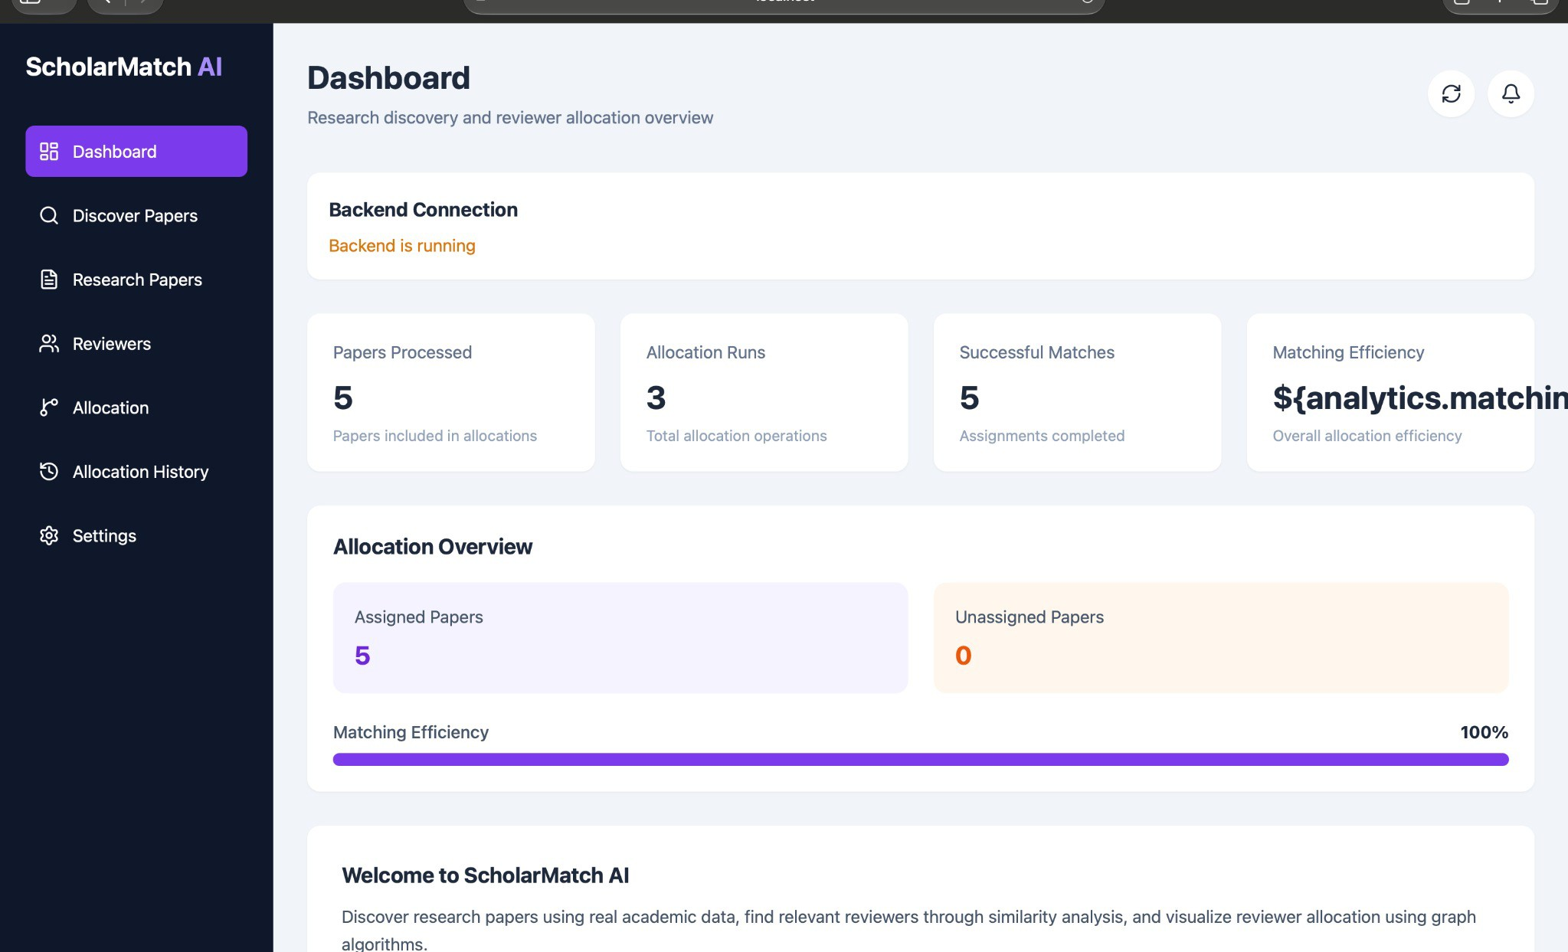

Figure C.2. Normal paper search
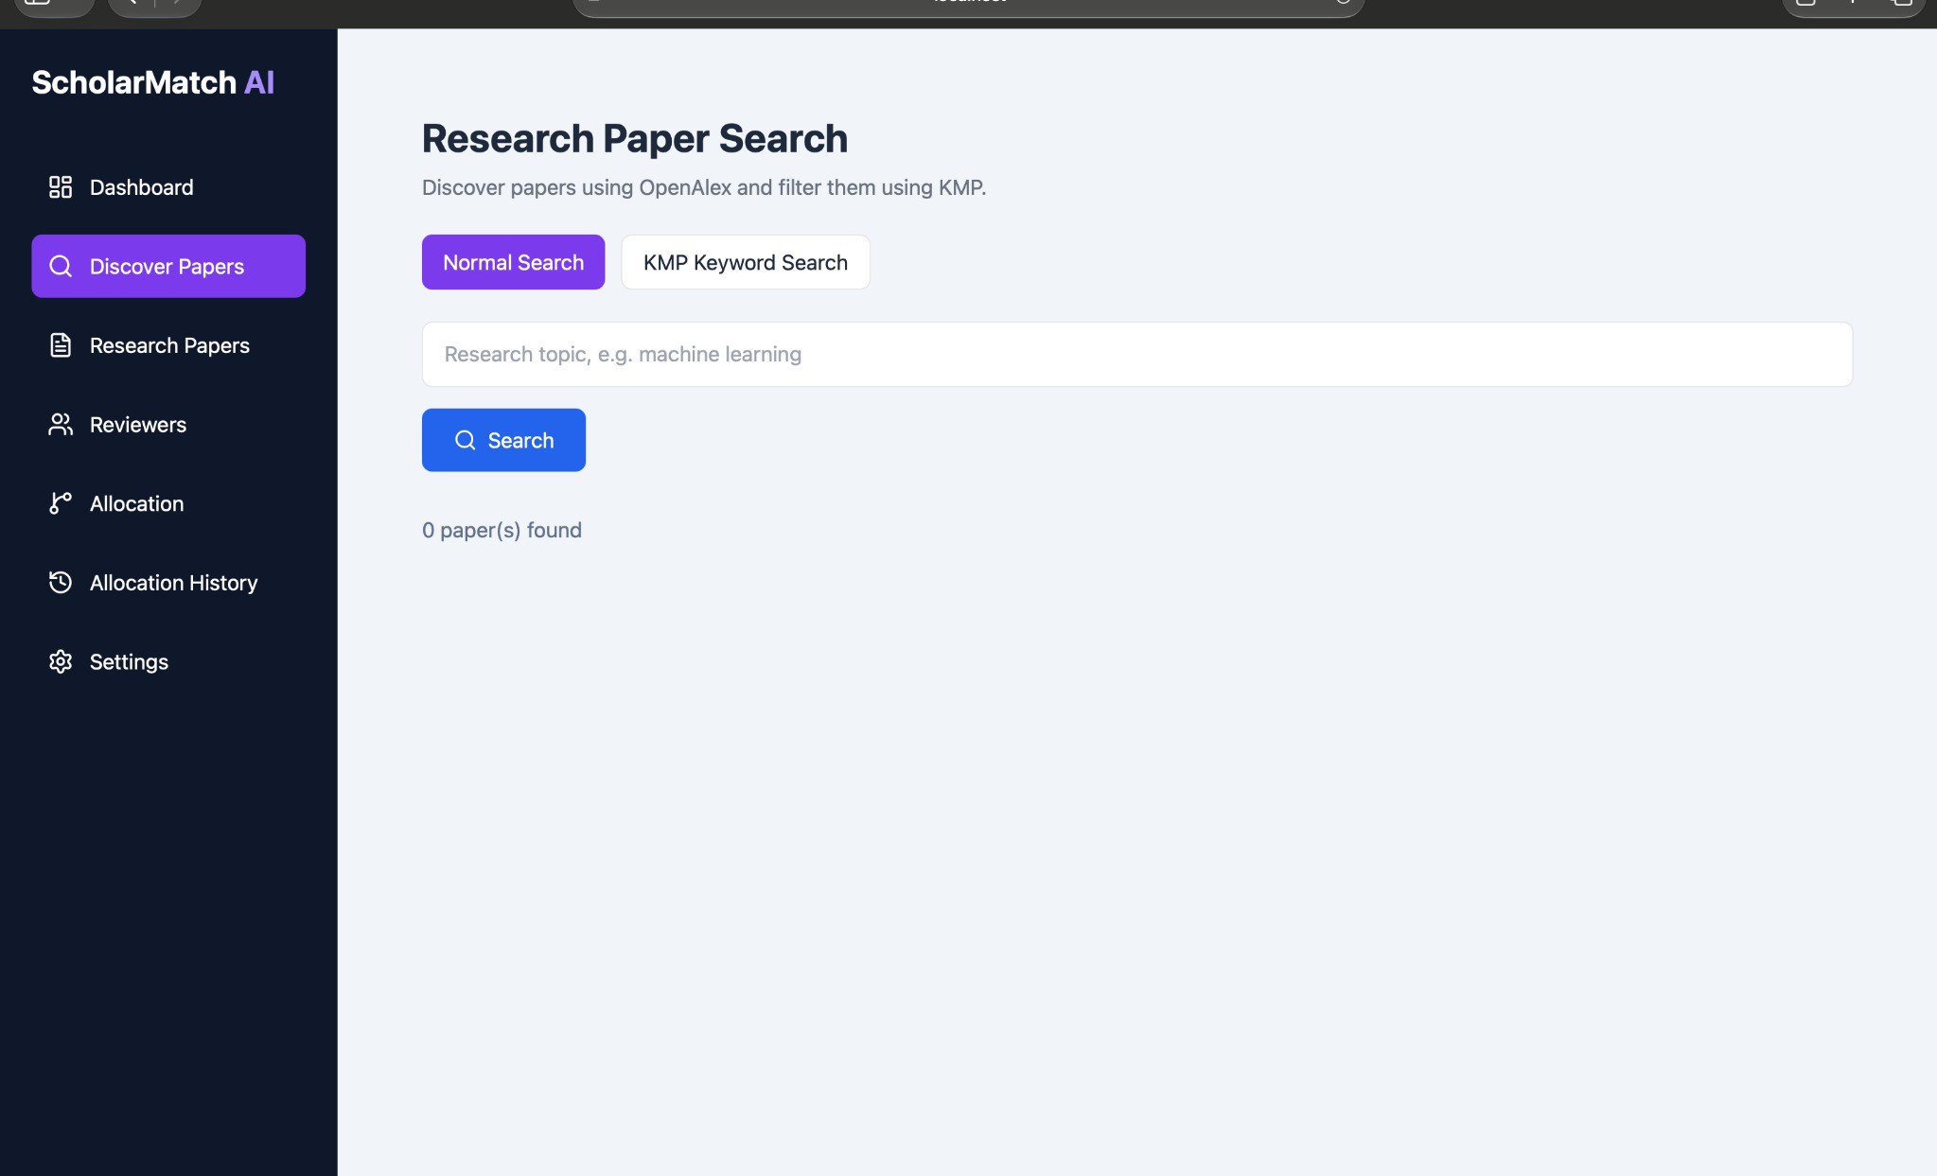

APPENDIX C — APPLICATION SCREENSHOTS (CONTINUED)

Figure C.3. Normal search results
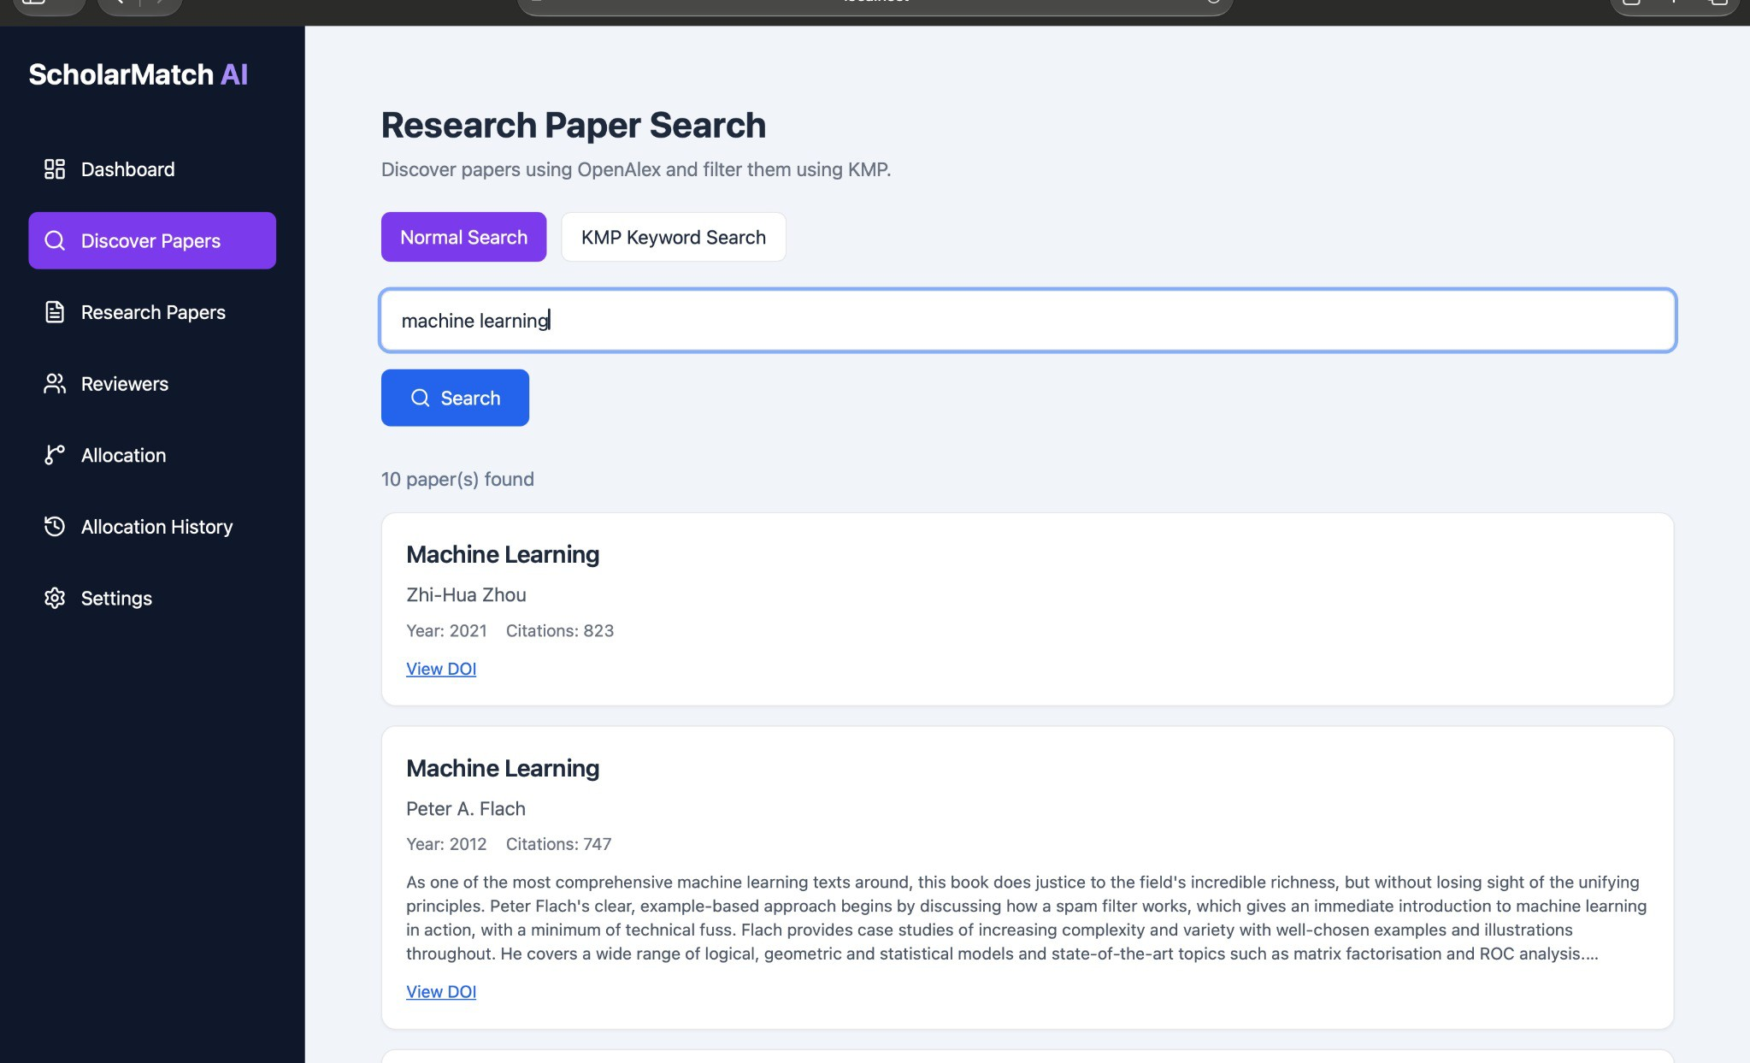

Figure C.4. KMP keyword search results
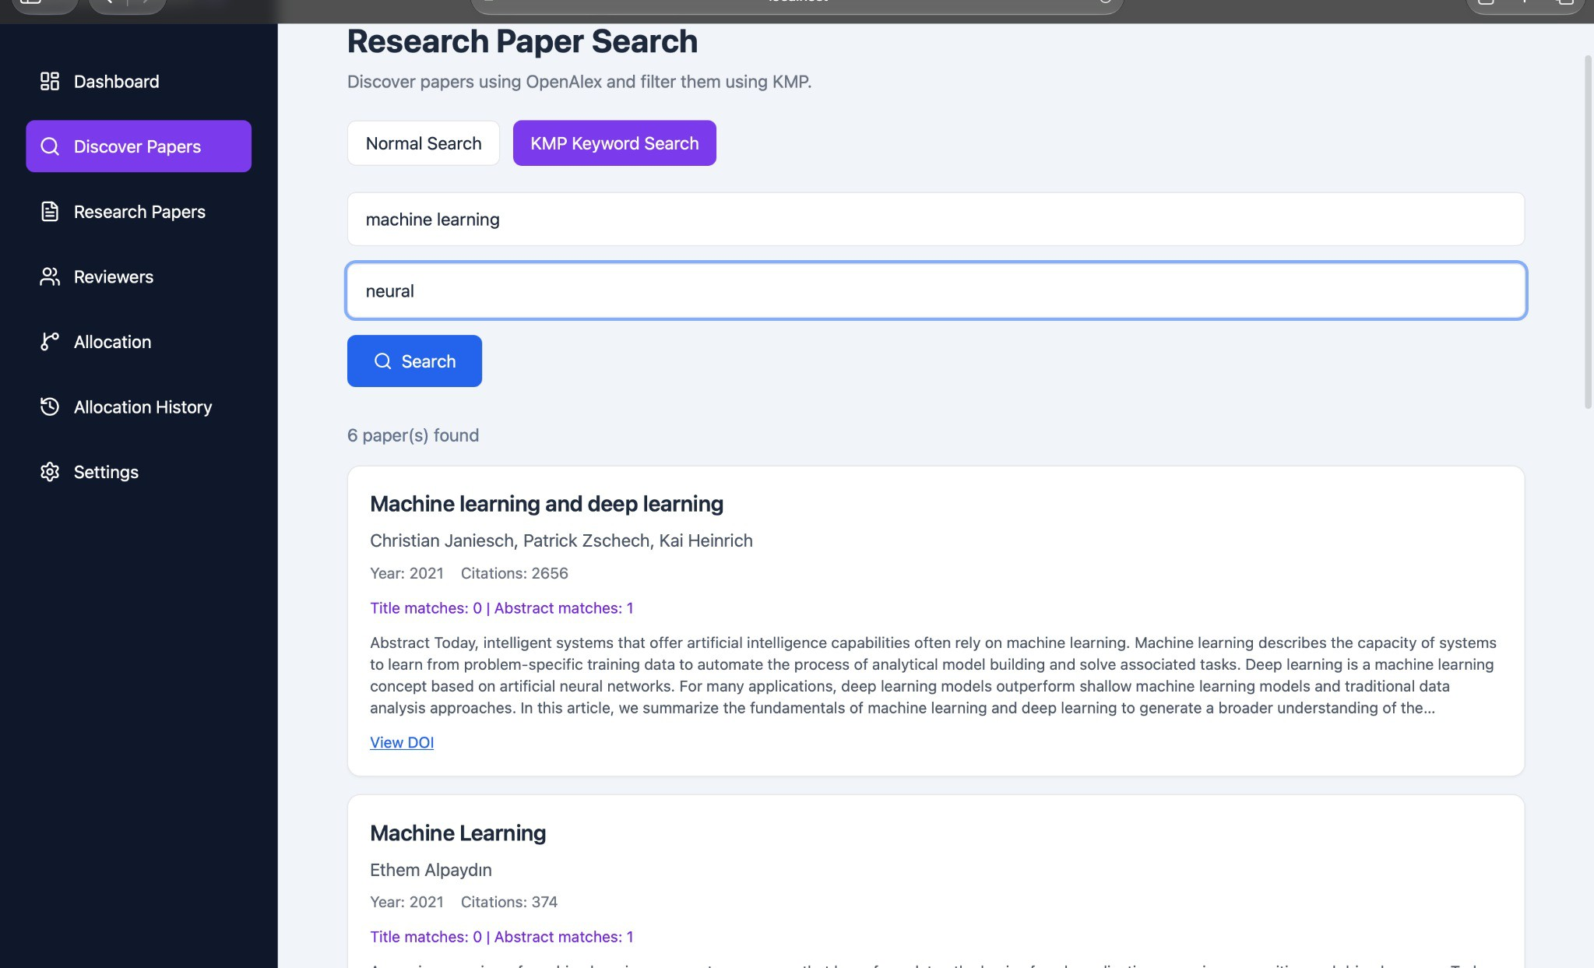

APPENDIX C — APPLICATION SCREENSHOTS (CONTINUED)

Figure C.5. Reviewer allocation form — initial state
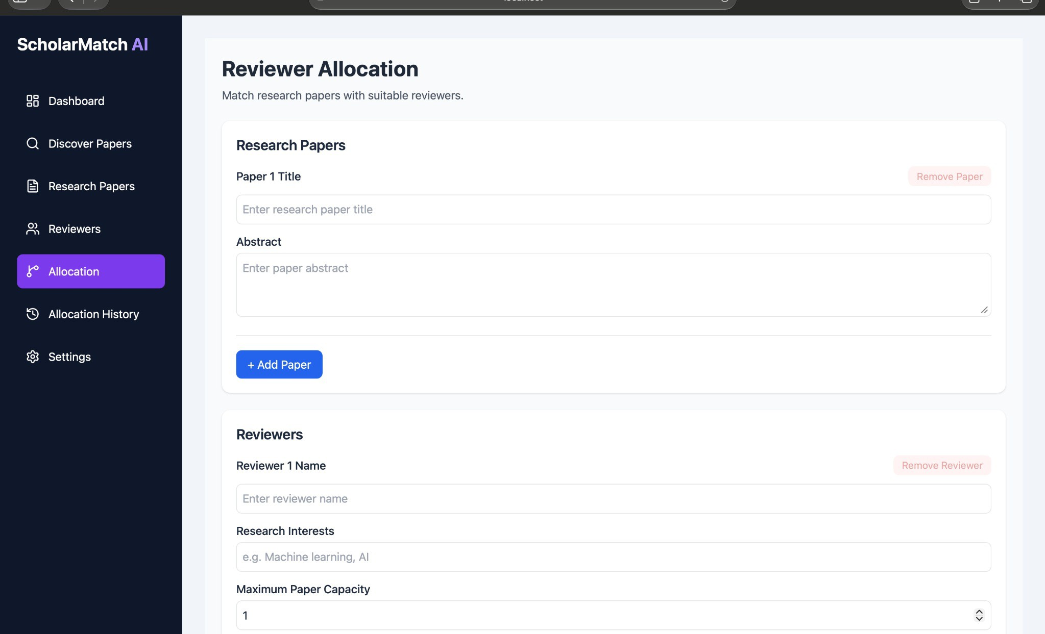

Figure C.6. Allocation results and reviewer workload chart
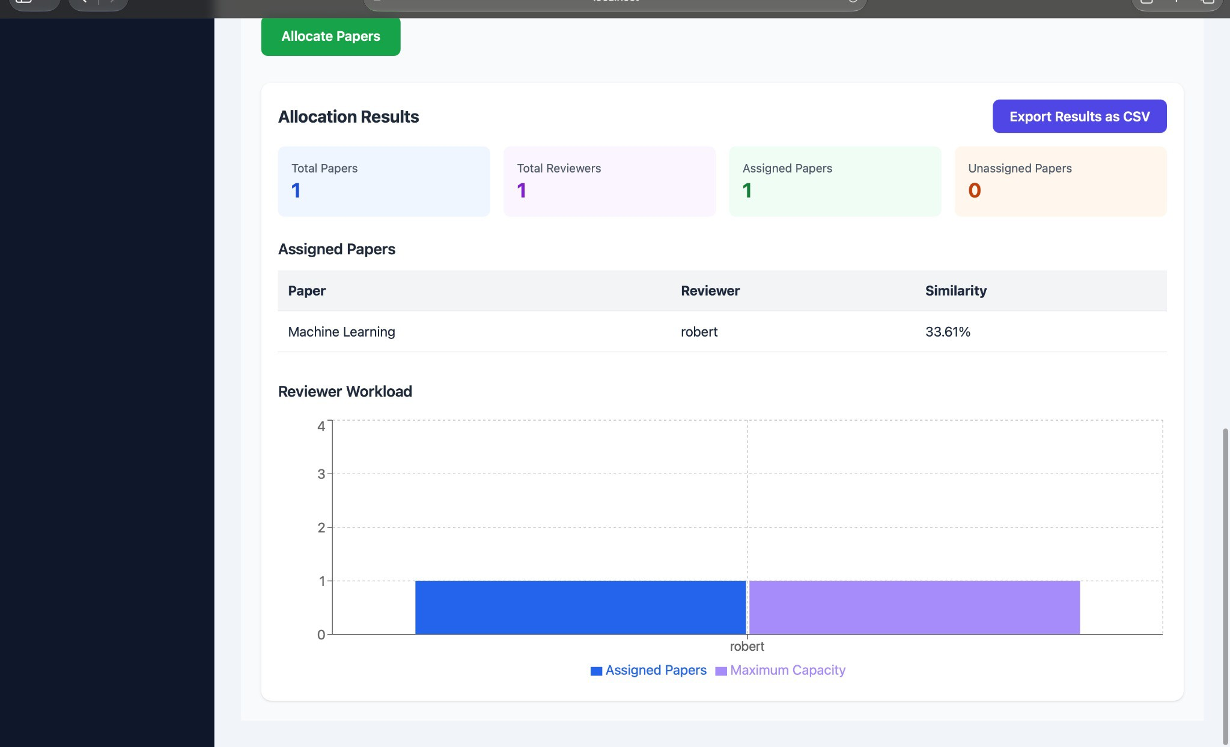

APPENDIX C — APPLICATION SCREENSHOTS (CONTINUED)

Figure C.7. Reviewer allocation form — populated inputs
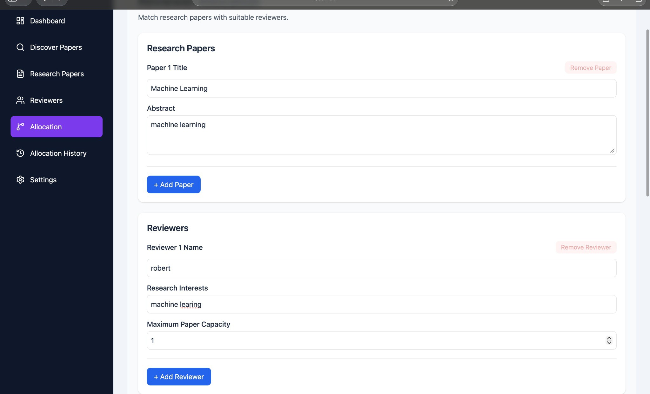

Figure C.8. Allocation history overview
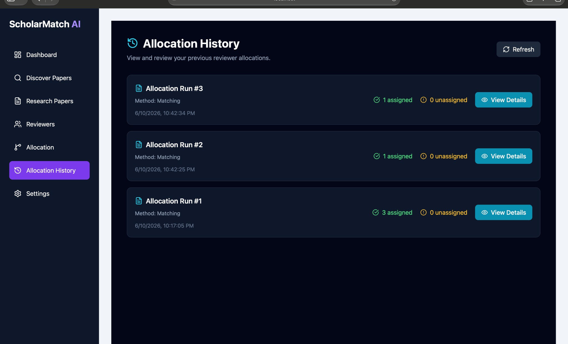

APPENDIX C — APPLICATION SCREENSHOTS (CONTINUED)

Figure C.9. Allocation history with five runs
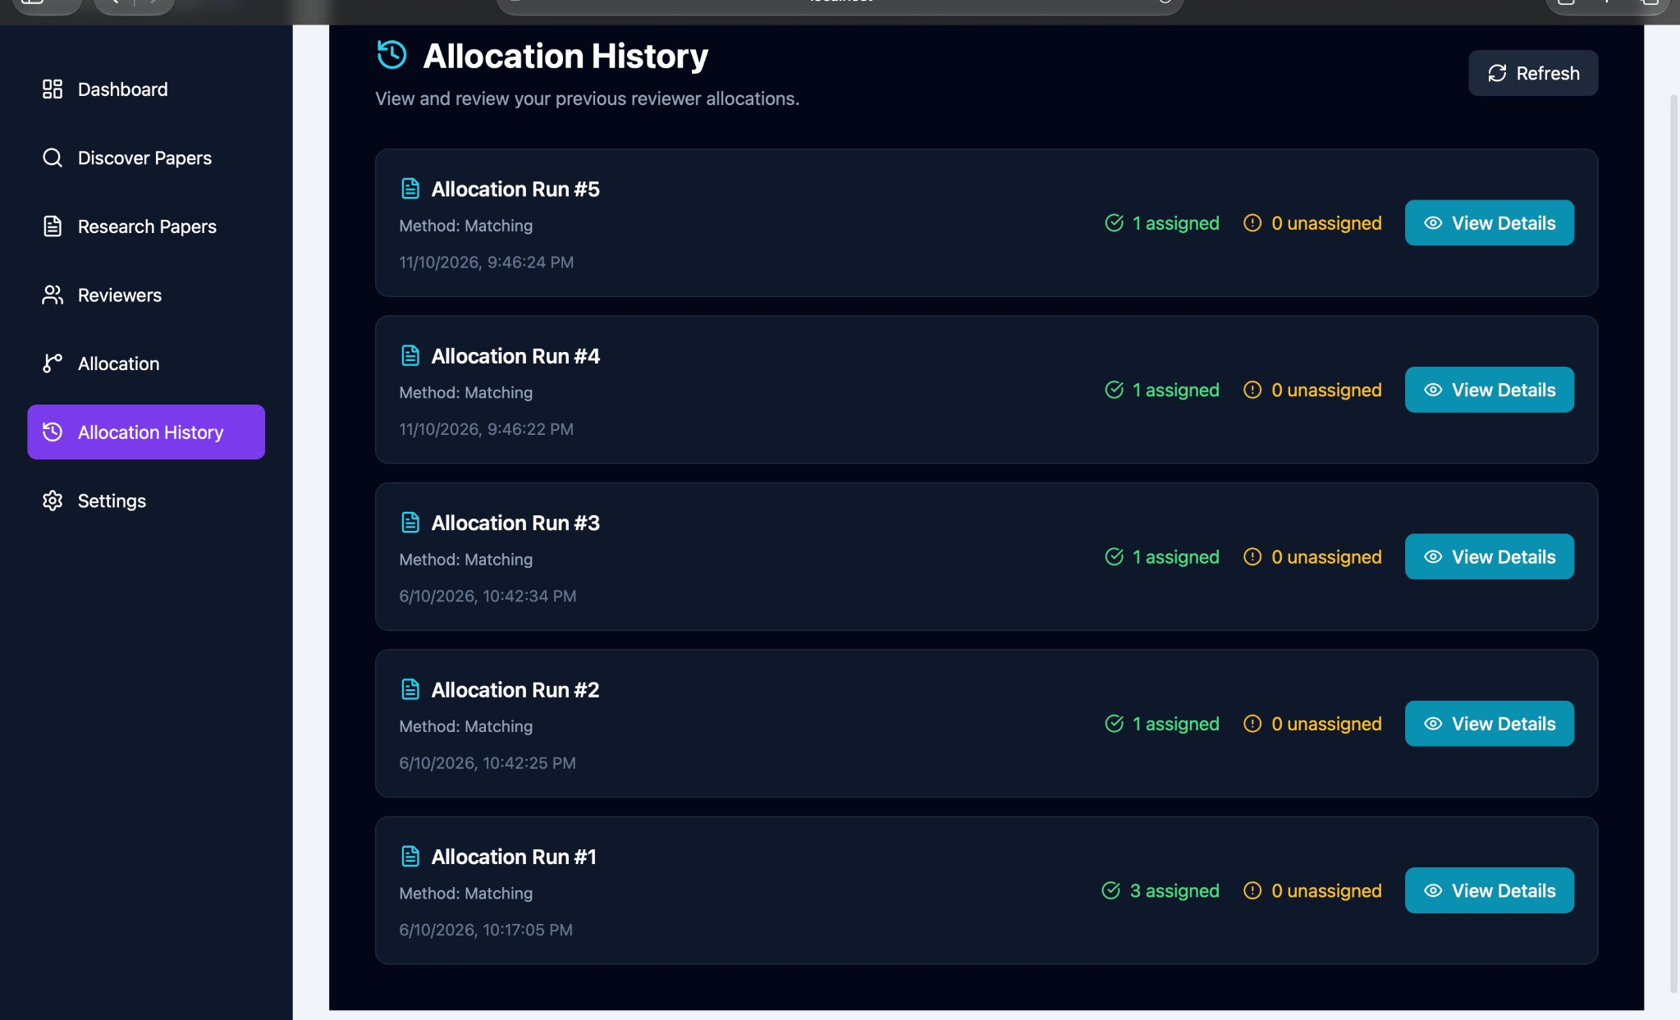

Figure C.10. Allocation history — run details
